Psychology 1000
Exam Review
Chapter 5: Sensations and Perceptions  Sensations  Sensory Processes  Sensory Systems  Visual System  Visual Transduction  Reconstruction of Visual Scenes  Auditory System (hearing)  Auditory Transduction  Coding of Pitch and Loudness  Sound Localization  Hearing Loss  Taste and Smell  Skin and Body Senses  Perception  Organizations and Structures  Perception Hypothesis Testing  Perception of Depth, Distance and Movement  Chapter 6: Sleep  Consciousness  Measuring Consciousness  Levels of Consciousness  Neural Basis of Consciousness  Circadian Rhythms  Environmental Disruptions  Daydreaming  Sleep  Why Sleep?  Sleep Disorders  Dreams  Drugs  Depressants  Stimulants  Opiates  Hallucinogens  Marijuana  Determining Effects of Drugs  Hypnosis  Theories for Hypnosis  Meditation  Learning  How do we learn  Classical Conditioning  Basic Principles  Applications of Classical Conditioning  Time of Pairing  Things that Affect  Conditioning  Operant Conditioning  Model  Difference Between Classical and Operant  Operant Consequences  Primary and Secondary Consequences  Reinforcement Schedules  Biology and Learning  Cognition and Learning  Escape and Avoidance Conditioning  Observation Learning  Cognition in Classical Conditioning  Cognition in Operant Conditioning  Behaviour Therapy  Memory  Basics  Three Component Model  What Evidence of STM and LTM  Encoding (Acquisition)  Storage  Retrieval  Forgetting  Disorders  Memory as a Constructive Process  Biology of Memory | 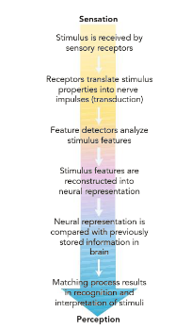  CHAPTER FIVE  -If sense organs are not defective we experience light waves as brightness and colors, air vibrations as sound  -We perceive the world around us as Psychophysics and Psychophysiology  -Synesthesia: “mixing of senses” their sense organs are defective which means different that example above (sound as colour or taste as touch, woman more likely than men)  -Steps in Sensations (image):  - Stimulus received by sensory receptors (eyes)  - Transduction: translation into language nervous system knows  - Feature Detectors: break down and analyze specific stimuli  - Numerous stimuli pieces are reconstructed into neural representation, then it is compared to previous knowledge about touch and taste  - Matching with internal knowledge (perception)  -In synesthesia there is some sort of cross wiring so activity in one part of brain evokes response from another  -Theories for Sensory Mixing:  - Pruning of neural connection that occurs in birth has not occurred in people with synesthesia (too many)  - Deficit in neural inhibitory processes in the brain that ordinarily keep input from one sensory modality from overflowing into another  -Binding Problem: how do all perceptions bind into one complete whole while keeping sensory elements separate  -Sensations: the stimulus detection process by which our sense organs respond to the translate environmental stimuli into nerve impulses that are sent to the brain  -Perception: make sense of what our senses tell us (active process of organizing the stimulus giving meaning)  -Sensory equipment of any species is an adaptation to the environment in which it lives in (animals have different adaptations then humans, night vision, hearing, etc.)  -Transduction: is the process where the characteristics of a stimulus are converted into nerve impulses  -There are more than 5 senses: balance, temp/pain/pressure & immune system (extract info needed for survival)  -Psychophysics: studies relationships between physical characteristics of stimuli and sensory capabilities (relationship between physical stimulus and psychological response) Fechner “father: of psychophysics  -Threshold: value of stimulus require to produce some response in the body (two types)  - Absolute Threshold: lowest intensity at which stimulus can be detected 50 percent of time (lower limit)  -Lowest the absolute threshold the greater the sensitivity, no point that separates none detection  -Vision is the most sensitive sensory system, then hearing, all the rest are weak (taste, touch smell)  -Concept of fixed absolute threshold in inaccurate due to the non fixed point that separates detection  -Decision Criterion: standard of how certain they must be that stimulus is present before they detect it  -Signal Detection: is concerned with the factors that influence sensory judgment (threshold is lower when detection is important)  - Difference Threshold: defined as the smallest difference between two stimuli that people can perceive  -Example with is the relationship between brightness & perceived brightness (Weber’s law)  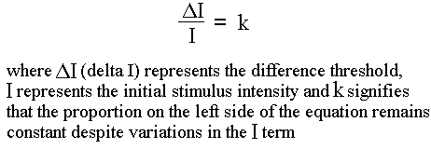  -Weber’s Law: difference in threshold of JND is directly proportional to the magnitude of the stimulus which the comparison is being made, can be expressed as a weber fraction  -Smaller the fraction the greater the sensitivity to differences (1/60 compared to 1/5)  -The value of the relative difference is constant for each sense, JND comes from comparing it to a new intensity  -Fechner’s Law: sensation increases with logarithm of intensity more general & cognitively economic  -Steven’s Power Law: more predictive across a variety of sensations, response to electric shock is quite large  -Subliminal Stimulus: one that is so weak or brief that although it is received by the senses it cannot be perceived  -Subliminal Perception: stimuli below the absolute threshold, can we perceive these stimuli? Are we affected by it?  -James Vicary: wanted to increase sales of popcorn and coke at movies, first he flashed subliminal messages on the screen that said by coke and popcorn below absolute threshold, measured sales and realized they went up  -Turns out Vicary made all of this information us, people became concerned because it could influence anyone  -William Tapley: Denver airport, believed everything within the airport represented the devil  -In general, no evidence that sub cuts influence consumer behaviour, but we are sensitive to subliminal keys  -Priming: sending stimuli to the person giving them a hint to the answer, turns out you can answer the question faster, (in stores you can see something that quickly influences you to purchase the product)  -Sensory Adaptations: diminishing sensitivity to an unchanged stimulus (frees out senses from constant and mundane information in the environment) doesn’t focus on important information  -Common sensory system attributes  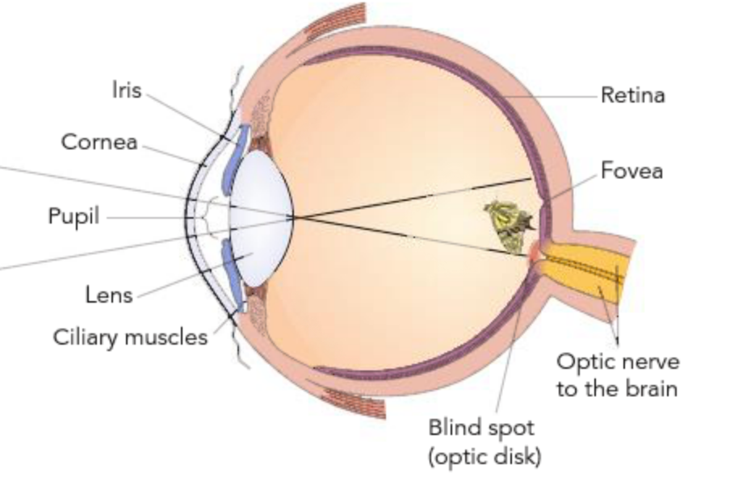  - Accessory Structures (outer ear channels sound to ear)  - Transduction (receptors, converts physical stimulus to nervous response)  - Coding (frequency)  - Interaction (with another system, or within the same system perception could be different)  -Normal stimulus for vision is electromagnetic energy, or light waves  -Humans can see 700 nanometers (red) to 400 nanometers (blue-violet) ROY G BIV  -Cornea: light waves enter, transparent protective structure at the front of the eye, involved in bending light waves and focusing  -Pupil: an adjustable opening that can dilate or constrict to control the amount of light entering eye  -Iris: pupil’s size is controlled by muscles in coloured iris, low levels of dilate let light in opposite for high levels  -Lens: behind the pupil, an elastic structure becomes thinner to focus on distant objects and thicker to focus on nearby objects, focuses the visual image on light sensitive retina (flips image but brain reconstructs for us)  -Retina: multi layered tissue at the rear of the fluid filled eyeball  -Myopia: good vision nearby but difficulty seeing far (nearsightedness) lens to long, image focus before retina  -Hyperopia: good distance vision but difficulty seeing close up (farsightedness) lens to short, focus beyond retina  -Rods: function best in dim light are primarily black and white brightness receptors (500 times more sensitive to light that cones) operate at low light intensities help you see in low brightness (not found in the fovea of the eye)  -Fovea: small areas in the center of the retina that only contain cones (most sensitive part, each cone has bipolar cell)  -Cones: colour receptors, function in bright illuminations, relatively insensitive (concentrated in fovea)  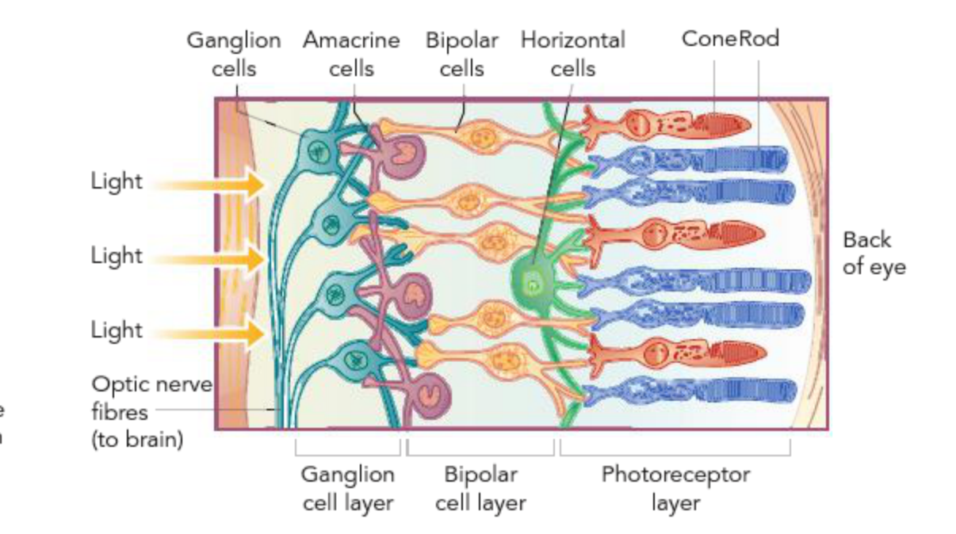  -Duplex Theory: each retina has way more rods than cones, evolved to have cones  -Bipolar Cells: rods and cones sent their messages to the brain via two layers of cells, have synaptic connections with the rods and cones, rods and cones not only form near the rear layer of the retina, but their light sensitivity points away from the direction of the light  -Ganglion Cells: bipolar axons synapse with ganglion dendrites with Amacrine cells what inhibit some messages  -Optic Nerve: collection of ganglion cells axons  -Visual Acuity: ability to see fine detail is greatest when the visual image projects directly into fovea  -Blind-Spot: ganglion cells exit through the back of the eye near the fovea creates a blind spot (no photoreceptors)  -Rods and Cones contain visual pigments, light hits them and two different chemicals are produced  -Rods: produce pigments called rhodopsin (red, then turns to bleached) bleaching is very easy, stare into bright light, they when you look away everything is white and hard to see, happens because pigments have been bleached  -Cones: pigments called chloroblabe (green), erythrolabe (red), cyanolabe (blue) shows that vision is made of three colours, responsive to different colours  -Photopigments: rods and cones translate light waves into nerve impulses through actions of protein molecules  -Absorption of light by molecules produce a chemical reaction that changes the rate of neurotransmitter release  Testing Rods and Cones:  - Dark Adaptation: sit in dark then get flashed bright light then see how long it takes to see the light after regeneration, plot on graph how, right after flash you cannot see anything then as time goes on you can start to see then it doesn’t get any more sensitive (recovery of cones, look directly as light so fovea more sensitive at first) after a while when you look to the sides you can get more sensitive by using rods (progressive improvement in brightness sensitivity that occurs over time under conditions of low illumination)  - Spectral Sensitivity: cones operating then use different colour lights to see how they respond, red, blue  Colour Vision: two theories try to explain how vision works  - Trichromatic Theory: three types of colour receptors in the retina, although all cones can be stimulated by most wavelengths to varying degrees individual cones are most sensitive to wavelengths that correspond to either, red, green, or blue (brain combines all of these signals)  - Opponent Process Theory: each of the three cone types respond to two different wavelengths, one type responds to red and opponent green anther to blue and opon yellow and third to black and opon white  -Duel Process Theory (modern): trichromatic theory was right about cones, they do indeed contain one of three different protein Photopigments that are most sensitive to wave lengths roughly corresponding to the colour red blue green, opponent process was partly correct process occurs but not at the level of the cones (ganglion cells)  -Colour Deficient Vision: 7 percent of males and 1 percent of females have colour deficiency in the red- green system and yellow- blue system or both caused by absence of sensitivity to Photopigments in certain cones  -Dichromat: colour blind in only one system  -Monochromat: sensitive only to black and white system and is totally colour blind  -Single Cell Recording: isolate single retinal ganglion cells, attach microelectrode & record output  -Project spot of light on screen and move until output is maximum (retinal area served by ganglion cell) movement in any direction decreases firing rate  -Receptive Field: determines what part of vision is most active, contains circles with on centers and off centers, the on centers and the most active regions and the off centers tend to have less response  -Horizontal Cell: connects receptors to an adjacent bipolar cell  -Lateral Inhibition: use of horizontal cells to inhibit adjacent chain purpose is to clean up vision and boost firing in one chain and reduce in another chain (stimulate receptor a it stimulates bipolar cell a and ganglion cell a but it also inhibits bipolar cell b in an attempt to clean up the visual picture)  -Matches responsive field intense light in middle, but if on the dies then we get a min response on the receptor  -Highest rate of firing when the light is super intense  -Phantom Spots: on center of the receptive field shows a dark smudge because there is a higher intensity of firing on the off surround portion of the receptive field (on center and off surrounds)  -From the retina, optic nerve sends nerve impulses to a visual relay station in the thalamus then routed to the visual cortex (occipital lobe) fovea is represented by a disproportionately large area of the visual cortex  -Feature Detectors: group of neurons within the primary visual cortex are organized to receive and intergrade sensory nerve impulses originating in specific retina (neurons fired most frequently when lines of certain orientations were present  -Other classes of feature detectors respond to colour, depth or movement  -Parallel Processing: using various feature detectors at once  -Visual Association Cortex: successively more complex features of the visual scenes are combined and interested in light of our memories and knowledge  -Recording Visual Cortex: in cortex response is to slit of light, cortical cells may be orientation specific motion sensitive (come cells respond in different circumstances)  -Retina Ganglion Cells: respond to spots  -Simple Cells: fires to a slit at a particular orientation on a specific retinal location, only in a very specific circumstance does it fire (simple cell straight line, when you change the orientation cells fire but not as much)  -Retinal ganglion cells are wired to simple cells they give it a specific orientation they fire because vertical lines hit every point (max stimulation, different areas in brain respond to different orientation of lines, each next section responds to a different rotation of lines, cortex put together these lines  -Complex Cells: respond to vertical lines as it comes across the screen, simple cells feed into complex cells (moving stils at a particular orientation)  -Hypercomplex Cells: respond to combinations of stimulus (object looking things cells that only respond to round objects) frog has a bug detectors that respond when small black dots move irregular across the field, happens to be dinner  -Frequency: the number of sound waves, or cycles per second (higher the frequency higher the perceived pitch)  -Hertz: technical measure of cycles per second (1 hertz one cycle per second)  -Amplitude: refers to the vertical size of the sound waves  -Decibels: physical pressures that occur at the eardrum (measure of amplitude)  -Three major sections  -Eardrum: moveable membrane that vibrates in response to sound waves  -Middle Ear: three tiny bones (smallest in the body) amplify sound 30x Hammer, Anvil, Stirrup  -Inner Ear:  - Cochlea: snail shaped tube filled with fluid (essentially mapped to the auditory cortex)  - Basilar Membrane: sheet of tissue (inside cochlea)  - Organ of Corti: 16000 tiny hair cells they are the sound receptors of the ear  -In case of loudness, high amplitude sound waves cause the hair cells to bend more and release more neurotransmitter substance at the point where they synapse with auditory nerve cells  -Certain receptor neurons have higher thresholds than other so they only fire to an intense sound  -Thus, loudness is coded in terms of both rate of firing the axons and in terms of specific hair cells firing  -Involves two different processes one for frequencies below 1000 Hz and another for higher frequencies  -Frequency Theory: nerve impulses sent to the brain match the frequency of the sound wave, encounters a major problem because neurons are limited in their rate of firing, individual impulses cannot match frequencies of 1000  -Place Theory: supported theory George Von Bekesy’s experiments, suggests that the specific point in the cochlea where the fluid wave peaks and most strong bends the hair cells serves as a frequency coding cue  -Nervous system uses information concerning the time and intensity difference of sound arriving at the two ears to locate the source if sounds in space (our binaural “two ear” sound localization is extremely sensitive)  -Example: a sound 3 degrees to the right arrives at the right ear only 300 msec before left and we can tell direction  -Conduction Deafness: caused by problems involving the mechanical system that transmits sound waves to the cochlea (punctured eardrum or loss of function in bones can reduce vibration transmission) hearing aid fixes this  -Nerve Deafness: caused by damage receptors within the inner ear or damage to the auditory nerve itself, cannot be help from hearing aid (can happen from exposure to loud sounds)  -Gustation (taste) & Olfaction (smell): both chemical senses because receptors are sensitive to chemical molecules  -People who lose their sense of smell typically believe they have lost their sense of taste  -Sense of taste respond to four qualities: sweet, sour, salty and bitter  -Taste Buds: chemical receptors concentrated along the edge and back surface of the tongue , sensory response is activated by certain proteins (each is more responsive to one or two basic taste qualities, weakly to others  -When substance is taken into the mouth, interacts with saliva to form chemical solution that flows into taste pore  -Smell: receptors for smell are long cells that project through the lining of the upper part of the nasal cavity into the mucous membrane (Olfactory Receptors receptor structure that resemble neurotransmitter binding sites)  -Olfactory Bulb: forebrain structure immediately above the nasal cavity that receives input of senses  -Pheromones: chemical signals found in natural body scents, may affect human behaviour in subtle ways  -Menstrual Synchrony: tendency of woman who live together or are close friends to become more similar in menstrual cycles  -Tactile Senses (touch): humans are sensitive to touch, pain, warmth and cold, sensations are conveyed by receptors in the skin, mixture of all four senses are common such as itchy skin (helps us avoid external danger, and feel pleasures)  -Gate Control Theory: proposes that the experience of pain results from the opening and closing of gating mechanisms in the nervous system (close gates less pain, open gates more pain)  -Endorphins: chemical substances that reduce pain, nervous system has its own built in endorphins (acupuncture is an effective pain reduction technique affects the brains pain and pleasure that is understood in terms of endorphin  -Kinesthesis: provides us with feedback about muscles and joints  -Vestibular Sense: body orientation or equilibrium (inner ear fluid  -Active creative process in which raw sensory data are organized and given meaning  -Sensory systems provide the raw materials from which experiences are formed, sense organs do not select what we will be aware of or how we experience it  -Two different processing functions  - Bottom Up Processing: the system takes in individual elements of the stimulus and then combines them into a unified perception (feature detectors analyze the elements in each letter of every word)  - Top Down Processing: sensory information is interpreted in the light of existing knowledge, concepts ideas and expectations (makes use of higher order thinking)  -Accounts for many psychological influences on perception, such as the roles of motives, expectations, previous experiences and cultural learning (all about context)  -Role of Attention: reading requires 100 million sensory messages, only a few register in awareness the rest you barely perceive (involves focusing on certain stimuli and filtering out other incoming information)  -Shadowing: technique used to study attention (listen to two different messages and remember one, most people can do it but at the cost of forgetting the other message)  -Inattentional Blindness: refers to the failure of unattended stimuli to register to consciousness (Pilots were so focused on instruments that they landed on a runway with another plane)  -Environmental and Personal Factors of Attention: stimulus characteristics that attract our attention including intensity, novelty, movement, contrast and repetition  -Humans ability to perceive and recognize objects in their peripheral visual field is greater for naturalist stimuli like animals than artificial stimuli like letters of numbers  -Perception must be a product of an organization by our nervous system  -Gestalt: theorist argued that the wholes we perceive are often more than the sum of their parts  -Figure Ground Relations: tend to organize stimuli into central or foreground figures and a background  -In vision the central figure is usually in front of or on top of what we perceive as background (images with two faces and vase are caused by stitching background and figures  -Gestalt Laws: similarity, proximity, closure and continuity  -Similarity: say that when parts of a configuration are perceived as similar they will be perceived as being together  -Proximity: elements that are near one another are likely to be perceived as part of the same configuration  -Closure: people tend to close the open edges of a figure or fill in gaps so that their identification of the form  -Connectedness: when things are touching you feel the need to say that they are connected  -Subjective Contour: beginning to see things that aren’t actually there  -Context: certain messages become more prevalent when hint was given  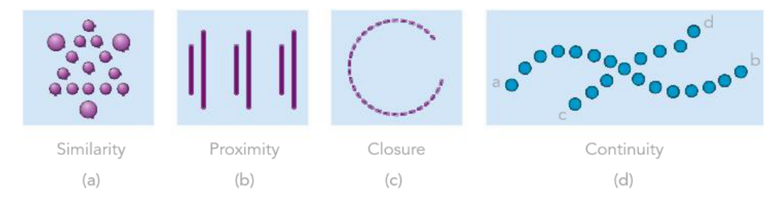  -Perceptual Schema: mental representations or images to compare a stimulus with  -Perception is a hypothesis about the nature of the object or more generally the meaning of the sensory information (system actively searches mental library of internal schemas for the interpretation)  -Perceptual Set: a readiness to perceive stimuli in a particular way (if told someone is a jerk, when you meet them you are more likely interpret what they do as jerk stuff)  -Perceptual Constancies: allow us to recognize familiar stimuli under varying conditions  -Shape Constancy: allows us to recognize people and other objects from many different angles  -Bright Constancy: relative brightness of objects remain the same under different conditions of illumination  -Size Constancy: is the perception that size of objects remain relatively constant even though images on retina change in size with distance  -Retina receives information in only 2D, but the brain translates these cues into 3D perceptions  -Monocular Depth Cues: cues that require one eye  -Painters rely on monocular cues to create depth in their pictures (light shadow)  -Relative Size: the larger image should be closer to me than the smaller image  -Overlap: one object interrupts the contours of the other, the completed object is closer to us  -Linear Perspective: perception that parallel lines converge or angle towards each other with distance (railroad)  -Texture Gradient: as objects appear in the distance the object clump together, high density in back  -Interposition: objects closer to us may cut off part of out view of more distance objects, provides another cue  -Other cues include: height, texture, clarity, relative size, motion parallax)(  -Binocular Disparity: each eye sees a slightly different image with the brain the visual input from the two eyes is analyzed by feature detectors that area attuned to depth (cues that require both eyes)  -Retinal Disparity: when looking at objects at various depths, the position of the image on the retina are in different orientations (some feature detectors are attuned to stimuli to points behind what we are gazing at  - Convergence: is produced by feedback from the muscles that turn your eyes inward to view a near object  -Muller Lyer Illusion: two lines with arrows, on with arrows pointed out and one with them pointed in, which is line is longer? Both are same size  -Primary cue for perceiving motion is the movement of the stimulus across the retina  -Relative motion of an object against a structured background is a cue, smooth motion can be produced if we arrange for the sequential appearance of two or more stimuli  -Stroboscopic Movement: movement produced when a light is briefly flashed in darkness and then, a few milliseconds later, another light is flashed nearby, if timed right it looks like the light has just moved (TV)  -Constructionist: create meaning from basic elements or features bottom up processing  -Feature Analysis: register small components and build into large meaningful units  -Biederman: recognition by components (recognize by geons) assemble a target by recognizing the geons associated with lines (cylinders, rectangles)  -Moment to moment awareness of ourselves and our environment (aware of relationship between self and world)  - Subjective and Private (other people cannot know what your reality is)  - Dynamic (forever changing, drift in and out everyday)  - Self-reflective (mind is aware of its own consciousness, you are the one who is conscious of it)  - Connected with processes of selective attention (consciousness reflects whats spotlighted at the moment)  -Common way is self report (identifies persons subjective thoughts), psychological measures establish relationship between bodily states and mental processes (objective but not subjective)  -Psychodynamic Perspective: Freud proposed that the mind consisted of three levels of awareness  -Conscious: contained thoughts, perceptions and other mental events of which we are aware of  -Preconscious: not currently available but could be (memories, what did I have for lunch today?)  -Unconscious: events we cannot accesses in conscious awareness (unconscious events are kept out of the mind)  -May not be accessible but it might leak out from time to time called Freudian Slips  -Freud: believed happy people never fantasized, only unhappy people  -Research supports Freud’s general thought: unconscious processes influences behaviour without knowing  -Cognitive View Point: reject idea of unconscious driven by urges, rather view unconscious works with conscious  -Controlled Processing: voluntary use of attention and conscious effort (learning to drive, eating)  -Automatic Processing: performed with little or no conscious effort (routine activities) lowers chance to solve probs  -Divided Attention: perform more than one activity at the same time (talking walking) without ability overwhelm  -Visual Agnosia: inability to visually recognize objects (can hear them but not see) aren’t blind cannot identify objects, occurs because of multiple brain pathways for processing visual information  -One pathway carries information to support unconscious guidance of movement, while the other carries information to support brain tasks related to perception, memory, emotion (conscious path was wrecked)  -Blindsight: person cannot see (flashed light in right visual field even though blind can guess that side 80-100% of the time, shows visual information can be processed and influenced outside of conscious awareness)  -Neuroscientists believe there is no single place in brain that controls consciousness, instead they view the mind as a collection of largely separated but interacting information processing modules  -Biological cycles (including mental alertness, wakefulness, sleep and blood pressure) peak levels in afternoon for physical tests and at night for mental tests  -Suprachiasmatic Nuclei (SCN): brain internal clock (internal timing mechanisms, influence by amount of light)  -Daylight stimulates the release of SCN, retina has cells that fire directly to the SCN light sensitive ganglion cells  -Melatonin: secreted by pineal gland, relaxing effect on body (SCN inhibits the secretion of melatonin)  -SCN raises body temperature and alertness, this is why daylight makes you feel awake  -Early Birds: circadian rhythms peak in morning with their blood pressure and alertness peaking early in the day  -Seasonal Affective Disorder: tendency to become depressed during certain months of the year (less light in the winter and fall more melatonin, occurs more frequently near the poles where they get less light)  -Jet Leg: sudden circadian disruption cause by flying across several time zones (Phase advances more difficult than phase delay, flying Vancouver to Halifax more problematic than east to west)  -Way to avoid: hydrate, avoid alcohol, stretch, light meals and exposure to light  -Nightwork Shift: driving home in morning daylight making it hard to reset biological clock (accidents more likely)  -Happens ever 90 mins, topics are failure or success, aggression, sex or romance, guilt (in order of frequency), alters mood in positive direction, low risk way to deal with problems  -Everyone does it at hours on end (bats sleep the most giraffes sleep the least, humans 8 hours, infants 16 hours)  -Beta Waves: high frequency waves but low amplitude (occur when awake and alert)  -Alpha Waves: occur at 8-12 cycles per second (occur when you close your eyes and feel drowsy)  -Delta Waves: very slow and large waves (stage 4 and partially stage 3)  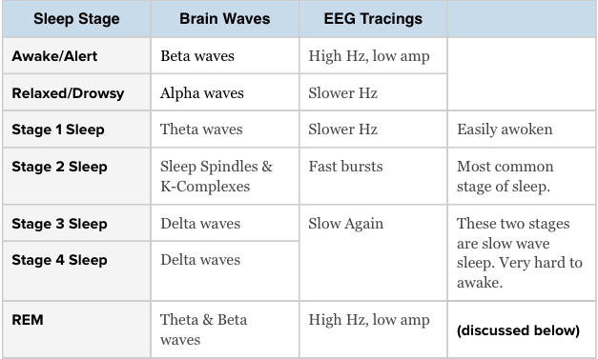  -Stages of Sleep: body goes from awake to stage 4 in 60-90 minuets, except instead of waking up you enter REM  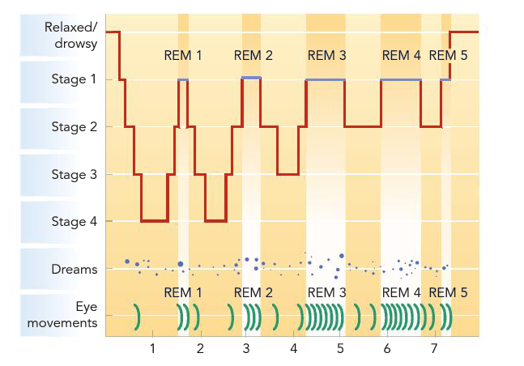  -Stage 1: dozy, just falling asleep (theta)  -Stage 2: sleep spindle active brain movement and k complex huge shifts in activity  -Stage 3: falling deeper into sleep cycles slow down  -Stage 4: deeply asleep don’t last in stage 4 for long  -REM: rapid eye movement, brain waves like an awake person, over the course of the night REM gets longer 4 get shorter (if woken up you will report a dream) cannot move muscles in this sleep stage, decreases in childhood  -Paradoxical Sleep: high aroused cannot move  -K Complex: most dramatic brain activity change that ever happens to humans, huge drop in EEG tracing (happens in stage 2 of sleep) can be triggered externally  -Sleep Deprivation: occurs when people get lack of sleep, causes attention lapse, irritability (people do worse on critical thinking tasks, but they think they did great, overall its bad short term long term any term  -Restoration Model: sleep recharges our rundown bodies and allows us to recover from physical and mental fatigue  -Chemical call adenosine accumulates and body slows down, restores chemical balance not completely true  -Evolutionary Model: sleeps main purpose is to increase a species chance of survival in environment  -If you are sleeping then less likely to encounter dangers and better survival (doesn’t explain nocturnal animals)  -Learning and Memory: sleep is a time when we store memories, REM deprived subjects show reduced ability to retain information (theory is only REM specific, Dr. Mikes favourite)  -Mood Adjustment Effects: speed of cycling into RE< correlated with positive mood on the following day, depressed individuals cycle into REM quickly (bodies way to trying to become less depressed)  -REM Rebound Effect: brain increases REM sleep after being deprived (when learning there is more REM sleep)  -Insomnia: refers to chronic difficult in falling asleep, staying asleep or experiencing rest sleep  -Stimulus Control: conditioning your body to associate environment with sleep (only sleep in bedroom, not study)  -Situational Insomnia: some sort of stress has happened and now you are having trouble sleeping because of this stress, good because after stress leaves you can go to bed  -Choric Insomnia: circadian rhythm problem, something on the inside is off (sleeping pills do not help)  - Thermoregulation Problem: failure to lower body temperature, makes it harder to sleep  -Narcolepsy: extreme daytime sleepiness and sudden uncontrollable sleep attacks (sleep does directly into REM)  -Lose of muscle tone when problem occurs, can be dangerous due to falling (genetic and environmental causes)  -Sleep Apnea: interruption in breathing during sleep (normal, but people with disorder don’t start breathing until they wake up, babies sometimes don’t wake up) in sever cases may stop for a minute, causes insomnia  -Causes by, obstruction of passage (snoring, easy to solve), abnormal brain function (circadian rhythm problems)  -REM-Sleep Behaviour Disorder: REM sleep paralysis doesn’t happen so you are acting out your REM dreams  -Parasomnia: various sleeping related problems  -Sleepwalking: occurs in stages 3-4 you are deep asleep, walking up is not dangerous if found direct back to room  -Occurs mostly in children, rare in adults, genetic factors behind it  -Sleep Talking: stages 1 or 2 so you are awake, and some people can respond (sensitive to external world)  -Nightmares: vivid, high anxiety dreams, significant stress correlated with increase frequency, common in children  -What drives nightmares? Antidepressants, beta blockers, antihypertensive, withdrawal, antihistamines  -Wood & Bootzin: do healthy people get nightmares? Surveyed 220 people found out anxiety unrelated to frequency (9-25 nightmares a year are about normal for anyone)  -Night terrors are more intense nightmares, common in stages 3-4, person wakes up screaming and in panic (hard to wake up when screaming because they are in deep sleep) found in children, grow out of this phase  -When do we Dream: 45 seconds after sleep onset, 15-40% of sleepers report dream activity in first six minutes  -Dreams occur when the brain is most active in REM sleep, occur most in the last few hours of sleep (REM and non)  -REM duration = dream duration, eye movement is related to action, remember the dreams closest to waking up  -What do we dream about: most dreams take place in familiar setting and often involve people we know  -Most people dream about falling, being pursued and school studies (greatest to least)  -Recent experiences shape dreams, woman dream about woman and men, men mostly dream about men  -Why do we dream?  - Freudian Theory: main purpose of dreaming is wish fulfillment (difference between surface and meaning)  -Battle of Id VS Ego, dreams are Ego suppressing Id’s (unconscious thoughts) censored and disguised thoughts  -Latent = actually desire directly from Id, manifest = laundered vision, censored content (contained symbols)  -Symbols where what Freud looks for… part of unconscious speaking (mostly sexual, anything that moved)  - Activation Synthesis Theory: random firing of the Pons, to thalamus then all areas are going off, cortex active  -Dream State Generator Activation (synthesis active) now we “make sense” of random neural activity  -Modular Consciousness: waking world is like dream world, waking world allows real perception input, in dream world we need to construct reality  - Cognitive Approach:  -Problem Solving Dream Models: dreams help us find creative solutions to problems (critics say no proof)  -Cognitive Process Dream Theories: focus on the process of how we dream (dreaming and waking same processes) children’s mental abilities develop with age so do dreams, rapid shifting of attention is common in both waking and dreaming  -Drugs alter consciousness just like sleeping and dreaming, modify brain chemistry  -Tolerance: intensity of effect produced by the same dosage level decreases  -Compensatory Response: brain attempt to reverse the effects of the drug (heart rate rises, brain will try to adjust)  -Physical setting where you take the drugs triggers compensatory response  -Withdrawal: occurrence of compensatory response after discontinued drug use (feel need to counterbalance)  -Misconceptions: drugs don’t always lead to significant withdrawal, physiological dependence is not the major cause of addition psychological dependence is (mind feels as if you need it, body doesn’t)  -Decrease nervous system activity, reduce anxiety (less feeling of tension, state of relaxation)  -Alcohol: most widely used drug in numerous country (increases GABA, decreases glutamate, decrease brain activity) subjective effects seem to have a “upper” phase from the inhibition followed by a “downer” (BAL)  -Alcohol Myopia: “shortsightedness” in thinking caused by inability to pay attention (increases risky behaviour)  -Barbiturates and Tranquilizers: sleeping pills and anti anxiety drugs (increase GABA) overdose = death, withdrawal can be serous (GABA main purpose is to reduce activity to neuron which it binds to)  -Increases neural firing and arouse nervous systems, boost heart rate, alertness, mood, irritability  -Amphetamines: reduce fatigue and appetite (increase dopamine and norepinephrine) causes heart failure/ stroke  -Amphetamine Psychosis: schizophrenia like hallucinations (occurs because of to much dopamine in body)  -Meth: insomnia, hyperactivity, anxiety, paranoia, meth mouth, heart attack  -MDMA: also boosts serotonin (causes cognitive defects, sexual dysfunctions, impaired immune responses  -Cocaine: blocks reuptake of NE and dopamine, excitation, sense of muscular strength, high does cause fever, vomit  -Morphine, codeine, heroin, oxycontin (first provide pain relief, second cause mood change) increase endorphins and dopamine (experience is pleasurable, however it reduces breathing rate, may cause coma and death)  -Mushrooms, LSD (not understood how it works), hearing colours, seeing sounds, flashbacks, panic, outbursts  -Hard to classify (hallucinogen, sedative) increases GABA and dopamine, not a gateway drug but still dangerous  -THC: bind to receptors, brain produces its own THC like things called cannabinoids  -Biological level suggests genetic factors influence sensitivity and tolerance, learning from parents can increase abuse of drugs (mostly with biological rather than adoptive ones  -Environmental level setting and other people around you affect usage (culture effects, western countries become aggressive when drinking, Camba culture do not become aggressive)  -Psychological level beliefs can influence, if you think you drank alcohol then you act drunk (drug uses among you people is often associated with a sense of meaninglessness and lack of direction in life  -Can’t be hypnotized against your own will, ability to be hypnotize is measured by the hypnotic susceptibility scale  -Explanation: does not cause action against own will, authority figures can cause people to do anything  -Many thinks hypnotize people do non hypnotize people can do  -Reduces pain tolerance, does not increase memory people recall more errors but are more confident in sayings  -Dissociation Theory: division of consciousness, one stream monitors hypnotist’s commands while the second monitors behaviours “hidden observer” (explains why behaviour in hypnosis seems involuntary or automatic)  -Social Cognitive Theories: hypnosis is just caused by the expectations of participants (role theorist emphasize that people immerse themselves in the hypnotic role)  -Mindfulness: free flowing of thoughts, feelings  -Concentrative: focus on specific sound, sensations (most commonly affects the frontal cortex)  CHAPTER 7  -Learning: process which experiences produce a relatively enduring change in an organism behaviour/ capabilities  -Behaviorism: focus on stimulus and response (stimuli comes in response comes out, don’t measure in between)  -Believe laws of learning apply to virtually all organisms, learning is inscribed (cognitive and biological play a role)  -Habitation: decrease in the strength of response to a repeated stimulus (key adaptive function)  -If organism responded to all stimulus they would become overwhelmed (helps scientists perform experiments)  -Sensitization: increase in strength of response to a repeated stimulus (occurs to strong or noxious stimuli)  -Purpose it to increase response to a potential dangerous stimuli (if shocked you react more the second time)  -Organisms learn through association of two stimuli such that one stimulus comes to produce a response that was originally produced through another stimulus (association of neutral stimulus with one that elicits a response)  -Pavlov’s Research: presented various types of food to dogs and measure natural salivary responses, started to notice that with repeated testing the dogs began to salivate before food was presented, foot steps triggered this  -USC UCR, Pair “CS” with UCS, CS CR  -Acquisition: refers to the period during which a response is being learned  -Unconditioned Stimulus: stimulus that elicits a particular reflex without prior learning (meat powder)  -Unconditioned Response: a response elicited by specific stimuli without prior learning (salivation)  -Conditioned Stimulus: neutral stimulus that comes to evoke a conditioned (bell paired with meat powder)  -Conditioned Response: response to a conditioned stimulus (salvation)  -USC-SC are paired multiple times, learning becomes more rapid when it is followed by some sort of reward  -When the UCS is intense conditioning may require less pairing, faster when time between CS and USC is short  -Three key facts:  - Attention to CS (orientation reflex if you can’t hear it you can’t learn)  - Model is not response contingent (doesn’t matter what the dog does, dog will salivate no matter what)  - CR does not equal UCR (CR is a cognitive response, it was learned and takes thought)  Examples: UCS (drill) UCR (fear), CS (dentist) paired with UCS, CS (dentist) CR (fear) /// UCS (get an a) UCR (feel good), CS (professor) paired with UCS, CS (professor) CR (feel good)  -Conditioned Love: much if what influences arousal is influenced by classical conditioning (even outfits)  - Reinforcement Affect Model: arousing stimulus positive feeling, stimulus paired with stranger, arousal stranger (experiment conducted by Don Byrne)  - May & Hamilton: female students listen to negative (classical music), neutral music, and positive (rock music) and they rate the attractiveness of males while music is still playing  -Sure enough the music does influence how the females rate the people (especially with negative music)  -Latency Response CS-CR: measure of response strength (negatively accelerated, more response at beginning then at the end, more learning occurs at the beginning) output measure is also negatively accelerated  -Output Measures: measuring the amount of response, at the beginning not a lot of response, more output at end  - Forward Pairing: CS comes before the UCS stimulus (bell than the meat powder)  - Simultaneous Pairing: CS and UCS at the same time (bell and meat powder occur at the same time)  - Backwards Pairing: present the UCS first then the CS (meat powder then bell)  -Forward pairing works the best when the time between CS and UCS is at an interval of 0.5  -Extinction: process of eliminating the controlled response (CR loses cue value, isn’t associated with UCS)  -CR-UCR is not unlearned it has been masked (spontaneous recovery can sometimes bring it back)  -Spontaneous Recovery: defined as the reappearance of previously extinguished CR after a rest period and without learning trials (why practical application of extinction of phobias is so hard to do)  -Stimulus Generalization: stimuli similar to initial CS elicit a CR easier than if the CS was extremely different  -Helps organisms survive because CS can be slightly different and they cans till respond in a defensive manner  -If being conditioned on a loudness of 7 then you respond to stimuli that are great and less that 7 but at a lower levels of strength (highest level at strength at conditioned level tells you how the best vision or hearing)  -Stimulus Discrimination: demonstrated when CR occurs to one stimulus but not another  -Higher Order Conditioning: neutral stimulus become CS after being paired with an already establish CS  -Not very effective because CS-UCS bond is no longer reinforced (bell, meat powder, then bell, light dog doesn’t salivate because he received no benefit)  -Law of Effect: stated that given situations a response followed by satisfying consequences will become more like to occurs, when followed by unsatisfying consequences less likely to occur (Thorndike)  -Instrumental Learning: because behaviour is instrumental to bring certain outcomes  -Association between stimulus and response is strengthen by reinforcement in operant conditioning  - Dominant Response: organisms will always have (cats dominant response is scratch, not what we want)  - Choose and Reinforce the Target Response what we want to see in an individual (cat pressing button)  - Stimulus situation target response (organism will learn)  -Situation is response contingent, because if animal doesn’t respond it doesn’t learn (classical conditioning isn’t)  -Operants: broader that responses (response-reinforcement bond is critical, when it gets reinforced occurs more)  -Operant conditioning contains three types of events:  - Antecedents: stimuli presented before a behaviour occurs (telling a dog to sit)  - Behaviours: actions organism emits (the dog sits)  - Consequences: following behaviours, including reinforcement and punishment (dog gets a treat)  -Classical is association between two stimuli (stimulus occurs before behaviour) and Operant is association between behaviour and consequences (behaviour changes after consequences)  -Discriminative Stimulus: signal that a particular response will now produce certain consequences (food on plate is a stimulus to start eating, teacher starts writing on board, time to start taking notes)  -Reinforcement: response is strengthened by an outcome that follows after it (treat after accomplishing task)  -Punishment: response is weakened by outcome that follows (being hit)  -Positive Reinforcement: response strengthened by subsequent presentation of stimulus (money, praise, reward)  -Food received when pressing lever, praise for job well done (getting something good, increasing wanted action)  -Negative Reinforcement: response strengthened by subsequent removal or avoidance of stimuli (headache meds)  -Umbrella to avoid rain, Advil to avoid headache (removing something bad, increase wanted action)  -Operant Extinction: weakening and eventual disappearance of response because no longer reinforced  -Resistance to extinction is strongly influenced by the pattern of reinforcement that was previously used  -Positive Punishment: response weakened by subsequent presentation of stimulus (bad grades, detention)  -May fail to generalize, works well when, swift, consistent, aversive (give something, decrease action)  - Discrimination Training: best idea is to punish unwanted behaviour, but also reward wanted behaviour  -Negative Punishment: response weakened by the subsequent removal or a stimulus (fines loss, loss of privilege)  -Less likely to create hatred of punishing agent that positive punishment (removing something, decrease action)  -Best Technique: punishment is not the best way to teach people, discrimination training works the best  -Higher order conditioning works the best in operative condition because S-R bond is always reinforced  -Primary Reinforcers: stimuli like food, water that naturally reinforce an organism because of then biological need  -Secondary Reinforcers: Stimuli associated with primary reinforcers like money (money to buy something else)  -Secondary reinforcers are classically conditioned to accomplish the same goals (good dog becomes associated with feeding and good behaviour) reinforcement can be delayed, but most effective if immediate  -Shaping: reinforcing successively towards a final response (getting someone to talk one stage at a time)  -Chaining: reward each response with opportunity to perform next response (bell turns on light, if light is on the lever gives food) works like higher order conditioning  -Operant Generalization: operant response occurs to a new antecedent stimulus or situation similar to original (child learns not only to touch his stove, but all stoves when they are on)  -Operation Discrimination: operant response will occur to one antecedent stimulus but not another  -Continuous Reinforcement: every response of a particular type is reinforced (produces fast learning)  -Partial Reinforcement: only some responses are reinforced (slow learning, more resistant to extinction) time or %  -Fixed Ratio Schedule: reinforcement is given after a fixed number of responses (FR-3 every three times)  -After reinforcement is delivered there is a pause, since you know the next response is not reinforced  -Variable Ratio Schedule: reinforcement is given after a variable number of correct responses (VR-3 average of three responses) less pausing after reinforcement, resistant to extinction, slot machines use  -Fixed Interval Schedule: first correct response that occurs after a fixed time interval is reinforced (FI-3 means reinforcement after first correct response after 3 mins) slow response first then very fast, exam schedules  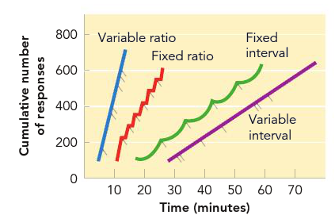  -Variable Interval Schedule: reinforcement is given for the first response that occurs after a variable time interval (VI-3 on average there is a three min interval between opportunities to get reinforcement) drug tests  -Post Reinforcement Pause: organism waits after being rewarded, then response is extremely fast, shows that some how animals are able to learn response rates  -Partial Reinforcement Effect: experience with “extinction” maintains responding because reinforcement it unpredictable (partial is better than continuous (VR or VI are most resistant to extinction)  -Best way to promote fast learning and high resistance is to begin reinforcing the desire on continuous, then switch to a partial schedule (preferably variable)  -Behaviorists thought that they could conditioning everything, they were wrong  -Preparedness: through evolution animals are biologically “pre wired” to easily learn behaviours related to their survival as species (behaviour contrary to natural tendencies are learned slowly)  -Conditioned Taste Aversion: pairing the smell and states of food with toxin so that the taste now repulses you  -Chemotherapy causes nausea so food can become classically conditioned to cause nausea (food is CS)  -Biological Fear? Much easier to classical condition fear of neutral stimulus if snake, rather than a flower (much of the conditioning id due to culture or evolution) phobias of cars, guns and knives are rare because they are common  -Instinctive Drift: tendency for an organism to drift back to instinctive behaviour (rats back to scratching)  -Cognitive approach through learning was not mechanical “stamping in process” it involved formation of cognitions… internal process of information (thoughts and beliefs), making predictions (SOR O means organism)  - Kohler: thought learning wasn’t all trial and error he made chimps solve tasks through incite (animals figuring out problem through solving) behaviorist argue that insight is a combination of reinforce actions  - Tolman: believed organisms made a Cognitive Map (mental representation of a layout) this provided knowledge and based on this knowledge an organism develop an expectancy of “what leads to what”  -Traditional S-R approach cannot explain these concepts very well  -Escape Conditioning: organisms learn a response to terminate an aversive stimulus (acquired and maintained through negative reinforcement) putting on a sweater to escape the cold, taking away the cold increase behaviour  -Avoidance Conditioning: organism learns a response to completely avoid an aversive stimulus (respond before stimulus begins, putting on sweater before going outside  -Shuttle Box: experiment with mouse where mouse bounces back and forth when floor is shock, then light…  -Two Factor Theory of Avoidance: classical and operant conditioning are involved in avoidance training  - Classical: light is classical conditioned to provide fear and you begin to move (light is CS)  - Operant: termination of light acts as negative reinforcer for the jump response  -Shows that animal must be thinking because it expects the shock when the light is one  -Contingency: given some event, one outcome is more likely to occur than another (light gives us better chance to respond) animal learn these contingencies Prediction & Control are involved in learning contingency  -Seligman (Learned Helplessness): animals who previously had no control over their environment learned that there was nothing they could do to stop the shock and became helpless (learned there was no contingency)  -Even if you put them in a safe identical chamber they wouldn’t try because they had no control  -Perception of Control: put people in a room with loud noises and tell them to do a task they can do it find, then when they are forced to do another task they screw up, however when in the second task they have an escape button they can complete it perfect because they have the ability to control what they are doing (button wasn’t use  -Relation to Depression: when learned to become helpless then it has been seen all contingencies are gone (no control, to help people recover you give them something to take care of and make sure it grows)  -Prediction and Control have a large effect on learning the contingency which effects learning  -Social Cognitive Theory: emphasizes that people learn by observing the behaviour of models and acquiring the belief that they can product behaviors to influence events in their lives  - Attention: must pay attention to model behaviour  - Retention: must retain information in memory for recall  - Reproduction: must be capable of reproducing the model’s behaviour to something similar  - Motivation: must be motivated to display behaviour  -Self Efficacy: represents peoples belief that they have capabilities to perform behaviours with desired outcome  -Behaviorists believed classical conditioning was a formed neural bond, cognitive believe expectancy link is formed  -Expectancy Model: what matters is not how well the CS and UCS are paired but how well the CS predicts the UCS  -If you are pairing a shock and a tone, and you add random shocks between the tone is ruins the pairing  -All about consistency, this is why other things are not automatically conditioned  -Role of Awareness: you have to be aware of the pairing (perceived connection is what matters, not actual)  -Latent Learning: refers to leaning that occurs but doesn’t demonstrate until there is an incentive performed (rat put in a maze, takes a long time to solve, but it can when food is there the rat learns quickly)  -Self Evaluation: external reinforcement and punishment are not the only consequences controlling behaviour  -If you believe what you are doing is good or society then whatever anyone says will not change behaviour  -Psychotherapy is based on principles of classical or operant conditioning (problem is error or failure in learning)  -Phobia: intense irrational fear of object or situation, relatively common (person is till in touch with reality)  -Over 200 recognized phobias, some are easy to cure, but the problem is they can generalize easily  -Common treatments are  -Exposure Treatment: fear viewed as CR, so extinguish by repeated presentation (fear of snakes, play with them)  - Flooding: patient is continuously resented with fearful object until it no longer produces a response (to quit smoking, if you smoke a whole pack at once, you will be sick real quick) limited value  - Implosion: patient must continuously imagine fearful situations (thinking about a room full of snakes), hard to do because patients wouldn’t want to think about stuff they do not like  -Counter Conditioning: replace the CR of fear with a more pleasant response, (1) identify a positive UCS-UCR connection (love of chocolate), (2) pair the feared object (snakes, at a low level) with positive UCS chocolate (3) gradually increase intensity of feared object, (4) “feared” object now results in positive CR (snakes in CS)  -Systematic Desensitization: (1) train client in muscle relaxation on cue, (2) client imagines fearful situations, receives relaxation cue, (3) client imagines even more fearful situation, receives cue (4) client progresses to actually experience of fearful situation and stay relaxed (In Vivo Desensitization) preferred method  -Aversion Therapy: behaviour maintained because of reinforcement contingency (alcohol relaxes body so you drink), to change behaviour, change the contingency through punishment (drink alcohol with antabuse then you become sick… It is effective but usually only provides short term effectiveness  CHAPTER 8  -Memory: refers to the processes that allow us to record and later retrieve experiences and information  - Encoding (acquisition): getting information into the system by translating it into neural code  - Storage (retention): retaining information over a period of time  - Decoding (retrieval): pulling information out of storage when we want to use it  -Model doesn’t assume each component corresponds with a specific part of brain, rather interrelated neural sites  - Sensory Memory: holds incoming sensory information just long enough for it to be recognized (very brief, difficult to retain for more than half a second, information fades because attention capabilities are limited)  -Iconic Store: visual sensory register, called an icon We usually refer back to icon and echo  -Echoic Store: auditory sensory register, called an echo  - Short Term/ Working Memory: holds information that we are conscious of at a given time (from sensory)  -Without rehearsal we will forget the information (also involved in recall LTM STM output)  -Memory Codes: visual or motor encoding that stores information so it can be retain in STM and LTM (form of memory code often does not correspond to the form of original stimulus, words are coded by meaning)  -Capacity: short term memory can only hold certain amount of meaningful information (5-9),  -One word is one item, can increase capacity through, Chunking: combining meaningful units into one  -Without rehearsal the “shelf life” of short term memory is usually around 20 seconds  -Maintenance Rehearsal: simple repetition of information (extends short term memory)  -Acoustic Coding: info in STM is coded through sound (interference occurs when similar sounding words get mixed up and become hard to remember the original)  - Long Term Memory: vast library of durable stored memories (can always add, storage is almost unlimited)  -Semantic Coding: information is coded by meaning, things that interfere with memory are words with similar meaning (cook and chef have similar meanings)  -Elaborative Rehearsal: involves focus on meaning of information or relating it to other things we already know (most effective in transferring information into LTM due to semantic encoding)  -Serial Position Effect: recall is influenced by a word’s position in a series of items  - Primacy Effect: occurs because we say the words and short term memory isn’t filled up yet (LTM)  - Recency Effect: last few works have benefit of not being bumped out (STM)  -When given time delay Recency Effect is no longer there because STM is almost eliminated  -Look at evidence from cases of brain damage (Clive Wearing), how he has STM but no LTM (knows piano)  -Trish: brain disorder, everyday she wakes up she relies on post it notes to get through the day because she has no STM, post it notes are reminders of what was in STM (can remember something’s in LTM before accident)  -Recall Tests: involves serial position effect, and Recency effect with primacy effect and time delay  -Effortful Processing: rehearsing, making lists, and taking class notes (studying for tests)  -Automatic Processing: info about frequency, spatial location, sequence and timing (order of stuff you did in a day)  -Levels of Processing: the more deeply we process, the better we remember (tougher the task, more thinking, more processing, better memory of event)  -Hierarchy: enhances associations between concepts, meaningful hierarchy is better than a random one  -Overlearning: continued rehearsal past point of initial learning, distribute learning is better than mass  -Chunking: refers to combining individual items into a larger unit of meaning (phone number into three parts)  -Mnemonic Devices: any sort of memory aid (Acronyms) doesn’t reduce the amount of raw information just organizes it into more meaningful units (information is stored in two codes verbal and non verbal)  -(1) Keyword Method: think of highly visualized image and link it to new concept, have words “interact”  -(2) Method of Loci: image, place each item in different locations, works best with interaction (geographical)  -(3) Peg Method: take an easy list (1,2,3,4) then use pegs to “hang” new info on 1-bun… rhyming works well  -Encoding Specificity: memory is aided when the context at learning is matched by the context at retrieval (comprehend rather than memorize, distribute the learning, use multiple coding methods, Blueberriess 1 cup)  -Duel Coding Theory: encoding information using both non-verbal and verbal cues enhances memory, because the odds that one cue will be available later to support recall is better (harder to used for something’s like jealousy)  -When we read, or listen to someone speak we don’t remember everything, rather we form a mental representation that captures the essential meaning or gist  -Schema: organized pattern of thought about some aspect of the work “concept or mental framework”  -We form schemas through experience and they strongly influence of perception, they crease a perceptual set, which is a readiness to perceive information in a certain way  -Associative Network: massive network of associate ideas and concepts (linking related ideas and concepts)  -Spreading Activation occurs which means activation of one concept means activation of another concept can be referred to as priming (when thinking about a fire truck, thought of fire and truck and red come to mind)  -Semantic network is a visual representation of associative network, each element is called a node  -Neural Network: each concept is represented by a pattern or set of nodes that become activated simultaneously  -When node 4 and node 76 go off you could think about a fire truck (all about the pattern of nodes)  Types of Long Term Memory: declarative and procedural memory  -Declarative Memory: involves factual knowledge (called declarative because we have to “declare” we know it  - Episodic Memory: store of factual knowledge concerning personal experiences (what, where did I eat)  - Semantic Memory: represents general factual knowledge about the world and language (Mt. Everest)  -Procedural Memory: reflected in skills and actions consists of skills that are expressed by doing things in particular situations (riding a bike) classically conditioned response are procedural memory  -Explicit Memory: conscious or intentional memory retrieval (recognition requires us to decide of stimulus is familiar, multiple choice or fill in the black question can involve recall or cued recall)  -Implicit Memory: memory unconsciously influence behaviour (driving or riding a bike)  -Priming: quickly read a list of words and later asked to finish fragments like KIT__, you will finish them with the words you previously read even if you couldn’t recall them originally  -Retrieval Cue: any stimulus whether internal or external that stimulates the activation of information stored in long term memory (seeing a picture of an old year book brings memories, involves deep processing to generate)  -Value to having multiple retrieval cues, retrieving self generated cues have personal meaning, if one fails try again  -Distinctiveness: if distinct from surrounding stimuli it is easier to remember, principle applies to events in life too  -Flashbulb Memories: recollections that see so vivid that we can picture them as they were a snapshot of a moment  -Despite people being confidence the accuracy of the message is not always good (can be good or bad events)  -Encoding Specificity: memory is enhanced when conditions present during retrieval match those during encoding  - Context Dependent Memory: easier to remember something in the same environment in which it was acquired (if you learn underwater or in noisy rooms then, better chance of remembering in that context)  - State Dependent Memory: our ability to retrieve information is greater when our state at the time of retrieval matches our original state (drugs effect memory because of this principle) same state easier  -Mood Congruence Memory: tend to recall information or events that are congruent with our moods (mood influences the kind of info we acquire and retrieve, if we are happy then happy memories, all about consistency)  -We forget more rapidly at the beginning then more slowly as time passes (more meaningful more retention)  -Why Do We Forget? Several explanations for normal memory loss, emphasizing encoding, decoding and memory  - Encoding Failure: not necessary forgetting information, but failing to encode the information into long term memory in the first place (much of what we sense is not processed deeply enough for memory)  - Storage Failure:  -Decay Theory: proposed that with time and disuse that memory traces in the nervous system fade away (predicts the longer the interval between learning and recall, less would be recalled, was sometimes false because people can reminiscence and recall numerous memories)  - Decoding Failure:  -Interference Theory: we forget information because other items in long term memory effect our ability to retrieve  -Proactive Interference: occurs when material learned in the past interferes with recall of newer material (learns Spanish, learns French, Spanish interferes with the recall of French works)  -Retroactive Interference: newly acquired information interferes with the ability to recall information learned at an earlier time (learns Spanish, learns French, French words interfere with the recall of Spanish words)  -Repression: may protect us by blocking the recall of anxiety arousing memories (controversial)  -Retrograde Amnesia: memory loss for events that occurred prior to the on sent of amnesia (concussion  -Anterograde Amnesia: memory loss for events that occur after initial on set of amnesia (after surgery)  -Infantile Amnesia: inability to remember personal experiences from the first few years of out lives (can be from brain regions not fully developed so we can’t encode, or no self concept we cannot make memories  -Dementia: impaired memory and other cognitive defects that accompany brain degeneration (over a dozen types)  -Senile Dementia: people who grow old and get dementia  -Alzheimer’s: progressive brain disorder, most common in people over 65, half a million people have it  -Early symptoms include forgetfulness, poor judgment and recent events lose (STM), ends with old memories fading and patient becomes “mentally vacant”  -Occurs from sever degeneration of hippocampus and cortex (frontal and temporal, problems with judgment occur as well because of the degeneration of the frontal lobe) cortex fold become more spaced out and deeper gaps  -Nerve degeneration in ACL tracks, reduction in ACL produces memory loss, NE, DA and serotonin are lost too  - Causes: chromosome 21 defect, it builds up protein that goes no where and results in plagues and tangles, ends up strangling neurons (blood brain barrier and aluminum which isn’t true are other causes)  - Treatment: nourishment and exercise, “smart drugs” and Advil slow progression, vaccines being developed  -Retrospective Memory: refers to memories from past events  -Prospective Memory: remembering to preform an activity in the future (good retrospective doesn’t equal good prospective)  -We construct a memory by piecing together bits of stored information in a way that intuitively makes sense  -People have general ideas about how events happen, and they use these ideas to organize memories  -Kinda like the game telephone, things get lost in translation because details are left out then story is changed  -Boundary Extension: remembering something you saw as being “wider-angle” than it really was  -Misinformation Effect: distortion of a memory by misleading post event information (single chance in word)  -Source Confusion: tendency to recall something or recognize it as familiar, but to forget where we encountered it  -Eye Witness Testimonies: not accurate, cross race identification are not accurate, same race is a little better  - Expectations: distortion of a memory by misleading post event information, we have preconceived though of thief, police should use control group (we just to conclusions)  - False Retrieval Cues: small changes in word, can really change your response (smashed, collided, bumped)  -Sensory and Working Memory: using visuospatial sketchpad (imaging something in your head) activates the same parts of visual cortex as looking at the object (Frontal Lobe higher activity during meaningful encoding)  -Long Term Memory: hippocampus helps convert STM into LTM, several areas of the brain are involved in storage  -Memory Consolidation: various components of memory are processed in different regions of the cortex and gradually bound together in the hippocampus (all information coming together)

