56.25/60
Assignment 1
According to the editors of Food Technology magazine (2015), several popular trends and demands in food consumption are met by Yves breakfast Canadian Veggie Bacon. Consumers prefer healthier choice since the Canadian veggie bacon contains no artificial ingredients, no trans-fat, and is made of vegan ingredients. Based on the date of available food consumption provided by Statistics Canada (2015), the available meat for consumers declined 2.1% from 2013 to 2014, which indicated that meat substitute products were increasing in demand. This product also meets the demands want to of morally conscious foods since it contains all natural ingredients instead of meat products. Consumers are more willing to spend money on nutritious food product and this product contains more than 10 essential vitamins and minerals. Compared to traditional bacon, Yves veggie bacon has reduced a large number of calories based on the same serving size (210 calories less than pork bacon). According to Magee, people who consume food high in fats and cholesterol have higher possibility of getting heart disease and stroke (2016). However, Yves veggie bacon contains no cholesterol and only 0.5g total fat while traditional pork bacon contains more than 35% of fat. Another current is that consumers trend to spend less time on cooking; thus, cooked bacon slices like Yves veggie bacon is more convenient for a quick breakfast.
5/5

2.
Major com
Carbohydrates | Simple |  | Complex
Carbohydrates | Evaporated cane juice (disaccharide) |  | Locust bean gum
Carbohydrates |  |  | Beetroot powder minor
Carbohydrates |  |  | Wheat starch
Carbohydrates |  |  | Carrageenan
Carbohydrates |  |  | Guar gum
Protein | Soy protein
Protein | Wheat gluten
Fat | Fat from disaccharide and beetroot powder
Water
Minor
Colours and pigments |  | Caramel (colour),
Aroma & Taste compounds |  | Natural liquid smoke, natural flavours, yeast, yeast extract
Mineral and vitamins |  | Salt, potassium chloride, thiamine hydrochloride, riboflavin, niacinamide, pyridoxine hydrochloride, cyanocobalamin, calcium pantothenate, ferric orthophosphate, iron oxide, zinc oxide, dimagnesium phosphate, dipotassium phosphate
20/20
Major components
Evaporated cane juice is a disaccharide which contains large amount of sucrose. The primary function of sucrose is adding sweetness to veggie bacon; also, the sugar acts as a water-binding agent and adds viscosity. As a type of simple sugar, evaporated cane juice provides sweetness depending on the molecular structure and interaction with sensory receptors in the tongue (Noei, 2016). Moreover, evaporated cane juice adds a caramel color to the veggie bacon through caramelization and Maillard browing.
Wheat starch creates the light flaky body of the veggie bacon and acts as a thickening agent. Galactomannan vegetable gum such as guar gum and locust bean gum act as thickening agents while maintaining structure of veggie bacon. Carrageenan is used as a thickening agent, gelling agent and it can stabilize the product. Beetroot powder acts as a thickening agent since it contains (cellulose) fiber. color It is very high in nutrition and also a good source of healthy fats and carbohydrates.
Proteins including wheat gluten and soy protein act as emulsifier and gelling agents. Also, wheat gluten adds viscoelasticity and contributes to the structure as well as the texture of veggie bacon.
Fats from sugar and beetroot powder lubricates the product and act as emulsifier. Moreover, the fats add flavor to bacon.
Water provides moisture and contributes to textural consistency; also, it helps to combine all the ingredients.
Minor components
Aroma and Taste compounds such as natural liquid smoke, Natural flavors, yeast and yeast extract add flavor to the product through interacting with sensory receptors in the tongue. As a coloring agent, caramel gives the bacon an appetizing color. Minerals contribute to flavors while acting as stabilizers or thickeners in this product, they influence the texture as well as the taste.--> in this formulation no functional or sensory roles -1 Vitamins contribute to the nutritional components and the flavor in this produce. However, some Vitamins are used as food additives to preserve the produce through slowing the progress of rancidity (Vitamin C).
14/15
4. Permitted Food Additives Dictionary
Caramel: coloring agent
Locust bean gum: thickening agent and gelling agent
Guar gum: gelling agent
Potassium Chloride: pH-Adjusting Agents, stabilizer
Riboflavin: coloring agent they do not act as food additives in this product -1
Iron oxide: coloring agent
4/5
5.
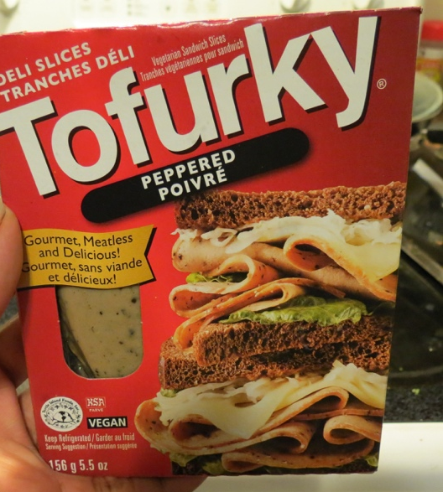
The similar product I have chosen is the Tofurky Deli Slices (Peppered).
Common Name and Bilingual: | Deli slice is the common name of this product and it is clearly labelled in bold face type in both English and French on the left top of the front label.
Storage instruction: | Storage instruction “Keep Refrigerated” in both English and French is clearly labelled on the bottom of the front label.
Net Quantity: | The net weight is labelled in bold face type as 156g (5.5 oz) in metric units on the bottom left of the front label and it is rounded to 3 figures.
Date Markings: | “Best before date” and “packaged on date” for this product is labelled in both English and French on the top of the inside package.
Ingredient list and Allergens: | The ingredients are listed in descending order. On the  bottom of list, “Vegan” is also clearly indicated.
Nutrition labelling: | A nutrition facts table is present  listing calories and 13 key nutrients  according to CFIA regulation. This product contains (per 5 slices or 52g) 100 calories, 3g of total fat, 0 g saturated fat, 0g trans-fat, 0mg cholesterol, 260mg sodium, 125mg potassium, 6g total carbohydrate, 3g fibre, 1g sugar, 13g protein, 0% Vitamin A, 0% Vitamin C, 2% Calcium and 4% Iron, 8% riboflavin, 15% Vitamin B6, 60% Vitamin B12, 8% pantothenate, 30% zinc based on a 2,000 calorie diet.
Legibility and location of the labelling information: | Net weight is located at the bottom right  corner. Type height meets the minimum type height of 1.6 mm.
Sweetener: | No sweetener added.
Country of origin: | This is stated as in “Product of U.S.A”
Identity and Principal Place of Business: | The name and address of the company is clearly  labelled. But there is no phone number on the label.
The ingredient list for the is shown in descending order of proportion in the product: | Water, vital wheat gluten, organic tofu (water, organic soybeans, magnesium chloride, calcium chloride), soy sauce (water, non-GMO soybeans, wheat, salt, culture), non-GMO expelled pressed canola oil, natural vegetarian flavors, non-GMO corn starch, pepper, white bean flour, garbanzo bean flour, lemon juice from concentrate, onion, celery, calcium lactate from beets, sea salt.

You need to specify if the packaging meets the criteria as a whole, since the question asks for it. -1.25

8.75/10

References

Food Technology Magazine Editors Share Top 10 Food Trend Predictions for 2016. (2015, December 16).
Noei, A. M. (2016). Lesson 2 Chemical & Physical Properties of Food. [PowerPoint slides]. Retrieved from https://connect.ubc.ca/bbcswebdav/pid-3778791-dt-content-rid-18271113_1/courses/SIS.UBC.FNH.200.101.2016W1.70510/Lesson2-carbs-16%20%5BCompatibility%20Mode%5D%281%29.pdf
Magee, E. (2016.). Can Bacon Be Part of a Healthy Diet? Retrieved from http://www.webmd.com/food-recipes/features/can-bacon-be-part-of-a-healthy-diet#1 date?
States News Service. Retrieved from http://www.highbeam.com/doc/1G1-437690589.html?refid=easy_hf
Date?
Statistics Canada. (2015). Food availability, 2014 [Data file]. Retrieved from http://www.statcan.gc.ca/daily-quotidien/150528/dq150528f-eng.htm

Make sure to follow APA style.
Food additive dictionary should be cited here.
On next assignment, improper citation results in 5 mark deduction.
4.5/5

