Midterm 1: CST8103 Networking Basics
Fall 2014

Time: 45 minutes; 48 questions; 1 point per question.

You need 40 points to achieve a perfect score. Points over 40 are bonus points up to a maximum of 5 bonus points.

Version A

Instructions:
- BEFORE answering any questions, please check that your copy of the test has all pages (as indicated in the footer at the bottom of each page). Please read all questions carefully, then answer question 1 first!
- YOU MUST MUST MUST BUBBLE YOUR NAME AND STUDENT ID on the scantron sheet!
- All answers should be circled on this test paper and then marked on the scantron answer sheet.
- If you do not find an answer which is clearly the correct choice, choose the best answer.

1. What is your:

NAME? Student Id?

(Continued on next page)

- [0 marks] What version of the test are you writing? The version letter is located on the cover sheet.
(1) A - this is answer
(2) B
(3) C
(4) D
- [1 mark] What entry will be added to a client’s ARP cache following a ping to a local PC?
(a) None – ARP is not used for local communications
(b) The remote host’s MAC address
(c) The client’s gateway MAC address
(d) The local PC’s MAC address Correct
(e) none of the above
- [1 mark] ****Which of the following best describes multiplexing?
(a) Breaking a data stream into smaller chunks
(b) Interleaving data from several sources over a single media Correct
(c) A computer processing multiple programs at the same time
(d) Having redundant routes for data
(e) Having more than one interface for use with the routing table
- [1 mark] What Windows command gives your information about your ARP cache?
(a) ipconfig
(b) arp -d
(c) ipconfig/all
(d) arp -print
(e) arp –a Correct
- [1 mark] A rule or set of rules that describe how communication takes place is known as a:
(a) function
(b) protocol Correct
(c) conversation
(d) handshake
(e) pain for students to memorize
- [1 mark] Find the incorrect statement?
(a) The Network Access layer PDU is a frame
(b) The Application layer PDU is data
(c) The Physical layer PDU is a byte Correct
(d) The Transport layer PDU is a segment
(
- [1 mark] Hosts on the same network segment communicate via?
(a) Enterprise firewall
(b) Directly Correct
(c) Their respective default gateway address
(d) The Internet
- [1 mark] Hosts on same network segment do not require?
(a) IP addressing
(b) MAC addressing
(c) A router Correct
(d) DHCP
- [1 mark] What is not true about a router?
(a) Is considered a switch for Ethernet cabling purposes Correct
(b) A layer 3 device
(c) Requires at least two interfaces
(d) Each interface corresponds to a unique network segment
- [1 mark] Examine exhibit 1. Consider a packet created by PC1 and intended for PC5 has reached Router1 and is currently in the process of being encapsulated in a frame for delivery to Router2. What can be said about the new frame’s source MAC and destination MAC address?
(a) The source MAC will correspond to PC1 and the destination MAC to PC4
(b) The source MAC will correspond to Router 1’s Fa0/1 interface and the destination MAC to Router 2’s Fa0/1 interface Correct
(c) The source MAC will correspond to Router 1’s Fa0/2 interface and the destination MAC to Router 2’s Fa0/2 interface
(d) The source MAC will correspond to PC1 and the destination MAC to Router 2’s Fa0/1 interface
(e)None of the answers!

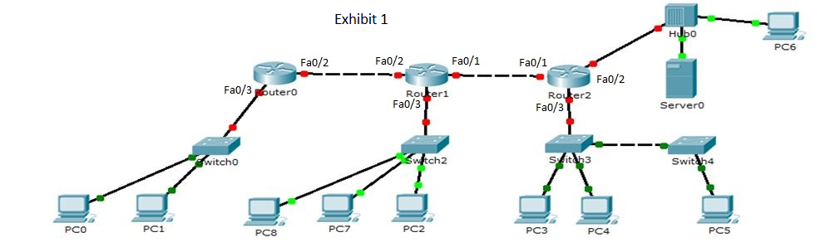

- ****[1 mark] You want to send your college transcript via the internet. Which compression scheme would you use to reduce the size of the data being transmitted?
(a) Lossy compression
(b) Lossless compression Correct
(c) Both a and b
(d) None of the answers

- *** [1 mark] Which media type is most likely to be used to connect a work area to a communications room where the cable length is less than 90m BUT the selected media must be completely immune to RFI and EMI noise sources?
(a) Coaxial
(b) Fibre Correct
(c) STP
(d) UTP

- *****[1 mark] ___1___ digital modulation technique uses a finite number of phases, whereas __2___ uses a finite number of frequencies and __3___ uses a finite number of at least two phases and at least two amplitudes.
(a) 1 PM, 2 FM, 3 QAM
(b) 1 PK, 2 FK, PAK
(c) 1 PSK, 2 FSK, 3 QAM Correct
(d) Don’t know
- *****[1 mark] Under what circumstance is the bit rate three times the baud rate?
(a) When the number of symbols is 8. Correct
(b) When the number of symbols is 3.
(c) In full duplex.
(d) In half duplex.

- *****[1 mark] Under what circumstance is the bit rate 50% the baud rate?
(a) When the number of bits per symbols is 4.
(b) When the number of bits per symbols is 3.
(c) When the number of bits per symbol is 2.
(d) None of the answers! Correct

- *****[1 mark] Under what circumstance does 1Gbps equal 250MBd?
(a) When the number of symbols is 8.
(b) When the number of symbols is 16. Correct
(c) When the number of symbols is 4.
(d) None of the answers!
- [1 mark] Refer to exhibit 2. In how many frames will a packet sent from 10.10.10.2 to 172.16.31.2 be carried in?
(a) 4
(b) 5
(c) 3 Correct
(d) 2
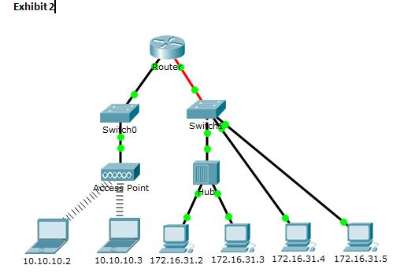
- [1 mark] A multi-access physical topology.
(a) Dictates the media access control method.
(b) Implies a multi-access logical topology.
(c) Requires a hub or switch to interconnect nodes.
(d) None of the answers! Correct

- [1 mark] What statement is true about layer 2?
(a) Divided into two sublayers – Link Control and Media Control.
(b) Enables upper layers to be media dependent and determines when a device can transmit on the physical media.
(c) Enables upper layers to be media independent and determines when a device can transmit on the physical media. Correct
(d) Corrects errors in transmission.
- *****[1 mark] The goodput is less than the throughput due to:
(a) External factors such as sharing limited bandwidth with multiple users.
(b) Your ISP’ speed.
(c) The goodput is greater than the throughput.
(d) Factors like encapsulation and decapsulation. Correct
- [1 mark] Referring to exhibit 3 and assuming all switches are “store and forward” switches. If all layer 2 protocols contain an FCS, how many FCS (CRC) calculations are made for a packet sent from PC0 to Server0?
(a) 8
(b) 9 Correct
(c) 5
(d) 4
(e) 7
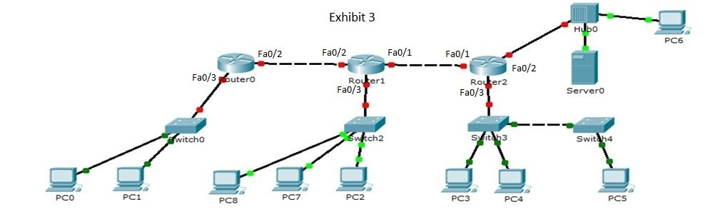

- [1 mark] Refer to exhibits 4, 5 and 6 where:
Exhibit 4 illustrates the network topology for this question;
Exhibit 6 is the outpout of the arp -a command executed on Client E;
Exhibit 5 is showing the content of the MAC table for the OTT switch.
Analyze the content of each of the exhibits to determine the following:
the IP address of the device connected to port Fa0/4.
(a) 192.168.10.1
(b) 192.168.10.21 Correct
(c) 192.168.10.22 next page
(d) 192.168.10.10
(e) Impossible to tell!

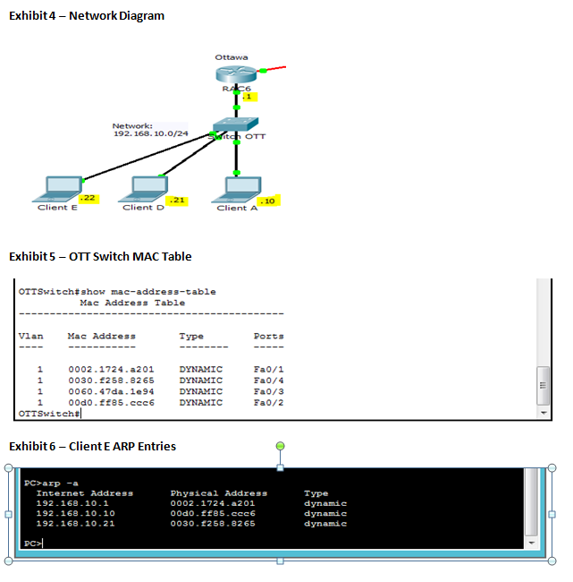

- [1 mark] When a switch receives a frame with a destination MAC address that it has NOT seen previously, the switch will:
(a) drop the frame because it is NOT for a known destination
(b) learn the MAC address and place it in the MAC address table
(c) flood the frame to all ports except the port the frame entered Correct
(d) learn the MAC address by sending an ARP to all devices

- ****[1 mark] The throughput is 250Mb/s and the overhead due to encapsulation/decapsulation is 1MB/s. What is the goodput?
(a) 249Mb/s
(b) 251Mb/s
(c) 242Mb/s Correct
(d) 258Mb/s

- [1 mark] Referring to exhibit 3, what is the number of collision domains?
(a) 6
(b) 17
(c) 15 Correct
(d) 14
(e) 16

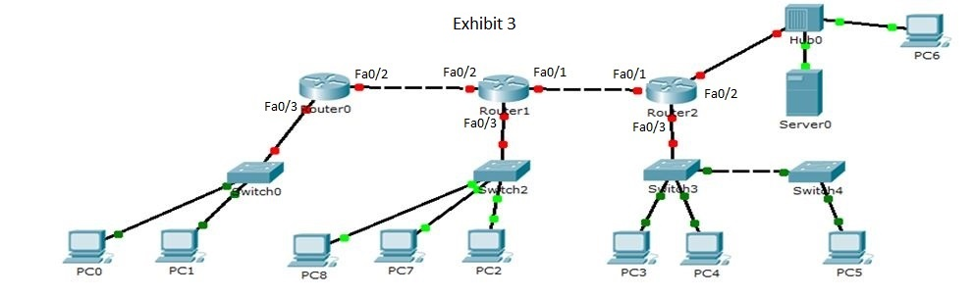
- [1 mark] What is a true statement about a switch?
(a) Each port is a separate collision domain. Correct
(b) Is a layer 1 device.
(c) Creates a single collision domain.
(d) None of the answers are correct as there is no such thing as a collision domain.

- [1 mark] What is an “RFC”?
(a) It's a document describing how a host computer should operate
(b) It's a “Remote Function Call” describing how network devices should work
(c) It's a “Request For Comments” describing how a protocol should work Correct
(d) It's a “Required Functions Commentary” describing how routers should operate
(e) It's not actually a networking term, its short for “Request for Caffeine”
- [1 mark] An RFC is a publication of which organization?
(a) ITF (The Internet Task Force)
(b) IEEE (Internet Electrical and Electronics Engineers)
(c) IEEE (Institute of Electrical and Electronic Engineers)
(d) IETF (Internet Engineering Task Force) Correct

- [1 mark] Ethernet is a specification created and managed by the?
(a) ITF (The Internet Task Force)
(b) IEEE (Internet Electrical and Electronics Engineers)
(c) IEEE (Institute of Electrical and Electronic Engineers) Correct
(d) IETF (Internet Engineering Task Force)

- [1 mark] 802.2 describes:
(a) The MAC sublayer which is the lower portion of the data link layer
(b) The LLC sublayer which is the upper portion of the physical layer
(c) The LLC sublayer which is the upper portion of the data link layer Correct
(d) None of the answers.

- [1 mark] 802.11 describes:
(a) The MAC sublayer of the data link and physical layers.
(b) The Wi-Fi specification. Correct
(c) The Ethernet standard.
(d) None of the answers.

- [1 mark] 802.3 operates over which media types:
(a) Wireless, Copper and Fibre.
(b) Wireless only.
(c) Copper and fibre. Correct
(d) None of the answers.

- [1 mark] Which of the following is the correct “bottom up” order of the TCP/IP networking model?
(a) physical, data link, network, transport, session, presentation, application
(b) layer 1 to layer 7
(c) Network Access, IP, Transport, Application Correct
(d) layer 1 to layer 5

- [1 mark] Which of the following is not one of the benefits achieved by moving from simple signaling methods (e.g. NRZ) to more advanced schemes that have a coding step such as 4B/5B before signaling?
(a) Better error detection due to invalid codes
(b) Codes can be chosen to balance the number of 1's and 0's
(c) Fewer bits need to be transmitted, resulting in faster data rates Correct
(d) It is possible to have control codes for “start” and “stop” that aren't confused with data
(e) The codes have enough transitions for timing & synchronization

- **** [1 mark] Which cable type should be used to connect two end points where 35 Kms of cable would be required?
(a) Shielded fibre
(b) Multimode fibre
(c) Single mode fibre Correct
(d) Thick Coaxial
(e) Wireless

- [1 mark] What is the destination MAC address of a broadcast ARP frame?
(a) Depends!
(b) FF:FF:FF:FF:FF:FF Correct
(c) 00:00:00:00:00:00
(d) None of the answers!

- [1 mark] What is an incorrect statement about a MAC address?
(a) 48 bits in length
(b) 12 hex characters
(c) Also called the logical address Correct
(d) Burned into ROM by the manufacturer of the interface
(e) The first 24 bits is the OUI

- [1 mark] What is an incorrect statement about Ethernet?
(a) Wired LAN specification
(b) Operates at speeds of 10Mbps, 100mbps, 1Gbps and 10Gbps
(c) Uses both CSMA/CD and CSMA/CA as the media access control method Correct
(d) Can operate in full and half duplex mode

- ****[1 mark] Which of the following media type would you NOT consider if you were concerned with spies listening on your digital conversations?
(a) Fibre
(b) Wireless Correct
(c) UTP
(d) Coaxial

- [1 mark] In which pane does Wireshark show the FCS field?
(a) top pane
(b) middle pane
(c) bottom pane
(d) middle and bottom
(e) none of the above Correct

- [1 mark] What is the value of the Ethernet frame Type/Length field when it encapsulates an ARP request?
(a) 0806
(b) 0x0800
(c) 0x0806 Correct
(d) none of the above

- [1 mark] What is the smallest legal Ethernet frame size that guarantees a collision will be detected before the end of a transmission?
(a) 64 bits
(b) 1500 bytes
(c) 64 bytes Correct
(d) there is no size limit!

- [1 mark] What is the first step of any transmission with CSMA/CD?
(a) Send out a Request to Send.
(b) Places a signal on the media and then listen to make sure there are no collisions.
(c) Listens for a signal and if none is detected begins transmitting. Correct
(d) Begins transmitting and hopes for the best.

- [1 mark] What is incorrect about encapsulation:
(a) Each layer adds layer specific headers
(b) Process of preparing data for transmission
(c) The segment is passed to layer 2 for encapsulation into a frame Correct
(d) Three levels of addressing are added

- [1 mark] What is an incorrect statement about addressing:
(a) The three levels of addressing are: Layer 4: Application Ports, Layer 3: IP addresses, Layer 2: Physical Addresses
(b) Ports identify the source and destination processes (applications)
(c) IP addresses are used to move packets across networks
(d) MAC addresses are used to move frames amongst devices connected to the same network segment
(e) All statements are true! Correct

- [1 mark] Find the incorrect statement concerning end and intermediary device types:
(a) An end device originates or is the ultimate destination of a data transmission.
(b) An intermediate device finds the best path to the final destination
(c) Intermediate devices will seek to optimize the transmission by applying loosy compression techniques. Correct
(d) An intermediate device is concerned about getting messages to their final destination and will never change the data!

- [1 mark] Find the incorrect statement:
(a) Devices of the same network segment share the same default gateway address.
(b) Devices of different network segment communicate via their respective default gateways.
(c) Each router interface has a separate IP address BUT all share the same MAC address. Correct
(d) A switch is layer 2 device and a router is a layer 3 device

- [1 mark] Find the incorrect statement:
(a) The internet is a public network and is also known as the network of network!
(b) An intranet is a private network that may or may not be connected to the internet. Firewalls are at the boundaries of the internet and intranet to protect the intranet and prevent unauthorized access to private intranet resources.
(c) An extranet is a type of network that gives business partners unrestricted access to any and all of an organization intranet’s resources. Correct
(d) All of the above statements are true!

- [1 mark] Referring to exhibit 7, find the incorrect statement:
(a) It is a layer 2 PDU.
(b) Header contains all or combination of: start of frame, physical addressing, length, type and control fields.
(c) Trailer contains all or combination of: end of frame and error checking fields.
(d) Frame headers and trailers are only required for Ethernet networks. Correct

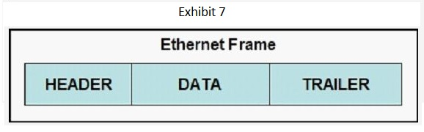

Use this page for rough work Your Name: _______________________

