ADM 1300 exam
15 multiple choices, 2 points each (30 points)
short answer questions. Complete 2 questions (10 points each)
Chapters 1-6. 8 and 11-intro to leadership

ADM1300 Exam notes (Slides)

Lecture 1:
Business: Profit seeking activities and enterprises that provide goods and services necessary to an economic system
Profit: The difference between the revenues earned and the costs earned by a business
Organization: Collection of people working together to achieve a common purpose
They provide useful goods and services that return value to society and satisfy customer needs

Organizations as an open system

The environment supplies:
People, money, materials, technology, information.

The organization creates:
Turning inputs into outputs (transformation process)

Environment consumers:

Finished goods and services which is fed back into the input system

Productivity and Performance:
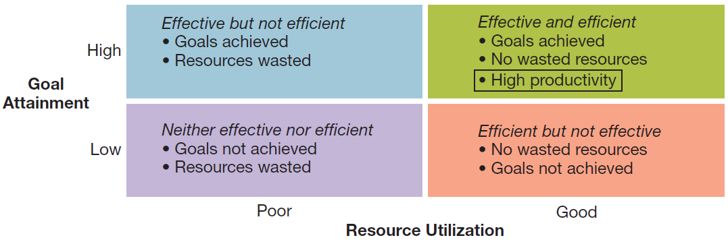

Diversity
Workforce Diversity: Differences among workers in gender, race, ethnicity, religion, sexual orientation and able-bodiedness.
Prejudice: Display of negative, irrational behaviours toward members of diverse groups.
Discrimination: Actively denies minority members full benefits of organizational membership
Glass Ceiling Effect: Invisible barrier limiting career advancement of women and minorities.

Globalization: Worldwide interdependence of resource flows, product markets, and business competition that characterizes our new economy. It is the process in which advancements in technology along with deregulation of markets opens boarders to bring vastly expanded flows of people, money, goods, services and information.

Organizational Environment:

Socio-Cultural: Demographics
Economic:
Technological:
Natural Environment:
Legal-Political:

Technology: It is an indispensable part of our everyday lives and has become a key tool in business, many businesses have taken to simply becoming E-businesses. For other businesses it is a necessity, whether you are checking inventory, making sales transactions, ordering supplies, analyzing customer preferences. Jobs now involve increasing multi-media resumes and electronic portfolios
Ethics: Code of moral principles that sets standards of what is right and good as opposed to wrong and bad in the conduct of a group or person.
Management: The art and science of getting things accomplished through others in organization.
First level Management: Mobilization = Team leaders in charge of small work groups of non-managerial workers.
Second (middle) level: Coordination= Middle managers in charge of relatively large departments/divisions
Third level: Strategic= Top leaders Responsible for the performance of the organization as a whole or for the entirety of one of its larger parts

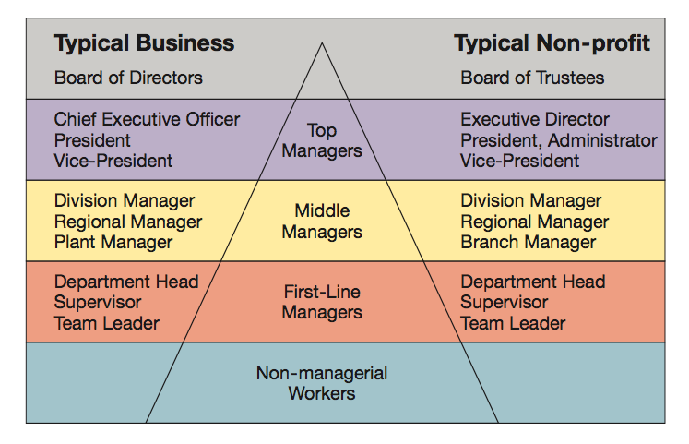

Managers in the new workplace’s jobs are more geared towards serving the customer and supporting workers’ efforts.
The Management Process: Management is the process of planning, organizing, leading, and controlling the use of resources to accomplish performance goals. All managers are responsible for the four functions.
- Planning: Setting performance objectives and deciding how to achieve them.
- Controlling: Measuring performance and taking action to ensure desired results
- Leading: Inspiring people to work hard to achieve high performance
- Organization: Arranging tasks, people and resources to accomplish the work

Informational roles: Giving, receiving and analyzing of information.
Interpersonal Roles: Interactions with persons inside and outside the work unit.
Decisional Roles: Using information to make decisions in order to solve problems or address opportunities.

Agenda setting and agenda implementation are behavior patterns of successful managers.
Agenda setting: What is wanted to be accomplished by the organization. Almost always informal and unwritten as well as concerned with people issues.
Networking is the sum of one’s formal and informal network of key people inside and outside the organization. Relationships are usually relevant to manager agendas.
Agenda Implementation: These networks are used by managers to implement agendas and they employ influence tactics to do so. Usually involves informal interactions and concern with people issues.

Robert Katz managerial skills:
- Conceptual: Critical thinking and analyzation of information in order to solve complex problems
- Technical: Applying special proficiency or expertise to perform particular tasks
- Human: Good with relationships and working well in cooperation with others

Daniel Pink: Competencies
- Communication: Sharing ideas and
- Team work: Working effectively with others
- Self-Management: Scrutinizing and modifying one’s own actions
- Leadership: Influencing and supporting others
- Critical thinking: Analyzing and gathering information
- Professionalism: Impression management and career advancement

Managerial Minds: Many managers use intuition to guide decisions and actions
- Sensing that a problem exists
- Performing well learned mental tasks rapidly
- Synthesizing isolated bits of information
- Double checking = doing formal/mechanical analysis.
Good intuition = problem identification and solving based on a long history of education and experience.

Management Past-to-Present:
Management is getting the right thing done through others. “Management Thought” developed over 100 years ago and has evolved quickly.

Classical Management, classical approaches:
- Scientific Management: Frederick Taylor
- Bureaucratic Organizations: Max weber
- Administrative Principles: Henri Fayot

Behavioral Management:

Lecture 2 Notes:

Management and Globalization: Key concepts in Globalization
- Global Economy: Resource supplies, product market and competition are on a worldwide scale as opposed to local
- Globalization: Growing interdependence of these components in global economy
- Global Manager: Informed about international development, transnational in outlook. Competent in working with other cultures, also aware of regional developments abroad
- International Management: Management in organizations with business interests in more than one country.

Reasons why businesses go global:
- Profits
- Expanding the market
- Customers
- Capital
- Labor

Market entry strategies:
- Global sourcing: Process of purchasing materials globally for local use
- Exporting: Selling locally made products in foreign countries
- Importing: Selling foreign made products locally
- Franchising: Fee paid for rights to use other firms name and production methods
- Licensing Agreements: Firm pays for rights to make and sell other company’s products

Direct Investment Strategies:
- Joint ventures: Operates in a foreign country through co-ownership by local and foreign partners
- Global Strategic Alliances: A partnership in which foreign and domestic partners share information, resources, knowledge for mutual gains.
- Foreign subsidiaries: Local operation completely owned by a foreign firm.
- Greenfield Investment: Builds an entirely new operation in a foreign country.

Global Business Environment:
- Political Risk: Potential loss in value of investment in foreign country due to instability and changes in political scene
- Local legal systems: Foreign law can be complex and is very unfamiliar so must familiarize to avoid problems
World Trade Organization (WTO): Resolves trade and tariff disputes among countries.
Protectionism: Wanting to protect domestic businesses from foreign influence is something which can harm global trading relationships
Complaints of Host countries against MNC’s
- Excessive profits
- Economic Domination
- Interference with government
- Use best local talent
- Limited technology transfer
- Disrespect for local customs
Complaints of MNC against host country:
- Profit limitation
- Resources overpriced
- Exploitative rules
- Foreign exchange restrictions
- Failure to uphold contracts
Mutual benefits for Host countries/MNC
- Larger tax bases,
- Increased employment opportunities
- Development of local resources
- Introduction of new industry
- Technology trading/transfer

Ethical Issues:
- Corruption, Sweatshops, Child Labor, Sustainable Development.
- Sustainable development: Working simply for “today” as opposed to the future

Artifacts of Culture:
- Monochronic Cultures: People tend to accomplish one thing at a time
- Polychronic Cultures: Time is used to accomplish many different things
- Proxemics: How people use space to communicate

Values of national cultures:
- Power distance
- Uncertainty avoidance
- Individualism-Collectivism
- Masculinity-Femininity
- Time Orientation

Global Management:
Comparative management: How managerial practices and perspectives differ amongst different countries and cultures

Most managerial practices are not universal and differ heavily from culture to culture, country to country. EX: Japanese practices pretty much can’t be duplicated anywhere else or U.S practices which might be ethnocentric.

GLOBE project: (Global Leadership and Organizational Behavior Effectiveness)
Researches the leadership, organizational practices and diversity among world cultures.

Four views of ethical behavior:
Individualism View: Does a decision or behavior promote one’s long term self-interests
Moral Rights View: Does a decision or behavior maintain the fundamental rights of all human beings?
Justice view: Does a decision or behavior show fairness and impartiality?
Utilitarian View: Does a behavior or decision do what is best for everybody.

Ethical Development (KOHLBERG):
- Pre-conventional: All acts are done in one’s best interest.
- Conventional: Upholds moral and legal laws, does what is expected.
- Principled: Lives by an internal set of moral codes values and ethics

Ethical Checklist: Recognize ethical dilemma, get the facts, identify opinion see if options are legal, check decision and take action
Social Entrepreneurship: Seeks novel ways of solving pressing social problems home and abroad. (Housing/job training for homeless, technology for poor families.)
Corporate social responsibility: Organizations working in a way which satisfies both their own interests and the interests of society as a whole.

Lecture 3:
Entrepreneur: Person who seeks opportunity and takes necessary risks to successfully operate a business. Different from small-business owners in their desire to expand business. And different from managers in their level of responsibility.
Entrepreneurship: Strategic thinking and risk-taking that creates new opportunities for individuals and organizations.
Social Entrepreneurs: People who use their ideas and strategic thinking not for money but to help solve a pressing social issue using the money earned as a means to the solution.

Lecture 4:

Planning: Setting out objectives and determining how to best achieve them
Steps of Planning: Determine objectives then see where you stand. Develop alternatives to situation then choose and implement
Why Plan? Improves flexibility, action orientation, time management, coordination and control
Higher management focuses more on longer time horizons.
Strategic plans: Set broad, comprehensive and longer term action directions for the entire organization.
Tactical Plans: Define what need to be done in specific functions to implement strategic plans
Types of Plans: Financial, marketing, HR, production

Planning tools and techniques:
Contingency: Mapping out alternatives solutions to your plan if circumstances change. They anticipate changing conditions.
Scenario Planning: Long-term version of contingency planning. Making alternatives to future scenarios for best and worst case.
Benchmarking: Use of external and internal comparisons to evaluate performance and identify any areas of improvement. Can involve adopting methods of other organizations who have found success in similar areas.
Management by objectives: Is a structured process of regular communication, team leaders and team members plan and review results jointly.
Formal agreement specifying worker’s goals for a specific time period. Plans through which objectives need to be accomplished.
Team leaders and members, jointly plan (setting objectives and choosing actions. Individually act: Performing tasks (members) providing support (leader). Jointly control: Performance review, discussing implication.
Type of performance objectives: Improvement, personal development, maintenance
Effective performance objectives are challenging, time sensitive, measurable, specific.

Organization:
The process of organizing people and resources to work together to accomplish a goal.
Organizational Structure: system of tasks, operations, reporting, relationships and communications that link diverse individuals and groups together.

Organizational Chart: Identifies the following aspects of organizational structure:
Division of work, supervisory relationships, communications channels, major subunits, levels of management.
Traditional Organizational structures: Departmentalization, grouping teams together to enhance coordination. Resulted in 3 types of structures
Functional: Similar skills employees are grouped together. Members work in their functional area of expertise. Good for small operations producing few new products.
Divisional: Group together people who work on the same product or process, server similar customers and/or work in the same geographical region.
Ex: Product structures focus on same product; geographical products focus on same region. Customer structures focus on same customers and clientele.
Matrix: Combines divisional and functional to gain advantages and minimize disadvantages in: Manufacturing, service, non-profit and MNC. Involves multiple reporting lines so people may have more than one boss.

Horizontal organizational structures:
Team structures: Permanent and temporary teams deployed to solve problems and complete special projects and accomplish day-to-day tasks. Often made up of cross-functional teams from various departments, convene for special tasks or project then get disbanded once goal is accomplished.
Network structures: A central core that is linked through networks with connections to external contractors and suppliers of essential services. Own only necessities and use strategic networking to outsource anything else needed.
Advantages of Network structures: Firms can operate with fewer full time employees and less complex structures, can cut a lot of overhead costs and work with increased operating security. Permits operating across great distances.
Disadvantages: Control and coordination problems may arise from network complexity. Potential loss of control over outsourced activities. Lack of loyalty among infrequently used contractors. Excessive outsourcing can be dangerous.
Boundary less: Blurring boundaries with subsystems and external boundaries with environment, made possible with combinations of teams and networks.

Lecture 5:
What is leadership? The influence that a particular individual exerts on goal achievement of others in an organization. Good leadership exerts influence in a way that achieves the organization’s goals. It is the process of inspiring people to work hard to accomplish important goals. Some challenge in the modern day are that times frames are reduced, and that success is expected on the first attempt and needing to take a long term view while meeting short term goals.
Managers have huge influence on the quality of their subordinate’s work experience and they guide their subordinates work behavior. An employee with a manager who has good leadership skills will generally work harder, enjoy their job, want to perform well.
Strategic Leadership: Leadership which involves being able to anticipate, envision, create flexibility and work with others to create a viable future for the organization.
Formal Leadership: Leaders with titles such as manager, executive, supervisor etc… are people who occupy formal leadership roles.

Nature of Leadership:
Power: The ability to influence someone to do the work.
Position: Based on position in hierarchy
Autocratic style: Emphasizes control over others and keeping information between leaders tight

Human style: People over work
Henry-Blanchard Style: leaders determine their styles based on their follower’s readiness
House’s path: Effective leaders guide their workers to go through paths to achieve goals
Directive, supportive achievement oriented.

