Experiment #3: Competition Studies of Substitution and Elimination Reactions

October 17th, 2016
CHM2123B

Introduction:
Chemical reactions are usually performed with the goal of obtaining a single target product. However, in a typical laboratory experiment, there is often not one but multiple reaction pathways that could be followed, leading to several products. These side reactions compete with the desired reaction and lower the yield of the wanted molecule. Conversion and selectivity are used to analyze a process that yields more than one product. The conversion represents the ratio of all products produced to the total that could have theoretically been formed, and the selectivity represents the ratio of the preferred product among the total products formed.
In this experiment, the two competing reactions will be elimination and substitution reactions, more specifically, the reaction pathways studied will be E2 and S_{N}2. An E2-type elimination reaction occurs when a strong base deprotonates a hydrogen from a β-carbon (adjacent to the α-carbon) on an alkyl halide. The electrons from the breaking C-H bond then attack the α-carbon and promote the departure of the leaving group, also forming an alkene double bond between the α- and β-carbon. This whole process is concerted. An S_{N}2-type substitution reaction is also concerted; in one step, the nucleophile attacks the α-carbon and the leaving group is displaced. Both reactions require antiperiplanar arrangement between two groups, meaning that they must have an 180º dihedral angle. For S_{N}2, the two groups are the nucleophile and the LG, and for E2 they are the hydrogen being deprotonated and the LG. These two reaction mechanisms are shown in Figure 1:
E2:  S_{N}2: | 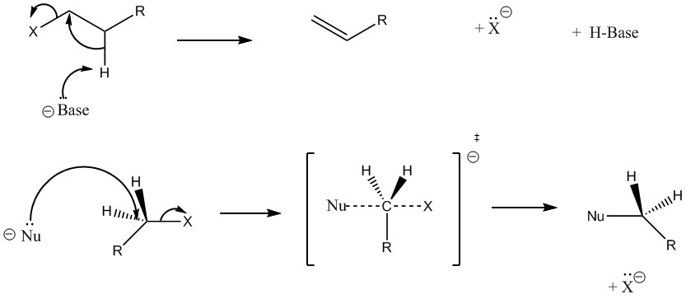
Figure 1: E2 and S_{N}2 reaction mechanisms
The goal of this experiment will be to perform the reactions of KOH with 1-bromobutane and 2-bromobutane and to study the competition between S_{N}1 and E2 pathways that will be taking place. All the possible products of these reactions are shown in Figure 2:
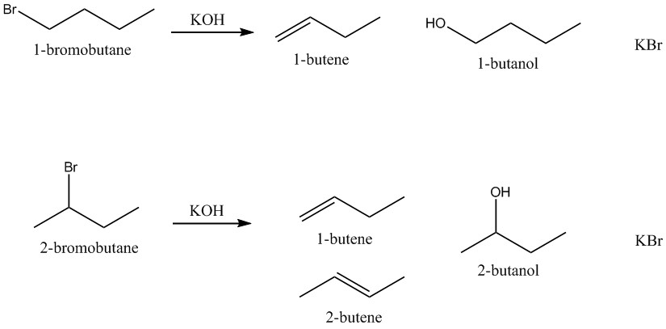
Figure 2: The possible products of the reactions of KOH with 1-bromobutane and 2-bromobutane
There will be three reaction trials performed; the first will be the reaction of KOH with 1-bromobutane at reflux, the second will be with 1-bromobutane at 50ºC, the third will be with 2-bromobutane at reflux. The elimination products, either 1-butene or 2-butene as shown in Figure 2, are gases; they will be collected in a eudiometer tube submerged in a 1L beaker and their volume will be measured. The pressure of the gas collected for each trial will be determined with the formula P_{gas} = P_{atm} – P_{water} – P* (where P* is the pressure exerted by the height of the water column above the level of water in the beaker). It will be assumed that the gas follows the Ideal Gas Law, pV = nRT, so knowing the pressure, volume and temperature of the gas, the moles of gas, and thereby the moles of E2 product, will be determined.
To calculate the moles of S_{N}2 product, the mass of KBr (a salt) produced in the experiment will be measured, and the moles will be determined. Both E2 and S_{N}2 reactions produce KBr as a side product, so the moles of KBr correspond to the moles of bromobutane consumed. Therefore, n_{KBr} = n_{gas} + n_{butanol}, and knowing the moles of KBr and moles of gas will allow to determine the moles of butanol, the S_{N}2 product, produced. From this, the selectivity of the reaction for E2 and S_{N}2 will be computed.
Experimental Procedure: refer to CHM2123 lab manual, pages 45-52.
Modifications
- The order of steps 20 and 21 was reversed.
- When performing the experiment with 1.5 mL of 1-bromobutane by heating the flask to 50ºC, the KOH was dissolving very slowly. A stir plate could not be placed under the flask due to the hindrance of the water bath, so the reaction mixture had to be stirred manually by unclamping the reflux condenser and the flask and gently swirling the reaction mixture inside.
Table of Reagents:
Compound | Molar Mass (g/mol) | Quantity  (g or mL) | Density (g/mL) | Mmol | Equivalents
1-bromobutane | 137.01 | 1.5 mL x 2 | 1.268 | 13.88 x 2 | 1
2-bromobutane | 137.01 | 0.7 mL | 1.255 | 6.41 | 1
KOH | 56.11 | 8 g x 3 | - | 142.58 x 3 | For reactions with…  1-bromobutane at reflux: 10.27 eq.  1-bromobutane at 50ºC: 10.27 eq.  2-bromobutane at reflux: 22.24 eq.
95% EtOH (solvent) |  | 40 mL x 3

Results and Observations:
Key Step | Observations
Dissolution of KOH in the reaction flask during the reaction of KOH with 1-bromobutane at 50ºC | The KOH, which was in large pellets, was very slow to dissolve
Gas collection during the reaction of KOH with 2-bromobutane under reflux | Two eudiometer tubes had to be used when collecting the gas. Some gas product may have been lost during the transition to the second eudiometer.

Reaction Conditions |  | Initial Eudiometer Reading V_{i} (mL) | Final Eudiometer Reading V_{f} (mL) | Pressure of Gas (atm) | Volume of Gas (mL) | Moles of Butene (mol)
1-bromobutane at reflux |  | 1.7 | 20.1 | 0.937 | 18.4 | 7.12 x 10⁻⁴
1-bromobutane at 50ºC |  | 14.1 | 15.5 | 0.931 | 1.4 | 5.40 x 10⁻⁵
2-bromobutane at reflux | 1st eudiometer | 11.0 | !54 | 0.976 | 43 | 1.73 x 10⁻³
2-bromobutane at reflux | 2nd eudiometer | 0 | 7.6 | 0.925 | 7.6 | 2.90 x 10⁻⁴
 |  |  |  | Total | 50.6 | 2.02 x 10⁻³
!Note: this is an approximated value
Reaction conditions | Mass of KBr (g) | Moles of KBr (mol) | Moles of Butanol (mol) | Conversion & Yield of KBr (%) | Selectivity (%)
 |  |  |  |  | Towards S_{N}2 | Towards  E2
1-bromobutane at reflux | 1.29 | 0.0108 | 0.0101 | 78 | 93.4 | 6.6
1-bromobutane at 50ºC | 0.44 | 0.00370 | 0.00365 | 27 | 98.6 | 1.4
2-bromobutane at reflux | 0.41 | 0.00345 | 0.00143 | 54 | 41.4 | 58.6

Room temperature for all three reaction trials: 22.0 ºC = 295 K
Atmospheric pressure for all three reaction trials: 101.0 KPa = 757.56 mmHg
Calculations:
Sample Calculations for 1-bromobutane at reflux
P_{gas}:
P_{gas}= P_{atm} – P_{water} – P*
P* = (Eudiometer reading at the level of water in the beaker – Final Eudiometer Reading) x 1.19 cm/mL
P* = (!50 mL – 20.1 mL) x 1.19 cm/mL
P* = 35.58 cm
P* = 355.8 mm H₂O x 1 mm Hg/13.6 mm H₂O
P* = 26.16 mmHg

!Note: This is an estimated value
P_{gas}= P_{atm} – P_{water} – P*
P_{gas} = 101.0 kPa x 7.5006 mmHg/kPa – 19.5 mmHg (at 295 K, from table 3.3) – 26.16 mmHg
P_{gas} = 757.56 mmHg – 19.5 mmHg – 26.16 mmHg
P_{gas} = 711.9 mmHg x 1 atm/760.0 mmHg
P_{gas} = 0.937 atm

Moles of butene:
n_{butene} _{gas} = pV/RT
= (0.937 atm) (0.0184 L) / (0.08205746 L atm K⁻¹ mol⁻¹) (295 K)
= 7.12 x 10⁻⁴ mol

Moles of KBr: n_{KBr} = m/M = 1.29 g /(119.002 g/mol) = 0.0108 mol

Moles of butanol:

n_{KBr} = n_{gas} + n_{butanol}
n_{butanol} = n_{KBr} - n_{gas}
= 0.0108 mol – 7.12 x 10⁻⁴ mol
= 0.0101 mol

Conversion (equal to % yield of KBr):

% conversion = n_{butene} + n_{butanol} x 100
n_{limiting reagent}

= n_{KBr .} x 100
n_{1-bromobutane}

= 0.0108 mol x 100
0.01388 mol

= 78%

Selectivity:

% selectivity towards S_{N}2 = n_{butanol} x 100  n_{butene} + n_{butanol}  = 0.0101mol x 100  0.0108 mol  = 93.4 % | % selectivity towards E2 = n_{butene} x 100  n_{butene} + n_{butanol}  = 7.12 x 10⁻⁴ mol x 100  0.0108 mol  = 6.6 %

Discussion:
The goal of this experiment was to study the competition between S_{N}2 and E2 in the reaction of KOH with 1-bromobutane and 2-bromobutane. The reaction of KOH with 1-bromobutane was studied under two different reaction conditions; under reflux and in a hot water bath at 50ºC. The reaction of KOH with 2-bromobutane was only studied under reflux.
To study the competition of the two reaction mechanisms, the % selectivity was calculated for each set of reaction conditions towards E2 and S_{N}2 products. The % selectivity of the first reaction performed, KOH with 1-bromobutane at reflux, was 93.4% towards S_{N}2 and 6.6% towards E2. This reaction tended to favour S_{N}2 because KOH is a small, strong base, and being unhindered makes it a good nucleophile. 1-bromobutane also has a 1º α-carbon which is favoured by S_{N}2 reactions since there is almost minimal steric hindrance (it is the next best after the methyl group). Thus the high nucleophilicity of KOH combined with the sterically unhindered primary α-carbon made this reaction favour S_{N}2. When the reaction conditions were changed and this reaction was performed with 1-bromobutane at 50ºC, the selectivity was 98.6% towards S_{N}2 and only 1.4% towards E2. The reaction favoured S_{N}2 even more because the heat was lowered; for this trial the temperature was monitored and kept at around 50ºC while for reflux, the solution was heated to a much higher temperature. Elimination reactions have a higher activation energy than substitution reactions and favour heat, so reducing the temperature of the reaction led to an even greater selectivity for S_{N}2.
The % selectivity for the reaction of KOH with 2-bromobutane was considerably different from the reaction trials with 1-bromobutane; it was 41.4% towards S_{N}2 and 58.6% towards E2. The selectivity was greater for E2 because there was a 2º α-carbon involved this time instead of a 1º α-carbon. The secondary α-carbon had a greater steric hindrance which made it less favorable for S_{N}2, so E2 competed effectively and more E2 products were obtained. The elimination products were 1-butene and 2-butene. Unlike with 1-bromobutane where only 1-butene could have been produced (there was only one carbon with bonded hydrogens adjacent to the 1º α-carbon), there were two products possible this time because hydrogens from the two carbons adjacent to the α-carbon were available to participate in the E2 reaction, shown in Figure 3 below:
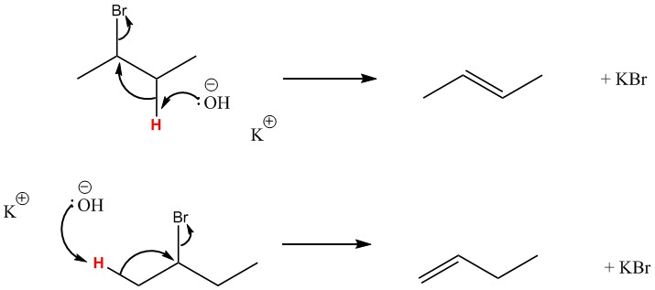
Figure 3: 2-butene and 1-butene formation from the reaction of 2-bromobutane with KOH
Using the method present in this experiment, it was impossible to distinguish which isomer was in higher yield. I suppose that it was 2-butene, the Zaitsev product, which is more stable due to it being a more substituted alkene. This product is easily formed since KOH is a non-bulky base and bromine is a small leaving group, which minimizes the steric hindrance during the deprotonation of the hydrogen. The hydrogen on the 2º β-carbon is therefore almost just as easily obtainable as on the 1º β-carbon, and the reaction favours the deprotonation of the hydrogen on the β-carbon that will lead to the more stable product.
The % conversion values for this experiment were 78% for the reaction of KOH with 1-bromobutane at reflux, 27% for 1-bromobutane at 50ºC and 54% for 2-bromobutane at reflux. The % conversion for 1-bromobutane at 50ºC was the lowest because, due to the lower temperature and the lack of stir plate and stir stick, the KOH took much longer to dissolve and the reaction had less time to occur due to time constrictions. To help the KOH dissolve, the solution inside the reaction flask had to be stirred manually by swirling the reflux apparatus. The slow dissolution of KOH was one source of error in this experiment, and to improve results, the solvent with KOH could be stirred inside a separate beaker and only put into the round bottom reaction flask after all the KOH pellets have dissolved.

Questions:
- n_{1-bromobutane} = n_{butane} = 0.01388 mol

V = nRT
p
= (0.01388 mol)(0.082057 L atm K⁻¹ mol⁻¹)(298 K)
1 atm
= 0.339 L

= 339 mL

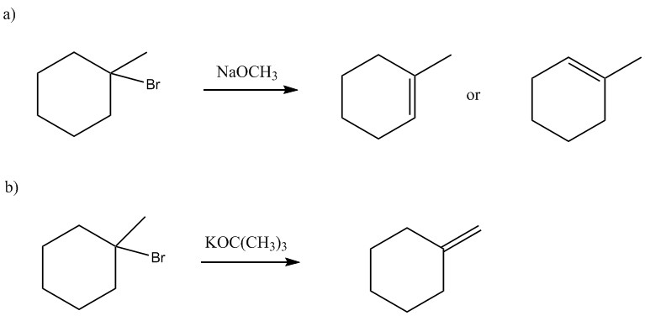

- Elimination
- Substitution
- Substitution

- Use a bulky, strong base such as DBN or KOtBu that can not undergo S_{N}2 due to steric hindrance.
- Increase the temperature to help the elimination reaction to make 1-pentene take place, since heat favours elimination reactions.

