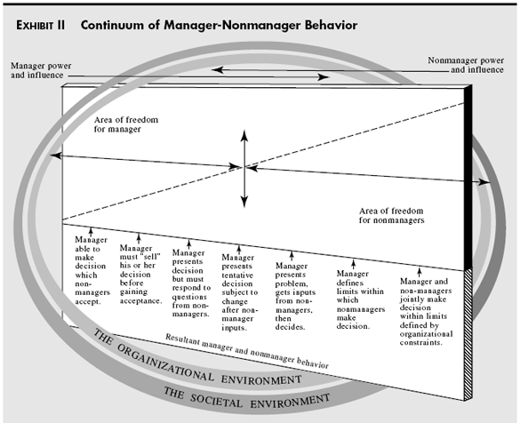
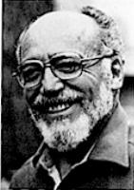

Traditional view:
- Command & control
- Decision making
TANNENNAUM & SCHMIDT: HOW TO CHOOSE A LEADERSHIP PATTERN
Modern view:
- Inspiration
- Creating vision
- Building effective team

- Manager is responsible for all delegated decisions
- Once delegated, should be member than authority figure
- Important for employees to recognize type of leadership to avoid confusion, resentment
- Quality over quantity the significance of delegated decisions to measure ‘democratic’
Forces in the manager:
- Value system/ own belief
- Confidence in subordinates
- Leadership inclinations
- Tolerance for ambiguity
Forces in subordinate:
- Needs for independence
- Readiness to assume responsibility for decision making
- High tolerance for ambiguity
- Interested in the work
- Necessary skills & knowledge
- Understand & identify with goals of org.

Forces in the situation:
- Type of organisation – hierarchy, culture
- Size of working units, geographical distribution, level of security and confidentiality amount employee participation
- Group effectiveness/ synergy: experience working together
- Problem itself

Pressure group, trade union, government legislation…

