Motivation: one needs no outside motivation, one wants to do it

Negative physical KITA: physical attack backlash

Negative psychological KITA: no tangible evidence slow ticking bomb

Positive KITA: reward, incentive, more status, promotion short term motivation
Employees
satisfied
and
motivated

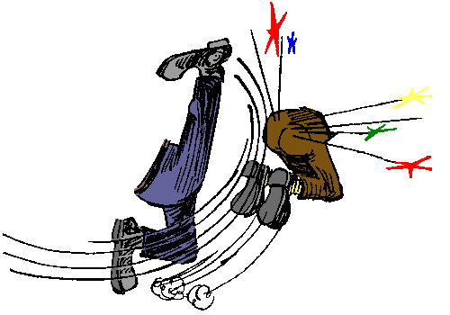
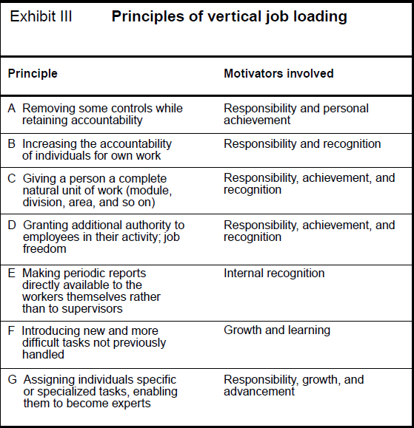
- Negative physical KITA: physical attack backlash
- Negative psychological KITA: no tangible evidence slow ticking bomb
- Positive KITA: reward, incentive, more status, promotionshort term motivation
Motivation: one needs no outside motivation, one wants to do it

HYGIENE FACTOR | MOTIVATORS
Company policy & administration | Achievement
Supervision | Recognition
Relationship with supervisor | Work itself
Work conditions | Responsibility
Salary | Advancement
Relationship with peers | Growth
Personal life
Relationship with subordinates
Status
Security
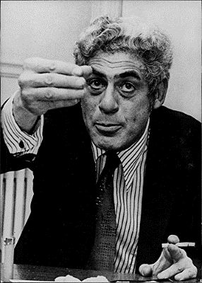
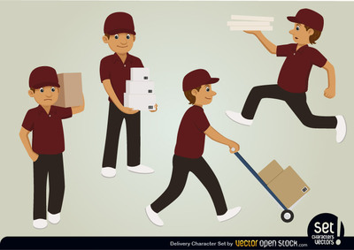





Job enlargement – horizontal job loading:
- Adding meaningless tasks to existing one (0+0)
- Increasing workload (0*0)
- Rotating (substituting 0 for 0)

Employees
motivated
Employees
not
dissatisfied
but
unmotivated
Employees
dissatisfied
and
unmotivated

