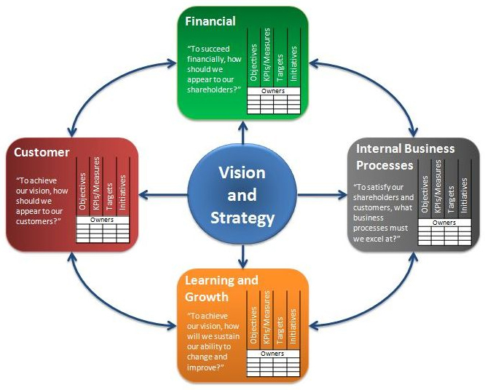

Financial bottom-line
Continuous improvement to existing products & processes
Introduce entirely new products with expanded capabilities
Operational effectiveness:
Cycle time, quality, employee skills, productivity, technology
Time
Quality
Performance & service
Cost
KAPLAN & NORTON: THE BALANCED SCORECARD – MEASURES THAT DRIVE PERFORMANCE

