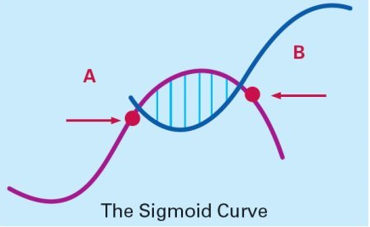

HANDY: SIGMOID/ S-SHAPED CURVE
Curvilinear logic: everything has its ups & downs
2nd curve must be completely different from 1st curve not re-inventing 1st curve
KAIZEN: continuous improvement only way to continue growing

Always assume company’s current position near the peak of 1st curve – a.k.a point A
Begins building a new curve: has time (testing and amending), energy, resources from 1st curve
>< Reluctant to change ‘everything is fine’ mindset likely to fail to recognize own demise
Formal leader:
+ if wants to stay able to foresee necessary changes + foster growth of new curve able to adapt to changes
+ If cannot leave the organisation

Dip in the curve = initial learning
New culture/ product, strategy
If introduce new people parallel change but gradual not radical; new + old work together until 2nd curve is established
Develop 2nd curve:
- Question
- Ideas/ possibilities/ hypothesis
- Testing
- Review result
Fertilizing 2nd curve:
+ Senior – give permission + encouragement don’t be a wet leaves create opportunities for the young to take over
+ Next generation: accept responsibility for 2nd curve thinking + commitment to carry out, endure early dip, live with 1st when 2nd develops

‘Great confusion’ – turmoil and conflict

Depleted resources, hard to move to 2nd curve
Former leader loses credibility
Individuals laid off

