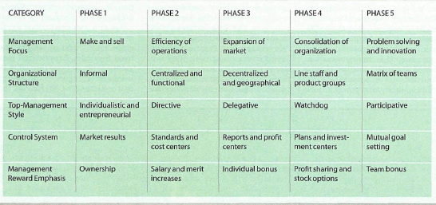

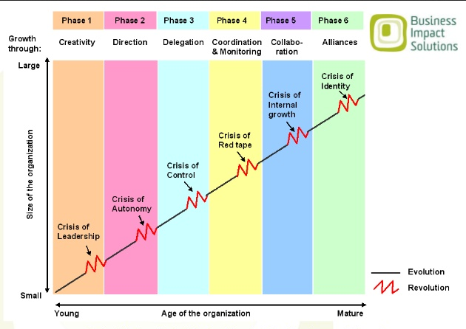
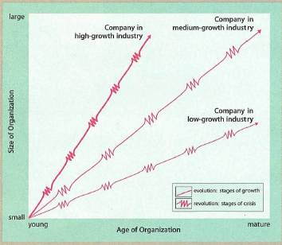
Organizational growth is characterized as a series of developmental phases
Top manager whose style is no longer appropriate should remove themselves
Organizations should not try to skip phase
Growth is not inevitable – manager who is aware of the problem ahead may decide not to expand the org.
Solution breeds new problems: management practice that works well in 1 phase may bring on crisis in another
How organizations develop?
GREINER – Evolution & Revolution as organizations grow

