Organizational Behaviour
Midterm Chpts 1-7

Chapter 1:

Organizational Behaviour: Is the field of study used to understand, explain and ultimately improve the attitudes/behaviours of people in a group setting (in the workplace).

The Roles of Management theory
Classical Approaches:
Scientific Management: using scientific methods to optimize and create work efficiency, processes and tasks (ex: you only cut wood or only bang nails)
Bureaucracy: members follow a strict chain of command with formal rules, high specialization and procedures and centralized decision making.
Human Relations Approach (movement):
Human Relations Movement: psychologist’s attributes of individual workers and the social forces within work groups have important effects on work behaviours.

Is OB common sense? No it is very detrimental to companies when there is conflict and there is never a definitive answer, therefore there can’t ever be a “never” or “always” because that’s false.

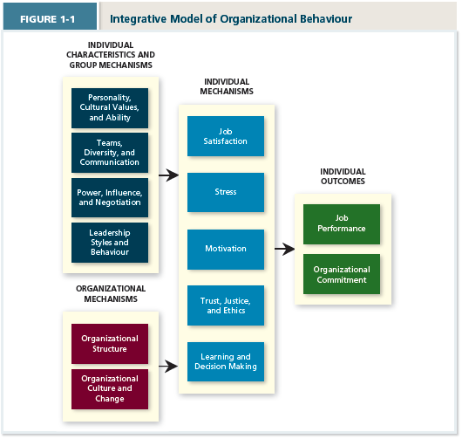

Individual Outcomes: Managers usually have it very strong for their employees since they want them to perform well at their jobs, and want them to stay and like the atmosphere.

Individual Mechanisms: How to specifically judge each employee how well they are working, willing to work and what they know that is most useful to their job. Stress, satisfaction, Motivation etc.. are key drivers of job performance.

Chapter 2:
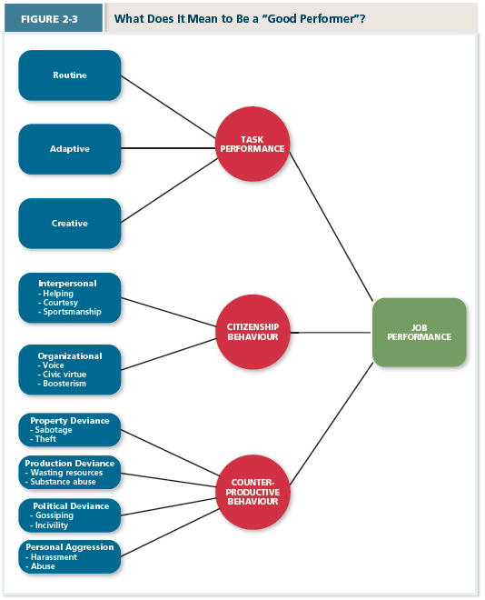
Task Performance: employee behaviours that are directly involved in the transformation of organizational resources into the goods and services that the organization produces.

3 Types of Task:
Routine: Well known Habits
Adaptive: thoughtful responses by an employee to unique or unusual task demands.
Creative: Ideals or physical outcomes that are BOTH novel and useful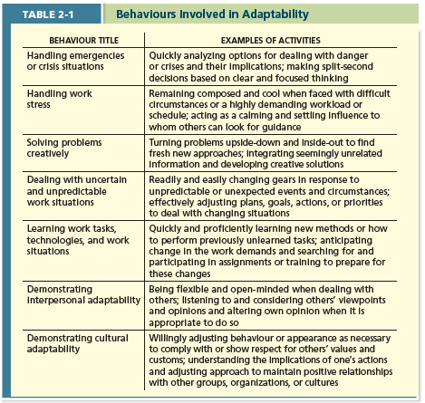
Citizenship behaviour: voluntary employee activities that may or may not be rewarded but that contributes to the organization by improving the overall quality of the setting in which work takes place.
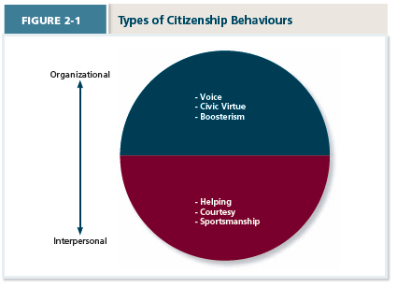
Organizational Citizenship Behaviour (OCB): Going above and beyond the normal expectations to improve operations of the organization as well as defending the organization and being loyal to it.
>Voice: involves speaking up and offering constructive suggestions for change.
>Civic Virtue: requires participation in company operations at a deeper than normal level
>Boosterism: representing the organization in a positive way when out in public.

Interpersonal Citizenship Behaviour (ICB): going beyond a normal jobs expectation to assist, support and develop co-workers.
>Helping: helping others with a higher work load
>Courtesy: keep coworkers informed about matters that are relevant to them
>Sportsmanship: involves maintaining a good attitude with co-workers even when they’ve done something annoying.

Counterproductive behaviours:
>Employee’s behaviours that intentionally hinder organizational goal accomplishment.
>Employees who engage in one form of counterproductive behaviour also will engage in others.
*can minimize that by doing personality tests, reference checks, background checks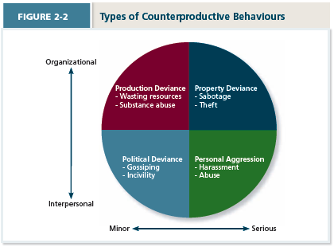
Property Deviance (Serious)
>Sabotage: purposeful destruction of physical equipment or assets of the organization.
>Theft: stealing from the company costing organizations upwards of 14.6 Billion $/ year

Production Deviance (Minor)
>Wasting Resources: when employees use too much of a material or take too much time to do it and produce little amounts of work.
>Substance Abuse: abuse before or during the time on the clock.

Political Deviance (Minor)
>Gossiping: having casual conversation about other people in which the facts are not confirmed as true (undermines morale).
>Incivility: communication is rude or impolite and lacking good manners (bully boss).

Personal Aggression (Major)
>Harassment: unwanted physical contact or verbal remarks from a co-worker.
>Abuse: employee is assaulted or endangered in such a way that physical and psychological injuries may occur.

Chapter 3:

Organizational Commitment:
-the desire to remain a member of the organization.
-employees who are not committed to their organizations engage in Withdrawal Behaviours which are actions that employees perform to avoid the work situation

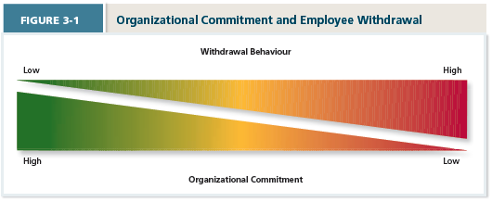
What Creates a desire to remain a member of an organization?
-emotional attachnment
-organizational culture
-free items
-good employer relationship (loyalty)

Forms of Commitment:
>Affective Commitment: the want to stay emotional commitment
>Continuance Commitment: the need to stay costs associated to leaving are too high
>Normative Commitment: the ought to stay feeling obliged
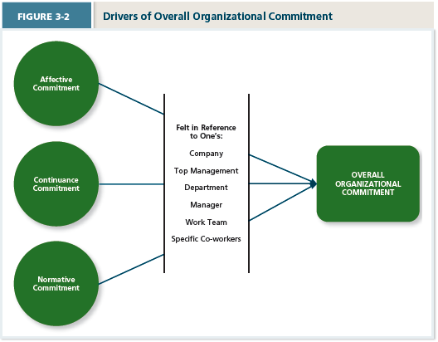
The Erosion Model: Employees with fewer bonds will most likely be the ones to quit the organization.
The Social Influence Model: employees who have a direct link to “leavers” will themselves be more likely to leave

Embeddedness ->> more commitment
Facets such as : –links –Fit –Sacrifice

Responses to negative event:
Exit: active, destructive response end or restricts organizational membership (WANT IS LOW)
Voice: active, constructive response in attempts to improve the situation (WANT IS HIGH)
Loyalty: passive constructive response “grin and bear it” (WANT IS HIGH)
Neglect: passive, destructive response-interest and efforts in the job has declined (WANT IS LOW)

Withdrawal resulting from exit and neglect:
Psychological Withdrawal: actions that provide a mental escape from work.
Physical Withdrawal: actions that provide a physical escape short term or long term from work.
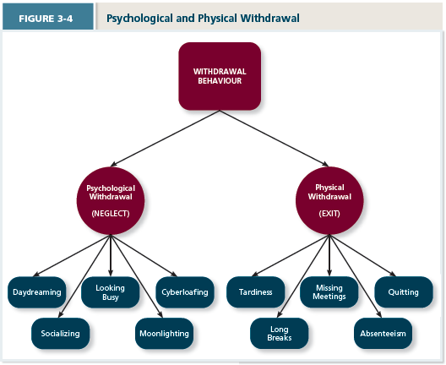
Independent Forms Model:
>various withdrawal behaviours are uncorrelated (random/hard to manage)

Compensatory Forms Model:
>various withdrawal behaviours are negatively correlated (less likely to do more)

Progression Model:
>model indicating that the various withdrawal behaviours are positively correlated (more likely to do more)
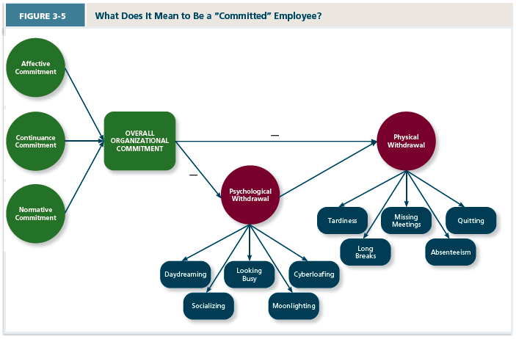
Changing Demographics:
As work groups become more diverse (racial, ethinic, age) there’s a danger that minorities or older employees will find themselves on the fringe of Social Network

Changing employee-employee relationships
Psychological contracts
Reflect the employees beliefs about what they owe the organization and what the organization owes them.
-transactional: I work, you pay
-relational: I am loyal, you give me security

Chapter 4:

Value-Percept Theory: people evaluate job satisfaction according to specific “facet” (aspect or feature) of the job

Dissatisfaction = (V _{want}- V _{have})·(V_{importance})
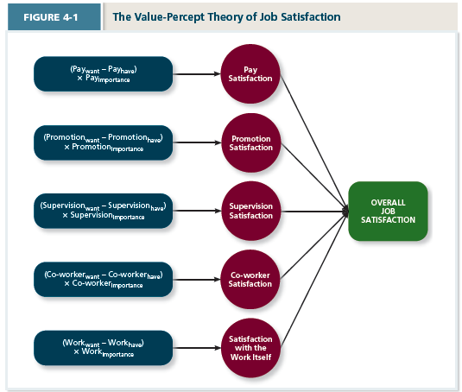

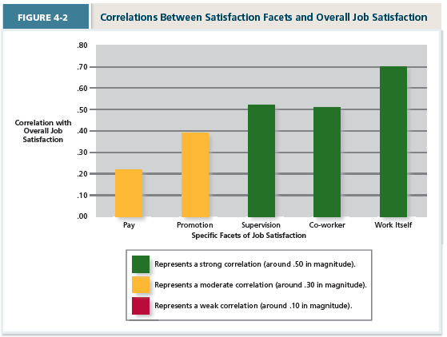

Job Satisfaction Theory:
*def on midterm
How to increase satisfaction for an employee say at mcdos
>increase skill variety and increase autonomy
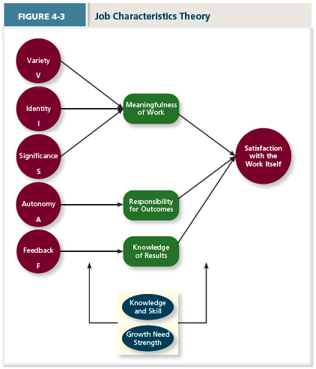

Moods: Feelings of mild in intensity, last for an an extended period of time and are not directed at anything.
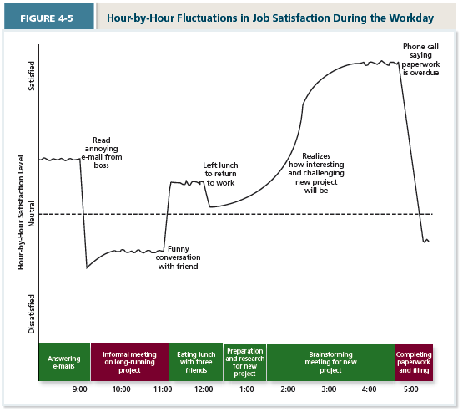

Affective Events Theory: a theory that describes how workplace events can generate emotional reactions that impact work behaviours.
Emotions -> short duration of intense feeling that is clearly directed at someone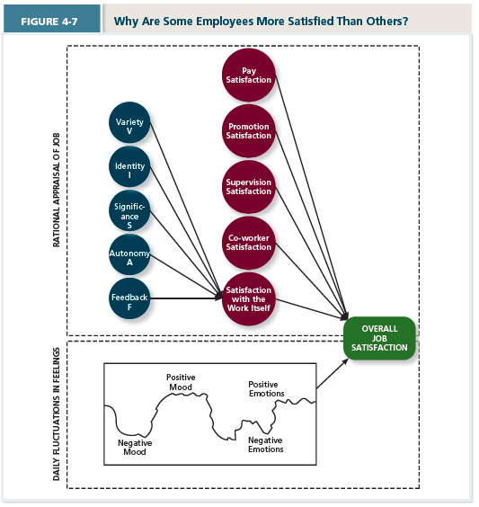
Chapter 5:

Stress: psychological response to demands (ie stressors) that exceed a person’s capacity or resources resulting in a negative consequence (strain)

Types of Stressors
>Hindrance Stressors: stressful demands that are perceived as hindering progress towards personal accomplishments (anger/anxiety).
>Challenge Stressors: stressful demands that are perceived as opportunities for learning, growth and achievement (pride/enthusiasm).

Work Hindrance Stressors: (MCQ)
- Role Conflict: others having differing expectations of what an individual needs to do in a role
- Role Ambiguity: lack of direction and information about what needs to be done in a role
- Role Overload: an excess of demands on an employee preventing him or her from working effectively
- Daily Hassles: minor day to day demands that interfere with work accomplishments

Work Challenge Stressors: (MCQ)
- Time Pressure: the sense that the amount of time allotted to do a job is not quite enough
- Work Complexity: the degree to which job requirements tax or just exceed employee capabilities
- Work Responsibility: the number and importance of the obligations that an employee has to others

Non-Work Hindrance Stressors: (MCQ)
- Work-family conflict: form of role conflict in which the demands of a work role hinder the fulfillment of the demands in a family role (or vice versa)
- Negative life events: events such as divorce or death of family member
- Financial uncertainty: uncertainties with regard to potential for loss of livelihood, savings or ability to pay expenses.

Non-work Challenge Stressors: (MCQ)
- Family time Demands: amount of time committed to fulfilling family responsibilities
- Personal Development: participation in activities outside of work that foster growth and learning
- Positive life events: events life such as marriage or birth that tend to be appraised as a challenge

How to cope with stressors?
Coping: Behaviours and thoughts that are used to manage stressful demands and the emotions associated with the stressful demands
Behavioural Coping: physical activities used to deal with stressful situations
Cognitive Coping: thoughts used to deal with a stressful situation
Problem-Focused Coping: behaviours and cognitions of an individual intended to manage the stressful situation itself
Emotion-Focused Coping: behaviours and cognitions of an individual intended to help manage emotional reactions to the stressful demands.
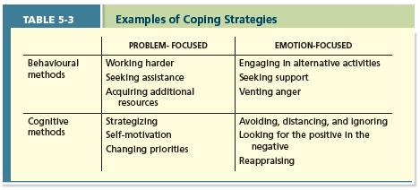

Discuss two theories to help Joe work harder:
- Goal difficulty has to be hard enough
- Accepted by both parties

Strains/ Burnout
Physiological Strain | Reactions from stressors that harm the human body
Psychological Strains | Negative psychological reactions from stressors such as depression, anxiety and anger
Behavioural Strains | Patterns of negative behaviours that are associated with other strains
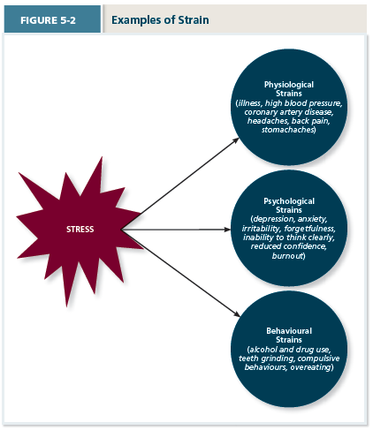

Burnout: emotional and mental and physical exhaustion from coping with stressful demands on a continuing basis.

Behavioural Patterns:
Type A Behaviour Pattern: people who tend to experience more stressors to appraise the demands as stressful and to be prone to experiencing more strains.

Type B Behaviour Pattern: basically the opposite

How to Deal: Social support- help one receives when confronted with stressful demands
>Instrumental support: help address the stressful demand directly
>Emotional support: help to address the accompanying emotional distress
>Social support: the help people receive from others when they are confronted with stressful demands
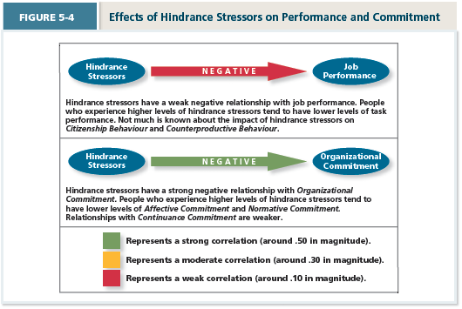

Application of Stress Management
>Assessment
>Reduce Stressors
>Providing Resources
>Reduce Strains

Stress Audit: an assessment of the sources of stress in the work place.
Job Sharing: Helps share the tasks of one person amongst two or more individuals.

Chatpter 6

Motivation: a set of energetic forces that determine the direction, intensity and persistence of an employee’s.

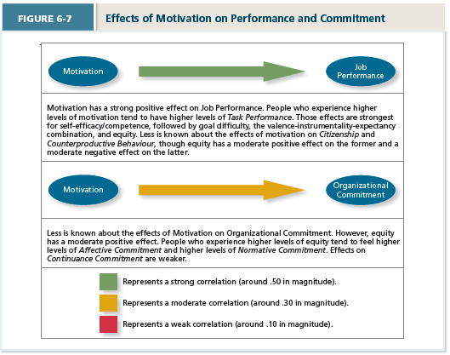

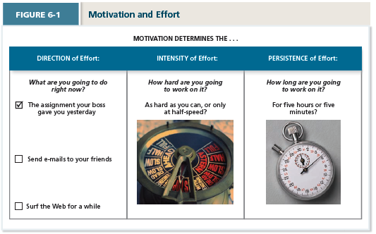
Needs: grouping or clusters of outcomes viewed as having critical psychological or physiological consequences.

The meaning of money-> the idea that money can have symbolic value (achievement, respect, freedom) in addition to economic value.

Specific and difficult goals: goals that stretch an employee to perform at his or her maximum level while still staying within the boundaries of his or her ability.
Motivational Force
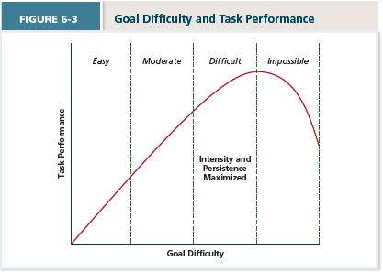
Equity theory: a theory that suggests that employees create a mental ledger pf the out
Goal setting theory: a theory that views goals as the primary drivers of the intensity and persistence of effort, Equity Theory

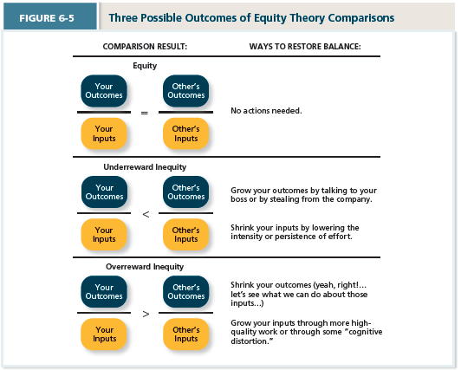

Expectancy theory: a theory that describes the cognitive process employees go through to make choices among different voluntary responses.

Expectancy: the belief that exerting a high level of effort will result in successful performance on some task.

Equity distress: internal tension that results from being over rewarded or under rewarded relative to some comparison other (I am motivated to behave in a way to maintain it back to normal)

Expectancy theory Model:
Individual effort (A)-> Individual Performance -> (B)Organizational Outcomes -> (C) Individual Goals

- Effort performance linkage
- Performance outcome links
- Attractiveness of rewards
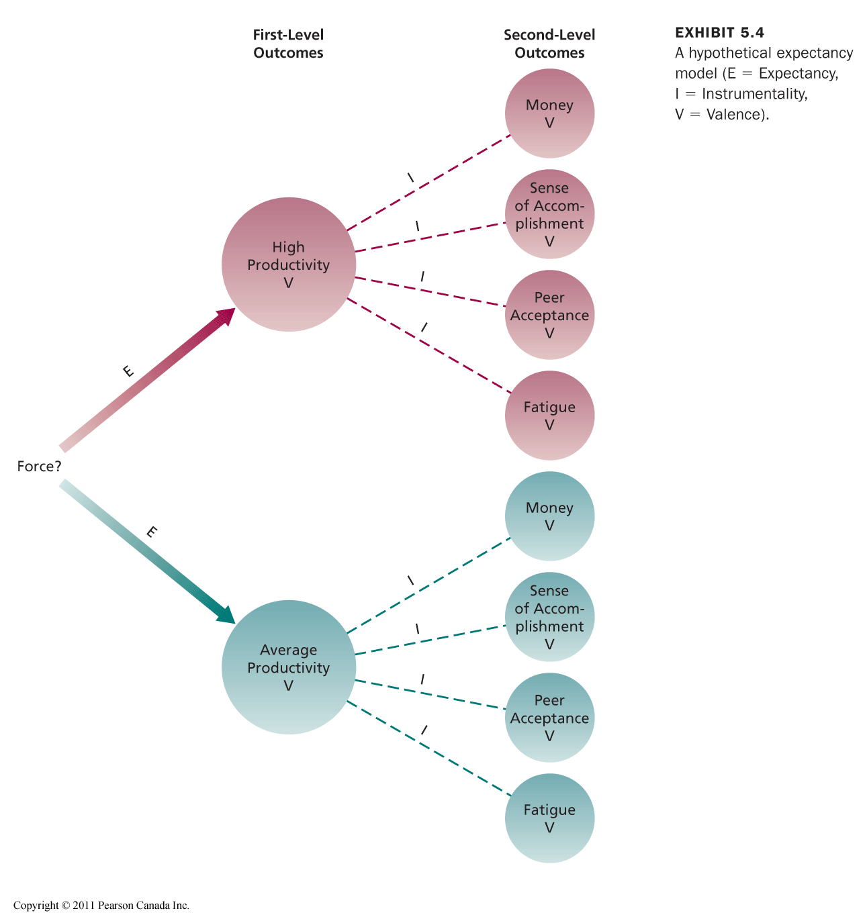
Pink: ((.6X5)+(.3X&))(.3)=1.53
Blue: ((.2X5)+(.1X&))(1)=1.7 tony will always work at avg intensity

Expectancy Relationships
Expectancy (E -> P)
- Perceived probability of individual effort which results a certain performance.

Instrumentality (P -> O)
- The perception that a particular level of performance will result in attaining a desired outcome (reward).

Valence
- Attractiveness/importance of performance reward (outcome)to the individual.

Calculating Expectancy

Prob (E > P) x ∑ (Prob (P > O) x Value (O))
E = Effort
P = Performance
O = ALL the outcomes associated with the performance, positive and negative.

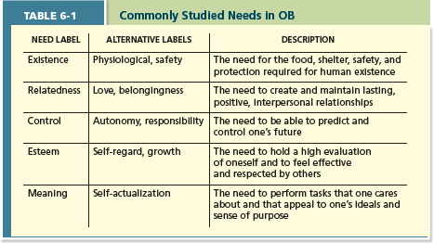

Maslow’s Hierarchy
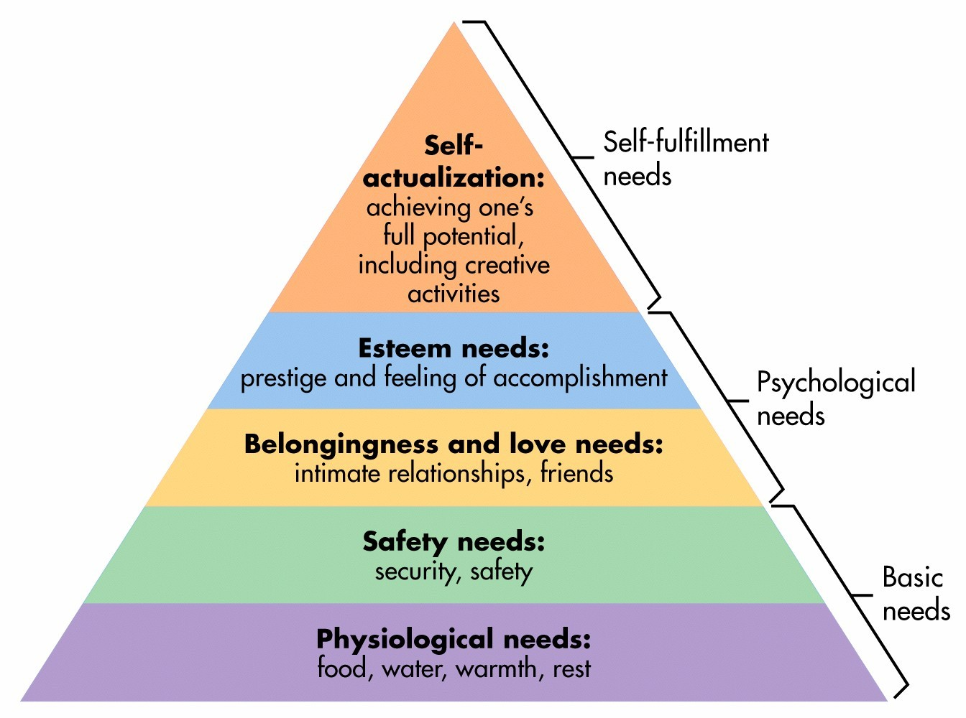

Cognitive distortion: a reevaluation of inputs an employee brings to a job often occurring in response to equity distress

Internal comparisons: Comparing oneself to someone in your same company

External comparisons: comparing oneself to someone in a different company

Intrinsic Motivation | Extrinsic Motivation
- Desire to put forth work effort due to the sense that task performance serves as its own reward.  Ex: enjoyment, accomplishment, skill development, (lack of) boredom/anxiety/frustration, interesting | - Desire to put forth work effort due to some contingency that depends on task performance.  Ex: pay, bonus, promotions, benefits, perks, awards, praise, support, free time, (lack of) demotions/disciplinary actions/terminations.

Chapter 7 Trust Ethics and Justice

Trust: willingness to be vulnerable to an authority based on positive expectations about the authority’s actions and intentions.

Disposition-based trust:
- Trust that is rooted in ones own personality, as opposed to a careful assessment of the trustee’s trustworthiness. (Trustor)
Cognition-based trust:
- Trust that is rooted in a rational assessment of the authority’s trustworthiness.
Affect-based trust:
- Trust that depends on feelings towards the authority that go beyond any rational assessment if trustworthiness.

Trust propensity:
- A general expectation that the words, promises and statements of individuals can be relied upon
Justice: the perceived fairness of an authority’s decision making.

Ethics: the degree to which the behaviours of an authority are in accordance with generally accepted moral norms.

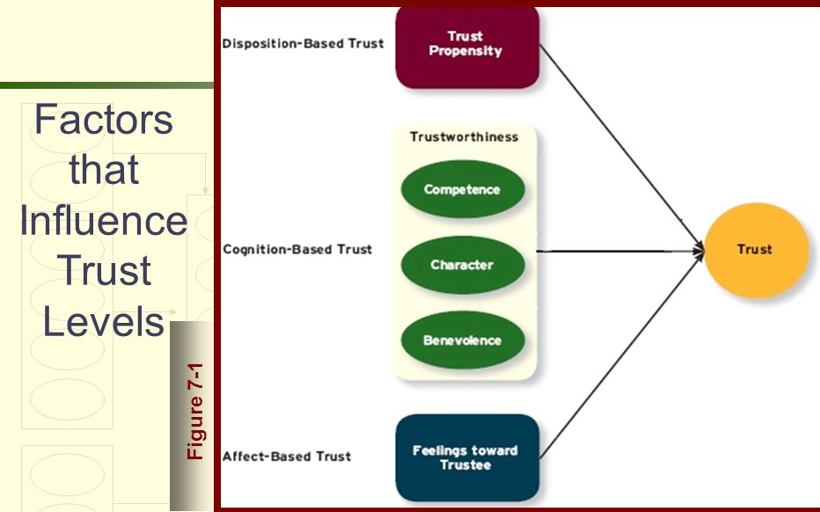

Ability: the skills and competencies and areas of expertise that enable an authority ot be successful in some specific area

Benevolence: the belief that an authority wants to do good for a trustor apart from any selfish or profit centered motives

Integrity: is the perception that an authority adheres to a set of values and principles that the trustor finds acceptable.
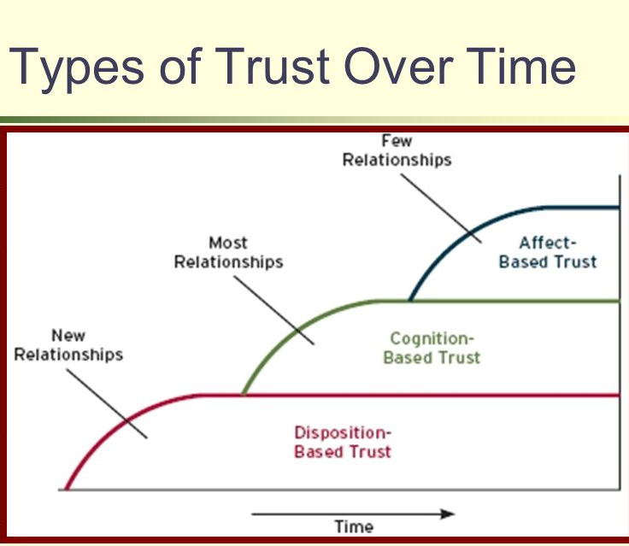
Types of Justice
Distributive justice: the perceived fairness of decision making outcomes

Procedural justice: the perceived fairness of decision making processes.
Interpersonal justice: the perceived fairness of interpersonal treatment received by employees from authorities.

Informational justice: the perceived fairness of the communications provided to employees from authorities.
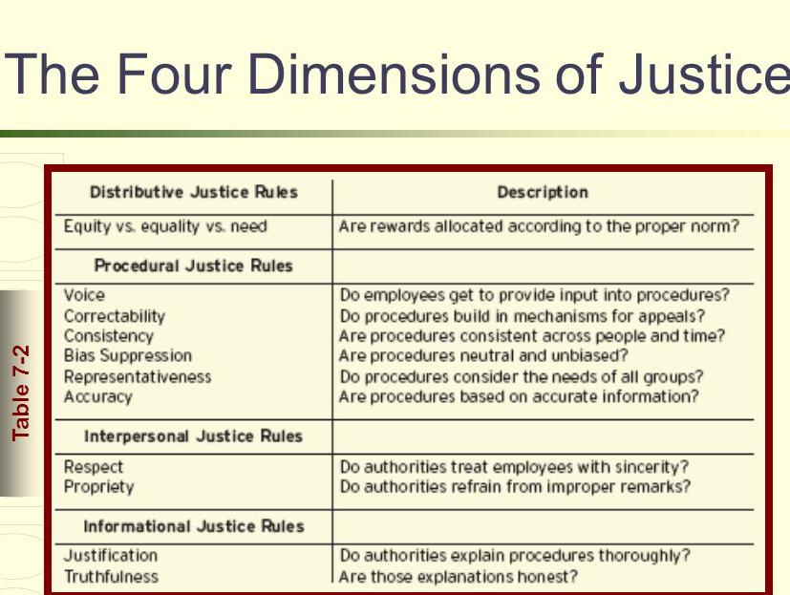

Effects of justice on theft during a pay cut:
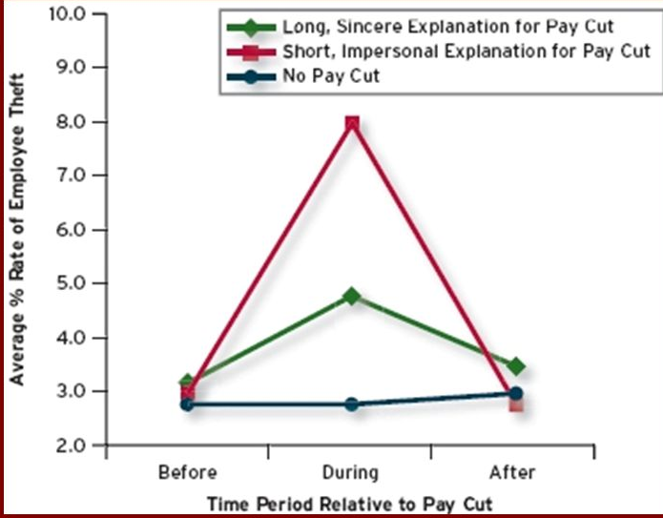
Types of Moral behaviours:
Whistle blowing: employees exposing illegal or immoral actions by their employer

Four component model: a model that argues that ethical behaviours result from the multistage sequence of moral awareness, moral judgment, moral intent and ethical behaviour
- Moral Awareness: recognition by an authority that a moral issue exists in a situation
- Moral intensity: the degree to which an issue has ethical urgency
- Moral attentiveness: the degree to which people chronically perceive and consider issues of morality during their experiences.
- Moral Judgement: when authorities can accurately identify the right course of action
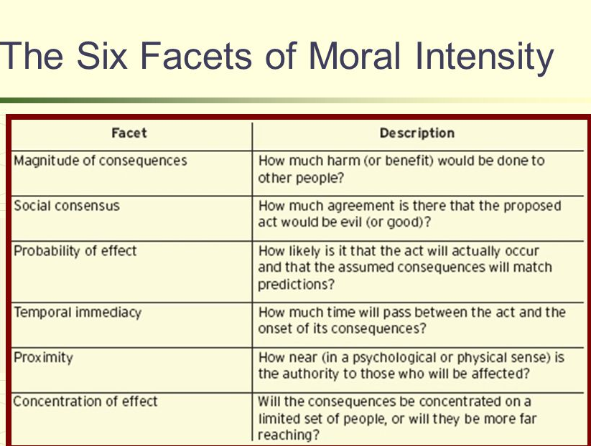

Cognitive moral development: As people age and mature, they move through several states of moral development, each more mature and sophisticated than the previous.

Moral intent: an authority’s degree of commitment to the moral course of action
Moral Identity: the degree to which a person views himself or herself as a moral person

Types of Trustworthiness:
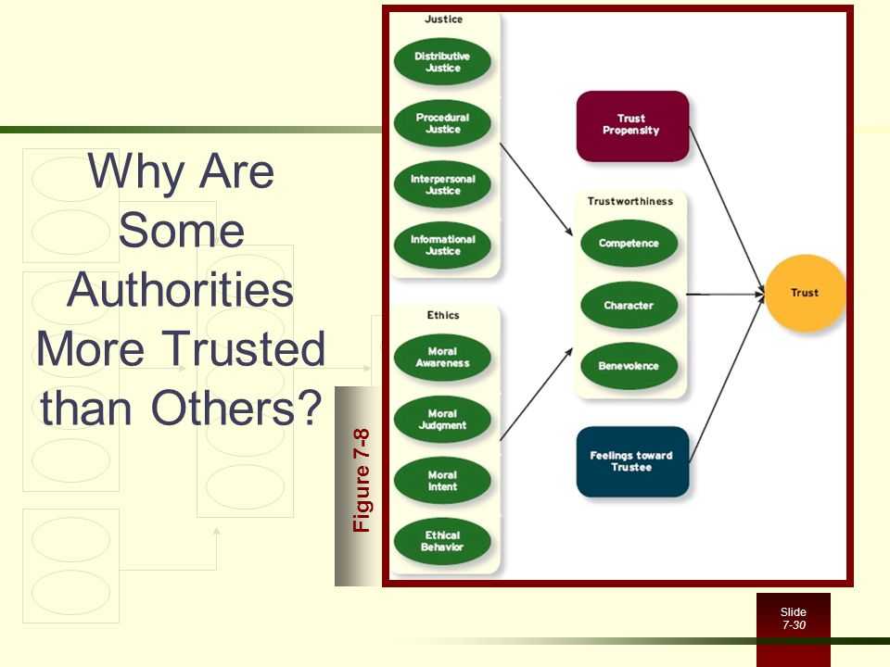

Economic Exchange: work relationships that resemble a contractual agreement by which employees fulfill job duties in exchange for financial compensation.
Social Exchange: work relationships that are characterized by mutual investment, mutual investment, with employees willing to engage in the “extra mile” sort of behaviours because they trust that their behaviours will eventually be rewarded.

