Student Name:

Student Number:

Partner’s Name and Student #:

Demonstrator's Name:

PLEASE NOTE:

If ANY of the above information is UNCLEAR or not provided, your grade
will NOT be re
corded!!

Lab Day (circle):

Tues aft

Tues night Wed Thurs aft Thurs night

Fri

Lab Week (circle): 1
2

Laboratory Report Form

Experiment 5.

Acid/Base Titrations

Checklist:

o Raw Data Sheet written in pen, signed by
TA AND Raw data from LabQuest attached o Data tables and graphs (6 minimum!)
made in Logger Pro attached o Report Form attached

Student’s Initials

Data Tables

Table 1. Formation of a stock solution of NaOH

Volume of concentrated NaOH solution (mL) | 4.00
Concentration of concentrated  NaOH solution (M) | 6.00
Volume of stock solution after dilution (mL) | 254
Approximate concentration of stock solution (M) | 0.094

Table 2. Standardization of Stock Solution of NaOH

Data | Trial 1 | Trial 2 | Trial 3
Concentration of  Standard Acid solution  (M) | 0.100 | 0.100 | ------
Volume of Standard Acid solution (mL) | 9.95 | 9.80 | ------
Volume of stock solution of  NaOH (mL)  (observed) | 9.461 | 9.934 | ------
Volume of stock solution of  NaOH (mL)  (LoggerPro) | 9.792 | 9.886
Concentration of stock solution of NaOH (M)  (observed) | 0.105 | 0.099 | ------
Concentration of stock solution of NaOH (M)  (from LoggerPro) | 0.102 | 0.099 | ------
Average Concentration of stock solution of NaOH  (M) |  | 0.101

Table 3. Determination of the Concentration of an Unknown Acid

Data | Trial 1 | Trial 2 | Trial 3
Sample Number of  Unknown Acid | 3 | 3 | -----
Volume of Unknown Acid solution (mL) | 10.00 | 9.70 | -----
Volume of stock solution of  NaOH (mL)  (observed) | 10.360 | 10.218 | -----
Volume of stock solution of  NaOH (mL)  (LoggerPro) | 10.790 | 10.260 | -----
Concentration of stock solution of NaOH (M) | 0.101 | 0.101 | -----
Concentration of Unknown  Acid Solution (M)  (observed) | 0.0523 | 0.0532 | -----
Concentration of Unknown  Acid Solution (M)  (LoggerPro) | 0.0545 | 0.0534 | -----
Average Concentration of  Unknown Acid solution  (M) |  | 0.0534

Observations (all parts of the experiment):

Each of the visual endpoints were recorded when a light pink colour was observed consistently throughout the solution. Afterwards, the Lab Quest program was left running until the pH of the solution became stable, typically between the values of 11 and 12.
The unknown acid, #3, was transparent, colourless and odourless.
The unknown juice, #4, was transparent and slightly tinted yellow, closely resembling lemon juice. However, the odour of the juice was unpleasant.

Table 4. Determination of the Mass Percentage of Acid in a Juice

Data | Trial 1 | Trial 2 | Trial 3
Sample Number of Juice | 4 | 4 | 4
Volume of Juice (mL) | 9.90 | 10.25 | 10.05
Volume of stock solution of  NaOH (mL)  (observed) | 11.356 | 12.110 | 13.009
Volume of stock solution of  NaOH (mL)  (LoggerPro) | 11.830 | 12.770 | 13.720
Concentration of stock solution of NaOH (M) | 0.101 | 0.101 | 0.101
Concentration of acid in Juice  (M)  (observed) | 0.0386 | 0.0398 | 0.0436
Concentration of acid in Juice  (M)  (LoggerPro) | 0.0402 | 0.0419 | 0.0460
Average Concentration of  Acid in Juice (M) |  | 0.0417
Density of Juice (g/mL) |  | 0.9998
Molar Mass of acid in Juice  (g/mol) |  | 192.12
Mass Percent of Acid in Juice  (%) |  | 0.801

GRAPHS: Attach Logger Pro data tables AND graphs (at least 6 [2 per part]) to this form!:

Graph 1: pH vs Volume for the Standardization of Stock Solution of NaOH – Trial 1
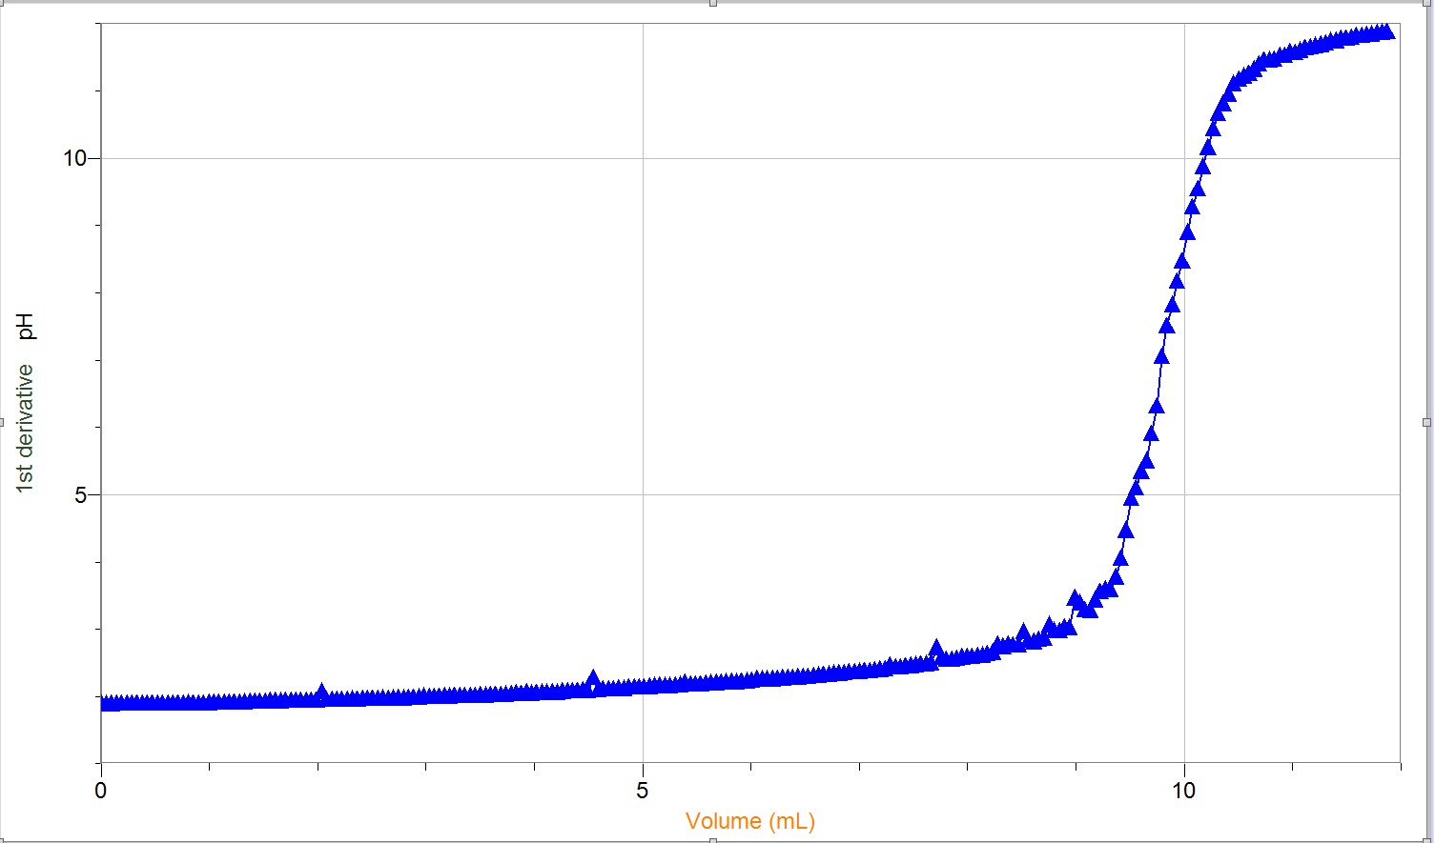

Graph 2: First Derivative of pH vs Volume for the Standardization of Stock Solution of
NaOH – Trial 1
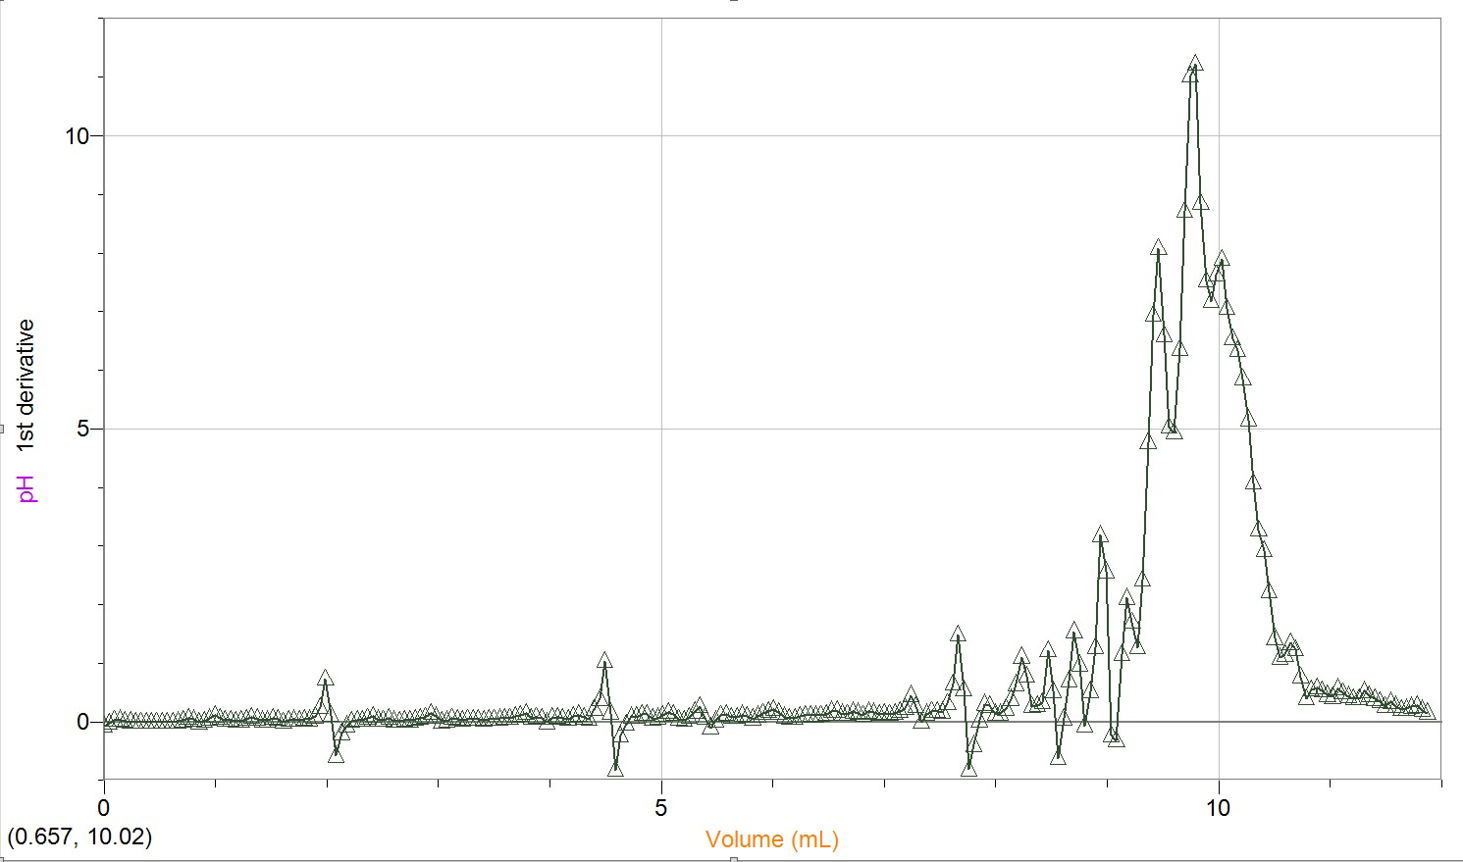

Graph 3: pH vs Volume for the Standardization of Stock Solution of NaOH – Trial 2
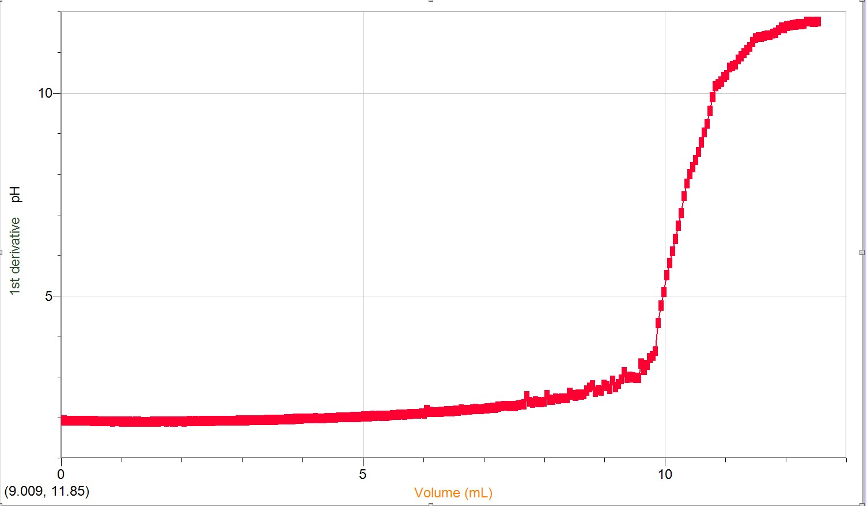

Graph 4: First Derivative of pH vs Volume for the Standardization of Stock Solution of
NaOH – Trial 2
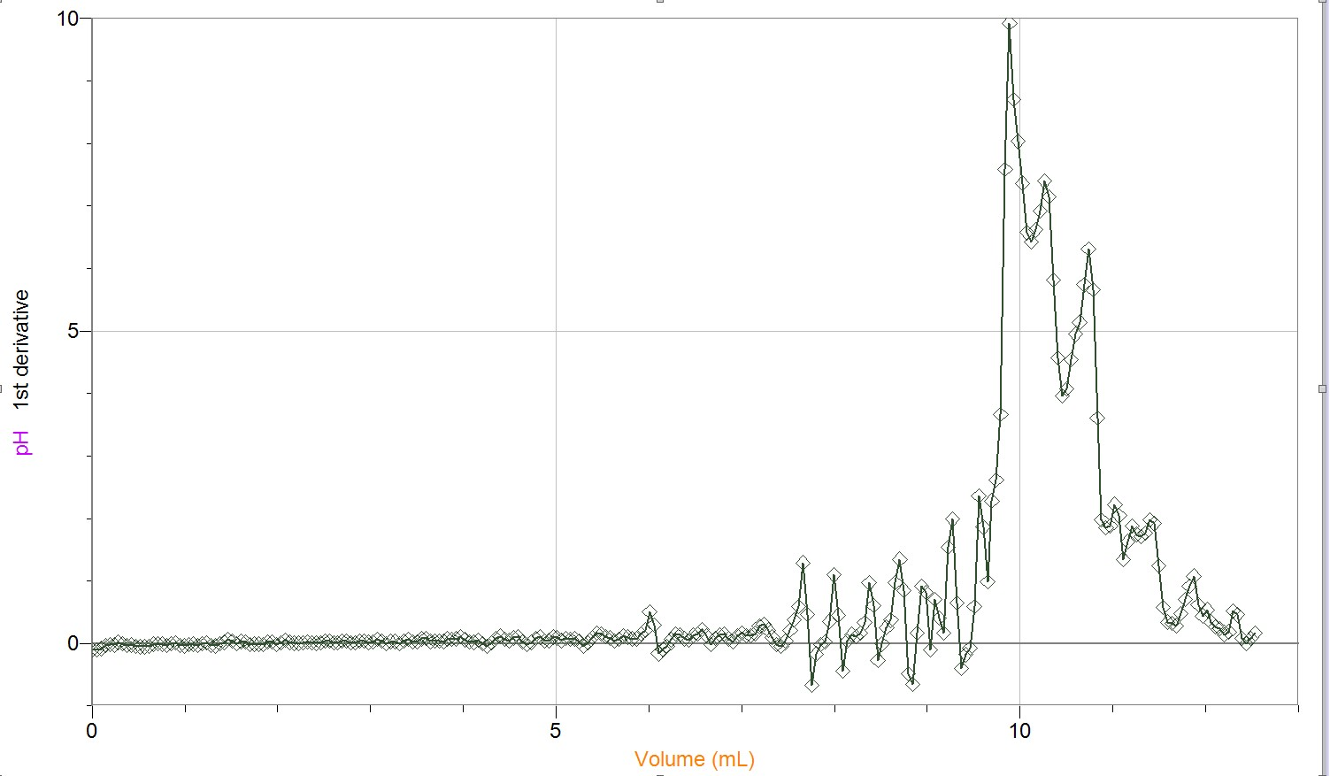

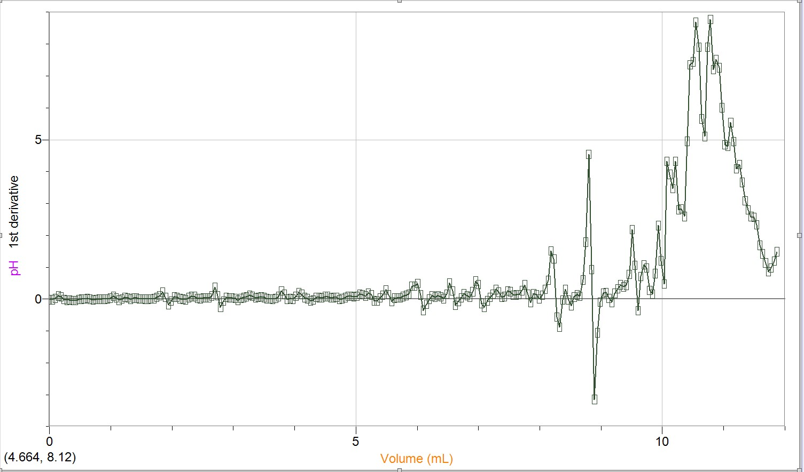
Graph 5: pH vs Volume for Unknown Diprotic Acid Trial 1
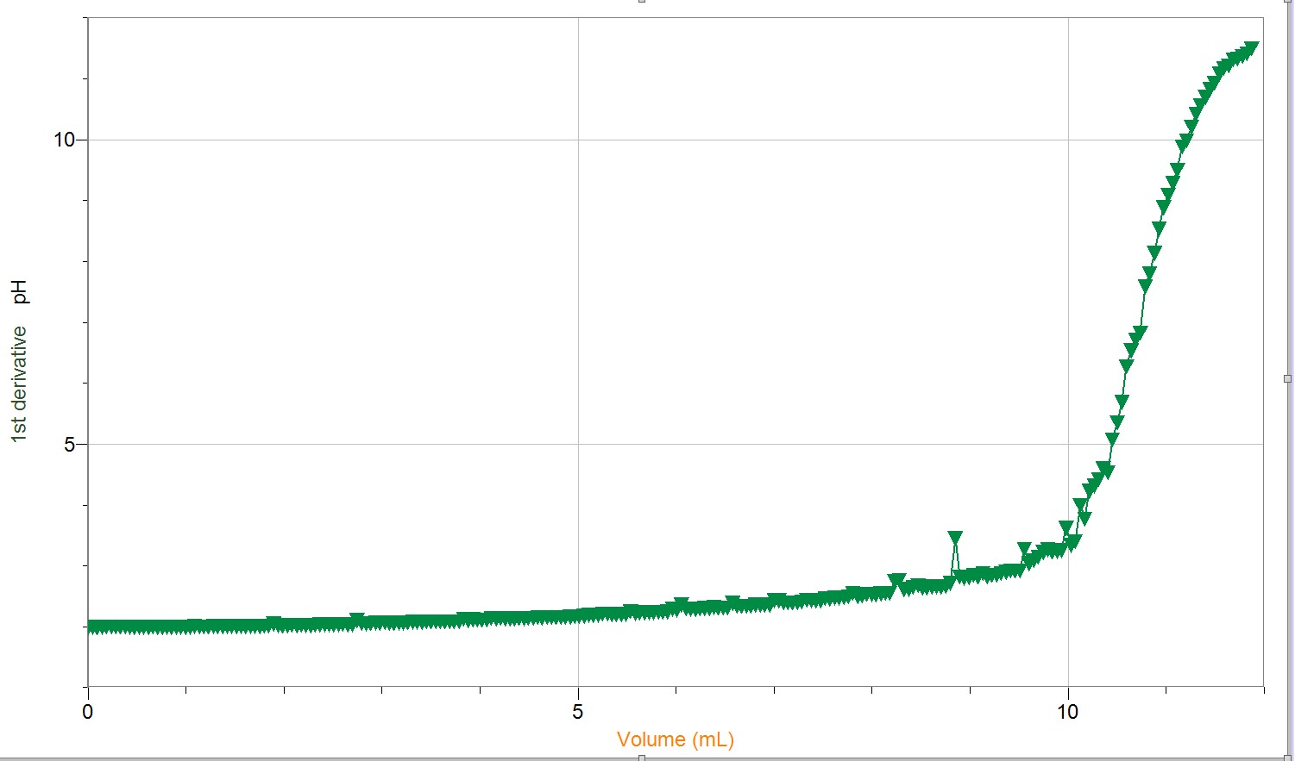

Graph 6: First Derivative of pH vs Volume for Unknown Diprotic Acid – Trial 1 Graph 7: pH vs Volume for Unknown Diprotic Acid Trial 2
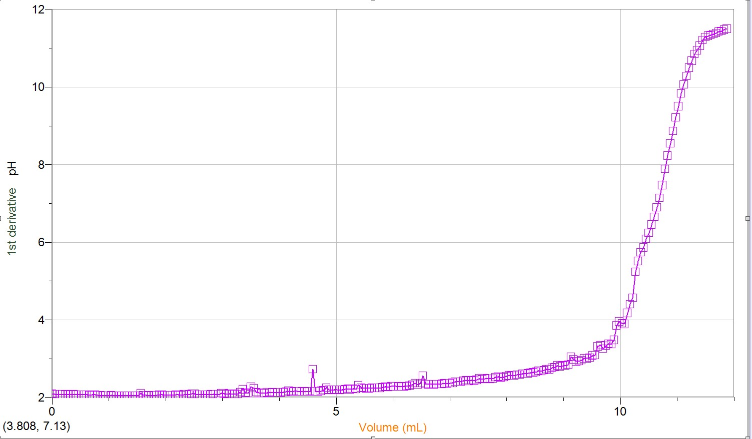

Graph 8: First Derivative of pH vs Volume for Unknown Diprotic Acid – Trial 2
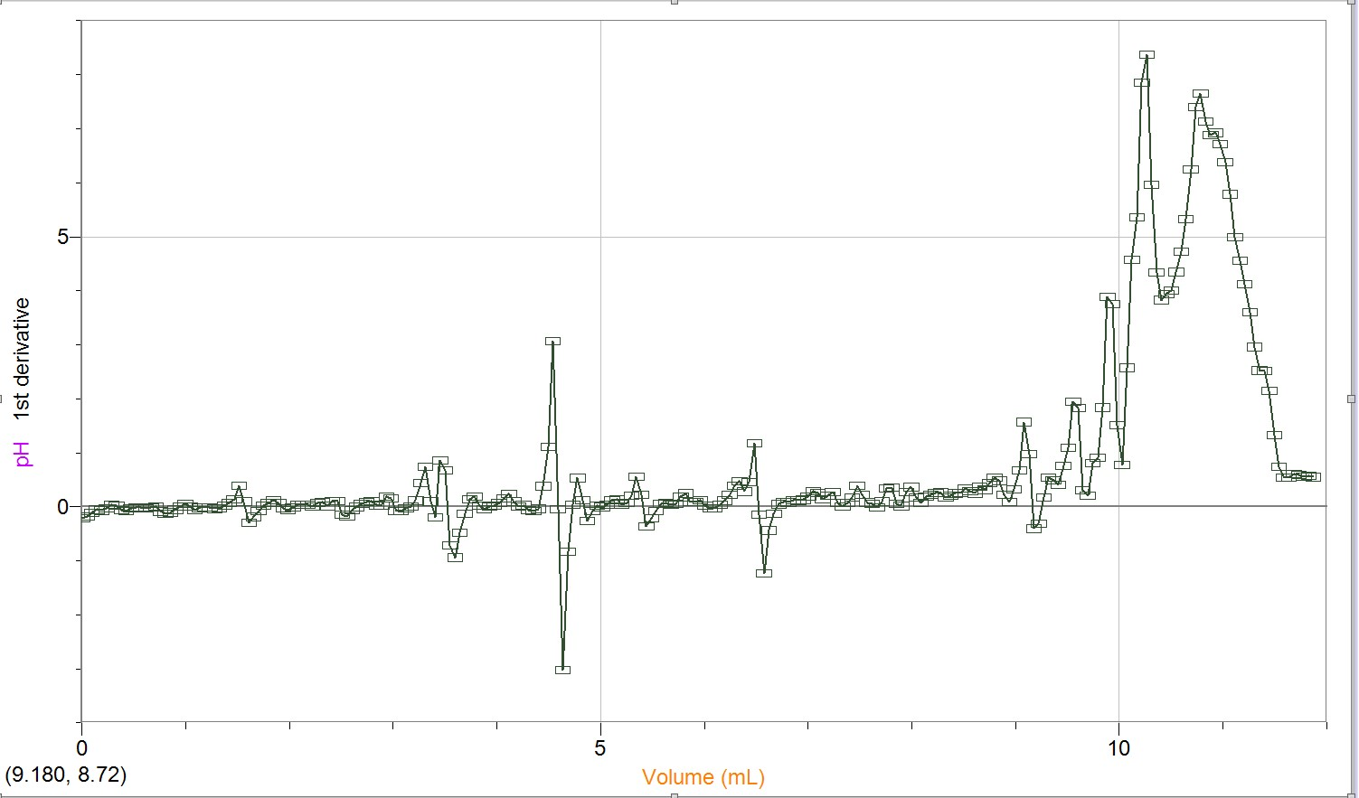
Graph 9: pH vs Volume for Acid in Unknown Juice Trial 1
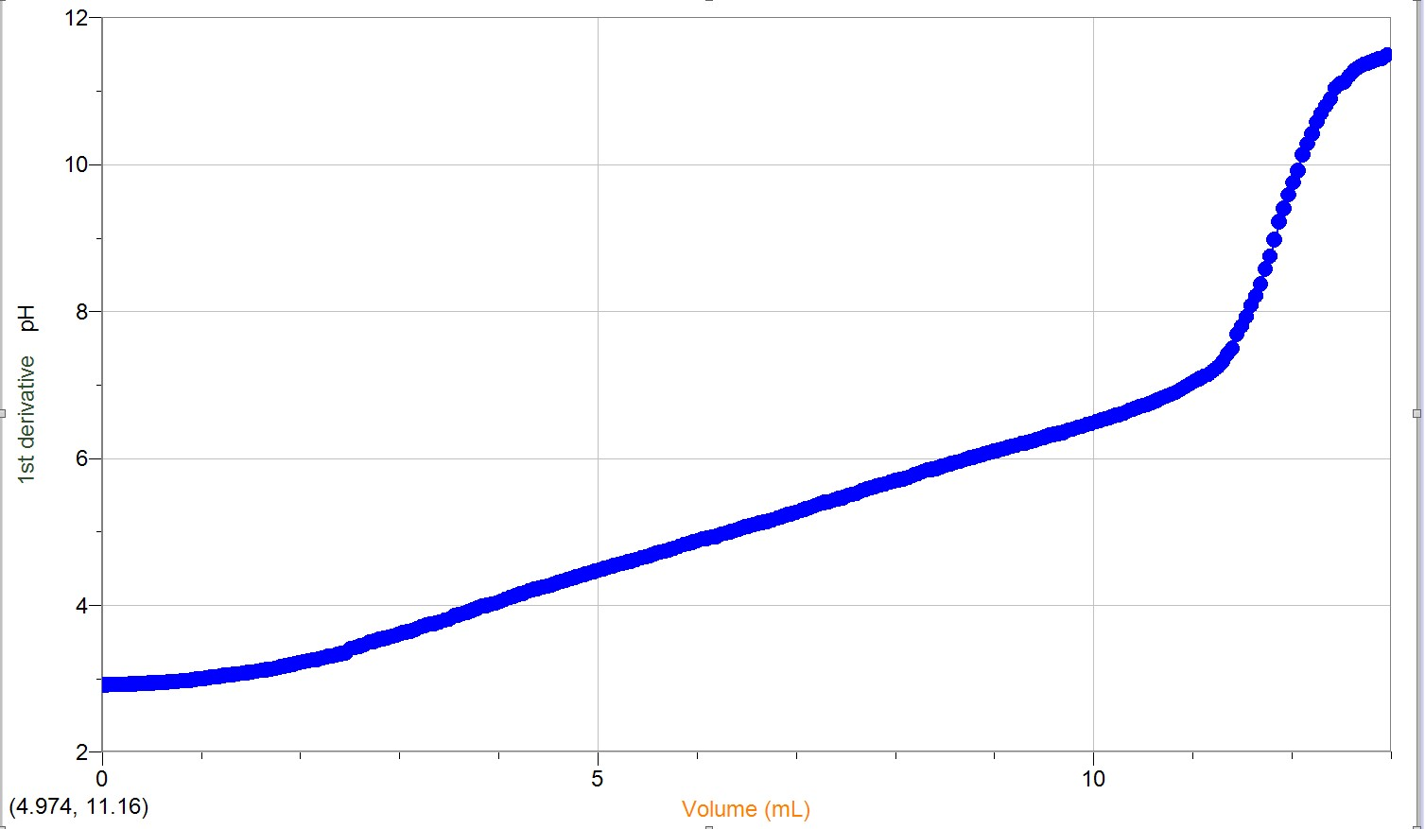

Graph 10: First Derivative of pH vs Volume for Acid in Unknown Juice – Trial 1
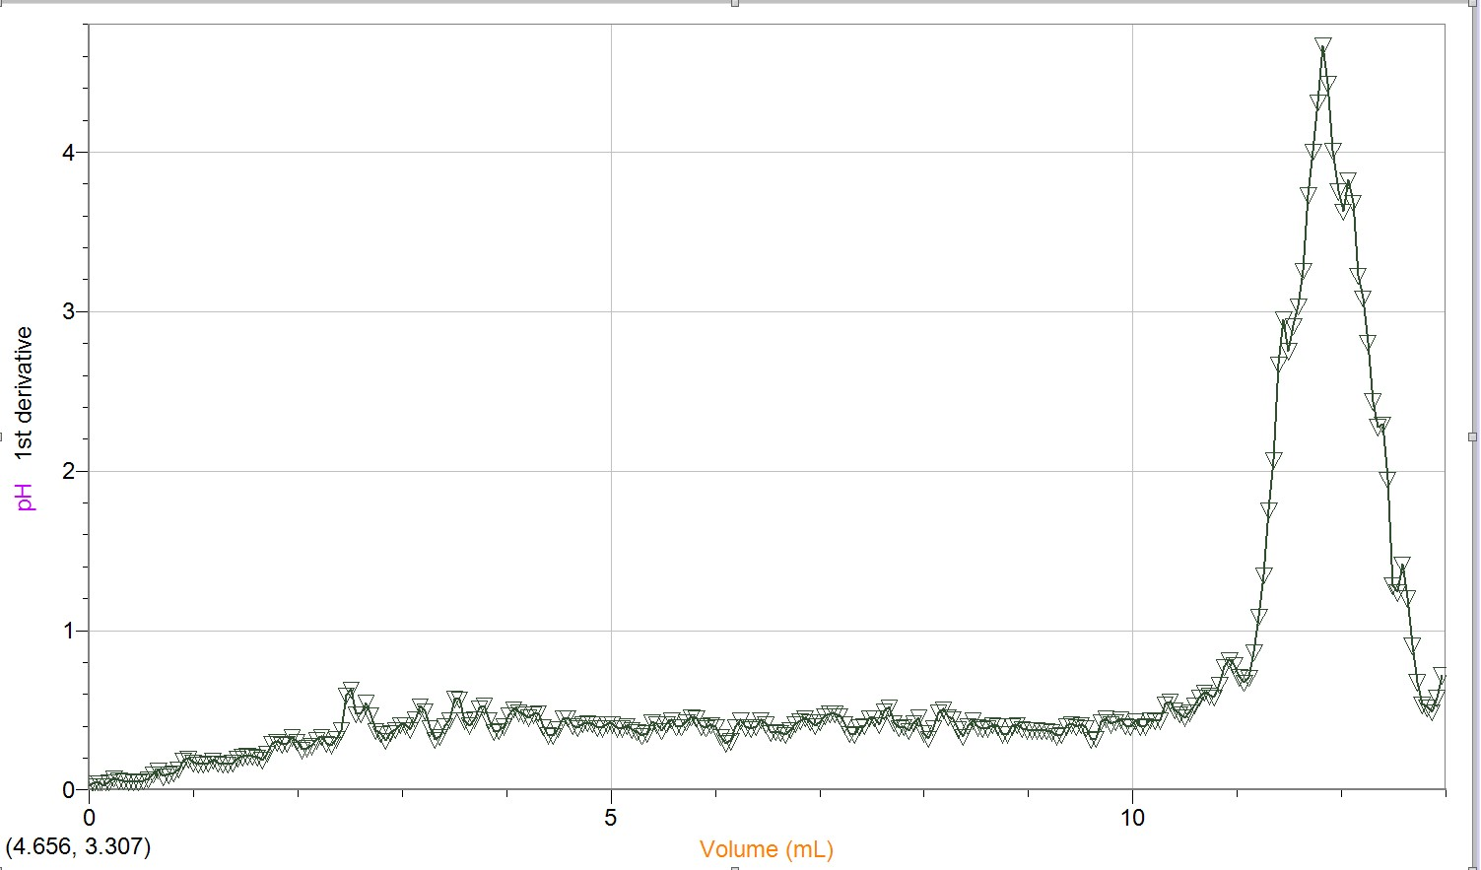

Graph 11: pH vs Volume for Acid in Unknown Juice Trial 2
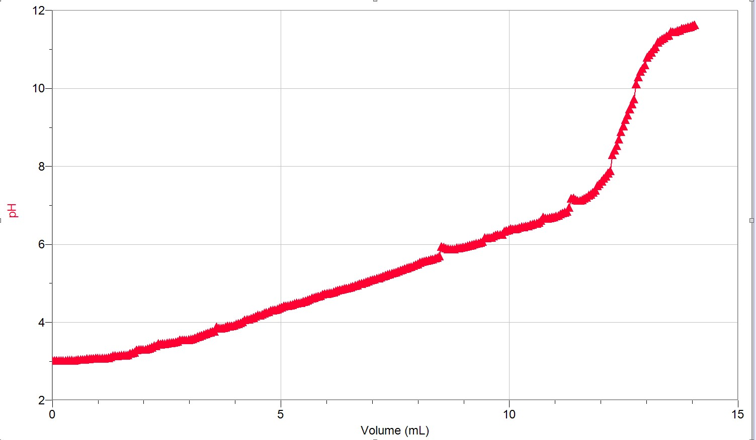

Graph 12: First Derivative of pH vs Volume for Acid in Unknown Juice – Trial 2
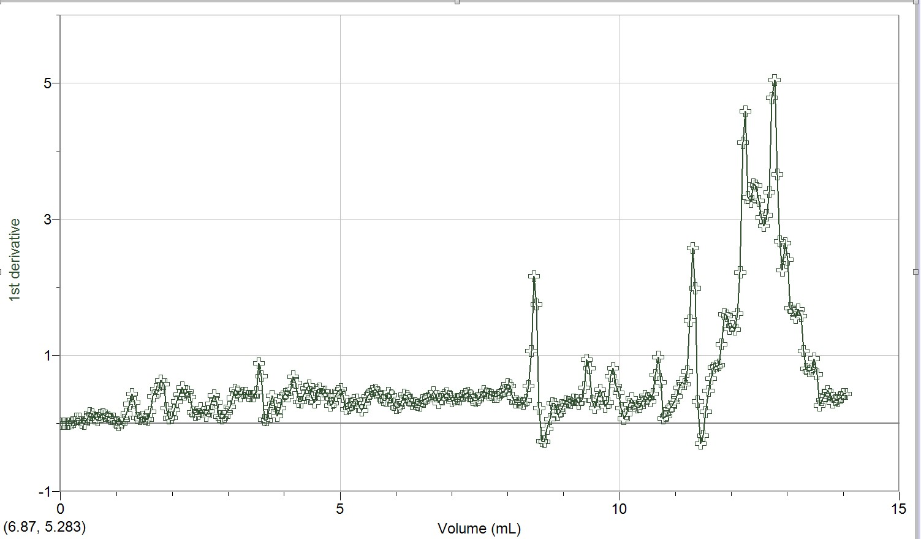
Graph 13: pH vs Volume for Acid in Unknown Juice Trial 3
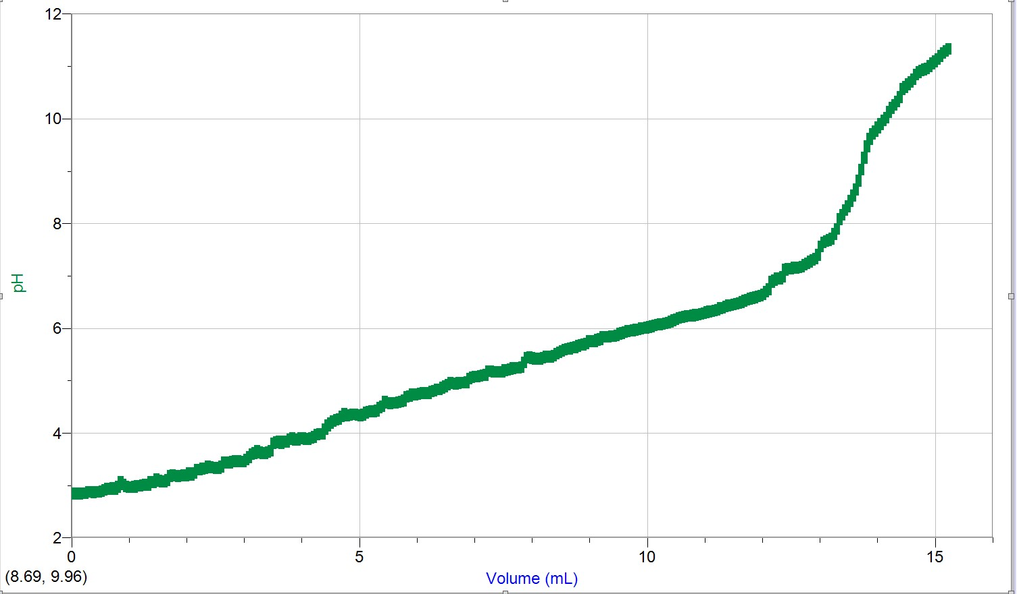

Graph 14: First Derivative of pH vs Volume for Acid in Unknown Juice – Trial 3
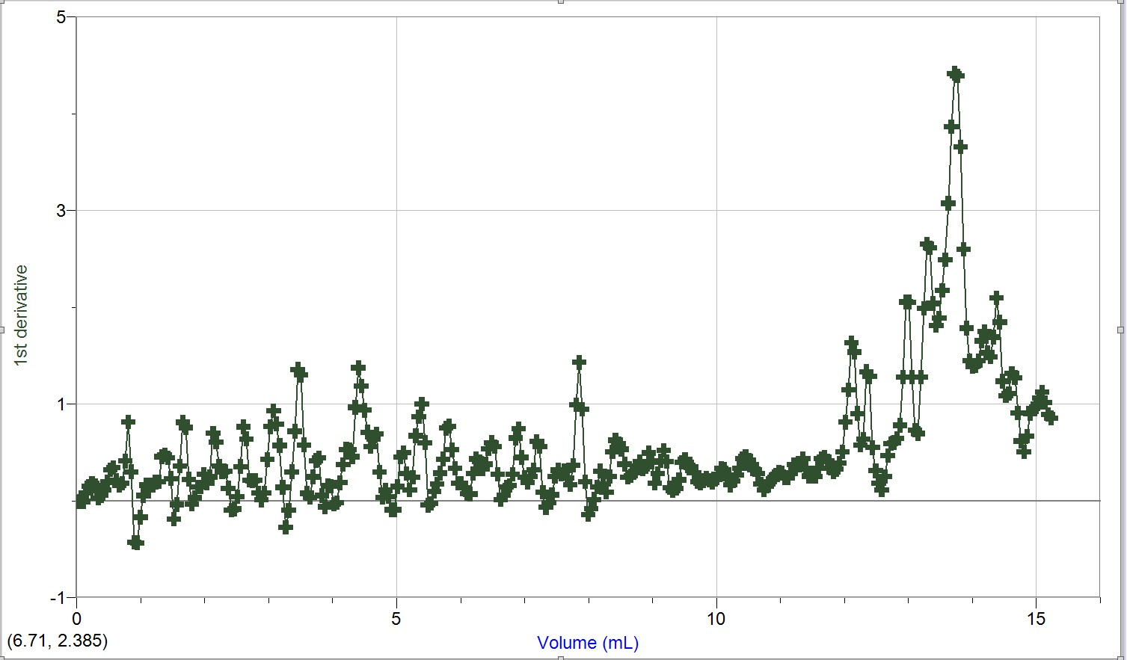

Calculation: (Part 1)

- Approximate concentration of stock solution

C₁ = 6.0 M C₂ = ( C₁V₁)/V₂
V₁ = 4.0 mL = (6.0M x 4.0mL)/254mL
V₂ = 254 mL = 0.09449 M
= 0.094 M

The approximate concentration of stock solution is 0.094 M.

Sample Calculation: (Part 2)

- Exact concentration of stock solution (from visual endpoint and cV calculations AND by FIRST derivative from titration curve using LabQuest 2 data):
The following calculations were performed using data from the first trial of Table 2.

Observed:

CHCl= 0.100 M CNaOH = (CHClVHCl)/VNaOH
V_{HCl}= 9.95 mL = (0.100M x 9.95mL)/9.461mL
V_{NaOH}= 9.461 mL = 0.1052 M
= 0.105 M

The exact concentration of stock solution from the visual endpoint is 0.105 M.

First Derivative:

CHCl= 0.100 M CNaOH = (CHClVHCl)/VNaOH
V_{HCl}= 9.95 mL = (0.100M x 9.95mL)/9.792mL
V_{NaOH}= 9.792 mL = 0.1016 M
= 0.102 M

The exact concentration of stock solution from the Logger Pro endpoint is 0.102 M.

3. Average concentration of stock solution:

Trial 1 Observed Value Visual Endpoint Concentration = 0.105 M
Trial 1 Logger Pro Value Endpoint Concentration = 0.102 M
Trial 2 Observed Value Visual Endpoint Concentration = 0.099 M
Trial 2 Logger Pro Value Endpoint Concentration = 0.099 M

average concentration = (0.105M + 0.102M + 0.099M + 0.099M)/4
= 0.101 M

The average concentration of stock solution is 0.101 M.

Calculation: (Part 3)

4. Concentration of Unknown Acid (from visual endpoint and cV calculations AND by FIRST derivative from titration curve using LabQuest data):

The following calculations were performed using the data from the first trial in Table 3.

Observed:

CNaOH= 0.101 M CHCl = (CNaOHVNaOH)/2 VHCl
V_{NaOH}= 10.360 mL = (0.101M x 10.360mL)/2(10.00mL)
V_{HCl}= 10.00 mL = 0.05232 M
= 0.0523 M

The concentration of unknown acid from the visual endpoint is 0.0523 M.

First Derivative:

CNaOH= 0.101 M CHCl = (CNaOHVNaOH)/2 VHCl
V_{NaOH}= 10.790 mL = (0.101M x 10.790mL)/2(9.70mL)
V_{HCl}= 10.00 mL = 0.05449 M
= 0.0545 M

The concentration of unknown acid from the Logger Pro endpoint is 0.0545 M.

5. Average concentration of unknown acid:

Trial 1 Observed Value Visual Endpoint Concentration = 0.0523 M
Trial 1 Logger Pro Value Endpoint Concentration = 0.0545 M
Trial 2 Observed Value Visual Endpoint Concentration = 0.0532 M
Trial 2 Logger Pro Value Endpoint Concentration = 0.0534 M

average concentration = (0.0523M + 0.0545M + 0.0532M + 0.0534M)/4
= 0.05335M
= 0.0534 M

The average concentration of the unknown acid is 0.0534 M.

Calculation: (Part 4)

6. Concentration of acid in juice (from visual endpoint and cV calculations AND by FIRST derivative from titration curve using LabQuest data):

The following calculations were performed using the data from the first trial in Table 4.

Observed:

CNaOH= 0.101 M Cjuice acid = (CNaOHVNaOH)/3 Vjuice
V_{NaOH}= 11.356mL = (0.101M x 11.356mL)/3(9.90mL)
V_{juice acid}= 9.90 mL = 0.03862 M
= 0.0386 M

The concentration of acid in the unknown juice from the visual endpoint is 0.0386 M.

First Derivative:

CNaOH= 0.101 M Cjuice acid = (CNaOHVNaOH)/3 Vjuice acid
V_{NaOH}= 11.830 mL = (0.101M x 11.830mL)/3(9.90mL)
V_{juice acid}= 9.90 mL = 0.04023 M
= 0.0402 M

The concentration of acid in the unknown juice from the Logger Pro endpoint is 0.0402 M.

7. Average concentration of acid in juice:

Trial 1 Observed Value Visual Endpoint Concentration = 0.0386 M
Trial 1 Logger Pro Value Endpoint Concentration = 0.0402 M
Trial 2 Observed Value Visual Endpoint Concentration = 0.0398 M
Trial 2 Logger Pro Value Endpoint Concentration = 0.0419 M
Trial 3 Observed Value Visual Endpoint Concentration = 0.0426 M
Trial 3 Logger Pro Value Endpoint Concentration = 0.0460 M

average concentration = (0.0386M + 0.0402M + 0.0398M + 0.0419M+ 0.0436M +
0.0460)/6
= 0.04168M
= 0.0417 M

The average concentration of the acid in the unknown juice is 0.0417 M.

=
8. Mass percentage of acid in juice:

Cjuice acid= 0.0417 M mass% = (Cjuice acid Mjuice acid)/ ρjuice x1000) x 100% M_{juice acid} = 192.12 g/mol = (0.0417M x 192.12g/mol)/(0.9998g/mL
ρ_{juice} = 0.9998 g/mL x1000) x 100%
= 0.8013%
= 0.801%

The mass percentage of acid in the unknown juice is 0.801%.

Discussion (in space provided):

There were several obtained values for the concentration of the stock solution of NaOH, the first being an approximate value using the volume and concentration of the original concentrated NaOH and the volume of water it was added to. This value was calculated to be 0.094 M. Later, more accurate values were calculated using data recorded by Lab Quest at the equivalence point through both visual analysis of a colour change and the Logger Pro software.
For the most part, the values at the equivalence point determined by Logger Pro were quite similar to those observed by the colour change. However, in each case the Logger Pro values were slightly larger than the observed values. This trend was seen not only for the trials calculating the concentration of the stock solution, but also throughout the trials with the unknown acid and juice. This could possibly be explained by the inconsistencies in our ability to observe a colour change in the solutions; if the drop rate was fast enough it would seem like the light pink colour was consistent in the solution, when in fact it was just reappearing as each drop was added. Also, the slight difference could be caused by the way the observed value was recorded. It was required that one person watched the Lab Quest monitor while the titration was being performed and recorded the value which flashed across the screen at the time which the other person believed to have seen a colour change. Not only were the values changing quickly and consistently, but they also jumped from value to value, instead of having a slow climb. Therefore it would be almost impossible to get the exact value which Logger Pro was able to calculate.
The differences in concentrations between trials were fairly small, though having greater
variation in the three trials of table 4 for the titration of the acid in the juice, demonstrating no significant errors in the lab.

Points to Ponder:
There is a factor of 1000 in the equation for the mass percent of the acid in the juice to account for the difference in units in the acid concentration (mol/L) and in the juice density (g/mL). This factor converts the density value from mL to L.
The original volume of concentrated NaOH used in the experiment does not matter, as long as a reasonable amount of water was then used to create the stock solution so that its concentration was reasonable to titrate the acids.
We determine the concentration of the NaOH just before we use it because it allows enough time for the ions to fully dissociate into solution. This initial and approximate concentration was later used as an experimental value to compare to more exact calculated values.
However, the drop rate for the stock solution may have been slightly too fast, resulting in some spikes or inflections in the first derivatives of the pH vs volume graphs. This is

especially apparent in the trials related to the acid in the unknown juice (graphs 10, 12 and 14).
Another source of error could be the improper calibration of the drop counter. There was difficulty with the equipment at the beginning of the lab which was fixed for most of the trials, but by the time the trials for the acid in the unknown juice was started, there may have been a shift in the buret, bringing it somewhat out of the reach of the drop counter and therefore leading to inconsistencies in that regard.

Conclusion: (2 sentences. Please note that the values you state as your results in this section will be used to determine your grade out of 5 for the results. Please include your unknown acid number and your juice name in this section.)

The concentration of the stock solution of NaOH was calculated to be 0.101 M. Using this value, the concentration of the unknown acid, #3, was determined to be 0.0534 M, the concentration of citric acid in the unknown juice, #4, was determined to be 0.0417 M, and the mass percent of citric acid in the unknown juice was determined to be 0.801%.

Raw Data (Initial Runs and First Derivatives):

Please note that only trials 2-8 were chosen to use in the final lab report. Disregard trials 1 and 9 if accessing the raw data on the Logger Pro software.



