Micro Economics Mid Term Review

Chapter 1
- Economics is the study of how scarce resources are allocated among alternative uses to satisfy human wants.
- Resources are scarce in most situations
- The price of resources reflects their value/ importance and is the mechanism by which they are allocated among economic agents (consumers, firms, resource owners.)

- Economists study how people make decisions

- How people interact with each other.

- Forces and trends that affect the economy as a whole.

Efficiency is getting the most from the resources
Equity is sharing resources fairly within a society
Opportunity cost of any item is whatever must be given up to obtain it

Microeconomics studies how households and firms make decisions and interact

10 principles of economics

- All decisions involve trade-offs a noted trade-off between efficiency and equity.
- The cost of something is what you give up to get it.
- Rationale people think at the margin
- People respond to incentives
^These are how people make decisions
- Trade can make everyone better off.
- Markets are usually a good way to organize economic activity
- Government can sometimes improve market outcomes
^These are how people interact
- A country’s standard of living depends on its ability to produce goods and services
- Prices rise when the government prints too much money
- Society faces a short run trade-off between inflation and unemployment
^How the economy as a whole works

Chapter 2
As scientists, economists make positive statements

As policy advisors, economists make normative statements

Positive statements can be confirmed or refuted
Normative statements cannot be confirmed or refuted

The circular flow diagram
- A visual model of the economy that shows how dollars flow through markets among household and firm.

Two markets
- Goods and services
- Factors of production

Two types of economic agents
- Households ( own factors of production and sell/rent them to firms in exchange for income) ( Buy and consume goods and services)
- Firms ( Buy/ hire factors of production and use them to produce goods and services)( Sell goods and services)

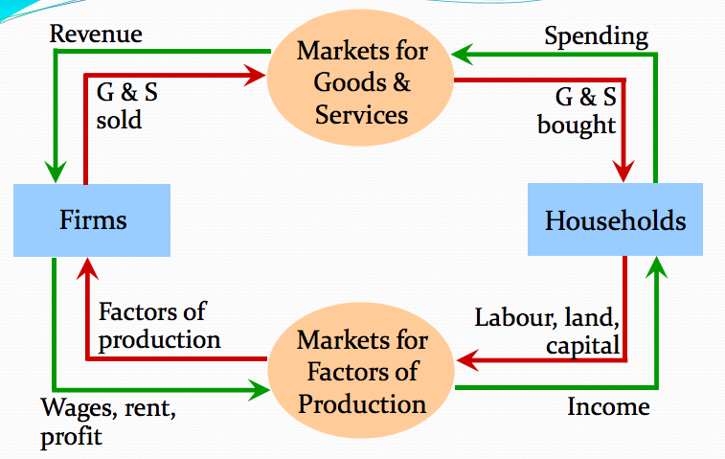

The production possibilities frontier (PPF)
A graph that shows the maximum combinations of two goods an economy can produce given its available resources and technology

A bow- shaped PPF illustrates the concept of increasing opportunity cost

Points inside the line are possible but not efficient
Points on the line are possible and efficient
Points outside the line are not possible

The slope of the ppf tells you the opportunity cost

Interdependence and trade allow everyone to enjoy greater quantity and variety of goods and services.
Absolute advantage means being able to produce a good with fewer inputs
Comparative advantage means being able to produce a good at a lower opportunity cost.

Chapter 4 notes

A market is a group of buyers and sellers of a good

A competitive market is one with many buyers and sellers each has a negligible effect on price

In a perfectly competitive market all goods are exactly the same, buyers and sellers are so numberous that no one can affect the market price.

Normal goods are those you want more of when your income increases
Inferior goods are those you wan less of when your income increases

Price is the only thing that does not shift the demand curve, it causes a movement alond the demand curve.

The law of supply states that the quantity supplied of a good rises when the price of the good rises, other things equal.

Chapter 5

Price elasticity of demand
Price elasticity of supply

Price elasticity is higher for close substitutes
Price elasticity is higher for luxury goods than necessities
A perfectly inelastic demand is when the elasticity is o
In-elastic demand is when the elasticity is less than 1
A unit elastic demand is when the elasticity is equal to 1
An Elastic demand is when the elasticity is greater than 1.

Chapter 6
A price ceiling set above the equilibrium price is not binding
A price celling set below the equilibrium price is binding.

