Experiment 1: Thin Layer Chromatography 19th of January 2016

Introduction

Chromatography is a method used for physically separating a mixture of compounds apart due to their differences in solubility. Chromatography is usually used to identify unknown compounds in a mixture such as ink,.
In this experiment, we have performed a special type of chromatography called the “thin layer chromatography” or TLC. Unlike usual chromatography paper, TLC plates are often attached to a plate which in this experiment, was made of silica gel. Silica gel is polar material; therefore, it attracts more strongly to polar compounds causing them move farther up the TLC plate. Each plate consists of three lanes: sample, reference, and co-spot. The sample lane is where the compounds in the sample is observed and is labeled in the TLC plate as S, the reference lane was where the reference material was added in order to monitor the reaction and is labeled in the TLC plate as R, and the co-spot lane is where both the sample and the reference materials are added in order to observe how close the Rf values of the two materials are and is labeled in the TLC plate as C.
This experiment has been divided to three parts: part A which involves identifying the components of an unknown mixture using TLC, part B which shows the effect of solvent on TLC, and part C, which involves finding the ratio of a mixture of compounds in a sample.
At the end of the experiment, part A has shown that the unknown sample mostly consists of benzophenone. In part B, it has been observed that at as polarity increases, the Rf values of the compounds also increase. While in part C, the ratio of the compounds in the unknown sample was identified: 46 % ortho and 54% para.

Data
Part A

Identification number of unknown sample: 57
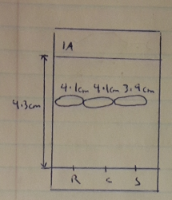
Figure 1: TLC 1A.
Sample lane: compound 57
Reference solution: benzophenone
Co-spot: benzophenone + compound 57
Solvent: 2:8 ethyl acetate (EtOAc) and hexanes
Rf of benzophenone = 0.95 cm
Rf of unknown sample = 0.91 cm

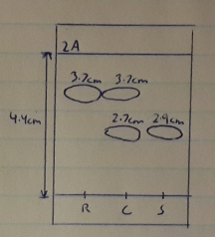

Figure 2: TLC 2A
Sample lane: compound 57
Reference solution: biphenyl
Co-spot: biphenyl + compound 57
Solvent: 2:8 ethyl acetate (EtOAc) and hexanes

Rf of biphenyl = 0.84 cm
Rf of unknown sample = 0.66cm

Part B
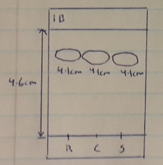
Figure 3: TLC 1B
Sample lane: compound 57
Reference solution: benzophenone
Co-spot: benzophenone + compound 57
Solvent: EtOAc

Rf of benzophenone = 0.89 cm
Rf of unknown sample = 0.89 cm

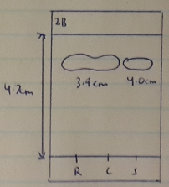
Figure 4: TLC 2B
Sample lane: compound 57
Reference solution: biphenyl
Co-spot: biphenyl + compound 57
Solvent: EtOAc

Rf of biphenyl = 0.83 cm
Rf of unknown sample = 0.85 cm

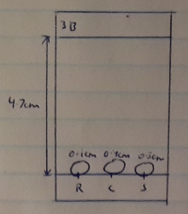
Figure 5: TLC 3B
Sample lane: compound 57
Reference solution: benzophenone
Co-spot: biphenyl + compound 57
Solvent: Hexanes

Rf of benzophenone = 0.021 cm
Rf of unknown sample = 0.064 cm

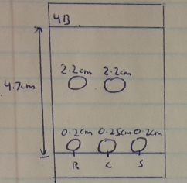
Figure 6: TLC 4B
Sample lane: compound 57
Reference solution: biphenyl
Co-spot: biphenyl + compound 57
Solvent: Hexanes

Rf of biphenyl = 0.043 cm & 0.47 cm
Rf of unknown sample = 0.043 cm

Part C
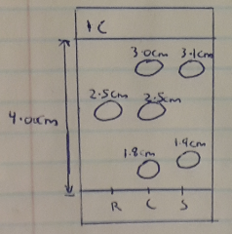
Figure 7: TLC 1C
Sample lane: XX
Reference solution: m-bromonitrobenzene
Co-spot: XX + m-bromonitrobenzene
Solvent: 9:1 Hexanes: Ethyl Acetate

Rf of m-bromonitrobenzene = 0.63 cm
Rf of XX = 0.78 cm & 0.48 cm

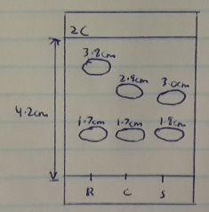
Figure 8: TLC 2C
Sample lane: XX
Reference solution: o-bromonitrobenzene
Co-spot: XX + o-bromonitrobenzene
Solvent: 9:1 Hexanes: Ethyl Acetate

Rf of o-bromonitrobenzene = 0.40 cm & 0.90 cm
Rf of XX = 0.43 cm & 0.71 cm

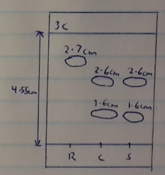
Figure 9: TLC 3C
Sample lane: XX
Reference solution: p-bromonitrobenzene
Co-spot: XX + p-bromonitrobenzene
Solvent: 9:1 Hexanes: Ethyl Acetate

Rf of p-bromonitrobenzene = 0.59 cm
Rf of XX = 0.35 cm & 0.57 cm

Figure 10: TLC plate (1C)
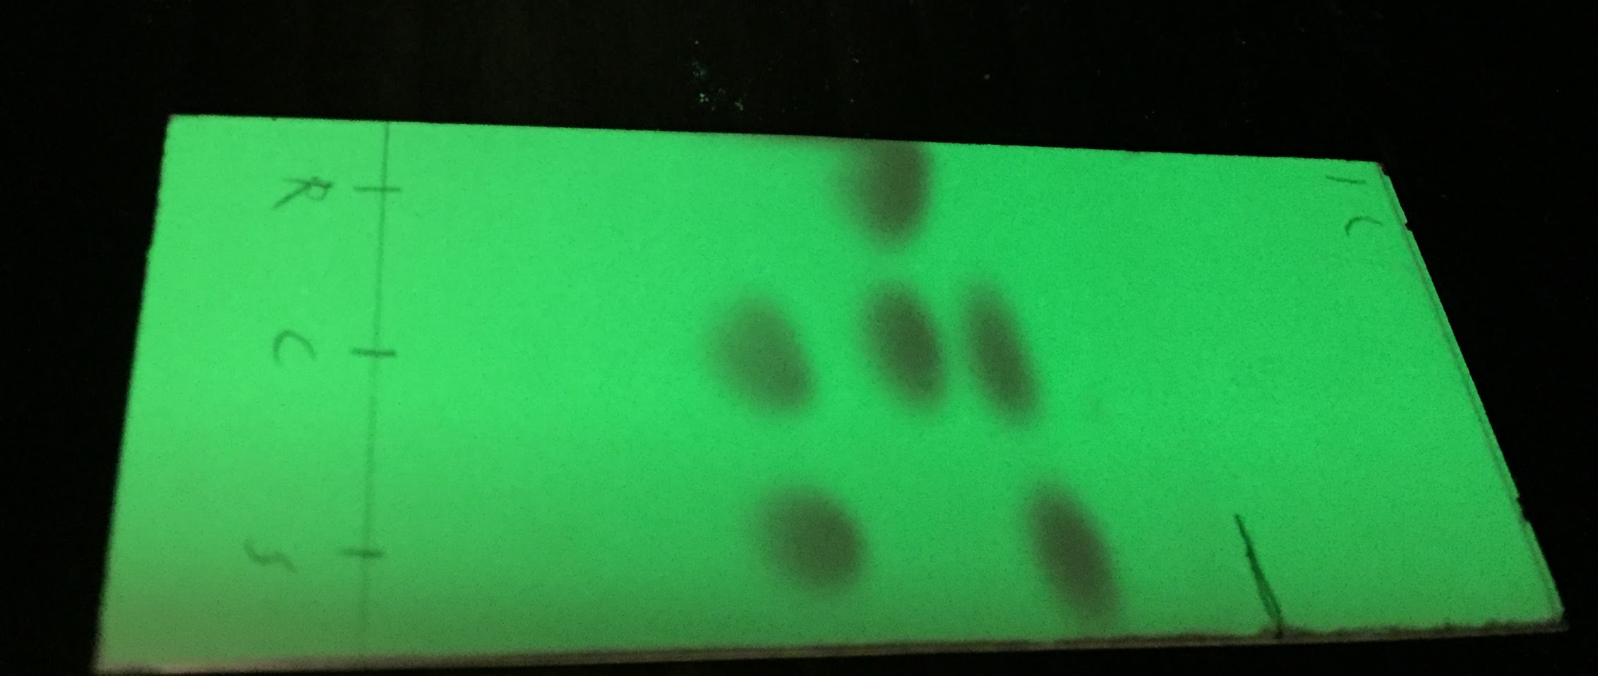

Figure 11: TLC plate (2C)
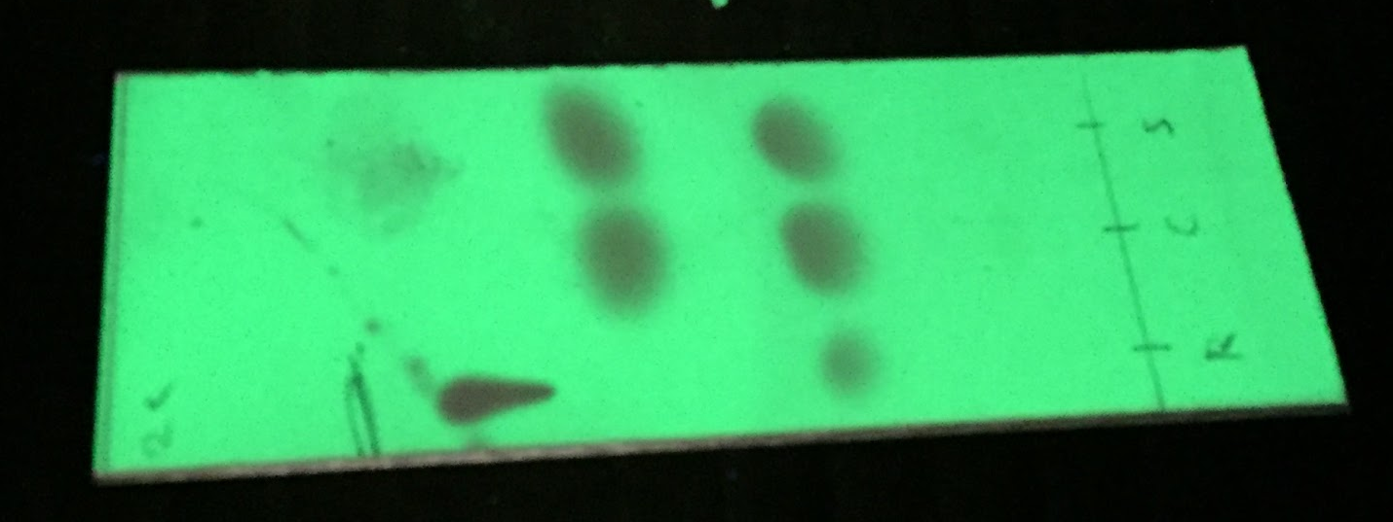

Figure 12: TLC plate (3C)
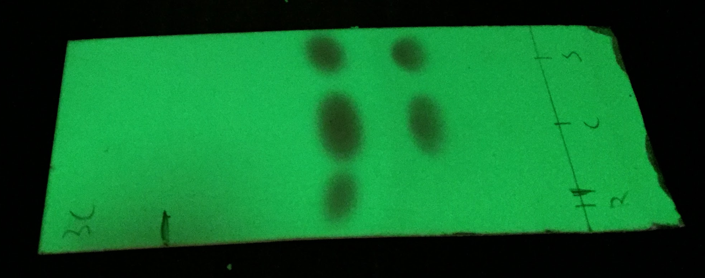

Procedure
The procedure for this experiment is outlined in the lab manual pg16-17. However, the procedure has been slightly altered:
- In Part C of the experiment, bromobenzene is not used; and the solution used was 9:1 hexanes: ethyl acetate.

Calculations

Part A

- Calculate the Rf values for all the spots in the TLC plates.

Rf = distance from starting point to solvent front
distance traveled by the spot

TLC 1A:
distance from starting point to solvent front = 4.3 cm
distance traveled by reference compound (benzophenone) = 4.1 cm
distance traveled by unknown sample = 3.9 cm
Rf of benzophenone= 4.1 cm / 4.3 cm = 0.95 cm
Rf of unknown sample = 3.9 cm / 4.3 cm = 0.91 cm

TLC 2A:
distance from starting point to solvent front = 4.4 cm
distance traveled by reference compound (biphenyl) = 3.7 cm
distance traveled by unknown sample = 2.9 cm
Rf of biphenyl= 3.7 cm / 4.4 cm = 0.84cm
Rf of unknown sample = 2.9 cm / 4.4 cm = 0.66cm

The Rf value of benzophenone closely matches the Rf of the unknown sample; biphenyl, on the other hand, has a greater Rf value than the unknown sample (and the co-spot lane shows the difference in distance). Therefore, the component of the unknown sample is benzophenone.

Part C

TLC 1C:
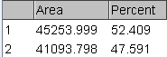

%peak 1 = area of peak 1 x 100%
area of peak 1 + area of peak 2
= (45253.999 / (45253.999 + 41093.798)) x 100% = 52.4%

%peak 2 = area of peak 2 x 100%
area of peak 1 + area of peak 2
= (41093.798 / (45253.999 + 41093.798)) x 100% = 47.6%

According to TLC 1C, the sample does not contain the compound m-bromonitrobenzene as the Rf value of the reference compound and the sample are different.
According to TLC 2C, the spot closest to the origin line is o-bromonitrobenzene (peak 2) as the Rf values are approximately the same; and according to TLC 3C, the spot closest to the solvent front is p-bromonitrobenzene (peak 1). Therefore, the sample XX is an ortho-para mixture.

o- bromonitrobenzene - 47.6%
p-bromonitrobenzene - 52.4%

Amount of ortho in ortho-para mixture = 1.0114x - 2.0208 where x = 47.6%
= 1.0114 (47.6) - 2.0208 = 46.1 % of the ortho isomer
Amount of para in ortho- para mixture = 100 - 46.1 = 53.9 %

The ortho: para ratio of XX is 46 : 54 or 1 : 1.2

Discussion
Part A
In order to identify the components of the unknown mixture, we compared the Rf value of the unknown sample with that of the reference compound; the ones that matched should be considered the same compound. In this part of the experiment, the Rf value of the unknown sample closely matched that of benzophenone; therefore, the unknown sample mostly consists of benzophenone.

Part B
When EtOAc was used as the solvent, the distance travelled by the solvent was approximately 4.5 cm and the spots were fairly close to the solvent front. However, when hexanes solution was used as a solvent, it has been observed that the spots on all three lanes has barely moved from the starting point; therefore, their Rf values are extremely small. Since EtOAc is more polar than hexanes solution, the intermolecular interactions between the silica gel and the compounds on each lane was disrupted; this allowed the compounds to travel farther up the TLC plate. Therefore, Rf values are directly proportional to the polarity of the solvent.

Answers to questions:

- As mentioned above, increasing the polarity of a solvent increased the mobility of the compounds.
- In the following set of compounds, benzoic acid would have the lowest Rf value as it is the most polar compound out of all the compounds, that is, it has higher ability to form hydrogen bonds.
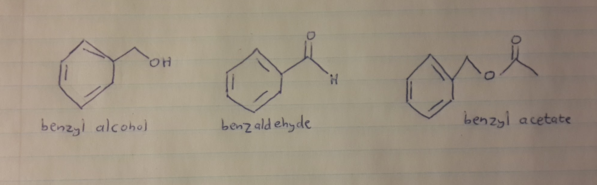

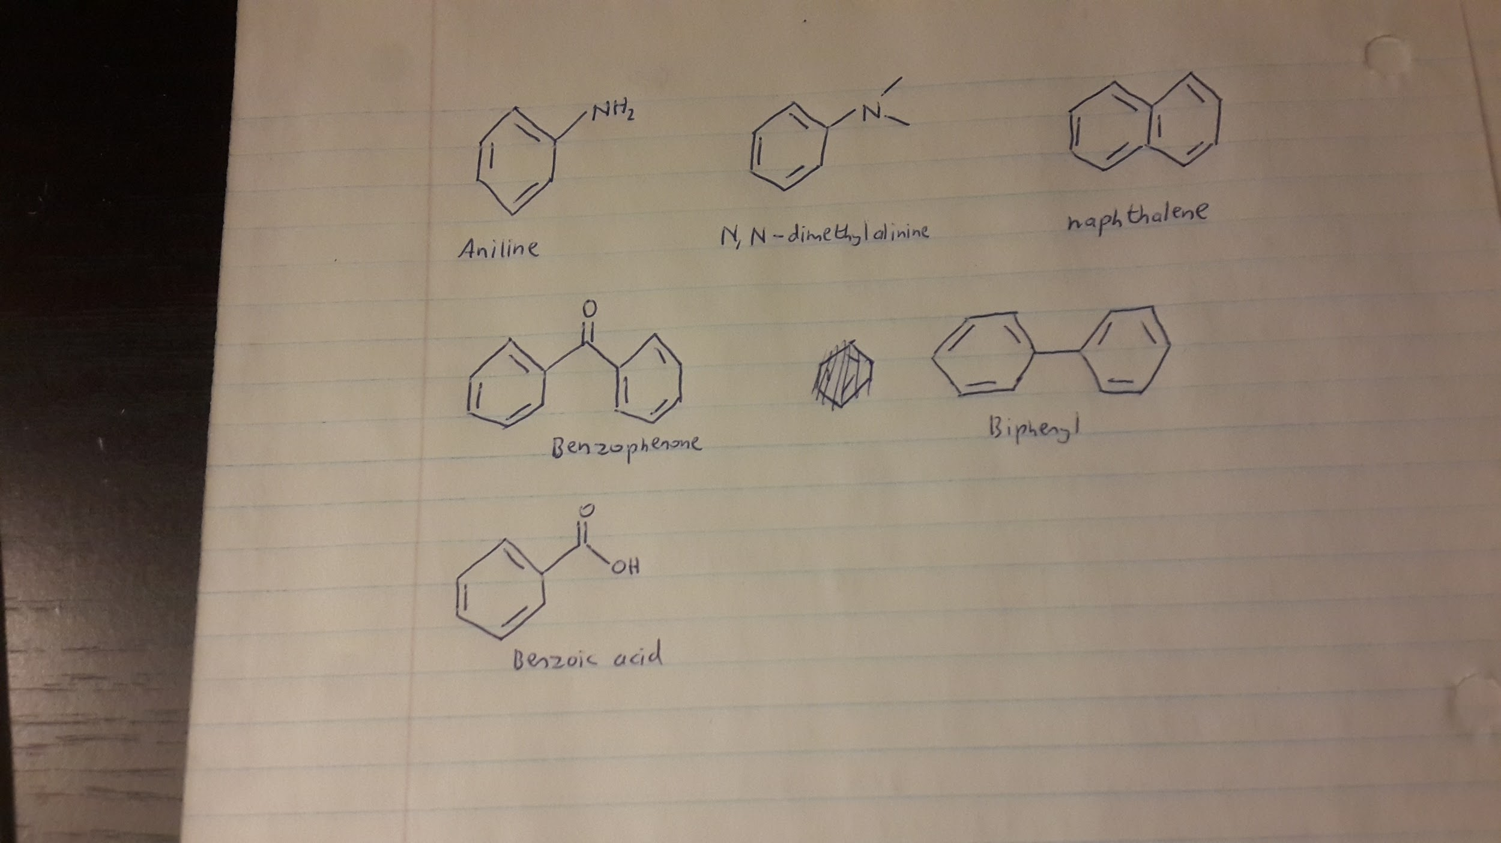

Conclusion

Part A: The unknown compound, 57, consists mostly of benzophenone.
Part B: When the polarity of a solvent increases, the Rf values of the compounds also increase and vice versa
Part C: The unknown sample, XX, is a ortho-para mixture with 46 % ortho and 54% para (or 1 : 1.2)

