Biochemistry review:
Topic 1:
Central Dogma:
- Classic relationship; DNA RNA Protein
- The central dogma of biology refers to the way that genetic information is stored and retrieved in living cells.
- Some of these RNAs are intermediates and carry information used to produce proteins.
- Proteins (and some RNAs) are the “active” workers in the cells; catalyzing reactions, moving things around, creating structures
DNA: genotypic
Some RNAs and Proteins: phenotypic
Proteins are encoded by DNA which is transcribed into RNA. Codons on the RNA (3 nucleotides) are identified by translational machinery and each codon synthesises one AA to the polypeptide chain.
AA’s only exist is L chiral form in animals, and are only extended on the carboxylic end
4 different types of AA’s:
- Polar: negative
- Polar: positive
- Polar: uncharged
- Non-polar
Major properties of AA’s:
- Hydrophobic/philic
- Size
- Ability to form H-bonds
Serine
There are phosphorylation sites on theses AA’s
Threonine
Tyrosine
Can test if phosphorylation is essential in proteins by replacing specific phosphorylative residues with non-phosphorylative residues and seeing if function is maintained.
The amino and carboxyl ends of the AA can be protonated or deprotonated.
- This protonation is pH dependent
Proline is an “imino” acid and is the least flexible of all the AA’s
Hydrophilic charged acidic (lewis acidic) amino acids mimic phosphorylation
- When the pH equals the pKa than the ratio of protonated : deprotonated is 50:50.
8 Amino acids to know:
(G): Glycine
(A): Alanine
(C): Cysteine
(S): Serine
(P): Proline
(K): Lysine
(D): Aspartic Acid
(F): Phenylalanine

Topic 2:
Sulfur in cysteine allows for di-sulfide bonds
Where do the AA’s face in protein?
- Hydrophobic away from water (typically inside)
- Hydrophilic outside to be surrounded by water
- Cysteine residues bind polypeptides to themselves
3 parts affect charge of AA’s:
- Amino terminus
- Carboxyl terminus
- R group (side chain)
Serine, threonine and tyrosine can all be phosphorylated by kinases to acquire new functions by changing conformation
- Phosphate makes the residue acidic
Protons move continuously in aqueous solutions
Calculate net charge of an amino acid in solution of varying pH:
pKa: the strength to attract H⁺
pH: the amount of H⁺ in solution $pH= pKa + log\frac{[A]}{[HA]}$
- Dissociation equation
- Ka equation
- H⁺ concentration in solution (molarity)
- Sub values into Ka equation
- Compute Ka and then pKa
pKa for carboxyl ends is 2 and for amino ends is 10
- Any change in pH by 1 is a 10 fold shift towards (de)protonation and ratios go from 1:1 to 1:10(roughly 1:10)
The charge is the sum of all the ratios multiplied by their charge
Topic 3:
Peptides are 50 AA long or less and polypeptides either are proteins or are grouped together to make proteins.
Electrostatic interactions are weaker in water, water forces hydrophobic groups together
The secondary structure is formed by H-bonding which is formed through the N-H and C=O interactions
This results in the folding pattern responsible for α-helices and β-pleated sheets
- beta sheets can be parallel or anti parallel & have tight rigid bonding
The type of AA’s in the sequence determine the structure of the sequence
Peptide bond formation enables protein formation
- Condensation reaction
- Covalent bond
- No rotation around the bond (resonance)
- Atoms involved are co-planar
- Restricts the possible folding patterns of the chain
Peptides: small numbers of joined residues
- di, tri, poly
- even some proteins can be called polypeptides
Backbone repeating structure:
N-C-C-N-C-C-N-C-C-N-C-C
Side chains of the amino acids stick out of the backbone
Proteins fold into many different shapes but certain structural elements are found in many proteins
General “rules” guiding how proteins obtain final form
- Primary: AAs form peptide bonds
- Secondary: beta sheets and alpha helices
- Tertiary: groups of beta sheets and alpha helices together
- Quaternary: several polypeptides together
Primary structure: the sequence of residues
- Proline is an imino acid and is not very flexible due to N bonding to 2 C’s
Secondary structure:
- Local folding pattern of the backbone
- Stabilized by H-bonding between N-H and C=O
  - 2 types: alpha helix and beta sheet
    - Other types involve turns, twist and other helices
H-bonding is strongest when all 3 atoms involved are in a line and is 1/20 the strength of a covalent bond
Alpha helix:
- 3.6 residues per turn
- 0.54 nm per turn
- Side chains outward facing
- Stabilized by Hydrogen bonding from backbone (internal)
- Proline causes kinks (not seen in alpha helices)
Beta sheets:
- Have more H-bonding therefore more rigid and stronger
- Can be done with more than one polypeptide
- Can be antiparallel (A) or parallel (B)
- Side chains point upwards and downwards
Most proteins have alpha helices and beta sheets

Tertiary Structure: concerns 3-D structure
- Stabilized by bonding between sidechains (disulfide bridges)
  - Or from backbone to side chain
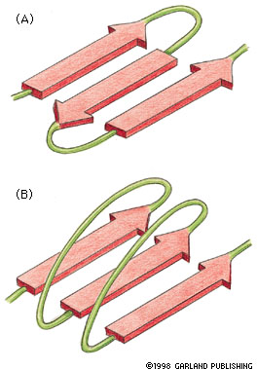
- Interactions between residues can be distant in sequence of AA’s
- Gives proteins overall shape
Hydrophobic interactions are most important
- The tendency of hydrocarbons to form intermolecular aggregates in aqueous medium
- Hydrophobic side chains ‘hidden from water
  - Cluster together; excluding water from hydrophobic interiors
- Charged side chains are mainly exterior

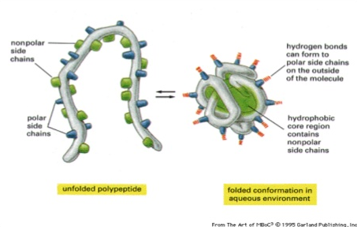
Tertiary structure is stabilized by multiple weak bonds and a very important covalent bond!
- Weak forces (other than hydrophobic interactions)
  - H-bonds
  - Van der Waals forces
  - Ionic bonds
- However, one type of covalent bond
  - Disulfide bond (inter and intra chain reactions)
    - Between cysteine residues in distant parts of the protein
    - Only form in oxidizing environments
Van der Waals force: The sum of the attractive or repulsive forces between molecules (or between parts of the same molecule) other than those due to covalent bonds, H-bonds, or the electrostatic interaction of ions with one another or with neutral molecules or charged molecules.
H-bonding happens from:
- Backbone backbone
- Backbone side chain
- Side chain side chain
Tertiary structure: Domains
- A critical concept for larger proteins
- Definition: distinct region of a protein
  - Domains can often fold independently
  - Domains provide structure and/or function
- Many proteins are made up of connected domains
- Related domains often found in different proteins
  - Evolution has ‘mixed and matched’ domains

Quaternary structure
- Many proteins consist of more than one polypeptide
- These are called a protein’s subunits
- Forces/bonds involved are the same as for tertiary structure
  - Hydrophobic interactions, H-bonds, Van der Waals, Ionic bonds, Disulfide bonds
Quaternary structure: Coiled coil
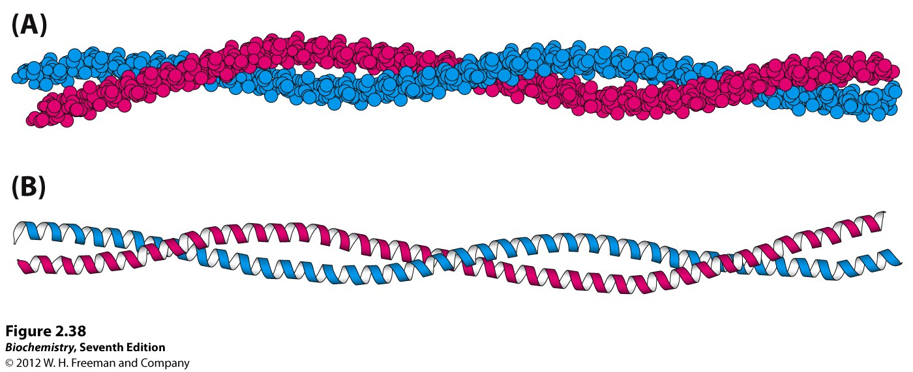
11 nm

- Repeating pattern every 7 residues abcdefgabcdefgabcdefg…
- Every a and d position is hydrophobic and every e and g usually a charged AA
- Hydrophobic stripes line the side of all subunits involved and these hydrophobic stripes are covered when coiled coil structure occurs
  - Eg) EB1- binds to end of microtubules, GCN4- transcription factor
How biochemists draw/visualize protein structure
- Wire: side chains & proximity, predict amino acids involved in function
- Ribbon: visualize secondary structures
- Space filling: gives a feel for shape, which amino acids are on the surface, predict interactions with water or proteins
Post translational modification:
- Phosphorylation, Ubiquitnation, Acetylation, Sumoylation alters stability or signalling
- Mysristylation, Farnesylation alters location
Lipo proteins bind lipids
Metalloproteins bind metal ions
Hemoproteins have an attached heme group
Protein folding: how does this happen?
- Likely specific to the sequence
- Co-operative: many weak interactions
- Molecular chaperons help proteins fold
- Probably stepwise
  - Hydrophobic interactions, then secondary then tertiary
Conformation flexibility and changes:
- Proteins aren’t completely rigid
- Various types of motion possible depending on structure
- Often, domains can move when connected by flexible linkers
- Conformational changes are when protein bends, usually to perform its function
Denaturation:
- Extreme conditions cause unfolding “denaturation”
  - pH, high temperature, alcohol, heavy metal salts, detergents or certain small molecules
    - Urea and guanidine hydrochloride are examples
- Break weak bonds that stabilize structure
- Involves disruption of destruction of secondary and tertiary structure
  - Primary sequence remains, is generally unaffected by denaturing agents
- Some denaturing agents only temporarily remove function
- Some are irreversible, like thermal denaturation
Protein families
- During evolution, new proteins come from older ones
- Protein family: related by evolution
- Similar primary sequence, structures, functions, and domains
- Amino acid residues that are necessary for function are found in all members
  - Conserved residues
Topic 4:
Name | Function | Example
Enzyme | Catalyzes covalent bond breakage or formation | Protein kinase
Structural | Provides mechanical support to cells & tissues | Keratin
Transport | Carries small molecules or ions | Hemoglobin
Motor | Generates movement in cells and tissues | Myosin
Storage | Stores small molecules or ion | Ferritin
Signal | Carries signals from cell to cell | Insulin
Receptor | Detects signals and transmits them to the cell | TrK (NGF)
Gene Regulator | Binds to DNA to switch genes on or off | P53

Protein topography
- Protein surfaces have a huge variety- ie. Shape, electronic properties
- Due to variety of amino acid side chains
  - Many arrangements of secondary and tertiary structure
Ligand-binding proteins
- Many proteins contain sites to which ligands specifically bind and form a “complex” with the protein
  - Ligand: molecule that can form this complex
- Binding occurs by multiple weak or a few strong forces
  - Extremely specificity
Ligand binding – Dissociation constant
- Kd (dissociation constant) is a measure of the strength or affinity of an interaction
- An equilibrium constant
- For a protein (P) binding ligand (L):$$Kd=\left[P\right]\left[L\right]/[PL]$$
Dissociation constants
- High affinity = tight bonding = small Kd
- Units are moles/L or (M)
- Biological examples:
  - Calmodulin/Calcium – (10⁻⁶M)
  - Antibody/antigen – (10⁻¹²M)
  - Estrogen/Estrogen receptor – microM
  - Biotin/streptavidin fM (10⁻¹⁵M)
Proteasome structure
- Molecular weight 700,00 – enormous: 28 polypeptide chains assembled
- Uses ATP to unfold proteins
Ribosomal complex (The Ribosome)
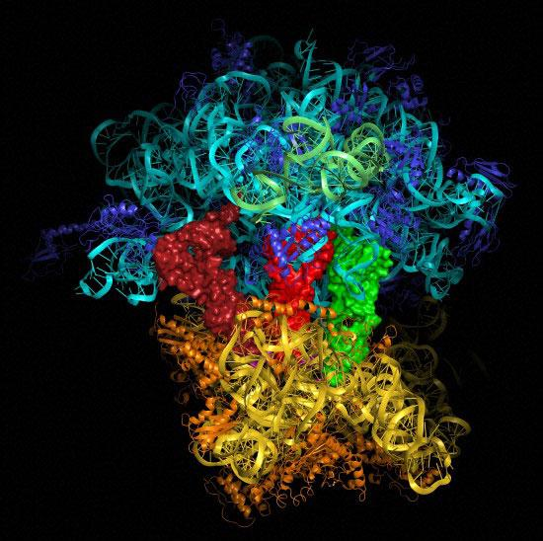
RNA: turquoise, green, yellow
Protein: orange, purple
tRNAs: green, red, reddish-brown

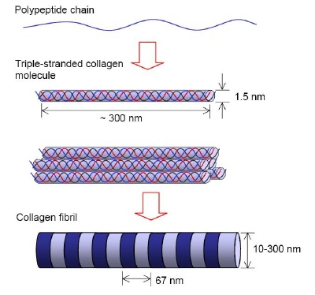
Collagen
- Most common protein in animals (about 25-30%)
- Extracellular, forms strong fibers or sheets
- Connects and strengths tissues
  - Bone matrix, tendons, connective tissue, skin
- Family of proteins numbered I to XIV
- Characteristic structure triple helical
Collagen molecule – 300nm long & 1.5 nm diameter
- Forms with 2 other molecules to make a triple stranded collagen molecule
Triple stranded collagen molecules assemble to form micro-fibrils
- These then assemble to form mature collagen fibrils
These collagen fibrils then aggregate to form a collagen fibre
Collagen helical folding
- Presence of so much proline prevents alpha helix
- Instead it forms a “poly-proline type II” helix
  - More extended than alpha helix
  - No intra-chain H-bonds because of proline steric repulsion
  - Stabilized by steric repulsion of proline side chains
  - 3 residues per turn
- Must be first synthesized as a precursor which is soluble called “pro-collagen”
  - Consists of 3 polyproline type II helices
Proline type II helix
- Mainly proline, hydroxyl-proline, and glycine
- Collagen has a characteristic sequence
  - Every third residue is Glycine
  - Lots of proline and hydroxyl-proline
    - Modified amino acid with hydroxyl group
    - The hydroxylation of proline and lysine residues plays a role in triple helix stabilization and cross-linking of collagen molecules
      - Hydroxyl-proline: OH groups can form H-bonds to help keep triple helix together
      - Hydroxyl-lysine: OH groups serve as sites of sugar addition and are involved in a cross-linking reaction that creates covalent bonds
- The three chains are hydrogen bonded to each other. The hydrogen bond donors are the peptide NH groups of glycine residues. The OH groups on hydroxyl-proline also form hydrogen bonds
Collagen properties
- Glycine in every third position is essential
  - Any other amino acid pushes chains apart
- Gives a thin (1.5 nm), long (300 nm), very strong molecule
- Quite hydrophobic, insoluble due to many exposed hydrophobic side chains
  - Must be first synthesized as precursor which is soluble called “procollagen”
  - These ”pro-peptides” increase solubility and prevent premature fibre formation
Collagen assembly
- Pre-pro-collagen is synthesised in ER and then tagged to be secreted
- Pro-collagen secreted from ER
  - Pro-peptides are not triple helical
- Pro-peptides forms triple helix before fibril assembly
  - “pro-peptidase” enzymes present outside cells cleaves off C and N terminus
    - Leaves “tropocollagen”: triple helical part and some olgiosaccharides come off to allow for cross linking
- Collagen molecules are covalently cross-linked in the fibril (inter & intra molecular cross-linking)
  - Lysine residues in different chains
  - Enzymatically attached
  - Gives further strength to the fibril
Lysyl oxidase: catalyzes formation of aldehydes from lysine residues in collagen, resulting in an aldol cross link
Disulfide bond bridges can occur but they are rare, and collagen type specific
Collagen-related disease
- Scurvy
  - Lack of vitamin C (ascorbic acid) in diet
  - Vit C is needed for enzyme that hydroxylates proline
  - Non-hydroxylated prolines = unstable collagen
- Osteogenesis imperfecta (bad bone)
  - Often glycine mutations
  - Prevent proper assembly of triple elix
  - Leads to lack of collagen
  - Malformed or absent bones
- Ehlers-Danlos syndrome (EDS)
  - Group of inherited connective tissue disorders
  - Caused by a defect in the synthesis of collagen
Antibodies (immunoglobulins)
- Immune response is triggered by foreign macromolecules (eg. Proteins, carbohydrates), known as antigens
- Immunoglobulins are soluble proteins that recognize and tag antigens for destruction
- Found in blood, lymph, bodily fluids
- Made by B lymphocytes
- Multiple types of immunoglobulins (A,D,E,G,M)
  - IgG is the main form found in the blood
IgG domains
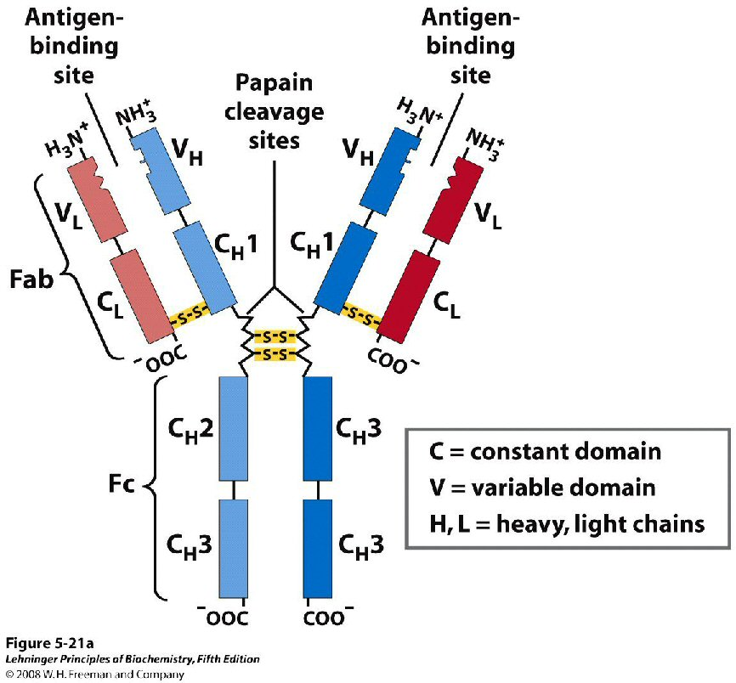
- Beta sheets
- Disulfide links two sheets together
- Hydrophobic center
- Heavy chains have oligosaccharides attached that make them “heavy”
- Heavy chains are generally longer as well
Proteolysis yields 3 fragments:
- 2 Fab (fragment antigen binding)
- 1 Fc (fragment crystallized) – effector site (mediates functions)
  - Activate the complement pathway
  - Bind to phagocytes
  - Bind to mast cells, basophils and eosinophils
  - Bind to NK cells
Surface complementarity is important to antigen binding site
Production & use of antibodies
- Created by injecting an ‘antigen’ (often rabbit or goat)
  - After immune response, antibodies harvested from blood
- Extreme specificity makes IgG a valuable tool
- Laboratory experiments: Identification of molecules in mixtures, eg. Immunoblot
- Clinical: diagnosis of disease, eg. HIV
- Clinical: therapy, eg. Anti-venoms
Topic 5:
Enzyme catalysis
- Biological catalysts
  - Perform nearly all chemical transformations in cells
  - Accelerate, but are unchanged by, a reaction
- Most enzymes are proteins
- Name often ends in ‘ase’
- Often extremely specific
  - They have ‘targeted’ or restricted ligands (called substrates)
  - Substrate: the molecules on which and enzyme acts
Types of chemical reactions carried out by enzymes
- Hydrolytic – cleavage using water
  - Nucleases, proteases, phosphatases
- Condensation – connect molecules together
  - Polymerases, synthases
- Isomerization – rearrange bonds
  - Isomerases
- Oxidation-Reduction – gain or loss of electrons
  - Oxidases, reductases, de-hydrogenases
- Group transfer – transfer chemical group
  - Phosphorylation, sumoylation, acetylation, glycosylation (N/O linked)
Active site of enzyes
- Part of the enzyme where the reaction takes place
  - Small part of enzymes surface (~5% or less)
  - Often a cleft or crevice between domains
- Substrate binds in active site
  - Multiple weak bonds
  - Dissociates from enzymes
How do enzymes catalyze reactions?
- Must understand a transition state
  - Transition state of a chemical reaction is defined as the state corresponding to the highest energy along the reaction coordinate. At this point, assuming a perfectly irreversible reaction, colliding reactant molecules will always go on to form products
  - Transition state is
    - 1) An intermediate form between the reactants and products
    - 2) A transient, high energy state
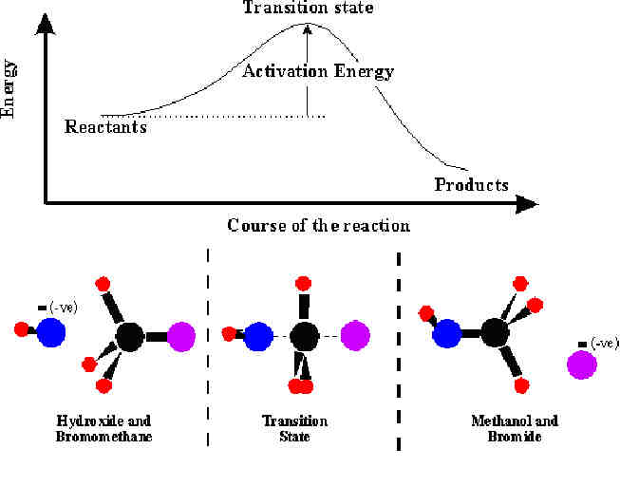
    - 3) A form that is different from both reactants and products
Energy must be put into the molecules to push them into the transition state (activation energy)
Overall energy released during the reaction (free energy)
Enzyme catalytic mechanisms: other points
- Enzymes lower activation energy
  - Makes it easier to reach the transition
- Highest affinity is for the transition state, and not the substrate or product
- Topography of the enzyme active site is complementary to the transition state
- Binding of the substrate pushes the enzyme towards the transition state, resulting in a strain on the substrate
- Enzymes work best at specific temperatures and pH
Induced fit hypothesis
- “the initial interaction between enzyme and substrate is relatively weak, but that these weak interactions rapidly induce conformational changes in the enzyme that strengthen binding”
  - * the enzyme changes conformation and increases the affinity to reach the transition state, stabilizing it and thereby reducing the activation energy required
Kinetics vs. Equilibrium
- Enzymes do not change equilibrium, ie. The final concentration of substrate and product
- Rather, enzymes allow the equilibrium to be achieved sooner
  - Can’t change thermodynamics, only accelerate reaction rate (kinetics)
- Both forwards and reverse reactions are catalyzed by an enzyme
- Enzymes also do not change the free energy difference between substrate and product (free energy)
  - Can’t change thermodynamics
Mechanisms to lower activation energies
- Enzyme binds to two substrate molecules and orients them precisely to encourage a reaction to occur between them
- Binding of substrate to enzyme rearranges electrons in the substrate, creating partial negative and positive charges that favor a reaction
- Enzyme strains the bound substrate molecules, forcing it toward a transition state to favor a reaction
Transition state analogues
- Compounds that resemble the transition state
  - Similar geometry, charge distribution
- But do not undergo a chemical reaction
- Excellent inhibitors because they bind tightly blocking the active site competitive inhibitors
- Inhibitors can also bind to other sites non-competitive
- Many drugs and antibiotics are enzyme inhibitors, and are most effective if they are transition state analogues
Apoenzymes and cofactors
- Some enyzmes (apoenzyme) require a partner (cofactor) to function
- Co-factors can either be essential or simply increase the rate of reaction
- Co-factors can either be proteins or metal ions such as iron or zinc
Enzymes function best under optimal conditions
- Optimal function at certain temperatures and pHs
  - Called optimal temperature and pH
- Bell-shaped curve
  - Instability of enzymes at extremes of temperature/pH
- Enzymes are ‘biological’ catalysts which speed up reaction rates

Example of a catalytic mechanism:
Lysozyme
- Small enzyme, MW ~ 20Kd
- Found in tars, saliva, mucus and eggs
- Hydrolyzes a polysaccharide found in cell walls of some bacteria
- Part of the innate immune system
- An evolutionarily older defense strategy found in plants, insects, fungi etc.
- Stabilized by disulfide bonds
The discovery of lysozyme
1909: Laschtschenko discovered anti-bacterial properties of egg white
1922: After WW1, Alexander lfaming (biologist and pharmacologist) observed anti-bacterial properties of nasal mucus from patient with a “head-cold”; the term “lysozyme” was created and is the name of the enzyme involved in destructing bacterial cell walls
** First enzyme for which detailed mechanism of catalysis was determined
Lysozymes cleaves a polysaccharide
- Involves glutamic acid at position 35 and aspartic acid at position 52
- Lysozyme pushes sugar into axial chair confirmation and then Glu & Asp surround the sugar. Glu donates an H⁺, Asp temporarily bonds with anomeric C on sugar (transient covalent bond), Glu polarizes H₂O and gains an H⁺, and OH replaces Asp on the sugar’s anomeric carbon.
Enzyme kinetics
- Study how rate of the reaction is influenced by substrate concentration, inhibitors, etc.
  - Can help discover how an enzyme works
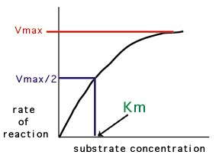
- Rate of reaction will depend on various factors
  - Affinity of enzyme for substrate
  - Substrate concentration
V vs [S] plot

Michaelis-Menten equation
Describes how the kinetics of the E-S complex, ie. How the S concentration and rate of the reaction relate to each other
$v=\frac{Vmax[S]}{Km+[S]}$
v is the initial velocity (before any product is produced)
Vmax is the maximal velocity (when E is entirely in ES form)
[S] is concentration of substrate
Km is the Michaelis constant
- Equal to substrate concentration at half of Vmax
- Reflects affinity end efficiency of enzyme
- Independent of enzyme concentration

How to use the Michaelis-Menten equation
$v=\frac{Vmax[S]}{Km+[S]}$
- Allows determination of Km and Vmax from velocity vs. [substrate] data
- For convenience, a double reciprocal plot is used
  - Equation is the inverse of Michaelis-Menten:
  - 1/v = (1/[S])(Km/Vmax) + 1/Vmax
  - Plot of 1/v vs 1/[S]
  - Gives a double reciprocal or “Lineweaver-Burk” plot (straight line)
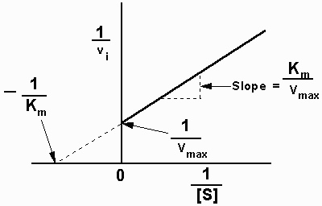
Enzyme inhibition
- Therapeutic drugs, natural inhibitors of metabolism, herbicides & pesticides
- 2 general types
  - Reversible
    - Binding of inhibitor to enzyme non-covalently
    - Inhibitor can be removed
  - Irreversible
    - Covalent bond formed with enzyme
    - Permanently blocks activity
Reversible inhibitors
Major category of reversible inhibitors: Competitive
- Inhibitor binds in active site
  - Structure similar substrate or product
- Block access to substrate
- Affects Km of the reaction, But not Vmax
- Large excess of substrate overcomes inhibition
*** Reduces the concentration of free enzyme available for substrate binding
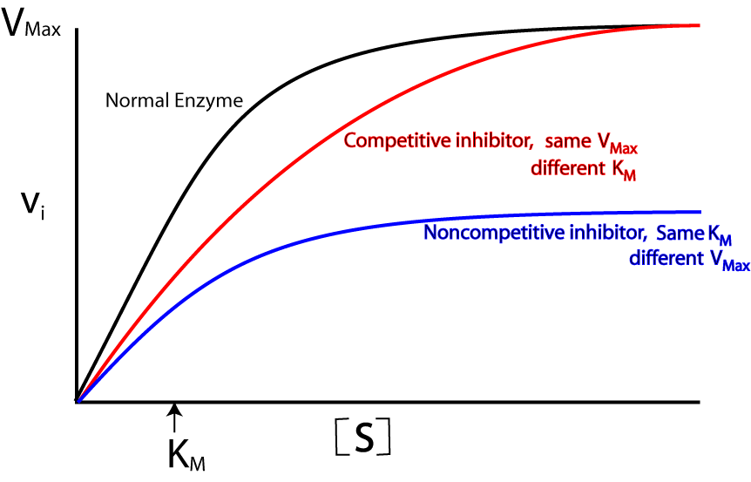
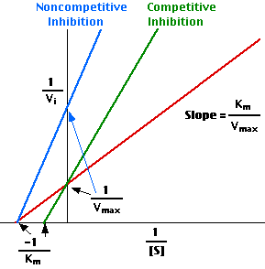
Non-competitive inhibition vertically translates line up on lineweaver burk plot
competitive inhibitor lowers the slope of line in the lineweaver burk plot
Enzyme kinetics: Summary
- Enzyme reaction rates vary with substrates concentration
- Can be described by two constants: Km and Vmax
- Kinetic analysis can give insight into mechanisms
- Development of enzyme inhibitors for various uses
Topic 6:
Why purify?
- For medical use: eg) human growth hormone, insulin, chemotherapy, auto-immune disorders, beano (alpha-galactosidase), Lactaid (glycoside hydrolase)
- To study structure and function: Difficult to understand activity in mixtures, Must be pure to determine structure
- For use as a reagent in the laboratory: eg) enzymes for manipulating DNA or growth factors to stimulate cells grown in cultures
The purification process
- Proteins are present in cells or secretions, and are thus complex mixtures – usually many different proteins
  - Plus other – DNA, lipid, small molecules, etc
- Need to remove unwanted material (contaminants)
- Proteins may differ in many properties
  - Size and shape
  - Charge
  - Location
  - Surface hydrophobicity

Before you begin
- Need an assay method
  - Must be able to detect in mixture
  - Measure some property of the protein of interest (formation of a product)
- Decide on a starting material
  - Human tissues, plants, bacteria, etc
Preparative vs. Analytical methods
- Both are used to purify protein
- Start with preparative method follow with analytical
Preparative methods: to homogenize (bust up) material
- Large scale- milligrams to kilograms
- Divide mixture into fractions
Analytical methods: to detect specific protein of interest
- Small scale – micrograms or less
- Small samples of fractions for analysis
Preparative methods
Step 1 – Homogenize
- Break open tissue or cells to release protein
  - Sonication = high frequency sound waves
  - Grinders of various types
  - Blenders/Homogenizers
  - Pressure
  - Detergents
- Compatible buffer solution
  - One in which the protein is “native” and is not denatured
Step 2 – Centrifugation
- Spin the homogenate to separate by size/density
- “differential centrifugation”
  - Low speed – 100 to 1000 x g (force of gravity)
    - Whole cells, nuclei, large debris are pelleted
  - Medium – 2000 to 50000 x g
    - Mitochondria, lysosomes
  - High speed – 60000+ x g
    - Ribosomes, viruses, large macromolecules
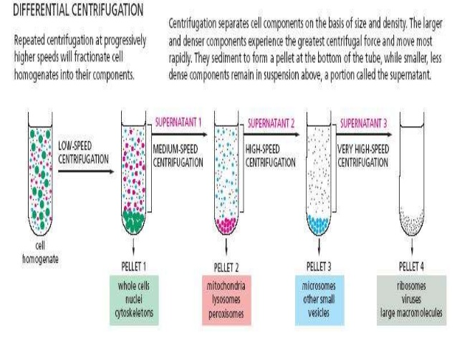
Preparative method:
Step 3 - Column Chromatography
- Further separates proteins based on characteristics like charge and size
- Requires two components
  - Mobile phase = aqueous buffer solution
  - Solid phase = usually small beads
    - Held in cylinder or column
  - Proteins in mobile phase interact (or not) with the matrix
  - Continuous flow of buffer solution carries unbound proteins along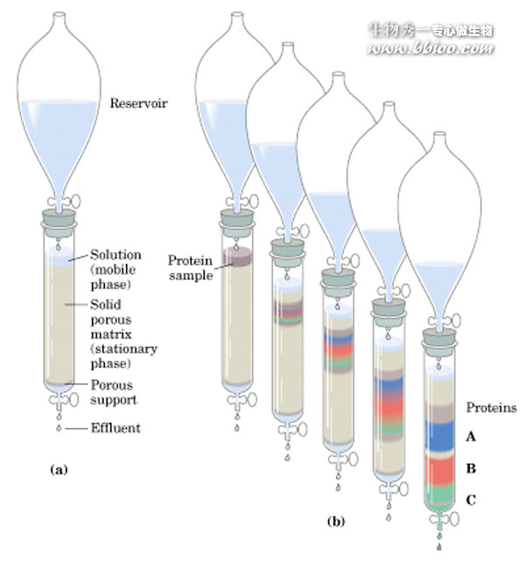

“Eluting” columns
- The effluent is collected (eluted) in ‘fractions’
- Generally a constant flow rate is maintained, and a fraction is collected every few minutes
- Usually many fractions from a single run
- Small samples from each fraction are used to detect specific protein of interest and to measure total proteins
  - absorbance at 280 nm wavelength measures total protein
  - Aromatic amino acids (W,F,Y) absorb at 280 nm
Types of column chromatography
Ion exchange
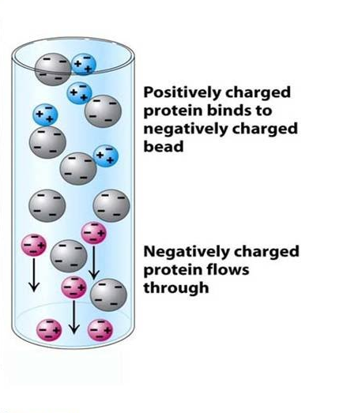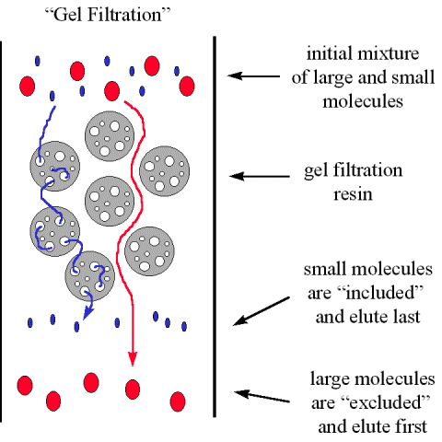
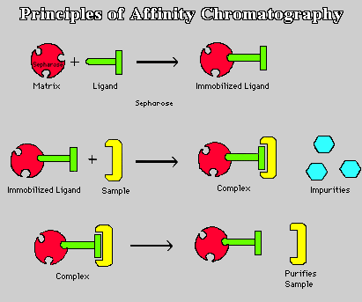

Ion exchange general principles:
- Ion exchange relies on attraction of opposite charges
- For example, diethylaminoenthyl (DEAE) is +’ve charged
  - Binds negative ions (anions)
  - If a protein is negatively charged, it will bind
    - Exchanging with ions previously bound
  - To get protein off, increase salt concentration
  - Eg) increase concentration of anions such as Cl⁻ to compete
  - Usually done as a gradient of increasing concentrtion
- Charge on protein varies with pH the pH where a protein’s net charge = 0 is called its isoelectric point (pl)
- If the pH is raised above the pl, the net charge will be –‘ve. pH below the pl, net charge will be positive
Gel filtration general principles
- In gel filtration beads contain holes
- If a protein can get into the holes it is slowed down
- If a protein is excluded, it will come out early
- Another name “size exclusion”
- In addition to size, protein shape also effects elution speed
Affinity chromatography
- Affinity chromatography relies on a specific interaction between a protein and aligand
- ‘ligand’ = a compund that binds to a protein
- If ligand is attached to column matrix, certain proteins will bind to it, others won’t
  - Flow of buffer will wash away all unbound proteins, leaving only the specifically bound protein
- Most powerful method of chromatography but requires knowledge of what ligand to use
SDS-PAGE
sodium dodecyl sulfate polyacrylamide gel electrophoresis
- Most common analytical method
- SDS is an ionic detergent
- Separates on the basis of polypetide chain size
- Charged molecules migrate in an electric field
- A gel acts a molecular sieve
  - Smaller molecules go faster
- In SDS-PAG, a gel is made of polyacrylamide (6-15%)
  - Hydrophilis polymer in long chains
- SDS used to denature proteins and give a negative charge
- Gels can be a single concentration or a gradient
- Low % gels for high MW proteins
- High % gels for low MW proteins
- Gradients used when you want to examine a range of different sized proteins
*** before electrophoresis, protein samples are heated in presence of SDS to make them all negative
Beta-mercaptoethanol added to break up disulfide bonds
Analysis of purified proteins
- X-ray crystallography
- Protein activity
- Kinetic studies
- Ligand binding assays
- Many more!
Topic 7:

Types of lipids
- Fatty acids – used for energy and structure
- Saturated – no double bonds
- Monounsaturated (cis or trans) – 1 double bond
- Polyunsaturated – 2 or more double bonds
C16:0 means 16 carbon long fatty acid with no double bonds
C16:1 cis-Δ⁹ means 16 carbon long fatty acid with a double bond on the 9th carbon from acid end
16:1 (n-7) means 16 carbon long fatty acid with a double bond on the 7th carbon from uncharged end
C16:2 means 16 C long fatty acid 2 double bonds
Fatty acid saturation and blood chloesterol
- LDL = low density lipoprotein, carries cholesterol to tissues
- HDL = high density lipoprotein, carries cholestrol away from tissues
Type of fat | Effect of LDL | Effect of HDL
Saturated | Increase | Increase
Cis unsaturates | Decrease | Increase
Trans unsaturates | Increase | Decrease

- Triacylglycerols – energy storage molecules
- 3 carbons glycerol ester bonded to 3 fatty acids
- Glycerophospholipids – used in membranes
- 2 fatty acids on a glycerol and a phosphate attached to one end of gylcerol
- Shingolipids – used in membranes (picture)
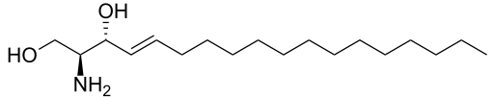
- Ceramide (seen below)
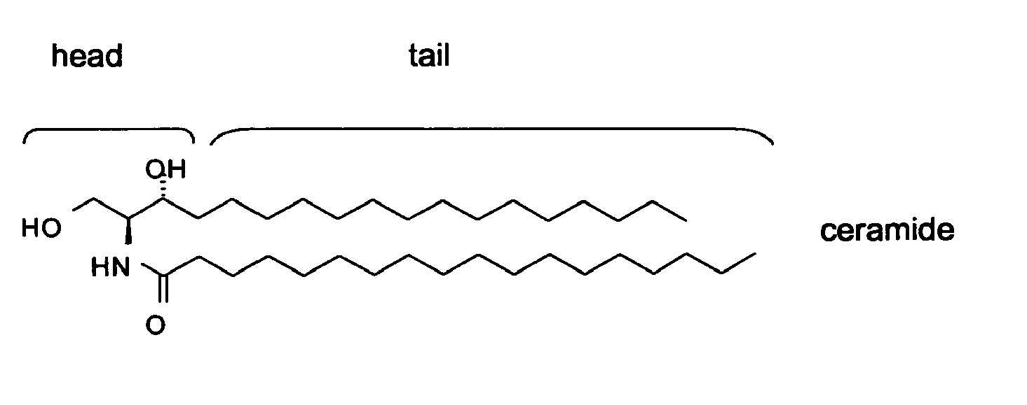
Sphingomyelin is a ceramide molecule with a choline phosphate group attached to the OH group on the head. Glycosphingolipids are like sphingomyelins except they contain a sugar group.
- Steroids – hormones (cholesterol – membranes)
  - Cyclopentanoperhydrophenanthrene ring system
includes testosterone, estradiol, cholesterol
- Other lipids, any long chain carbon molecule that isn’t a sugar
Amphipathic lipids: some parts are polar while others are non polar
amphipathic lipids asscociate in a bilayer which forms a circle around the cell which is energetically favourable
Lipids can diffue within the bilayer
Diffusion rate determined by:
- Temperature
- Length of chains
- Degree of unsaturation
- Cholesterol concentration
Lipids can flex their tails, rotate their tails, difuse laterally and switch to other side of membrane (rarely occurs)
Cholesterol and membrane fluidity
- At 37’C, cholesterol fills in spaces between phospholipids, decreasing fluidity
- At low temperatures, cholesterol hinders packing of phospholipids, increasing fluidity
Bilayers are asymmetrical and glycerophospholipids, sphingomyelins and glycolipids are distributed asymmetrically but cholesterol distribution is symmetric.
Proteins exist to put lipids back on correct side if they happen to flip flop and switch sides of membrane
Topic 8:
Composition of membranes by mass is roughly:
Protein: 50%
Fat: 50%
Carbohydrates: 1-2%
Functions of membrane proteins:
- Transporters and channels
- Anchors
- Receptors
- Enzymes
Implication: membranes are not just passive barriers to polar molecules
Facilitated Transport:
- Transporters: specific binding site, conformational changes during transport allowing molecule to cross membrane
- Channels: open pathway, discriminating based on size and charge

Active vs. passive transport
- Passive: molecule moves down electrochemical gradient (simple diffusion, channel mediation, transporter mediated)
- Active: molecule moves against electrochemical gradient (active transport)
Application: toxins target ion channels
- The venoms of poisonous animals contain small peptides, some of which bind to ionchannels disrupting their function
- Results in paralysis
Membrane proteins, 2 categories:
- Integral membrane proteins
  - Transmembran proteins: typical span membrane odd # of times so C and N terminals are opposite of each other (not all the time though)(segments that are hydrophobic usually generally associated with corssing the membrane)
  - Monolayer-associated alpha helix: only on one side of the membrane
  - Lipid-linked: while protein is not in membrane, it is covalently attached to the head of lipids or to sugars which are also covalently bonded to lipids that make up mebrane
- Peripheral membrane proteins
  - Protein-attached: proteins attached to another integral membrane protein
Transmembrane proteins
- Proteins usually span membranes as alpha helicies but can be beta sheets (beta barrels)
- Single alpha helix of about 20 hydrophobic AA’s
- Have aqueous pore in middle of multiple alpha helices
Mobility of integral membrane proteins
- Proteins can diffuse in plane of bilayer, except when restricted (usually by anchor proteins)
Topic 9:

- Sugars (monosaccharides) and polysaccharides are carbohydrates
- Will have either a ketone or aldehyde group with hydroxyl groups
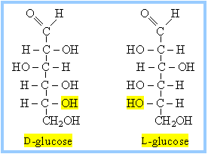
Monosaccharides
- General formula (CH₂O)_{n}
  - Triose (3)
  - Tetrose (4)
  - Pentose (5)
  - Hexose (6)
  - Heptose (7)
Represented by fischer projections
L and D forms shown
- Most biological monosaccharides are in the D orientation at the highest numbered chiral carbon
Some hexoses Cyclization of glucose
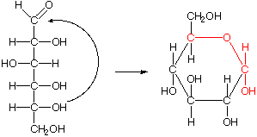
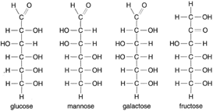
- Prefers cyclized form, prefers to be oxidized
Haworth projections
- Clyclized monosaccharides are represented by haworth projections
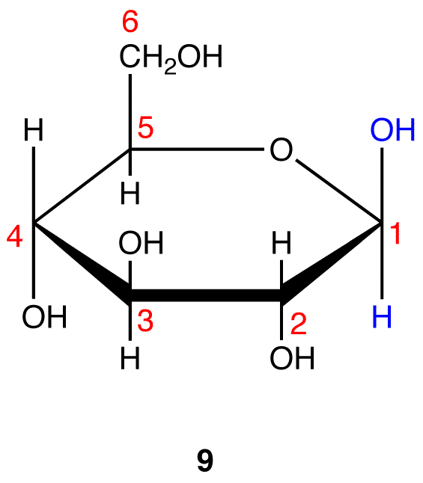
Beta glucose, anomeric carbon’s OH is on same side of ester bond as C6
Alpha glucose, anomeric carbon’s OH is on opposite side of ester bond as C6
Shown here is Beta form

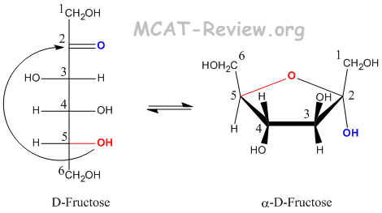
The hydroxyl on C5 attacks the C2 ketone
Pyranose vs. Furanose
- Pyranose
  - 6 carbon membered ring
- Furanose
  - 5 carbon membered ring
Disaccharides
- Monosaccharides can be joined together in a condensation reaction
Beta-galactose + glucose lactose + H₂O
Lactose, or galactose-beta(14)-glucose
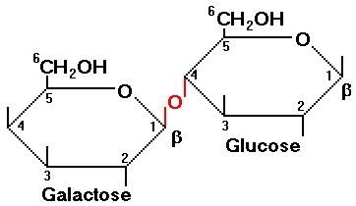
Can be either alpha or beta
This carbon must always beta in lactose (irreducible)
Alpha-glucose + beta-fructose sucrose + H₂O
Polysaccharides as energy storage
- Glycogen (in animals)
  - Chains of 12-14 glucose monomers joined in alpha(14) linkage
  - Interior chains have two branch points with alpha(16) linkages
  - First chain is covalently attached to the protein glycogenin

- Starch (in plants)
  - Two components:
    - Amylose (20-30%): alpha(14)-polyglucose, very few branch points
    - Amylopectin (70-80%): alpha(14)-polyglucose, ~5% of monomers involved in alpha(16) linkages
  - Humans can easily digest glycogen and starch
Cellulose: unbranched beta(14) polyglucose
Chitin: unbranched beta(14) polymer of N-acetyl-beta-glucosamine
Pectin: Unbranched alpha(14) polymer mainly of D-galacturonic acid, partially methylated
- Usually poorly digested by humans: “dietary fibre”
Oligosaccharides as cell coating
- Sugars are covalently attached to lipids and membrane proteins
- Protect cells and make them slipperly
- Sugars are sometimes used for cell-cell recognition
Topic 10:
Gibbs free energy (G)
Reactants Products
ΔG= G_{products}-G_{reactants}
- ΔG determines whether a reaction is energetically favourable or unfavourable
- ΔG is affected by
  - Properties of the molecules
  - Reaction conditions
Energetically favourable (spontaneous, not instant)
- ΔG<0
- Products are favoured, net conversion of reactants to products without energy input
- Can still go the other way but one direction is favoured over the other
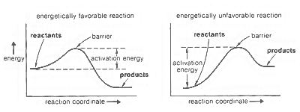
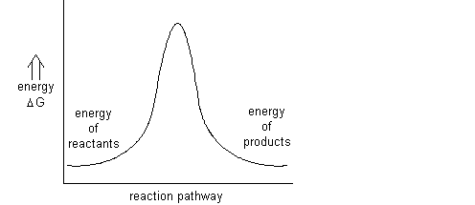
Reaction at equilibrium
- ΔG=0
- Neither products nor reactants are favoured

Le Chatelier’s Principle
- Reaction shifts to counteract changes in concentration of reactants or products
- Reaction is “reversible”
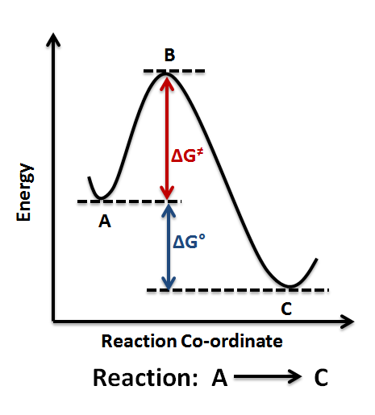
“Irreversible reactions
- Products are very strongly favoured
- Insensitive to changes in concentration
Energetically unfavourable reaction
- ΔG>0
- Reactants are favoured
- Changing concentrations enough to favour products may or may not be possible
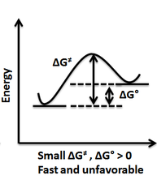
- Example: formation of glutamine
  - Glutamate + NH₄⁺ glutamine + H₂O
  - ΔG=+3.4 kcal/mol
Reactions may be coupled
- An energeticall favourable reaction can be used to make an unfavourable reaction proceed
- The reactions must be chemically “coupled” together
- A favourable reaction
- Glucose + 6O₂ 6CO₂ + 6 H₂O
  - ΔG= -686 kcal/mol
Winning combination?
- Glutamate + NH4⁺ glutamine + H2O
- Glucose + 6O2 6CO2 + 6 H2O
  - Glucose + glutamate + 6O₂ + NH₄⁺ glutamine + 6CO₂ + 7 H₂O
  - ΔG=3.4 kcal/mol – 686 kcal/mol = -683 kcal/mol
  - Most of the energy would be wasted as heat
Stepwise oxidation Direct burning of sugar in non-living system
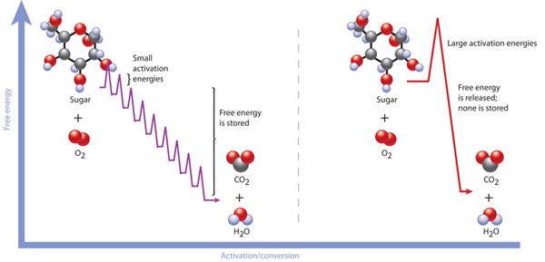
Small activation energies overcome by enzymes that work at body temperature
- Cells store energy from food in carrier molecules to be spent a little at a time
Adenosine triphosphate
- The main energy carrier in living systems
- Hydrolysis of Atp is energetically favourable
- ATP + H₂O ADP + P_{I}
- ΔG = -7.3 kcal/mol
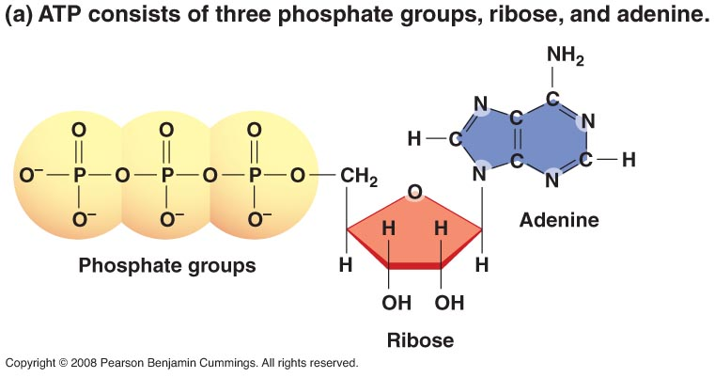
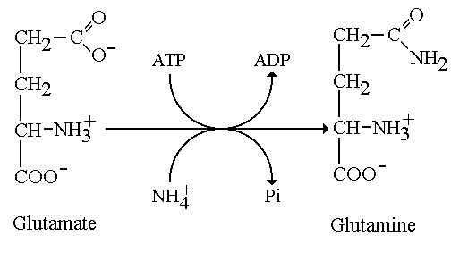
Hydrolysis of ATP is favourable because…
- Release of P_{I} lowers charge repulsion
- Release of P_{I} increases resonance stabilization
- Products are more highly solvated
- ATP/ADP ratio is usually high
- “high-energy” phospahte bonds for all of above reasons
Net reaction of coupled processes:
- Glutamate + NH₄⁺ + ATP glutamine + ADP + P_{I}
ΔG = 3.4 – 7.3 = -3.9 kcal/mol
What if we need more energy?
- Hydrolyze ATP to AMP and 2P_{I}
  - ΔG = -15.8 kcal/mol
- Couple to a reaction that releases more energy
  - Phosphocreatine + H₂O creatine + P_{I}
  - ΔG = -10.3 kcal/mol
Reduction-Oxidation reactions
- Some biological reaction require a molecule to be reduced
- A redox reaction involves transfer or electrons
- Leo says Ger
  - Lose Electrons Oxidation, Gain Electrons Reduction
- In a redox reaction one molecules is reduced the other is oxidized
- Oxidation state of carbon increases with the number of electronegative atoms bonded to it
NADH and NADPH
- NADH = Nicotinamide adenine dinucleotide
- NADPH = Nicotinamide adenine dinucleotide phosphate
  - Each can carry 2 electrons when reduced
A biological redox reaction
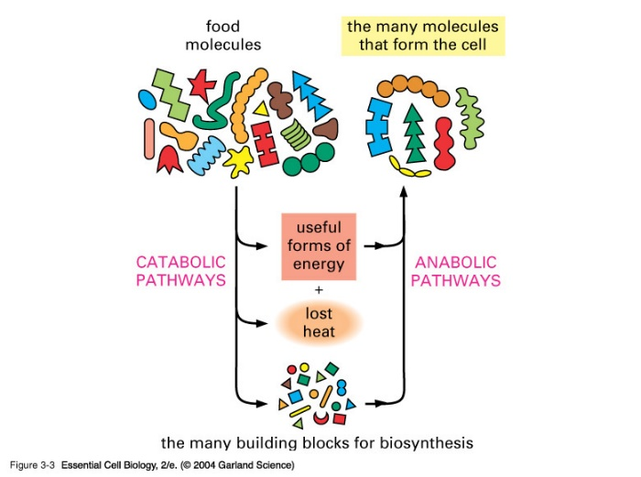
Acetaldehyde + NADH + H⁺ (alcohol dehydrogenase) Ethanol + NAD⁺
- Acetaldehyde is reduced to ethanol
- NADH is oxidized to NAD⁺
- In general, NADH is used in ATP production and NADPH is used in biosynthesis
Topic 11:
Metabolism -------------------------------------------------- >
And reducing power
Metabolic pathways
A B C D E
- Flux = rate of conversion of A to E
- Conversion is efficient when net ΔG for whole pathway is negative
- Some reactions, ΔG << 0
Targets of regulation in pathways with many reactions are irreversible reactions
- No going back after those reactions
Ways to control the rate of a reaction
- Change amount of enzyme (not fast way to control reaction rates)
  - Transcription
  - Translation
  - Degreadation
- Change concentration of substrate or product (hard to do in cell)
- Change anzyme activity
  - Allosteric regulation
  - Covalent modification
  - Association with regulatory protein
Allosteric enzymes
- Allosteric = other solid or other shape
- Shape of active site is changed by the binding of effector at a different site (allosteric site)
- Allosteric enzymes are usually multimeric (ie, more than 1 subunit)
  - Can also active enzymes
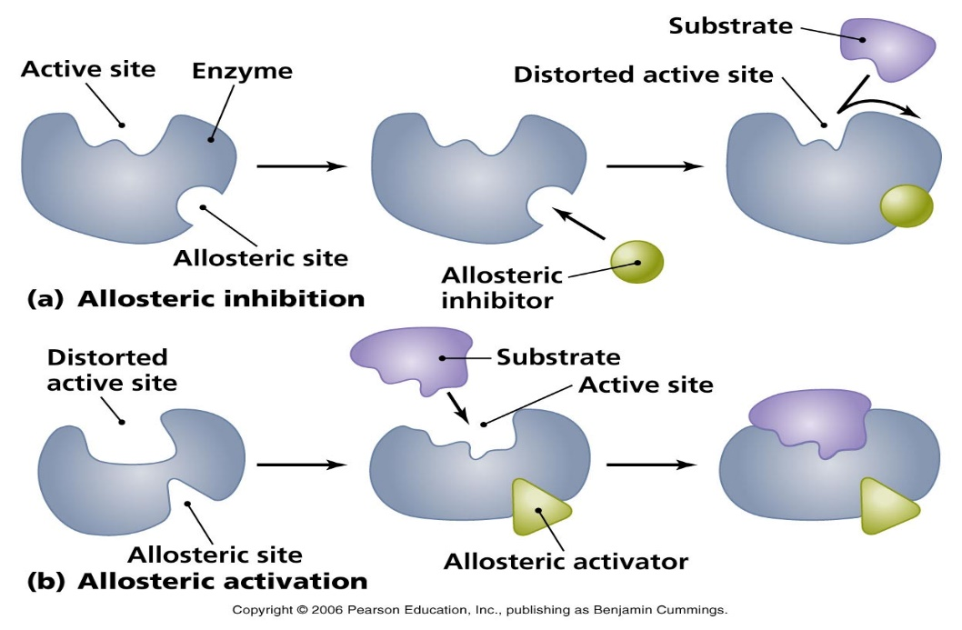
- Change in active site upon effector binding alters enzyme activity
- Higher [effector] means more binding of effector to enzyme
Covalent modification
- A chemical gorup (eg. Phosphate) is added covalently to the protein to change its function
Topic 12:
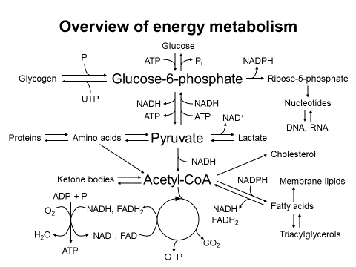
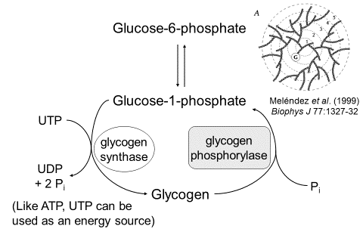
Carbohydrate metabolism

- Glycogen synthesis and breakdown
- Glycolysis and fermentation
- Gluconeogenesis
- Pentose phosphate pathway
Carbohydrate storage as glycogen
- Glycogen synthase adds glucose to glycogen by extending the glucose-alpha(14)-glucose chain till it reaches 13 or so long
- Glycogen synthase also adds 2 branch points per 13 unit chains in glucose-alpha(16)-glucose linkages

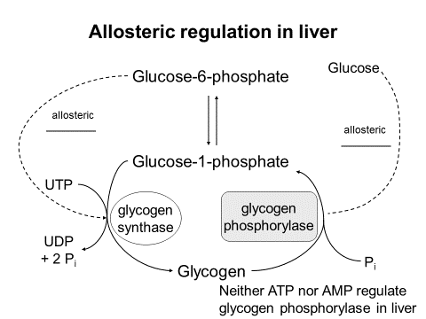
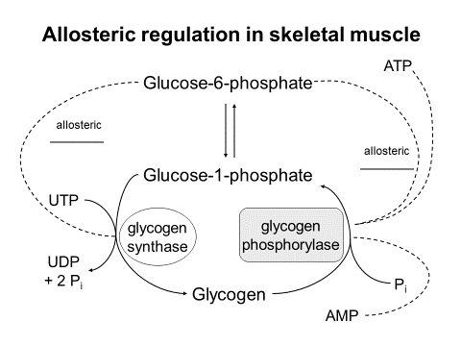
Note the differences in regulation
- ATP will inhibit glycogen phosphorylase, and AMP will activate glycogen phosphorylase to generate more energy
  - Liver does not respond to its own energy concentrations (selfless)
Control by Covalent modification (phosphorylation) in liver and muscle
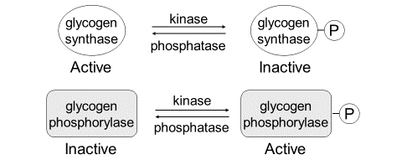
- Insulin leads to dephosphorylation in liver & muscle
- Glucagon leads to phosphorylation in liver
  - Epinephrine also phosphorylates enzymes (fight or flight emergency response)
- Insulin doesn’t directly enter cell and dephosphorylate enzymes but is messanger that binds to receptor which then starts cellular events to dephosphorylate enzymes
- Glucagon does the same thing but ends with phosphorylation of enzymes
Glycolysis: NET REACTION
Glucose + 2ADP + 2P_{I} + 2NAD⁺ 2Pyruvate + 2ATP + 2NADH
Electron transport
Useable energy
Oxidation in mitochndria

ΔG values for gylcolysis reactions
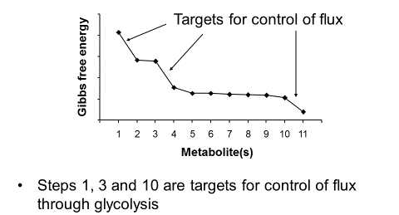
- Step 1: Hexokinase
- Step 3: Phosphofructokinase
  - Inhibited: Citrate, ATP (molecules for energy are in high concentrations)
  - Activated: AMP, ADP, P_{I}, Fructose-2,6-biphosphate (intermediate near end of gluconeogenesis)
- Step 10: pyruvate kinase: don’t want to make pyruvate if energy in cell is high and intermediates can be used for biosynthesis
Fermentation: a pathway that produces ATP with no net oxidation of carbon
- Glycolysis cinsumes NAD⁺; to convert glucose to pyruvate, NAD⁺ must be regenerated
- When O₂ is present, this is done by electron transport chain
- When O₂ is absent, other reactions regenerate NAD⁺
- 2 strategies
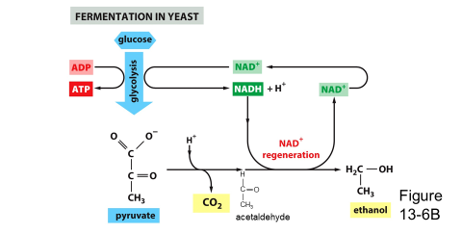
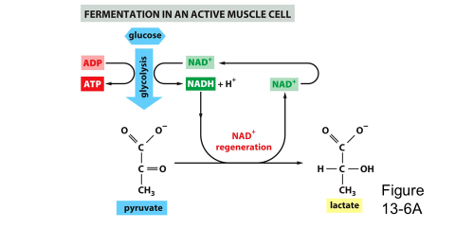
Glucose + 2ADP + P_{I} 2Ethanol +CO₂ + 2ATP
Glucose + 2ADP + P_{I} 2Lactate + 2ATP

Summary of glycogen and glycolysis
- Excess glucose is stored as glycogen in a process that is regulated allosterically and by enzyme covalent modification (phosphorylation) in response to hormone
- In glycolysis, 1 molecule of glucose is oxidized to pyruvate, forming 2ATP and 2NADH
- Glycolysis is regulated allosterically and by availability of glucose
- Fermentations produce ATP in the absence of O₂, with no net oxidation
Gluconeogenesis
- Occours in liver (& kidneys)
- Supplies glucose to body when glycogen stores are low (primarily for the brain)
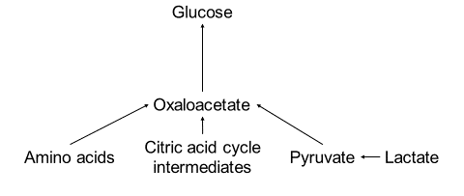

- How can it proceed if pyruvate is lower energy?
- Concentrations of substrates are different therefore le chatliers principle says it will shift to make more glucose as a end result
- Non-equilibrium reactions proceed differently in reverse direction
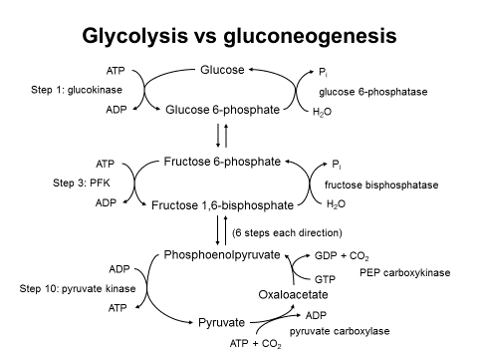
  - Requires energy input
Net reaction
2Pyruvate + 4ATP + 2GTP + 2NADH Glucose + 4ADP + 2GDP + 6P_{I} + 2NAD⁺
- (glucose is exported from liver)
Fructose biphosphatase in gluconeogenesis is feedback inhibited Fructose-2,6-biphosphate (also inhibited by AMP (not enough energy to make glucose, so use another pathway)

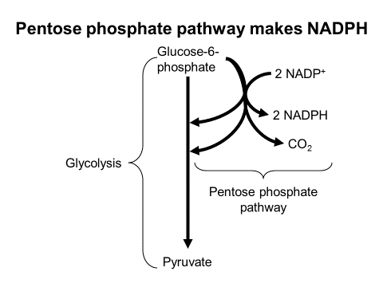
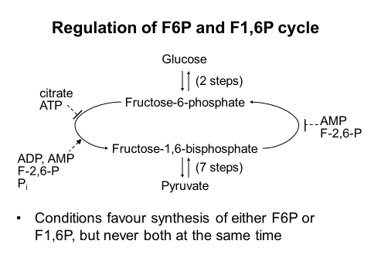
- Ribose-5-phosphate os a pentose phosphate pathway intermediate and can be used to biosynthesize nucleotides
Topic 13:
The mitochondrion
- Many small pores that allow small molecules(<5000Da) to cross into/outof intermitochondrial space
- Inner membrane prevents ions and polar molecules from crossing, unless a special pathway exists; folds to form cristae
Cellular respiration
Pyruvate + O₂ CO₂ + H₂O
- Pyruvate oxidation occours in 2 stages
- Decarboxylation of pyruvate to form acetyl-coenzyme A
- Oxidation of the acetyl of acetyl-CoA in the citric acid cycle
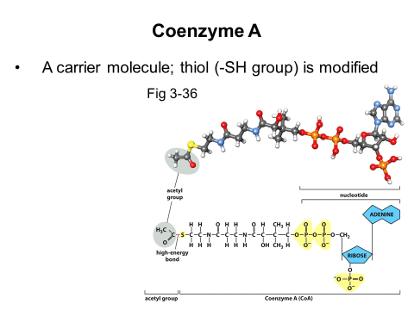
- Formation of acteyl CoA from pyruvate
Pyruvate + NAD⁺ + CoA (pyruvate dehydrogenase) Acetyl-CoA + CO₂ + NADH
- Pyruvate dehydrogenase complec: 3 different enzymes in multiple copies; 60 polypeptide chains in all
- Acetyl-CoA and NADH are competitive inhibitors (when NADH & acetyl-CoA concentrations they compete with pyruvate and NAD⁺ without lowering the maximum kinetics)
- Inactive when phosphorylated and active when not phosphorylated
  - Phosphorylation of the complex is promoted by Acetyl-CoA and NADH
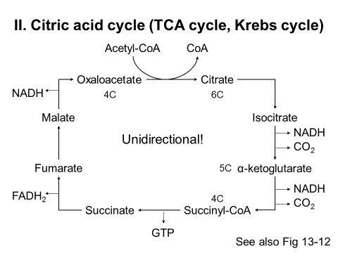
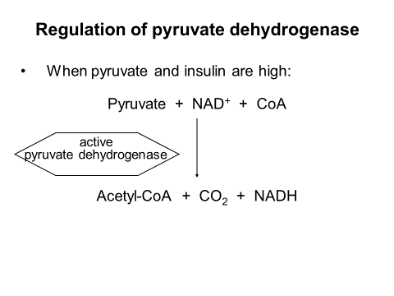
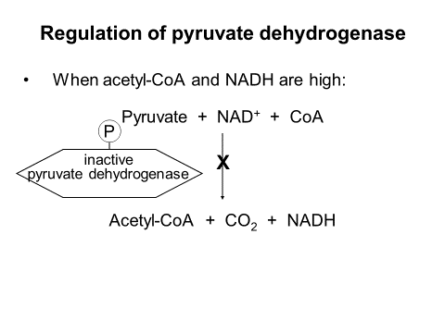
  - Conversely Pyruvate and insulin promote dephosphorylation

Net reaction of the Critic Acid Cycle:
Acetyl-CoA + 3NAD⁺ + FAD + GDP + P_{I} 2CO₂ + CoA + 3NADH + FADH₂ + GTP

Waste Recycled Electron transport chain ATP equilvalent (useable energy)

Regulation of the Citric Acid Cycle
- Availability of substrate
- Competitive inhibition by products (feedback inhibition)
- Allosteric regulation
Topic 14:
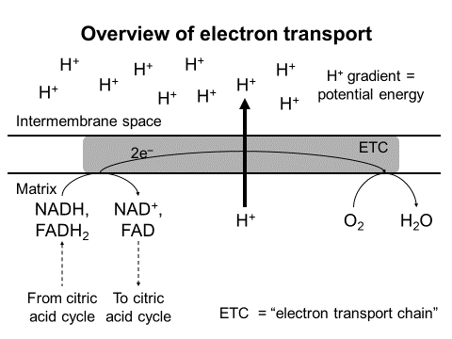
An aside: cofactors & coenzymes
- Cofactor: a non-protein chamical group that enables an enzyme to catalyze a reaction
  - Not necessarily tightly bound to enzyme
- Coenzyme: a cofactor that is mostly an organic molecule (carbon based)
- Prosthetic group: A cofactor that remains tightly bound to the enzyme
- Coenzymes are chimically changed as the reaction is catalyzed, so they can be considered substrates (eg: pyruvate oxidation and CoA)

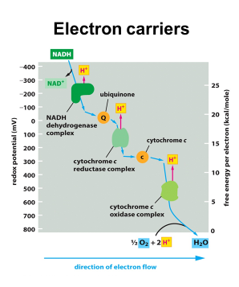
Electron carriers
- Most are embedded in the four large intergral protein complexes of the electron transport chain
- Electron carriers differ in their affinity for electrons (increasing affinity as you go down the chain)

- Electrons pass from a carrier with low affinity to a carrier with higher affinity
- The electron transport chain has 5 types of electron carriers
- In approximate order of increasing affinity for electrons:
- Flavins
- Iron-sulfur centres
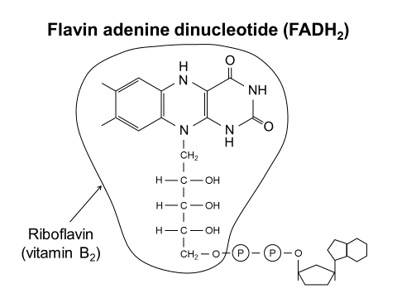
- Ubiquinone
- Cytochromes
- Copper centres

- Flavins (bound to protein)
  - Isoallxazine (flavin ring) can accept two electrons (along with 2 protons)
- Iron-sulfur centres (always protein bound)
  - Each centre can accept one electron (Fe³⁺ Fe²⁺)
  - Different types exist
    - Sulfur surrounds the iron centers, these sulfurs are from cysteine residues in the protien
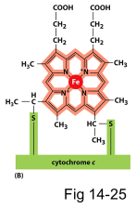
- Ubiquinone (freely diffusing lipid)
  - A lipid that freely diffuses in the membrane; also called Coenzyme Q or simply Q
  - Accepts 2 electrons
    - Has a one electron bearing free radical form
- Cytochromes (peripheral membrane protein in intermembrane space)
  - Proteins that contain heme groups, with an iron ion at the centre
  - Can accept one electron at a time
- Copper centres (always protein bound)
  - Copper ions, usually coordinated by histidine side chains
  - Can accept one electron (Cu²⁺ Cu⁺)
  - Bound to Glu and Cys
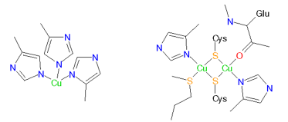

Electron transport protein complexes
- Four large complexes (1,2,3,4) made up of many polypeptide chains
- Embedded in the inner mitochondrial membrane (integral membrane proteins)
- Contain electron carriers as cofactors or coenzymes
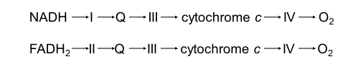
- Electron flow:

Complex 1: NADH dehydrogenase
- Accepts two electrons from matrix NADH (not cytsolic)
- NADH Flavin (FeS)_{n} Q
- Pumps 4 protons across the membrane (from matrix to intermembrane space) per electron pair
- NADH + Q + 5H⁺_{mat} NAD⁺ + QH₂ + 4H⁺_{IM}
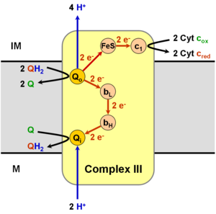
Complex 3: cytochrome b-c₁ complex

- Accepts 2 electrons from QH₂
  - QH₂ Fe₂S₂ cyt. C₁ cyt. C
  - Q⁻ cyt. B Q (or Q⁻)
- This process is repeated with a second QH₂
- Net result of the “Q cycle”: 4 protons are added to the intermembrane space per 2 cytochrome c’s reduced, and 1 QH₂
Net reaction: QH₂ + 2cyt. C(ox) + 2H⁺_{mat} Q + 2cyt. C (red) + 4H⁺_{IM}
Q cycle explained:
When 2H⁺ are removed they are pumped out and e⁻ is transported down the electron carriers to cyto c
2nd e⁻ is then trnasported to another Q by cyt. B’s heme groups, making the free radical semiquinone goes through the pathway again, semiquinone is now fully reduced and grabs 2 H⁺ from the matrix and will leave to allow cycle to continue
Complex 4: cytcochroe oxidase complex
- Accepts one electron at a time from cytochrome c
- Cyt. C Cu₂ heme a Cu-heme a₃ O₂
- One proton is pumped to the intermembrane space per electron, and additional protons are taken from the matrix to make H₂O
- 4 cyt c (red) + O₂ + 8H⁺_{mat} 4 cyt c (ox) + 2H₂O + 4H⁺_{IM}
Complex 2: succinate dehydrogenase
- Accepts two electrons from succinate and transfers them to FAD to make FADH₂
- Electrons go from FADH₂ to iron-sulfur centres, then to coenzyme Q
- DOES NOT PUMP PROTONS ACROSS MEMBRANE
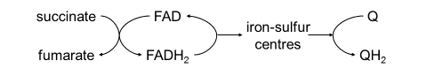
FADH₂ + Q FAD + QH₂
Electron transfer within complex 2
Kreb cycle
- FAD/FADH₂ is covalently bonded to complex 2
Electron transport
- Iron-sulfur centres are permanetly associated with complex 2
- Q/QH₂ transiently associates with complex 2
  - NADH made in cytosol transfers it electrons to Q via a protein in the inner mitochondrial membrane (reduces FADH₂)
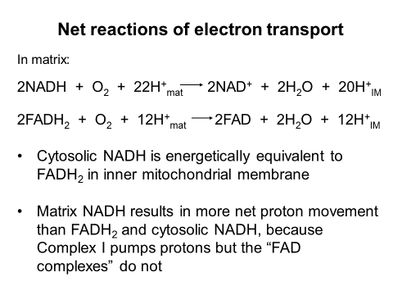
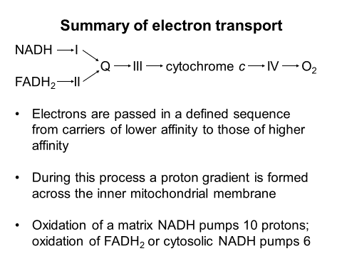
  - ^^^ only happens in muscle and brain cells
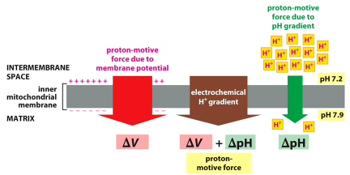
Topic 15:
Proton gradient from electron transport
- Electron transport chain pumps protons out of the mitochondrial matric
  - IM: pH = 7.2, Matrix: pH = 7.9
Chemiosmotic hypothesis
- In 1961 Peter mitchell proposed the chemiosmotic hypothesis that the protonmotive force drives synthesis of ATP
- This theory explains why destruction of the proton gradient inhibits ATP synthesis
- Conversely, creation of an artificial proton gradient stimulates ATP synthesis
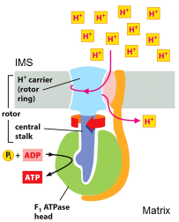

F₁F₀ ATP synthase
- A protein that allows protons to flow down their electrochemical gradient
- The energy from this proton movement is used to make ATP
- ATP is made in the matrix
- H⁺ proton rotor ring is turned by H⁺
- Central stalk turns and this turning catalyzes the reaction

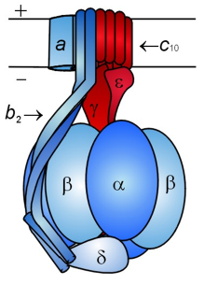
E. coli F₁F₀ ATP synthase
F₀
- 3 subunits: ab₂c₁₀
F₁
F₀
- Proton channel
- Transmembrane
F₁
- 5 subunits: α₃β₃ϒδε
- Makes ATP
- Peripheral
Mechanism of ATP synthesis
Role of each subunit
F₀
- A – helps from proton channel; anchors b₂ in membrane
- B₂ – forms second stalk (that “stator”) that prevents α₃β₃ from rotating
- C₁₀ – helps form proton channel; rotates during proton movement
F₁
- Α₃β₃ – form active sites (one on each β); conformational changes causes ATP synthesis
- ϒ – forms part of central stalk; rotates with c₁₀ to cause conformational changes in α₃β₃
- Δ – helps attach b₂ to α₃β₃
- Ε – helps assemble complex; inhibits ATP hydrolysis (doesn’t unmake ATP)
Net reaction of ATP synthase
- For each full rotation of the c₁₀ ring:
  - 10 protons croos the membrane
  - 3 ATP is made
- Therefore synthesis of 1 ATP requires movement of 3.33 protons across the membrane
3 ADP + P_{I} + 10H⁺_{IM} 3ATP + 3H₂O + 10H⁺_{mat}
ΔG is negative for this reaction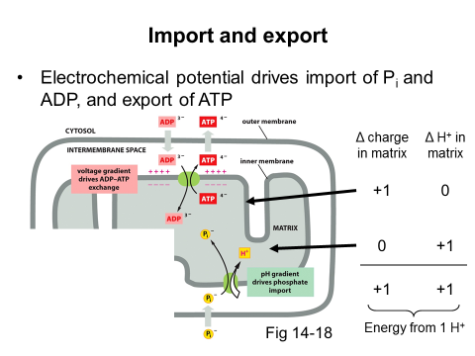
Stoichiometry of ATP synthesis
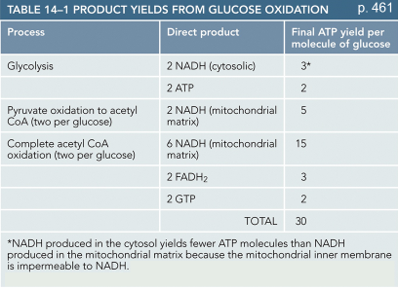
- Assume: ATP synthase uses 3H⁺ to make 1 ATP and import-export costs 1 H⁺
- So total cost of making 1 ATP is 4H⁺
- Oxidation of matrix pumps 10 H⁺ so 1 matrix NADH allows synthesis of 2.5 ATP
- Oxidation of FADH₂ or cytosolic NADH pumps 6 H⁺, allowing synthesis of 1.5 ATP

Topic 16:
Release of acetyl-CoA from acid sotrage
- Happens under low glucose conditions
- Triaclglycerols broken down to glycerol and fatty acid
  - Glycerol is sent to the liver for gluconeogenesis
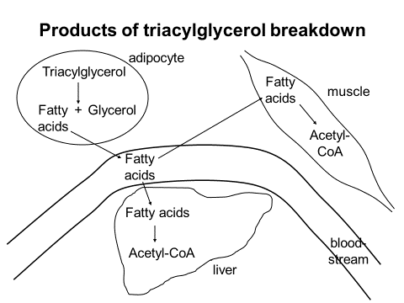
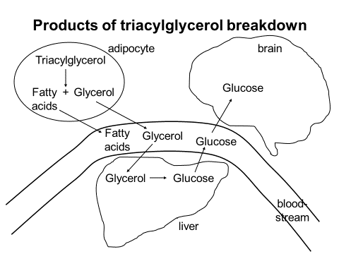
  - Fatty acids go into beta-oxidation which happens in the liver and muscle cells (not brian)
Activation of fatty acids in cytosol
- Fatty acyl-CoA is transported into the mitochondrial matric
  - Carboxyl group is converted into a ketone group with a sulfur from the CoA adjacent to ketone bearing carbon
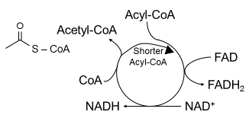
Beta oxidation of fatty acids in the matrix

- Carbons are removed from fatty acid 2 at a time
- Produces 1 NADH and 1 FADH₂ per “cycle” or every 2 carbons removed from fatty acid
- No ATP directly produced
- Net reaction for acyl-CoA with “2N” carbons:
Acyl-CoA + (N-1)FAD + (N-1)NAD⁺ + (N-1)CoA N Acetyl-CoA + (N-1)FADH₂ + (N-1)NADH
Enters citric acid cycle, or (inliver) converted to ketone bodies (for brain)
Donate electrons to electron transport chain

- Oxidation of unsaturated fatty acids yields fewer FADH₂ and may consume NADPH (attachment of different function to make a fully reduced carbon more sugar like)
- Oxidation of “odd” fatty acid chains yields one propionyl-CoA which enter CAC as succinyl-CoA (will make 2 NADH less than acetyl-CoA)
FADH₂ come from different sources
Q
- FADH₂ from citric acid cycle
- FADH₂ from cytosolic NADH (brain/muscle only)
QH₂
- FADH₂ from fatty acid oxidation

- Each FADH₂ gives electrons to Q to make QH₂ but using different protein complexes
Ketone bodies (only in liver)
- How acetyl-CoA is transported from liver to other tissues
- Low glucose conditions
  - Acetone, Acetoacetate, Beta-hydroxybutyrate
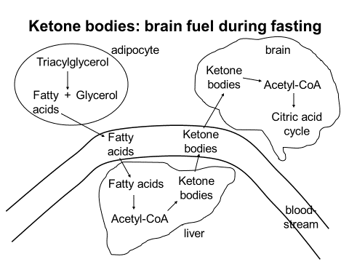
Fatty acid biosynthesis
- High glucose conditions
- Tricarboxylate transport system moves acetyl-CoA into cytosol, consuming ATP and NADH but making NADPH (how?)
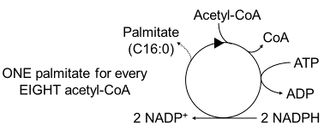
- Similar to Beta-oxidation of fatty acids, but in reverse
- Cosumes NADPH instead of NADH or FADH₂
- 1 ATP consumed per “cycle”
Net reaction
8Acetyl-CoA + 14NADPH + 7ATP Palmitate + 8CoA + 14NADP⁺ + 7ADP + 7P_{I}
- Enzymes exist to add double bonds
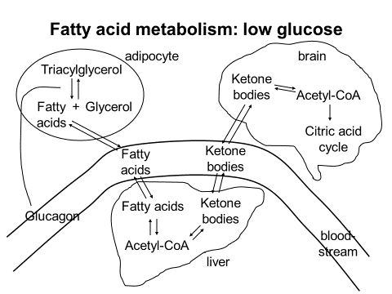
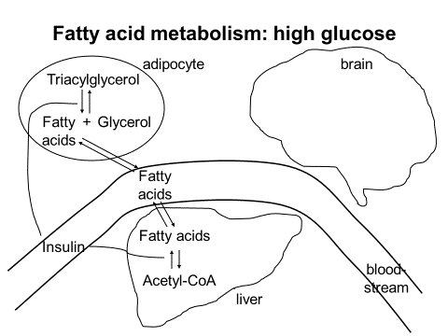
- Fatty acids are sotred as triacylglycerols or used to make membrane lipids

Synthesis and breakdown pathways
- Glycolysis and citric cycle provide precursors for synthesis of many biomolecules
  - All carbons of cholesterol are derived from acetyl-CoA
(HMG-CoA reductase)
Proteins as an energy source
- Amino acids can be converted to intermediates in glycolysis and the citric acid cycle
- Provides about the same energy by mass as carbohydrates

Topic 17:
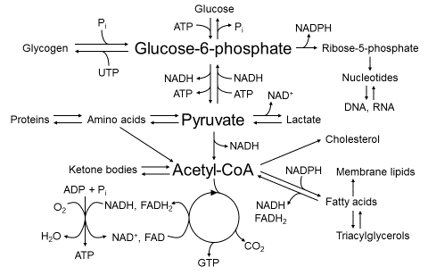
Fed state
- Blood glucose is high, pancreas secretes insulin
- Initially, flux through glycolysis and CAC is high because of high [substrate] and [insulin]
- Eventually, [ATP] and other energy indicators increase, inhibiting glycolysis and CAC
- Glycogen synthesis, fatty acid synthesis, pentose phosphate pathway, and biosynthesis are favoured
Unfed state
- Blood glucose is low, pancreas secretes glucagon
- Glucose is produced from glycogen and then gluconeogenesis (from amino acids obtained from protein degradation)
- Adipocytes release triacylglycerols from storage to create acetyl-CoA through beta-oxidation
  - Liver will create ketone bodies for brain to use
- Biosynthesis is not favoured
Diabetes
- Insulin response is low or non-existent
- Type 1: auto-immune destruction of pancreatic cells that produce insulin
- Type 2: insulin resistance coupled with impaired insulin secretion
- Glucose doesn’t enter cells efficiently, so cells act as if [glucose] were low: resembles unfed state
- Triacylglycerol degradation and gluconeogenesis are stimulated
- Ketone bodies accumulate in blood, acidifying it, leads to dehydration and low blood volume
  - Very thirsty, body’s attempt to dilute blood pH

