Laboratory Report Form

Experiment 3.

Acid Base Titrations

Student Name:

Student Number:

Partner’s Name and Student #:

Demonstrator's Name:

Lab Day (T/W/Th/F):

Lab Week (even/odd):

Lab time (10:00, 2:30, 6:30)
Introduction:

Acids and bases are substances that are very prevalent in the lab as well as in the real world. Both strong acids and bases can be corrosive and therefore should be used with care. A defining trait of bases is that they are bitter in taste, where as acids are sour.

The two most common ways of defining acids and bases are the Arrhenius definition and the Bronsted-Lowry definition. Firstly, the Arrhenius definition states that bases are substances that, when dissolved in water, donate hydroxide (OH⁻) ions. On the other hand, acids donate a proton in the form of a hydrogen ion (H⁺).

LiOH_{(s)} → Li⁺_{(aq)} + OH⁻_{(aq)} [1]

In the above example, LiOH follows the above equation when placed in water, losing its hydroxide ion. Thus, it is an Arrhenius base.

HCl_{(aq)} → Cl⁻_{(aq)} + H⁺_{(aq)} [2]

In the second example, HCl follows the above equation when places in water, losing is hydrogen ion. Thus, it is an Arrhenius acid.

A major flaw in the Arrhenius definition is that some substances, such as HCO₃⁻ do not donate hydroxide ions but still act as bases. This is where the Bronsted-Lowry definition comes in. It explains that bases are hydrogen acceptors when placed in water; the definition of acids remains the same. Based on the types of acids and bases used in this specific experiment, the Arrhenius definition will be used.

The amount of water and acid/base added together will give the concentration of said acid/base. The units of this concentration are moles per litre and the relation is expressed by the equation below.

$Concentraion \left(\frac{mol}{L}\right)=\frac{amount of solute (mol)}{volume of solution (L)}$ [3]

A less concentrated solution contains more water and less acid/base, where as a more concentrated solution contains less water and more acid/base.

In addition to being described by their concentrations, acids and bases can also be described by their strength. A weak acid/base, when placed in water, does not completely dissociate. A strong acid/base will completely dissociate when placed in water. This means that there will be very little reactant left over as it will all have dissociated to from products (see equation [2])

The term neutralization reaction is used to describe the general reaction between acids and bases which form a salt and water. The amount of acid added to perfectly titrate the base is referred to as the equivalence point and the amount of acid needed to neutralize a base can be found using the stoichiometry of the reaction. Below is an example of an acid base reaction.

H2SO4 (aq) + 2 NaOH (aq) → Na2SO4 (aq) + 2 H2O (l) [4]

The equation below can be used to determine the approximate value of the concentration of the NaOH solution by relating the initial and final values of concentration and volume.

C₁V₁ = C₂V₂

When calculation the exact values of concentration the below equation can be used. Where ‘c’ stands for concentration, ‘V’ stands for volume and ‘a’ and ‘b’ are the stoichiometric coefficients for the acid and the base respectively.

C_{base} x V_{base} = $\frac{b}{a}$ C_{acid} x V_{acid}

To find the coefficients we must know if the acid is monoprotic, diprotic or triprotic (as the acid is unknown and therefore the chemical equation is not known). The acid to base ratio, or stoichiometric coefficients are 1:1 for a monoprotic acid, 1:2 for a diprotic acid and 1:3 for a triprotic acid.

References: “Titration of a Diprotic Acid: Identifying an Unknown”, 25, Vernier Software and Technology, pg. 25-1, 2007

An indicator is used, in the case of this experiment it is phenolphthalein, to indicate the endpoint of the titration. An indicator is a weak acid that dissociates differently based on the acidity of a solution. The name indicator refers to the fact that its dissociated states have different colours and therefore are used to indicate change in pH. The endpoint and equivalence point should be very close if the correct indicator is chosen and the titration is performed well.

Procedure:

As described in the lab manual. (Acid Base Titrations, Dr. Rashmi Venkateswaran, n.d., pg. 79-83)
Data/Observations/Results:

Table 1. Formation of a stock solution of NaOH

Volume of concentrated NaOH solution (mL) | 4.8 ml
Concentration of concentrated NaOH solution (M) | 6 M
Volume of stock solution after dilution (mL) | 254.8 ml
Approximate concentration of stock solution (M) | 0.1 M

Table 2. Standardization of Stock Solution of NaOH

Data | Trial 1 | Trial 2 | Trial 3
Concentration of Standard Acid solution (M) | 0.1000M | 0.1000M | ----
Volume of Standard Acid solution (mL) | 10.10 ml | 10.00 ml | ----
Volume of stock solution of NaOH (mL) | 9.652 ml | 9.870 ml | ----
Concentration of stock solution of NaOH (M) | 0.1046 M | 0.1013 M | ----
Average Concentration of stock solution of NaOH (M) | 0.1030 M

Table 3. Determination of the Concentration of an Unknown Acid

Data | Trial 1 | Trial 2 | Trial 3
Sample Number of Unknown Acid | 3 | 3 | ----
Volume of Unknown Acid solution (mL) | 10.05 ml | 10.05 ml | ----
Volume of stock solution of NaOH (mL) | 7.522 ml | 9.391 ml | ----
Concentration of stock solution of NaOH (M) | 0.1030 M | 0.1030 M | ----
Concentration of Unknown Acid Solution (M) | 0.0452 M | 0.0481 M | ----
Average Concentration of Unknown Acid solution (M) | 0.0467 M

Table 4. Determination of the Mass Percentage of Acid in a Juice

Data | Trial 1 | Trial 2 | Trial 3
Sample Number of Juice | 2 | 2 | ----
Volume of Juice (mL) | 10.15 ml | 9.95 ml | ----
Volume of stock solution of NaOH (mL) | 9.957 ml | 10.17 ml | ----
Concentration of stock solution of NaOH (M) | 0.1030 M | 0.1030 M | ----
Concentration of acid in Juice (M) | 0.0337 M | 0.0351 M | ----
Average Concentration of Acid in Juice (M) | 0.0344 M
Density of Juice (g/mL) | 1.0001 g/ml
Molar Mass of acid in Juice (g/mol) | 192.124 g/mol
Mass Percent of Acid in Juice (%) | 0.6608%

Standard Acid Trials:
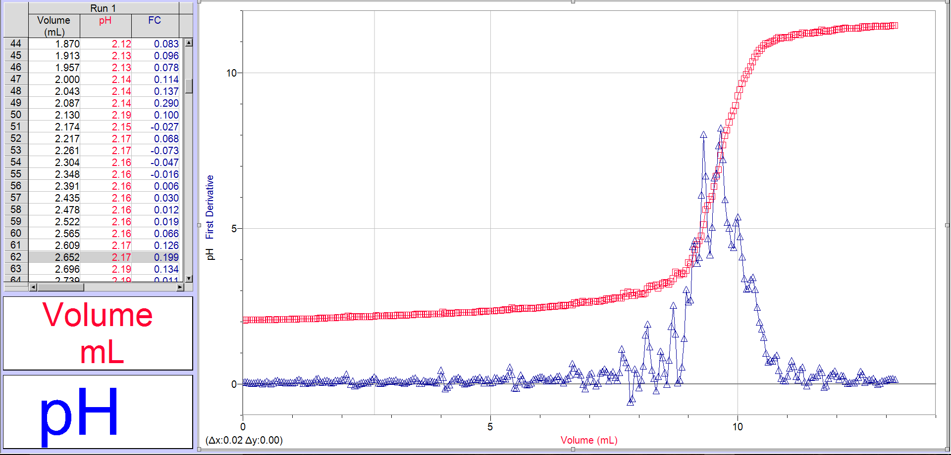
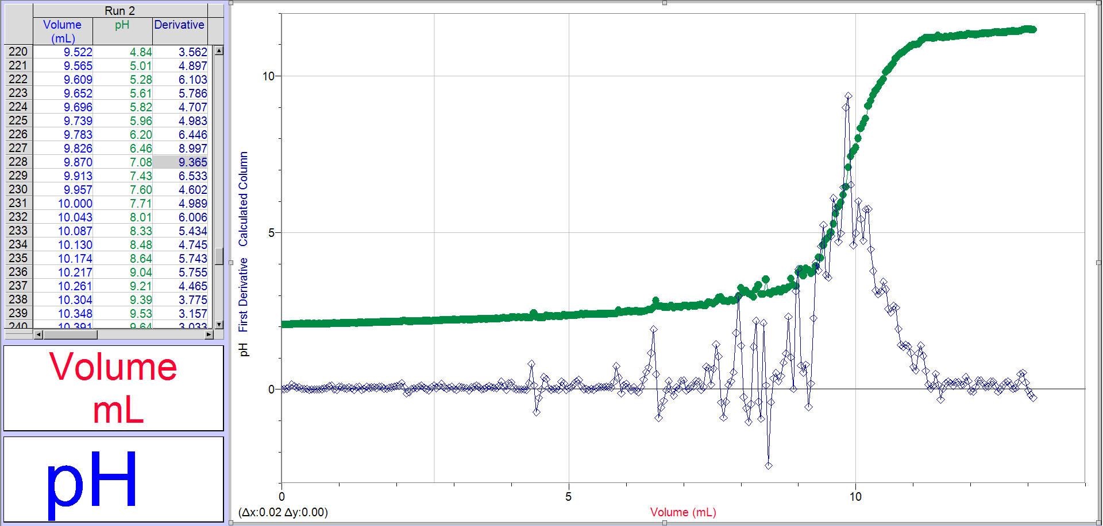

Unknown Acid Trials:

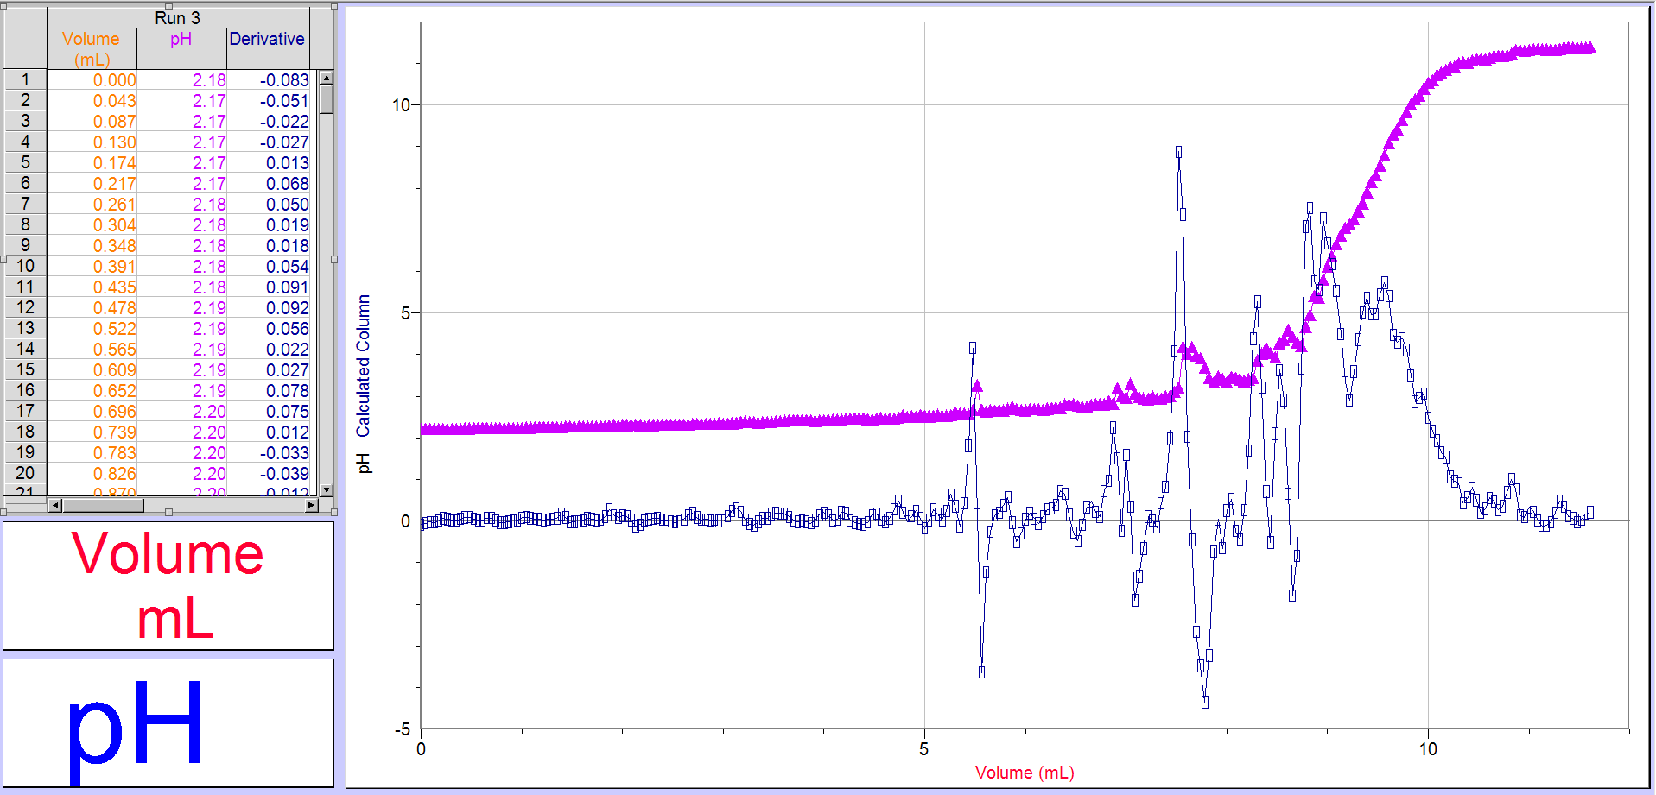

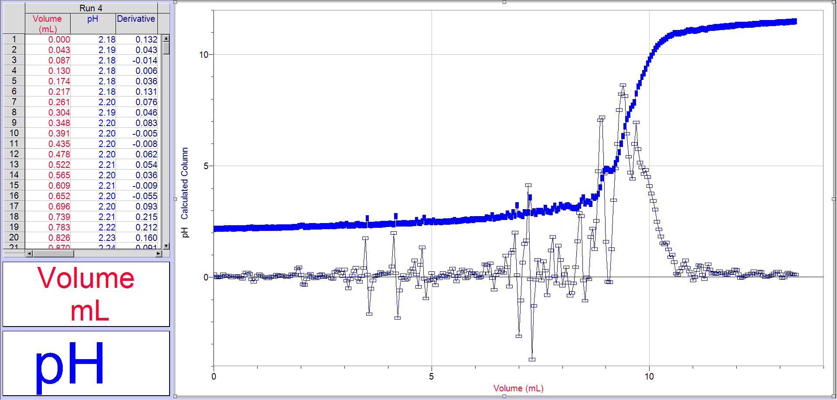

Juice Trials:

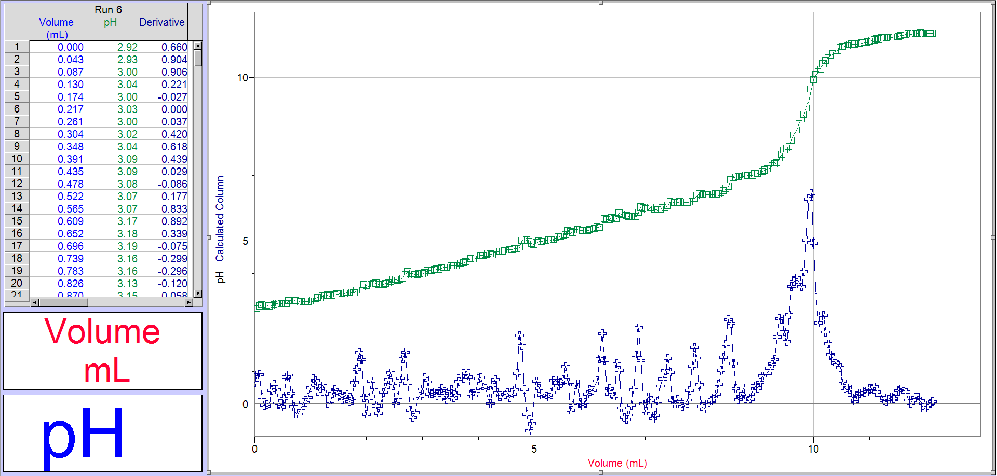

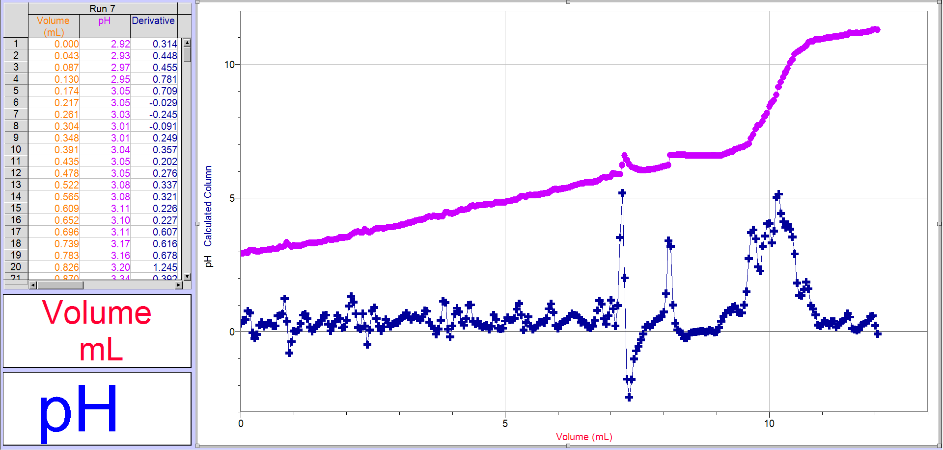

Calculations:

- Approximate concentration of NaOH solution

C₁V₁ = C₂V₂
(6)(0.0048) = C₂(0.2548)
C₂ = 0.1 M

- Exact concentration of NaOH solution

Trial 1:

C_{base} x V_{base} = $\frac{b}{a}$ C_{acid} x V_{acid}
C_{base} x (0.009652 L) = $\frac{1}{1}$(0.1000 M)(0.01010 L)
C_{base} = 0.1046 M

Trial 2:

C_{base} x V_{base} = $\frac{b}{a}$ C_{acid} x V_{acid}
C_{base} x (0.009870 L) = $\frac{1}{1}$ (0.1000 M)(0.01000 L)
C_{base} = 0.1013 M

Average:

$$\frac{Trial 1+Trial 2}{2}$$

= 0.1030 M

- Exact concentration of unknown acid

Trial 1:

C_{base} x V_{base} = $\frac{b}{a}$ C_{acid} x V_{acid}
(0.1030 M) (0.008826 L) = $\frac{2}{1}$ C_{acid} x (0.01005 L)
2C_{acid} = 0.0904 M
C_{acid} = 0.0452 M

Trial 2:

C_{base} x V_{base} = $\frac{b}{a}$ C_{acid} x V_{acid}
(0.1030 M)(0.009391 L) = $\frac{2}{1}$ C_{acid} x (0.01005 L)
2C_{acid} = 0.0962 M
C_{acid} = 0.0481

Average:

$$\frac{Trial 1+Trial 2}{2}$$

= 0.0467 M

- Exact concentration of acid in juice

Trial 1:

C_{base} x V_{base} = $\frac{b}{a}$ C_{acid} x V_{acid}
(0.1030 M)(0.009957 L) = $\frac{3}{1}$ C_{acid} x (0.01015 L)
3C_{acid} = 0.1010
C_{acid} = 0.0337 M

Trial 2:

C_{base} x V_{base} = $\frac{b}{a}$ C_{acid} x V_{acid}
(0.1030 M)(0.01017 L) = $\frac{3}{1}$ C_{acid} x (0.00995 L)
3C_{acid} = 0.1052
C_{acid} = 0.0351 M

Average:

$$\frac{Trial 1+Trial 2}{2}$$

= 0.0344 M

- Mass percent of acid in juice

= $\frac{(C acid)(MM acid)}{\left(DENSITY juice\right)x1000}$ x 100%
= $\frac{(0.0344 M)(192.124 g/mol)}{\left(1.0001\right)x1000}$ x1 00%
= $\frac{6.6090656}{1000.1}$ x 100%
= 0.6608%

Discussion:

Conclusion:

In this experiment, it was calculated that the exact concentration of the NaOH solution was 0.1030M. The exact concentration of the unknown acid was calculated to be 0.0467 M. The exact concentration of the acid in the juice was 0.0344 M with the mass percent of the acid in the juice being 0.6698%.

