Oncogenes typically include:
- Growth factor receptors and proteins the help growth factors receptors to function
  - examples: HER2/neu, Ras
- Proteins that are involved the transcription of genes involved in cell proliferation
  - example: myc
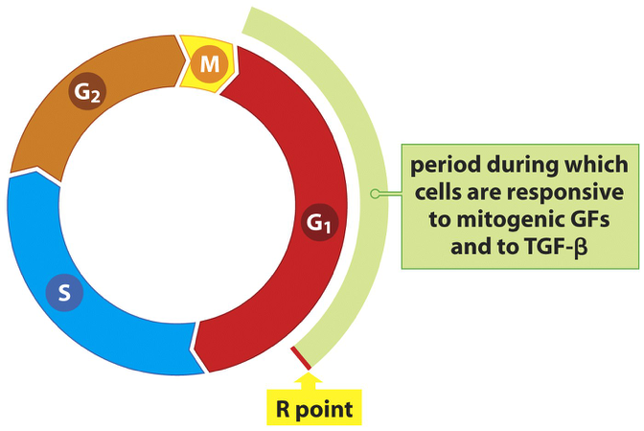
Oncogenes often function by pushing the cell to enter the cell cycle at G1

The transcription factor Myc induces the expression of cyclin D to help push cells in to G1

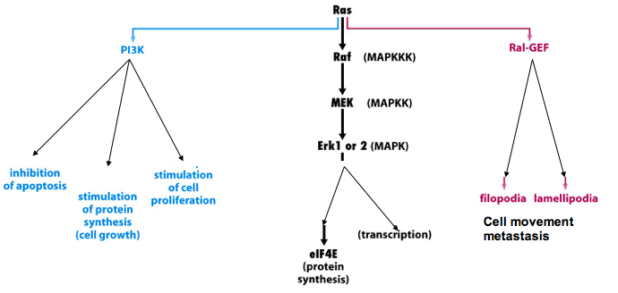
Ras is an excellent oncogene since it promotes many features of cancer

Since Her2/neu is an oncogene that promotes Breast cancer cell growth, it has been a target for therapies
- Perception (Trastuzumab) is an antibody used to target and kill cells expressing HER2/neu on their surface and has been a very successful therapy for this kind of breast cancer.

Cancer is progressive disease and can be discovered at different stages:
- When a cancer is found and surgery and imagine is done the tutor can be staged:
  - the TNM system is based on the extent of the tumour (T), the extent of spread to the lymph nodes (N), and the presence of metastasis (M). A number is added to each letter to indicate the size or extent of the tutor and the extent of spread.

Stage Definition
- Stage 0: carcinoma in situ (early cancer that is present only in the layer of the cells in which it began).
- Stage 1, Stage II, and Stage III: higher numbers indicate more extensive disease: greater tutor size, and/or spread of the cancer to nearby lymph nodes and/or organs adjacent to the primary tumor.
- Stage IV: the cancer has spread to another organ

Oncogenes cooperate with tumor suppressors.
So even if an oncogene is activated, cells still need to get rid of the p53 tumour suppressor in order to become cancerous

Experimental skin papilloma (premalignant growth) and progression to cancer

Can factors in the body function as tumour promoters?
Breast Cancer: a mutation happen in a cell in the great epithelium. If the cell does not divide then nothing will happen, but if it does, it can propagate the mutation and result in new mutations that cooperate to produce a cancer cell.
What causes these cell to divide? Estrogen. Therefore estrogen can act as a tumour promoter.
Evidence: Hormone Replacement therapy and late menopause can contribute to breast cancer
Therapy: Tamoxifen is used to treat breast cancers to block the estrogen receptor.

Cancer can leave the primary tissue and metastasize at secondary sites. Where cancers of a specific type will establish a metastasis depends on where the target tissue is relative to the blood circulation and the type of tissues the cancer cels prefers.

Summary
- cancer is a proliferative disease of tissues involving DNA mutations of different combinations of genes that originate in a wide variety or ways
- Tumor suppresor genes and oncogenes cooperate to provide growth and survival signals to cancer cells
- Cancer is progressive and moves through stages that may require many years to complete
- If a cancer is left untreated it may enter the blood vessels and lymph nodes and set up secondary metastases in other tissues resulting in eventual death

Cancer Chemotherapeutics - chemotherapeutics interfere with the replication of DNA or mitotic events during the cell cycle

- Antimetabolites
  - mechanisms of action are based on the structure of the drugs which are closely related to normal molecules made by the body and therefore interfere with normal processes
  - 2 classes:
    - inhibiting the synthesis of purine and pyrimidine precursors
    - ex,: methotrexate and 5-flurouracil
    - directly competing with the normal molecules in DNA or RNA synthesis ex: Gemcitabine
    - Relatively few or mild side effects
2. Antibiotics
Doxorubicin/Adriamycin:
generate reactive oxygen species which can create DNA strand breaks
intercalation between bases resulting in uncoiling of DNA
Applications: many cancer subtypes including blood cancers and adenocarcinomas
3. Drugs that inhibit microtubules
- inhibitors of microtubules prevent mitosis by interfering with the mitotic spindle
- a) taxols; paclitaxel and docetaxel - needles of the european yew (semi-synthetic)
- b) Vinca alkaloids: vincristine and vinblastine - derived from periwinkle
- indications for taxanes: metastatic ovarian and breast and lung cancers
- ind. for vinca: both hemtalogic cancers and solid epithelial carcinomas
4. Drugs that target DNA unwinding enzymes (topoisomerases)
- anthracyclines: doxorubicin, podophyllins
- campothecins: topotecan
5. Platinum compounds
- Cisplatin: binds to the DNA helix and kinks it so that it cannot be copied
  - application: many cancers that are often refractory to other treatments
  - metabolism: directly eliminated through the kidneys

Side effects of chemotherapeutics:
- GI irritation
- stomatitis (inflammation of mouth)
- hepatoxicity (liver toxicity)
- nausea and vomiting
- alopecia (loss of hair)
- bone marrow suppression

Specific toxic effects of drugs
- adriamycin causes cardiotixicity - due to damage of heart tissue
- taxanes and vinca alkaloids cause neurotoxicity (confusion, memory loss, movement disorder)
- cisplatin is very toxic and also causes ototoxicity (ringing in ears/loss of hearing)

