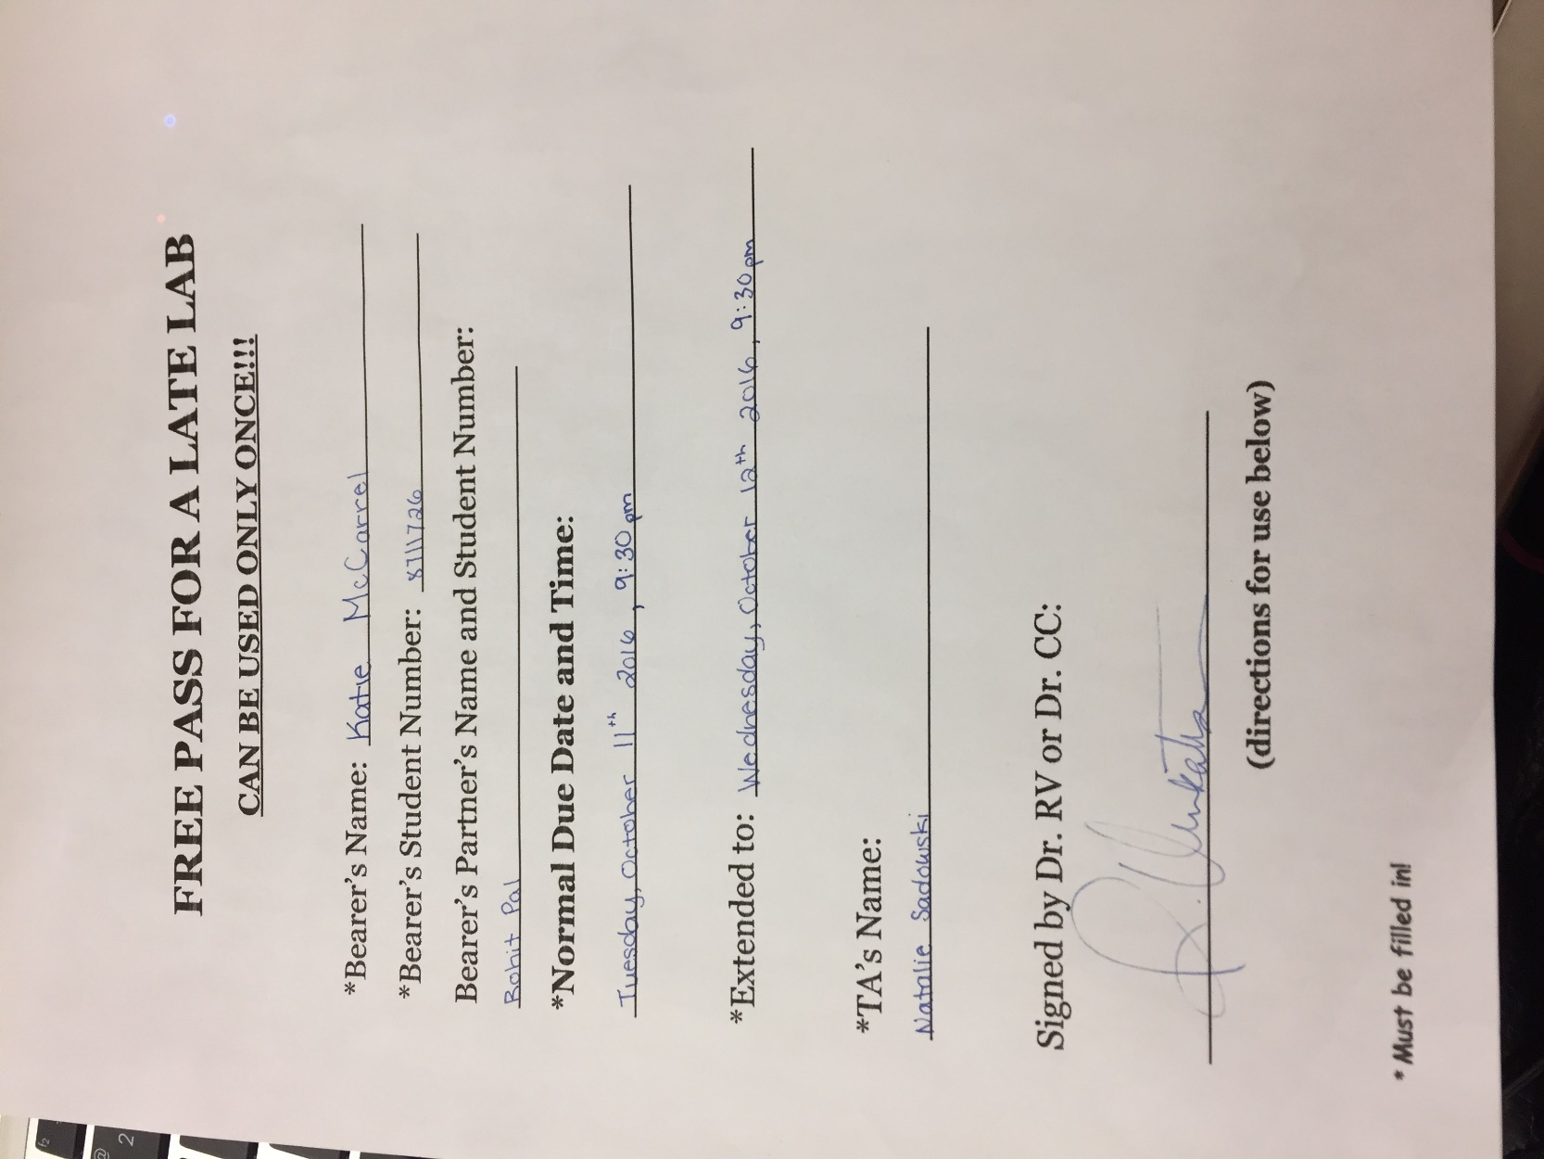

Student Name: Katie McCarrel

Student Number: 8711726

Partner’s Name and Student #: Rohit Pal, 8902128

Demonstrator's Name: Nathalie Sadowski

PLEASE NOTE: If ANY of the above information is UNCLEAR or not provided, your grade will NOT be recorded!!

Lab Day (T/W/Th/F): Tuesday

Lab Week (even/odd): Even

Lab time (10:00, 2:30, 6:30): 6:30

Laboratory Report Form

Experiment 2.

Equilibria

Checklist:

- Raw Data Sheet written in pen, signed by TA and attached
- Completed Report Form attached

Student’s Initials KM

Procedure

As described in the lab manual (Ref)

Table 1. Observations and Discussion

[Cu(H₂O)₄]²⁺ (aq) + 4 NH₃ (aq) [Cu(NH₃)₄]²⁺ (aq) + 4 H₂O (l)

-CuSO₄ clear, blue liquid
-NH₃ Clear liquid, very strong odour

-CuSO₄ + NH₃ with 3 drops of NH₃ added to 1 mL of 0.1 mol/L CuSO₄ the liquid became a more opaque, dark blue liquid.

-HCl Clear liquid

-CuSO₄ + NH₃ + HCl 27 drops of 1 mol/L HCl was added, as a result the liquid turned back to a cloudy light blue liquid. Since it was cloudy, it indicates a precipitate was formed.
-When 4 drops of NH₃ was added for the second time, the solution transformed into a translucent liquid. The reaction for this acted as a gradient effect as it started from the top of the solution and worked its way down.

2AgNO₃ (aq) + Na₂CO₃ (aq) Ag₂CO₃ (s) + 2 NaNO₃ (aq)

-AgNO₃ Clear liquid
-Na₂Co₃ Clear liquid

-AgNO₃ + Na₂Co₃ 0.5 mL of 0.01 mol/L AgNO₃ was added to 0.5 mL of 0.01 mol/L, as a result a cloudy, yellow-brown substance was formed. Since it was cloudy, it indicates that a precipitate of Ag₂CO_{3 (s)} was formed.

2 H⁺ (aq) + CO₃²⁻ (aq) H₂CO₃ (aq) H₂O (l) + CO₂ (g)
-HNO₃ clear liquid

-When 3 drops of 6 mol/L HNO₃ was added to AgNO₃ + Na₂CO₃, the yellow-brown colour turned clear.
-Carbonic acid was produced and will turn into water making the colour the same, thus meaning that it will be a colourless solution
-The second time that HNO₃ was added, after only 4 drops the solution changed into a white, cloudy liquid which produced hydrogen gas and heat.
-The chemicals ate in a state of equilibrium, temperature, concentration and pressure can also change the equilibrium.
Ag⁺ (aq) + Cl⁻ (aq) AgCl (s)
-HCl clear liquid
-When 6 drops of 0.1 mol/L HCl was added the solution turned into a off-white cloudy liquid.
-Since it was cloudy, it means a precipitate was formed, thus supporting that AgCl _{(s)} was formed.

Ag⁺ (aq) + 2NH₃ (aq) [Ag(NH₃)₂]⁺ (aq)
NH₃ clear liquid, very strong smell.

-When 6 drops of concentrated NH₃, the solution transformed back into its clear liquid state.
-Instead of producing AgCl as a precipitate, [Ag(NH₃)₂]⁺ was formed, which dramatically changes the colour from the off-white to clear.
-The second time 5 drops of NH₃ was added and it turned the solution to a clear, colourless liquid.

H⁺ (aq) + NH₃ (aq) NH₄⁺ (aq)
-The second time HNO₃ was added, it made the solution clear
- 4 drops of HNO₃ was added, and once that happened the solution turned white and cloudy.
-Possible H_{2 (g)} was released.

Ag⁺ (aq) + I⁻ (aq) AgI (s)

-KI Clear liquid

-When 3 drops of 0.1 mol/L of KI was added, the solution went from a clear liquid to an off-white, cloudy, opaque liquid.
-Makes sense to be cloudy because a solid form of AgI was formed as precipitate.

2Ag⁺ (aq) + S²⁻ (aq) Ag₂S (s)

-Na₂S Clear, colourless liquid
-Once 2 drops of 0.1 mol/L of Na₂S was added, it turned into an opaque black-grey-brown liquid.

CH₃COOH (aq) + H₂O (l) H₃O⁺ (aq) + CH₃COO⁻ (aq)
-CH₃COOH Clear liquid
-Universal indicator translucent red liquid.
- The pH of the acid that was taken with the pH paper was 2, since the paper was dark orange.
-NaCH₃COO Clear, colourless liquid
-CH₃COOH + NaCH₃COO translucent liquid, slightly red from universal indicator.
-Distilled water Clear, colourless liquid, pH of 7.
-Distilled water + Universal indicator Translucent, red liquid.
-5 drops of HCl was added to a well with distilled water. The pH was taken again and the result was a dark orange colour on the pH paper, indicating it also had a pH of 2. The colour also got slightly darker
- Acetate + water Slightly red from universal indicator, also translucent liquid.
-NaOH clear liquid
-NaOH + water turned a purple colour, still a translucent liquid with a pH of 12.
-NaOH + acetate lighter orange colour, translucent liquid

4Cl⁻ (aq) + [Co(H₂O)₆]²⁺ (aq) [CoCl₄]²⁻ (aq) + 6 H₂O (l)
-CoCl₂ Red, translucent liquid.
-HCl Clear, translucent liquid.

-CoCl₂ + HCl 6 drops of HCl was added to CoCl₂ and the solution turned purple for a brief moment before adding 2 more drops turning it to a dark blue. 6 drops in total wee added, the translucent dark blue liquid also produced a small amount of H_{2 (g).}
-With the addition of water it turned into a pink translucent liquid. The water changed the concentration is the substance.
-Possibly due to the reduction of CoCl₂ [CoCl₄ ]⁽²⁻⁾
- 8 drops of H₂O was then added to the solution which made it a clear, transparent liquid.

4 Br ⁻ (aq) + [Cu(H₂O)₄]²⁺ (aq) [CuBr₄]²⁻ (aq) + 4 H₂O (l)
CuBr₂ A black shiny powder
CuBr₂ + H₂O 5 drop of water was added to the CuBr₂ which made the substance more liquid like as well as black and opaque. There were still some sold CuBr_{2.}
Adding another 10 drops completely dissolved the metal. It was a black opaque liquid.
Adding another 25 drops, it was black at the bottom, thus meaning all the metal settled at the bottom. After some time it eventually turned green.
-KBr solid white crystals
-Adding KBr made it a deep forest green.
-With heat it became a dark brown opaque liquid, completely dissolved the KBr.
-CoCl₂ + heat red clear liquid with small blue bubbles forming around the sides of the test tube. Once it was removed from heat, the blue disappeared.

Calculations:

pH of H₂O and HCl

$$C_{1}V_{1}=C_{2}V_{2}$$
C₁ = 0.1 mol/L
V₁ = 0.25 mL
C₂ = ?
V₂ =1.25 mL

C₂ = (C₁ ∙ V₁)/(V₂)
C₂ = (0.1 M ∙ 0.25 mL)/(1.250mL)
C₂ = 0.02 mol/L

$$pH=-\log{{[H]}^{+}}$$
pH = -log [0.02 mol/L]
pH = 1.7

Water has a pH of 7, the pH of the substance was 1.7 therefore the substance became more acidic by a pH of 5.3.

pH of H₂O and NaOH
$$C_{1}V_{1}=C_{2}V_{2}$$
C₁ = 0.1 mol/L
V₁ = 0.25 mL
C₂ = ?
V₂ =1.25 mL

C₂ = (C₁ ∙ V₁)/(V₂)
C₂ = (0.1 M ∙ 0.25 mL)/(1.25mL)
C₂ = 0.02 mol/L
$$pH=-\log{{[H]}^{+}}$$

pOH = -log [OH⁻]
pOH = -log [0.02 mol/L]
pOH = 1.7

Therefore the pOH of the substance is 1.7

$$pH+pOH=14$$

pH= 14- pOH
pH =14-1.7
ph 12.3

Water has a pH of 7, the the pH of this substance is 12.3, therefore water became more basic by a pH of 5.3.

pH of the Buffer solution

$$pH=\left(pKa\right)+\left(\frac{\log\left[A^{-}\right]}{\left[HA\right]}\right)$$
pKa = -log(1.8 x 10 ⁻⁵)
pKa = 4.75

CH₃COO

C₁ = 0.1 mol/L
V₁ = 0.25 mL
C₂ = ?
V₂ = 0.5 mL

C₂ = (C₁ ∙ V₁)/(V₂)
C₂ = (0.1 M ∙ 0.25 mL)/(0.5mL)
C₂ = 0.5 mol/L
NaCH₃COO

C₁ = 0.1 mol/L
V₁ = 0.25 mL
C₂ = ?
V₂ =1.25 mL

C₂ = (C₁ ∙ V₁)/(V₂)
C₂ = (0.1 M ∙ 0.5 mL)/(1.25mL)
C₂ = 0.04 mol/L

NaOH
C₁ = 0.1 mol/L
V₁ = 0.25 mL
C₂ = ?
V₂ =1.25 mL

C₂ = (C₁ ∙ V₁)/(V₂)
C₂ = (0.1 M ∙ 0.25 mL)/(1.25mL)
C₂ = 0.02 mol/L

 | NaCH₃COO | H₃O | CH₃COO
Initial | 0.04 | 1.78 x 10⁻⁵ | 0.04
Change | -0.02 | +0.02 | +0.02
Equilibrium | 0.04 -x | 0.02 | 0.06

$$pH=pKa+\left(\frac{logA^{-}}{\left[HA\right]}\right)$$
pKa = 4.75

pH = -log (0.06/0.02)
pH = 5.23

 | NaCH₃COO | H₃O | CH₃COO
Initial | 0.04 | 1.78 x 10⁻⁵ | 0.04
Change | -0.02 | +0.02 | +0.02
Equilibrium | 0.02 | 0.0 | 0.06

Conclusion:

The chemical equilibriums in the experiment followed Chatelier’s principle, otherwise known as the Equilibrium Law


