Nutrition, energy and Nutrients
-Nutrition is a science that studies the interactions between living organisms and the food they consume
-The energy that fuels the human body comes indirectly from the sun via plants
-Energy is measured in kilocalories
-Essential nutrients must be supplied in the diet

Nutrition and the Canadian diet
Past | Present
more time spent obtaining food ingredients | Purchase convenient and processed foods to save time
More time spent preparing foods | Spend less time preparing food
less variety (consumed seasonal foods) | More meals eaten outside of the home (fast food restaurants)
Family sat together to eat | Families not eating together
Meals at a leisurely pace | Meals eaten quickly, on the go
Reasonably-sized portions | Larger portions

Nutrition and the Canadian diet
-Concern in the past was obtaining all the nutrients needed for good health
-Concern now is limiting consumption to prevent obesity and chronic diseases associated with it
-Costs less to have coffee and english muffin vs mocha and muffin

How healthy is the typical Canadian diet?
-The Canadian Community Health Survey (CCHS) shows that the Canadian diet is not as healthy as it could be
-Approximately 50% of Canadian adults do not meet the recommended servings for vegetables and fruit
-2/3 of Canadians age 30 years or older do not meet the recommended servings for milk and alternatives
-Many Canadians are not meeting the recommended intake for grains
-Only in the meat and alternatives group do Canadians meet the recommended intake
-With the consumption of more processed and convenience foods, the Canadian population is consuming more kilocalories, sodium, fat and fewer nutrients

Leading cause of death is CANCER, HEART DISEASE AND STROKE

What is a nutrient?
Nutrients: Components of food that are indispensable to the body’s functioning
-They provide energy
-They serve as building material
-They regulate body processes
Help maintain or repair body parts
Support growth

Six classes of nutrients
1 Kilocalorie = 1 Calorie!
- Water
Carbs: 4kcal/g
Lipids: 9kcal/g
Protein: 4kcal/g
Alcohol: 7kcal/g
- Carbs
1 kcal = 4.18kJ
- Fat
- Proteins
- Vitamins
- Minerals

Food energy
Calories: Units of energy
-Amount of heat energy needed to raise the temperature of 1 kilogram of water 1 degree C

Grams: units of mass
-Foods and nutrients quantities are often measured in grams

Micronutrients
-Micronutrients provide NO ENERGY for the body but are necessary for proper functioning of the body
-Micronutrients include vitamins and minerals
-Micronutrients are very important for good health but are required in small amounts
-Micronutrients can be found in most foods. Fresh foods are a good natural source of micronutrients
-Fortified processed foods also supply vitamins and mineral. Canada allows fortified foods, in which micronutrients lost in processing are replaced

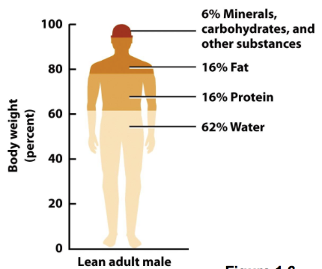
Composition of the human body

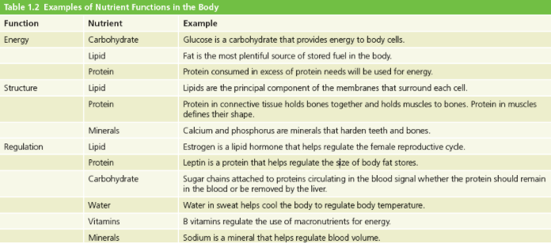
Essential nutrients
-Nutrients that the body either cannot make, or cannot make fast enough from other raw materials
-Nutrients that must be obtained from food. If not, deficiency will occur

Malnutrition
-Malnutrition can mean eating too little or too much of one or more nutrients
-A well chosen array of foods will prevent malnutrition
Includes:
Nutrient deficiencies (undernutrition)
Nutrient imbalances
Nutrient excesses (overnutrition)
Foods contain:
Nonnutrients: compounds other than the 6 nutrients present in food that have biological activity in the body
Phytochemicals: Nonnutrient compounds the confer colour, taste, and other characteristics on food

Ingredients of a nutritious diet
A Adequacy
B Balance
C Calorie control
M Moderation
V Variety

-It is important to recognize that ALL 5 principles must be applied to obtain a nutritious diet

Adequacy
The dietary characteristic of providing all of the essential nutrients, fibre, and energy in sufficient amounts to maintain health and body weight

Balance
The dietary characteristic of providing foods of a number of different types in proportion to each other, such that foods rich in some nutrients do not replace foods that are rich in other nutrients

Calorie control
Control of energy intake
-Match Kcal in with kCal out

Moderation
The dietary characteristic of providing constituents within set limits
-Nothing in excess

Variety
The dietary characteristic of providing a wide selection of foods
-No one food provides all necessary nutrients
-Selecting a variety of foods helps the body to obtain all necessary nutrients
-There are many interactions between foods. Selecting a variety of foods means you will provide the fuel the body needs, even if some food interactions are not positive

Excuses for not eating well
Excuse
No time
Crave fast food
No money
Take vitamins instead
Love sweets
Solution
Frozen foods
In moderation
Pills don’t have fibre or phytochemicals

Factors that affect food choices
Food availability
1. Geography
2. Transportation and mobility
3.Available income
4. Food storage and preparation equipment
Cultural and personal background
1. Religious dietary laws
2. Ethnic menu preferences
3. Social acceptability
4. Cultural events
5. Psychological and emotional factors
6. Health concerns

Others
1.Convenience
2. Media/Advertising

Understanding science helps us understand nutrition
-Nutrition is a science
-Developing an understanding of the processes in nutritional science will help us to understand the relationship between health and nutrition
-Understanding nutritional processes will help us make wise nutrition decisions
-Advances in nutrition are made using the scientific method
-The scientific method uses an unbiased approach to examine the interaction of food, nutrients and health

Scientific method
1. Observation
2. Hypothesis
3. Experiments
4. Theory

Sorting out nutrition information
-Does the claim make sense?
-Where did the information come from?
-Was the info based on well-designed experiments
-Were the results interpreted accurately?
-Who stands to benefit?
-Has it stood the test of time?
-Does it pose a risk?

Reliable nutrition information in Canada
Government
Health Canada, Canada food inspection agency, and The Public health agency of Canada
Non-profit institutions
Dieticians of Canada, Canada Medical association, heart and stroke foundation, canadian cancer society
Educational institutions
Universities and peer-reviewed journals

CHAPTER 2
Nutrition recommendations for the Canadian diet
-In the 1860’s the industrial revolution induced the British government to make the first nutritional recommendations
-Today, the world health organization makes international health recommendations
-Canada makes nutritional and health recommendations for its citizens in eating well with Canada’s food guide

Dietary pattern
-A description of a way of eating that includes the type and amounts of recommended foods and food groups, rather than individual nutrients

Dietary reference intakes (DRI)
-A set of reference values for the intake of energy, nutrients, and food components that can be used for planning and assessing the diets of healthy people in the US and Canada

Dietary reference intakes
-Used for planning and assassin diets of HEALTHY PEOPLE
-Vary according to LIFE STAGE and GENDER
-Have replaced Recommended Nutrient intakes (RNI)
-Promote good health and reduce chronic disease
-DRIs have developed for:
1. Energy (carbs, proteins, fat)
2.Water soluble vitamins (B&C)
3. Fat soluble vitamins (A,D,E&K)
4. Minerals (Fe, Ca, K, Mg, F, Se, Zn, Na, P)
5. Water

Recommended dietary allowances (RDA)
Nutrient intake goals for individuals; the average daily nutrient intake level that meets the needs of nearly all healthy people in a particular life stage and gender group.

Adequate intakes (AI)
Nutrient intake goals for individuals; the recommended average daily nutrient intake level based on intakes of healthy people in a particular life stage or gender group and assumed to be adequate.

Estimated average requirements (EAR)’
The average daily nutrient intake estimated to meet the requirement of half of the healthy individuals of a particular life stage and gender group; used in nutrition research and policy making and the basis upon which RDA values are set

Acceptable Macronutrient distribution range (AMDR)
Values for carbs, fats, and proteins expressed as % of total daily caloric intake; ranges of intakes set for the energy yielding nutrients that are sufficient to provide adequate total energy and nutrients while reducing the risk of chronic diseases

Tolerable Upper intake levels
The highest average daily nutrient intake level that is likely to pose no risk of toxicity to almost all healthy individuals of a particular life stage and gender group. Usual intake above this level may place an individual at risk of illness from nutrient toxicity
Carbs (45-60%)
Proteins (10-35%)
Fat (20-35%)

Energy recommendations
-The DRIs make 2 types of energy intake recommendations
Estimated Energy Requirement
Used to calculate kcalorie intake needed to maintain body weight
Acceptable macronutrient
Range for healthy intake

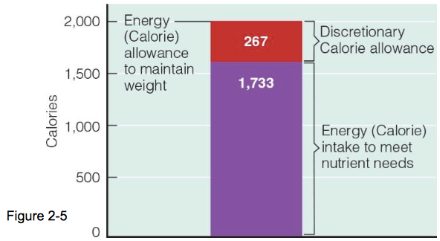
Discretionary calorie allowance

Nutrient density
Nutrient density is a measure of the nutrient a food provides compares to its energy content
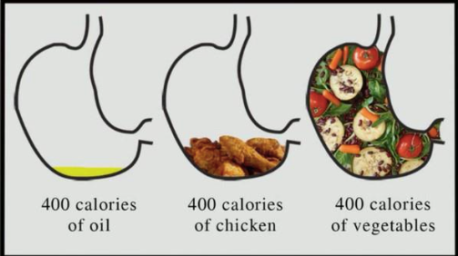
Eating well with canada’s food guide
-Provides recommended SERVING SIZES for each food
-individuals should consume foods from ALL FOUR FOOD GROUPS to meet needs for vitamins, minerals, and other nutrients
-eating the recommended types and amounts of foods REDUCES RISK FOR CHRONIC DISEASE (diabetes,heart disease, cancers, osteoporosis)

Suggestions
-Food choices should be LOW IN FAT, LOW IN SUGAR, LOW IN SODIUM, HIGH IN FIBRE
-Choose WATER to quench thirst
-READ FOOD LABELS to assist in making better food choices
-BE ACTIVE - provide recommendations made for physical activity

Portion control
-To control calories, the diet planner must learn to control food portions
-The trend in North America: larger food portions
-Body weights have been increasing

Food labels
By Canadian law, a food label must include
1. Common or usual name of product
2. Name/ address of manufacturer, packer, or distributor
3. Net contents by weight, measure, or count
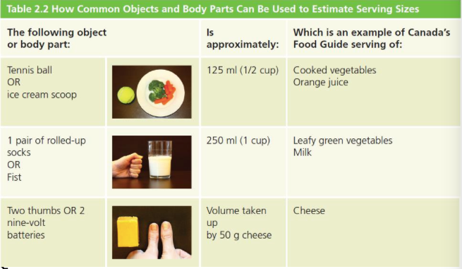
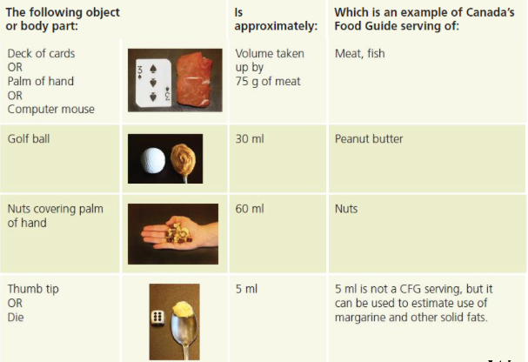
4. Date by which the product should be sold (if perishable)
Predicting food size
5. Nutrition facts panel
6. the ingredients, in ordinary language, by descending order of predominance by weight

Nutrition information provided on food labels
1.Nutrition facts
2.Ingredients lists
3.Nutrition claims
4. Health claims
What food products have nutrition facts
-Almost all pre-packaged foods have nutrition facts
-Some exceptions include:
-Fresh fruits & veggies
-Raw meat & poultry, fish/seafood
-Food prepared or processed at the store (bakery buns, salads)
-Foods that contain few ingredients (coffee beans)
-Alcoholic beverages

Use nutrition facts
-To easily compare similar foods
-To look for foods with little or a lot of specific nutrient
-To select foods for special diets
-TO MAKE INFORMED FOOD CHOICES

Nutrition facts are based on a specific amount of food
Compare this to the amount you eat
The specific amount:
-listed under the nutrition facts title
-listed in common measures you use at home and a metric unit
-not necessarily a suggested quantity of food consumption

Why are daily values used on labels?
-Daily values (DV) are another set of nutrient standard, practical for people seeking to make wise choices
-DRI values vary from group to group. On a food label, however, one set of values must apply to everyone
The DV reflects the needs of an “average” person
This is based on a 2000 calorie per day intake

The % DV is:
-used to determine whether there is a little or a lot of nutrient in the amount of food
-A benchmark to evaluate the nutrient content of food
-Based on recommendations for a healthy diet

How to use the % DV
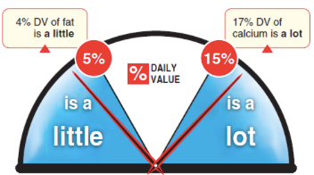
Step 1: LOOK at the amount of food
Nutrition facts are based on a specific amount of food
Compare this to the amount you eat
Step 2: Read the % DV
The % DV helps you see a specific amount of food has a little or a lot of a nutrient

5% DV or LESS is a LITTLE
15% DV or MORE is LOT
Step 3: CHOOSE
Make a better choice for you. Here are some nutrients you may want
MORE: Fibre, Vitamin A, Calcium, Iron
LESS: Fat, saturated and trans fat, sodium
The ingredient list
-Lists all of the ingredients for a food by weight, from the most to the least
-Is a source of information for certain nutrients
-Is a source of information for people with food allergies
-additives, food colours and flavourings must be listed

Nutrient claims
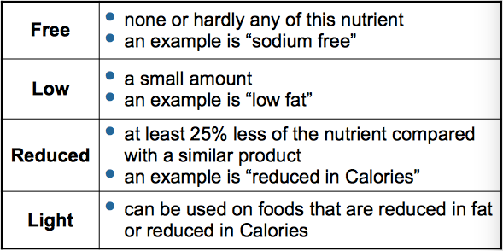
When you want to decrease the amount of certain nutrients, look for:

-If serving size is small enough they could round to zero if the ingredient was less than 0.5 grams per serving
-Since 2006 new FDA regulations requiring disclosure of trans fats

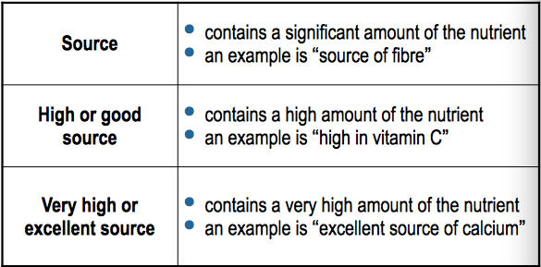
When you want to increase the amount of certain nutrients, look for:

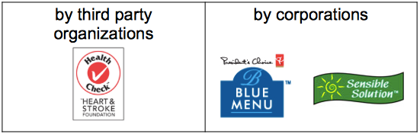

General health claims
General health claims are generally developed:
-Consumers should not solely rely on general health claims to make informed food choices

Natural health products labelling
The Natural health products directorate of health Canada regulates:
1. Vitamin and mineral supplement
2. Natural health products
3.Herbal remedies
4. Traditional medicines
5. Homeopathic products
Labels on health products must include:
1.Product name
2. Product licence holder
3. Natural product number (NPN) and Homeopathic number (DIN-HM)
4. Medicinal and non-medical ingredients
5.Dosage form
6.Recommended use or purpose
7. Risk information

Nutrition labelling summary
-Use nutrition facts, the ingredient list, nutrition claims and health claims to make informed food choices
-Nutrition facts are based on a specific amount of food- compare this to the amount you eat
-Use the % Daily value to see if food has little or a lot of nutrient.

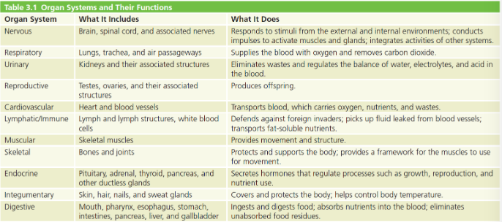
CHAPTER 3
Organ system of the body
The nervous system
Nervous system
-Brain and spinal system are the main controls
-Receives and integrates information from sensory receptors all over the body
Role in hunger regulation
-Cortex: perceives sensations of hunger and appetite
-Hypothalamus: monitors the availability of nutrients and water

Fight or flight reaction (stress response)
-The body’s ability to respond to danger
-Neurotransmitters released when danger present
-Glands supply epinephrine and norepinephrine (hormones)

Cardiovascular system
Transport of nutrients and waste
-Blood passes through the digestive system (delivers O2 & picks up nutrients)
Fats
-Travel via lymph back into the blood
All blood leaving the digestive system is routed directly to the liver (for chemically alteration for absorption)
Kindeys
-Cleanse the blood of wastes

The endocrine system
Hormones
-Chemical messengers
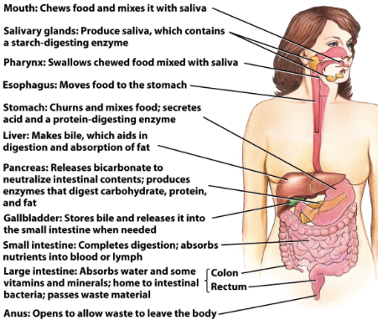
-Secreted and released directly into blood by glands (eg. pancreas, pituitary)
-Stimulate organs to take action
Examples:
-Gastrin (stomach and small intestines)
-Cholectokinin (small intestines)
-Insulin, glucagon (pancreas)

Link nutrition and endocrine system
Nutrition affects the endocrine system
-Fasting, feeding, and exercise alter the hormonal balance
Hormones affect nutrition
-Regulate hunger and affect appetite
-Carry messages to regulate the digestive system
-Leptin (‘satiety hormone” from fat tissues) helps regulate appetite
-Stress hormones (cortisol, epinephrine) suppress hunger and digestion and absorption

The digestive system

4 basic processes of digestive processes
1. digestion
2.Absorption
3.secretion
4.motility

Digestion: Process of breaking food into components small enough to be absorbed by the body
Absorption: Process of taking substances into the interior of the body
Gastrointestinal tract: Hollow tube consisting of the mouth, pharynx, esophagus, stomach, small & large intestine and anus
Transit time: the amount of time it takes food to pass the length of the GI tract
Feces: Body waste, including unabsorbed food residue, bacteria and dead cells

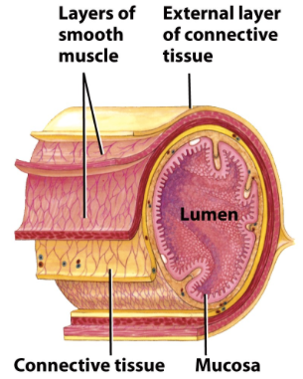
Structure of the Gut wall

Digestive secretions
Digestion inside the GI tract is assisted by digestive secretions
Mucus: viscous material produced by goblet cells; mucus moistens, lubricates and protects GI tract
Enzymes: protein molecules that speed up chemical reactions; enzymes are not changed during reactions

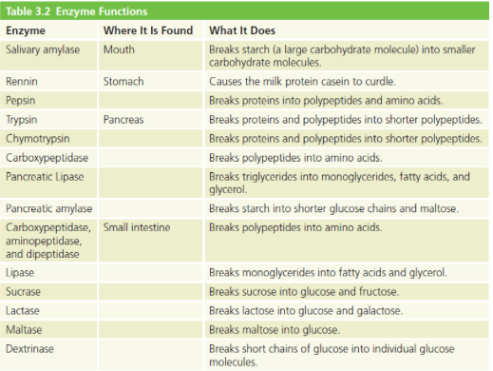
Digestive enzymes

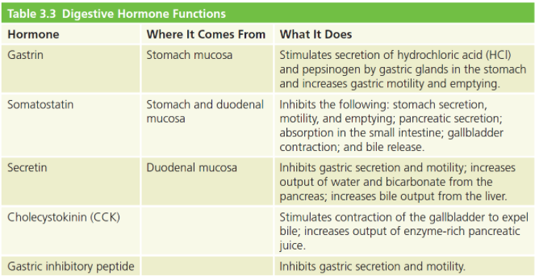
Digestive hormones

Barrier function of the GI tract
The GI tract limits the absorption of toxins and disease-causing organisms
Antigen: A foreign substance (almost always a protein) that, when introduced into the body, stimulates an immune response
-Food allergens can cause an overreaction of the immune system (anaphylaxis)
Some cells of the immune system are present in the GI tract:
-Phagocytes
-Lymphocytes
-Antibodies

Digestive tract
Flexible, muscular tube
mouth - throat - esophagus - stomach - small intestine - large intestine - rectum - anus
Total length about 8 meters
Body surrounds digestive canal
Main job:
-Digest food to its components, absorb, and excrete

Mouth
The mouth is the entry point for food into the digestive tract
-Saliva in the mouth moistens food
-Saliva contains salivary amylase, which helps to break down carbs and lysozyme, which help inhibit bacterial growth in the mouth
-Chewing mechanically breaks down food, increasing the surface area in contact with digestive enzymes

Mechanical digestion
-Breakdown of food into a form that allows nutrients to be absorbed
-Begins in the mouth; aided by chewing, saliva
-Stomach and small intestine
PERISTALSIS helps liquefy food
Chyme/digesta help create a paste-like substance
SEGMENTATION helps mix food and divides it into smaller portions

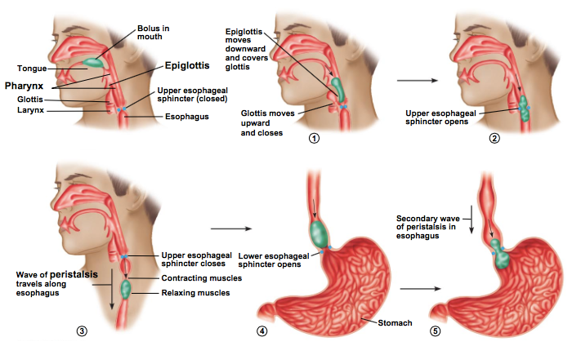
Pharynx and epiglottis

Stomach
Chyme: a mixture of partially digested food and stomach secretions
Parietal cells: Cells in the stomach lining that make hydrochloric acid and intrinsic factor in response to nervous or hormonal stimulation
Pepsinogen: An inactive protein-digesting enzyme produced by gastric glands and activated to pepsin by acid in the stomach
Pepsin: A protein digesting enzyme produces by the gastric glands. It is secreted in the gastric juice in an inactive form and activated by acid in the stomach

The muscular stomach
-Bolus enters the stomach from the esophagus via the gastroesophageal sphincter
Heart burn, gastroesophageal reflex disease (GERD)
-Stomach mixes bolus with acidic gastric juice into chyme
-Stomach temporarily stores food until it moves onto the duodenum
-Each peristaltic wave, 1-2tsp of chyme flows into the duodenum via the PYLORIC SPHINCTER

Regulation of stomach
-Thoughts, smell, sight, taste of food stimulates gastric secretions and stomach motility
-Food entering stomach increases gastric secretions and motility
-Food entering the small intestine triggers hormonal and nervous system signalling

Stomach
-Thought, smell, sight, or taste of food sends signals to brain to increase stomach muscle contraction
-Stretching of stomach sends signal to brain to release of gastrin from stomach lining, which stimulates the release of gastric juices
Water, HCL, digestive enzymes, mucosa, intrinsic factor
-Stomach lining is covered with thick mucus
Damages causes inflammation of gastritis
ULCERS are caused by helicobacter pylori

What would affect the rate of gastric emptying
A number of factors influence the speed of the process by which food leaves the stomach
Consistency of food
Nutrient composition of a food
Size of the meal

Small intestine
Villi: finger like protrusions of the lining of the small intestine that participate in the digestion and absorption of nutrients
Microvilli: Minute, brush like projections on the mucosal cell membrane that increase the absorptive surface area in the small intestine
Lacteal: A tubular component of the lymphatic system that carries fluid away from body tissues. Lymph vessels in the intestine are known as lacteals and can transport large particles such as products of fat digestion

-Pyloric sphincter
Controls exit of chyme to the small intestine
-Secretions of the following fluids aid in digestion
Bile: emulsifier, made by the liver & stored in the gallbladder
Pancreatic juice: secreted by the pancreas, contains an acid-neutralizing again (bicarbonate)
-The organ of DIGESTION and ABSORPTION
-Intestinal wall hold digestive enzymes for last-minute breakdown

Small intestine secretions
Pancreas secretes pancreatic juice containing:
Bicarbonate: neutralizes acid in chyme (from the stomach)
Pancreatic Amylase: Digests carbs into sugars
Pancreatic proteases: digests proteins into amino acids
Pancreatic lipases: Digests fats into fatty acids
-Brush border secretes enzymes that complete digestion of Carbs and proteins
-Liver secretes bile which emulsifies fat (breaks down droplets) so lipase can access fat molecules
-Gall bladder stores bile

Secretin: A hormone released by the duodenum that signals the release of pancreatic juice rich in bicarbonate ions and stimulates the liver to secrete bile into the gallbladder.
Cholecystokinin: A hormone released by the duodenum that stimulates the release of pancreatic juice rich in digestive enzymes and causes the gallbladder to contract and release bile into the duodenum.

Chemical digestion
Digestive juices are secreted by:
• salivary glands, stomach, pancreas, liver, and small intestine
Digestive juices contain enzymes that break down nutrients.
Digestion begins in the mouth.
Saliva contains enzymes that break down
-starches (salivary amylase)
-fats (lingual lipase)
Protein digestion begins in the stomach.
Gastric juices (water, enzymes, hydrochloric acid) are required to activate the protein digesting enzyme (pepsin).
Acid strength is determined by its pH.

Large intestine
The large intestine does not participate in digestion.
The large intestine can absorb water and some vitamins and minerals.
The large intestine contains the colon and the rectum.
Water, nutrients and fecal material may spend up to 24 hours in the large intestine.

Absorption of nutrients
Absorption
-Nutrient molecules transverse intestinal lining cells
-Cells absorb nutrients and deposit in blood (carbs, protein, minerals) and lymph (fat, vitamins)
-The cells of the small intestine are selective, increasing absorption of some nutrients that may be short in supply

Absorption and malnutrition
-The digestive system is sensitive to MALNUTRITION
-servere undernutrition will result in the shrinking of the absorptive surface of the small intestine
-This cause impaired digestion, and the impaired digestion worsens malnutrition

CHAPTER 4

Photosynthesis
CO2 + H2O =C6H12O6 + O2

Carbohydrates
-Carbs are ideal nutrients because they:
help meet energy needs
feed the brain and nervous system
keep the digestive system fit
keep the body lean
-Simple vs complex carbs

Sugars: Mono vs Disaccharides
Monosaccharides
Glucose, fructose, galactose,
Disaccharides
Lactose, maltose, sucrose

Hydrolysis reaction: the chemical reaction that breaks down sugar molecules apart
Condensation reaction: the chemical reaction that links two sugar molecules together

Complex carbohydrates
Starch and glucagon
Starch
Polysaccharide
Plant’s storage form of glucose
Packed in granules
Glycogen
Storage form of glucose in humans and animals
Fibres
Supporting structures of plants
Resists digestion by human enzymes;
Digestive bacteria in intestines can break down some fibres
Soluble fibres: viscous, fermentable, fibres are often gummy and add thickness to foods
Insoluble fibres: Nonviscous, less fermentable fibres are tough, stringy, or gritty in foods

Soluble fibres Insoluble fibres
-Oatmeal -Whole wheat bread
-Oat bran -Barley
-Nuts and seeds -Wheat bran
-Most fruits - Seeds
-Dry beans and peas - Most vegetables

Carbs in the food guide
Canada’s Food Guide recommends:
Increase consumption of unrefined carbohydrates, such as whole grains, vegetables, legumes, and fruits.
Decrease intake of refined carbohydrates and added sugars from foods such as baked
goods and soft drinks.
Grain products Meats and alternatives
Low fat & low sugar choices nuts, dried beans and legumes
Vegetables Milks and alternatives
Starchy vegetables provide higher Lactose
amounts of carbs (potatoes, corn)
Fruits Oils and fats
Vary in water, fibre and sugar Don't contain carbs
concentrations Naturally occurring vs. added sugar
-Caution: limit juice to no more
than 1/3 of daily servings fruit

Naturally occurring vs. added sugars
-“Sugar” on food label account for both
-Naturally occurring sugars usually contain other important nutrients
-Canadians consumed the equivalent of 12 teaspoons of sugar and syrup daily in 2009
-WHO suggests limiting added sugar to no more than 10% of total calorie intake each day

Added sugars in our diet
Added sugars: sugars and syrups that have been added to foods during processing or prep
Empty calories: refers to foods that contribute energy but few other nutrients

Whole grain vs. refined grain
• Refined grains (e.g., corn flakes, puffed rice) are made largely from the endosperm and are mostly starch.
• Refined grains sold in Canada may be enriched with thiamin, riboflavin, niacin, and iron and fortified with folate.
- They do not contain the magnesium, Vitamin E, B6 or a number of other nutrients that are lost during processing.

• Whole or unrefined grains contain:
Bran layers: good source of fibre and vitamins
Germ: good source of vegetable oils and vitamin E
Endosperm: contains starch and some protein

Carbohydrate intake
-RDA for carbs: 130 g/day for adults and children
This provides for the minimum amount of glucose used by the brain
-AMDR for carbohydrates: 45 to 65% of energy.
-Carbohydrate sources should be unrefined
-No more than 25% of carbohydrates consumed should come from added refined sugars.
-AI for fibre: 38 g for young adult men and 25 g per day for young adult women.
-Canada’s Food Guide recommends that Canadians choose foods with little or no added sugar.

How to calculate AMDR of carbs
How many grams of carbohydrates can someone on a 1,800 kcal diet consume if he/she stays within the AMDR?
High-fibre diet: More cholesterol (in bile) is carried out of the body

Good carb: more fibre & complex CHO.. take longer to break down into glucose e.g.: veggies,
Bad carbs: foods with refined carbs (eg; made from white flours and added sugars . cakes)
Low-fibre diet: More cholesterol (in bile) is reabsorbed and returned to the bloodstream
Health benefits of fibre-rich foods
• Reduced risk of heart disease
• Reduced risk of diabetes
• Reduced risk of bowel disease
• Promotion of healthy body weight

• Lower cholesterol and heart disease risk
Complex carbohydrates (whole grains), legumes, vegetables
• Soluble, viscous fibre
Bind with cholesterol-containing bile in the intestine and carrying it out with the feces

• Blood glucose control
Soluble, viscous fibres from foods trap nutrients and delay their transit through the digestive tract, slowing glucose absorption.

• Maintenance of digestive tract health
• All kinds of fibre along with ample fluid intake
• Benefits of fibre
Prevention: constipation, hemorrhoids, appendicitis, diverticulosis
• Further benefits of fibre
Prevention: digestive tract cancers (colon)

- • Healthy weight management
    - Carbohydrates provide fewer
    - Calories than fat (per gram)
    - Complex carbohydrates tend to be low in fats and added sugars, delivering less energy per bite.
    - Fibre creates feelings of fullness and delays hunger.
    - Key is to select nutrient-dense carbohydrates and limit refined sugars!
Indigestible Carbohydrates and Bowel Disorders
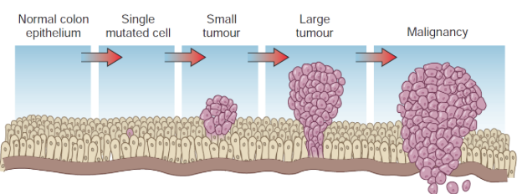
- Epidemiological studies have shown that the incidence of colon cancer is lower in populations that consume diets high in fibre.

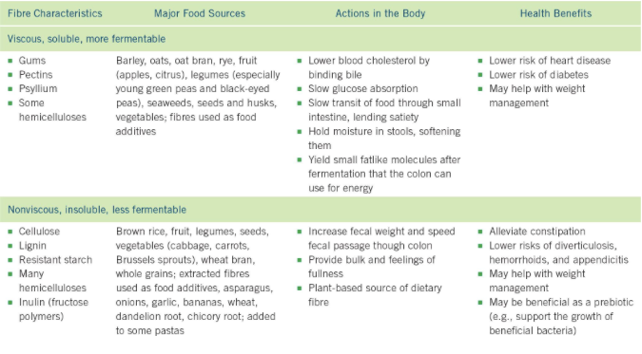
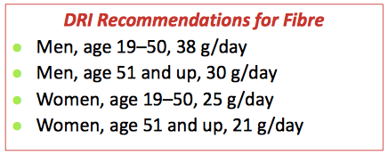
Characteristics, Sources, and Health Effects of Fibres
Fibre recommended intakes
• Excessive fibre intake should be avoided.
• Caution:
Purified fibres • Dehydration
Binders (chelating agents) in some fibres reduce absorption of other nutrients.

From Carbohydrates to Glucose– Digestion and Absorption
- Starch and disaccharides are broken down
    - Monosaccharides for absorption
- Digestion of starch
  - Begins in the mouth
Splits starch into shorter units
• Ceases in the stomach
• Resumes in small intestine (pancreatic amylase)
• Resistant starch is less digestible
Bacteria of the colon may break it down

• Sugars
Split to yield free monosaccharides
Enzymes on small intestine lining • Travel to the liver
• Fibre
Fermented by bacteria in the colon
Odorous gas
• Gradually increase fibre intakes
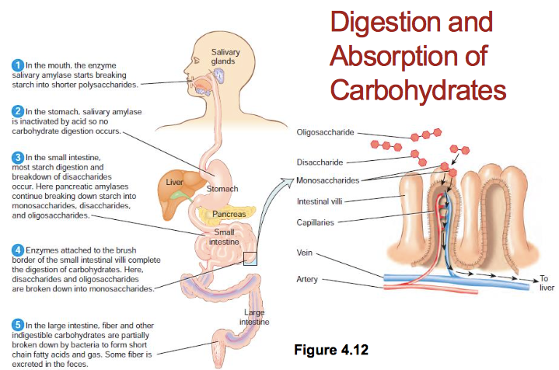

Digesting Milk
- Ability to digest milk carbohydrates varies
  - Lactase enzyme
Made by small intestine
• Symptoms of intolerance
Nausea, pain, diarrhea, and gas
• Nutritional consequences
• Dietary strategies
- Milk allergy: Involves the immune system; not the same as an intolerance

Meeting Calcium Needs
• Canada’s Food Guide recommends 2 to 3 servings of milk and milk alternatives per day.
• To meet calcium requirements, individuals who are lactose intolerant can:
-(if the intolerance is not too severe) divide milk servings into smaller portions and spread them throughout the day
-consume foods like tofu, fish, and vegetables
-consume calcium-fortified foods, milk treated with the enzyme lactase and lactase tablets.

Carbohydrates – Absorption
• In small intestine, monosaccharides are absorbed into the blood stream
• A soluble-fibre-rich meal dilutes the stomach and small intestinal contents and slows the digestion and absorption of nutrients
- Simple carbohydrates and low- soluble fibre foods cause a spike in blood glucose

The Body’s Use of Glucose
- Basic carbohydrate unit used for energy
Glycolysis (anaerobic)
Krebs cycle (aerobic): produces CO2 and H2O
• Body handles glucose carefully.
Maintains an internal supply
Tightly controlling blood glucose concentrations
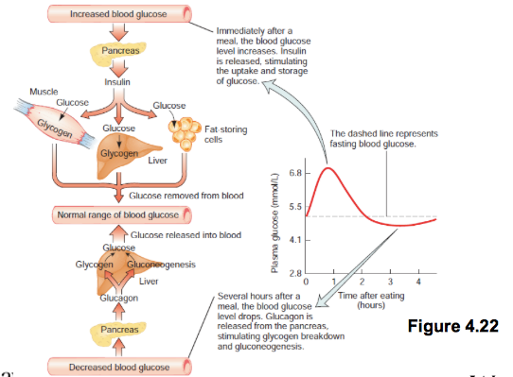
- Brain, nervous system, red blood cells

Regulating Blood Glucose

Rationale for Low-Carbohydrate Weight Loss Diets
• Foods high in carbohydrates stimulate the release of insulin.
• Insulin promotes energy storage, mostly from fat.
• The more insulin you release, the more fat you store.
• Low-carbohydrate diets cause less insulin to be released.
• With low-carbohydrate diets, the body produces more ketones.
• Ketones help suppress the appetite.

Low-Carb Diets – Good or Bad?
In case of severe deficit of carbohydrates:
- Protein converted to glucose (gluconeogenesis)
no longer available for other important functions (enzymes, hormones, and antibodies and regulation of fluid balance.)
• Breakdown of fat incomplete: formation of ketone bodies
Ketosis cause a decrease in appetite
• Side effects of very low-carb diets include: nausea, headaches, dizziness, fatigue, bad breath, and dehydration.
• Low fibre intake + dehydration causes constipation.
• Exercise and fitness performance is reduced
because of low energy level.

Splitting Glucose for Energy
• Glucose can be converted to fat.
Fat cannot be converted to glucose to feed the brain
Dependence on protein when insufficient carbohydrate •
Protein-sparing action
• Ketosis
Shift in body’s metabolism
Disruption of acid-base balance
- DRI minimum of digestible carbohydrate
130 gram a day

Storing Glucose for Energy
• As blood glucose (BG) rises or drops, the pancreas is the first organ to respond.
Rise in BG = release of the hormone insulin
Drop in BG = release of the hormone glucagon
• The brain stores a small amount of glucose
Emergency reserve to fuel the brain in severe glucose deprivation
• Muscles and liver store glycogen
Muscles conserve for their own use.
The liver is generous with its glycogen.

Hypoglycemia
- Abnormally low blood glucose (<2.2–2.8 mmol/L)
Postprandial hypoglycemia (rare)
Fasting hypoglycemia
• Symptoms
• Causes
Poorly managed diabetes • Medications
Alcohol abuse
Others

The Glycemic Response
• The measurement of the elevation of blood glucose and insulin in response to a food item
Food score on a scale, Glycemic Index (GI), compared with standard food, given a score of 100
- Diabetes
- Glycemic load (GL)
A lower GL = less glucose build up and less insulin needed

• Many factors can affect glycemic index:
Time of day of the test, body size and weight, blood volume, and metabolic rate
May vary from person to person
Depends on how the food is prepared
A food’s ripeness
Food combinations in a meal

Handling Excess Glucose
• Once the liver and muscles have stored glycogen to capacity, the body burns glucose for energy instead of fat.
• This results in:
-fat being left in the bloodstream until picked up and delivered to fatty tissue
-the liver breaking the excess glucose into small fat fragments and storing
-the fat cells taking up glucose and converting it to fat directly

Diabetes
• Chronic disease characterized by elevated blood glucose concentrations
• Common forms of diabetes
Type 1 diabetes – insulin dependent
Type 2 diabetes – insulin resistant
- Management of diabetes
Nutritional intervention
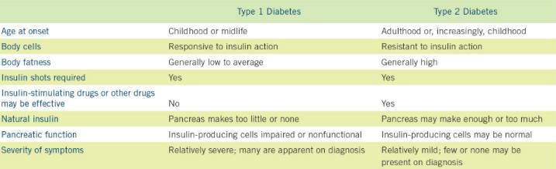
Physical activity

Diabetes Treatment
• The goal of diabetes treatment is to keep blood glucose levels within normal ranges.
• Treatment includes a combination of diet, exercise, and, if necessary, medication (oral or injected).
- Evidence is accumulating that refined sugar may play a role in the development of type 2 diabetes.

Tools for Diabetes Management
• The Canadian Diabetes Association has developed Just the Basics and Beyond the Basics to help individuals control their blood glucose levels.
• Just the Basics: simplified dietary plan
use a divided plate to ensure proper portions
choose whole grains
avoid simple sugars
Eat 3 meals per day at about the same time each day
- Beyond The Basics: poster used for meal planning
Foods divided into groups by carbohydrate content.
Poster is filled in by a dietitian

Sugar and Dental Caries
• Carbohydrate as sugar has been named as the main causative factor in the formation of caries.
• Starch supports bacterial growth if the bacteria are allowed sufficient time to work on it.
- Important:
Length of time the food stays in your mouth
The food’s composition
How sticky the food is
How often you eat the food
Whether you brush your teeth soon afterwards

Artificial Sweeteners
• Also called “nonnutritive sweeteners.”
Do not elicit glycemic response (or less severe)
Do not contribute to dental caries
Calorie-free
But all substances are toxic if consumed in high-enough dose
Not proven to help in weight control
- In general:
Moderate intakes of artificial sweeteners pose no health risks for most people.

Alternative Sweeteners
Types of alternative sweeteners available in Canada include:
- Cyclamate – tabletop sweetener, limited sale.
• Saccharin – tabletop sweetener, purchased in pharmacies.
E.g., Sweet ‘N Low®, Sugar Twin®
• Aspartame – tabletop sweetener, used in uncooked foods. Health Canada ADI 40 mg/kg body weight.
E.g., NutraSweet®, Equal®, NutriTaste ®
• Sucralose – tabletop sweetener, used in foods, heat stable. ADI 9 mg/kg body weight.
E.g., Splenda®
• Acesulfame K – used in foods, heat stable. ADI 15mg/kg body weight. • E.g., Sweet One®
• Neotame – used in foods, heat stable.
• Sugar Alcohols – chemical deriatives of sugar, listed on the label under carbohydrate, provides less energy than sugar.
E.g., sorbitol, mannitol, Lacitol, and xylitol

• Stevia (stevia glycosides)
Leaves of stevia plants are particularly sweet
Long recognized by the native people living in the regions these plants grow
Little is known about its effects on human health
Essentially free of calories and sweeter than table sugar
In Canada it can be added to table-top sweeteners
In the US it is sold as supplement as Truvia® and NuSteviaTM

CHAPTER 5
Eating to Lower Cholesterol Levels
• Flaxseed provides soluble fibre and omega-3 fatty acids.
• Plant sterols and stanols are similar in structure to cholesterol but inhibit cholesterol absorption.
• Nuts are high in monounsaturated fat, omega-3 fatty acids, antioxidants.
- Fatty fish (salmon, mackerel, sardines) is high in omega-3 fatty acids

Usefulness of Fats in Body
• Structure
Cell membranes
Contour of body
Building material for other compounds
• Protection – shock absorption
• Temperature Insulation
• Regulation
Hormones
Essential fatty acids and eicosanoids
Growth, skin integrity, fertility
Blood pressure, blood clotting, immune function
- Energy source and storage

• Fat in food:
provides a concentrated Calorie source • gives aromas and flavours
lends tenderness to the food
stimulates appetite
contributes to satiety

Three classes of lipids
1. Triglycerides
Make up 95% of fat in food and the human body • Glycerol and fatty acids
2. Phospholipids
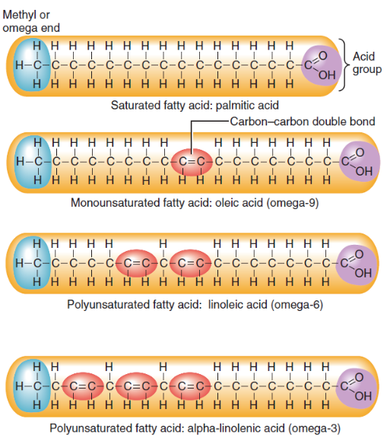
Glycerol + fatty acids + phosphorus • E.g., lecithin
3. Sterols
E.g., cholesterol

Fatty Acids
• Most animal fats contain saturated fatty acids.
• Unsaturated fatty acids contain some carbons that are not saturated with hydrogens.
• Omega-3 and omega-6 fatty acids are unsaturated fatty acids.
- Coconut oil is a medium chain fatty acid.

- Depending on which fatty acids are incorporated into a triglyceride, the resulting fat will be:

- softer (liquid)
shorter-chain fatty acids
more unsaturated
melt at lower temperature
- harder
longer-chain fatty acids
more saturated
melt at higher temperature

Saturated vs. Unsaturated Fatty Acids
- Saturated fatty acid (SAFA)
Filled to capacity with hydrogen
- Unsaturated fatty acid
“Empty spot” where hydrogen missing
1 point of unsaturation = monounsaturated fat (MUFA)
2+ points of unsaturation = polyunsaturated fat (PUFA)

Omega-3 and Omega-6 Fatty Acids
Naming of fatty acids is assigned based on where the first unsaturated/double-bond occurs.

What Are Trans Fatty Acids?
These fats are not made by the body.
Occur naturally in very small amounts in some foods:
-Dairy foods, beef
Pose risk to heart health
-Raise LDL cholesterol
-Lower HDL cholesterol
-Produces inflammation in the body

• Trans fatty acids can be created by hydrogenation.
• Hydrogenation causes some double bonds to become saturated.
• Hydrogenated fats can be found in margarines, vegetable shortening, and shelf-stable baked goods.
- Trans fatty acids have be shown to raise blood cholesterol levels and increase the risk of heart disease.

Phospholipids
• Glycerol, two fatty acids, and a phosphorus molecule
• Soluble in fat and soluble in water with phosphorus molecule
• Form the lipid bilayer in the membranes
- Acts as an emulsifier (a substance that mixes with both fat and water)

Sterols
• Sterols are a type of lipid found in plants and animals.
• Sterols do not dissolve in water.
• Cholesterol is a type of sterol found only in animals.
90% of cholesterol in the body is found in cell membranes.
Needed to synthesize vitamin D (in skin), bile, and some hormones (testosterone, estrogen, cortisol)
• Diets high in cholesterol (from animals) can increase the risk of heart disease.
- Plant sterols can help reduce cholesterol in the body.

Digestion of Lipids
- Digestion
Mouth
Milk fat in infants; little importance in adults
- Stomach
Small amount of fat begins digestion due to gastric lipase.
- Small intestine
Bile is excreted into the small intestine to assist with fat digestion by mixing fat with watery fluid.
Pancreatic enzymes are excreted to split fat into small particles.

Absorption of Lipids
• Fatty acids are now split from their glycerol backbone.
• Bile shuttles lipids (micelles) across the mucus layer.
- Triglycerides in food are absorbed with 98% efficiency

Transport of Fats
• Smaller lipids (glycerol and shorter-chain fatty acids) pass directly into the bloodstream and to the liver.
• Larger lipids are transported in protein carriers, lipoproteins.
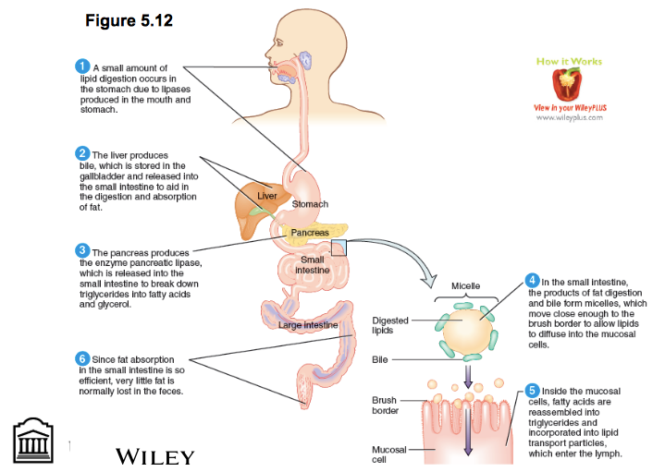
-Lipoproteins can be released into the lymph that leads to the blood
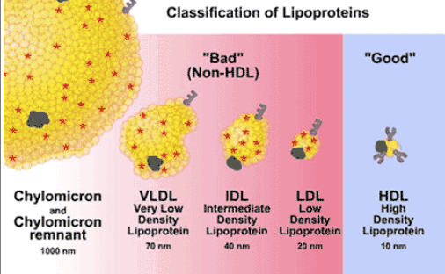
-Inside the intestinal cells, TG, protein and phospholipids form chylomicrons (a type of lipoprotein) so the can travel within the watery blood to the liver and other tissues

Lipoproteins
Hydrophobic lipids are packed within a hydrophilic exterior shell formed by phopholipids and protein
Composed of
- Triglyceride
- Phospholipid
- Cholesterol
- Protein

The density of a lipoprotein is determined by its lipid-to-protein ratio

Chylomicron: a droplet of fat present in the blood or lymph after absorption from the small intestine.

Low-Density Lipoproteins (LDH)
• The liver is the major lipid-producing organ in the body.
• Triglycerides produced in the liver are incorporated into entities called very-low-density lipoproteins (VLDLs).
• VLDLs transport lipids out of the liver and deliver them to cells in the body.
• The enzyme lipoprotein lipase removes triglycerides from VLDLs, creating intermediate density lipoproteins (IDLs).
• Approximately two-thirds of IDLs return to the liver; the remainder are transformed in the blood into low-density lipoproteins (LDLs).
- LDLs contain less triglyceride and more cholesterol than VLDLs. LDLs deliver cholesterol to the cells.
• If the amount of LDL cholesterol in the blood exceeds the amount that can be used by the cells, the result is a high level of LDLs.
- High levels of serum LDLs have been associated with an increased risk for heart disease.

High-Density Lipoproteins
• Most cells cannot break down cholesterol.
• Cholesterol is returned to the liver to be eliminated from the body.
• This reverse cholesterol transport is done by high-density lipoproteins (HDLs).
• High levels of HDL in the blood help to prevent cholesterol from depositing in the artery walls.
- High levels of HDL are associated with a reduction in heart disease risk.

Lipid Functions in the Body
• Most lipids in the body are triglycerides stored in adipose tissue.
- Deposits of adipose tissue help to
Define body shape
Provide stored energy
Insulate the body from temperature changes
Protect internal organs against physical shock.
• Lipids in the body are important for lubricating body surfaces, such as the mucous membranes of the eyes.
• Cholesterol is used to make several hormones, including estrogen and testosterone.
- Fatty acids and glycerol can be used to produce energy in the form of ATP.

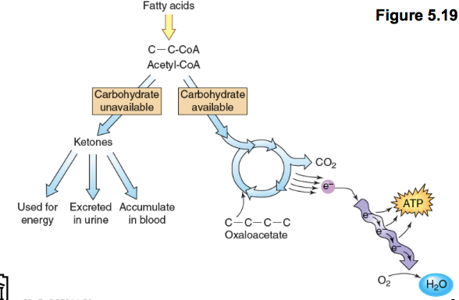
Ketone Body Formation

Retrieving Fatty Acids from Adipose Tissue
- Body conserves fat molecules in fat deposit
for example, muscles, breasts, fat layer under skin
• Uses stored fat when body runs out of fuel from food by dismantling stored triglyceride
• Releases free fatty acids into blood
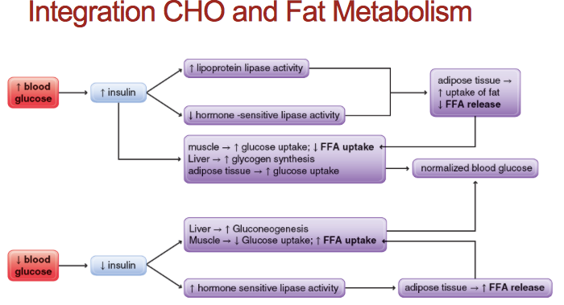
• Carbohydrate must be available when fat is being broken down for energy
Role of Insulin
• Insulin stimulates the storage of triglycerides during times of energy excess
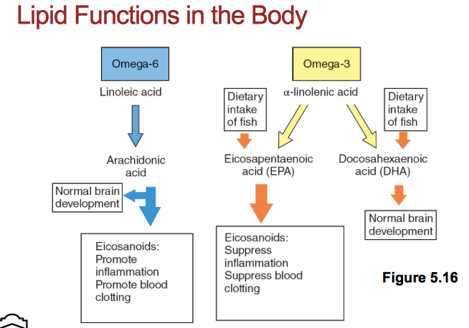
• After a meal adipocytes take up glucose and fatty acids from the blood
• Insulin stimulates conversion of excess glucose to fatty acids: lipogenesis
• Insulin inhibits lipolysis

Lipid Functions in the Body
• PUFAs help to regulate blood pressure and blood clotting.
Eicosanoids are made from omega-3 and omega-6 fatty acids. Eicosanoids help regulate blood clotting, blood pressure and immune function.
• Essential fatty acids are important for
-Growth
-Skin integrity
-Fertility
-Structure and function of cell membranes

Essential Fatty Acid Deficiency
• If adequate amounts of essential fatty acids are not consumed, a deficiency can result.
• Linoleic and linolenic acids are stored in adipose tissue therefore
Primary deficiency unlikely
Secondary deficiency possible
CF disrupt lipid absorption and utilization
- Symptoms include: dry, scaly skin, liver abnormalities, poor wound healing, growth failure in infants and impaired hearing and vision.

Fat in Milk, Yogurt, and Cheese
• Despite containing saturated fat, milk and yogurt also provide calcium and protein
unlike cream, butter, whipped cream, sour cream, cream cheese (they are grouped as solid fats).
• Cheese is the single-greatest contributor of saturated fat in the diet
- The fat content of dairy products may vary to include less-fat, low-fat, and no-fat options

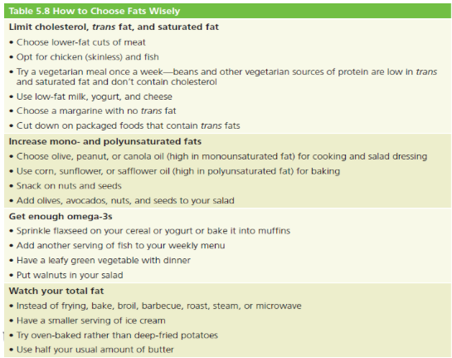
How to Choose Fats Wisely

Risk Factors for Heart Disease
- The more of these factors present in a person’s life, the more urgent the need for changes in diet and other controllable factors to reduce heart disease risk.
High blood LDL cholesterol
Low blood HDL cholesterol
High blood pressure (hypertension)
Diabetes (insulin resistance)
Obesity
Physical inactivity
Cigarette smoking
An “atherogenic” diet (high in saturated fats, including trans fats, and low in vegetables, legumes, fruit, and whole grains)
Family history, older age, and male gender are risk factors that cannot be changed.

Reducing Risk of Heart Disease
- Dietary factors that may help to reduce the risk of heart disease include:
Consuming omega-3 and omega-6 polyunsaturated fats
Consuming monounsaturated fats
Consuming plant foods, including fruits and vegetables, whole grains and legumes
Adequate intake of B vitamins
Moderate alcohol consumption

Mediterranean-type Diet
• Research has shown that this type diet is associated with a low risk of heart disease
- Traditional Mediterranean diets are:
-Low in saturated fat (<10 percent of Calories from saturated fat)
-Very low in trans fat
-Rich in unsaturated fat, starch and fibre, nutrients and phytochemicals that support good health

CHAPTER 6
Proteins
Proteins: nitrogen-containing macronutrient formed by one or more amino acids
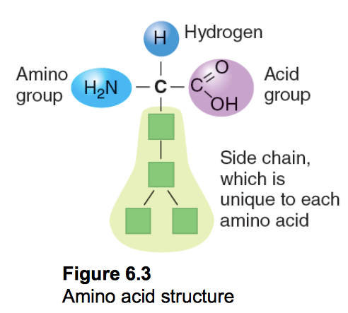
- Differs from carbohydrates and fats because of nitrogen
- Size
Small: few amino acids (di- or tripeptides)
Polypeptide: > 12 amino acids
Intermediate: 250-300 amino acids

Amino Acids
• Central carbon atom
- Amine group with nitrogen
- Carboxylic acid group
- Unique side chain (R-group)
Electrically charged
Neutral
Important for tertiary structure
20 different ones

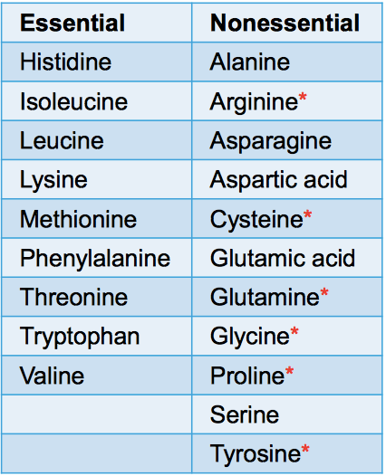
Essential vs. Nonessential Amino Acids
• Essential
More in animal products
• Nonessential
• Conditionally essential
Infants cannot make AA*
Phenylketonuria (PKU) • tyrosine
Diet lacking one of the essential AA

Proteins that May Harm Certain Individuals: Phenylketonuria
• PKU is an inherited condition, attributed to a defective gene, in which the body cannot metabolize phenylalanine.
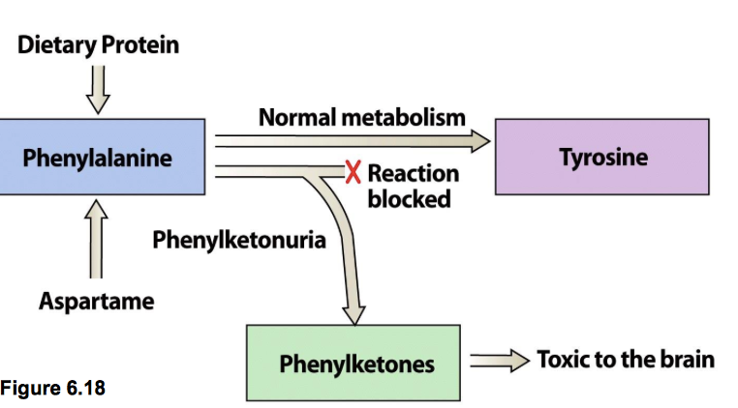
- Aspartame contains phenylalanine.

Transamination
- When a nonessential amino acid is not available from the diet, it can be made in the body by the process of transamination.
Transamination: Transfer an amino group from an essential amino acid to an α–keto acid to make an nonessential amino acid

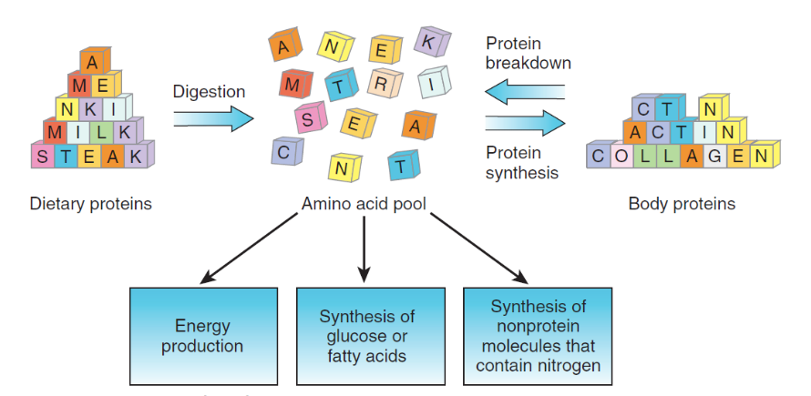
Recycling of Amino Acids

Amino acid pool: All of the amino acids in body tissues and fluids that are available for use by the body.
Protein turnover: The continuous synthesis and breakdown of body proteins.

Peptide Bonds
Peptide bonds: are chemical bonds that link amino acids
- Formed between the acid group of one group and the nitrogen group of the next
- Strands of amino acids attract or repel one another
Coils
Folds
- Side chain: electrically charged or neutral

Protein Synthesis
Cell signaling
Calls for the need to synthesize a protein
Transcription
Synthesis of a strand of mRNA
Translation
mRNA binds to ribosomes
tRNA translates the info and delivers AA in the correct sequence

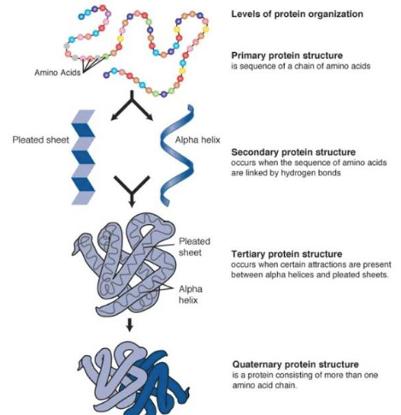
Structure of Proteins

Proteins Shape and Function
• several strands may cluster together into a functioning unit, or
- a metal ion (mineral) or a vitamin may join to the unit and activate it (prosthetic group)

The Variety of Proteins
- Protein shapes enable the performance of different tasks in the body.
- Inherited amino acid sequences
Each protein has a standard amino acid sequence
Determined by heredity
Alterations to sequence (mutation)
Sickle-cell disease

Denaturation of Proteins
Denaturation: process by which a protein’s 3d structure is altered
Denaturing agents include:
heat, alcohol, acids, bases, or the salts of heavy metals
Denaturing in the human body starts with the strong acid of the stomach
Irreversible destruction

Digestion of Protein
• Stomach
Protein digestion begins in the strong acid of the stomach
Gastrin causes release HCl and pepsinogen → pepsin
Protein in food is denatured.
Uncoils protein strands
Enzymes (proteases) attack peptide bonds.
• Small intestine
Many proteins are in the form of polypeptides.
Release of secretin and cholecystokinin (CCK)
Further break down to strands of dipeptides and tripeptides

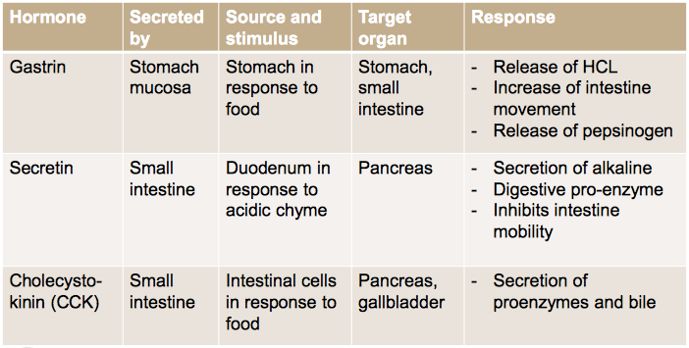
Hormones of the GI Tract

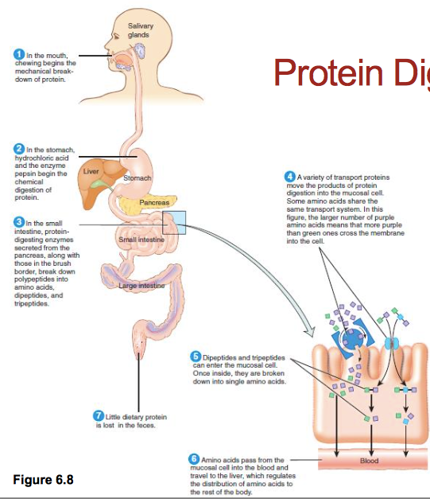
Protein Digestion and Absorption

Absorption of Amino Acids
• Absorbed by cells of small intestine
-As single amino acids
-Most dipeptides and tripeptides are reduced to single amino acids.
-Some larger molecules escape the digestive process.
- Separate sites for absorption of different amino acids.
- Released into the bloodstream
Carried to the liver
Protein Digestion and Food Allergies
• Food allergies are triggered when a protein from the diet is absorbed without being completely digested.
• Proteins from milk, eggs, nuts, wheat, soy, fish and shellfish and peanuts are common causes of food allergies
• A rapid, severe allergic reaction is called anaphylaxis.
• People with GI disease are prone to allergies because their damaged intestines allow for the absorption of whole proteins.

The Roles of Body Proteins
• Supporting growth and maintenance
Amino acids must be continually available to replace old or build new proteins.
• Protein turnover: the process of breakdown, recovery, and synthesis of protein
In adults, about 300 to 400 grams of protein turns over each day, accounting for about 20 percent of our resting energy needs.
• Building enzymes
Enzymes are catalysts, speeding up reactions
They are among the most important of the proteins formed in living cells.
Catalyzing reactions
Enzymes, such as this one that speeds up the breakdown of starch, are protein molecules. All chemical reactions occurring within the body require the help of enzymes. The specific structure or shape of each enzyme allows it to interact with the molecules in the specific reaction it accelerates. Without enzymes, metabolic reactions would occur too slowly to support life.
- Building hormones, and other compounds
Hormones, messenger molecules
Various body glands release hormones in response to changes in the internal environment.
e.g., insulin and glucagon
Hormones elicit the responses necessary to restore normal conditions in the body.
e.g., tyrosine use to make epi and NE, thyroxine, melatonin
• Building antibodies
Each antibody destroys one specific invader. • The body develops immunity to the invader.
It remembers the invader and attacks more rapidly the next time.
• Maintaining fluid and electrolyte balance
Regulates the quantity of fluids in the compartments of the body
By maintaining stores of internal proteins and also of some minerals, cells retain the fluid they need.
Transport proteins in the membranes of cells. continuously transfer substances into and out of cells
• Blood clotting and wound healing.
Proteins form web that traps platelets: blood clot
Collagen replaces blood clot and forms scar tissue.
• Provide structure
Collagen is a structural protein that forms a supportive matrix in bones, teeth, ligaments and tendons.
Structural components of cell membranes and organelles
• Facilitates movement
Nearly half of the body’s protein is present in skeletal muscle (actin and myosin)
Protein deficiency can cause muscle wasting
• Providing energy and glucose
Provides energy if needed (inadequate energy or carbohydrate intake)
Amino acids can be converted to glucose (unlike fatty acids)
To maintain blood glucose level
The amine group is stripped and may be incorporated by the liver into urea
No storage compound for protein for an over- supply of amino acids. Extra AA are stored as fat.

Transport Proteins: Proteins help transport materials throughout the body and into and out of cells. e.g. the protein hemoglobin,

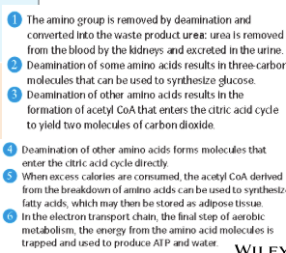
Producing ATP from amino acids

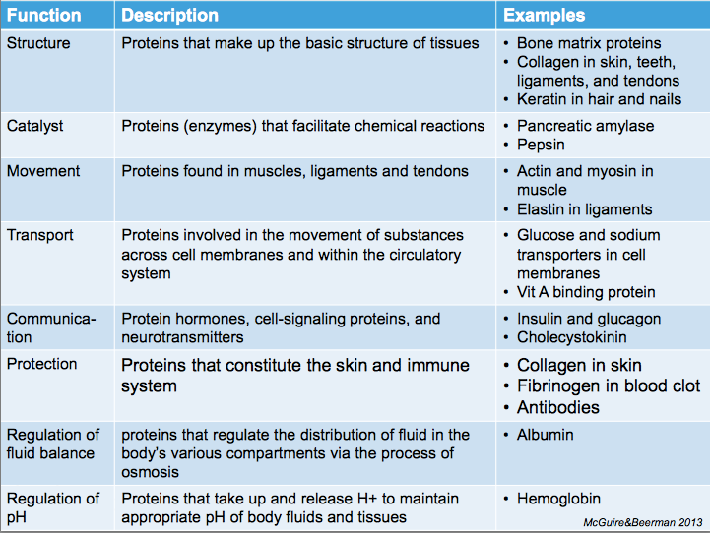

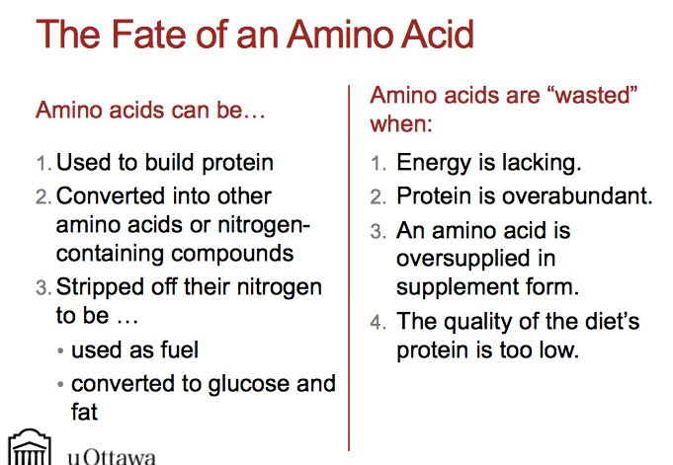

Amino Acid Supplements
• The body is designed to handle whole proteins best: allows for effective absorption
• An excess of groups of chemically similar amino acids compete for carriers in cell membrane
• Amino acid supplements are regulated as natural health products in Canada.
Warning: Until research is available, no level of amino acid supplementation can be assumed safe for all people

DRI for Protein
• The DRI for adults depends on:
1. body size (0.8 g/kg body weight)
2. AMDR: 10–35% of total daily Calories
- RDA for amino acids is given in mg/kg/day
Changes with age
Different for endurance and strength athletes
• Underlying daily protein needs is nitrogen balance.

Nitrogen Balance
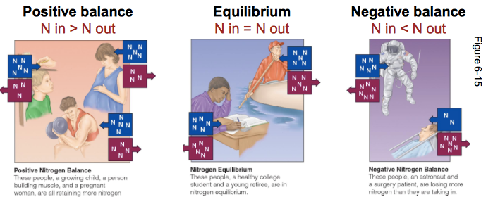
- Protein intake recommendations are based on nitrogen balance: the amount of nitrogen consumed versus nitrogen excreted
Factors on the Body’s Use of Protein
- The body’s response to protein depends on:
The body’s state of health
Malnutrition
Infections
Other nutrients and energy taken with the protein
eg: vitamins and mineral
Protein quality

Protein Quality
Depends on two factors:
1. Protein digestibility
animal proteins most easily digested (>90 percent)
next are legumes (80-90 percent)
grains and plants (70-90 percent)
moist heat improves digestibility; dry heat impairs digestibility

2. Amino acid composition
• High-quality protein provides enough of all essential amino acids. (animal&soy)
• Limiting (insufficient) amino acids will slow protein synthesis. (plant)

Complementary proteins
- Eating a combination of foods so that amino acids that are low in some foods will be supplied by the other.

Mutual Supplementation
- The concept of combining two incomplete protein sources so the limiting amino acid in one food makes up for the lacking in the other

Measuring Protein Quality
• Digestible indispensable amino acid score (DIAAS %): AA composition + digestibility
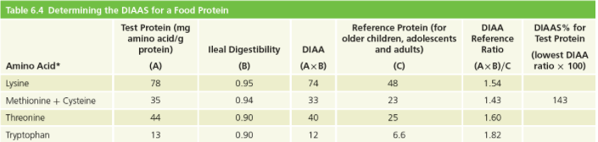
- 1.00 fully digested, 0.10 only 10% is digested
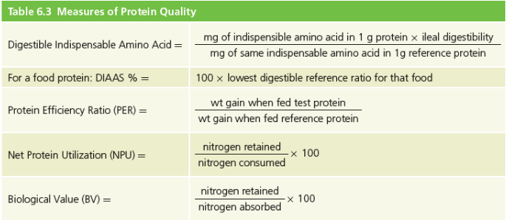
Considering Protein Quality
Protein Deficiency
- Consuming too little protein
Protein and energy deficiency go hand in hand.
Protein-energy malnutrition (PEM)
Most widespread form of malnutrition worldwide
- Takes on two forms:
Marasmus
Kwashiorkor

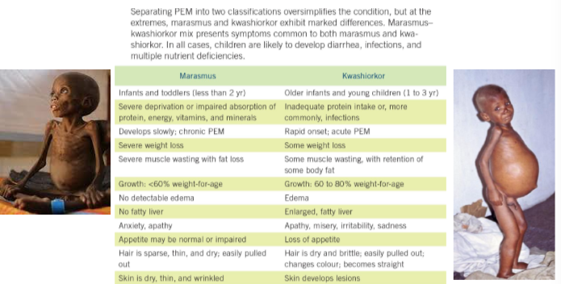
PEM: Marasmus and Kwashiorkor

Protein Excess
• Elevated protein intakes over long periods of time can result in:
Hydration and kidney function issues
Bone health issues
Kidney stones
Increased risk of heart disease and cancer

High-protein diets
• Excess dietary amino acids can be deaminated and converted to fatty acids and stored as triglycerides in adipose tissue
• Increased urea output
kidney stones, dehydration, loss of calcium (?)
High-protein diets are often:
high in animal proteins with high saturated fat and cholesterol and low in fiber
low in grains, fruits, and vegetables
high in calories and fat
Increased risk of heart disease, cancer, obesity, diverticulosis and diabetes mellitus

Vegetarian Diets
• In affluent countries, vegetarian individuals have lower rates of many diseases.
- Vegetarian diets: plant-based diets that eliminate some or all animal foods
- Poorly planned vegetarian diets typically lack iron, zinc, calcium, vitamin B12, vitamin D and the longer chain omega-3 fatty acids

Meeting Protein Needs with a Vegetarian Diet
• A healthy vegetarian diet can be achieved by modifying selections from Canada’s Food Guide.
• Servings of vegetables, fruits and grains will remain the same.
• Meat and Alternatives group contains– dried beans and peas and nuts and seeds.
- Substitute for the dairy foods fortified soy milk.

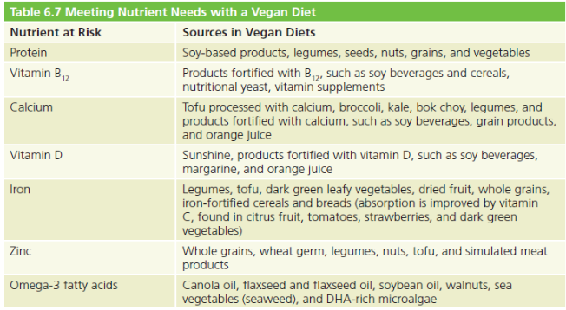
Meeting Nutrient Needs with a Vegan Diet
Positive Health Aspects of Vegetarian Diets
• Weight control
• Reduced heart disease risk
Diet is lower in saturated fat and cholesterol than meat- based diets.
Consumption of soy protein has shown a positive influence on blood lipids.
- Defence against high blood pressure • Defence against certain cancers

Diets During Critical Times
- Critical times in life include:
- Pregnancy and infancy
Vit B12, vit D, calcium, iron, zinc and protein
- Childhood
Protein, iron, vit B12 and food energy
- Adolescence
Vit B12, calcium and vit D • Aging and illness

