Prof. M. Buyukkurt
COMM 226, Section A
October 29, 2014
Assignment 2
ERD Diagram:
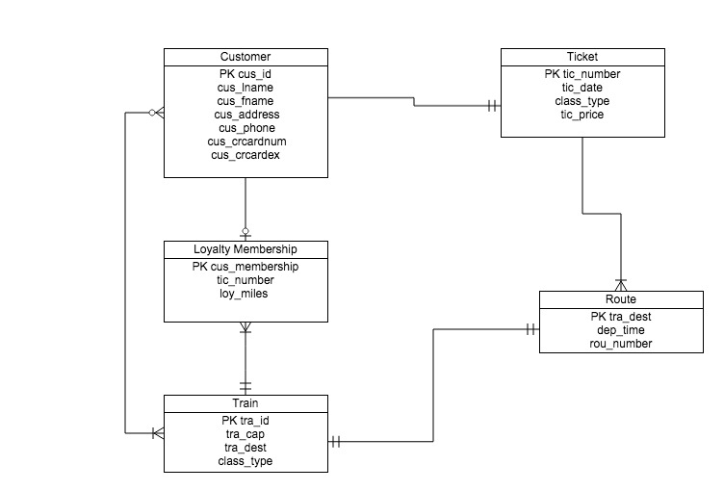

Data Dictionary:

