CHM2123 – Laboratory of Organic Chemistry II
Experiment 3 – The Kinetic Study of Nucleophilic Substitution

Introduction:
In any organic experiment, there are often competing reactions that may occur. For this experiment specifically, there was a possibility of either an E2 or S_{N}2 reaction happening based on the reagents that were used. The overall goal of the experiment was to adjust the amount of heat and the type of bromobutane to observe the effect it had on the competing reactions. This was varied using a different type of heating apparatus as well as changing the substitution on the alpha carbon in the reagents (1-bromobutane or 2-bromobutane).

Scheme 1: Example of elimination and substitution reactions
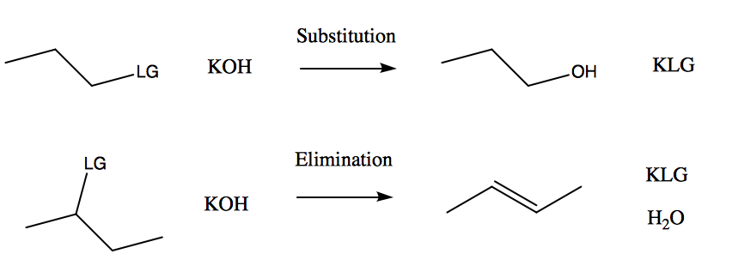

Both E2 and S_{N}2 reactions occur in concerted steps, meaning that the loss of the leaving group and the hydrogen elimination/nucleophile addition happen at the same time. Since the nucleophile/base is one of the most important factors used to improve reaction selectivity and product purity, potassium hydroxide was used. Since it is a strong base, this prevents E1 or S_{N}1 reactions from occurring during the experiment. The solvent used was ethanol, a polar protic solvent. Typically, reactions with bimolecular rate determining steps work better with polar aprotic solvents due to their effect on carbocation formation, but polar protic can also work with E2 and S_{N}2 reactions.
For this experiment, a round bottom flask was used on a heating apparatus with a reflux condenser attached to the top. The reaction mixture was continually stirred while it refluxed and a eudiometer tube was connected so that the amount of gas released could be collected. The entire set-up for this experiment was located in the fume hood where the reaction mixture was observed for approximately 15 minutes for each of the three trials.

Experimental Procedure:
- Refer to CHM2123 lab manual, pages 49-51
  - modifications – 0.5 mL of bromobutane was used for all three trials

Table of Reagents:
Compound | Molar Mass (g/mol) | Quantity  (g or mL) | Density  (g/cm³) | Moles | Equivalents
KOH | 56.1 | 8.08  8.00  8.02 | 2.12 | 0.144  0.143  0.143 | 15
1-bromobutane | 137.0 | 0.5 (x2) | 1.27 | 0.0046 | 1
2-bromobutane | 137.0 | 0.5 | 1.26 | 0.0046 | 1
ethanol (95%) | 46.1 | 35 (x3)  5.0 (x3) | 0.816 | 0.620  0.0089 | 678

Table of Observations:
Key Step | Observation
1-bromobutane reflux | - impurities in the round-bottom flask caused the solution to turn bright yellow and darken in colour throughout  - the bubbling was initially very rapid  - the initial KOH used was in solid, round crystal form and the final precipitate was a white powder
2-bromobutane reflux | - the reaction mixture was white and mostly transparent  - less precipitate formed than last time  - a large quantity of gas was produced during the reaction  - gas production slowed down after addition of the reagents
1-bromobutane water bath | - there was minimal bubbling in the eudiometer, and it almost completely stopped after the 1-bromobutane addition  - some milky white precipitate was present in the reaction mixture but it was not filtered out  - no solid product was obtained

Table of Results:
Reaction conditions | Pressure of gas (atm) | Volume of gas (mL) | Moles of butene | Mass of KBr (g) | Moles of KBr | KBr % Yield | Moles of butanol
1-bromobutane at reflux | 0.947 | 11.2  (+49) | 0.00044 | 0.4047 | 0.00034 | 7.4% | 0.0001
1-bromobutane at 50°C | 0.934 | 1.0 (+11.5) | 0.00004 | 0 | 0 | 0% | 0
2-bromobutane at reflux | 0.943 | 7.2  (+100) | 0.00003 | 0.2106 | 0.00018 | 3.9% | 0.00015

Calculations:
- 1-bromobutane reflux used as a sample

Pressure of gas in eudiometer
atmospheric pressure = 101.4 kPa = 760.6 mmHg
height of water in beaker = 140 mm
length of eudiometer tube = 560 mm
height of water in tube = 50 – 11.2 = 38.8 mL = 434.6 mm
height of water above level = 434.6 mm – 140 mm = 294.6 mm
P* = 21.66 mmHg
p = P_{atm} – P_{water} – P*= 760.6 mmHg – 18.8 mmHg – 21.66 mmHg
= 720 mmHg = 0.947 atm

Moles of Butene
n_{gas} = PV/RT
= (0.947)(0.0112) / (0.08206)(294) = 0.00044

Moles of Butanol
n_{KBr} = n_{gas} + n_{butanol} = n_{E2} +n_{SN2}
n_{butanol} = 0.00044 - 0.00034 = 0.0001

Conversion = (n_{E2} + n_{SN2}) / (n_{limiting}) x 100%
= (0.00044 + 0.0001) / (0.0046) x 100% = 11.7%

Selectivity = n_{E2} / (n_{E2} + n_{SN2}) x 100%
= n_{SN2} / (n_{E2} + n_{SN2}) x 100%
= 0.00044 / (0.00044+0.0001) x 100% = 81.5%
= 0.0001 / (0.00044+0.0001) x 100% = 18.5%

Percent Yield = [actual moles/theoretical moles] (100%)
= 0.00034/0.0046 (100%) = 7.4 %

Additional Table of Results:

Reaction Conditions | Conversion | Selectivity
1-bromobutane at reflux | 11.7% | E2-81.5%, SN2-18.5%
1-bromobutane at 50°C | 0% | E2-100%, SN2-0%
2-bromobutane at reflux | 39.1% | E2-16.7%, SN2-83.3%

Discussion:
The focus of this experiment was to distinguish between elimination and substitution reactions, both with bimolecular rate determining steps. The main procedure was performed in three different trials, with one factor that affected the reaction being altered each time, such as temperature of the reaction mixture and the type of alkyl halide used. In the first trial, 1-bromobutane was mixed with potassium hydroxide under reflux conditions. This elevated temperature caused the results to yield mostly butene (elimination) with only 18% butanol (substitution). Since 1-bromobutane has a primary alpha carbon, it is typically difficult to specify for either elimination or substitution, and a mixture of products is very common.
This result was similar in the second trial using 1-bromobutane again, this time using a hot water bath instead of the heating mantle. Unfortunately, since the 50°C water bath kept the reaction mixture at a much lower temperature than the heating mantle, the reaction didn’t progress in the same way. Prior to adding the bromobutane, a small amount of bubbling appeared in the eudiometer, however as soon as it was added the reaction nearly stopped. Almost no additional gas was produced, which was contrary to the previous reaction where a second eudiometer tube had to be attached due to the large quantity of bubbling. Even after waiting for nearly twenty minutes and ensuring that the water bath was kept at precisely 50°C, no solid product was obtained during the suction filtration. Due to the small amount of gas, the calculations showed that there likely was an E2 reaction, although the lack of solid KBr demonstrated that either there was no reaction or the precipitate was too fine to be filtered out.
In the final trial, reflux conditions were again used but this time using 2-bromobutane, which has a secondary alpha carbon. In theory, the more substituted the alpha carbon is the more likely it is that an elimination product will be favoured due to hindrance. However, the results that were obtained in the lab seemed to have the opposite yield (mostly S_{N}2 product). This may have occurred due to the elevated temperature of the heating mantle or that ethanol (polar protic) was used as the solvent, which often causes elimination reactions to be favoured over substitution. In this trial, there was a very large quantity of gas produced both before the 2-bromobutane addition and after it. This was expected since amount of gas obtained directly correlated to moles of butene, which should have been the main component in the products.
When measuring the amount of gas released in the reaction, it was necessary to record how much has had been produced prior to adding the bromobutane and use that as the starting point. In the procedure, it states that as soon as the bubbles had stopped forming the reagents had to be added, which was necessary to ensure that the gas reading was accurate. For all three trials, the calculations showed that the pressure of the gas inside the tube was slightly lower than atmospheric pressure despite the smaller volume. This showed that the gas had different molecular properties than typical atmospheric gas, such as attractive forces between the atoms.
The selectivity showed that the product ratio (E2:S_{N}2) for the first trial was 4:1, second 1:0, and third 1:5. Overall, the yield for all three trials were not very good and were below 40%. This was likely due to inconsistencies with the temperature and not being able to keep it high enough for all of the reactant to react. Additionally, both S_{N}2 and E2 reactions work best with a polar aprotic solvent, and in this lab the polar protic solvent ethanol was used. This may have reduced the yield of butanol especially since the negative anions are surrounded due to the hydrogen bonding, which often prevents them from functioning effectively as a nucleophile.
Questions:

- n_{bromobutane} = n_{butene} = 0.0046 mol
T = 25 + 273 = 298 K
V = nRT/P
= (0.0046mol)(0.08206atm/molK)(298K) / (1atm) = 0.11 L

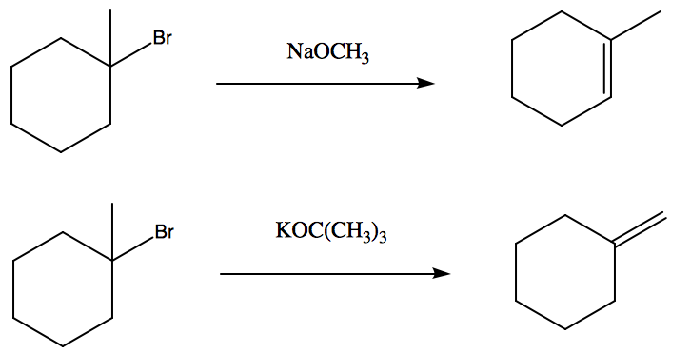

  - elimination (tertiary alpha carbon)
  - substitution (primary alpha carbon)
  - substitution (alkyl group alpha carbon)

- Firstly, the alpha carbon could be changed from primary to tertiary or secondary
(2-bromopentane) since substitution reactions don’t work well with highly substituted alpha carbons due to the hindrance between the carbon groups and the nucleophile. Secondly, a stronger base could be used such as sodium hydride, which does not function as a good nucleophile so the substitution reaction would be avoided and
1-pentanol would not be produced.

