Midterm 2:

- Sensation

- Electrical signals travel along the nerves as an action potential
- The “message” that arises in a sensory neuron is always the same: a travelling electrical signal.
- Sensation is objective (more or less. Sensation is probably similar in all humans and presumably all animals that share one or more of our specific receptors). “Bottom up” processing.
- Perception is intergrtion of sensory information with permanently stored memories to form “percept”… this takes place at a “higher” level in the brain
- Perception is very subjective. “Top down” processing

Physics of energy:
In all modalities, our receptors provide at least five critical features of the physical characteristics of a stimulus:
1. Its modality. What type of experience that is bombarding the receptor? Is it light energy? Sound?
2. Its frequency. How often is the receptor stimulated?
3. Its intensity. How much energy is there? Is it loud? Is it bright?
4. Its location. Where does this stimulus come from?
5. Its duration. How long does the stimulus persist? When does it start? When does it stop?

Thresholds:
- All receptors require a certain minimum amount of physical energy to result in an action potential across the sensory nerve.
- If there is not enough energy, the sensory nerve will not fire
- There are 2 types of thresholds that are typically measured:
1. Absolute:
The minimum amount of phycial energy necessary to detect a stimulus on 50% of presentations
2. Difference Threshold:
Aka Just Noticeable Difference (JND)
Detection of minimum change in energy; Weber’s Law states that deltaI/I =k
(The difference in intensity over the original forms the intensitys constant (k)
- Signal detection theory: the measurement of a threshold (whether the absolute or the difference) requires the observer to consciously perceive a stimulus. Note that this is not sensation. Sensation is objective. Perception (and consciousness of perceiving) is subjective.
- The measurement of the threshold can be influences by subjective factors.
- subliminal perception is the ability to perceive stimuli that are below threshold.

- Consciousness
I) The Prcoess of Attention
-“detection” and “awareness” of the outside, “external” environment or the “internal”, mental environment form part of the definition of what we call “consciousness”. However they are not sufficient. Think a computer can do all this… but a computer it is not conscious.
- if we had defined consciousness as the ability to detect an external stimulus, then by this definition, the computer is conscious.
- Humans are different than animals… we are self conscious… that meaning we are conscious that we are conscious. But maybe some animals are too? That being said we are “more there” than other animals… but how can you scientifically define “more there”…
- How can consciousness be measured?

We shall consider consciousness in two ways: as a state and as a process.
• The sleep-wake cycle is divided into a waking and a sleeping state. In the alert and waking state, the observer is aware of their environment and is thus said to be in a state of consciousness. During natural sleep, the observer is no longer (apparently) aware of their environment and is thus said to be in a state of unconsciousness. Sleep as a state of unconsciousness will be studied later in this section.
• While in the waking state, the observer, although conscious, is not conscious of everything. Rather it appears that the observer must restrict attention to only a very small portion of their environment. This is called the selective attention process and permits the observer to become conscious of highly relevant stimulus input. However, this comes at a cost. The observer will not be conscious of less relevant input.
• Consciousness involves more than simply detecting and becoming aware of an external stimulus input. It also involves something abstract called experience. This perceptual experience is highly personal and subjective and can therefore be easily altered.

Consciousness as a Process
- Sensory receptors are constantly bombarded with input
- Think of the “cocktail party” study… of the many people speaking, you can make yourself only conscious of the one or two people whom you are speaking with
- Therefore, we are conscious of only a small portion of the sensory input that is bombarding our receptors
- This is because our brain has limited capacity to process information
- The basic features (location, intensity, duration, pitch-colour…) of all incoming stimuli are extracted automatically (without effort), whether attended or not. The extraction of these basic features takes place prior to consciousness (i.e., we are not yet conscious that a stimulus has been presented).
- We become conscious of only a portion of these extracted features… we become conscious of what is: relevant.
RELEVANT:
- How do we determine what is relevant?
-Psychological (personal) relevance
-Biological relevance

Active and Passive Attention
- To become conscious requires additional processing after the initial extraction of basic features. This additional processing is called attentional processing:

Psychological (personal) relevance = active attention

Biological relevance = passive attention
How do we become aware of the stimulus input that is RELEVANT? Yet banish from awareness that which is NOT relevant????
- One method, active attention, requires considerable cortical effort and considerable “focusing” in order to distinguish relevant input from irrelevant input. The observer chooses to become aware of that which is relevant.
- A second method, passive attention, requires no effort. Rather, certain highly privileged stimulus input will force the observer to switch attention away from whatever they were doing and now attend to the processing of something that is deemed to be much more relevant.

Active/Selective Attention:
Psychological (personal) relevance
-Only the most relevant stimulus attains consciousness
- Our brains have a limited capacity to process information
- Selectivity. We are free to CHOOSE what information to attend to
- Active attention requires us to distinguish what is relevant and what is irrelevant
- This is a very complex task
- Requires focusing and vigilance
- Active attention is modulated by a “central executive” (probably the frontal lobe). It is the central executive that decides what is relevant and how much cognitive capacity the task will require.
- A memory that is relevant must be formed and stored in the working (short-term) memory system of the hippocampus
- Storage and maintenance of this working memory requires effort
-REQUIRES EFFORT

Passive Attention:
Biological relevance
- Requires no effort
- A biologically relevant stimulus input will force the observer to….
- Switch attention away from what they are doing…
- And now attend to processing of something that is potentially more relevant.
- It is “potentially” more relevant because the observer does not know if the input is indeed highly relevant until it is processed further
- Intrusion into consciousness
- Distraction

Capacity Theory
- Daniel Kanheman (Noble Prize 2002 in Ecenomics)… regarded all cognitive processing as a “task” to be completed
- Cognitive tasks make more or less demands on limited cortical “resources”. Complex tasks make more demands on the limited capacity of the processing system than others than are less complex.

- We have limited capacity to carry out cognitive tasks. This is because of limited resources and a “central executive” must determine how these resources will be divided

Controlled Processing
- Requires effort; uses processing resources
- Processing of one task affects performance on another
- Resources devoted to one task are not available to the processing of another task
- Serial processing. In a strict serial task, the processing of a secondary task cannot begin until the processing of the first task has been completed

Automatic Processing
- No effort; no processing “resources”
- Several tasks can be carried out
- Parallel processing
- Tasks that origionally required effort can become, with practice, effortless or automatic
- Think reading words… over time it becomes automatic
- Identify the colour of the words………
- The Stroop task, the subject is presented with a list of words (colours) printed in different conditions…
in one condition they are asked to name the word, the other name the colour

Multitasking and Parallel Processing:
- More than one task can be carried out at once, but at no cost (detriment in performance on any of the tasks)…
- Also called divided attention
- Often, resources are not available
- Then, the observer must decide which tast to process.. the tasks are then carried out using serial processing
- Note that in a strict serial task, the processing of one task must be completed before processing of the other begins.
- The so-called digital generation (most university students) often are said to be capable of true multitasking (they study, listen to music, text, surf the web at the same time… in parallel). In actual fact, they switch from one task to the other, and this comes at a cost. Performance on any one of the tasks will deteriorate when attention is switched to another task.

Dual Processing (Two Track Mind)
- while you are carrying out one cognitive task that requires controlled, effortful processing, you can also carry out a second task (thus dual processing), if this second task requires only automatic (and thus, effortless) processing. These tasks are thus carried out in parallel by the two-track mind.
- It is, for example, possible to carry out two controlled tasks in parallel (i.e., at the same time) provided that the sufficient resources are available (i.e., neither of the controlled tasks require an extensive use of resources).

II) Conscious and Unconscious States: Natural Sleep

Consciousness as a state (wake and sleep states)
- Sleep-wake states
- Conscious waking state
- Unconscious sleeping state
- What is sleep?
- Sleep is not unique
- Consists of 2 divisions: NREM and REM
- Sleep is rhythmic

Recording Sleep in Humans:
- EEG: electroencephalogram
- EMG: electromyogram
- EOG: electrooculogram
- Other activity: respiration, heart beat/pressure, temperature
How does an experimenter know if a subject is conscious?
- Over behaviour: subject signalled awareness
- Physiology: EEG, brains response to stimuli

EEG Arousal
- beta (awake and alert) high frequency 15 Hz+, low amplitude EEG
- alpha (relaxed) 8 -12 Hz, rhythmic EEG
- theta (light sleep-drowsiness) 4-7 Hz EEG
- delta (deep sleep; coma) low frequency 1-4 Hz, high amplitude EEG

Biological Rythms
• Circadian: every 24 hours (e.g., sleep-wake cycle)
• Ultradian: within 24 hours (e.g., eating cycle)
• Menstrual: (monthly cycle…more or less)
• Annual: (reproductive/mating cycles in many animals)
• In humans, sleep is a circadian rhythm
• The onset and offset of sleep is largely biological controlled by the detection of light-dark.

SCNucleus and Pineal Gland
- We normally sleep on a 24hour schedule regulated by the light-dark cycle
- the SCN detets lightness-darkness
- The SCN Is a group of nuclei in the inferior region of the hypothalamus
- The optic nerve sends information about light and darkness to the SCN
- The SCN relays this information to the pineal gland, located superior (above) and posterior to the thalamus
- The pineal gland is an endocrine gland and releases a hormone called melatonin
- Melatonin released upon the detection of darkness
- Melatonin is responsible for “feeling” tired
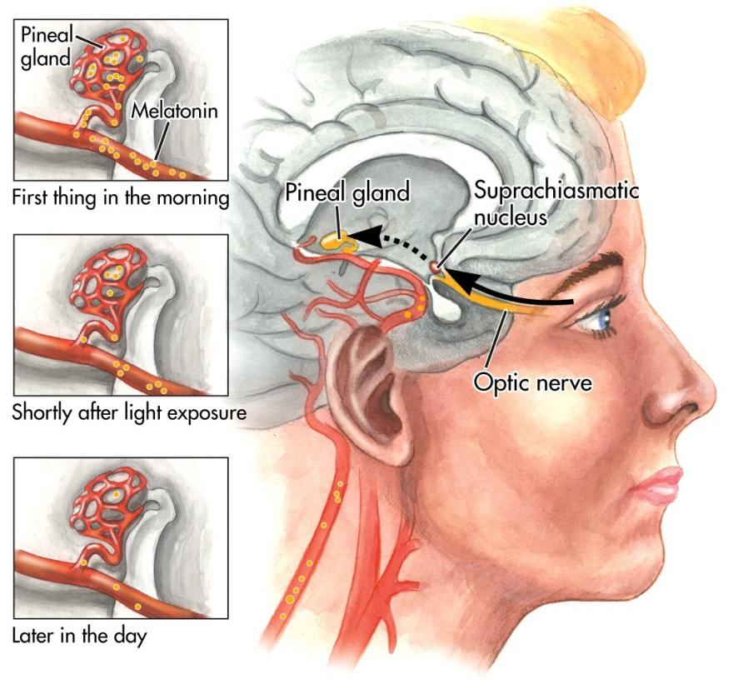
You may think What is the Effect of Constant Light/Darkness?
- The animal is now in constant darkness and because it no longer receives cues about the 24 light/darkness cycle, a new sleep-wake cycle develops.

Stages of Sleep:
- Awake:
EEG shows fast frequency, low amplitude (beta, maybe alpha)
Subject is “conscious” and is aware of their environment
Most young adults spend about 16 hours awake
- Stage 1
Breif period during the transition from a waking to sleeping state
EEG slows (less than 50% alpha)
loss of muscle tonus
EOG shows slow rolling movements
Hypnogogic reverie
Subject begins to lose conscious awareness of external environment

- Stage 2
EEG shows slower frequencies (theta, delta)
Presence of spindles and K-Complexes
EMG lower
very little conscious awareness of the external enviornement
Subject is definitely asleep
Occupies ½ of our total sleep

- Stage 3-4 (Slow Wae Sleep or SWS)
EEG shows mainly slow frequency high amplitude delta waves
EMG tonus very low
Very deep sleep
Subject may show no conscious awareness of eternal environment
Occupies about 25% of our total sleep
Mainly occurs in the first half of the night
-REM
Aroused EEG (like stage 1 or Waking)
- But subject is very difficult to awaken (thus name “paradoxical sleep”)
- 90 min cycle
- Most of stage REM at the end of the night
- Muscle inhibition (but not total)
- Rapid eye movements
  - Dreaming
  - Absence of frontal lobe functions
  - Period of profound unconsciousness?
  - However, lucid dreamers can signal they are dreaming. Moreover, an experimenter can influence the content of their dreams.

- Stages 2,3,4 are often combined to form non-REM (NREM) sleep:
Stages 2, 3 and 4 show theta and delta EEG. Stage 2 has less delta and more theta while stage 4 has more delta and less theta.
- Period of profound unconsciousness?
- Loss of frontal lobe control?
- Sleep spindles; inhibitor of processing of external stimulus input.
- The K-Complex. Function? A means to detect stimuli during the night? Or a sleep protector?
- Night terrors; sleep walking (but sleeper is unconscious!) within stage 4



