Proterozoic Eon

9+2 Organization
- bundle of 9 pairs of microtubules surrounding two single microtubules
- provides structure for the cell
- found inside cilia and flagella of eukaryotes

Alteration of Generations
- aka metagenesis
- describes the life cycle of plants
- regular alteration between modes of reproduction; making haploid and diploid between generations
- diploid cells (2n) undergo meiosis to make spores (n)
- spores undergo mitosis to form a gametophyte
- n gametes then meet by mitosis to form a zygote again

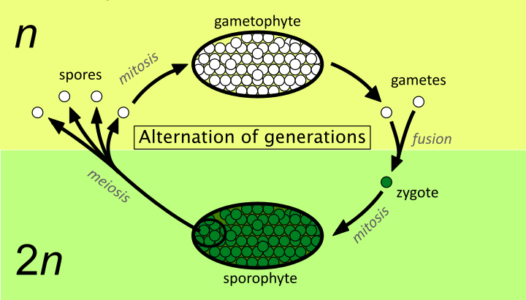

Amoeboid Movement
- most common form of movement in eukaryotes
- “crawling” motion
- actin and myosin are used for movement rather than formal structures of mobility
- viscosity of cytoplasm is altered in different areas of the cell to coordinate flow of movement

Asexual Reproduction
- produces offspring that are genetically identical to single parent
- any reproductive methods which do not involve meiosis
- genetic changes occur solely due to mutation

Autotroph
- organism that produces complex organic compounds from simple substances
- usually obtains energy from sun to oxidize inorganic substances

Eubacteria
- prokaryotic, morphologically the same but metabolically diverse
- within the domain of prokaryotes
- no membrane bound nucleus or structures

Bacteriophage
- a virus which replicates within bacteria
- consists of genetic material surrounded by protein capsid
- requires a host cell’s “machinery” to reproduce

Basal Body
- protein structure found at the base of cilia or flagellum
- formed of a centriole and other protein structures
- act as anchoring sites for proteins, facilitating movement and providing structure

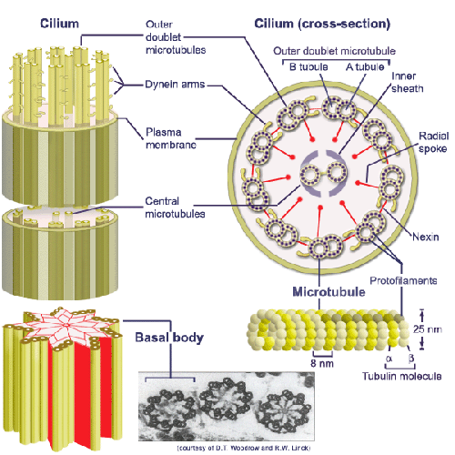

Bikont
- eukaryotic cell with two flagella
- movement in an upward direction
- used for obtaining food
- thought to be the ancestor of plants

Cellular Division of Labor
- each organelle within a cell fulfills it’s own role contributing to cell survival
- only possible in eukaryotic cells, thanks to separate membrane bound structures
- prokaryotic organisms must do tasks individually

Cellular Gliding
- process of movement in bacteria not using flagella
- uses dynes and kinesins
- first way of moving

Centriole
- cylindrical structure composed primarily of tubulin
- consists of nine triplets of microtubules
- found in centrosomes of most animal cells

Centrosomes
- serves as the microtubule organizing center (MTOC)
- key role in mitosis of animal cells, spindle fibers emerge from here

Chloroplast
- contains chlorophyll
- site where photosynthesis takes place
- supports endosymbiotic theory due to double membrane structure (it was engulfed)

Choanoflagellate
- single celled aquatic protists
- closest living relative of animals
- flask shaped body with microvilli surrounding collar to move and consume food
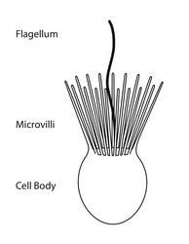

Cilia
- microscopic hair-like structures protruding from cells, composed of microtubules
- can be motile or non-motile
- motile cilia allow for movement of materials on the surface (ie in respiratory tract)

Cirrus
- a bundle of cilia serving as a foot-like structure
- allowing for walking rather than swimming

Contractile Vacuole
- regulates the quantity of water inside a cell
- vacuole expels water through contraction

Crossing Over
- process during meiosis where homologous chromosomes line up on the metaphase plate and swap genetic material
- results in genetic variation
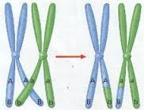

Cytoskeleton
- network of protein filaments within the cell
- provides structural support and cell shape

Diploid
- contain complete set of chromosomes for a cell (two copies)
- reduced by meiosis

Diplontic
- life cycle of an organism that has somatic cells which are diploid
- gametes can be haploid

Dyenin Molecular Motor
- motor proteins which use ATP to move along microtubules in cells and transport cellular substances
- allow for movement of cilia and flagella

Ectoplasm
- outer layer of cell’s cytoplasm
- provides elastic support to the cell membrane

Endomembrane System
- the different membranes within the cytoplasm of a eukaryotic cell
- divide the cell into structural and functional compartments
- includes nuclear membrane, endoplasmic reticulum, golgi apparatus, lysosomes, vesicles and cell membrane
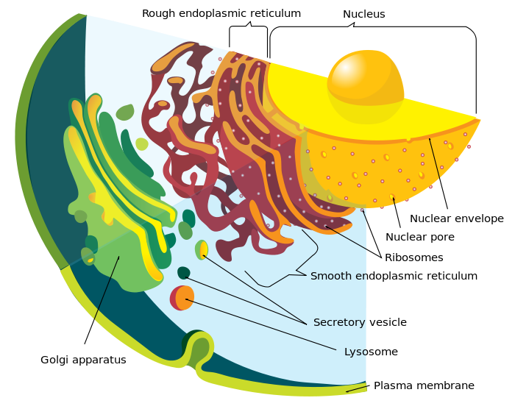

Endoplasm
- more fluid, granular inner layer of cytoplasm
- allows for intracellular transport

Endosymbiosis
- theory explaining the origins of mitochondria and chloroplasts
- states that organelles were engulfed by eukaryotic cells
- symbiotic association is formed, the couple benefit each other
- ie. mitochondria provide energy for the cell while the cell provides required nutrients for ATP to be made

Eukarya
- domain containing all organisms which have a nucleus and membrane bound organelles (eukaryotes)

Flagellum
- whip-like appendage protruding from a cell body
- main function is movement (can be sensory)
- flagellum can differ greatly biochemically, contributing to the diversity of bacteria
- found in both prokaryotes and eukaryotes

Formylmethione
- derivative of amino acid methionine
- inserted during translation as the start codon
- not used by eukaryotes

Gametocyte
- a cell that divides to form gametes

Gametophyte
- stage during the alteration of generation in which the cell is haploid
- undergoes fertilization to form a zygote which then divides to form a new diploid organism

Haploid
- a single set of unpaired chromosomes
- present in gamete cells

Haplontic
- life cycle where cell is mainly haploid
- diploid cell is only briefly formed
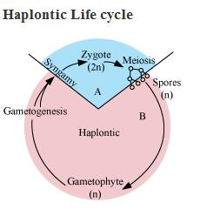

Heterotroph
- cannot manufacture it’s own food
- depends on complex organic substances for nutrition

Histone Proteins
- help condense DNA into chromatin
- positively charged so it can interact with DNA (negative)
- DNA tightly coils around the proteins to form chromosomes

Host
- a species that is “fed” upon by a parasite
- ie. virus on a cell

Kynesin Molecular Motor
- attaches to microtubule and moves along it
- powered by hydrolysis of ATP
- allows for transportation of cellular cargo

Macronucleus
- nucleus occupying a large portion of the cell
- has only genes required for “housekeeping” functions

Malaria
- parasite which invades red blood cells
- causes chills and a fever
- passed on by the bite of a mosquito

Meiosis
- cell division producing four haploid cells from a diploid cell
- undergoes steps of mitosis twice
- forms gametes for sexual reproduction

Merozoite
- single cell organism produced by multiple fissions of a parasite within a host
- capable of beginning a new reproductive cycle

Metachronal Wave
- the coordinated wave motion of structures (ie cilia)
- allows for the effective movement of a substance over a surface

Methionine
- amino acid present in humans
- coded for by the initiation codon
- first amino acid used in eukaryotic cells during translation

Micronucleus
- smaller nucleus occurring in paramecium
- contains a complete set of genes
- responsible for genetic reorganization during binary fission

Microtubules
- tubular structure present in cell cytoplasm
- allows for movement, structure and transport
- formed from tubulin to form hollow structures

Mitochondria
- structure supplying energy to the cell (makes ATP)
- belief it was engulfed (endosymbiosis theory)
- has own DNA

Mitosis
- process allowing the cell to divide into two daughter cells
- cells are exact genetic copies of parent nucleus
- stages are prophase, metaphase, anaphase and telophase
- DNA and structures are replicated and mitosis allows for the division
- ends with cytokinesis (splitting of cytoplasm)
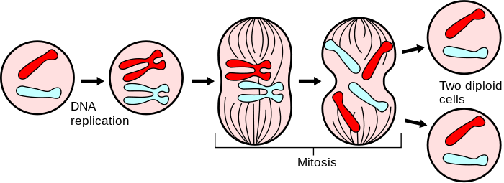

Molecular Motors
- protein machines allowing for movement within the cells
- driven by ATP hydrolysis
- include myosins, dyneins and kinesins

Myosin Molecular Motor
- generates the force of muscle contraction
- pushes actin filaments towards each other to allow for movement of muscle
- motor protein in amoeba movement

Nuclear Envelope
- regulated membrane barrier separating nucleus from cytoplasm
- consists of outer and inner membrane as well as intermembrane spaces and associated structures

Operon Genes
- a group of genes of DNA fragment which operates as a single transcription unit
- composed of an operator, promoter and more structural genes
- regulates other genes responsible for protein synthesis

Pandemic
- a disease spread over a whole population/world
- typically crosses international borders and affects large numbers of people

Parasite
- an organism that lives on or in another organism
- benefits at the hosts expense

Peptidoglycan
- found as a layer to the cell walls in bacteria
- serves to strengthen the cell wall
- made of complex sugar polymers and amino acids

Pericentriolar Material
- matrix of proteins surrounding centrioles
- organizing centers for the growth of the mitotic spindle

Phagocytosis
- process of a cell of engulfing a particle
- specific form of endocytosis

Phytoplankton
- microscopic marine plants
- turn inorganic substances into organic substances for themselves (autotrophs)

Pinocytosis
- “cell drinking”
- form of endocytosis where small particles are brought into the cell
- cell ingests extracellular fluid and the dissolved solutes

Planar Flagellar Beat
- the rhythm of the flagella beating
- described as planar and wave-like

Plankton
- small organisms living within the water
- food source for many aquatic organisms

Plasmodium
- genus name of the parasite which causes malaria
- single celled organism which is able to divide only within a host cell

Plastid
- major double-membrane organelle found within cells of plants
- site of manufacturing and storing important chemical compounds
- contain own DNA and ribosomes

Polygenomic Classification
- so this term literally doesn’t exist
- base word is polygenic; meaning a trait controlled by two or more genes
- possibly classification of organisms based on their polygenic traits?
- idk I tried

Primary Consumers
- a living organism which eats producers
- usually herbivores

Primary Endosymbiosis
- process by which a eukaryote engulfs another living prokaryote
- organism then uses prokaryote to their advantage
- ie. process gave rise to first photosynthetic eukaryotes with chloroplasts

Primary Producers
- organisms which can produce their own food source
- lie at the bottom of the food chain
- autotrophs

Proterozoic
- extended from 2500 Ma to 542 Ma
- sparked the Cambrian explosion of biodiversity
- oxygen rich early atmosphere allows for aerobic life

Protista
- organisms which are unicellular and form no tissues (?)
- eukaryotic creatures (enclosed DNA) but behave as prokaryotes

Pseudopod
- a temporary protrusion on an amoeboid cell allowing for movement and feeding
- caused by movement of cytoplasm within the cell

Reverse Transcriptase
- enzyme used to generate complementary DNA from RNA
- used commonly by virus RNA

RNA Polymerase
- enzyme allowing for assembly of RNA strand from free flowing nucleotides
- essentially allows translation
- simple process in bacteria; complex in archea and eukarya

Saprophytic
- organisms living on dead or decomposing material
- breaks down dead organic material into simpler compounds for consumption

Secondary Endosymbiosis
- occurs when an organism which performed primary endosymbiosis is then engulfed
- eukaryotic cell survives within the larger due to an endosymbiotic relationship
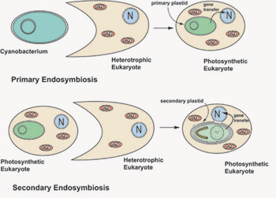

Sexual Reproduction
- a new living organism is produced from the combination of genetic information from two individuals
- gametes fuse to form a zygote

Spiral Flagellar Beat
- specific spiral shape held during bacteria movement due to the semi-rigid fibers of the flagella

Spore
- one celled reproductive unit capable of producing an individual without sexual fusion
- produced commonly by plants

Sporophyte
- diploid multicellular generation of spores
- function is to divide to produce more haploid spores

Sporozoite
- motile infective form of the malaria parasite
- occurs when introduced into the host

Supergroup
- classification for clades which is above kingdom but below domain
- a proposed way to organize eukaryotes into monophyletic groups

Trophozoite
- growing stage of the malarial parasite
- occurs when they are obtaining nutrients from the host (“feeding”)

Tubulin
- protein which is the major building block of microtubules
- intracellular cylindrical filament structure

Unikont
- eukaryotic cell with a single flagellum
- thought to be ancestor of all animals

Zooplankton
- heterotrophic plankton
- small organisms found in aqueous environments

Zygote
- a single diploid cell as the result of two gamete cells
- contains genetic information from two parents

