University of Ottawa

EXPERIMENT 2:
THE KINETIC STUDY OF NUCLEOPHILIC SUBSTITUTION
Emily MacInnis
8254462
Edith Berko
7586276
Claryss Christolin
8869281

Abdullah Akbar
CHM2123
LABORATORY OF
ORGANIC CHEMISTRY II
section D

due
October 6, 2016

INTRODUCTION
The purpose of this experiment was to understand the kinetics of a reaction under different conditions. This was done by monitoring the rate of the reaction. The speed of the reaction is dependent on several factors such as temperature, the concentration of the reagents and the solvent used. As for example as the temperature increases so does the number of collision, making the reaction go faster.The rate of a reaction can be calculated by this formula:
k [reagent 1]^{x} [reagent 2] ^{y}
The variable k is the rate constant of the reaction, which takes into consideration all the conditions that can slow or speed up the rate of the reaction . The exponents x, y represents the order of the reaction. The order of a reaction is usually determined experimentally more specifically graphically.
A zero order reaction occurs when the formation of the product is independent of the concentration of the reagents.
[A] = [A]₀ – kt
A first order reaction occurs when the formation of the product is dependent on the concentration of one of the reagents.
[A] = [A]₀e^{-kt}
A second order reaction occurs when the formation of the product is dependent on the concentration of both reagents.
Nucleophilic substitution
Nucleophilic substitution reaction involves a nucleophilic (electron donor) and an electrophile (electron acceptor).
They are two types substitution reactions: S_{N}1 and S_{N}2
A SN2 reaction takes place in one whole step, the nucleophile attacks the electrophile and the leaving group comes off. The formation is dependent on the concentration of the nucleophile and the electrophile, making it a second order reaction.
In the first part of the experiment we observed the effect of the leaving group on the rate of the reaction of 1-chlorobutane with KOH. A good leaving group can stabilize its negative charge, through resonance or strong withdrawing groups and are usually weakly basic. Using concepts of titration, we are able to determine how much KOH is in the aliquot by measuring how much acid, in our case HCl, is needed to neutralize it. With the KOH concentration titrated we can graphically determine the rate constant of the reaction and the order of the reaction by plotting a [KOH], ln[KOH] and 1/[KOH] vs time graphs.
Similarly, in the second part of the experiment we observed the effect of the solvent on the rate of the reaction of the hydrolysis of tBuCl at different % completion. We are able to determine how much tBuCl remains in solution, by taking the initial concentration of tBuCl and multiplying it by the percent that is not consumed in the reaction. With the remaining [KOH] we can experimentally, with the aid of graphs determine the rate constant and the order of the reaction.

MECHANISM
Part A: Sn2 Reactions
Hydrolysis of 1-chlorobutane and 1-bromobutane by KOH to a primary alcohol
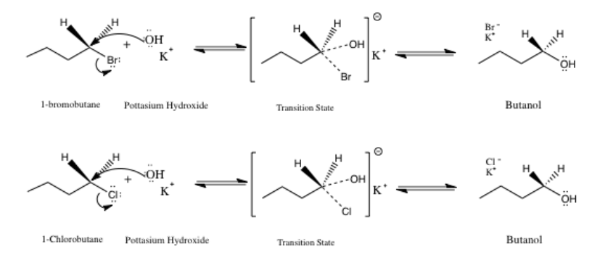
Part B: Sn1 Reaction
Hydrolysis of tert-butyl chloride by H2O to a tertiary alcohol
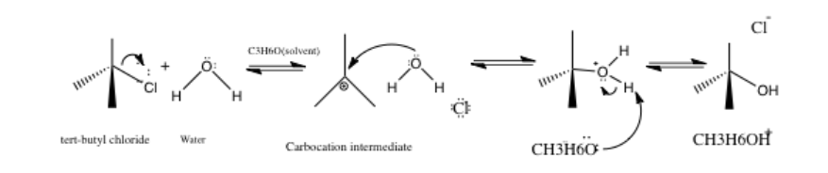

TABLE OF REAGENTS
Table of Reagents- Part A
Compound | Molar mass  (g/mol) | Quantity  (g or m L) | Density  (g/mL) | Mmol | Equivalents
0.1 M 1-chlorobutane | 92.58 | 40 ml | 0.89 | 380 | 5
0.1 M HCl | 36.46 | -- | 1.19 | -- | --
2.0 M KOH in EtOH | 56.105 | 10 ml | 1.046 | 180 | 2
EtOH | 46.068 | 5ml | 0.7854 | 85 | 1

Table of Reagents- Part B
Compound | Molar mass  (g/mol) | Quantity  (g or m L) | Density  (g/mL) | Mmol | Equivalents
0.1M tBuCl in acetone | 92.57 | 3 ml | 0.851 | 27 | 2
0.02 M NaOH in water | 39.997 | 1.5 ml | 1.04 | 52 | 4
Acetone | 58.08 | 3ml | 0.79 | 40.8 | 3

PROCEDURE
Part A: See pages 39-40, Experiment 2: The Kinetic Study of Nucleophilic Substitution, CHM 2123 Laboratory of Organic Chemistry II, Department of Chemistry, University of Ottawa, 10 Marie Curie, Ottawa, Ontario, K1N 6N5.
*No modifications were made to the procedure
Part B: See page 40, Experiment 2: The Kinetic Study of Nucleophilic Substitution, CHM 2123 Laboratory of Organic Chemistry II, Department of Chemistry, University of Ottawa, 10 Marie Curie, Ottawa, Ontario, K1N 6N5.
*No modifications were made to the procedure

OBSERVATION & RESULTS
Key Steps | Observations
Part A
Removing the Aliquot | 1-chlorobutane is a clear, transparent solution. The solution stopped boiling when KOH was added and began to boil a few minutes later
Adding Phenolphthalein | Solution turned pink after adding 2-3 drops
Titration with HCl | Solution turned cloudy white after HCl was added, precipitate of KCl was formed
Part B
Adding bromothymol blue | 3 drops were added, solution turned dark, translucent blue
Addition tBuCl | Over time, the solution turned paler blue until it turned a pale, almost white, translucent yellow
85:15 H2O: acetone solvent system | At 10% completion, the colour change occurred quickly. As the percent completion increased, so did the time it took for the colour change to occur
70:30 H2O: acetone solvent system | For 10% completion, the time it took for the colour to change was significantly longer than for the first solvent system and the time increased as the completion increased like before.This trend continued for all completion percentages.

Part A-Table of Results:
Reaction Time(mins) | 2 | 15 | 30 | 45 | 60
V_{aliquot} (ml) | 5.00 | 5.00 | 5.00 | 5.00 | 5.00
V_{i} HCl (ml) | 0.10 | 0.20 | 0.20 | 0.6 | 0.1
V_{f} HCl (ml) | 16.4 | 15.8 | 15.5 | 15.7 | 15.5
ΔV HCl (ml) | 16.3 | 15.6 | 15.3 | 15.1 | 15.4
Mol of HCl (c $Δ$V) | 0.00163 | 0.00156 | 0.00153 | 0.00151 | 0.00154
Mol of KOH  neutralized in titration | 0.00163 | 0.00156 | 0.00153 | 0.00151 | 0.00154
[KOH] neutralized | 0.326 | 0.312 | 0.306 | 0.302 | 0.308
[KOH] neutralized  (avg class results) | 0.33 | 0.32 | 0.31 | 0.31 | 0.30

Graph 1A. The zeroth order reaction for the hydrolysis of 1 chlorobutane and 1-bromobutane with KOH
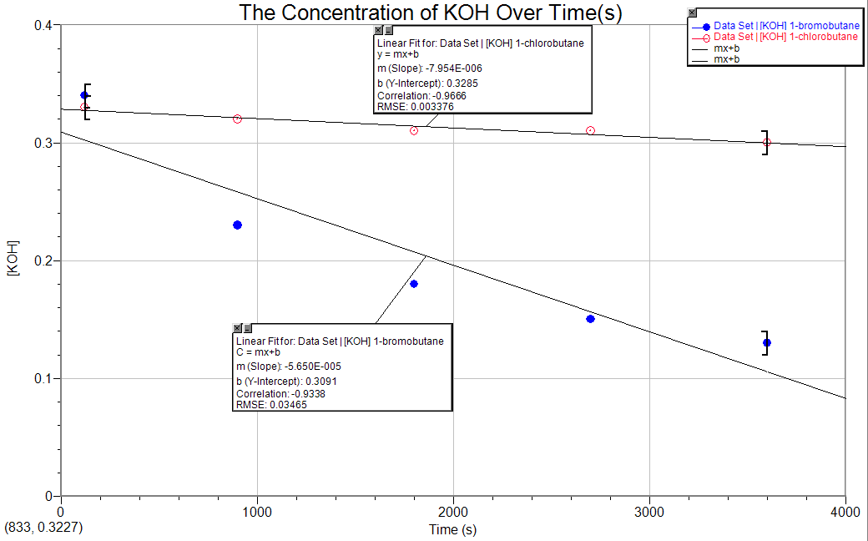
*1-chlorobutane: y= -7.954E-006x+0.3285 R ² = -0.9666 *1-bromobutane: y= -5.650E-005x+0.3091
R ² = -0.9338

Graph 2A: The first order reaction for the hydrolysis of 1 chlorobutane and 1-bromobutane with KOH
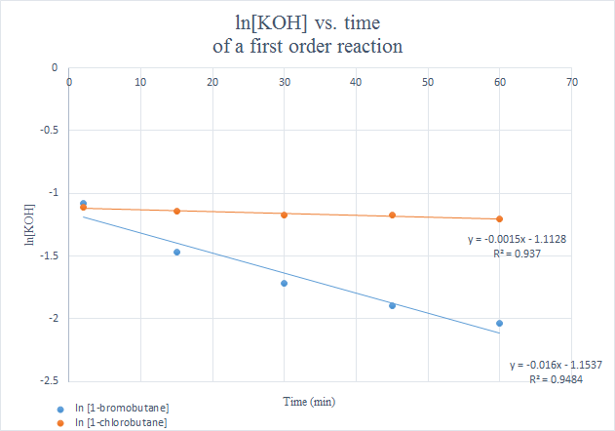
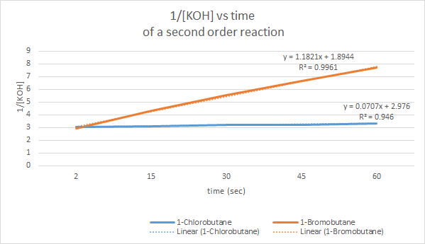
Graph 3A: The second order reaction for the hydrolysis of 1 chlorobutane and 1-bromobutane with KOH

Part B
Table 1B: Hydrolysis of tert butyl chloride with 85:15 H₂0:Acetone
% Conversion | 10% | 20% | 30% | 40%
0.10 M tBuCl in acetone | 3ml | 3.0ml | 3.0ml | 3.0ml
0.02 M NaOH in water | 1.5ml | 3.0ml | 4.5ml | 6.0 ml
Distilled water | 15.5ml | 14.0ml | 12.5ml | 11.0 ml
Time(s) to colour change #1 | 8.63 | 31.9 | 51.5 | 205
Time(s) to colour change #2 | 11.23 | 40.08 | 62.17 | 174
Time(s) to colour change #3 | 9.74 | 33.35 | 63.87 | 134.67
Avg time of trials | 9.867 | 105.33 | 59.18 | 171.22
[tBuCl] | 0.0135 | 0.012 | 0.0105 | 0.009
ln ([tBuCl]) | -4.305 | -4.42 | -4.56 | -4.71
___1___  [tBuCl] | 74.07 | 83.33 | 95.24 | 111.11

Table 2B: Hydrolysis of tert butyl chloride with 70:30 H₂0: Acetone
% Conversion | 10% | 20% | 30% | 40%
0.10 M tBuCl in acetone | 3.0ml | 3.0ml | 3.0ml | 3.0ml
0.02 M NaOH in water | 1.5 ml | 3.0 ml | 4.5 ml | 6.0ml
Distilled water | 12.5ml | 11.0ml | 9.5ml | 8.0ml
Avg time of trials | 38.8 s | 266.4s | 850s | 1800s
[tBuCl]remaining in solution (M) | 0.0135 | 0.012 | 0.0105 | 0.009
ln ([tBuCl]) | -4.305 | -4.42 | -4.56 | -4.71
___1___  [tBuCl] | 74.07 | 83.33 | 95.24 | 111.11

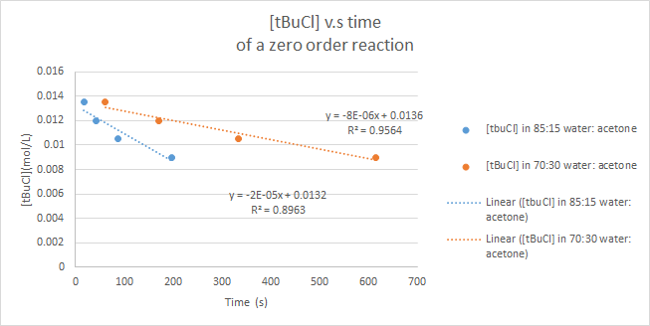
Graph 1B: The zeroth order reaction for the hydrolysis of tBuCl with 70:30 H₂0: Acetone and 85:15 H₂0:Acetone

Graph 2B: The first order reaction for the hydrolysis of tBuCl with 70:30 H₂0: Acetone and 85:15 H₂0:Acetone
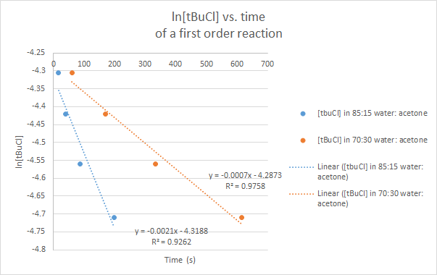

DISCUSSION

The purpose of the experiment was to use different experimental techniques to measure the forward progression of a reaction and to observe the effects different variables have on the rate of Sn1 and Sn2 reactions.
Part A
The purpose of part A of the experiment was to analyze the effects different leaving groups have on the rate of a reaction for a Sn1 reaction. In this experiment, 1-chlorobutane and 1-bromobutane were separately reacted with KOH in a reflux apparatus. A reflux apparatus prevents the loss of volatile substances while the reactants are being heated. After refluxing began, 5mL of the solution was removed at the time intervals: 2, 15, 30, 45, and 60 minutes. Phenolphthalein was added to the aliquot and turned the solution pink. It was used as an indicator for the titration of the aliquot to indicated titration completion. The aliquot was titrated with HCl and when the solution turned clear, the titration was completed. From here, the known volume of HCl needed to neutralize the basic solution was used to calculate the concentration of KOH. The reaction progression and rate was determined by measuring the concentration of KOH over time.
Data was gathered from multiple experiments and the average of each haloalkane reaction were plotted as graphs illustrating zero, first, and second orders of the rate of the reaction. The rate constant and the rate order were analyzed for each graph. In graph 1A, the zero order of the two substances is shown. For 1-bromobutane, the data points more closely resemble a curve over the linear fit. This indicates that this reaction is not of order zero since the slope of [KOH] over time is not truly linear. In graph 2A, the first order of the reaction is shown for both substances. Once again, the slope of ln[KOH] over time for 1-bromobutane is more reminiscent of a curve than a line and is negative. A first order reaction would have a negative, linear slope. It can be concluded that 1-bromobutane is not a first order reaction. In graph 3A, the second order of the reaction is illustrated. For 1-bromobutane, the slope of 1/[KOH] over time is linear and positive. This indicates that it is a second order reaction since second order reactions have positive, linear slopes. This reaction can therefore be classified as a second order reaction Sn2 reaction since the concentration of both reactants affect the rate equally. For 1-chlorobutane, a linear negative slope is observed for both graph 1A of zero order and graph 2A of first order, a positive linear slope is observed for graph 3A of second order. While all slopes could indicate any order, the slope of the second order graph is the most accurate making it a second order Sn2 reaction as well.
Another purpose of this experiment was to determine which halogen is a better leaving group. This was done by comparing the reaction rates for each reaction. The best leaving group is the reaction which occurs the fastest. The k value for 1-bromobutane is 1.1821M-1*s-1 and the k value for 1-chlorobutane is 0.0707M-1*s-1 for second order rate. Since the rate constant for 1-bromobutane is larger than that of 1-chlorobutane, 1-bromobutane has a faster rate. This can be explained by the fact that bromine is a larger halide than chlorine. It is more capable of stabilizing the negative charge since there is a larger area around the ion. Chlorine is smaller and therefore less able to stabilize that charge making it a slower reaction.
When comparing the group data to the global data, the k values illustrate the same trend. 1-bromobutane has a faster reaction rate in both sets of data (k=1.1821M-1*s-1 for group data and k=0.07767M-1*s-1 global data). Although the group rate was much greater than the global data, the conclusion is still valid since the k values for 1-bromobutane are larger than 1-chlorobutane. Experimental error, such as not removing the aliquot from the reflux apparatus at the appropriate time interval, could explain such variation. 1-chlorobutane is slower as shown by k=0.0707 for the group data and k=0.00587 for the global data. Once again, these k values vary significantly and do so for the same reasons 1-bromobutane would since both reactions were completed using the same methods.
Additionally, the group R^2 value for 1-bromobutane was 99.61% and for 1-chlorobutane was 94.60% obtained from graph 3A second order. Out of all the R^2 values, those of graph 3A (second order rate), were higher than those found in graphs 1A and 2A with respect to each compound. The same is evident in the global data with a correlation of 98.796% for 1-bromobutane and 98.18% for 1-chlorobutane for the second order reaction over smaller values of R^2 for zero and 1st order reactions (0th= brome:83.943% chloro: 97.515% , 1st= bromo: 93.339% chloro: 97.873%). This further indicates that the the reactions of 1-bromobutane and 1-chlorobutane with KOH individually are second order reactions.
An error that likely affected the results was that 3.9mL of the 55mL aliquot was spilled while measuring out the aliquot at the 30 minute mark. This likely affected the concentrations of KOH calculated for the 45 and 60 minute marks since less aliquot was refluxing during these times.
Part B
The purpose of this portion of the laboratory was to determine the effects different solvents have on a Sn2 reaction. The hydrolysis of tBuCl was conducted in two separate solvent systems. The first was 85:15 H2O: Acetone and the other was 70:30 H2O Acetone mixture. These solvents were created in the lab by combining different combinations of 0.02M NaOH, H2O and acetone. The proportions mixed allowed the hydrolysis of tBuCl to consume 10%, 20%, 30%, and 40% of the tBuCl in the solution. In order to maintain thermal equilibrium for the reactions, each was conducted in a water bath since the reaction is exothermic. Temperature fluctuations alter reaction conditions thus affecting the rate of the reaction since it would not remain a constant. Rate increases when temperature increase and rate decreases when temperature decreases.
Sn1 reactions are a stepwise process. The rate determining step for this reaction was the dissociation of the Cl ion (tBuCl acted as an electrophile in this reaction with Cl as its leaving group). This rate determining step depended on the concentration of tBuCl. The Cl ions in solution reacted with water to produce hydrochloric acid. This byproduct was used as a mean to monitor the progression of the reaction. Bromothymol blue was used as an indicator. It is blue when around a pH of 7.6, but changes to yellow when pH is below 6. As the reaction progressed, the solution turned from blue to a pale, almost colourless, yellow. This colour changed occurred as more HCl was formed and was used to calculate the time it took for the reaction to be completed and thus the rate.
As illustrated in graph 2B, tBuCl reacted much faster in 85:15 H2O: Acetone than 70:30 H2O: Acetone. Sn1 reactions occur in polar protic solvents. When the ratio of H2O was decreased from 85 to 70, there was less available for the reaction to occur thus slowing the rate. This also explains why when there was a smaller percentage of tBuCl available to react, the reaction was faster. There was plenty of water for the reaction to occur. Conversely, when that was more tBuCl available in the solution, the reaction took longer since there was proportionally less H2O to react with.
For the 70:30 H2O: Acetone solvent, individual data required about 39s for the 10% of tBuCl reaction to reach completion while group data require more time at about 57s. This trend changed for all other centrations of tBuCl at 20%, 30%, and 40%. Individual data was almost double that of group data for each of these three percentages of tBuCl (20%: I=266s G=140s; 30%: I=850s G=473s; 40%: I=1800 G=958s) . Such a drastic variation between individual and group data was likely because of the H2O to acetone ratio not being 70:30. Since individual data indicated a significantly longer reaction time, the H2O ratio to acetone was likely much smaller than it should have been. As discussed previously, smaller concentrations of H2O result in a slower reaction since Sn1 reactions require a polar protic solvent. This occurred when the solvents were prepared in the lab.
Additionally, the group R^2 values for the zero order reaction were 89.63% correlation for solvent 85:15 H2O: acetone and 95.64% correlation for 70:30 H2O: acetone. The group R^2 values for the first order reaction were 92.62% correlation for solvent 85:15 H2O: acetone and 97.58% correlation for 70:30 H2O: acetone. Since there was an increase in the % correlation from the zero order reaction to the first order reaction, it can be concluded once more that the reaction is of first order. The global results further enforce this with R^2 values for the zero order reaction were 84.45% correlation for solvent 85:15 H2O: acetone and 93.46% correlation for 70:30 H2O: acetone. The R^2 values for the first order reaction were 89.44 % correlation for solvent 85:15 H2O: acetone and 96.63% correlation for 70:30 H2O: acetone.
It was determined that this reaction was a first order reaction. Both solvent systems had slopes that were more linear in graph 2B of first order reactions than graph 1B of zero order reactions. As discussed in Part A of the discussion, the rate order graph with the best linear fit is the order of the reaction. The R^2 values also illustrate that this is a first order reaction. While the zero order has a 95.64% correlation for solvent system 85:15 H2O: Acetone and a 89.63% correlation for solvent system 70:30 H2O:Acetone, the correlation was greater for the first order reaction. There was a 97.58% correlation for solvent system 85:15 H2O: Acetone and a 92.62% correlation for solvent system 70:30 H2O:Acetone. Even though these values only varied slightly, the first order rates still had a greater correlation. Sn1 reactions are known to be first order reactions, so it is safe to conclude it was a first order rate reaction.
To summarize, 1-bromobutane and 1-chlorobutane hydrolysis with KOH, were found to be second order substitution reactions as indicated by graphs 1A, 2A, and 3A. 1-bromobutane was a faster reaction since its k value (1.1821M-1*s-1) was greater than that of 1-chlorobutane (0.0707M-1*s-1 making it a better leaving group.
For Sn1 reactions, the more polar protic solvent results in a faster reaction. 85:15 H2O: Acetone solvent resulted in a much faster reaction than 70:30 H2O:Acetone solvent as shown by graphs 1B and 2B. These graphs also indicate that a first order reaction occurred. the R^2 values of the first order graph were greater than those of the zero order great with respect to each solvent system.

QUESTIONS
1. Arrange the following haloalkanes ( from most reactive to least reactive) in SN1 reaction
Most Least
H2C=CHCH(Br)CH3 H2C=CHBr CH3CH(Br)CH3 CH3CH2Br

3. Indicate how CH3CH2CH2CN could be prepared by a nucleophilic substitution ?
CH₃(CH₂)₃Br + NaCN -> C5H9N1


