Hadean Eon 1st eon
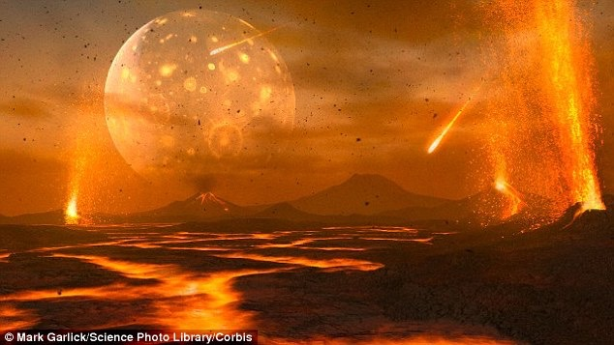
4550Ma-3800Ma

intro:
-Earth is 4,500 million years old
-multicellular life only rose 500 million years ago
-violent time in earth’s history
-continuous bombardement and molten rock
-gave way to oceans as earth’s crust cooled and solidified
-absence of oxygen
-lab experiments prove that lightning and volcanic gases reacted and created a pre-biotic soup of simple organic molecules (lipid and proteins)
-compounds from deep sea hydrothermal and meteriote materials
-compounds build monomers
-no one has been able to synthesize RNA or DNA
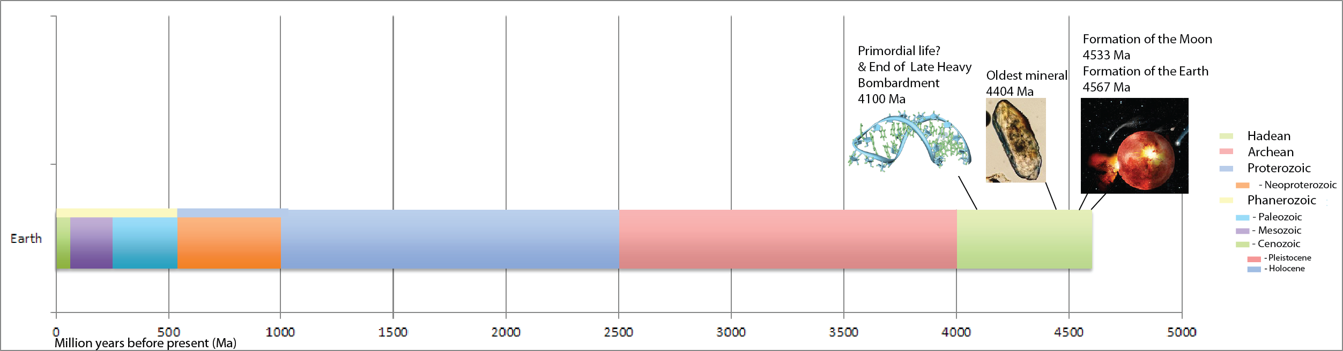

4550Ma- Birth of solar system, escaping gases build early atmosphere
4500Ma- Meteorite bombardement
4400Ma- Earth’s core forms
4200Ma- great oceans form
4055Ma-Oldest known rocks formed
3850Ma-evidence of life
3800ma- bacteria diversifies

Key Words:

Adhesion:
The binding of a cell to another cell, or a cell to a surface, ability to remain together, intermolecular attraction between different molecules, hydrogen bonding of H2O to other polar surfaces, water sticks to other objects, adherence of molecules to the walls of conducting tubes.

Archean Eon: (3800-2500Ma) After 1.3 billion years of planet’s existence, age of bacteria that starts with anaerobic forms and finishes with aerobic forms including cyanobacteria that transform planet to modern oxygen-rich environment.

Biomonomers: include amino acids (peptide bonds), monosaccharides (glycosidic bond) and nucleic acids (phosdpholiester bond), and isoprene.

Biopolymers: polymers produced by living organisms. Molecules formed of biomonomers. Isoprene monomers create lignin (2nd most abundant biopolymer and is one of the primary structural components of most plants). Lipids and triglycerides (glycerol and 3 fatty acids)
Polynucleotides- long polymers which are composed of 13 or more nucleotide monomers .
Polypeptides- short polymers of amino acids and polysaccharides which are often linearly bonded polymeric carbohydrates. Cellulose is the most common organic compound and biopolymer on earth (33% of planet’s matter).

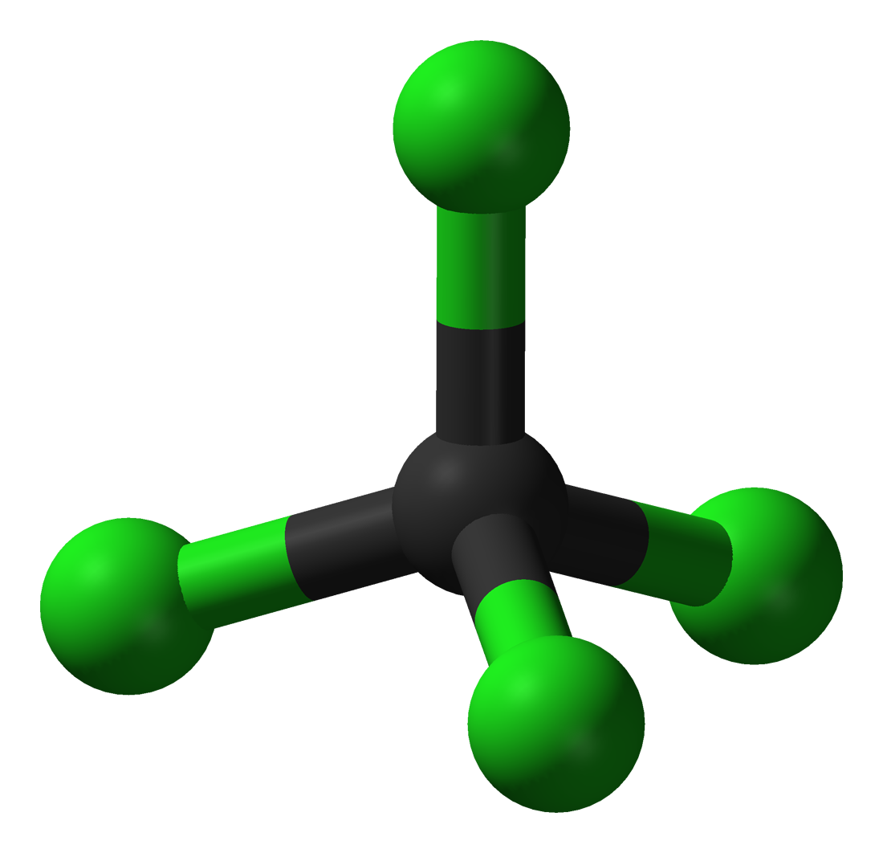
Building Phase of the Earth: Earth being bombarded by asteroids containing minerals and water, occurred when Jupiter & Saturn were not correctly aligned and asteroids in solar system were not bound to the asteroid belt. AKA late heavy bombardment. During this phase many new elements brought by asteroids colliding with earth entered the molten mix of the earth’s surface, creating new chemical reactions.

Carbon: Has a perfect tetrad structure, “central to life, carbon atoms link in chains, bind with other atoms to make the array of organic chemicals that constitute life itself, from DNA to toenails”
Carbon is the most abundant tetrad structure on earth, silica is also a tetrad structure but it is not as abundant as carbon.

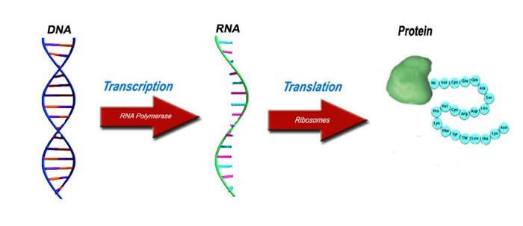
Cenozoic Era: (65Ma- Now)Another recovery phase, includes vertebrate diversification, The age of mammals. Birds also appear and increase in numbers and insects and plants continue co-evolutionary war, and link between flowering plants and insect pollinators changes appearance of whole planet. Chordate fish also appear.

Central Dogma: describes the two-step process, transcription and translation, by which the information in genes flows into proteins: DNA → RNA → protein. Transcription is the synthesis of an RNA copy of a segment of DNA. RNA also has the ability to become DNA (reverse arrow). DNA is a bank of codes to form proteins and replicates itself. RNA acts as a messenger and can create DNA (AIDS). Proteins form structures and processes for cell activity. the central dogma states that genes are expressed in the phenotype or morphology of an individual via protein action. the central dogma is split into two parts – transcription and translation. the information to make a protein comes from a gene in the DNA molecule – referred to as “a template” or “master”. in order for one gene to direct the production of numerous essential proteins, copies of the “master” must be made. every copy will eventually amount to a specific polypeptide sequence. therefore, the central dogma is a sequence of events that begin with a genetic code and end with a protein. the template region of DNA is first “copied”, or transcribed into an mRNA, and then “converted” into a polypeptide chain, or translated

Chemical Evolution: Organic molecules beginning to emerge from inorganic molecules. Occurred in ancient oceans as carbon atoms linked together to form the biomonomers of life. Primordial gases such as methane, ammonia, and hydrogen were thought to have been 1st organics. Hydrothermal vents in the deep ocean along fault lines caused the thermal reactions with gas and molten rock to occur. The water pressure was so high that water did not boil, resulting in a brew of organic molecules and another source for organic molecules as the precursors to the biopolymers of life.
Life originally developed from nonliving matter such as amino acids
Inorganic precursors from which organic molecules could have been synthesized (due to free energy and no oxygen)
Molecules served as monomers, assembled into polymers like protein or RNA
Polymers grouped inside membranes
aggregation of complex hydrothermal vents, interstellar organics, miller-urey, biopolymers, biomonomers

Cohesion: property of like-molecules sticking together (surface tension), capillary action occurs when water molecules stick together. ability of a molecule to stay bonded or attracted to another molecule of the same substance. high resistance of water molecules to separation.
water has a high tendancy to stick together due to polar characteristics, tendency of molecules to "stick together"

Crystal Lattice of water: structure that causes water’s solid form to be less dense than its liquid form (density decreases at 4 degrees celsius, and then freezes, liquid water lies beneath frozen water and becomes insulated). A symmetrical 3-dimensional arrangement of atoms inside a crystal. Water also disassociates ions by surrounding elements of compounds completely (dissolving everything necessary for life). Water also exhibits Brownian motion (the erratic random movement of microscopic particles in a fluid, as a result of continuous bombardment from molecules of the surrounding medium)

Emergence: Organisms are more than the sum of their individual parts. (example two elements are reactive on their own, like chlorine and sodium, and neutral in a compound). Another example, Hemoglobin, used for oxygen transport involves binding of one oxygen molecule that facilitates the binding of others.

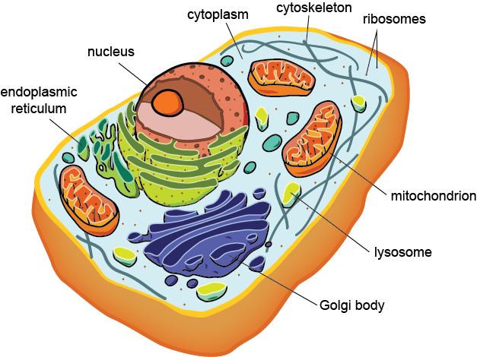
Eras: sub-level of Eons

Eukaryotes: cells containing a nucleus and other organelles encased in membrane (taxon eukaryota). Formed in proterozoic Eon.

Mesozoic Era: (245-65Ma) a recovery period where “invasion of land” is perfected, and land plants and animals increase in numbers and variety. Era ends with end of dinosaurs from global catastrophe.

Evaporation: gaseous form of water. which is hard to obtain (in nature) because water has a high specific heat capacity (hard to increase its temperature). As water evaporates, it stabilizes the earth and forms moderate atmospheric temperature.

Geological time scale: (Lyell) palaeontologists determined various layers of sedimentary rocks represented very distinct times in Earth’s history. Shows 4 eons, with eras (subdivision of eon) and periods.
Hadean Eon: formation of the earth, 4,500Ma-3,800Ma
Archean Eon: single celled prokaryote bacteria predominated (3,800Ma-2,500Ma)
Proterozoic Eon: single celled eukaryotes (2,500-500Ma)
Phanerozoic Eon: 550ma until now, multicellular life.
3 eras of phenerozoic eon:
-pangea broken apart, tectonic plates have drifted
-organisms have mixed, modified, and been isolated from each other (land).
1: Cambrian Explosion- (550-250Ma) diversification of animal life, animals fed on protists that populated ancient seas. Fossils show oceans populated with animals and some show first attempt of plants and animals to rise up from the oceans and onto the land.
2. Mesozoic (245-65Ma)- a recovery period where “invasion of land” is perfected, and land plants and animals increase in numbers and variety. Era ends with end of dinosaurs from global catastrophe.
3. Cenozoic (65Ma- Now) Another recovery phase, includes vertebrate diversification, The age of mammals. Birds also appear and increase in numbers and insects and plants continue co-evolutionary war, and link between flowering plants and insect pollinators changes appearance of whole planet. Chordate fish also appear.

Goldilocks zone: distance around a star in which life is possible. The closer to the star, the more intense the star’s intensity from nuclear fusion of hydrogen atoms to helium is. Almost 99% of the matter in our solar system is tied (bound gravitationally) to the sun. Lighter gas planets are located at the edge of the solar system while heavy iron cored planets orbit closer to the sun. Earth is just the right size and mass (with an iron core) for its gravitational field to hold onto escaping gases to form the 1st atmosphere. Planets in the goldilocks zone have stabilized water.

Greenhouse Gases: (effect) phenomenon in which certain gases faster the accumulation of heat in the lower atmosphere, maintaining warmer temperatures on Earth. includes CO2, water vapour, ozone, methane and nitrous oxide.

Habitable Zone: Earth lies within a habitable zone around the sun. All components of the solar system were formed at the same time by gravitational condensation present in an interstellar cloud. the region of space around a star where temperatures would allow for liquid water. The habitable zone varies depending upon the type of star and how much energy it emits.

Haden Eon (Full introduction): (4550Ma-3800Ma) -Once the Big Bang ended a massive nebula of gases and dust started to contract and as it did, its centre reached a critical mass resulting in a nuclear explosion igniting our sun that still burns today. Our sun is an out of control nuclear explosion where hydrogen atoms are undergoing fusion into helium and the resulting energy is spread through our galaxy. The closer you are the greater the intensity, and its not just light! Almost 99% of the matter in our solar system is tied up in the sun with the rest swirling around the new-formed sun in a massive disk. But this wasn't a homogenous mix of material, the explosion that ignited the sun propelled the lighter gases to the edge of the galaxy and the heavier substances remained near the centre. The result is outer planets of frozen gases and the inner ones have heavy iron cores. As a result of gravitational pulls the swirling material started to stick together and the planets started to form.

-One big kid on the block, Jupiter, sucked in huge amounts of material; some of it stuck and some didn’t and was shot back across the solar system hitting other planets in its path. These were violent times in the solar system and huge meteorites and asteroids impacted on the new planets with enough energy to liquefy them and kept them molten and contribute their own elements to the molten mix. It was one of these impacts on planet earth that caused a huge chunk to break off and become our orbiting moon. Gradually the largest pieces were pulled into the gravitational pull of the sun and formed planets and what remained were the asteroids and meteorites that still circle within our solar system. Any impacts that did occur after this were smaller allowing the planet to cool and a crust to form on its surfaces.

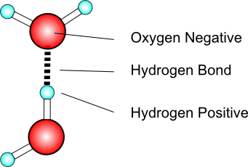
-Stabilization of the newly formed planet had occurred and although meteorites still ploughed into the earth they were never of a size that could cause global damage of the type seen during the building phase. Once stability occurred the various components had a chance to “settle” and the dense iron core of the earth remained molten and hot and the lighter gasses escaped. Earth was just the right size, and its gravitational field held onto the escaping gases and the first atmosphere surrounded the planet. As it cooled its surface formed a crust through which were vented the various gases from the molten central core, out gassing. Earth’s first atmosphere was different from what we see today, methane gases, sulphur gases and above all no oxygen. As the earth cooled further water vapour turned to liquid and simply put, the rains began to fall and cover the earth with its first water blanket, the precursor to the present oceans. The stage was set, but at this point it was a barren and sterile world where the heating into the thousands of degrees Celsius from the molten planet insured that any life that may have occurred was killed. That would all change soon.

Hydrogen Bond: present between two hydrogen atoms (non-polar covalent) or between two molecules that are composed with hydrogen atoms (polar covalent). The non-covalent bond is formed by unequal electron sharing between hydrogen atoms and oxygen, nitrogen, or sulphur atoms.

Hydrophilic: refers to polar molecules that associate readily in water

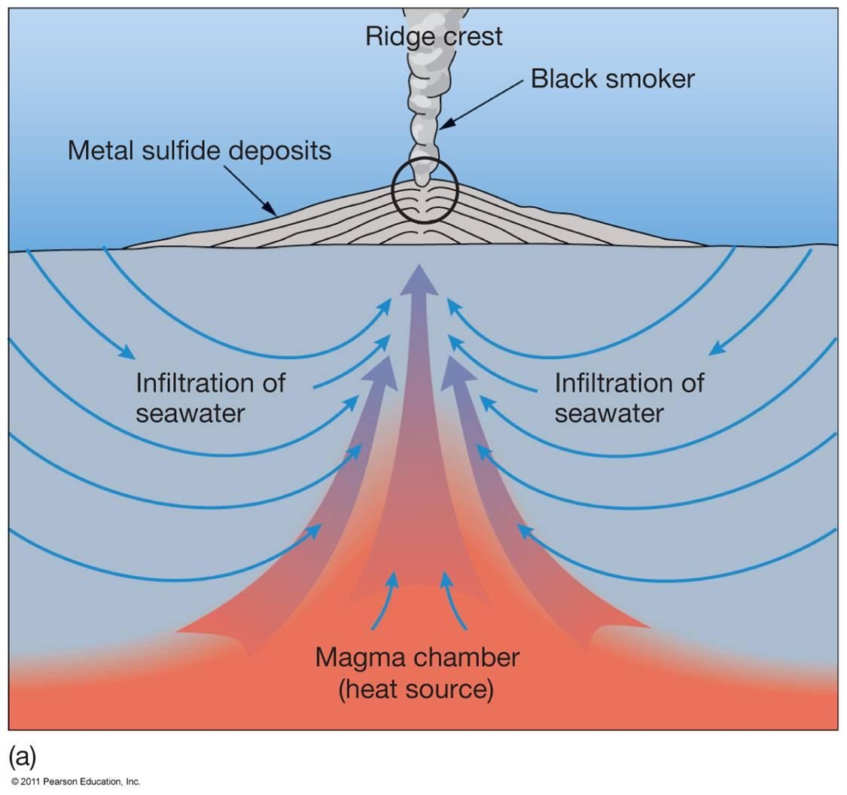
Hydrophobic: refers t non-polar substances that are excluded by water and other polar molecules.

Hydrothermal vents: located at the bottom of the ocean, volcanic activity created high temperature and water pressure was very high to produce chemical reactions with primordial gases methane, ammonia, and hydrogen, that produced a brew of organic molecules and another source for the organic molecules as the precursors to the biopolymers of life. The water pressure at these depths is so great that the water does not boil, so temperatures exceed the boiling point while water remains in its liquid form and unique reactions occur.

Interstellar organic compounds: idea that life arrived on earth via an asteroid (panspermia) as bacterium is frozen in ice. this particular bacteria is able to survive extreme conditions and similar forms are still present on earth today.

Interstellar space dust: Contracted to form the sun after the big bang by forming a critical mass at its centre, and eventually exploding and continuing to ignite as the sun underwent nuclear fusion, turning hydrogen atoms into helium atoms.
the presence of carbon which is what a dying red sun spews out as space dust.

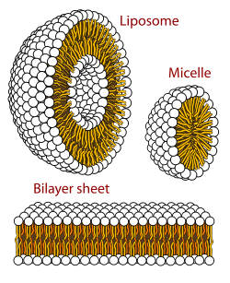
Late Heavy Bombardment: is a period of time approximately 4.1 to 3.8 billion years ago during which a large number of impact craters are believed to have formed on the Moon, and by inference on Earth, Mercury, Venus, and Mars as well. The LHB is "late" only in relation to the main period of accretion, when the Earth and the other three rocky planets first formed and gained most of their mass; in relation to Earth or solar system history as a whole, it is still a fairly early phase. Planets were growing bigger due to asteroid collisions, and it was suspected that gas giants Jupiter and Saturn had a 2:1 orbit ratio that exerted gravitational pull on asteroid belt when the two planets were aligned (harmonic), causing uranus and neptune to flip their orbits and an asteroid belt to form later on, ending the bombardment.
Got so close that they had effect on each others orbits which pushed them further away from the sun, which made the orbit belt start to move.
Liposome: A spherical sac of phospholipid molecules that contains at least one phospholipid bilayer. Can be created in a lab. Ex. Micelles

Micelles: in aqueous solutions, a spherical molecule that has polar or charged groups and non-polar regions. usually a water insoluble product is inside of the sphere. Has only one phospholipid layer.

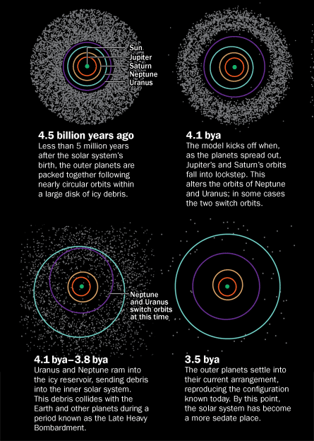
Miller-Urey Experiment: a laboratory simulation of the reducing atmosphere in the early earth, with the absence of oxygen. Components of reducing atmosphere hydrogen, methane, ammonia, and water vapour were placed in a closed apparatus and exposed to an energy source in the form of sparking electrodes. water vapour was added back into the “atmosphere” in one part of the apparatus and subsequently condensed back into water by cooling another part. The result was a large assortment of organic compounds of urea, amino acids, lactic, formic, and acetic acids, after condensing the atmosphere into a liquid. 1st experiment to demonstrate abiotic formation of molecules critical to life. Biomonomers could be produced spontaneously in the earth’s early atmosphere.

Nice Model: Scenario for the dynamic evolution of the solar system. Proposes migration of the giant planets from an initial compact configuration to their present positions.
1st photo- early configuration before jupiter and saturn reach 2:1 resonance.
2nd photo- scattering of objects in solar system after orbital shift of neptune and uranus.
3rd photo- current configuration.

Non-polar compound: have non-polar covalent bonds that occur when the electronegativity of two atoms is equal. (equal sharing of electrons).

Paleozoic: Era - 542million years ago to 251 million years ago, began with the breakup of pangea, plants became widespread and first vertebrate animals colonized land. (occurs within proterozoic eon).

Panspermia: theory that life one earth came from an extraterrestrial organism. It is thought that the organism already had central dogma machinery within it before earth. Presumed that said organism arrived via meteorite into the rich organic soup of earth. therefore, it must have been tough organism that survived space travel and entrance into the earth’s atmosphere. The discovery of extremophile bacteria living in harsh environment of the deep sea volcanic vents means this is a likely candidate, but not everyone agrees.

Period: Subdivision of an era.

Phanerozoic Eon: Multicellular organisms, current eon on Earth’s history that began with the Cambrian explosion.

Polar compound: Molecule with geometric arrangement of one side carrying a positive charge and the other carrying a negative charge. unequal electron sharing, can be turned into an ion soluble in water.

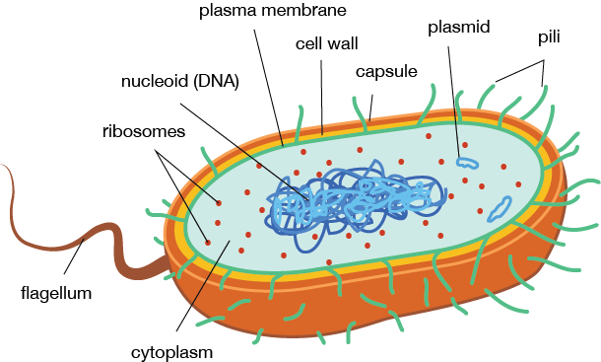
Prebiotic Soup: rich mix of chemicals and compounds such as amino acids, methane, sugars, nitrogen bases, and ammonia. Complex self-replicating organic molecules that were the precursors of life may have developed in this primordial soup.

Prokaryote: Single-celled organism with neither a distinct nucleus with a membrane nor other specialized organelles. Include bacteria and cyanobacteria. First developed in Archean Eon before eukaryotes.

Proteins first hypothesis: proposes that proteins were the first form of self-reproducing life because some proteins bind amino acids and nucleotides, and match protein sequences to make RNA (central dogma. Amino acids also polymerize abiotically when exposed to dry heat, hypothesis assumes enzymes came before DNA genes (protein enzymes are needed for DNA replication)
Clay hypothesis: believed that clay assists in polymerization of proteins and nucleic acids at the same time. Clay attracts small organic molecules and iron and zinc are inorganic catalysts for polypeptide formation. RNA nucleotides and amino acids associate in such a way that polypeptides were ordered by and helped synthesize RNA; both polypeptides and RNA arise at the same time.

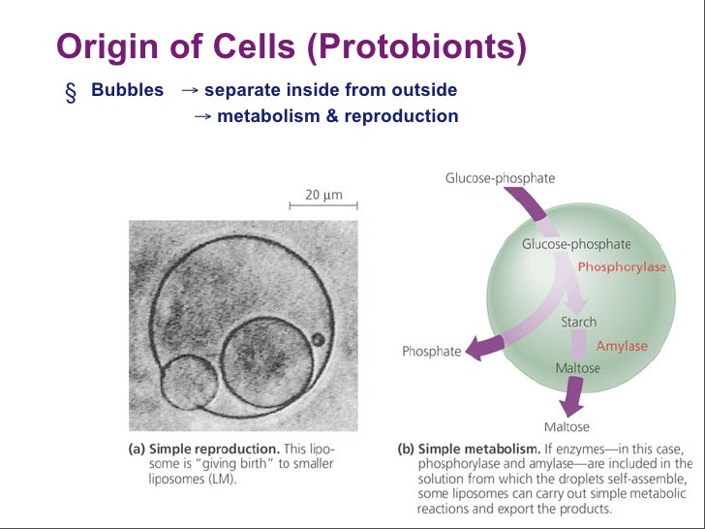
Proterozoic Eon: (2,500-543Ma) Oxygen atmosphere, single celled aerobic organisms.

Protobionts: systems that are considered to have been the precursors to prokaryotic cells. A protobiotant is an aggregate of abiotically produced organic molecules surrounded by a membrane or membrane-like structure. Spherical collection of lipids.

Protocell: A fatty acid vesicle, which is a simpler form of a cell membrane, in which RNA replication occurs autonomously without the help of enzymes.

Reducing atmosphere: primordial atmosphere of earth (4 billion years ago) contained water vapour, methane, hydrogen and ammonia. There was no oxygen.
All molecules were fully reduced, so electrons are able to be shared easily
Abundance of O2 prevents complex, electron-rich molecules from being formed (Oxidizing Atmosphere)

Reverse transcriptase: (Rt) is an enzyme used to generate complimentary DNA (cDNA) mostly associated with retroviruses. The catalyzed transcription is the reverse process of normal cellular transcription of DNA into RNA. Process occurs in HIV.
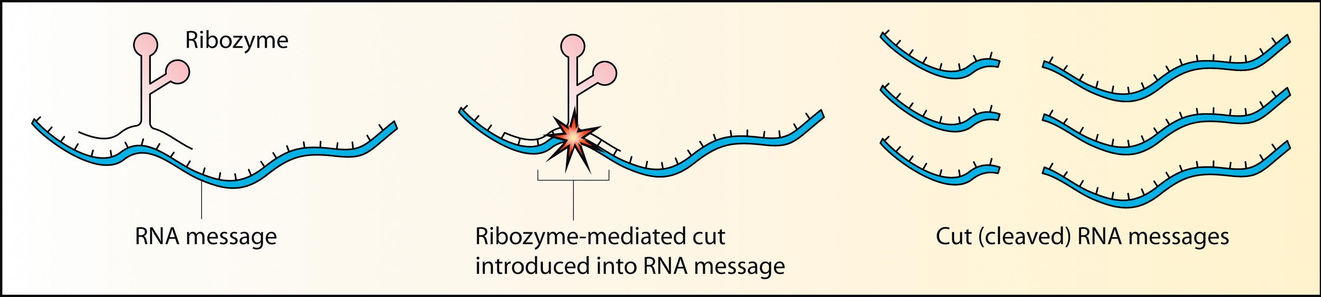
Ribozymes: an RNA molecule capable of acting as an enzyme, and also an RNA based catalyst that is part of the biochemical machinery of all cells. Catalyzes reactions on precursor RNA molecules that lead to their own synthesis. Ribozymes have catalytic properties because these single stranded molecules can fold into very specific shapes based on intramolecular bonding / base pairing.

RNA world: RNA can serve as a carrier of information (due to nucleotide sequences) and a structural/ functional molecule similar to a protein. the first cells may have only contained RNA which was replicating and could catalyze a small # of reactions critical for survival.

Specific heat: the heat required to raise the temperature of the unit mass of a given substance by a given amount (usually one degree)

Spontaneous origins: the hypothetical process by which living organisms develop from non-living matter, also the archaic theory that utilized this process to explain the origin of life.

Stabilizing phase of the earth: Earth starts to develop a crush on top of the molten lava. Earth has a unique mass that is able to hold onto an atmosphere so molecules can be trapped to survive. water vapour in air starts to cool down and H2O starts to accumulate on the earth’s surface, forming the oceans. However, if another meteorite were to strike then water would become vaporized because of the intense amount of heat and the cycle would start over again. Bombardment from meteorites stopped at the end of the Hadean Eon

Surface tension: the result of an inward pull amount molecules of a liquid that brings molecules on a surface closer. H2O has a high surface tension because of hydrogen bonds. Surface tension is also a measure of how difficult it is to stretch or break the surface of liquid, and is also responsible for capillary action. At the top, water molecules are in contact with air, so surface tension is created.

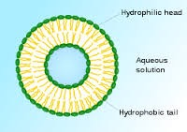
Surfactant: reduces surface tension of water by absorbing the liquid-gas interference. surfactants can also form micelles and vesicles in water. When micelles form, polar phosphate heads stick out towards H2O, and tails form a core that can encapsulate an oil droplet.

Vesicle:is a small structure within a cell, consisting of fluid enclosed by a lipid bilayer. Vesicles form naturally during the processes of secretion (exocytosis), uptake (phagocytosis and endocytosis) and transport of materials within the cytoplasm.

Volcanic gassing:The principal components of volcanic gases are water vapor (H2O), carbon dioxide (CO2), sulfur either as sulfur dioxide (SO2) (high-temperature volcanic gases) or hydrogen sulfide (H2S) (low-temperature volcanic gases), nitrogen, argon, helium, neon, methane, carbon monoxide and hydrogen.

