University of Ottawa
Professor: Dr. Voicu Groza
TAs: Heli Amarasinghe, Maryam Hezaveh, Opeyemi Adesina, Hamdam Nikkhah, Simran Deep Singh
Fall 2016
Lab 2- Design and Simulation of Sequential Logic Circuits

Experiment Date: September 28st 2016
Submission Date: October 9th 2016
LAB Section B

Introduction
This Lab serves as practice in the conversion of functional requirements into the logic circuits and implementation using Altera. This lab will also introduce students to the design of sequential circuits based on Altera’s Quartus development environment and their implementation and testing with an FPGA
These different parts of implementations include:
• Entering the design of synchronous counters using Quartus II graphics editor
• Assigning the input-output pins and preparing the design for downloading and testing on the Altera DE2-115 board
• Testing the counter by: Displaing the counter outputs as binary values on LEDs and by using an oscilloscope and tracing and recording the waveforms at various flip-flops
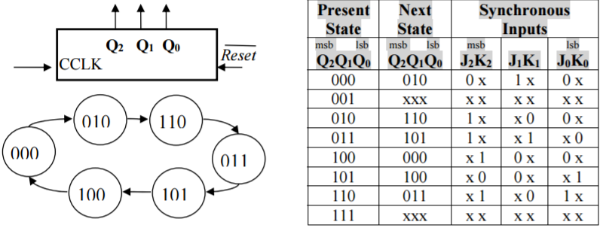
Pre Lab Discussion
Part A

Part B
These are the counting sequences that are implemented with JK flip flops. We must derive and simplify the Boolean expressions of every flip-flop input using Karnaugh maps.

Pre Lab Solution
These are the two solutions of A and B taken from karnaugh maps of the JK flip-flops
- J₀ = Q₂Q₁ K₀=Q₁’ J₁=Q₂’ K₁=Q₀ J₂=Q₁ K₂=Q₀’
- J₀=1 K₀=1 J₁=Q₃’Q₀ K₁=Q₁Q₀ J₂=Q₁Q₀ K₂=Q₁Q₀ J₃=Q₂Q₁Q₀ K₃=Q₁Q₀
Design Section
Truth Table of part A
Present State |  |  | Next State |  |  | Synchronous Inputs
Q2 | Q1 | Q0 | Q2 | Q1 | Q0 | J2K2 | J1K1 | J0K0
0 | 0 | 0 | 0 | 1 | 0 | 0 x | 1 x | 0 x
0 | 0 | 1 | x | x | x | x x | x x | x x
0 | 1 | 0 | 1 | 1 | 0 | 1 x | x 0 | 0 x
0 | 1 | 1 | 1 | 0 | 1 | 1 x | x 1 | x 0
1 | 0 | 0 | 0 | 0 | 0 | x 1 | 0 x | 0 x
1 | 0 | 1 | 1 | 0 | 0 | x 0 | 0 x | x 1
1 | 1 | 0 | 0 | 1 | 1 | x 1 | x 0 | 1 x
1 | 1 | 1 | x | x | x | x x | x x | x x
Truth Table of part B
Present State |  | Next State |  | Synchronous Inputs
Q3Q2 | Q1Q0 | Q3Q2 | Q1Q0 | J3K3 | J2K2 | J1K1 | J0K0
0 0 | 0 0 | 0 0 | 0 1 | 0 x | 0 x | 0 x | 1 x
0 0 | 0 1 | 0 0 | 1 0 | 0 x | 0 x | 1 x | x 1
0 0 | 1 0 | 0 0 | 1 1 | 0 x | 0 x | x 0 | 1 x
0 0 | 1 1 | 0 1 | 0 0 | 0 x | 1 x | x 1 | x 1
0 1 | 0 0 | 0 1 | 0 1 | 0 x | x 0 | 0 x | 1 x
0 1 | 0 1 | 0 1 | 1 0 | 0 x | x 0 | 1 x | x 1
0 1 | 1 0 | 0 1 | 1 1 | 0 x | x 0 | x 0 | 1 x
0 1 | 1 1 | 1 0 | 0 0 | 1 x | x 1 | x 1 | x 1
1 0 | 0 0 | 1 0 | 0 1 | x 0 | 0 x | x 0 | 1 x
1 0 | 0 1 | 0 0 | 0 0 | x x | 0 x | x 0 | x 1
Part A Circuit Diagram:
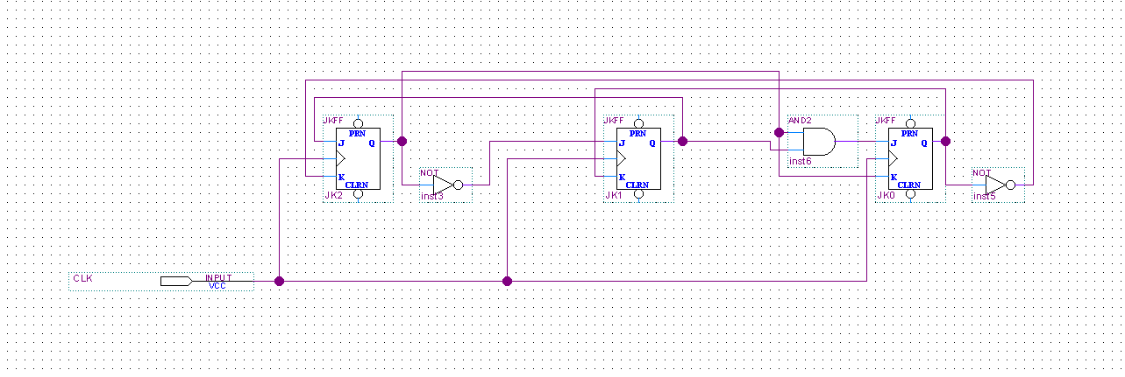
This is the circuit of the logic equation mapped out on the Quartus II Software. 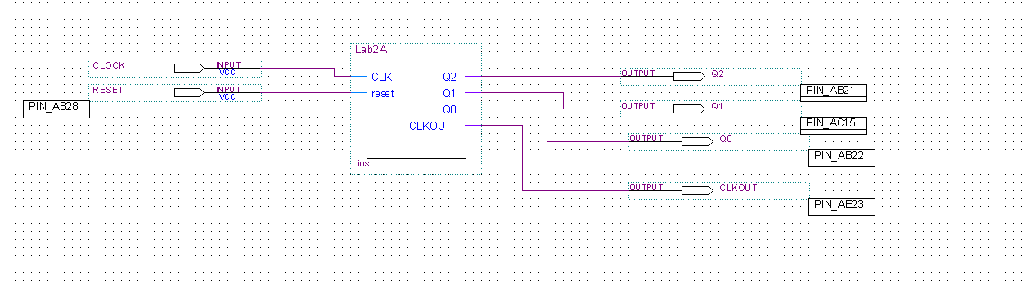
These are the outputs of Part A and the synchronous inputs.
Part B Circuit Diagram:
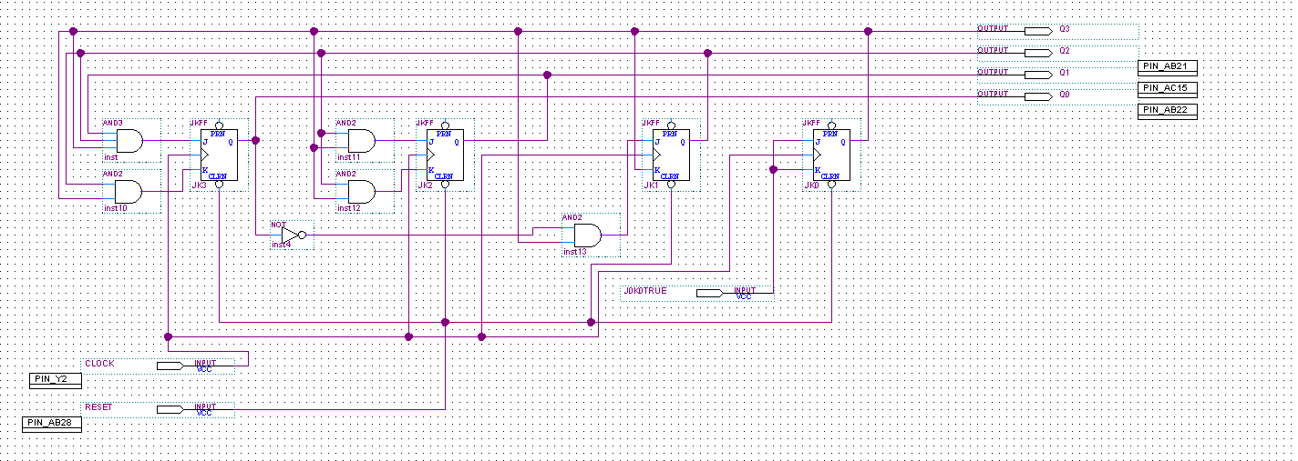

Real Implementation
Part A
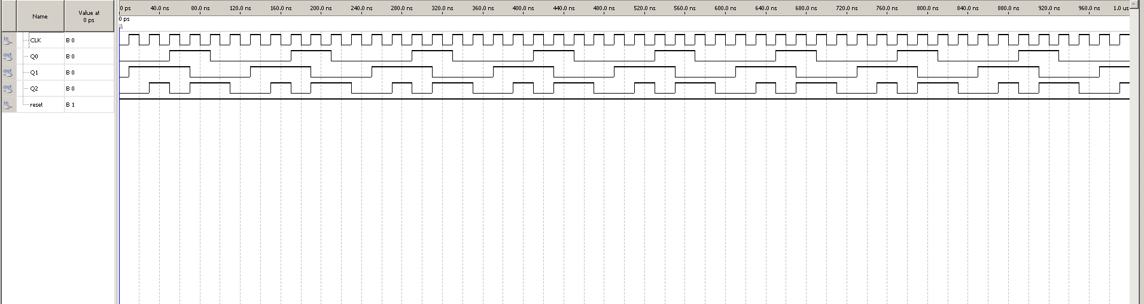
This is the completed waveform diagram. The simulation ran as expected and we ended up with a working design.
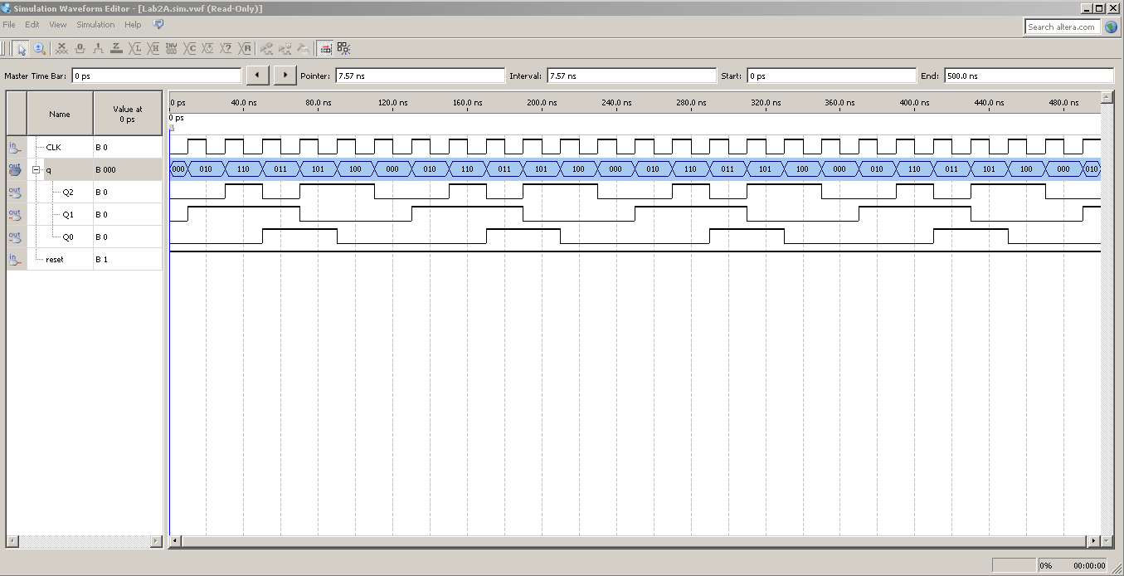
This is the complete waveform which shows the values of the outputs.
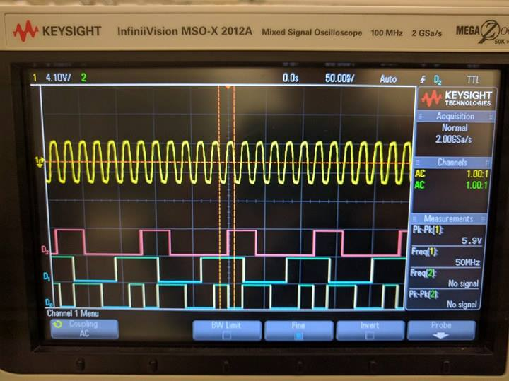
This is the waveform shown on the oscilloscope tracing the waveforms at different flip-flops.

Part B
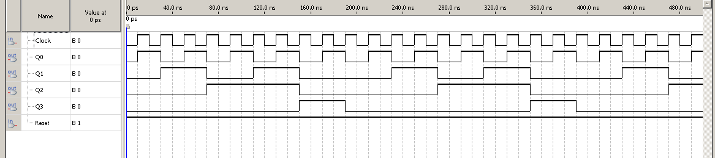
This is the completed waveform of part B
After the waveform we also assigned the inputs and outputs to these pins
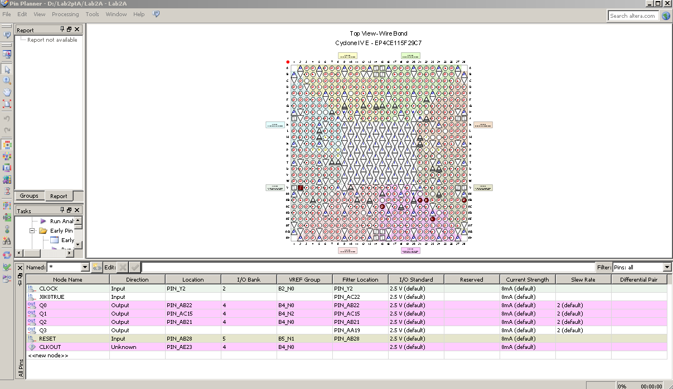 After the waveform we also assigned the inputs and outputs to these pins
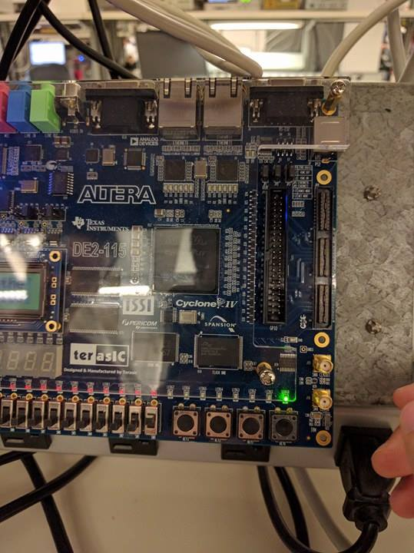
A picture of the first output in the sequence to part B

Discussion
Through this experiment, we created two sequential circuits using JK flip-flops and implementing them through AND gates. Through the preparation we obtained the state tables and Karnaugh maps of the sequences, which were used as theoretical results. The truth tables obtained were then compared with the actual results, which was conducted during the lab with the Altera card and Quartus Software. Here we had the basic idea of how the output would be. And we successfully did after compiling and programming the circuit to the Altera DE2-115 card get the same results as expected. For Part A, we used an oscilloscope which shows how the flip-flops change over time, this allowed us to see a different way to implement our logic diagrams. For Part B, we used the switches and LED lights. Through this, we were able to check if we simulated the circuit correctly. Comparing it with the tables obtained from the prelab verified the results outputted by the Altera DE2-115 card and the oscilloscope. An error we had in the lab was setting up the oscilloscope to display the waveform correctly. In the end the experiment was a success as it helped our group design and implement sequential circuits through the Altera card and an oscilloscope.

