MIDTERM ANATOMY AND PHYSIOLOGY #1

What are the levels of structural organizations that up the human body?
- Chemical level
Learning objective
- Name the different levels of structural organization
- List the 11 organ systems and identify their components

- Cellular level
- Tissue level
- Organ level MUST BE COMPRISED OF AT LEAST 2 TISSUES
- Organ system level

What is an atom? Tiny building blocks that form molecules They are made up of Electron Protons and Neutrons. Example= Calcium ion

What is a molecule? Basically a collection of atoms for example like water and protein

What is an organelle? The association of molecules to form basic components of the
microscopic cell like the rough endoplasmic reticulum or Golgi apparatus

What is a cell? They are the smallest unit of living things stomach cell. Examples of this would include muscle cells and fat cells

What are tissues? A group of similar cells that have a common function. Muscle Tissue, Connective Tissue, Nervous Tissue and Epithelium Tissue.
Integumentary system | Forms the external covering and protection of the body (skin)
Skeletal system | Protects and supports the body’s organs provides a framework (Femur)
Muscular system | Allows manipulation of the environment and loco motion (Rear Deltoid)
Nervous System | Fast acting control system  (spinal cord)
Cardiovascular system | The transportation of blood and oxygen Carbon dioxide and other nutrients ( Heart)
Endocrine system | Glands that secrete hormones and regulate processes( pituitary gland)
Lymphatic system/immunity | The removal of foreign species from the body ( white blood cells)
Urinary system | The elimination of nitrogenous waste from the body (kidneys)
Respiratory system | Keeps blood constantly supplied with oxygen and the control center of gaseous exchange (lungs)
Digestive system | Breaks down food into absorbable units  (stomach)
Male Reproductive system | Production of sperm
Female Reproductive system | Production of Eggs  (Ovaries)
Leaning objective
- Be able to list the organelles of a cell and name all their functions

Cell part | Structure | Function
Mitochondria | Rod like double membrane structures; inner membrane folded into projections called cristae | Site of ATP synthesis and the powerhouse of the cell
Ribosomes | Dense particles consisting of two subunits, each composed of ribosomal DNA | The site of protein synthesis
Rough Endoplasmic Reticulum | Membranous system enclosing a cavity caked the cistern and coils through the cytoplasm. Externally studded with ribosomes | Final stage of assembling polypeptide chains into proteins and packaging them so that they can be used inside the cell or outside the cell.
Smooth endoplasmic Reticulum | Membranous system of sacs and tubules free of ribosomes | Site of lipid and steroid synthesis, lipid metabolism and drug detoxification
Golgi Apparatus | A stack of flattened membranes and associated vesicles close to the nucleus. | Packages, modifies, and segregates proteins for secretion from the cell, inclusion in lysosomes and incorporation into the plasma membrane
Peroxisomes | Membranous sacs of catalase and oxidase enzymes | Detoxification of toxic substances. Catalase breaks down hydrogen peroxide
lysosomes | Membranous sacs containing hydrolase | Site of intracellular digestion.
Microtubules | Cylindrical structures made of tubulin | Supports the cell and gives it shapes. Involved in intracellular movement
Intermediate filaments | Protein fibres ;composition varies | Stable cytoskeleton; resists mechanical forces
Microfilaments | Fine filaments composed of the protein actin | Involved in muscle contraction
Centrioles | Paired cylindrical bodies, each composed of none triplets microtubules | Forms the basis of cilia and flagella

Leaning Objective
- List the several functions od epithelial tissue
- Name and be able to classify types of epithelial tissue
- Define Gland
- Differentiate between endocrine and exocrine glands
- Describe how multicellular glands are classified structurally and functionally

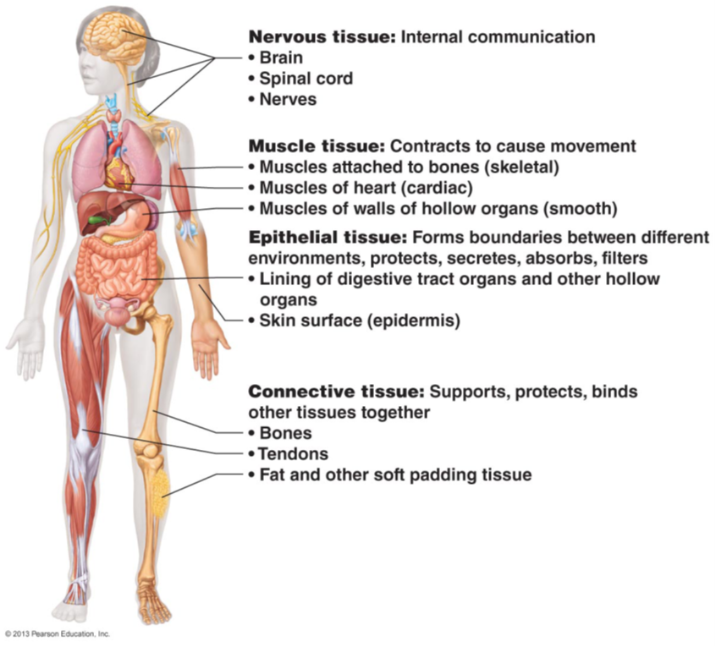
TISSUE
groups of structurally similar cells that perform common/related function

So what are the functions of epithelia Tissue?
Protection -Cells of the skin protect underlying tissue from

Absorption- Cell epithelial cells lining the GI tract absorb nutrients from digested food

Filtration- the epithelium of the respiratory tract protects the body by filtering out dirt and particles and
cleaning the air that’s inhaled. The blood is filtered in epithelial tissue in the kidneys.

Excretion -Epithelial tissues in the kidney excrete waste products from the body and reabsorb needed
materials from the urine. Sweat is also excreted from the body by epithelial cells in the sweat gland

Secretion- in glands, epithelial tissue is specialized to produce secretion e.g. enzymes, hormones and
lubricating fluids

Sensory reception -Specialized epithelial tissue containing sensory receptors is found in the skin, eyes, ears, nose, tongue

What is the basal lamina and what is its function?

Basal Lamina – This is a non-cellular, adhesive sheet consisting of glycoproteins secreted by the epithelial cells plus some fine collagen fibers. The basal lamina acts as a selective filter that determines which molecules diffusing from the underlying connective tissue are allowed to enter the epithelium, also acts as a scaffolding along which epithelia cells migrate to repair the wound

Classification of Epithelia Tissue

Name | Description | Function | Location
Simple squamous epithelium | Single layer of flattened cells and is disc shaped | Allows materials to pass by diffusion and filtration; secretes lubricating substances | Kidney glomeruli; air sacs of the lungs, lining of heart, blood vessels and lining of ventral body cavity
Simple cuboidal epithelium | Single layer of cube like cells | Secretion and absorption | Kidney tubules; ducts and sec
Simple columnar epithelium | Single layer of tall cells; could contain cilia or microvilli | Absorption; secretion if mucus | Digestive tract, gallbladder and excretory ducts of some glands
Pseudo stratified columnar epithelium | Single layer of cells differing in heights; appears stratified because of the different kind of nuclei in each region | Secretes substances particularly mucus | Trachea and most of the upper respiratory tract
Stratified squamous epithelium | Thick membrane composed if several cell layers | Protects underlying tissues in areas subjected to abrasion | Moist lining of the esophagus, mouth and vagina; also epidermis of the skin
Transitional epithelium | Resembles both stratified squamous and stratified cuboidal | Stretches readily, permits stored urine to distend urinary organ | Lines the uterus, bladder and part of the urethra

Glad- A gland consists of one or more cells that make and secrete a particular product
- Can be (internally secreting) exocrine
- Can be (externally secreting) endocrine

Just know that exocrine glands are ductless and they produce hormones that travel within the body like growth hormone
Merocrine/eccrine
- secrete products by exocytosis
- most common type
- eg pancreas, salivary glands, most sweat glands

Holocrine
- accumulate products until cells rupture
- only eg sebaceous glands

Apocrine  - accumulate products, but only cell apex pinches off with secretory product  - whether this type exists in humans is controversial | 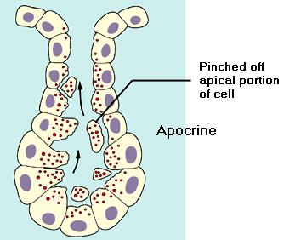

Learning objective
- Indicate common characteristics of connective tissue and describe its structural elements
- Describe the types of connective tissue found in the body and indicate their characteristic functions
- And be able to list them

Characteristics of connective tissue
- Common origin- arises from mesenchyme which is an embryotic tissue
- Degree of vascularity- They range from being highly vascularized to being avascular
- Extracellular matrix- This endows connective tissue to bear weight, withstand tension and endure abuses

Types of connective tissue:

Name | Description | Function | Location
CT proper: loose connective tissue, areolar | Gel-like matrix with all three fibres types; cells: fibroblasts ,macrophages, mast cells and some white blood cells | Wraps and cushions organs its macrophages phagocytize bacteria and plays a role in inflammation | Widely distributed under epithelia of the body
CT proper: loose connective tissue, adipose | Matrix as in areolar, but very sparse basically fat cells | Provides reserve fuel; insulates against heat loss and protects organs | Under the skin in subcutaneous tissue; around kidney ad eyeballs, abdominal and breasts
CT proper: loose connective tissue, reticular | Loose network of reticular fibres in a gel-like ground substance; reticular cells lie in network | Form a soft internal skeleton that support other cell types | Lymphoid organs(Lymph nodes, bone marrow and spleen)
CT tissue proper: dense connective tissue, dense regular | Primarily collagen fibers | Attaches muscle to muscle bone to bone or muscle to bone | Tendons and most ligaments
CT tissue proper: dense connective tissue, dense irregular | Primarily irregularly arranged collagen fibers | Withstands tension exerted in many directions and provides structural strength | Fibrous capsules of organs and joints; dermis of the skin and subcutaneous digestive tract
CT tissue proper: dense connective tissue, elastic | Contains a high proportion of elastic fibers | Allows tissue to recoil after stretching | Walls of large arteries like the aorta and bronchial tubes
Cartilage: hyaline | In hyaline cartilage protein fibers are large and predominantly collagen. | Supports and reinforces; serves as a resilient cushion; resists compressive stress | Covers end of long bones in joint cavities, forms the cartilage in the ribs cartilage if the nose and larynx
Cartilage: elastic | Similar to hyaline but more elastic fibres | Maintains the shape of a structure while allowing great | Support the external ear and epiglottis
Cartilage: Fibrocartilage | Thick collagen fibers are predominate | Tensile strength allows It to absorb compressive shock | Intervertebral discs, discs of knee joints

Cells
Every class of connective tissue has a resident cell type that exists as in an immature (“blast”) and a mature (“cyte”) form
• “blasts” are actively dividing/synthesizing cells during growth & repair
• “cytes” primarily provide a level of maintenance

TISSUE TYPE | CELL TYPE
TISSUE TYPE | “BLAST” | “CYTE”
1. CT PROPER | Fibroblast | Fibrocyte
2. CARTILAGE | Chondroblast | Chondrocyte
3. BONE | Osteoblast | Osteocyte
4. BLOOD | Hemocytoblast | Erythrocyte (RBC)  Leukocyte (WBC)  Thrombocyte (Platelet)

Physiology of Muscle Tissue
Learning objective
- Describe the microscopic structure of skeletal muscle fibers and explain the cellular mechanisms of excitation-contraction (pp. 279-288)
- Describe the neuromuscular junction (pp. 288-295)
- Describe the contractile properties of skeletal muscle (motor unit, isotonic & isometric contractions, spatial & temporal summation, etc) (pp. 296-301)
- Associate various muscle types with their metabolism and their speed of contraction and rate of fatigue (pp. 301-307)
- Compare the properties of smooth muscle with those of skeletal muscle (pp. 308-314)

Skeletal Muscle | Cardiac Muscle | Smooth Muscle
Cardiac, Striated, Voluntary multi nucleus | Skeletal, Striated, involuntary one nucleus | Visceral, non striated, involuntary and also one nucleus
STEPS FOR THE CONTRACTION OF MUSCLES

Muscle Functions

- Generate movement: locomotion, manipulation, blood flow & pressure, respiration, propelling of food, urine, etc.

- Maintain posture: constantly working against gravity

- Joint stabilization: eg: shoulders, knees when moving parts of skeleton

- Generation of heat: maintenance of body temperature

Functional Characteristics of Muscle

Excitability (Irritability): ability to receive and respond to a stimulus” stimulus usually a chemical (NT, hormone, pH) response = AP along sarcolemma + muscle contraction

Contractility: ability to shorten forcibly when adequately stimulated”

Extensibility: ability to be stretched or extended”

Elasticity: ability to resume resting length after being stretched

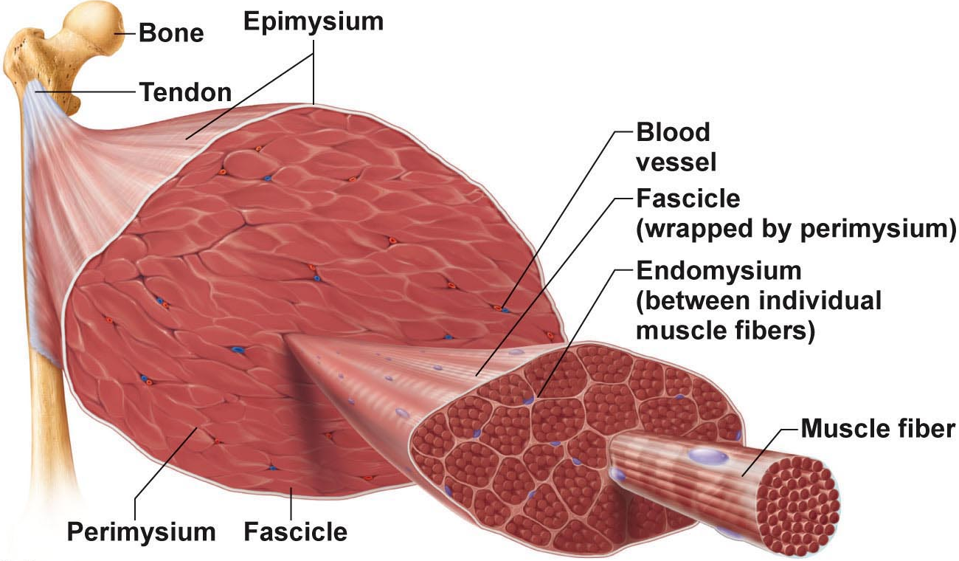

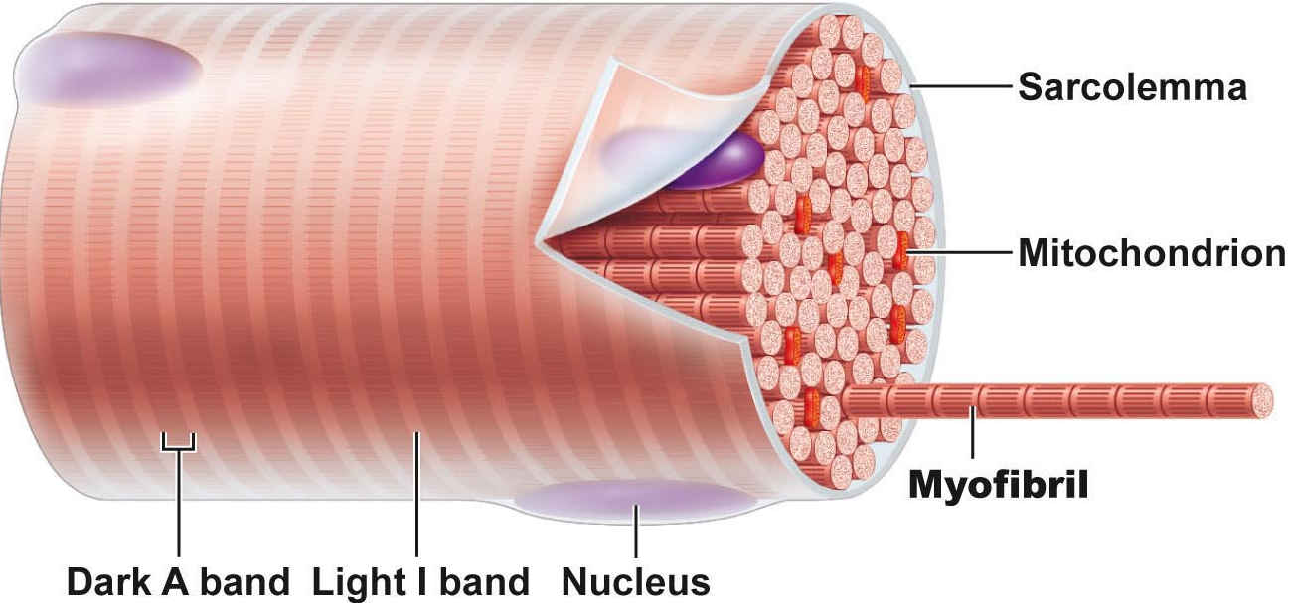
Myofibrils (cont)
sarcomeres extend from one Z disc to the next Z; sarcomeres give this muscle type the name “striated muscle”
myofilaments:
actin: = thin filaments - across I band & partly into A band
myosin: = thick filaments - entire width of A band
zones & lines:
Z disc = anchors thin filaments & connects all myofibrils of a cell (nebulin, connectin)
H zone: area with no thin filaments (relaxed muscle)
M line: fine strands connecting adjacent thick filaments (desmin)

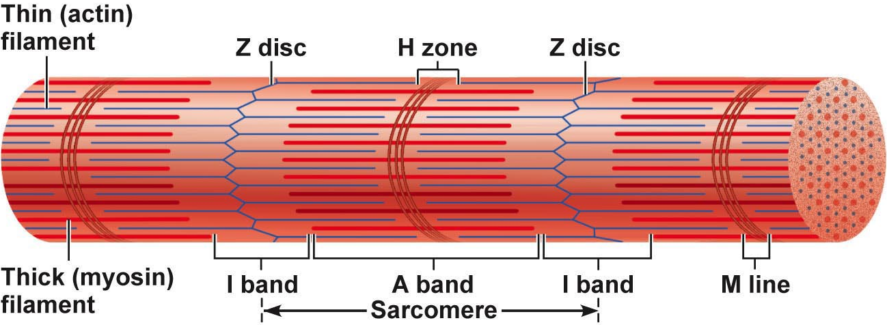

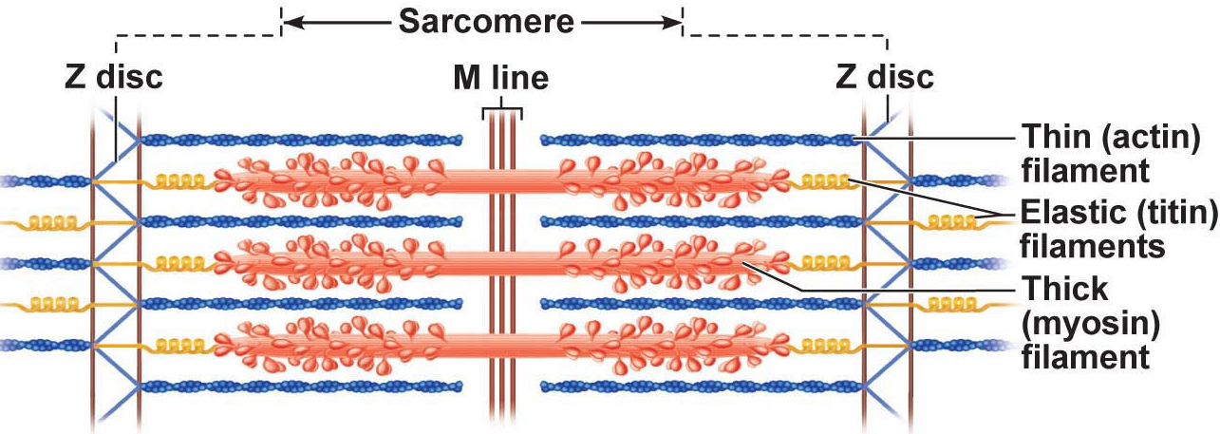

Sarcoplasmic Reticulum:
• elaborate web of ER around each myofibril inside PM
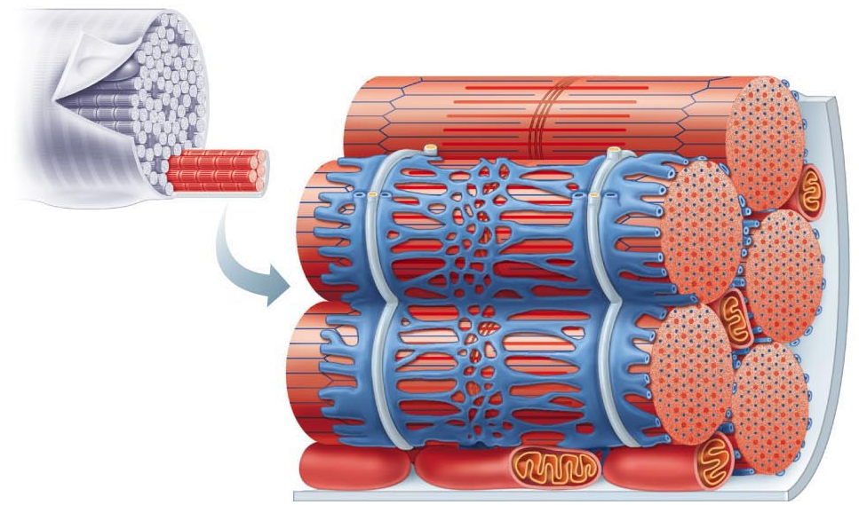
• most SR tubules run longitudinally; pairs of terminal cisternae across A-I junctions
ROLE: regulate intracellular Ca⁺⁺; storage depot for Ca⁺⁺ releases it when muscle stimulated to contract

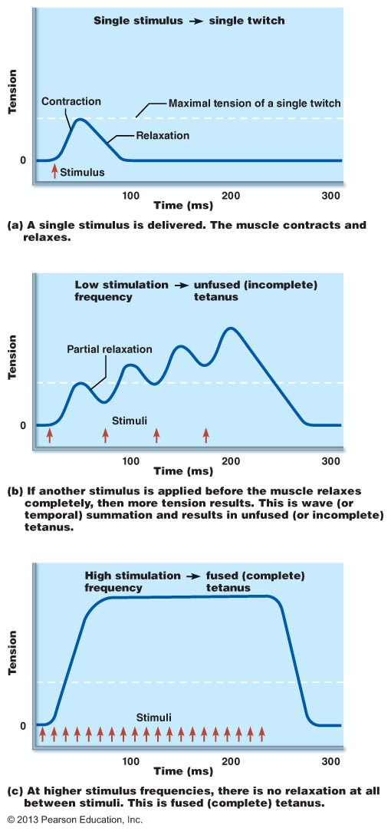
Motor unit: Consists of one motor neuron and all the muscle fibre that it innervates or supplies

Muscle twitch: a motor unit’s response to a single action potential of o motor neuron

Latent period: the few seconds following stimulation when excitation-contraction coupling occurs’

Period of contraction: dross bridges are active at this point in time

Period of relaxation: the re-entry of calcium into the sarcoplasmic reticulum muscle contraction decreases to zero

Graded Muscle responses: The variations, needed for proper control of skeletal movement

Recruitment: also called multiple motor unit summation controls the force of contraction more precisely

Threshold stimulation: stimuli that produces no observable contractions

Threshold stimulus: observable contractions are noted

Maximal stimulus: strongest stimulus that increases contractile force
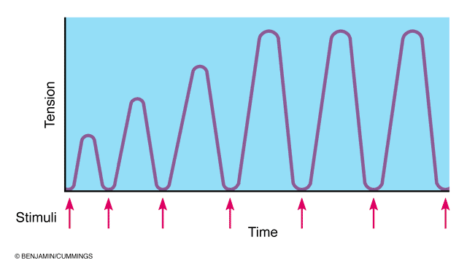

Isotonic and isometric contractions

Isotonic contractions (iso=same; ton= tension): muscle lengths change and moves a load
- Concentric contractions: those which muscle shortens and does work such as picking up a book or kicking a ball
- Eccentric: generates forces as the muscle lengthens; for example, your calf muscle as you walk up a hill
- We use concentric and eccentric in our everyday lives for example when we do a bicep curl *think of that*

Isometric contractions: tension may build to the muscles peak tension producing capacity but the muscle neither shortens nor lengthens this occurs when a muscle tries to lift a load greater the force
ISOTONIC MOVEMENT
ISOMETRIC MOVEMENT
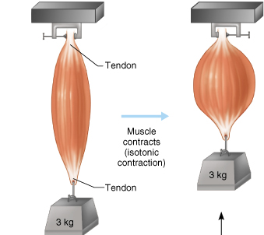
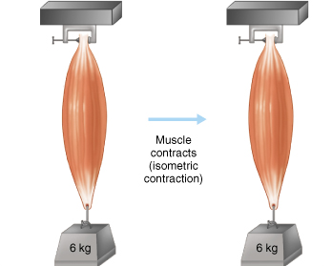

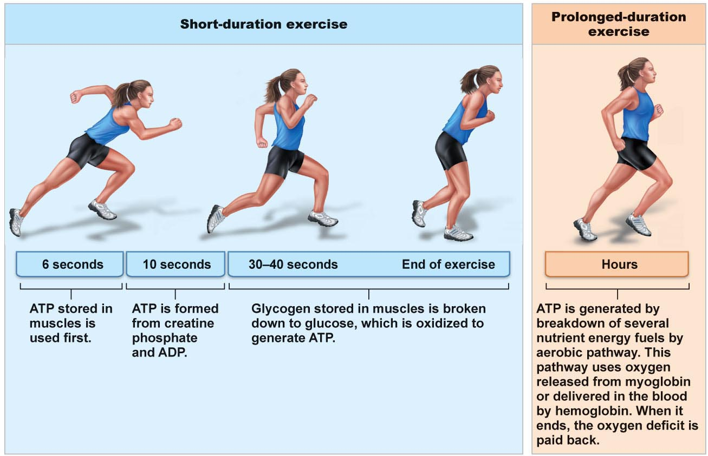
What are the 4 types of energy sources use for contraction
- Stored ATP for the formation of cross bridges
- Direct phosphorylation of ADP by creating phosphate basically when the atp runs out in the 10s
- Aerobic Respiration- Derives energy from glucose through many steps
- Anaerobic respiration- makes lactic acid (faster than aerobic respiration)
Muscle Fatigue
state of physiological inability to contract; results from a relative deficit of ATP (total absence would cause contractures contributors: build-up of lactic acid, ion imbalances (Na⁺/K⁺ pump requires ATP!)
Best for intermediate activities

Muscle fiber type:
Slow oxidative fibers: thin cells with slow-acting myosin ATPases - - contract slowly (red = lots of myoglobin); primary energy fuel is fat
• lots of mitos, capillaries, aerobic enzymes: oxidative
• fatigue-resistant, but not powerful (thin) -
Fast glycolytic fibers: large, pale (white), little myoglobin & diameter 2x that of slow oxidative fibers; fast-acting myosin ATPases & contract quickly
• few mitochondria; lots of glycogen reserves: glycolytic
• will fatigue (WHY?), but powerful
Fast oxidative fibers: red or pink, intermediate cell size; fast-acting myosin ATPases & contract quickly; high myoglobin content & O₂-dependent; fairly fatigue-resistant
most body muscles have a mixture of fiber types; genetics can alter distributions & subsequent athletic strengths
Best for short term rapid movements
Endurance-type activities

THE PLAMA MEMBRANE
Learning objective
- Describe the structure of the plasma membrane
- Describe and differentiate among the various types of transport across the plasma membrane
- Describe osmosis and explain its role in fluid homeostasis

The fluid mosaic model depicts the plasma membrane as incredibly thin, composed of a double layer of lipid molecules with protein molecules plugged into it
Fluid because the integral proteins move from side to side

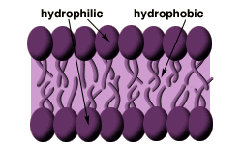
A phospholipid is a molecule that is made up of two fatty acid chains one is head is hydrophobic and one head is hydrophilic

Peripheral proteins: attached to integral proteins (usually internal side of PM); can be enzymes, involved in attachment functions, shape changes

Cytoskeleton: anchors to PM; can also interact with receptors

Glycocalyx: ensemble of carbohydrates attached to lipids & proteins on extracellular face; “sugar coating” on PM make sure the cell knows whats coming aka the signal
NB: glycocalyx changes when cell becomes cancerous - can even change repeatedly to avoid recognition by immune system

Cholesterol: overall: reduces general membrane fluidity & stabilizes its structure – too much cholesterol causes membranes to lose flexibility

What do my integral protein friends do?
TRANSPORT
RECEPTION
ATTACHEMEMNT TO CYTOSKELTON
ENNZYME ACTIVITY
INTERCELLULAR JOINING
CELL-CELL SIGNALING
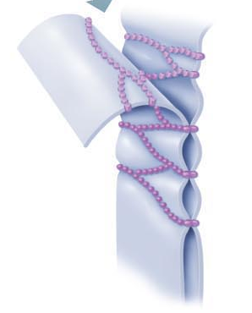
TIGHT JUNCTIONS
- fusion of adjacent plasma membranes to prevent passage of molecules
- why would these structures be important in the lining of the digestive tract?
- We don’t want leakage of highly acidic solutions

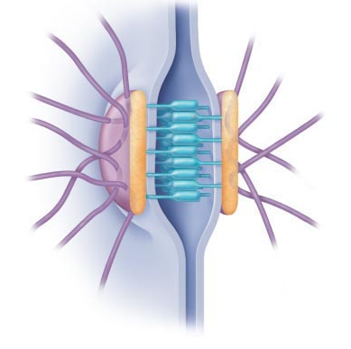
Desmossones
Found on yhe cytoplasmic face if each plamama membrane; anchoring junctions: molecular linking of cells to resist mechanical stress

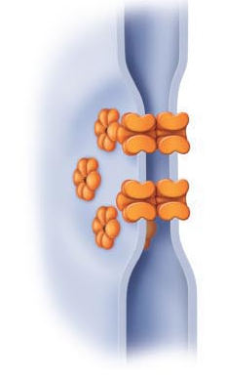
Tight Junctions
molecular channels between cells to allow passage of cytoplasmic molecules connexins electrically-excitable tissues

What are 4 major functions of the plasma membrane

- effective barrier between the intracellular & extracellular fluids
- selectively permeable
- allows the cell to respond to changes in the extracellular fluid
- site of cell-to-cell interaction and recognition

*to maintain homeostasis and function normally, a cell must be extract needed items , keep valuable materials inside & discard wastes*

Diffusion
- The tendacy of ilecules to move from an are of high concentration to an area of low concentration
- Based on kinetic energy
- Can be affected molecular size and the temorature of the enviroment
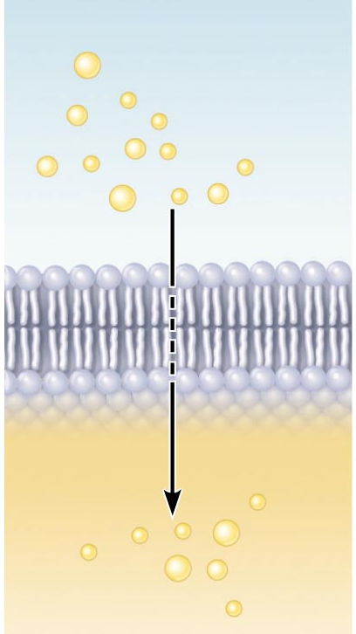
Simple Diffusion:
- nonpolar, lipid-soluble: O₂, CO₂, fats, urea, alcohol
- O₂ & CO₂ follow gradients into and out of cells, respectively
- molecule is moving down its concentration gradient

Carrier-Mediated

lipid-insoluble molecules too large to pass through membrane pores/channels

Features of facilitated diffusion:
1) specific
2) not ATP-requiring (glucose to glucose-6-P right after entry)
3) limited by carrier saturation
4) movement down concentration gradient
5) can be inhibited by certain substances

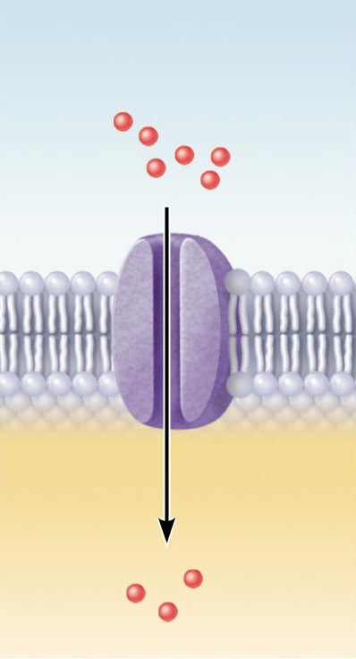
Channel-Mediated
- selective due to pore size, charges of a.a. that line channels
- some are always open (leakage channels)
- opening of others is controlled (gated channels)
- but movement always down concentration gradient
- can be inhibited, can show saturation & are usually specific

Active Transport
ATP used because substance is:
- too large for pores
- lipid insoluble
- moving against concentration gradient

like FD, requires a carrier: combines specifically & reversibly with substance
unlike FD, solute pumps move substances (amino acids, Na⁺, K⁺, Ca⁺) AGAINST CONCENTRATION GRADIENTS
many active transport systems are coupled systems:
(a) symport: eg: Na⁺ & amino acids or glucose, Na⁺,K⁺,2Cl⁻ cotransporter
(b) antiport: eg: Na⁺/K⁺ ATPase

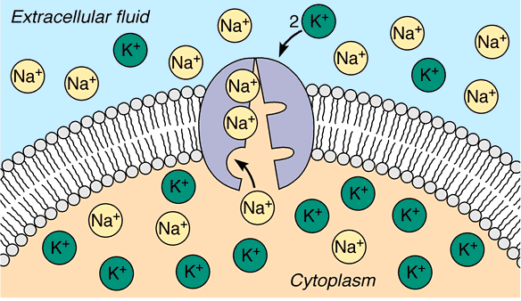

3 Na⁺ ions are pumped OUT for every 2 K⁺ ions pumped IN - moving AGAINST their concentration gradients to maintain cell responsiveness

- When we talk about osmolality and tonicity we talk about different things. Osmolality is what happens before the cell comes in contact with a solution and tonicity is when the cell actually comes in contact with the actual solution and can describe what is actually happening to that specific cell

THE NEURON
Learning objective
- Identify the different regions of the neuron and associate each region with the functions of reception, propagation and transmission of nerve impulses
- Explain the phenomena (diffusion of ions, types of ion channels) that are responsible for the electrical activity of neurons (resting membrane potential, action potential
- Describe the factors that influence propagation of the action potential along an axon
- Explain the mechanisms of synaptic transmission (synapse, post-synaptic potentials, synaptic integration

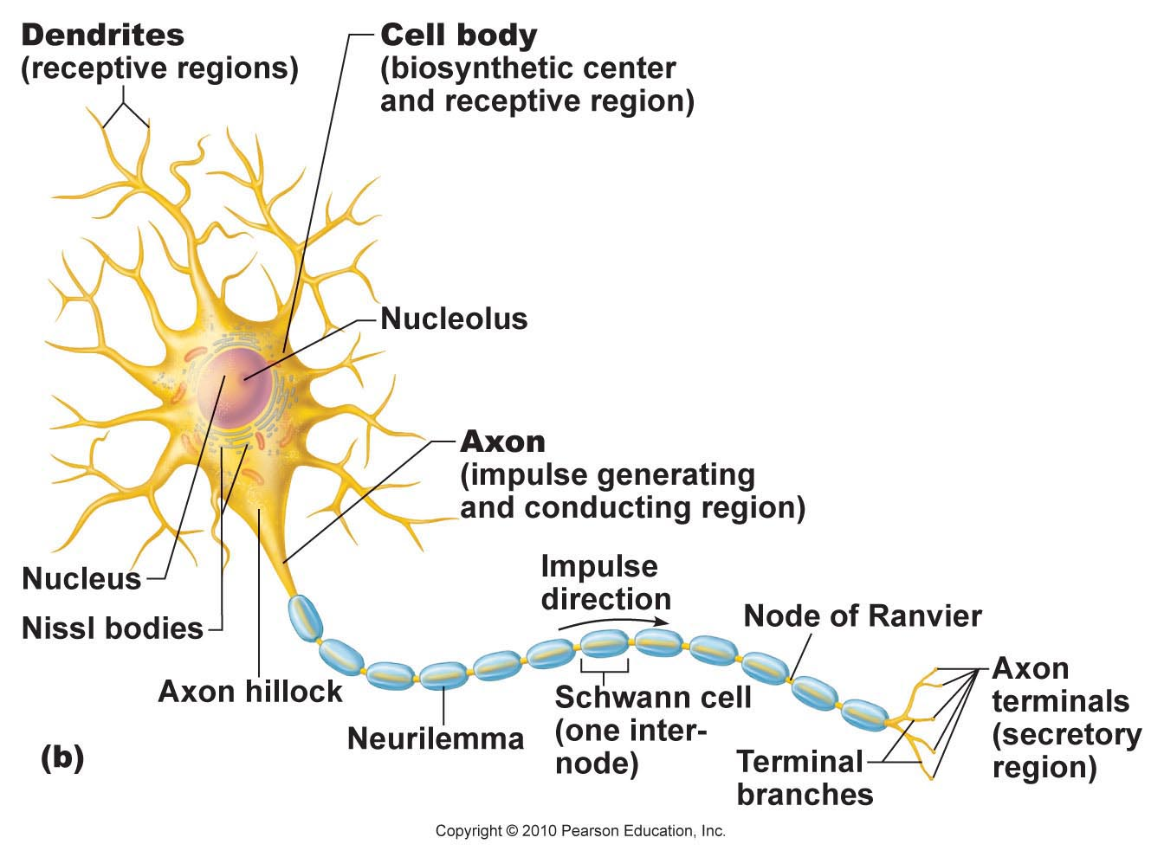
Dendrites: (receptive region)
• short, tapering, branched extensions; usually hundreds/cell body
• enormous SA for reception from other neurons
• conduct impulses toward cell body
• short distance, graded potentials

Axon
• arises from axon hillock; variable length (can be > 1 metre)
• rate of conduction increases with axon diameter
• usu. 1 axon/neuron; branches at end (~10,000 telodendria) which end in axonal terminals

Fundamental principles of electricity

- voltage: electrical potential energy due to separation (PM) of oppositely-charged particles (ions) (-70 mV for many neurons)

- resting membrane potential: all cells polarized; RMP cell-type-dependent (neg)

Channels in plasma membranes:

1. Passive or leakage channels: always open
2. Active or gated channels: signal required to open/close
a) chemically-gated (neurotransmitter/hormone)
b) voltage-gated (change in membrane potential)
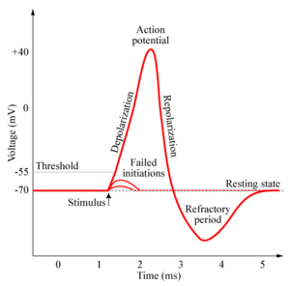
channels ion-specific: channels open ions move in response to electrochemical gradients

*APs do not decrease in amplitude with distance travelled!!*

• voltage-gated channels on axons open & close in response to local currents (graded potentials)



