3 – Facial injuries

Facial trauma
- With any trauma, our main goal is
  - UABC
  - In-line spinal immobilization
  - Shock prevention
- Several injuries can appear after a facial trauma
  - Mandibular fracture
  - Mandibular dislocation
  - Maxilla fracture
  - Zygomatic fracture
  - Nasal fracture
  - Auricular hematoma
    - Also known as
      - Cauliflower ear

Mandibular fracture

MOI
- Direct hit

Classification
- Unilateral
- Bilateral
- Multiple
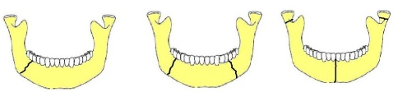
S&S
- Inside the mouth
  - Pain
  - Numbness
  - Sensitive to touch
  - Bleeding at the gums
  - Ecchymosis at the floor of the mouth
  - Lost teeth on either side of fracture
  - Malocclusion
- Outside of the mouth
  - Numbness at the chin and lower lip
  - Swelling
  - Bruising
  - Deformity

Treatment
- Stabilization
  - Mouth gard
  - Barton bandage
- Ice
- Send to hospital

Mandibular dislocation

MOI
- Lateral blow to an open mouth

S&S
- Pand + deformity in the anteriorly to the ear
- Inability to close mouth
- Deviated chin to the contralateral side
  - Chin moves to the normal side

Treatment
- Ice
- Reduction procedure by MD

Maxilla fracture

Lefort Classification
 | REGION | DESCRIPTION
I | Horizontal | Floating palate + Upper dental row
II | Pyramidal | Inferior orbital rim
III | Transverse | Cheek bone  Aka craniofacial dissociation

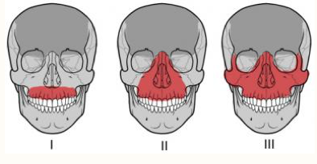
S&S

LEFORT I | LEFORT II | LEFORT III
Malocclusion  Mobility of teeth Upper lip swelling | CSF rhinorea  Epistaxis  Bilat. Ecchymosis  Cheek paresthesia  Infraorb. Margin deformed  Gross edema | Face lenghtening  Ocular levels depression

Treatment
- ABC
- Ice
- Refer to hospital

Zygamotic fracture

Assessment
- ABCs
- Head assessment
- Palpation

S&S
- Diplopia
- Periorbital + subconjunctival ecchymosis
- Unilateral epistaxis
- Cheek paresthesia + loss of cheek projection

Treatment
- Ice
- Transport to hospital
- Position of comfort (supine)
- Covering both eyes might decrese pain

Nasal fracture

Nose
- Nasal cavity bleeds a lot because it is
  - Extremely vacscular
- Nasal bone is the most fractured facial bone since
  - Projection that is central + anterior
  - Weak structure
- The nasal injuries and fractures are often
  - Unrecognized
  - Untreated

Assessment
- The 3 first steps are the same as the zygamotic fx
  - ABCs
  - Head assessment
  - Palpation
- The following steps are
  - Crepitus test
  - Visualize septum

Treatment
- Bleeding control
- Ice at the ridge of the nose and the neck
- For aesthetic purposes, need to be reduced
  - Within 5 days
- Patient should not
  - Blow nose
  - Be supine
- Patient should
  - Lean forward

Bleeding control for Epistaxis
- If not controlled after 10 minutes
  - Try upper lip pressure point
  - Refer to MD if needed
- Procedure
  - Lean forward
  - Pinch right below the bony ridge

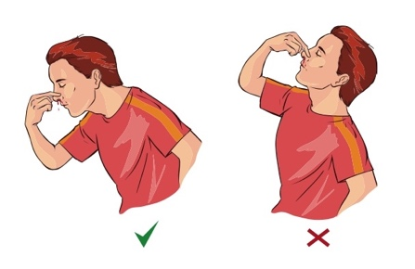

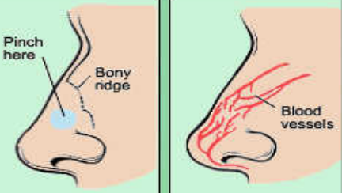

Auricular hematoma

Description
- Also known as
  - Blow nose
- Caused by blood collection of fluid under the
  - Perichondrium
- If left untreated, can lead to
  - Permanent deformity
- Can be prevented with
  - Ear protector

MOI
- Excessive rubbing
- Exterior portion of ear suffers a blow

Treatment
- Ice
- Aspiration by MD followed by
  - Compression for 3-5 days



