Experiment 1- Microscopy

- What is the name of the program that is used to take digital photographs of organism seen in the microscope? _______________________.
- What are the two types of microscopes used in the BIO1140 lab component? _______________________ and _________________________.
- The _____________________ microscope is used to view items that are too large or too think.
- The _________________________ supports the various objectives (4x, 10x, 40x).
- The _______________________ supports the specimen being observed.
- The ________________________ permits rapid change in distance between the specimen and the objective.
- The ________________________ permits small changes in distance between the specimen and the objective.
- The _______________________ is the piece with which one looks at the specimen.
- The _______________________ is the magnifying element that is closest to the specimen.
- The _______________________ is a system of lenses that concentrates the light furnished by the illuminator.
- The _______________________ allows one to focus the concentrated light onto the specimen.
- The _______________________ is used to reduce glare from unwanted light by adjusting the _______________________ of the cone of light that comes from the condenser.
- The 40x on the objective engraving represents the _______________________.
- The 0.95 located on the right of the 40x represents the _______________________.
- The 160 / 0.17 below the above represents the _______________________.
- If the ocular or objective is dirty, you use _______________________ to wipe them.
- In a dissecting microscope, the letter “e” would look like ____ when viewed.
- In a compound microscope, the letter “e” would look like ____ when viewed.
- Working distance _______________________ as the magnification increases.
- The depth of field _______________________ when magnification increases.
- The other name for a dissecting microscope is a _______________________ microscope.
- Dissecting microscopes can be used with two types of light: _______________________ and _______________________.
- The _______________________ light is directed unto _______________________ specimens whereas the _______________________ light is directed unto _______________________ specimens.
- Cells can be organized into two types: _______________________ and _______________________ cells.
- _______________________ cells are much larger than _______________________ cells.
- Linear chromosomes are seen in _______________________ cells, while circular chromosomes are seen in _______________________ cells.
- The eukaryotic specimen used in this lab is named _______________________ and it is a _______________________ (plant or animal?)
- _______________________ takes place in the chloroplasts of the Elodea leaf.
- _______________________ is responsible for the green colour of the Elodea.
- _______________________ is the directed flow of the cytosol and organelles around plant cells.
- The _______________________ cannot be seen in plant cells under the microscope because it is too thin. To resolve this problem, _______________________ is added to the specimen, which removes the _______________________ from the plant, making the plasma membrane more visible. The organism that has the cell minus the cell wall is called a _______________________.
- The prokaryotic cell used in this experiment is called _______________________.
- The name of the shrimp larvae observed in this lab is _______________________, and 1-2 drops of _______________________ solution is used to slow down the larvae.

- What is the name of the organism shown below? _______________________.
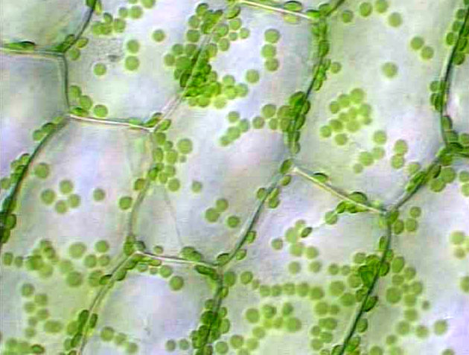

- What is the name of the organism shown below? _______________________.
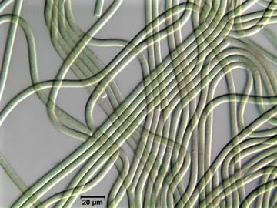

Experiment 2- Permeability of the Red Blood Cell

- What is the scientific name of the red blood cells used in this experiment? _______________________.
- These types of cells can be kept for a long time for 3-4 days in _______________________ or one week in _______________________.
- Erythrocytes contain large quantities of the pigment _______________________.
- When the volume of a cell exceeds a critical volume, the cell _______________________ and the pigment is released to the external environment; the phenomenon is called _______________________.
- The movement of water across a semi-permeable membrane is called _______________________ and water moves freely across the membrane with the help of proteins called _______________________ that form canals through the membrane.
- Water movements are driven by _______________________ which is the ability for water to move from the compartment with lower solute to higher solute.
- The volume of a cell placed in a _______________________ solution will increase due to massive entry of water inside the cell.
- Water flowing from the inside of the cell to the outside of the cell, causing the plasma membrane to shrink is therefore placed in a _______________________ solution.
- When molecules in a solution cross the membrane against their own concentration gradient, _______________________ occurs.
- Solutes can diffuse through a membrane at various different _______________________ depending on their functional groups.
- Hemolysis occurs when erythrocytes are placed in a _______________________ environment.
- A solution is called _______________________ if it has the same concentration of solutes as the cellular fluid.
- When the suspension turns _______________________ and the line is clearly visible, you know hemolysis has been reached.
- Adding 0.350 M of NaCl to blood will cause the cell to shrivel _______________________ (more/less?) than adding 0.065 M of NaCl.
- Which of the following images below represents red blood cells undergoing hemolysis? _______________________.

a)
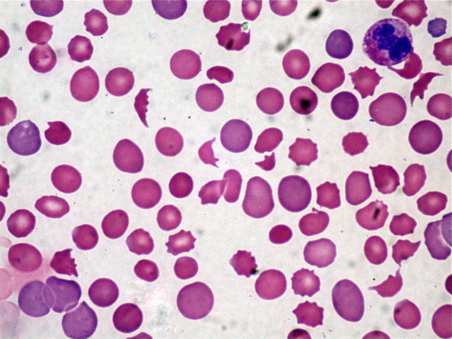
b)
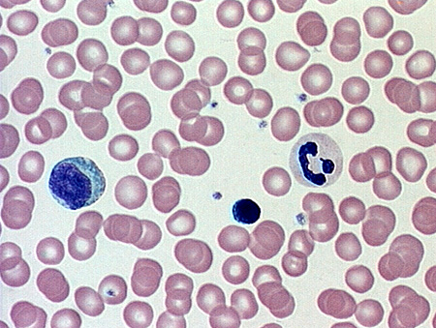

Experiment 3- Cellular Processes in Amoeba proteus

- The objective of this experiment was to follow and measure the diameter of the _______________________ for the organism _______________________ under the microscope and take pictures of it.
- The light on the compound microscope must be very _______________________(dim/bright?) when observing the Amoeba proteus.
- The Amoeba proteus is a protist that belongs to the _______________________ group.
- The Amoeba proteus is a _______________________ (single/multi?) celled(ular) organism that is a _______________________ (eukaryote/prokaryote?)
- The Amoeba proteus is found in _______________________.
- It extends its _______________________ as a way to move and catch food that will be later digested in food _______________________.
- The name of the “fake feet” on the Amoeba proteus are called _______________________, which are made of extensions of long polymers of _______________________.
- During the formation of a pseudopodium, molecules of free _______________________ bound to each other to create a series of long polymer fibers called _______________________.
- The amoeba must constantly fight excess water entry by _______________________, and they release this excess water thanks to a _______________________.
- The Amoeba proteus has how many contractile vacuoles? _______________________.
- Time zero corresponds to the time when the amoeba _______________________ and this is specifically called _______________________.
- A typical contractile vacuole cycle lasts for _______________________ minutes, but it may sometimes take longer.
- _______________________ endocytosis may be induced by a large variety of substances such as _______________________.
- A solution of _______________________ was used in this lab to induce pinocytosis.
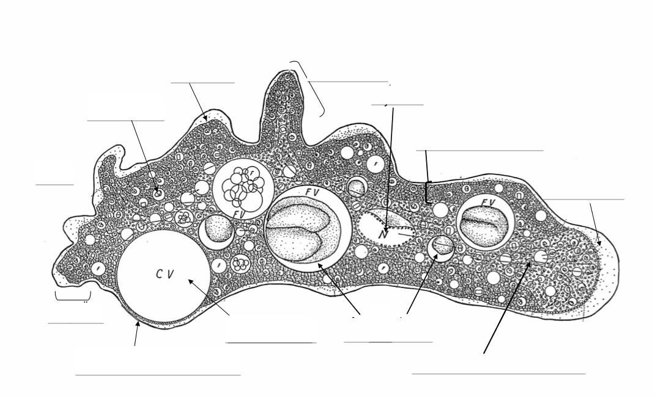
- Label the following parts of the image for Amoeba proteus.
- Label the following parts.
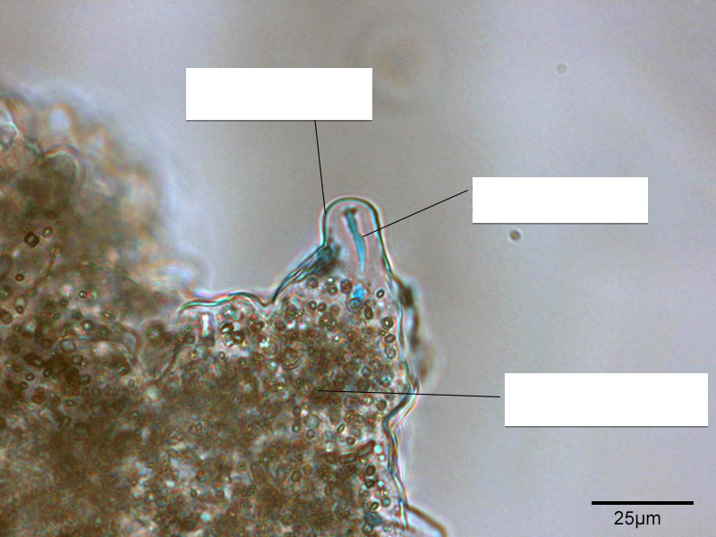
17. Label the following parts.
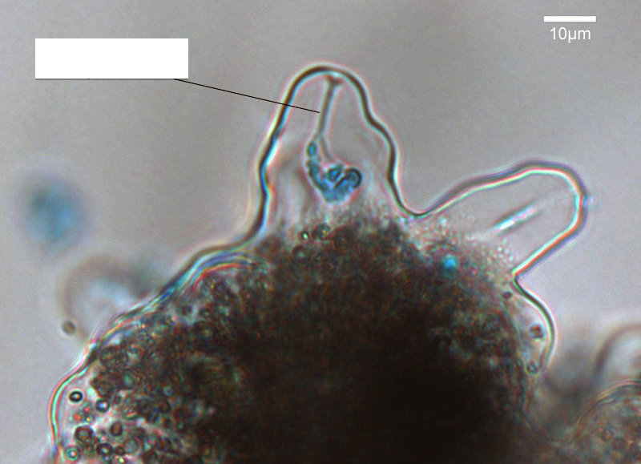

Experiment 4- Mitosis

- All cells have a common fact, they all at one point _______________________.
- The process that permits one cell to divide into two is called _______________________.
- Cell division that will give rise to two daughter cells identical to the original mother cell is called _______________________.
- The cell cycle can be broken down into two main parts: _______________________ + _______________________.
- The M phase consists of _______________________ and _______________________.
- Interphase consists of _______________________. (4 parts)
- A cell spends most of its time in _______________________.
- The _______________________ phase is where cells grow before DNA replication
- The _______________________ phase is when all DNA is replicated and synthesized into proteins.
- The _______________________ phase is the period after DNA replicates and prepares for division. This is where production of structures needed for mitosis are made.
- The _______________________ phase is where the cell cycle is at rest.
- The duplicated chromosomes consist of two _______________________ joined together by protein complexes called _______________________.
- _______________________ is the part of cell division where the chromosomes are equally distributed between two daughter nuclei.
- The five main stages of mitosis are:
  - _______________________
  - _______________________
  - _______________________
  - _______________________
  - _______________________
- The division of the cytoplasm at the end is known as _______________________.
- _______________________ is the stage that the cell is in between mitotic divisions. DNA replication occurs during this stage and all you see is the nucleus and heterochromatin.
- _______________________ is the stage where the chromosomes shorten and thicken. The two centromeres separate and migrate towards the opposite poles of the cell.
- _______________________ is the stage between prophase and metaphase, where the kinetochore forms.
- _______________________ is the stage where the centromeres start to separate and line up in the equator.
- _______________________ is the stage where each chromatid move to the opposite poles of the cell.
- _______________________ is the stage where the chromosomes become longer and thicker, and the nuclear membrane reforms. Also, _______________________ occurs during this phase where cell walls form around plant cells.
- Mitosis is more easily seen in _______________________ cells because the chromosomes stand out more clearly.
- The stain used for chromosomes is called the _______________________ stain. The stain colours the DNA _______________________.
- The DNA is first hydrolyzed with hot _______________________ which removes the purine bases and frees the aldehyde groups of the sugar. The resulting product is called _______________________, aka DNA lacking purines. This is what reacts with the stain.
- The timing of the acid hydrolysis is _______________________ minutes and this is very important because over hydrolyzing or under hydrolyzing will cause reduced staining.

- Fill in the blanks.

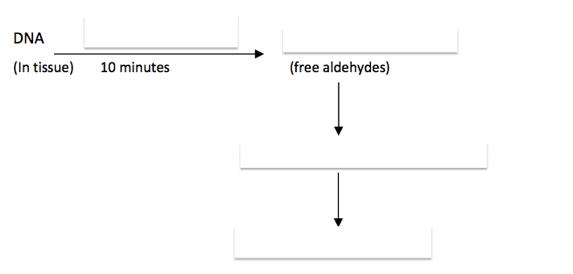

- The _______________________ is the inactive region where the cells are arrested in the G1 of interphase.
- The _______________________ result in most of the increase in length of the root.
- The _______________________ is the zone of cell division and apical growth.
- The _______________________ is where most of the primary tissues mature.
- The _______________________ cells transport water and salts from the soil to the rest of the plant.
- The _______________________ cells transport carbohydrates from the photosynthetic portions of the plant to the roots.
- The roots do not have _______________________ and cannot make their own food.

- Label the longitudinal section of the root tip below.
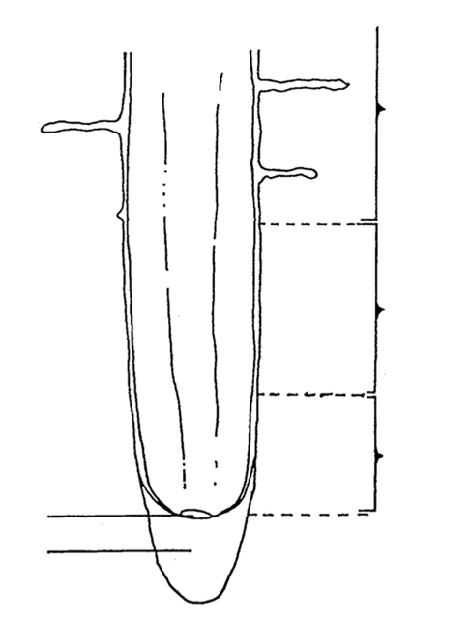

Experiment 5- Meiosis

- _______________________ was studied in the rat testes and _______________________ was studied in the rabbit ovary.
- Label the epidermis, filament, parenchyme, pollen cell precursor, and pollen sacs in the Lilium anther early prophase stage below.

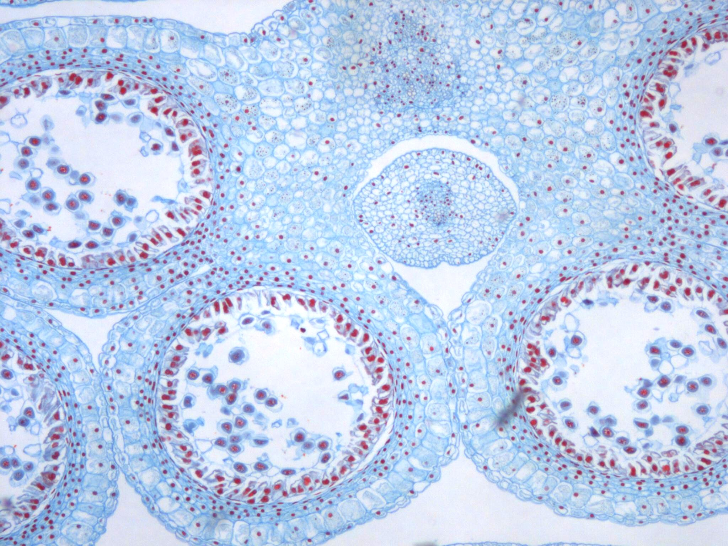

- Label the spermatozoid and the egg nucleus in the diagram below.
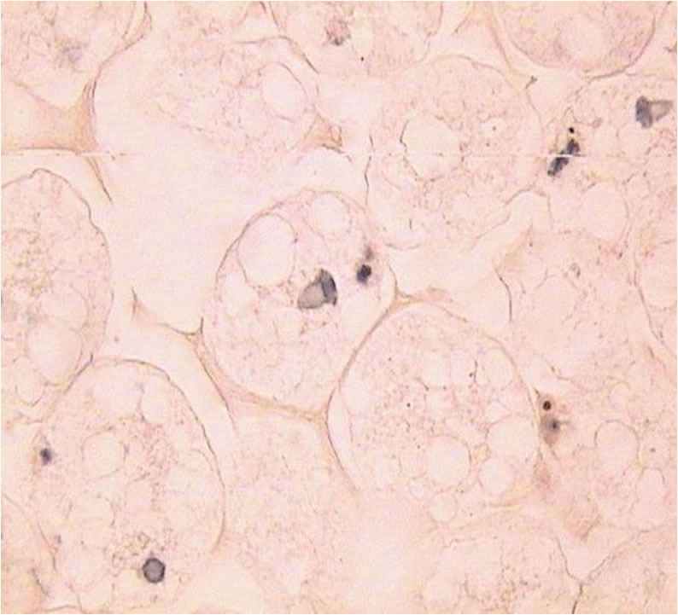

- The stage of meiosis in the cell below is the _______________________ stage. Label the shell, chromosomes lined up at the equator, and pronucelus.

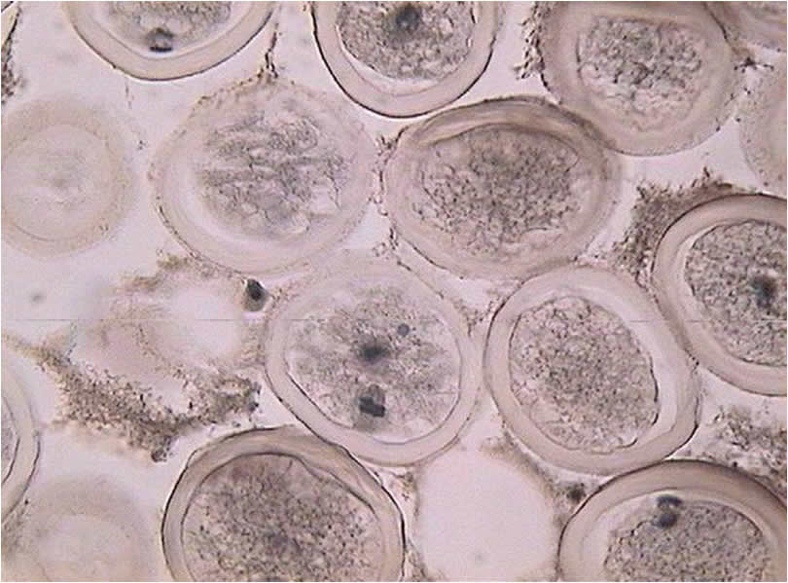

5. What stage is the cell in below? _______________________.
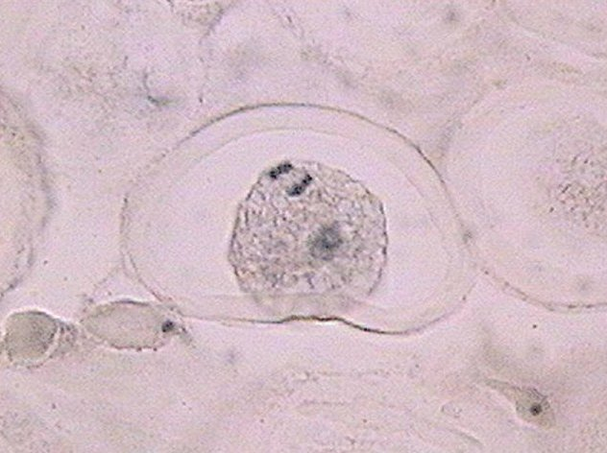

6. Label the polar body and perivitelline space in the image below. The stage this cell is in is _______________________.
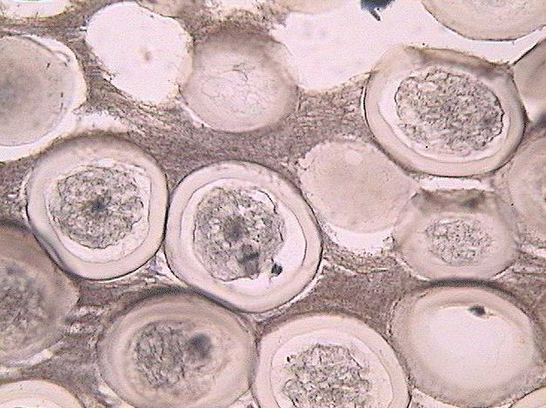

7. The stage that the cell is in below is _______________________. 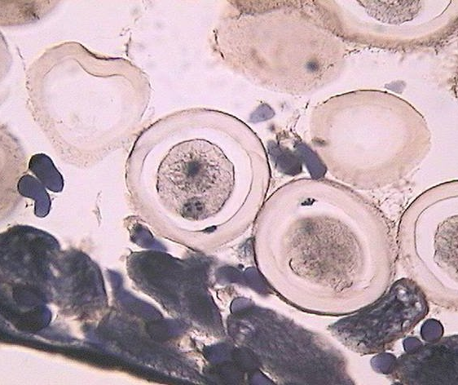.

8. Haploid male and female _______________________ in interphase prior to fusion is called _______________________. (image seen below)
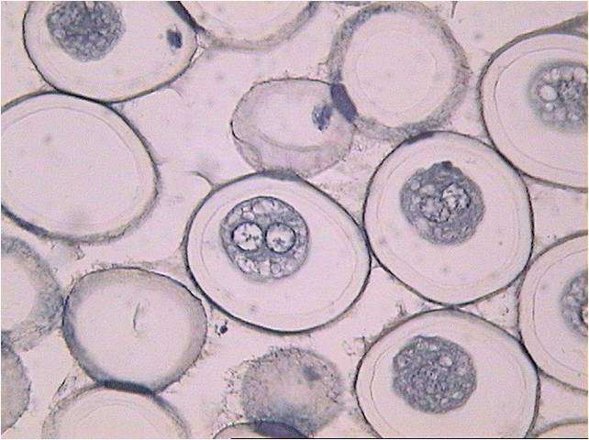

9. Label the basal lamina, sertoli cell nucleus, spermatogonia, primary spermatocyte, secondary spermatocyte, sperm cells, and spermatids in the cross section below.
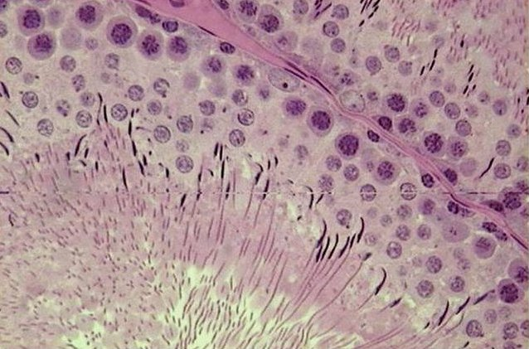

10. Label the primordial follicle, the ovary epithelium, and interstitial cells in the image below.
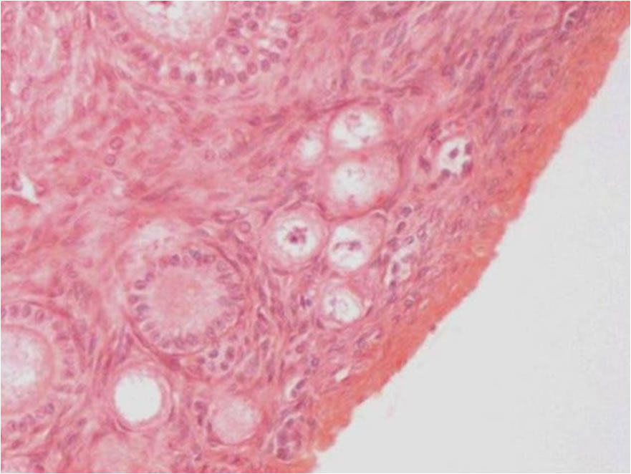
11. Label the cuboidal follicular cells, the primary oocyte, and the oocyte pronucelus in the rabbit ovary below.
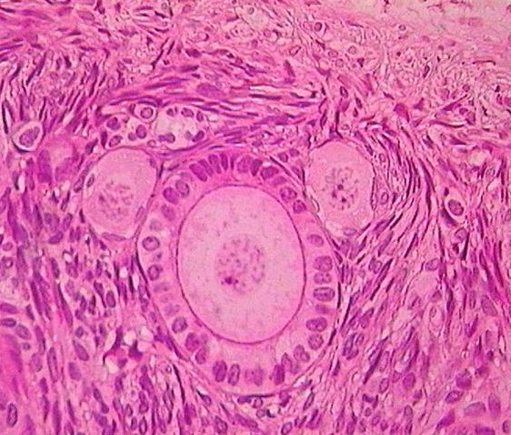

12. Label the fluid-filled cavity and the secondary oocyte in this image.
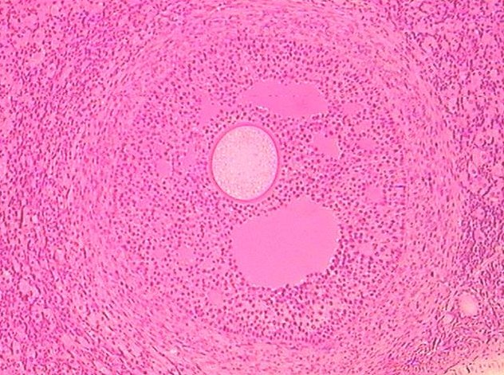

so
fca

- Is there DNA duplication in meiosis? _______________________.
- The net result of meiosis is _______________________ cells, and the daughter cells are _______________________ to each other.
- Each daughter cell contains only _______________________ chromosomes, half the number in the mother cell.
- Meiosis only occurs in _______________________ reproducing organisms.
- Sporophyte’s form haploid _______________________, which divide to produce _______________________, which eventually produce gametes. Those gametes fuse to form diploid _______________________. This type of meiosis is called _______________________.
- _______________________ precedes Meiosis 1 and is composed of G1, S and G2; the result of this stage is two _______________________ sister chromatids attached at the centromere.
- RNA and proteins are synthesized in _______________________ stage.
- The five sub-stages of Prophase 1 are:
  - _______________________
  - _______________________
  - _______________________
  - _______________________
  - _______________________
- At the beginning of _______________________, the nuclear membrane breaks down and the homologues line up on the equator. The two sister chromatids attach their _______________________ via microtubules to the same spindle pole.
- In _______________________, the homologues are pulled away from each other toward opposite poles.
- In Telophase 1, the spindle breaks down and the _______________________ reforms.
- During the interphase like stage called _______________________ between meiosis 1 and meiosis 2, does DNA replication occur? _____________.
- The product after meiosis 2 is _________ haploid cells.
- The name for a flowing plant is an _______________________.
- The lily examined in this experiment was called _______________________.
- What is the proper name for the formation of male gametes? _______________________.
- __________ sperm are produced from each pair or meiotic divisions.
- In the female _______________________, the whole cytoplasm and stored food must be retained in the egg for the use of the developing embryo.
- While the large cell is the egg, the small one is called a _______________________.
- One of the earliest studies of meiosis on egg formation was done in the parasite roundworm _______________________.
- As the spermatozoa reach the eggs in the oviduct, _________________ (how many?) penetrates each egg.
- The haploid egg and sperm nuclei remain in the interphase for a while, and they are called the male and female _______________________.
- During what phase is the first polar body extruded from the secondary oocyte? _______________________. The second polar body? _______________________.
- The oocyte floats in a fluid space called _______________________.
- The process where haploid male and female pronuclei remain in interphase for a while and then fuse is called _______________________.
- Label the cross section of the tubule below.
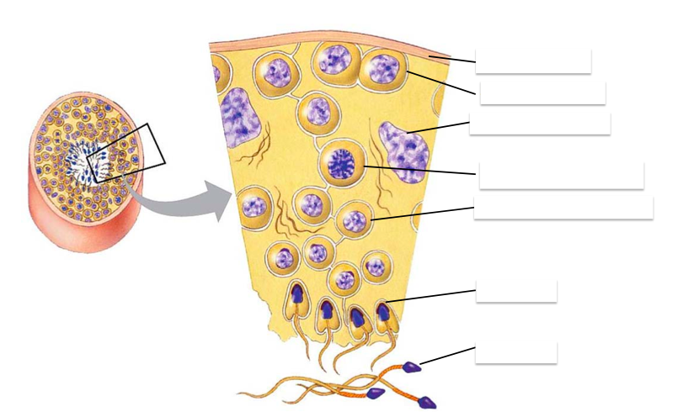
- _______________________ are large cells found in the walls of the seminiferous tubules, and they fed and regulate the spermatids.
- _______________________are easily recognized by their long thin flagellum.
- _______________________ will differentiate into functional spermatozoa.
- Ovaries of a newborn mammalian female already contain all the _______________________ she will ever need during her reproductive years.
- Each oogonium is surrounded by a layer of _______________________ and together they constitute a _______________________.
- _______________________ are small round structures that contain one oogonium within one layer of follicular cells.
- _______________________ are larger follicles with a few layers of follicular cells. Each follicle contains a primary and secondary oocyte.
- _______________________ are large follicles that are occupied by a clear fluid-filled cavity.

- Label the cross section of a mammalian ovary below.
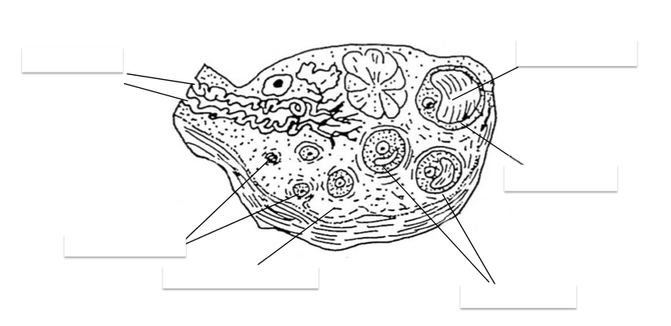

Appendix

- Quantitative variables are placed along one axis only, in the _________ axis for vertical bar graphs.
- _______________________ have quantitative scales along both axes.
- _______________________ graphs are used when many data points (n>30) are available at constant intervals, in order to see trends or changes in a variable through time.
- _______________________ are used to investigate the relationship between two different sets of data.
- While the graph takes up 2/3 of the page, the bottom 1/3 should be used for the _______________________.
- Only _______________________ tick marks can be placed per quantitative axis, but there is no limit in the qualitative axis.
- If means are plotted, _______________________ bars must be indicated and be slightly less prominent than the data points.
- For more than 2 symbols used, a _______________________ should be created. Less than 2 symbols can be described in the caption.
- When underlying the genus and species, each must be underlined _______________________.
- The caption is located _______________________(above/below?) the table body.
- No _______________________ lines should be used when creating a table.
- _______________________ may be used to explain an abbreviation, symbol or term in the caption, heading or body of the table.
- The biological drawing should be located either in the center or slightly to the _______________________ of the page, and should take up about _______________________ the page.
- Should a frame be present around your drawing? ____________
- Should there be shading, stippling and cross-hatching? ___________
- All labels should be located _______________________, not off to the side. If needed, a _______________________ can be used, which is a straight line.
- No unlabeled structures should be shown, and a _______________________ bar should be presented in the bottom right corner of the diagram.
- The caption should be located immediately _______________________ the drawing and begin with a figure number.
- Abbreviations used on the drawing must be listed at the _______________________ of the caption alphabetically.

