Lab #2 – The Kinetic Study of Nucleophilic Substitution
Jonathan Brar 8209351 and Mahdi Mahallati 8224478
October 6th, 2016
TA: Binjie Li
CHM2123

Introduction
Studying the kinetics of a reaction is important in trying to understand the mechanism of a chemical reaction as it allows us to determine if it will give us the products we want at a decent rate. The condition of the reaction can be tinkered with to give us our desired yield of products or even stop a reaction from occurring at all. The rate of a reaction can be determined by observing the disappearance of the starting materials or the formation of the products.

The rate of the reaction depends on many variables. The larger the amount of reactants there are, the higher the chances of collisions happening which lead to bond breaking and formation which can greatly affect the rate of the reaction. This is the concentration of reagents. The equation for the rate of the reaction is given by: r=K(A)^{x}(B)^{y}
X and Y denote the order of the reactions. It can be either a 0 order, 1st or 2nd. A reaction is 0 order when one of the reactants is independent of the products but the other reactant is dependent on then. The reactant that is dependent in the above example would be first order. A second order reaction is when the products rely on both reactants.
The goal of part A of this experiment is to observe the effect that a leaving group has on the rate of the reaction. A nucleophilic substitution will occur in this part. The electrophile has an alpha carbon which is where the nucleophile attacks as well as a leaving group which stabilized the additional electrons that are received. We are observing chlorine and bromide as the leaving group in this experiment. The LG can have a major effect on the rate of the reaction. Good leaving groups will polarize the carbon – leaving group bond which will decrease its potential energy. This will result in the increase of the reaction rate.
The goal of part B is to observe how changing the solved will increase the rate of the reaction by analyzing the amount of time required to consume a known amount of reactants while using different solvents. The lower the amount of solvent used, the higher the concentration of the reactants affects the reaction rate. Different solvents can also affect the polarity. Polar solvents break dipole bonds making loose ion pairs which in turn increases the reactivity.
A titration will be used in Part A to determine the rate of the reaction. Titration is a technique used to determine the concentration of an unknown solution given the concentration of another solution.

Experimental Procedure
Refer to the CHM2123 Lab manual pages 39-40

Table of reagents
Compound | Mol.mass (g/mol) | Quantity (g or mL) | Density (g/ml) | Mmol | equivalent
NaOH | 39.997 | 27 mL in total | 2.13 | 20 | 3.9
Acetone | 58.08 | 3 mL | 0.7900 | 5.1 | 1
tBuCl | 92.57 | 3 mL | 0.851 | 100 | 19.6

Reaction mechanism
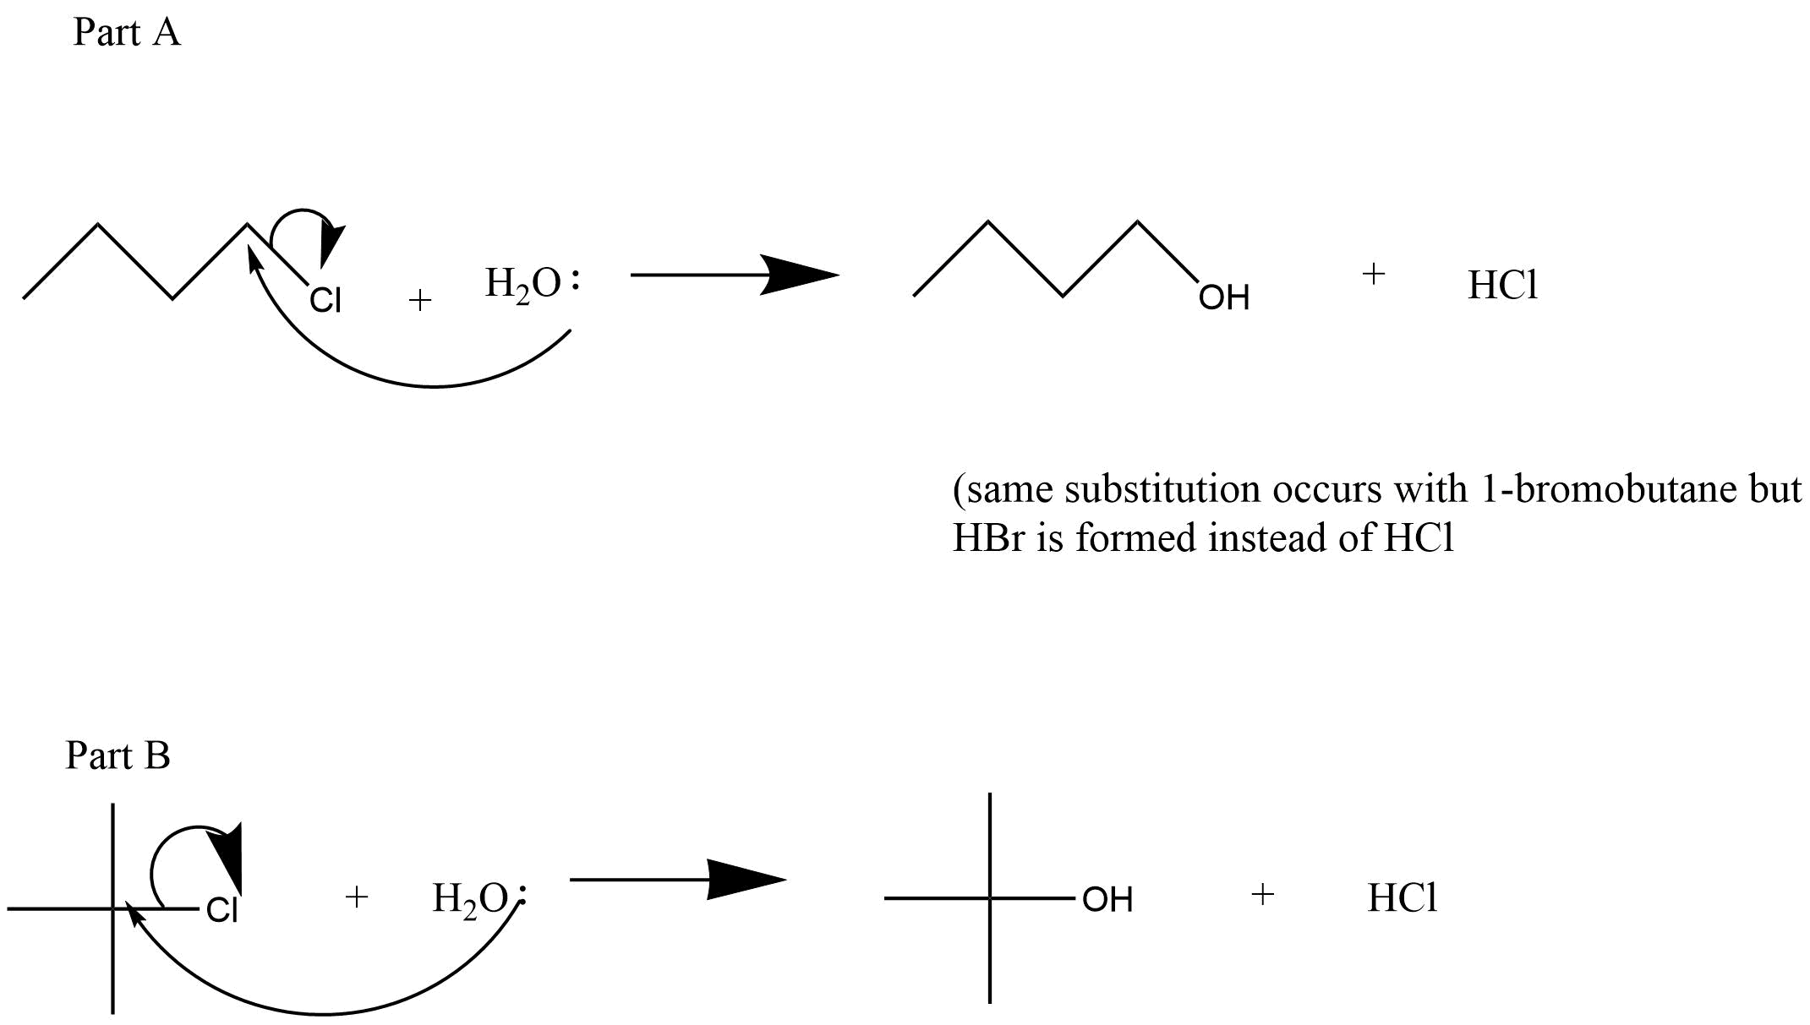

Observations
Part A observations

Part B observations
Key steps | Observations
NaOH | Clear, transparent, liquid
Bromothymol Blue indicator | Blue liquid
tBuCl | Clear, transparent, liquid
Color of indicator changing | The blue solution turned to a yellow, clear liquid

Results
85:15 H₂O acetone
% Conversion | 10% | 20% | 30% | 40%
Average times (s) | 11.7 | 31.29 | 57.92 | 88.63
(tBuCl) in solution | 0.0139M | 0.012M | 0.0105M | 0.009M
Ln(tBuCl) | -4.276 | -4.422 | 04.556 | -4.710
1/(tBuCl) | 71.94 | 83.33 | 95.23 | 111.11

All rate constants for each reaction of 85:15 rate constant values
% Conversion | K value:Zero order (m/s) | K value:First order (m/s) | K value: Second order (m/s)
10% | 0.00735 | 0.16 | 5.29
20% | 0.0028 | 0.0677 | 2.34
30% | 0.00154 | 0.0389 | 1.47
40% | 0.00102 | 0.0271 | 1.14

70:30 H₂O: Acetone
% Conversion | 10% | 20% | 30% | 40%
Average times (s) | 27.68 | 154.34 | 391.31 | 695.73
(tBuCl) in solution | 0.0135M | 0.012M | 0.0105M | 0.009M
Ln(tBuCl) | -4.276 | -4.422 | -4.556 | -4.710
1/(tBuCl) | 71.94 | 83.33 | 95.23 | 111.11

All rate constants for each reaction of 70:30 H₂0: Acetone
% conversions | K Value: Zero order (m/s) | K Value: First order (m/s) | K value: second order (m/s)
10% | 0.00312 | 0.0723 | 2.31
20% | 0.000570 | 0.0137 | 0.475
30% | 0.000228 | 0.00575 | 0.217
40% | 0.000130 | 0.00346 | 0.145

Sample calculation shown for 85:15 H₂O: Acetone for 10% conversion as an example
Zero Order | First Order | Second Order
- = (A)₀ – Kt  K = ((A)₀ – (A))/t  K = ((0.10M – 0.0139M))/11.7s  K = 0.00735 M/s | A = A₀ e^{-kt}  -kt = ln(A/A₀)  K = -ln(A/A₀)/t  K = -ln(0.0139M/0.10M)/11.7s  K = 0.16 M/s | 1/A = 1/A₀ + kt  K = (1/A – 1/A₀)/t  K = (1/0.0139M – 1/0.10M)/11.7s  K = 5.29 m/s

Average time = (T1 + T2 + T3)/3
Average time = (10.93 + 10.02 + 14.22)/3
Average time = 11.7 seconds
(tBuCl) in solution
C₂ = ((C₁V₁/V₂)) x 0.9
C₂ = (0.10 M tBuCl)( 0.003L)/(0.020L) x 0.9
C₂ = 0.0139 M
Ln (tBuCl) = ln (0.0139 M)
Ln (tBuCl) = -4.276
1/ (tBuCl) = 1/ (0.0139 M)
1/ (tBuCl) = 71.94

% Error = (personal Rate constant – Average rate constant)/ (Average rate constant) x 100%
% Error = (-0.0048 – (

Graphs

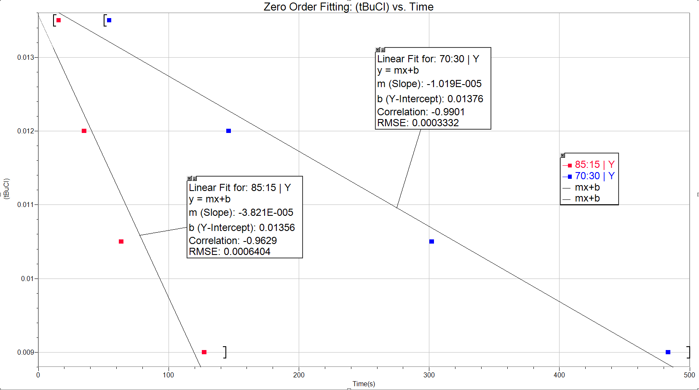
R² (blue) = 0.9901
R² (red) = 0.9629
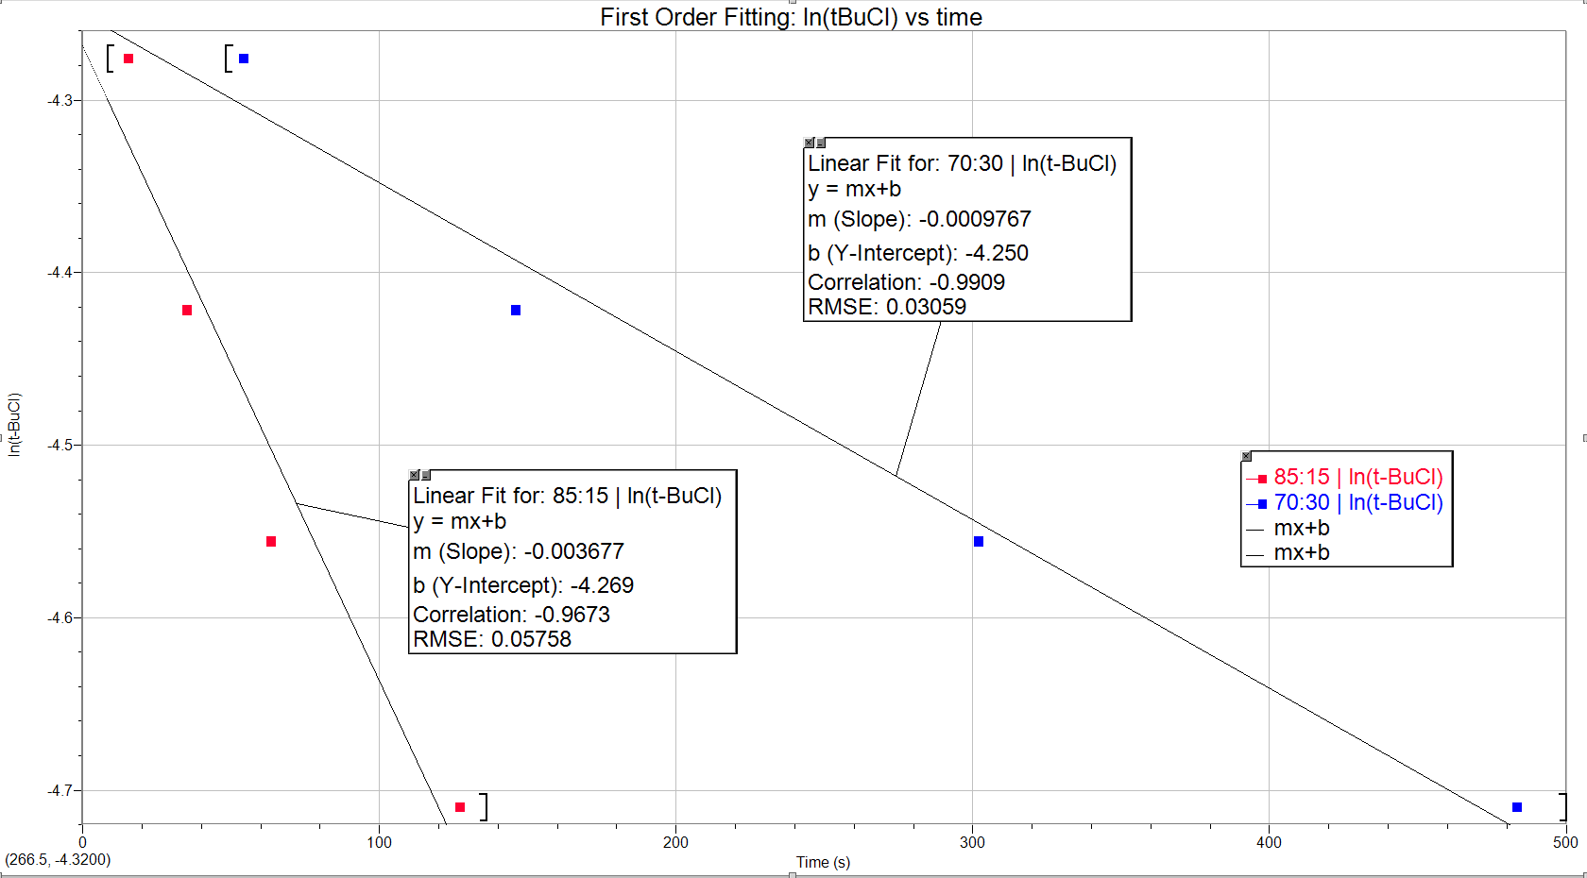
R²(blue) = 0.9909
R² (red) = 0.9673

Questions
- From Most reactive to least: CH₃CH₂Br > CH₃CH(Br)CH₃ > H₂C=CHBr > H₂C=CHCH(Br)CH₃
- Amongst the following pairs, predict which one would be the best nucleophile in a solution of ethanol
  - CH₃CH₂OH vs. CH₃CH₂ONa – CH₃CH₂ONa is the better nucleophile because ethanol is a polar protic solvent which means the lower you go in the periodic table the better the nucleophile. The ability of nucleophiles to form hydrogen bonds decreases as we go down therefore the lone pairs of Na are more free to leave.
  - Br⁻ Vs. I⁻ - I⁻ is the better nucleophile in ethanol because it is lower in the periodic table than Br.
  - The second molecule is the better nucleophile because Fluorine is more electronegative than the carbon making it a worse nucleophile.
- CH₃CH₂CH₂CH₂I + NaCN CH₃CH₂CH₂CH₂CN + NaI

