Lecture 2 – Life expectancy
Life expectancy
- Wide variation over time
- Pre industrial Europe: 40 years
- Today: 83 (females), 78 (males)
- Economy changes from low to high per-capita income – corresponding transition from morality and high fertility to low mortality and low fertility
- Increase #births: lack of education, low funds (birth control)
- Changes in pattern of disease:
- Age of pestilence and famine:
  - high mortality rate = famine and infectious disease
**Pestilence: a fatal epidemic disease
- Age and receding pandemics:
  - decrease in epidemics and famine and a consequent decline in mortality rate. Fertility rate high = population explosion
    - Ex: Ebola: warned against travel to infected countries, seminars to inform staff of hospital…
- Age of degenerative and “Man – Made” diseases:
  - fertility declines as people begin to live longer and to die of emerging industrial and degenerative diseases such as cancer…
- McKewon offers explanation that the decline in mortality rate is almost entirely due to decline in infectious disease:
  - Improvement in nutrition – about half of the increase
  - Hygiene – fewer water and food borne diseases (account for one sixth of improvement)
  - Increasing control od disease- causing micro-organism – immunization and medical therapy were together responsible for about one-tenth of life expectancy
  - Birth control – Effect of medical resources is small compared to socio-economic resources

Political economy perspective
- The Political Economy Perspective emphasizes that the place of workers in the global economy, in terms of occupational conditions such as employment, income, security, and safety, is the prime determinant of equality, living conditions, and, through both direct and indirect influences, health.
- Dependency Theory explains how the global economic order and the processes of globalization are prime determinants of global inequality.
- From the political economy perspective, there are three types of national economic actors
**Globalization: interaction of all driven by trade, information tech
- Core countries (Canada):
  - Diversified economies, strong and stable governance structures, and large middle classes
  - Civic liberties supported – little class conflict
  - Exploit countries in the periphery and semi-periphery by extracting raw materials, employing them as inexpensive labour, and using them as consumers at the end of the process.
- Periphery countries (Cambodia):
  - Considerably less-developed or diversified economies and limited infrastructure and technology
  - Economies are often based on subsistence agriculture and a few simple products such as tea, fruits, coffee, metals, or lumber
  - Weak state organization
  - May need foreign capital and may make agreements with international corporations to give these firms special access to raw materials, a compliant labour force, and product marketing—corporate investment has not helped in the long-run
**infrastructure: basic physical and organizational structure that will allow it to function
- Semi- periphery countries (Mexico):
  - Fall between core and periphery countries
  - Less likely to develop because the corporations have substantial levels of power and control in the context of global capitalism
Death, disease and disability in global context
- Socio-economic, political and cultural factors affect he Most major causes of death around the world today are preventable and could be eliminated with relatively minor and inexpensive interventions such as:
- The eradication of:
  - poverty
  - violence
  - war
- Improved access to:
  - safe nutritious food
  - clean drinking water
  - birth control
  - health care and immunization
  - health and longevity around the globe
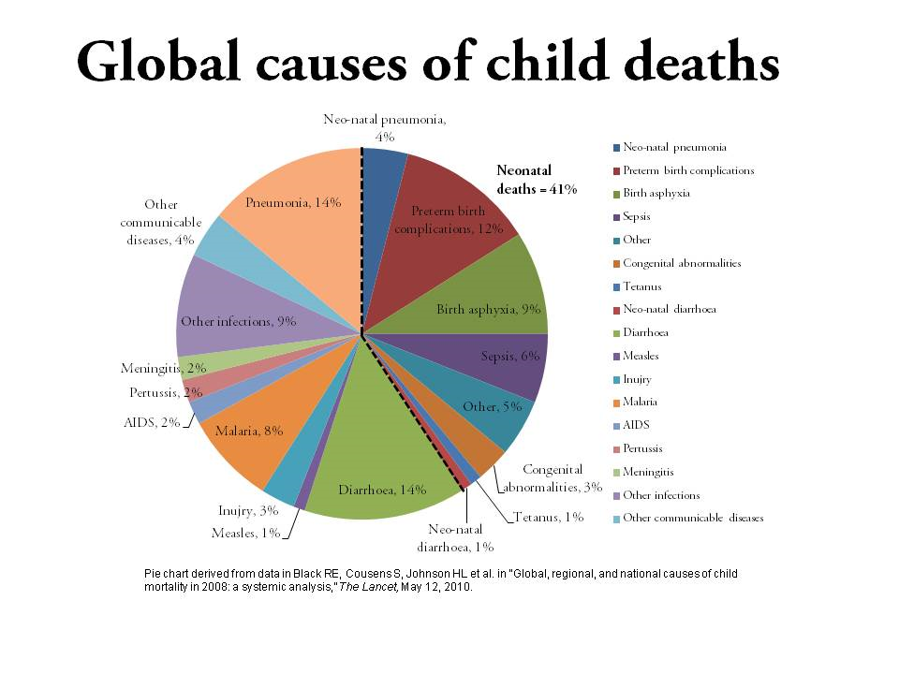
- Poverty and inequality
  - Income level = context for all other elements of life (work, education, food)
  - Wennemo
    - Relative income inequality within a country seemed more important than overall level of economic dev in the country with respect to infant mortality rate
    - Level of unemployment, family and social security = benefits related to infant mortality rates
- Food security
  - Food security refers to a situation, either chronic or acute, in which people do not have access to enough safe, nutritious, and culturally acceptable food.
  - Improvements in nutrition, particularly in the quantity and quality of the protein component, have a much larger impact on morbidity and mortality than any other public health or medical measure.
  - Education important factor
- Physical and social environment
  - The availability of a sufficient amount of clean drinking water is a crucial factor in health.
  - More than one-sixth of the world’s population lacks access to safe drinking water.
  - Numerous fatal and debilitating chronic illnesses are spread by unsanitary water.
    - Cholera: infection intestine
    - Dysentery: inflammation of intestine causing blood
      - Bactrial, viruses, parasites
- Safety, Security and stability
  - As local and international inequities grow, so, too, do violence and war—consequently, death, disability and disease can be expected to increase
- Position of women
  - The position of women in a society has a significant impact on the health of the people.
  - When women are educated and have a relatively higher household income they tend to be more informed about the nutritional needs of their children and more able to ensure that they are met.
- Birth control, pregnancy and childbirth
  - (1) When pregnancy is unwanted, women may seek illegal abortions, which are extremely dangerous
  - (2) As a result of malnutrition, women’s bodies may be undernourished, resulting in difficulties
  - (3) Pregnancy takes a toll on the body due to nutrients needed for the baby as well as the mother
  - (4) Rest is important, and most women in developing nations do not have the leisure to take the necessary rest
  - (5) Childbirth itself is responsible for a much higher rate of maternal mortality in the developing nations than in the developed nations
- Comprehensive healthcare
  - Health care can be divided into three types: primary, secondary, and tertiary.
    - Primary: family doctor
    - Secondary: specialist
    - Tertiary: specialist and co-specialist involved in hospitals etc.
    - Quartrinary: advanced diagnosis
  - Immunization important yet controversial
    - Decrease in immnunizations – potential link to autism
- Serious infectious and bacterial diseases have all but disappeared in the developed world.
- Three of the most significant health problems around the globe are HIV/AIDS, mental disorders, and wars and natural disorders.
- HIV/AIDS is one of the most devastating diseases worldwide—globalization has had a significant impact on the spread of the disease around the world.
Death, disease and disability in Canadian society
- In Canada, the infant mortality rate has dropped significantly as a result of better nutrition and living standards for the mother and baby, as well as improved prenatal and postnatal medical care.
- Today, cancer, heart disease, and stroke are the leading causes of death.
- Heart disease, stroke, cancer, and accidents are called the diseases of civilization, affluence, or ‘man’ (i.e., the ‘Age of Degenerative and “Man-Made” Diseases’).
- Causes of disease in developed countries (e.g., lifestyle, environmental) are different from those of the diseases of developing nations (e.g., food security, lack of clean water, birth control).
- Physical Activity
  - 49 % of Canadians are moderately physically active
  - Rates highest among younger Canadians
- Weight
  - 24% of Canadians are overweight
  - 44% over the age of 55 are overweight
  - Males more overweight than females
  - Leads to numerous health problems
    - Cardiovascular disease
    - Diabetes
    - Some cancers
  - Eating disorders

