SOC MIDTERM NOTES
Unit 1 – What is sociology?
Study of society
Interactions with others
Abstraction
Can’t see it but we know that it is real
The impact it has on us

Observation #1
Humans are social animals
Compelled to be together
Joy of being with others
Predictor of happiness – Do I belong?

Observation #2
A person and people are fundamentally different things
- Emergent property (thing that emerges when you put 2+ together)
- Family = Emergent
- Personality, language is an emergent property/social knowledge + culture
- Behaviors, body language, economy, rules, expectations, laws
Self organize, negotiate
Division of labour (People who make our food)
Sociology’s subjecy matter – Relationship between individuals and society
Individuals construct a society

No specific readings – introduction to sociology

Unit 2 – Studying society

Questions at the heart of sociology
- Why are things the way that they are (and not some other way)
- We are a big world
- We ask ourselves why everyday
- Looking at things differently
- Example with the car (how it works)
- Social circumstances
- Why do we need a job? Human history has changed
- What is behind this

- Thinking about society 2. How to approach and study society

What is society?
- An abstract thing
- Concrete abstraction
- Even though we cannot see it its still there, all the time
- We are the authors
- Social animals
- Happiness takes over
- Deepest origins of happiness come from happiness
- Emergent properties * important
- Social world is becoming more and more complex

Idea #1 – Societies are the product of human interactions
- Human creations
- The way that things are today doesn’t mean that they have to be like that in the future
- Real influence 1960’s
- Desire of social change
- Social norms = Expectation of a certain behavior example of clothing
- In our country, clothing is mandatory, some places it is not
- Comfortable

The first idea is that we get there through agreement
EX: A club, a study group, company
- We can get there through conflict
- The law is powerful, laws that surround property
- Expressly look at who is holding power
- Why do we agree to follow rules that disadvantage us?
«We are always participating in something larger than ourselves.» - Allan Johnson p. 13

Idea #2 – While people create societies, are autonomous from any single person
- Self-perpetuating – To reproduce/follow on
- Self-enforce – Make sure everybody does the same thing
- Acceptance of a core structure gets transmitted through time
- 30 years ago – roles are the same – 40,50,60 years ago
- Role set by institutions
- Self enforcing
- Human nature
- Butting in line at the bookstore, not against law, why don’t we do it anyways
- When people break social norms – People get mad – Don’t do much
- Complain, grumble, draw attention of others, and feel uncomfortable because we care about what others think.
- When we violate we get negative attention
- Culture shock
- Experiment 1960’s – asking students to break social norms (elevator experiment)
- Staring people in the eyes

Idea #3 – There is no “natural” or “right” configuration of society
- Comfortable in our way of doing things
- Navigators of our own culture
- Example of family (happy, nuclear family)
- Families have been overwhelmingly different
- Organize the “family”
- Social organization
- Nuclear family has emerged because of various reasons ex; Economic change
- Family begins to shrink, re organize
- Dwelling space has grown
- Debate on growing families or minimizing families
Sociology – A more precise definition
- Study of how individuals create, reinforce, and challenge society and its composing elements, how society in turn affects individuals and groups

How to study a society
- Seeing the strange in the familiar
- See what we know so well
- We try to step back and mentally pretend we’re not part of it
- Why do we do the things that we do
- Mental exercise (When we do that, we realize strange things)
- Investigating the social world

Example – Going to school
- 15-20 years of their life – why?
- Stuff people want you to learn
- Contributing to society
- Shown to sumbit to authority
- Sounds like a work place
- Train kids how the world works
- Where to be an individual
- Learn how to be something
- Debate of homeschooling
- Encounter state/government through rituals + curriculum
- Remembrance day, Canada day etc.
- What is important
- Free’s parents to work
- Social interaction/ socialization component
- Creates a ranking system (GPA, Grades, ABCD)
- The categories we fit in
- Study society but also members of it
- Step back from our own experience and learn through fresh eyes
- Traveling internationally
- Open spaces for the possibility of “why”
- Economy has risen around education

Macrosociology (BIG)
- Looking at “big” social forces and institutions
- Politics
- Religion
- Economy
- Taking a look at the origin
- They tend to give us a path
- Having sex in the 1950’s you were shunned
- Pregnant teens – Expected to leave home; Even if its not against the law does not mean that they are less of a compulsion
- What is its function?
- Macrosociologists do their research at this scale
- Elevators; people don’t interact
- Not engaging, where you’re not meant to
- Rules
- Script
- How we speak, how we behave
- Patterns of expected behavior or speech

Creating patterns and script
- The idea of how its supposed to be
- Queues
- Stepping left, stepping right when encountering people

Microsociology
- Looking at everyday live experiences
- Why people behave in patterned ways
- Expectations, “norms” and scripts
- Relationships within groups

Existence of scripts: universal
Content of scripts: Always changing – different; culture shock

Norms: influence people, feeling uncomfortable, not being in tune
-Looking at the big and the small
Line up for the movie theater; no communication in line
Line ups in India;
- More active, desperate, touching shoulders
- Cutting in line
- Comfort zone
- Men and women who don’t line up together
- Women don’t want to get groped

Human responses to cultural disasters

The sociological imagination
C Wrigt Mills 1916-1962 (American)
- Seeing the strange in the familiar
- Linking personal experiences to broad social patterns and forces; Youth employment rate, personal problem? OR routed in the way that systems work

Student and youth un-employment
-Why are things the way that they are?
- Not good enough

Lectures on this Unit 2
- Monopoly as a social system
- Microsociology - Small, focuses on peoples everyday experiences and behaviors
- Group dynamics: Family dynamics, identity
- Norms: Shared expectations of behavior, maintaining social order. Norm in a locker room act differently then norms at the dinner table.
- Norms for students: Sitting quiet, raising your hand = strong norms
- When they are broken we notice it right away
- Sensitive to context
- Eye contact - When it is not, when it is
- Macrosociology – Big things in the social world
- Organizations, institutions, social forces, major subject in macrosociology = poverty and inequality
- Macro’s are interested in the deep structure of the world
- Education system
- School used to be a luxury
- Sociology as a discipline
- Different areas or disciplines (ex: physics, chemistry)
- Sociology – scientific approach to the world
- Methods: Observation, controlled experiments, interviews, discourse analysis, focus groups, surveys
- Empirical approach
- Qualitative methods: meaning interpretations, culture
- Quantative methods: Behaviors, values, attitudes

Unit 3 Socialization

Socialization: Life long process, how we learn to become functioning members of society
- How we learn to reconcile our individuality with expectations of other people
- Key point of interaction between individuals and society
- Shows how we reproduce society – key norms
- Societal expectations both guide and constrain us throughout our lives

We are all individuals but we are also members
- Members of different groups, networks, families, teams etc.
- Socialization: Process through which people reconcile their individuality with society
- Learn how to do things

- Primary socialization: Early in life, boundaries of immediate family
- Secondary socialization: Occurs throughout life course

Primary socialization
- Establishing a persons identity
- We learn about what we are
- Occurs within family
- First steps
- Learn from our surrounding
- Seeing violence then doing it
- Appropriate vs not appropriate
- Some people value their culture later on and some don’t

Secondary socialization – learning and relearning social expectations and rituals
- Complex process
- Refinement
- Tim’s vs McDonalds lineups
- New situation – this is why there’s frosh week
- Continuous
- Example of line ups and how we respect them, such as university (first year)
- Encountering new situations and adjusting to them

Socialization helps us “get along” and allows us to understand one another and coordinate our actions - without socialization, there is no society
- Culture shock, hard for new immigrants
- Following “scripts” not even realizing how we behave because we’re used to it and just go with it.

Notes on lecture for Unit 3 – in class

Socialization – Nathan Young
- The processes through which we learn to become members of society (simple definition)
- We learn to become who we are in a context
- Sexual interactions and learning impulsion
- How to treat others
- How to fit In and how to belong
- How we learn to become a member

Key debate in social sciences
- Nature vs. nurture
- We are who we are, because of the way our brains are structured
- We are learners and we learn
- Those who tend to commit crimes, chances are stronger that they came from a family with a poor impulse control or a lifestyle you learnt from
- Nature vs nurture;
- Who is smarter
- People who marry within groups

Understanding human behavior
- Looking for laws (in all the wrong places)
- We don’t look for laws we look at patterns, forces and trends
- Sociology tends to fall on the nurture side
- We tend to believe that we are who we are because that’s how we learnt to act
- We have a lot of knowledge (raw material of a personality)

A more specific sociological definition
- The process through which we learn to reconcile our individuality with the demands and expectation as well as forces entered by and within a society

The exceptional nature of the human infant
- Example of the baby, infant and the horse, fish
- We cant do anything / animals can when born
- Why is this
- Animal babies have a lot more instinct, pre-programmed
- Human beings go much further in intellectual
- All about software, can be reprogrammed, hardware (less)
- We learn who we are by interacting with other people

Primary socialization
- We are learners
- We do this through family (1st) mostly occurs through immediate family
- Learning conversation
- Example at the grocery store
- Seeing beyond the self
- There are motifs that go beyond you
- Recognitions of abstractions – Family members, relatives and friends

Key insight
- The basic building blocks of personal identity are provided by others
- Females and university … Social norms – What are our roles

Females dominance vs male dominance – Gender rand gender socialization
Intentional socialization vs unintentional socialization
Looking at parents, knowing whether you’re a boy or a girl, what it means to be a girl and what it means to be a boy

The “Pink-Blue” issue
- 1970s-1980s – The movies (Disney) – They are all wearing blue dresses
- Blue was the color of virgin marry
- Purple = Boy color in the roman times
- Labels are very flexible
- Sleeping beauty then and now (pink and blue reversed)
- Aurora ; In blue, prince in pink ; Now; Aurora in pink and prince red and blue
- 19th century almost the same outfits
- Gendering through clothing + color schemes = Later on in life
- Consuming
- Now – Ultrasounds that reveal the gender
- Parents now prepare for the baby and chose clothing
- 1970’s gender neutral thing
- Pink and blue – Telling the boys from the girls in American book

At issue SEX vs GENDER
SEX: Your equipment (Biological elements)
GENDER: “What we learn” How we represent ourselves, gender rules
- Having long hair, no actual connection between sex and hair
- Having piercings
- Clothing (dress code)
- Manors
- Wearing jewelry
- Drinking
- Public presentation
- Sex shaming boys vs guys
- Expression
- Communication by adults on child objects/clothing
- Credibility and expectations
- Reputation for a woman and reputation for a man (Sports, gymnastics and dance)
- Movies – Women roles – How much they speak about men
- Gender socialization; On the mid term and in final exam

How gender socialization happens
- Direct messaging; you are a girl/boy and this is what it means to be that
- Observed roles; how do females and men interact
- Reward and sanction – What is rewarded and sanctioned
- Peer reinforcement (old age home and peer groups)

Secondary socialization
- Process, procedure that goes on
- Beyond family (lifelong)
- 1. Institutions (School, religion, media, workplace)
- 2. Peer groups, politics
- Peer groups: They have more influences on some kids (8 or 9) than their own parents (2nd part of unit)

The impact of institutions
- The reinforcement principle
- Rules and turn taking (share)
- Listening to authority
- Schools
- Gender socialization
- How to act
- Parenting vs teaching
- Values

- Wealthy kids in school vs unwealthy kids in school
“The greater the disjuncture between behavior reinforced at school and at home, the smaller the likehood that the student will see success at school as relevant” – Susan Wilson

Another institution – What role does the media play in socialization
- Consumerism, advertisement
- The bodily ideal
- Female role (Ex: clueless, the movie)
- Girl shows vs boy shows

What roles does media play in socialization
- Kids and video games
- Children who come from violent homes; Violence is an option because it was in their primary socialization
Does the media make kids more violent? An on going debate; Violence is popular (Example of things we see online)

The “Social reality” principle
The bystander effect ; psychology
“The world is a violent place”
But media could be suggesting this type of idea
Super sensitization
The way people consume their media
Fear and anxiety comes out of media

Secondary socialization – influence of peers
- A sense of belonging
- Being accepted
- High school – groups
- How people walk, looking at the small things
- Situational norms via examples, cues and feedback
- Hugely influencual in transition from child vs adult
- Group formation (Exercises in inclusion and exclusion)
Group identity markers: example; picture of goths and gangstersCharles Horton Cooley (American, 1864-1929)

“The looking glass self” (1902)
The way we think of ourselves, makes our opinion/understanding
Sociology high school notes

George Herbert Mead (American 1861, 1931)

Significant others – generalized other

Lectures for Unit 3 – Socialization in brief
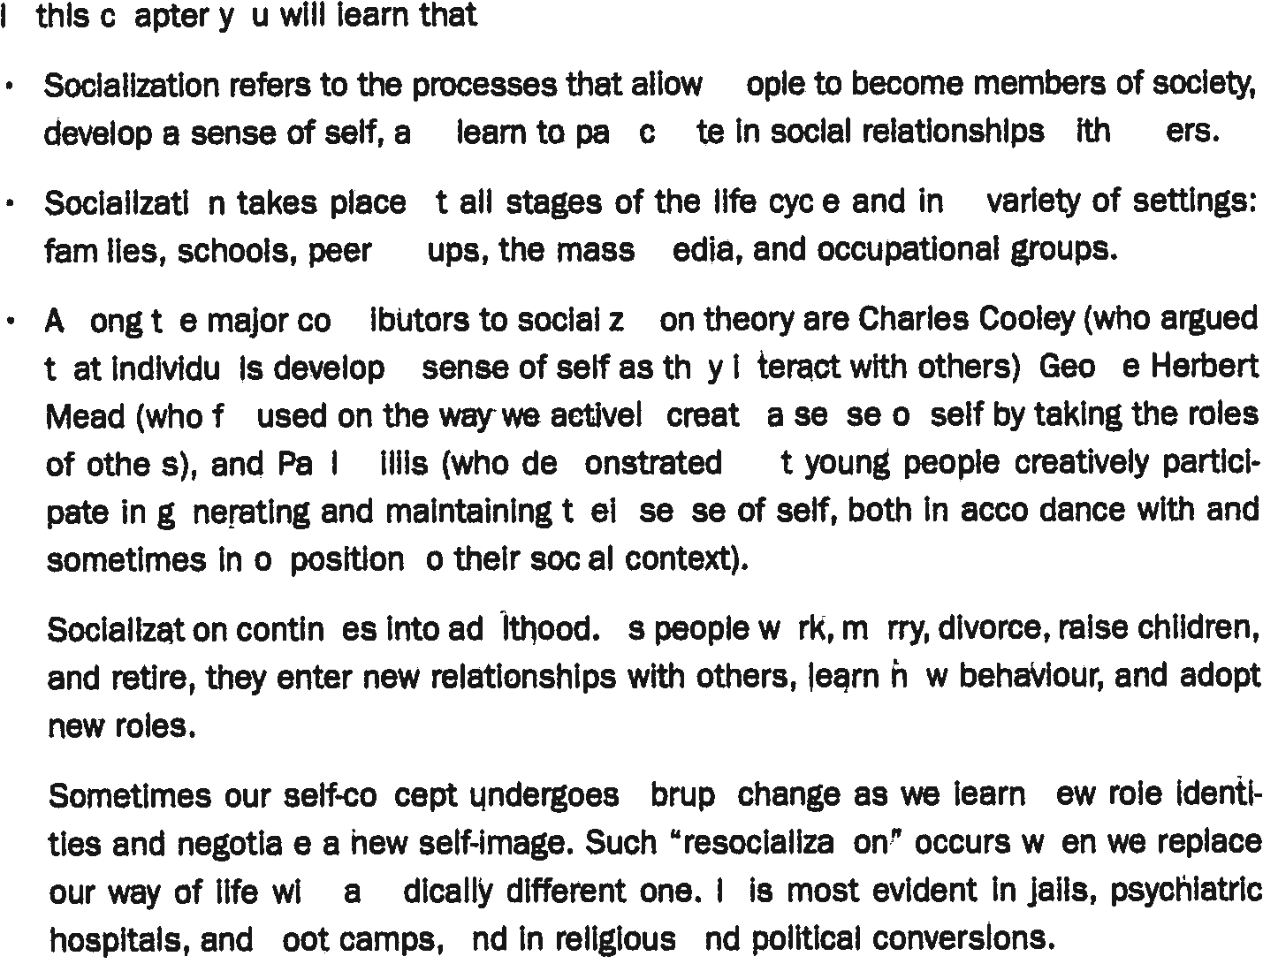

- Self; sense of individual identity that allows us to understand ourselves and differentiate ourselves from others
- To have a self we must interact with others
- Primary group; family provided by intimate face to face association and cooperation
- Taking role of other (Mead); essential skill children grow up with, Taking the role of other conformity and individuality, our true selves, creating our self
- Game stage (Mead); Children have developed a generalized impression of the behavior people expect as well as awareness of their own importance to the group and vice-versa.
- Generalized other: conception of how people in general – not specific- will respond in a situation
- I ; Subjective or active part of our self, Allows us to react and assess ourselves,
- Me: aware of ourselves and social objects, imagine ourselves in others perspective first
- Anticipatory socialization: “The process by which aspirants to a particular social role begin to discern what it will be like to function in that position.”
- Adult socialization: process by which Adults take on new statuses and acquire new and different social identities.
- Agents of socialization; individual, groups and institutions that impart and from which we acquire, the range of information required to interact effectively and participate in society.
- Peer group: influences people who are usually of the same age and enjoy same things
- Resocialization: a significant change in how we live, in the kinds of people with whom we interact or in the ways we understand others or ourselves often requires a process of resocialization.
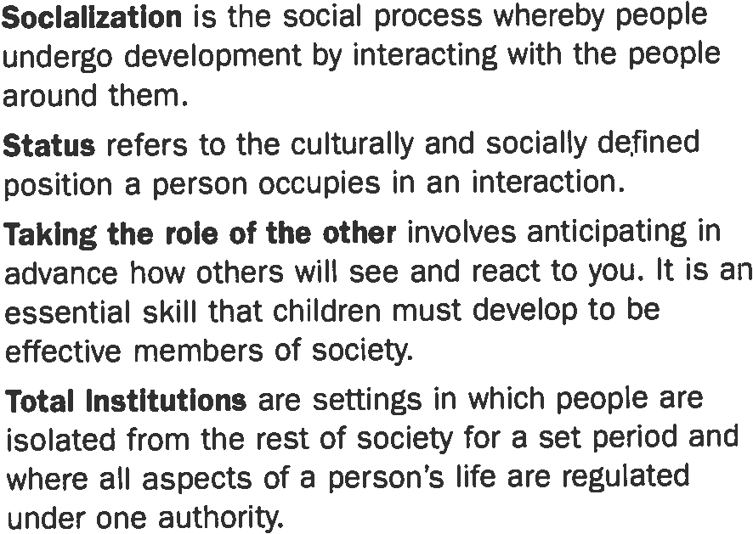

Next page talks about lecture 2 – Kindergarden and boot camp

Unit 4 The sociology of everyday life : Status, role, identity

- Why the social world is structured the way it is
- How we navigate it…
- Looking at roles
- Roles
But first… Sociology in history…
- Where does social cohesion come from
- Come together to do things
- Sense of being together
Emile Durkheim (1858-1917)
- Mechanical solidarity – Sense of togetherness
- Organic solidarity
- Very few roles
- “If you go back in time, people were more typically formed in small groups”
- Members of that group, knew everyone else, knows what to do, a lot in common ( 1 way of being cohesive)
- Today is very different
- What is it that keeps us together
Organic solidarity
- The fact that we’re different what keeps us together
- The fact that what you do really matters to me
- Rather than being together because we need each other.
- Organic metaphor: We are like the human body

Three paradigms within society

- What is a paradigm (EXAM) : A general way of looking at things, it is not a theory. Mather idea’s, its our perspective we pull out of ideas.
EX: Why do people go to war (harms way) … Psychological field, social influence, etc. (Those are theories)

Paradigms usually follow each other and they are multiple ways that we understand behavior

Three paradigms within society

- Structural functionalism (functionalism)
- What is the structure and the use of what I am looking at
- This kind of knowledge is what we used when talking about school and learning
- Examination of a structure
- Ex: religion, institutions, leaders, what are the functions? Provides them with a spiritual well being, provides them with a moral code, provides them with a purpose that validates their existence
- Roles is a thing that connects us
- Symbolic interactionism (interactionism)
- Ex; religion takes shape of the participants
- Interactions are the primary thing
- Context dependent – depends on interaction
- Observation that the way we interact is through symbols / each other
- Body image; communication to another person
- Conflict theory
- Occasionally very different interests
- Competing to get what we need
- What I want might conflict what you want
- How conflict is channeled and how gets resolved – conflict theory
- We’re in constant conflict
- Emphasis on how does this play out
- Roles tend to go in pairs
- Roles of teacher and student – embody a lot of conflict

- Sociological figure from the past
- Paradigms are made to go side by side
- Arguments intense
- Blending them is okay and encouraged

A “structural functional” view of roles…

- Society is made up of roles that individuals assume (doctor, burraucat, janitor, etc.)
- Role – What I want to be in the future
- Role – The role that we intend to fill
- Roles – Some roles are important then the individual
- These roles form a “frame work” that allows society to function
- Example of the doctor and the patient
- The roles that matter
- Go back to the structuring of the role
- A functionalist idea – the “role set”
- Roles only make sense in relation to one another (they are structured in sets)
- Roles contain internal hierarchies
- Role sets are critical
Ex: Education system – ROLE SET
Admin
Principal
Vice principal
Teacher
Student Parent
* Constant interaction, fit together, creates stability
- Acting outside of a role is very difficult
- Who we are, our classification
- Different role environments

How powerful roles are vs our behavior
Powerful stimulant
It is critical to understand we are occupying roles (functionalist)

The power of roles in influencing human behavior
- The Zimbardo experiment
- He recruited students (75)
- Livefor two weeks in the bsiment of Stanford psychology building
- Assigned people “guard” roles (not all)
- Gave them sticks
- Made others as prisonners
- Guards keep prisonners from unbehaving
- Got to 6 days (expirement got cancelled)
- Wife went to do interviews made him stop
- Day 2 Guards were getting into their roles
- Restrict the prisonners
- Day 3 – Observable changes in the prisonners
- Some plotted revenge
- Behave as prisonners, panic attacks
- Made prisonners wear aper bags
- Day 5-6 they let out because he could not manage
- They had no rules
- Roles dominate rules

- What we take from this
- Strong cohesion
- People adapt
- Roles are powerfull
- Zimbardo was apologetic
- He did not really see how bad it was
- He got into his role too

Roles a recap so far
3 paradigms in sociology

Functionalism; roles are framework of society, more important than the individuals who occupy them

Functionalism: Social world organized into “role sets”

The power of roles

The power of roles in influencing human behavior
The Milgram Experiment
Shocking someone – teacher + student
Random people are chosen; the teacher is random, student actor, experimenter actor
Said; “you have to continue”

Sociological point of view: What makes authority (Prison experiment)
Why do they play along?
-We go through events/roles that we don’t have much power in
-Who’s going to be responsible for this (Milgram experiment)
-The way we conform to roles in predetermined ways is incredible
Assumptions of the structural functionalist paradigm
1. If it exists, it likely has a function
Ex: school, religion
Organic metaphor: example of the human body

2 Social structure is (more or less) built on consensus
People agree, materialistically put at strongest advance, we still play along
Even students who fail, every one agrees
School is an acceptable thing
Accepting authority – based on consenses
Almost all structures can be competition
People who are set up to fail

Paradigm: perspective (popping the hood lock on the car)

Strengths: Very good for explaining stability, purpose, meets a need
Weaknesses: Not good at explaining change (How are things created) ex: dramatic changes, not good at explaining individuality (agency)

Tend to look at the structure rather then the individual
Devalues individuality
A symbolic interactionist view of roles
- Roles emerge out of interactions ; if not predetermined
- Example of roles; parent, siblings, friend, doctor, teacher etc.
- It is the actual role/actions/performance that really matter

Concept: We actually try to protect others performances…

- Roles are negotiated everyday using “symbols” (language material)
- Sometimes we have qualities that help us perform
- Ex: hating your job, but playing the part
- Ex: the waitress; functionalist – waitress brings food
- But in interactionism symbolism – Performance; happy, small talk, perky

- Think about how this applies to all of our actions
- Roles can be coordination
- When a waitress goes in the back, role change
- We are acting, but we are the audience at the same time

Functionalism: Roles are the product of social structure (a social need) and we comform to them
Interactionism: Roles are the product of social performances that individuals use to “locate” themselves relative to others and pursue social goals
- Play roles to accomplish things
- Achieving a social goal
- Waitress: highly stricted role
- Role playing: role predetermined
- What happends when they are backstage
- Complaining about others (It’s a role)
- Understanding the contrast of these two for the midterm
Key concepts in terms of interactionism
Erving Goffman: 1922-1982 Canadian
“The presentation of self in everyday life (1959)
- The way we take on roles are very associated with the meanings
- Presentation: complex, critical concept of the social world

- A dramaturgical view of roles: Articulation of expected script we are like actors on a stage, everyone is acting and being an audience as well.
- Impression management: A thing we engage in constantly we are aware on how we look in the eyes of people with whom we are speaking “failed interaction” if we do not succeed. Ex: clothing, appearance, “norms” that we follow apart of some kinds of scripts
- Symbols and accounts: Ways in which we explain ourselves to others. Ex: waitress, asking for a new meal = explaining self also manages the impression that we’re not trying to be hateful. Explanation we give our actions.

Codes – example of guy with glasses (exercise)
- Age and maturity and code
- Managing these things slightly
- Combination of codes that we put a label on
- Meaning of codes; threatening

- Mutual protection: Our performance is validated. When we lie? Smooth it over, will protect you in order to protect me, people are learners

Status-interaction that is under way

Goffman and Mead
- Presentation to self to “significant others”: People we already assigned a type of signification
- Presentation to self to “generalized other”: People we haven’t encountered yet. Has yet to make an impression on us, prepare a presentation, walking through campus,we are giving off impressions
- People who know us may see that we are trying to project an impression to some (example of Young mister duphus)
- Project to assume a new role – Conflict
- This goes well over a functionnalist’s perspective

Role conflict - 3rd pigmund
Conflict theory view of roles

Karl Marx (1818-1883) Analyse the way social interractions work “Hierarchy”
- Roles reflect power (especially economic power)
- Functionalis could say this too but it’s a different way
- Impalance empower, dominant roles that comme with economic power

Roles reinforce power structures and are vehicles of social control
- Pyramid of capitalist system photo
- Who has power, what do social structures look like
- Why protected by law
- Power

Mutual aversion (alienation) Undercover boss example, mutual aversion of these roles

Unequal interactions between classes
- Dominant, submissive

Unit 4 readings

Understanding interaction

- Role taking: seeing things through other peoples eyes in order to adjust ourselves to the situation; we engage in communication
- Failed communication: Possibility that our attempts at role taking will lead us to formulate a definition of the situation that varies from the definition held by the other person
- In class experiences and conflicting values and thoughts
- Gathering info about others: Taking a look at social attributes is the 1st thing
- Social attributes: informational significance because they help define the identities of self and others
- Social status: mother, teacher, doctor etc.
- Ascribed status: acquired at birth (gender, race)
- Achieved statuses: occupational statuses, educational
- Master attributes: Central attribute, highly visible, unalterable attributes such as race, gender and age, powerful
- Sexual identification: A story of a transgender …
- Configuration of attributes: We formulate a conception of people based on this
- Young vs old
- Racial distinctions, Physical attributes
- Judging people by the cover and letting them go for those reasons
- Physical attraction plays a big part in social interaction
- We respond to mirrors as if they represent an unseen audience
- Moral characteristics and assessing physically
- Obesity vs society; image of “perfect”
- Accounts: excuses or justification given by people when social interaction is disturbed by rule violations
- Men were taught to express anger, women its sadness
- Too much focus on physical appearance lose their true selves (identity)
- Judging clothes and race
- What men and women wear at work and what it says about them as an individual
- Info provided by discourse : Learning about others by asking questions
- Expression given; verbal symbols or their substitutes which one uses admittedly to convey info
- Expression given off; non verbal, presumably unintentional conveyance of information
- Controlling info and managing impressions
- Impression management; trying to project certain identities of ourselves, building our own attributes
- Dramaturgical view: The idea individuals systematically control the info they provide others about themselves in order to manage the impressions they are presenting, approval seeking animals
- Role makers: seen through dramaturgical views
- Goffman; human beings act on a stage, perform for others, impress and are impressed, both actors and audiences
- Drama view; Presentation of self in a calculated and often contrived way
- Multiple identities
- Mutual protection
- Conformity; behaviors conform to societal expectations
- Cynicism and sincerity in Role Taking; False info about identity, deceiving others with false info
- Performers who believe their own performances

Us, it and social interaction
- We are in social systems and they are in us
- Relation to cultural, structural and ecological aspects
- The self is more important than all
- Having a name to participate in social life
- George Meads theory; a childs perspective learnt
- Not understanding the concept of having a point of view
- Not understanding the self and the needs until identifying ourselves with the help of others and how they feel
- Becoming aware of a point of view
- Self exists only in relation to other selves
- How we chose to feel/change or react to ourselves
- Self vs culture
- Social identity
- Occupy a role in a typical well known role
- We have complete control of our own social identities and occupations
- Significant and specific – Is a specific thought or an idea contributed by someone as an individual
- We depend on info that comes from outside ourself
- The looking glass self; generalized other
- Oppression in society based on race, gender, disability
- Self depends a lot on society’s perception of us
- Behaiour: involves no interpretations
- Action: uses language to anticipate what her behavior would mean to someone else
- We wait for responses and constantly question what impression we have on others
- In Social life; we are all actors and part of somebody’s audience
- Out of character = performance into question
- We are objects of culture
- The importance of culture and how we add to and create the base of culture and cultural behaviours
- Appearance and action mirror themselves
- Assuring people
- Not actually listening and being oblivious while one talks
- Ritual; fabric that holds together a social aspect – Johnson
- Tannens theory; playing in same same sex groups but where do they come from – boy / girl
- Inequality; Systems that damage and limit a persons life
- Interplay; gives significance to everything we do and the choices that shape how we do it.

Unit 5 - Deviance and «Normality»

- What is deviance?
What is the common answer to this question…
- Class answers
- Someone who defies the law, defying a social norm or an expectation, statistical deviance, we tend to define it to an unusual label

- Young’s notes
-An activity or way of being that is unusual (?)
-Expression of statistics
-Statistical norm, being on the positive side or the negative side
-An activity or way of being harmful (?)
-Violates a certain expectation
-It is not what this person does but what other people say about it
-Condemned as being not right
-Unusual or harmful even if it isnt

- A better definition…
-Social control
- “Ways of acting and ways of being that, within particular social contexts and in particular historical periods, elicit moral condemnation.” (Sacco, p.193)

In an exam question; how we explain deviance in a way that is different then the popular account (harmful and unusual)
Object into effort to control

- Sociological perspectives on deviance
- Not a moral term, but an analytical one: moral question we put it aside, what does this mean and not what the rules are
- Deviance as a double sided coin: Define another way of acting, another space, when you define something as deviant you are creating a claim of what is normal and not normal. When we talk about deviance we tend to talk about normality a lot. Making a claim not only about what is unusual or harmful and not about what it actually is. (MORAL CLAIMS, not sociological)
- Deviance can tell us a lot about change and how it happens: Things that used to be considered deviant are now classified as being normal

Ex: Tattoos, sexuality (homosexuality) but the transition still not over, women in the work force,
Ex of the contrary: smoking, drinking on the job (variation) car safety, drinking and driving,
Same sex marriage - poll

- Why do we seek to control the behaviour of others?
- Trying to reinforce our own vision of what is normal
- Always two sides to these kinds of claims
- Discomfort in other people’s choices

Paradox #1 ; Deviance is normal
- Morally condemnable acts
- It’s easy to lie
- Lying
- Swearing
- Easy to act in this way
- Drinking after a long weekend
- We are rule followers and rule breakers all the time

- Types of deviance
- Primary deviance; Every day deviance that we engage in all the time: lying, cheating, smoking, bad words, stealing, etc. Small acts of violation of the expectations in play. We are all primary deviance. Being in primary deviance so much that we transition into secondary deviance.
- Secondary deviance: Involves more frequent violations of very fundamental norms. The kind of deviance that will get into our reputations and our cores, the kind that will follow us through life. Doesn't always have to do with how we transgress but how others view us. Ex: If you steal something are you a thief as an identity; take a stapler, laundry soap etc. What is a thief? Regular basis, a habit, getting arrested and labeled in a specific way. Attached to you as a person/label. The kind of activities you engage in. Stigma contextually attached to a person who will potentially determine who they are as a person.

- Has more to do with the context rather than a stage of life

Paradox #2; Does deviance have a social function
-Example of hazing; initiation (sports team, clubs, hockey teams) not gender specific
-Hazing is an act that is pretty generally condemned (parents and universities hate the image it gives)
-Hazing can be important to the victims
-This group is powerful enough that we can cancel out other rules (hazing and why)
-Social function of prisons

- Why do people act in deviant ways?
- Why/how are some behaviors subject to social control?

Lecture for Unit 5 – Deviance
- Deviance: first response is to list types of people or types of behaviors they think deserve the label, these lists are incomplete, tell us nothing about why or how. People who fall short of certain expectations are viewed as deviant
- Social interaction: Deviance as a result of this
- Social groups and how we show disapproval
- Not everything could be labeled as deviant
- Humphreys experience: Observing by staying away, staying safe, cannot show what he is doing, people found out his experiment, he won the trial, mixing danger and research, about the victims, surveys must be very secretive or else we can get them hurt by abusers
- Deviant behavior
- Objective: behavior or condition itself,
- Subjective: Placement of that condition by members of society in their system of moral satisfaction
- Questions we ask about deviance…
1.The causes and forms of deviant behaviours
2.The content and character of moral definitions
3.The issues that arise over labels of deviance
- Why do they do it?
1.Implies that most of us share a conformist view of the world in which the important thing to understand is why some deviant minority refuses to to act the way “we” act.
2.The moral status of deviant behavior is never called into question. In a sense, the WHY comes into question, why did they do it, assumption
- Strain theory: Looking at society rather than personalities of individuals, answer could be found in cultural or social structures
- Strain theory states that social structures within society may pressure citizens to commit crime.
- Experiencing loss strain
- Cultural support theory; focuses on the way patterns of cultural beliefs create and sustain such conduct – Cohen
- Control theory: The logic strain and cultural support theories contrasts quite sharply with the logic of a third point of view. People refrain from deviant behaviors because diverse factors control their impulses to break “social norms”
- Situated transaction – See phone picture
- Gender: Correlates with wide range of behaviors, males vs females
- Age, class and ethnicity ex: poor people and violent crimes … First nations
- Poor: violent, drugs, alcohol but not embezzlement and fraud
- Social constructionism: it FLAWS this The deviant qualities of people and acts, we convince ourselves, reside within the people and acts themselves
- Claim makers: What are sources of distinctions that the members of society make between what is and what is not deviant? (ex) Claims making process
- See phone pictures for the steps…
- Claims: using compelling statistics, linking emergent concern to problems already on the public agenda, using emotionally compelling examples to typify the seriousness and character of the threat posed by the behavior
- Control theory; Conservative and radical
- Conservative; Social conflicts regarding the moral meaning of conduct emerge from diverse sources
- Power is seen as relatively diffuse and thus not concentrated in any one sector of the society
- Status groups: Study of moral differentiation is the study of how some groups in society are able to influence systems of social control as to allow them to compete more effectively in their struggle to achieve their goals
- Master status: Label of deviant overrides all other status considerations
- Status degradation ceremony: rituals during which the status of deviant is conferred

Unit 6 - Social Class and Social Structure
Study of social class is at its root
Difficult readings in these units

Why are some people rich and some people poor?
- Drive
- Born into a wealthy family
- Where you live
- Inevitable product in the way that we structure things in our own country/systems
Findings from 150 years of sociological research
1. Society is a “sorter” and a “categorizer”
Not just labels, categories that go with labels, they are a mad map to treat people differently)
2. Many of these categories are involuntary
We don’t get to choose them, they are not our choice (born in a specific time, place, family)
3. These categories are sticky
Fluid in a way, don’t change well, not in a easy way, they stick onto us. Example: vote in the House of Commons voted to child poverty by the year. From 1989-2005 child poverty rate that is unchanged. Before taxes 2005 17% and now 2015 is 19%. Grown by 3 times so 3 times as much money that is floating around. What this tells us about sticky ness is that the categories themselves are very sticky, children of 1989 are now grown ups, and yet something going on that puts them into the category of being poor, and it is still there. It is also sticky because of the way that they are now; they are extremely likely to be the parents of the poor kids now. Tendency and the pattern is that if you were born poor it will perpetuate. Life course and category.
Inequality Vs Structural inequalities
Inequality of Outcome, heat of understanding social class
It is the product of any kind of competitive system, they will have unequal outcomes, put people against each other, which is competitive. University – A, B, C, D students = Product of competition, tends to be acceptable, some people will do well, others will do poorly. Those with natural talents will rise to the top, others wont. Everyone essentially treated in the same way. Meritocracy; Accept the fact that some people will do better and some will do poorly. Outcome of a person’s merit. Graded scale. The idea we have; it was fair but I didn’t make it.
Structural inequalities
Idea that inequality built right out of the structure of how the system works. Not about merit or system but how university works. You have to pay to be at University, in order to get in the door of these big jobs. There are an awful lot of people who should be here but their not. They don’t get a chance to compete, excluded because of the way that the system works. Structural inequality; a lot of people should be here but their not. Think of those who are born privileged. Playing on the easy stage, chances are they will do ok. But born in different circumstances, a lot harder, hard stage. Poverty is the product of the way the broader system is structured.

Social Class
Popular meaning vs. sociological meaning
How we define it, and what sociological perspective we have
Sociological it has nothing to do with consumption
Social class; where you are located in the power majors, what is the relationship that you have in what is the means of productive (ability to generate a certain amount of wealth, anything to do with where you are located. Some people will have a relationship with the means of production (back in the day farming through ones ownerships)
Karl Marx (1818-1883)
Conflict theorist, that the social world is competitive and how those conflicts are resolved is a question of the social world. Everything has to do with the social class. Social class is at the core of what he has to say.
“The history of all hitherto existing society is the history of class struggles. Freeman and slave, patrician and plebian, noble and peasant…” –Marx
Dominant class has control over the economy, the means of production, how it is generated
Mutual dependency as well, can’t live without labor of dominant class
Max Weber (1864-1920)
Writes after Marx, a lot is in response to Marx, meaning culture and religion, class’s one thing among men,

