1

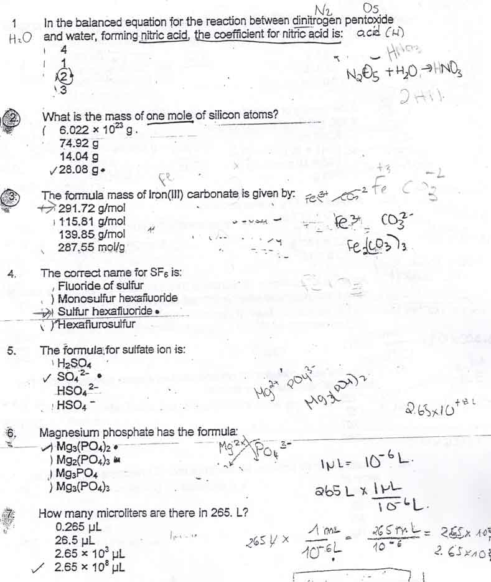
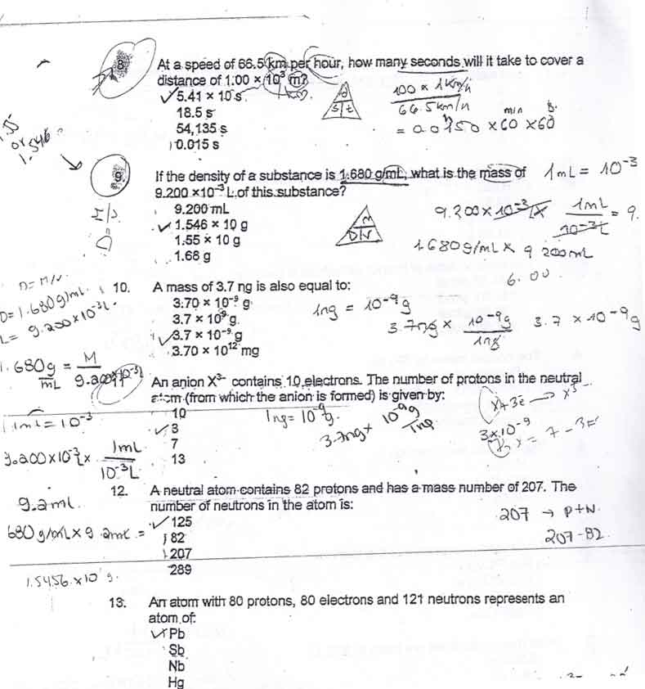

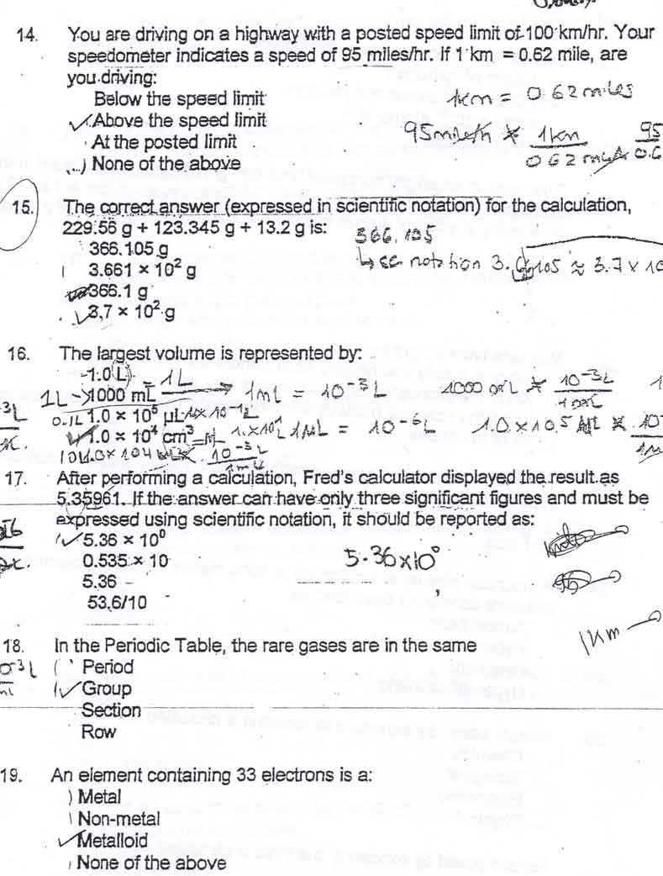

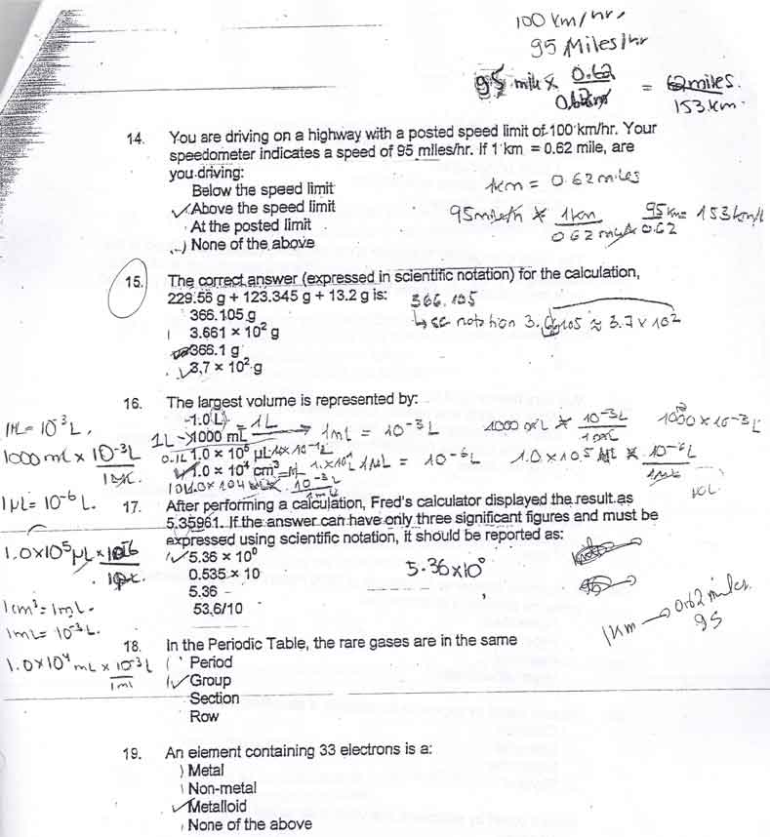

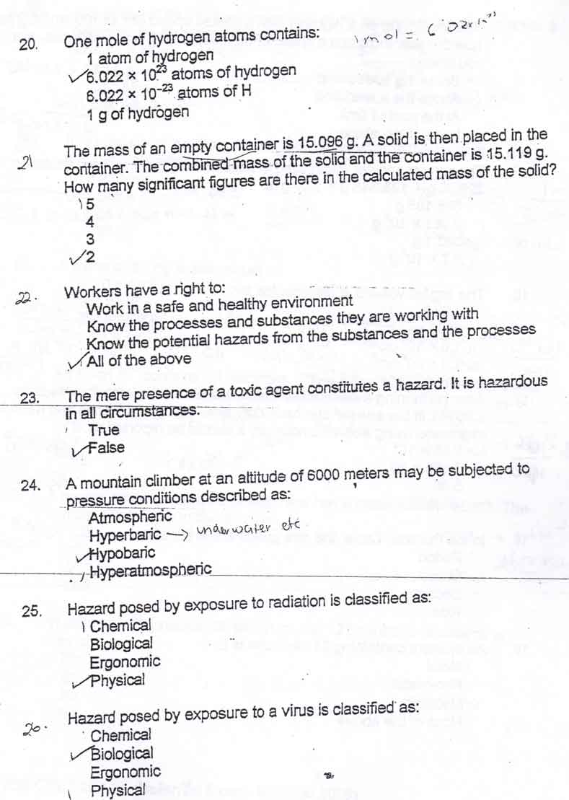
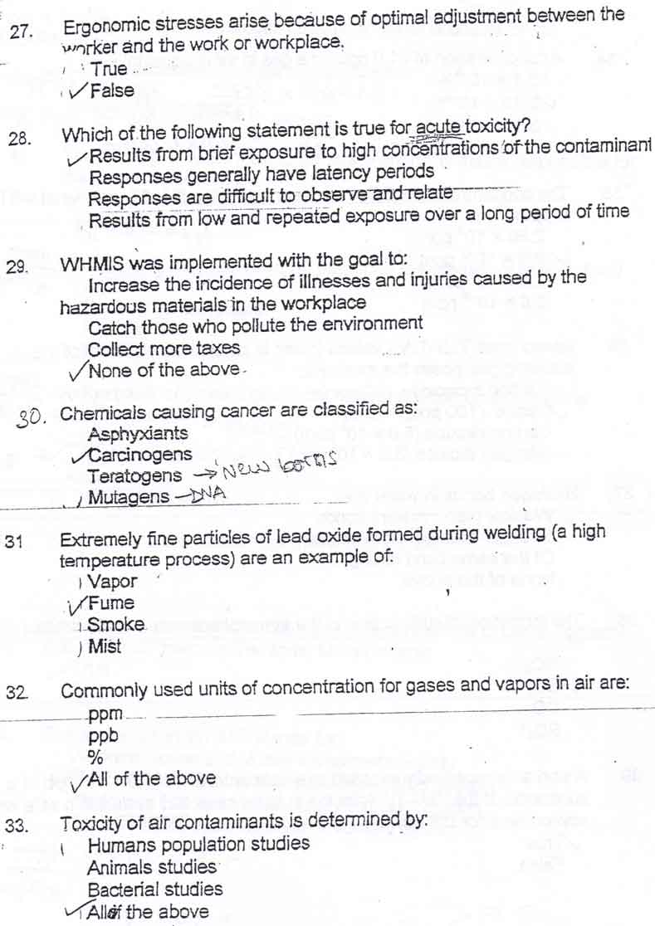

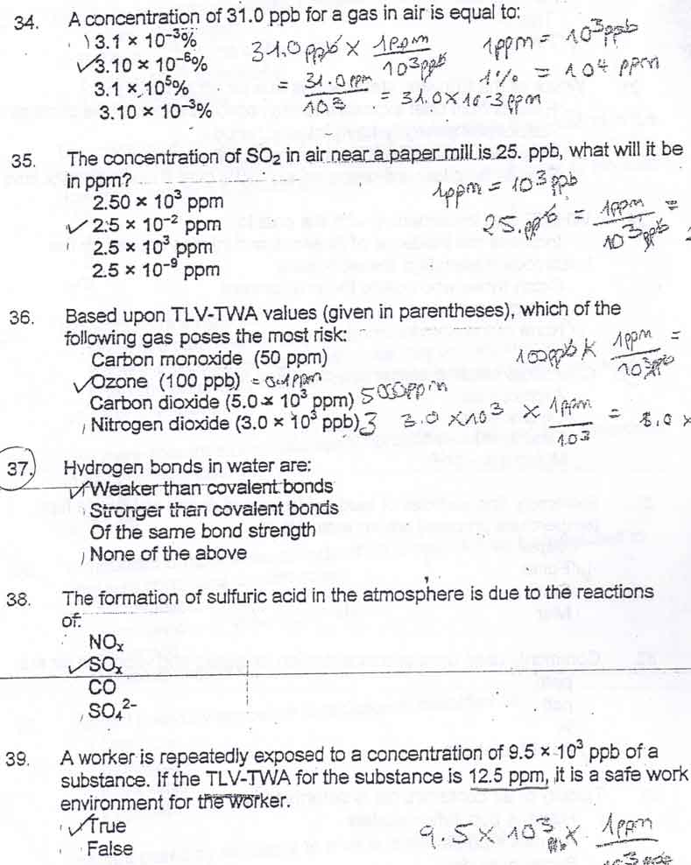

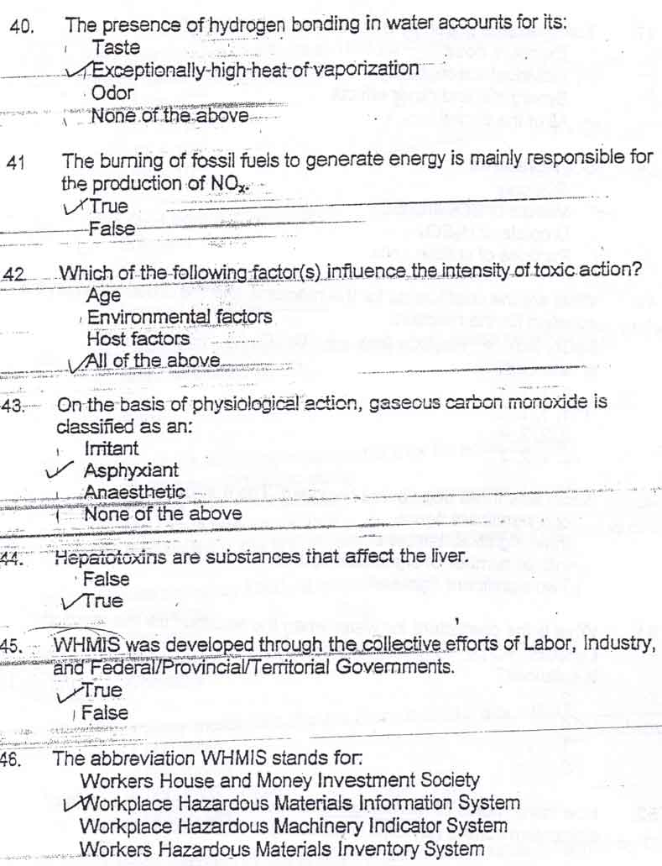

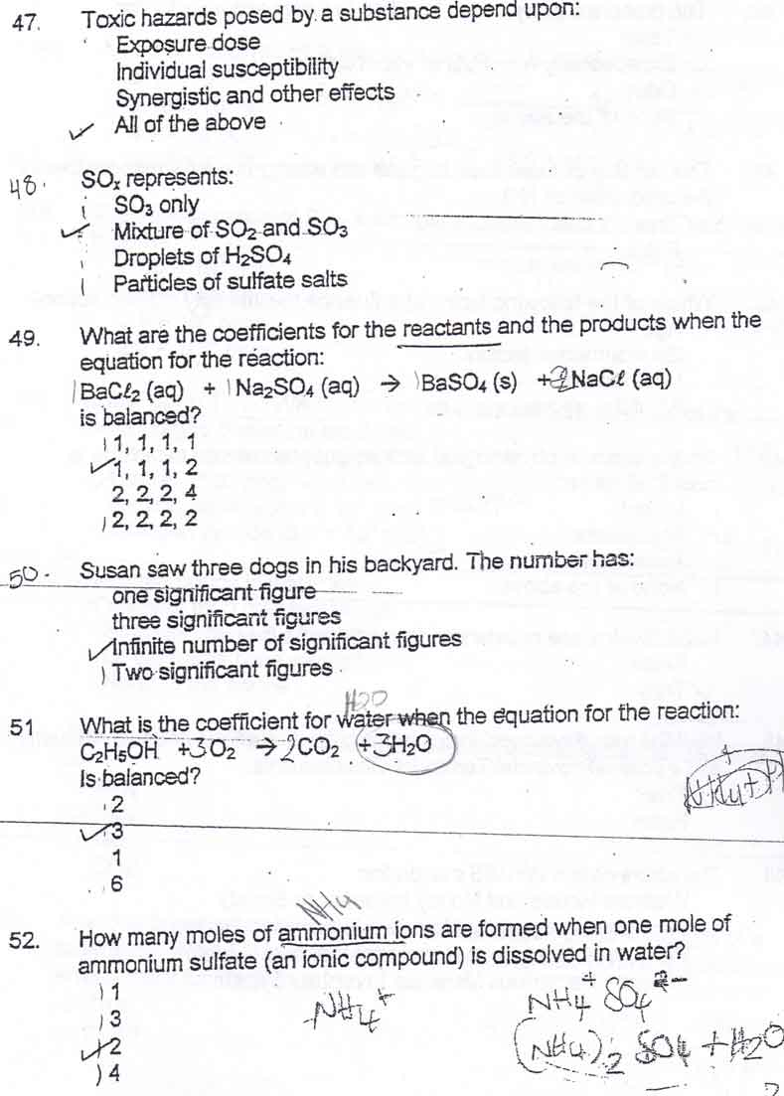
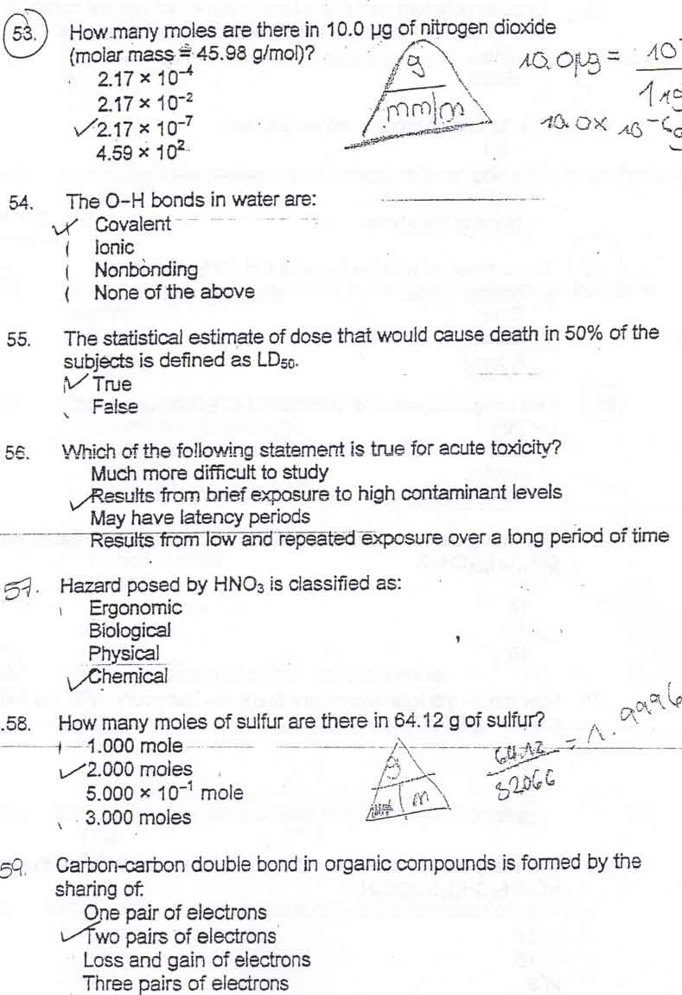
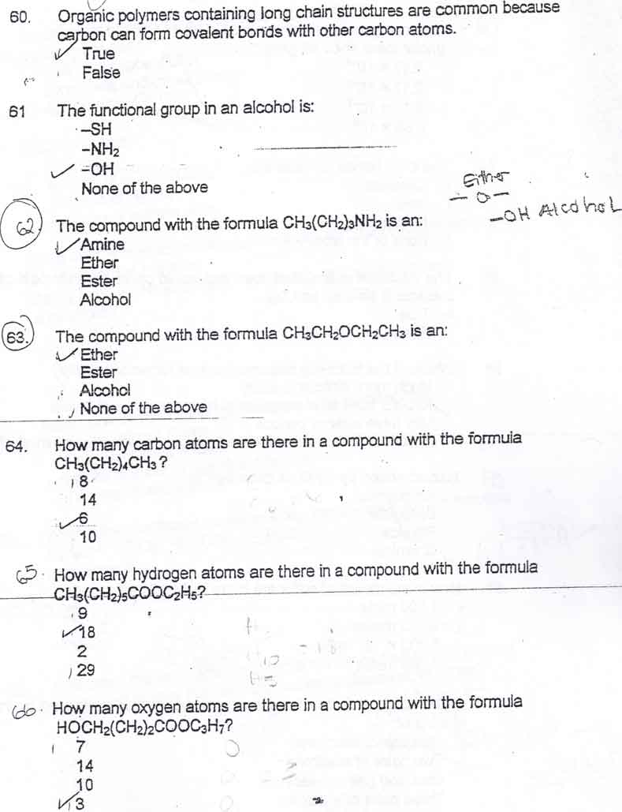

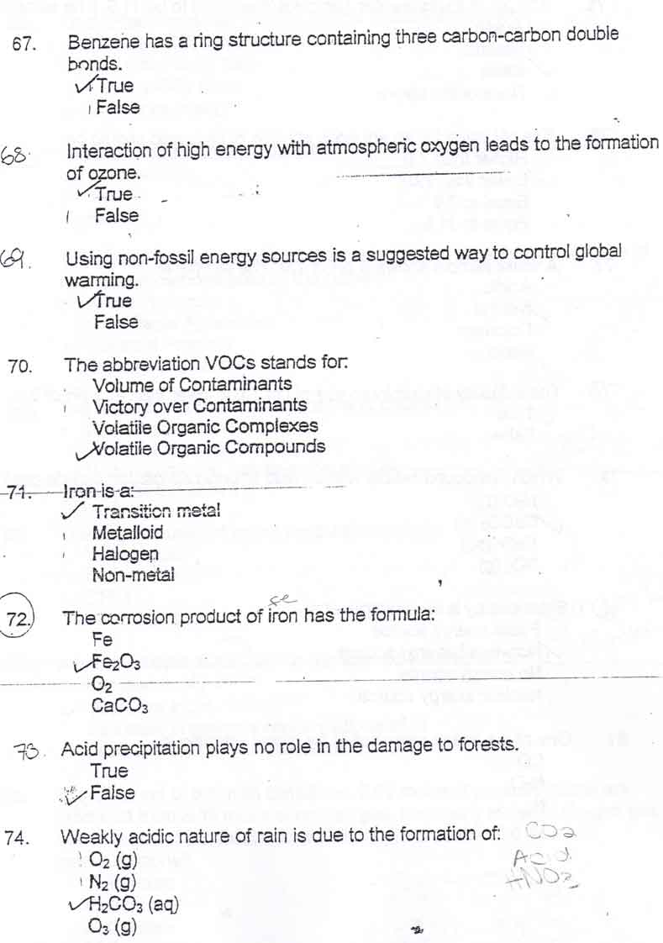
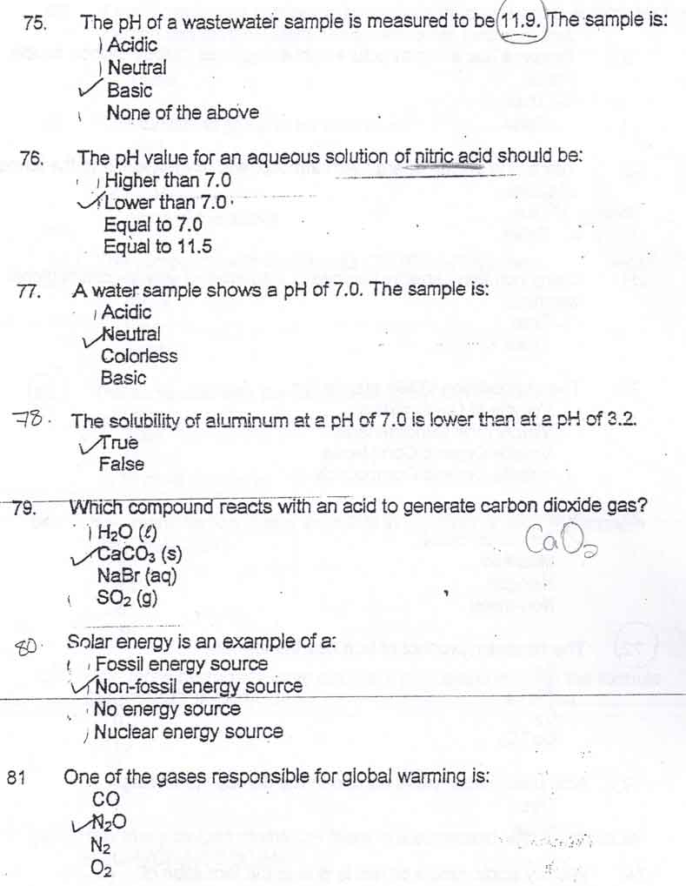

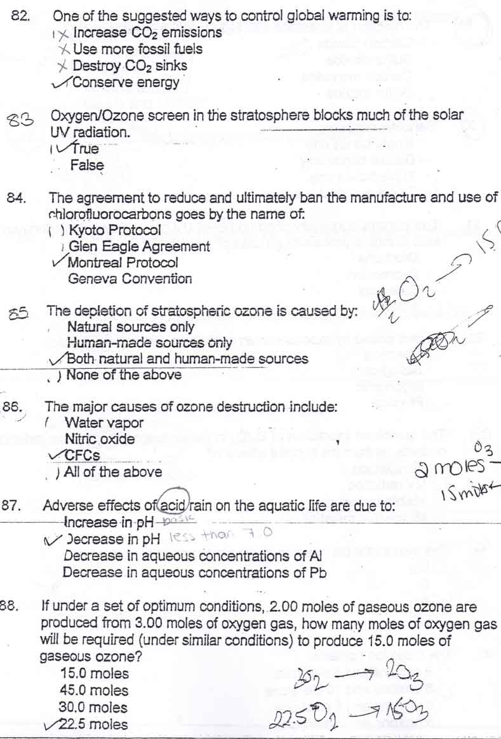
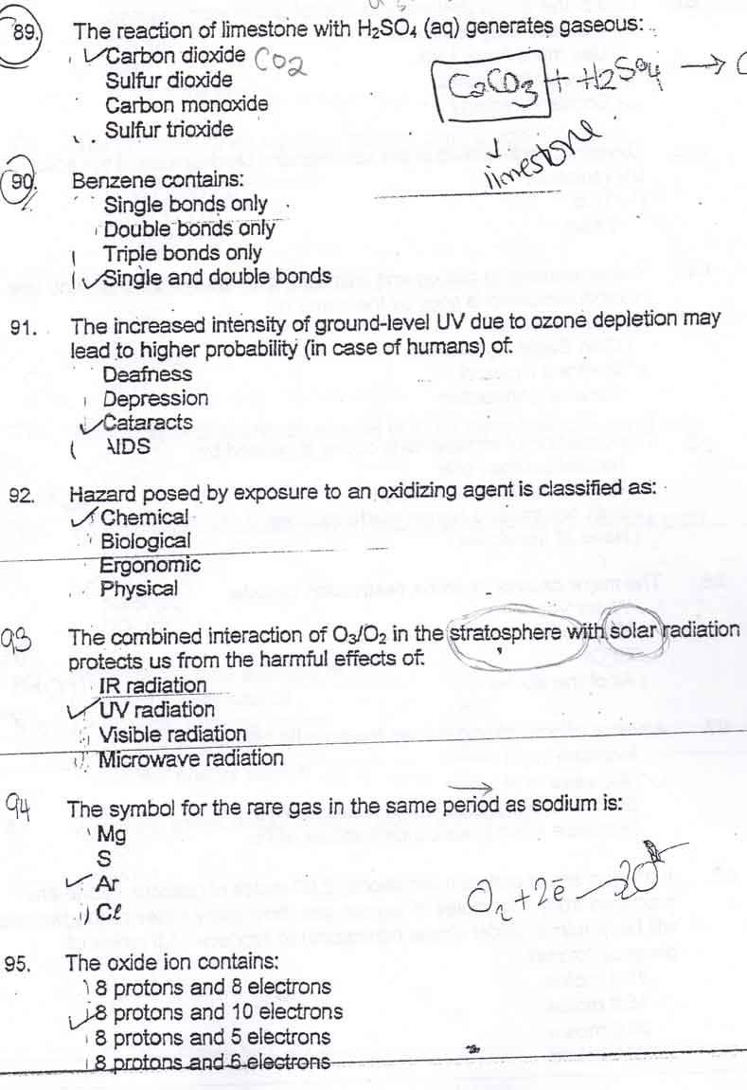
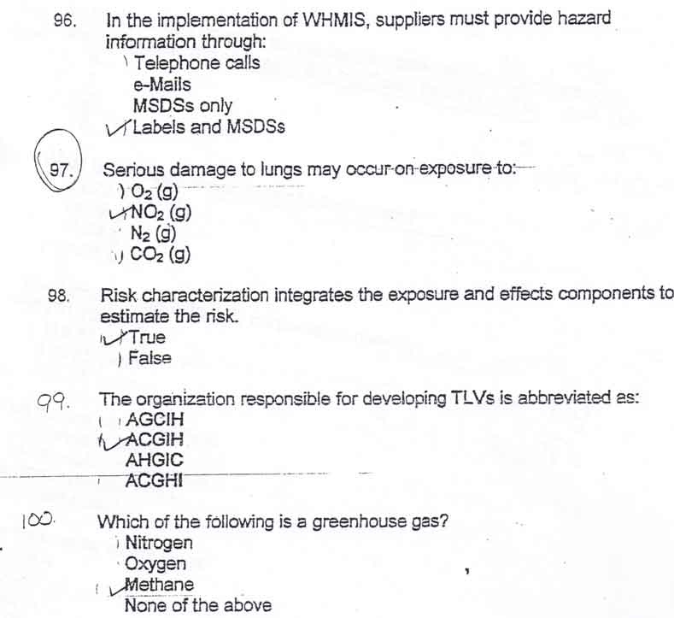

American Conference of Governmental Industrial Hygienists (ACGIH)
Threshold Limit Value (TLV) TWA = Time-Weighted Average
Volatile Organic Compounds = (VOCs)
North American Free Trade Agreement (NAFTA)
International Register of Potentially Toxic Chemicals (IRPTC).
WHMIS: Workplace Hazardous Materials Information System
MSDS stands for: Material Safety Data Sheet
IRPTC stands for: International Register of Potentially Toxic Chemicals
HAART = Highly active antiretroviral therapy = three-drug cocktail treatment for AIDS
OTC means over the counter
SSRI = Selective serotonin reuptake inhibitors
CFC = Chlorofluorocarbon

1% = 10⁴ ppm = 10⁷ ppb conversion

N₂ (g) + 3 H₂ (g) → 2 NH₃ (g)
molar mass of ethanol (C₂H₅OH) = 46.06 g/mol
d= st
m/s km/hr
1 cm³ =1 ml
Micro =1 µ g = 1 x 10 ⁻⁶ g
NANO =1 n g = 1 x 10 ^{-9 g}

The largest vol of these is 1.0 L 1000 mL 1.0 × 10⁶ µL >>1.0 × 10⁴ cm³

Chemicals causing malformation in newborns are: Teratogenic

Chemicals causing changes in DNA are known as: Mutagens

A concentration of 21.0 ppm for a gas in air is equal: 2.10 × 10⁻³ %

A concentration of 51.0 ppb for a gas in air is equal: 5.10 × 10⁻² ppm

Based upon TLV-TWA which poses the most risk: ( answer is the least)
Sulfur dioxide (2 ppm) Carbon monoxide (2.5 × 10⁴ ppb)
>>Ozone (100 ppb) Nitrogen dioxide (3.0 × 10⁻⁴ %)

A worker is repeatedly exposed to a concentration of 2.50 × 10 ⁶ppb of a substance. If the TLV-TWA for the substance is 250 ppm, is it a safe work environment for the worker?
Yes No (why? 2.50 × 10 ⁶ppb = 2500 ppm > 250 ppm)

A worker is repeatedly exposed to a concentration of 2.5 × 10⁻⁴ % of a substance. If the TLV-TWA for the substance is 5.0 ppm, is it a safe work environment for the worker?
>>Yes No

The unit used to express exposure to gases or vapors is: Any of these: ppm, ppb, %)
The unit used to express exposure to particles is: mg/m3 (or mg/m³, µg/m³)

7 - At a speed of 66.5 km per hour, how many seconds will it take to cover a distance of 1.00 × 10³ m? ==5.41 × 10¹ s 18.5 s 54,135 s 0.015 s

8 - An atom has 11 protons, 10 electrons and 12 neutrons. The atom is:
Neutral ==Positively charged Negatively charged None of the above

9 - A neutral atom containing 20 protons and 40 neutrons loses two electrons. The species formed is: An anion ==An ion having a charge of 2+ Neutral

X-Rays = risk of being exposed to Physical

chronic toxicity Results from brief exposure to high concentrations of the contaminant

Ozone = O³ made by some photochemical reactions and causes Reduced lung function

global warming by: CO₂, CH₄, N₂O not these CO N₂ O₂

Production of acid rain is due to NOx and SOx x is any number like 2, 3, 4

- Surfacants make water a more effective cleaner by reducing its surface tension.
- An anionic surfactant has a Negative charge is TRUE.
- Water hardness: due to Calcium in the water ( ALSO THESE Ca²⁺ and Mg²⁺or group 2A)
- The polar end of the surfactant is attracted to water cause water is polar.
- Household cleaners contain corrosive chemicals. Be careful!
- Shampoos contain anionic surfactant to remove oil and dirt.
- Sunscreen products to absorb UV rays.
- Laundry detergents contain many ingredients to perform many/diverse functions.
- to wet a surface effectively reduce the surface tension
- Cationic surfactant has a Positive charge
- Non-ionic surfactants are neutral
- Detergents eliminate films cause they are less affected by ion that cause hardness
- In cleaning process the surfactant is attracted to the water cause it is polar.
- In cleaning, soaps provides Chemical Interaction.
- Curling of hair involves reduction then oxidation
- First step in hair color involves oxidizing agent H₂O₂
- Alpha-Hydroxy acids are Cosmeceuticals
- Perfumes are blended bases on their volatility and molecular size
- Deodorants contain mainly antibacterial agents and perfumes
- Pigments added to lipstick for color
- Skin moisturizer maintains moisture of the skin.
- Alkaline Earth (2A) metals make water hard
- The C – C bond is Covalent
- Carbon is classified as a nonmetal
- Long Chains and cyclic structures are possible cause C forms covalent bonds with other C.
- Functional group in alcohol is -OH
- CH3OCH3 is an ether. Or -O-
- Benzene ring has 6 C and 6 H, Cyclohexane has 6C and 12 H
- CH3NH2 is an amine
- CH₃(CH₂)₄CH₃ has 14 H’s
- A compound with –NH₂ is an amine
- A Functional group is the chemically functioning part of a molecule
- AIDS is a viral infection
- Cephalosporins act as antibiotics by affecting the development of bacteria cell walls.
- Superbugs show resistance to many known antibiotics
- Treatment of depression with antidepressants
- Three-drug cocktail (HAART) is used to treat: AIDS
- Chemotherapy is treatment with chemicals.
- Aspirin is an analgesic
- Certain steroids are anti-inflammatory because they suppress inflammatory responses of the body.
- Aspirin is effect because it reduces the production of prostaglandins.
- To reduce drug related risks: read labels, learn about warnings, inform the nurses about all Rx and OTC and diet supplements taken.
- SSRI is an anti depressant.
- Tetracyclines inhibit synthesis of bacterial proteins
- AIDS is treated with antiviral agents
- Alkylating agents are used as chemotherapeutic agents is TRUE
- OTC means over the counter
- Pneumonia is a bacterial infection
- Benzene has 6 C and 6 H
- Pneumonia is s bacterial infection
- Seratonin neurotransmitter
- steroids are used as anti-inflammatory
- To reduce drug risk u should inform the health givers
- Protease is a antiviral
- Shampoos contain Anion surfactant
- Curling hair involves reduction then oxidation
- First step in coloring hair involves oxidizing agent
- Sunscreens contain chemicals to absorb UV radiation.
- Alpha-hydroxy acids are Cosmecuticals.
- Ingredients of Perfumes are blended based on their molecular size and volatility.
- The ingredients of deodorants are antibacterial agents and perfumes.
- Pigments are added to lipstick to provide smoothness.
- Skin moisturizers are used to maintain moisture content of the skin.
- The effective Chemical agent in body deodorant is Antibacterial agent.
- Surfacants make water a more effective cleaner by reducing its surface tension.
- An anionic surfactant has a Negative charge is TRUE.
- Cations are positively charged
- Water hardness: due to Calcium in the water (ie Ca²⁺ and Mg²⁺or group 2A)
- The polar end of the surfactant is attracted to water cause water is polar.
- Household cleaners contain corrosive chemicals. Be careful!
- Shampoos contain anionic surfactant to remove oil and dirt.
- Sunscreen products to absorb UV rays.
- Laundry detergents contain many ingredients to perform many/diverse functions.
- to wet a surface effectively reduce the surface tension
- Cationic surfactant has a Positive charge
- Non-ionic surfactants are neutral
- Detergents eliminate films cause they are less affected by ion that cause hardness
- In cleaning process the surfactant is attracted to the water cause it is polar.
- In cleaning, soaps provides Chemical Interaction.
- Curling of hair involves reduction then oxidation
- First step in hair color involves oxidizing agent H₂O₂
- Alpha-Hydroxy acids are Cosmeceuticals
- Perfumes are blended bases on their volatility and molecular size
- Deodorants contain mainly antibacterial agents and perfumes
- Pigments added to lipstick for color
- Skin moisturizer maintains moisture of the skin.
- Alkaline Earth (2A) metals make water hard
- The C – C bond is Covalent
- Carbon is classified as a nonmetal
- Long Chains and cyclic structures are possible cause C forms covalent bonds with other C.
- Functional group in alcohol is -OH
- CH₃OCH₃ is an ether.
- Benzene ring has 6 C Cyclohexane has 6C and 12 H
- CH3NH₂ is an amine
- CH₃(CH₂)₄CH₃ has 14 H’s
- A compound with –NH₂ is an amine
- A Functional group is the chemically functioning part of a molecule
- AIDS is a viral infection
- Cephalosporins act as antibiotics by affecting the development of bacteria cell walls.
- Superbugs show resistance to many known antibiotics
- Treatment of depression with antidepressants
- Three-drug cocktail (HAART) is used to treat: a)Cancer b) pneumonia, c)Depression…d) none of the above is correct or AIDS
- Chemotherapy is treatment with chemicals.
- Aspirin is an analgesic
- Certain steroids are anti-inflammatory because they suppress inflammatory responses of the body.
- Aspirin is effective because it reduces the production of prostaglandins.
- To reduce drug related risks all of these: read labels, learn about warnings, inform the nurses about all Rx and OTC and diet supplements taken.
- SSRI is an anti depressant.
- Tetracyclines inhibit synthesis of bacterial proteins
- AIDS is treated with antiviral agents
- Alkylating agents are used as chemotherapeutic agents is TRUE
- OTC means over the counter
- Pneumonia is a bacterial infection
- Benzene has 6 C
- Pneumonia is s bacterial infection
- Seratonin neurotransmitter
- steroids are used as anti-inflammatory
- To reduce drug risk u should inform the health givers
- Protease is a antiviral
- Weakly acidic nature of rain is due to CO₂
- pH =4.9 means Acidic
- pH = 11.2 is Basic , pH = 7 means neutral
- Vinegar has pH less than 7 because acidic
- Acid rain due to Nitrogen and Sulfur
- Limestone and Acid releases CO2.
- Corrosion of Fe gives rust = Fe₂O₃
- Aluminum is more soluble than at pH =4.2 than at 9.6 true
- Mobility of Pb in the soil is dependent
- Suggested to control acid rain is cleaner energy sources.
- Ground level ozone forms photochemical smog - - TRUE
- Ozone/Oxygen in stratosphere with solar radiation protects us from UV radiation
- High Intensity UV and O₂ interaction leads to OZONE formation. TRUE
- In the stratosphere O₂ & O₃ interact with solar energy to form a dynamic system
- Depletion of stratospheric Ozone less effective filtration of solar UV
- Depletion of stratosphere ozone caused by both natural and man-made sources
- Increased UV to Skin Cancer
- The agreement to ban chlorofluorocarbons is the Montreal Protocol.
- The agreement to reduce and ultimately ban the manufacture and use of CFCs goes by the name of: = Montreal Protocol
- If 2 mole of O₃ needs 3 moles of O₂, then 30 moles of Ozone needs 45 moles O₂
- Welders are at risk to Ozone exposure TRUE
- Weakly acidic nature of rain is due to formation of H₂CO₃
- pH =1.9 means Acidic
- pH = 9.2 means Basic
- NaOH has pH > 7
- Limestone and sulfuric acid react to give CO₂
- Aluminum less soluble in ph=9.2 than at pH =5.6
- Green house gas is Methane
- Nuclear is a non-fossil fuel.
- O₂ + O₃ + solar energy produces a dynamic system
- Montreal Protocol signed to ban use of chlorofluorocarbans.
- non-fossil energy sources such as hydroelectric, solar, nuclear, and wind

