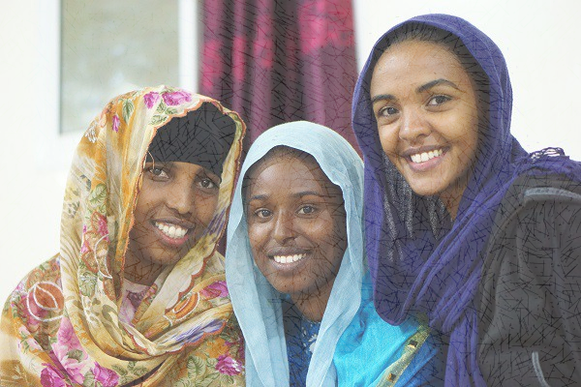
Somaliland Sun
School

Project Proposal 2016
Project Sponsor: Ministry of Education
Author: Shetal Patel

Project Proposal 2016
Partner Organization: Ministry of Education and Donor Representatives
Author: Shetal Patel

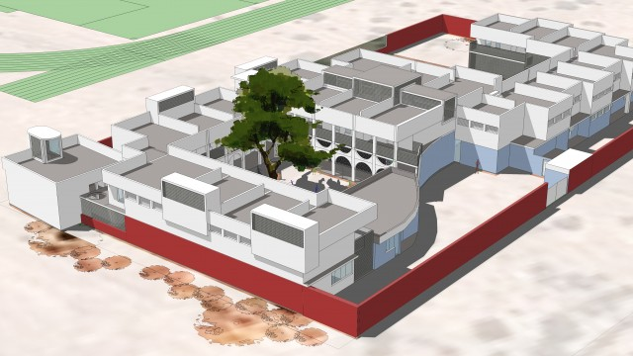

The objective of this project is build two schools buildings and initiate basic education of children and illiterate adults in the villages of Kam-barwaqo and Fadhi-xun and mobilize the community. Somaliland Sun School (SSS) will offer education to the very poor, disadvantaged and underdeveloped villages where the Somali NGO’s has failed to establish schools in Kam-barwaqo and Fadhi-xun. Moreover, SSS will encourage communities to use the school as a center for education.

Project design of SSS
Project
Description

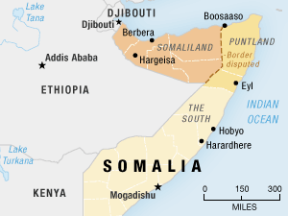
Map of Hargeisa, Somaliland, Ethiopia

Location
The Somaliland Sun School will be located in the of Somaliland, in the Hargeisa District, in the villages of Kam-barwaqo and Fadhi-xun. This location is suitable because these villages lack an education system and is located in a busy neighborhood where the majority of the population is illiterate.
SOMALILAND SUN SCHOOL WHERE YOU ARE BORN TO SHINE


Timeline

The Somaliland Sun School proposes their plan to launch on October 13th, 2016 and plans to complete this project by the beginning of April 2017. Somaliland Sun School must work hard at keeping up with this vigorous 6-month timeline. The following flow chart provides a timeline that displays how the action will take place:

BUILDING A BRIGHTER FUTURE

 Budget

Type | Amount | Total
Construction of 3 classes, 2 washrooms and water tank in Kam-barwaqo village | $ 14 000
Construction of 3 classes, 2 washrooms and water tank in Fadhi-xun village | $ 14 000
Construction of 1 library in Kam-barwaqo village | $ 15 000
Construction of 1 library in Fadhi-xun village | $ 15 000
Educational equipment and training hand tools and materials (i.e. chalk boards, overheads, etc.) | $ 8000
Grand Total |  | $ 66 000

Potential Value

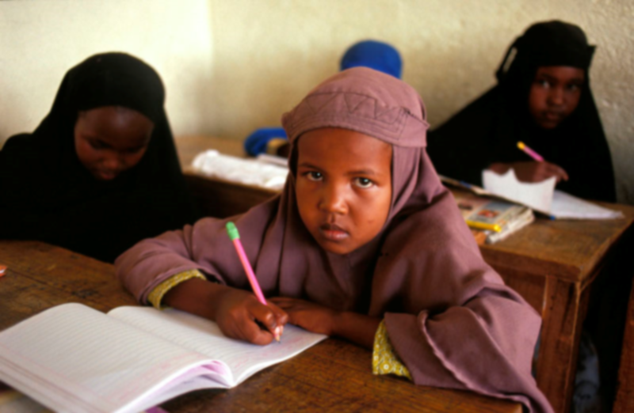
Why Somaliland Sun School is valuable to the community:
- Establishes an educational framework
- Provides a healthy learning environment
- Collaborates with the local community and community leaders
- Has an outstanding teaching staff
- Uses up-to-date facilities and learning equipment
- Fosters lifelong learning in Kam-barwaqo and Fadhi-xun
- Student progress is monitored and supervised on a regular basis

Bibliography

- "2014 School Projects - Somali and American Fund for Education." Somali and American Fund for Education. N.p., n.d. Web. 11 Oct. 2016.
<http://safeeducation.org/current-construction/>

- Abaarso School Students. Digital image. SomalilandInformer. N.p., n.d. Web. 11 Oct. 2016.
<http://www.somalilandinformer.com/somaliland/somaliland-the-american-people-supporting-facilities-modernization-at-the-abaarso-school/>

- "Basic Education for Children and Illiterate Adults in Somalia | Corporate NGO Partnerships." Basic Education for Children and Illiterate Adults in Somalia | Corporate NGO Partnerships. N.p., n.d. Web. 11 Oct. 2016.
<http://www.globalhand.org/en/search/org/request/7288>

- By Tackling the Problem in This Manner We Hope to Bring about Sustainable Lasting Change to the Communities We Serve. "Challenging Illiteracy in Somaliland | NRC." NRC. Nashon Tado, 8 Sept. 2016. Web. 11 Oct. 2016.
<https://www.nrc.no/news/2016/september/challenging-illiteracy-in-somaliland/>

- Hargeisa School Girls. Digital image. Edan Adan Hospital Foundation. N.p., n.d. Web. 11 Oct. 2016.
< http://www.ednaadan.org/galleries/somaliland-gallery/>

- Map of Somali & Somaliland - NPR. Digital image. Somalilandpress. N.p., n.d. Web. 11 Oct. 2016.
< http://www.somalilandpress.com/this-guy-is-from-hargeisa-shoot-him-in-the-head-and-take-the-money-security-officer/>

- School - Somaliland. Digital image. JB Architects. N.p., n.d. Web. 11 Oct. 2016.
<http://www.jb-architects.co.uk/?p=1395>

