Psyc 457 Notes for Midterm #2 (Nov.9)

Oct.19

Gulls become upset when predators get close to their nests – parents’ assaults distract predators from their offspring = mobbing gulls may increase their reproductive success, which enables them to pass on the hereditary basis for joining other gulls in screaming at, defecating on and assaulting those that get too close or eat their eggs.
- The costs of mobbing (time and energy spent) were outweighed by the fitness benefits.

Fitness costs = the negative effect of a trait on the number of surviving offspring produced by an indiv or a reduction in the number of copies of it’s alleles that it contributes to the next generation.

Fitness benefits = positive effects of the trait on reproductive and genetic success.

Adaptive Value = the contribution that a trait or gene makes to inclusive fitness.
- Adaptation is a hereditary trait that has spread or is spreading by natural selection and has replaced any alternative traits in the species. (an attribute has a better fitness-benefit-fitness-cost ratio).
- This definition does not require that the naturally selected trait to be “perfect”
- Selection cannot create the best of all possible genes for a particular task but has to wait for a mutation to occur.

Any hereditary improvement in a gull’s ability to thwart predators would tend to select for improvement in that predator’s ability to circumvent the bird’s defense, which results in an Arm’s race = the result of selection acting on 2 parties that are in opposition to one another, as in the increasing sophistication of defensive mechanisms in a species that is preyed upon by an increasingly sophisticated predator.

Kruuk made a prediction that the benefit experienced by mobbing gulls in protecting their eggs should be directly proportional to the extent that predators are actually mobbed. He tested this experimentally by placing 10 chicken eggs outside a Black-headed gulls nest or colony where mobbing pressure is low = more likely to be eaten and found, When eggs were placed inside the colony, predators were constantly harassed = mobbing is adaptive to black-headed gulls that helps protect their eggs.

Reproductive Success = the total number of offspring or grand-offspring that reach the age of reproduction
- The number of young that survive to fledging, the number of mates inseminated, he quantity of food ingested per unit of time, the ability to acquire a breeding territory = all proxies for an indiv’s reproductive success.

Adaptations & Adaptive Value (Ch.5)
- Foraging for food + predator avoidance
- The term adaptation – Alcock says, “hereditary trait that is spread among a species by Natural Selection, replacing alternative forms of the same trait”.
- Concept of adaptive value = the benefits of inclusive fitness
- Key Aspect: replace alternative forms of the trait in the past or present; fitness cost ratio must be higher than benefits of the alternative form of the trait.
- Adaptational traits that have benefits are seldom perfect! Nature, seldom, produces something that would be considered perfect.

Box 5.1 (pg.103) – Why a trait may not be perfectly adaptive.
- 3 constraints of an adaptive value of a trait:
  - 1) Appropriate Mutation must be formed
    - How can a trait later become non-adaptive? = changes in the environment, whether it be geological, climate or region change…they slowly occur.
    - Some traits that were selected because they were adaptive to the environmental pressures, may not be so adaptive or better for the environment now if the pressures change!
  - 2) Pleiotrophy
    - Very common to the development of a behavioral trait – one trait can add developmental effects to multiple traits.
    - Ex) Species = gene that prolongs their life (Somehow), that same gene might produce some other kind of feature like a diminished reproductive success (less sperm for males).
    - Negative and positive parts to Pleiotrophy
  - 3) Co-Evolution (which occurs when individuals interact in ways that affect each others fitness)
    - In and out of adaptiveness
    - As the members of one group or species change in response to selection pressure imposed by another group, selection may favor counter-responses, as in the coevolutionary arms race between predator and prey.
    - The inability of selective processes to generate an immediate effective solution to an altered environmental problem means that some less than perfect traits can remain for a time within a species.

Not all gulls nest on the ground
- Black-legged Kittiwake (in the picture below)
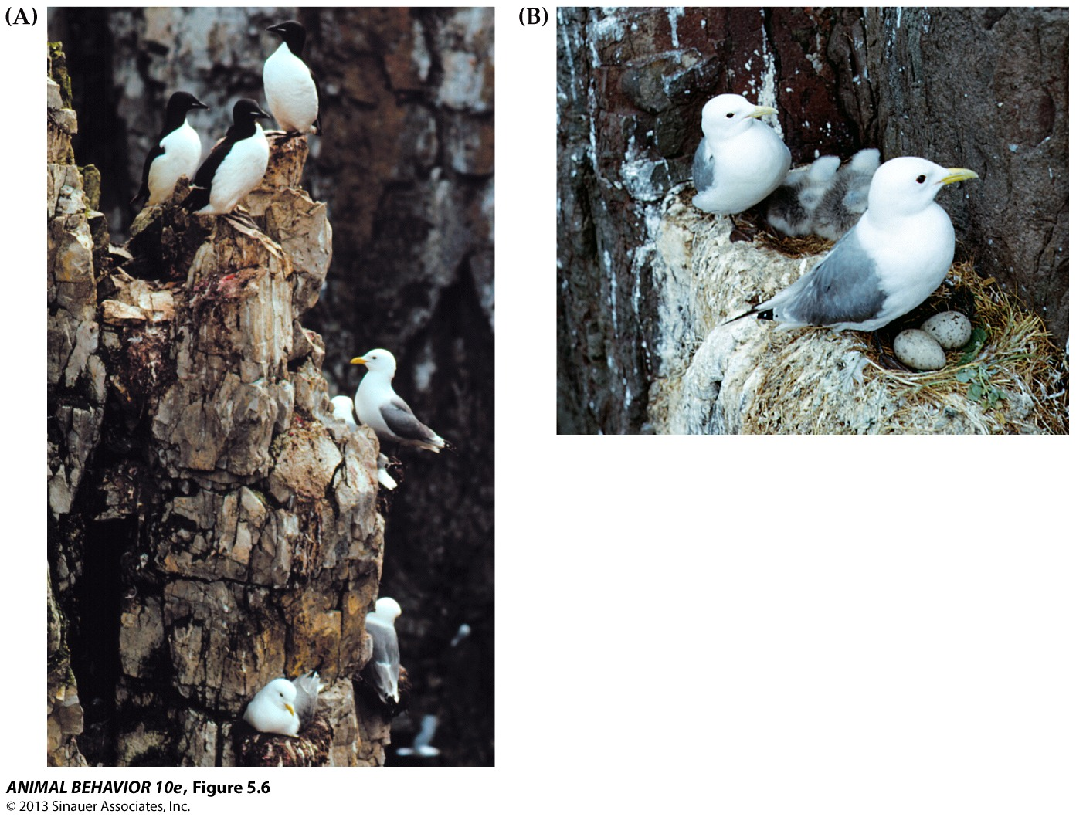

The comparative approach = involves looking at different species that vary in their relatedness and looking at different traits of the species closely related and looking at the phylogeny and relationship between traits + environment where these traits exist.
- The comparative method = a procedure for testing evolutionary hypotheses based on disciplined comparisons among species of known evolutionary relationships.
  - Can use this approach to test Kruuk’s explanation for mobbing by black-headed gulls by checking the following prediction: if mobbing by ground-nesting black-headed gulls is an evolved response to predation on gull eggs and chicks, then other gull species whose eggs and young are at low risk of predation should not exhibit mobbing behavior.

- Most gull species build their nest on the ground!
  - Easy for territorial mammals to take the nest. They engage in mobbing = few small birds harassing one big bird. How they protect their next, not perfect but good enough that it’s adapted to most species of gulls.
- Black-legged kittiwake = they build their nests on cliffs. By adapting this behavior, this species of gulls have dealt with predation pressure in different ways = nest is not accessible by predators who eat eggs = predation pressure is gone = an example of divergent evolution! (The share many structural and behavioral features with black-headed ground-nesting gulls, but the mobbing behavior evolved in response to predation pressure on the eggs and chicks of nesting adults + lose mobbing behavior).
  - Compare this behavior with other gull species; one might expect that the lack of pressure to mob may lead to the lack of the gene for mobbing behavior.

Gull phylogeny and two scenarios for the origin of cliff-nesting behavior
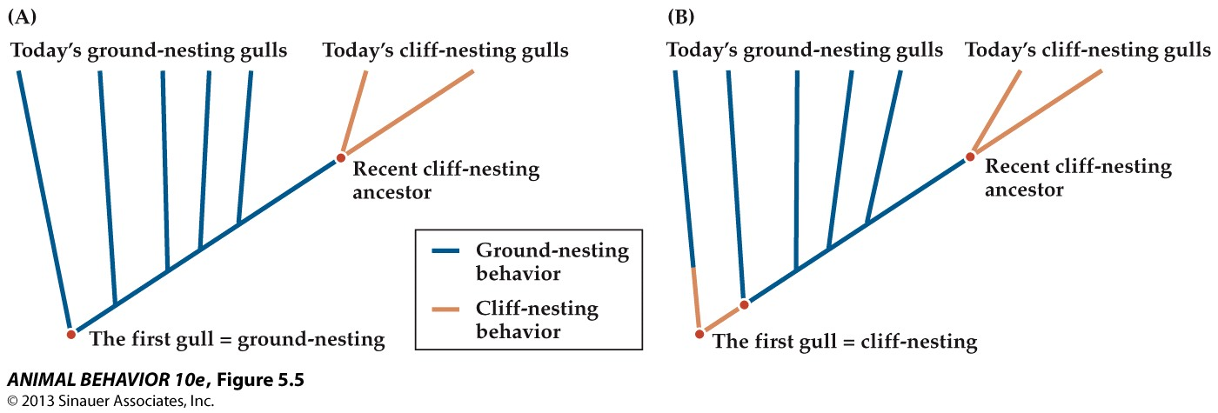

Gull Phylogeny and 2 scenarios for the origin of cliff-nesting behavior (Figure 5.5 above)
- 2 different possible scenarios for the evolution of cliff-nesting behavior
  - The cliff-nesting behavior evolved once
  - In the second map, it evolved twice!
    - Ground nesting became a favorite trait, then cliff-nesting came up again later on
    - Descendants of a more recent cliff-nesting gull species that evolved from a ground-nesting ancestor.

Comparative approach = comparing behaviors between species
- Good reason to believe that ancestral gull was a ground-nesting species because out of 50 species, most nest on the ground and mob enemies that hunt for eggs and chicks.

Philosophical principle, Occam’s razor = principle of parsimony = simpler explanations are more likely to be correct than complex ones.
- Cliff-nesting gulls currently have few predators because it’s hard for small mammalian predators to scale cliffs and predatory birds have a hard time maneuvering near cliffs in turbulent winds = reduction in predation pressure.
- Cliff-nesting gulls are predicted to have modified or lost the ancestral mobbing behavior.

The logic of the comparative method (Figure 5.7)
- Members of same evolutionary lineage share a common ancestry = share many of the same genes = similar traits, such as mobbing behavior (widespread among ground-nesting gulls). But the effects of shared ancestry can be overridden by a novel selection pressure (reduction in predation can lead to divergent evolution by the cliff-nesting kittiwakes = no more mobbing).
- Convergent evolution, which is mobbing behavior of some colonial swallows, even though they’re not related to gulls, they come from different ancestors long ago. These colonial swallows and gulls have converged on a similar anti-predator behavior in response to shared selection pressures from predators that have easy access to their nesting colonies.
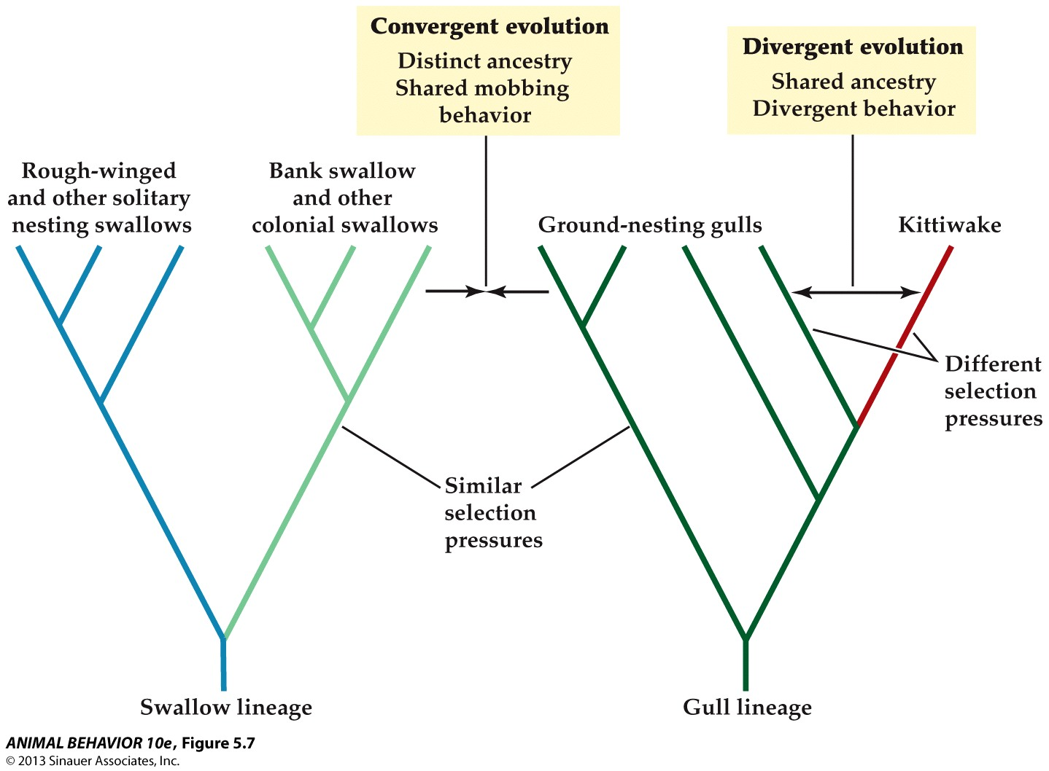

- All gull species – nest on ground = mobbing behavior protects the eggs = direct fitness benefit, but other gulls build cliff-nests = ex. Of divergent evolution. Can say it occurs when conditions change or better adaptation has been found for a problem.
  - Divergent evolution = most common change that we’re likely to see = shared ancestry. Def.: The evolution by natural selection of differences between closely related species that live in different environments and are therefore subject to different selection pressures.
  - Convergent evolution = distinct ancestry shared mobbing behavior. Def.: The independent acquisition over time through natural selection of similar characteristics in two or more unrelated species.
    - Species from different evolutionary lineages that live in similar environments should experience similar selection pressures + predict to evolve similar traits = if true, they will adopt same adaptive solution to a particular environmental obstacle to reproductive success.

As soon as we see a difference in their traits and their environment = divergent evolution.

Sometimes natural selection can come up with some solutions (cliff-ground-cliff = can occur in same lineage over time)
- Which is convergent (ancestors that don’t possess that trait).

Oct. 21

Adaptations & Adaptive Value Con’t
- Alcock discussion Question 5.2 (pg. 104)
- 5.2 Stephen Jay Gould and Richard Lewontin claimed that adaptationists—a group that contains most of the world’s behavioral ecologists—often make the elementary mistake of believing that every characteristic of living things is a perfected product of natural selection, when in reality many attributes of living things are not adaptations (see Box 5.1). One of the effects of making this mistake is, according to Gould and Lewontin, the tendency of adaptationists to invent fables as absurd as the fictional “just so stories” of Rudyard Kipling, who made up amusingly silly explanations for the leopard’s spots and the camel’s hump. How might adaptationists defend themselves against these charges? Do adaptationists have the means to discover whether an evolutionary explanation for a particular trait is wrong?
  - “Just so stories” = yes, they make sense but they’re just stories…when explaining adaptive behaviors, the challenge is given to someone and they say, oh it’s an adaptation.
- How might adaptationists defend themselves against these charges? = look back in history/evolution, genetics = make hypotheses that are testable.
  - Mis-characterizing adaptationists because they assume they say “just so stories”

Dilution Effect = Safety in numbers that comes from swamping the ability of local predators to consume prey.
- Communal mobbing behavior is an example of a social defense against predators = has costs and benefits.
  - Ex) Harvester ants come together to mate for only a few days each year = form a dense aggregation. Dragonflies and birds can locate swarms where they capture and eat these ants, but the odds that any one ant will be targeted (fitness costs of gathering together in conspicuous masses) are small given ratio of ants to predators (fitness benefits in being part of a mating aggregation).
  - Ex) Mayflies = synchronizes the change from aquatic nymph to flying adults = emerge from the water for a few hours on a few days each year. Higher the density of emerging indivs (females) from a stream, the lower the risk to any one mayfly of being inhaled by a trout as they make the risky transition, which is followed by mating.
- Advantages to social defenses = improved or shared vigilance and communal defense or use the ability to hide behind someone.
  - Ex) Population of antelope, they stay well apart to reduce their conspicuousness to predators. One Mutant indiv approaches another animal and positions itself to use their companion as a living shield (this tactic would incur some costs – 2 animals would be more conspicuous and attract more attacks), If costs are consistently outweighed by the survival benefit gained by social mutants, the social mutation would spread through the pop = lead to all members aggregating with indivs jockeying for the safest position within the group = improving their odds at someone’s expense (Selfish herd = a group of indivs whose members use others as living shields against predators).

Game Theory = an evolutionary approach to study of adaptive value in which the payoffs to indivs associated with one behavioral tactic are dependent on what the other members in the group are doing.
- Users of this theory treat indivs as participants in a contest in which the success of one competitor is dependent on what its rivals are doing.
- Ex) Getting more of one’s genes into the next generation.
- Hamilton’s selfish herd hypothesis can be tested using this theory = competition among group members for the safest positions.
  - Ex) Redshanks that are targeted by hawks are father away from their nearest neighbors in the flock than those birds standing from their nearest neighbors.

Cryptic Behavior
Solitary prey often evolve camouflaged color patterns along with behavioral tactics that enhance their concealment = potential tactic is for the cryptically colored animals that select the kind of resting place where they’re hard to see.
- Ex) peppered moth = industrial coot darkened the color of the forest trunks, the whitish moths living in these environments became more conspicuous to birds which ate the white moths and consumed the allele for the color pattern. Paler indivs were at special risk of attack when they were placed on dark backgrounds = those moths that were more conspicuous to human observers were at higher risk of attack and capture by birds.

Peppered moths settle within the shade patches below where branches meet the trunk, so if the moth’s perch site is an adaptation, we can predict that resting underneath tree limbs should be better protected against predators = true, birds overlook these moths.
- Whitish moths perch head up on white birch with forewings over body = it’s adaptive because birds overlook them (when given choice for resting site).

Darwinian Puzzle of Conspicuous behavior = Cryptic behavior comes with costs.
- Time and energy finding the right background
- Walnut Sphinx and Peacock butterfly make themselves conspicuous by producing sounds like whistling squeaks or flapping wings when approached by predator and hissing sounds +ultrasonic clicks to scare off predators.
- Bright coloration of a monarch butterfly = how can that be adaptive? = feed on poisonous milkweeds as larvae = highly toxic species and birds learn to stay away from these butterflies after a few encounters.

Cost-Benefit Approach = fitness benefits of an evolved trait must exceed its fitness costs.
- How can a monarch butterfly, that induces vomiting gain fitness since they rarely fly off? = possibility exists that toxicity evolved via indirect selection = dead indivs educate potential predators of close relatives = helping genetically similar monarchs pass on genes.

Foraging Behaviors
- Leaf cutter ants use leaves to feed their fungus farm to produce their own food
  - Not all ants are leaf cutters, but are kin-related to leaf cutters = form of agriculture (50,000 years before humans started agriculture).
  - Solves food getting problem – one of the problems animals suffer from = because animals can live to reproductive age without territory, other members of a group. But food is a general problem all species face = animals can’t live to reproductive age without food.
- 2 living organisms (ant + fungus)
  - Symbiosis = relationship between 2 different organisms where there’s an interaction (usually a positive benefit to both organisms benefit = mutualism, 1 form of symbiosis).

Fungus-Farming in Attine Ants
- Cultivars (plant species) are propagated vegetatively (as asexual clones) within nests, and between parent and offspring nests.
- The foundress queen (dominant breeder = produce other queens to start their own colony) carries in her mouth a pellet of fungus from the natal nest that she uses to start her own garden/farm and colony.
  - Ants that are born destined to be queens are told to get out and start their own colony, so they take a piece of fungus farm = Vertical Propagation.
- This mode of “vertical propagation” across generations and colonies suggest that attine fungi are ancient clones that have strictly coevolved with their hosts.
- A phylogeny of fungi farmed by ants
- Within a colony, different castes perform different roles = some are foragers that collect and search for suitable plant material to bringing back to the nest. Some work at distributing the fertilizer in the fungus patch.
- Some work at removing contaminated areas from the fungus patch and carrying them into dumb chambers.
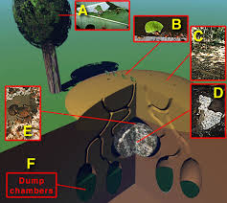
  - The parasitic fungus “Escovopsis” is a major pest in ant fungus farms

The white substance on the ant is “Streptomyces bacteria” which produces numerous antibiotics.
- Currie hypothesized that this bacteria is used by the ants for parasites (Escovopsis): they tested this hypothesis.
- 20 species of ants in different geological locations had this bacteria on them. Maybe during the reproductive process, it’s passed on to each generation. They captured these ants in flight while reproducing = the bacteria was present on the females but not in any males.
- Only females are involved in the starting of new nest and forming itself
  - Lines of evidence that Currie’s hypothesis was right = it was the same bacteria in all species = adaptive trait (being vertically propagated).
- The screened for the effect of the bacteria in the ants. They looked at the effects it had on other pathogens = selectively effective against the Escovopsis (suppressing this parasitic fungus). Another species (parasitic fungus) that’s mutually symbiotic with ants = propagated by ants
  - Example of adaptations in the food getting problem.

What are the appropriate food items to being home?
- Some animals have to know what certain foods look like
- Timbergen = concept of the search image = when animals first encounter a food type, they receive useful info. As they encounter this food item more and more, their representation of this item becomes more and more elaborate. Also, the more they capture this prey or encounter it = makes it easier for the predator to detect it and capture it (size, color, smell…)

Major problem of learning (experience capturing prey) = initially hardwired knowledge.
- Different animals are born with distinctive knowledge about food sources
  - Ex) chickens aren’t known what food is, but they know they can peck on pellets on the ground. They instinctively know to peck on the ground, but they’re not good at first – they’ll peck at anything.
- Search image = learn what’s good prey and what’s not through experience
  - Ex) toxicity of monarch butterflies to birds
  - Not a blank slate at birth = all animals have a different natures (genotypes and phenotypes are distinctive)

Choosing among foods: Prey Size
- How large a prey item should an organism attempt to eat?
  - Assuming the goal is to maximize energy, individuals should choose items that lead to the highest gain in Energy/Time = how long should an animals stay in an area before they should move to another?
- Optimal Foraging Theory (OFT): different models that make use of principle = optimization
  - How they distribute foraging techniques among different locations
- These models always have constraints = certain amount of time during the day to get food…
- Some say to eat the biggest prey, but it takes a lot of time and energy to capture it.

Optimal clam size in the Foraging Crows
- Crows leave quite a few clams behind after digging them up, why? = the answer lies in the handling time = takes longer to open large clams than small ones. It pays to get the bigger clam, but harder to open
- (Gain small)/handling time < (Gain large)/(search time + handling time)
- Takes some time to find small and large clams, but takes more time to open bigger ones and not small.

Mussel Selection by Oyster Catchers
- Energy maximization predicts that catchers should choose the largest clams
- But they often leave the largest ones untouched, why? = the handling time for the largest mussels leads to a dramatic drop in profitability (amount of energy you got from the prey)
- They would take the mussels by flying 4-5m up and dropping them till they break open
- Developed a search image for clams that are optimal to drop
  - Why don’t they fly higher to drop bigger clams? = it uses more Energy!

Oct. 26

Adaptations & Adaptive Value (Con’t)
- Don’t need abou-shara paper (won’t be tested on it!)

Foraging Behavior (collecting food resources)
- A lot of different approaches that a lot of species use to solve the food-gaining problem.
- Leaf cutting ants are the most successful herbivore in the tropics! More successful than birds…
- We spoke about choosing among food-prey size:
  - Adaptive to maximize the amount of energy for foraging
  - Used to predict the strategy used.
- Measure of physical fitness a proxi for reproductive success.
- Assumption: that those foraging optimally to save the amount of energy leads to reproductive success**
- OFT: consider the decisions animals makes about how long they should spend at a foraging location, what size prey…
  - Profitability of prey = the amount of energy you got from the prey you captured.

Ex) Crows foraging for Whelks…they choose smaller whelks because they’re easier to open, they don’t have to fly as high to drop = use less energy to open small whelks compared to large ones.
- Speculation = amount of time it takes to handle different sizes!

(Gain small)/handling time < (Gain large)/(search time + handling time)
- Always take a small clam if a large one takes longer to open and longer to search for.

Mussel Selection by Oyster Catchers
- Energy maximization predicts that catchers should choose largest clams, but often leave the largest oysters untouched, why? = the handling time for the largest mussels leads to a dramatic drop in profitability.

OFT = explains/predicts patterns of foraging behavior.
- It considers costs & benefits of continuing to forage at present locations vs. moving to a different location
- Ex) Foraging in Honeybees = different patches (clusters of flowers) contain different amount of nectar and vary in size + density.
- Factors that go in calculations honeybees make when they decide why they go to certain locations or not:
  - Reinforcement frequency (schedule) depends on patch size and density
  - Foraging utilizes energy (cost), which also depends on size of patch + density.
    - Closer patches (more dense) = less time to travel + less time to search for nectar (less energy used)
  - Different patches separated by various distances = cost of travel between patches increases with distances.
- OFT takes into consideration ongoing changes in reinforcement schedules and energy costs
- Patch density decreases as foraging continues; this reduces reinforcement frequency and increases the costs of continuing to forage in the same patch
  - Cost of continued foraging increases as weight of accumulated nectar increases.

OFT makes important assumptions:
- Animals have complete knowledge about their environment
  - Unpredictability of everyday changes in the environment
    - Info changes quickly = so they don’t know everything = they don’t know much about varying variables. Does the model work?
    - Can only work in environment with stability.
  - Molar maximizing is adaptive! **imp
    - Maximizing over the long term and increases reproductive lifetime success.

Actual foraging decisions probably depends on:
- Risk of predation while foraging and presence of signals that predicts predation.
- Presence of competitors

Avoiding Predation
- Leaf mimicry in praying mantis (physical adaptations to avoid being eaten) – physical appearance that makes them look like leaves.
- The great potoo (bird) uses a camouflaged color pattern and cryptic behavior to avoid detection by its’ predators.

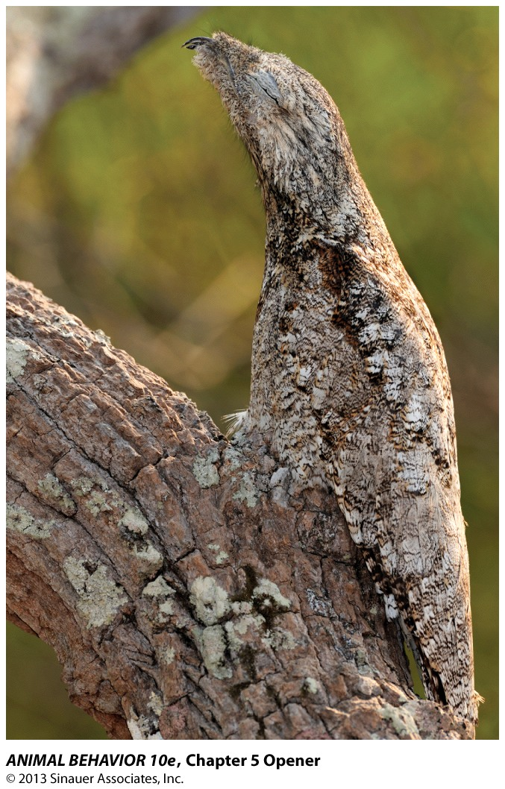 How do its’ predators find the great potoo? = Every time you capture a prey, your visual representation or search image becomes stronger!

Why do some animals look so conspicuous?
- Batesian Mimicry = mimicry in which an edible animal is protected by it’s resemblance to a noxious one that is avoided by predators
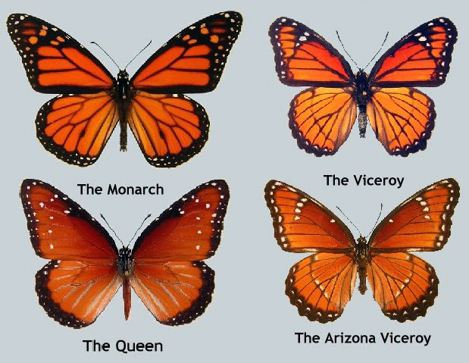
- Why are monarch butterflies so colorful?
  - To make the bird learn that they get sick after eating one butterfly because of the toxins they contain from feeding off of toxic milkweeds as caterpillars. Birds are good at associating visual images with being sick = learn by having a few encounters with them.
- Mimicry is an adaptation of how predators hunt = visual dimension is what birds are most sensitive too!
  - If the butterfly were dull colored, it would be hard for birds to distinguish it
- There are other butterfly species that make themselves look like monarchs and that’s they survive because birds avoid their coloring and pattern which resembles those of a monarch and birds learned not to eat them!
- Another ex is the gazelles stot (to leap several feet in the air to scan ahead for predators or tell predators they have seen them and have plenty of energy). For stotting to evolve, both the gazelle and cheetah have to benefit from the interaction = stotting is a honest signal indicating thst the stotter will be harder to capture and makes it advantageous for cheetahs to accept the attck deterrence signal and call off the hunt to avoid wasting time and energy.

Optimality Theory: the notion that adaptations have greater benefits-to-costs ratios than the putative alternatives that have been replaced by natural selection.
- Ex) northern bobwhite quail = spend winter months in small groups called conveys (2-22 indivs). An Intermediate group has 11 indivs = they gain from protection against predators. Members from larger groups are safer from attack from overall group vigilance (at least one member with head up and scanning) = larger groups react more quickly. Although, there is greater competition for food, so they move more each day than the group of 11.
  - Intermediate group has the best of all situations = survival rates are higher in winter!
- With foraging decisions = get enough food to survive and reproduce, the various behaviors come with costs and benefits.
  - Ex) northwestern crow hunting for food on a tidal flat in BC = spots a clam, mussel… picks it up, flies up and drops it onto hard surfaces. The adaptive significance = it can’t use its beak to open hard shells. Zach made predictions…
    - 1) They flew up with large whelks to about 3.5 to 4.4 cm long
    - 2) The crows flew up about 5m to drop them
    - 3) Kept trying till they broke
  - He concluded that the caloric cost of gathering food has to be less than the caloric benefits gained by opening whelks.
    - Ex) calories to open whelk (0.5 kC) and subtracted from food energy in whelk (2.0 kC) = net gain of 1.5 kC. Dropping medium sized whelks = net loss is 0.3 kC because many more drops.

**Focus on prey that 30-45 mm mussels and those not covered in barnacles! – they do!

OT fails to consider the trade offs between foraging success and predation risk = would fail to predict the dugongs’ behavior accurately
- They feed off sea grasses and pull them from the root called rhizomes or crop them. By cropping the grass, they strip quickly and leave and scan properly for enemies but don’t secure as much energy compared to pulling them from the roots = but when pulling from roots have increased risk of predation because the heads are buried in the ocean floor and they cannot see well.
- Another ex is elk where they thrive in meadow with an abundance of food but change foraging behavior when wolves come and hide in woodland where they’re harder to find = elk pay the price (less food and less chances of giving birth and less chances of having half until winter has decreased too). To reduce the chance of getting killed, the lower their energy intake, which increasing chances of malnutrition.

Frequency-Dependent Selection (Game theory + feeding behavior)
- An evolutionary process in which the fitness of a phenotype depends on its’ frequency relative to other phenotypes in a given population.
  - Ex) human flu virus = spreads through the community, but after a while, because it’s so common, some people develop a resistance to it = high frequency of virus leads to it’s demise. This virus does better in its’ earlier stages. Adds space for an alternative strain of same disease.
  - Ex) in textbook = Scale eating sicklings (right and left skewed jaws). The right jawed sickling is good at going up on the left side = animals don’t like this, so they adapt well enough to know these fish will attack right away on the left, so they defend the left side, but leave the right side vulnerable. So there are more left-sided skewed jaw genes
- Balances occur between frequency-dependent phenotypes in a population

“Paper-Scissor-Rock” in male side-blotched lizards
- 3 color morphs with different behavioral phenotypes
  - Orange (Ultra-dominant, large territory and harem of females)
  - Blue (dominant, small territory, single female)
  - Yellow (“sneakers”, no territory, and no female)
- Frequency-dependent = each of the morphs does well against one but not the other.
  - Yellow = called sneaker because they look like females and they sneak into the harem of the orange lizard and can’t distinguish between the two and the yellow starts to mate with the orange’s females.
  - Orange = cost of orange? = they don’t live as long as blue or yellow because of the high levels of testosterone.
  - Blue = how do they live longer? = they don’t have a big territory to defend (less energy is used to protect it and less females to protect compared to orange)

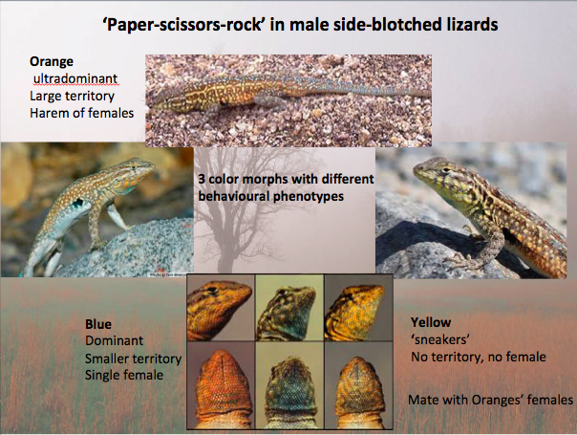

Predator avoidance
- Some animals forage at night because they’re predators are daytime foragers, but then the predator might adopt a night time foraging behavior (or vice versa for the prey).

Conditional Strategy: an inherited mechanism that gives an indiv the ability to alter its behavior adaptively in light of the conditions it conforts.
- Ex) socially dominant competitors on the beach
- Left- and right- jawed cichlids where they’re locked into a behavior phenotype = can’t alter behavior.

Oct. 28

Ch. 10 (Distinguishing Proximate/ Ultimate Questions)
- Alcock’s been mostly focusing on Ultimate questions
- We’re now going to focus on proximate analysis of behavior

Emphasis to read p.294 = Connecting 4 levels of analysis
- Don’t need to have a proximate/ultimate understanding to have a complete understanding…need to know how each behavior came to be from evolution or consequences of evolution.

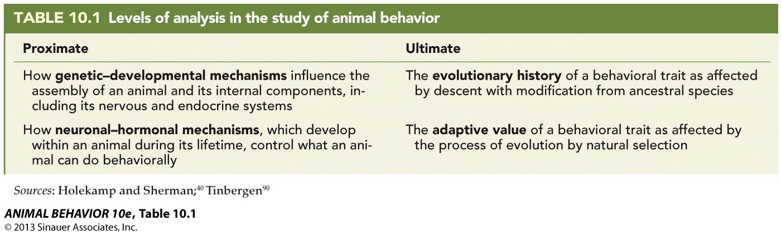

All mammals have differences, but also similarities = i.e. the structure of the brain (the way it’s organized) have a similar look and pattern (includ. Humans).

Biological conservation among species = mammalian brain works the way the mammalian brain works – so if we’re looking at one aspect in one species’ brain; it doesn’t matter which species because we’re learning something about ALL mammals!
- They reflect variations as a consequence of evolution

Levels of analysis in the study of animal behavior (table above 10.1)
- Proximate and ultimate questions

Recruitment patterns in the honeybees (2 types of activities)
- Forager bees = go out and collect nectar and bring it back to the hive.
  - When they come across a new source of food, they go to the nest and do a dance – which indicates to others in the hive the direction and distance to the food source.
- Scouts = go out to find a new location for a hive
  - When a new queen is born while a queen is already in power, that new queen must leave to start a new nest.
  - When they come back to the hive, they do a dance, which indicates distance and location of newly found nest.
  - Both do dances for 2 types of situations = waggle dance for a nest location is a different behavior from the waggle dance for a food source = they do less waggle dances when they have an more and more successful runs (finding new locations).

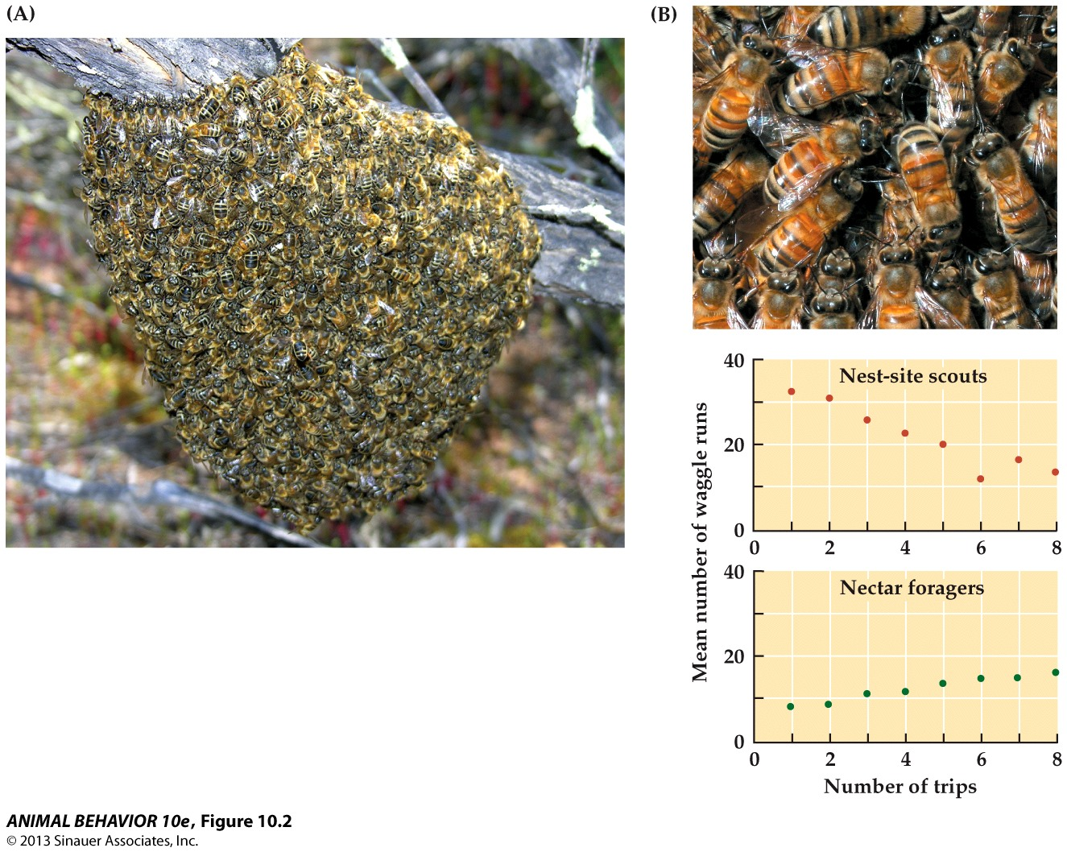

- Waggle run = waggles in a circle (point on graph indicates a waggle run)
  - Waggle dance = transmits info
  - To recruit a lot of bees, have to redo this waggle dance over and over.

Discussion Q.
- The difference in the way they behave is perceived differently by different bees in the colony.

Studying proximate mechanisms of behavior in the experimental psychology laboratory: the hippocampus and spatial-information processing (NOT IN TEXTBOOK)
- Use mice/rats or birds
- A lot of different approaches to asking questions about a mechanism = converging operations = different ways we look at something, converge on the same approach or converge onto same results or prediction.

Radial-arm Maze (elevated off the ground)
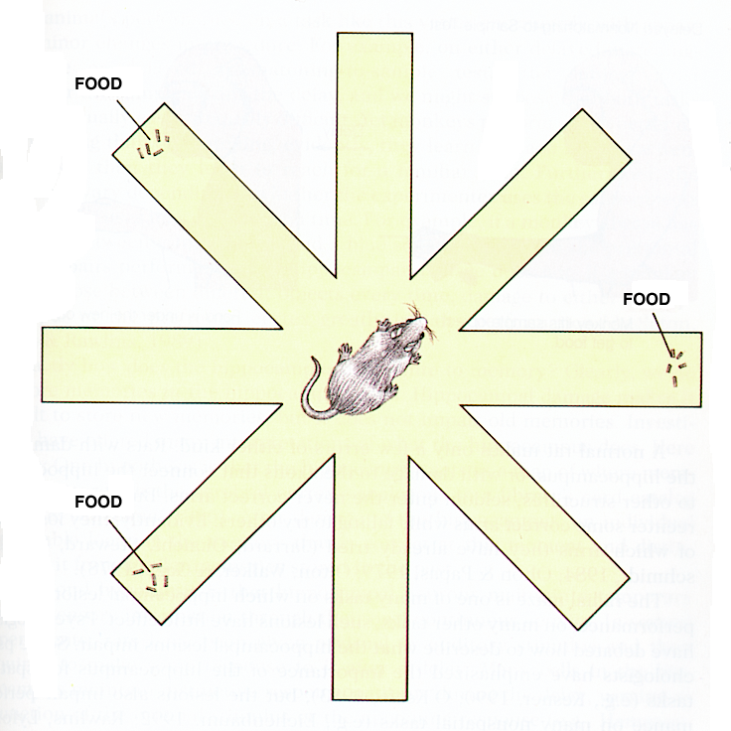
- Used to study spatial memory of rats (spatial navigation)
- Use spatial info for the environment they’re in = need to have certain brain mechanism involved
  - Ex) simplest task = bait at all arms of maze. Key feature is the food wells are located at the very end, so the animal can’t see the food.
  - Watch where the animal goes and ends when animal successfully eats all the food
  - They make relatively random trips to all arms, till they eat all the food, but the first time they were placed in the maze, they made several return trips to the wells they’ve already ate from = errors. After a few trials, the error rates decrease = means they learned something.
- One can ensure that the mice learned something because they’re using certain types of spatial info or they smell themselves in the arms they’ve already visited – they use neural-factor cues.
- Eliminate the way mice use olfactory cues and move the structure around in respect to the arms being in the same place after taking the mouse out.
  - If their behavior is following the rotation of the maze, the mouse is following a cue within the maze.
  - Extra-maze cues (cues outside the maze!) = visual and spatial info
    - i.e. painting on the wall or coats.
- If rats have experience in the maze and you turn off the lights, they will use their spatial representation of the maze to get around, but if they had none, they would have to use the spatial information that have (in-maze cues)

Water Maze (25 cm deep with 20 cm of water)
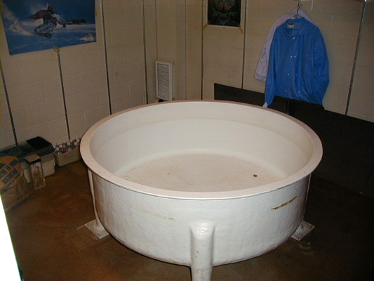
- Escape platform = below the surface of the water, so rat can’t see it
Non-visible platform
- Place a rat in different starting locations in the maze = 1st trial, they will swim around and they’re a bit scared, but by the 2nd and 3rd trial, they start getting used to it.
  - Ex. Of procedural manipulation of behavioral changes?

- If you look over trials = latency to find the platform gets better. The line drops off after a # of trials
  - Successful trials = start in different locations, if you placed in the same spot through all trials, they wouldn’t have to learn where the platform is = they would just know which direction to swim in to get to it.

Probe Trial (platform removed from the water maze)
- We expect the rat to swim where the platform used to be or just swim around the area = the time spent swimming in the platform quadrant
  - If swimming randomly, expect 25% of the time spent in the platform quadrant.

Hippocampus lesion surgery = after a certain amount of trials, they get just as good as the controls
- Reinforces that the hippocampus is needed in spatial-information processing

1) 2)

2 different ways animals are solving the problem (with or without the hippocampus).
- Circle 1 = control rats (with hippo.) will swim in the top right hand corner for more than 25% of the time.
- Circle 2 = hippocampus-disrupted (Without hippo.) will keep swimming in circles and stay near the wall (can get out that way)
  - Hippo.-dependent animals find something without spatial knowledge

Response characteristics of neurons in the Hippocampus
- Group of cells in hippocampus:
  - Place cells
  - Grid cells
  - Edge cells
- Means that these cells prefer to fire at specific stimuli. Selectively respond to stimuli.
  - Ex) place cells are neurons that fire at something in a specific place or position in the environment or animals being in a certain environment (particular place in space)
- The place cells don’t selectively fire when an animal first discovers or lives in an new environment, as the animal develops a spatial representation of this environment do these place cells develop preferences to a position the animal is in.

- Correlation between hippocampus size or circuit-level changes in the hippocampus and spatial memory ability in same species.
  - Ex) monogamous and polygamous fouls.

Nov.2

Monogamy in brain Physiology = looking at genetic basis.
- The V1a receptor protein is encoded by an avpr1a gene (lacking in polygamous prairie vole). This extra gene has a developmental effect
- Females prefer a mate with this gene (males are more monogamous and paternal)
- If you transfer the genes into a brain that’s lacking them = it produces more V1a proteins and enable the animals to form bonds

Songbird learning (Ch.10)
- Similarity to the development of speech (reason psychologists are interested).

Hearing songs in a bird’s environment is critical to mimicking the songs heard in their dialect or species.
- Birds reared in isolation don’t get that opportunity but if they listen to tapes of those songs, they should be able to sing that song in time. They sing on schedule when older.
- If you played a song of another species, the bird would mimic that dialect

If a bird can’t hear itself sing (deafened before it could vocalize) will never produce anything like a normal song or duplicate a copy
- The ability to hear oneself sing is critical for development of a complete song.

If young, isolated, hand-reared birds listen to songs only listen to songs of other species, they won’t duplicate the song but will incorporate notes from that other bird species’ song into their complete song later on.
- Ex) White-crowns listening to sparrow songs
- They develop aberrant songs similar to those male birds that never heard a any song bird at all.

- Imitation = rare type of learning in the animal kingdom
  - 4000 species of songbirds – 10% is diversity of song learning
  - Don’t have innate knowledge of adult songs (they have to learn it)
  - Very common = only learn to imitate the songs of their own species (males sing, but females call)
  - Songs are a function of attracting mates during breeding season.

- Difference in which species sings or not (usually only males) and whether it’s a function of attracting mates.

- Common themes among diversities
  - General aspects of songbirds that have been conserved (of genetic history)
  - Learning occurs during a juvenile sensitive period = which means in the 1st spring that a nestling is born, is when it learns the song.
  - 2 phases to learning a song:
    - Sensory Learning Phase = exposed to adult versions of song (either of father or other adult neighbors). They learn what the song they’re going to sing in the future, is suppose to sound like.
    - Sensory Motor Learning Phase = slightly longer phase. Bird is emitting sounds, hearing own vocalization and gets auditory feedback to try and get closer to adult bird song.
      - Last phase of sensory-motor is the crystallization phase = emitting the song its’ going to sing it’s entire life.

By listening to it’s own plastic song (incomplete versions of the more complex full song it will eventually sing) and comparing those sounds to its memories of hearing the full song = able to shape it’s own song to match it’s memory. When it a good match, it repeatedly “practices” the right song = crystallizes a full song!

Social acoustical experience can override purely acoustical stimulation during the development of song learning = white-crowned birds reared in isolation hear adult sparrows sing but can’t see them, but learned the social tutor’s song.

- Auditory feedback is a very important part of sensory-motor phase! If a bird is deaf before the sensory learning phase, it won’t produce a proper adult song ever! Will develop an abnormal song.
  - Auditory input is also important for the beginning of sensory motor learning (learning the songs you’re trying to vocalize!)

- Animals reared in isolation during their sensitive period and don’t hear song, don’t develop songs. But that changed later on = if they hear a song of another species in the sensitive period, they will produce a song that resembles those of the others species.
  - Benefits from hearing a song from another species (social context)

- Birds of the same species in different locales have different dialects (they sound generally the same).
  - Not genetic, but experience-dependent
  - Lines of evidence that shows the importance of song imitation? (possible exam question)
    - If the bird is exposed to the song, during their sensitive period, of the neighboring locale, it will sing the dialect.

- Selective on the info it lets in = song of its’ species
  - Ex) bird hatches but hears multiple birds singing (the father, other adults, neighboring adults of another locale…), but it sings only one song (song of its’ species).
  - Birds can acquire songs of another species, but it doesn’t always happen
    - Song selection by bird is dependent on imitation.

2-3 months of age is restricted to a sensitive period (sensory-motor learning phase)
- 3-4 months is too late to learn a song
- 1st year exposed to an adult song, but that bird won’t produce a song itself till next spring because it’s not old enough to mate. But during that period, there won’t be further exposure to songs and no vocalizing either. Learning occurs during the sensitive period before and because they don’t have exposure now means that it’s been store in long-term memory = permanent.
  - Long-term memory = auditory template = what kind of evidence for auditory template make a song innate?
- Sensory learning phase = selective for remembering species-appropriate song
  - 2 phases of sensory-motor phase:
    - 1) Subsong (like a babbling baby) = young males can’t help but sing, they make soft, rambling vocalization). No evidence of imitation
      - Activity in brain system is involved with song production
      - Learning to communicate through sound.
    - 2) Plastic song (most modifications occur) = phrases that correspond to the adult song.
      - Long period, it could last for a couple of weeks
      - If something happens mid-plastic phase, can sing immature song

**Sensory learning (over weeks while in the nest) = long term memory
**Sensory motor (a year later with no exposure to songs)

Functions the brain can carry out = Important things brain has to accomplish
- 1) Song Motor Command
  - Syrinx = larynx equivalent (mammalian)
- 2) Vary motor Commands in the auditory template
- 3) Auditory Feedback
  - To compare songs and learn
- 4) Comparator Mechanism
  - Comparing the auditory template goal to what the animal is producing.
  - When they differ (auditory feedback), there is a variation, so when they sing next time, there’ll be variability in the song. If the auditory feedback match, the next time they sing, it’ll be the same song.
  - Brain mechanism that produces variability, but if they match (2 inputs to the comparator) = it has to produce the same song, but produce different songs = 2 different inputs.
  - Means for comparing attempted songs and desired songs

Important neural circuitry (Figure 10.14)
- Song learning system of typical songbird
- HVC (higher vocalization center) = forebrain
  - Cortical structure
- Projection neurons to RA (projects to motor nuclei, in the brain stem = controls syrinx)
  - Motor nuclei is involved in production of songs.
- 1) HVC -> projection neurons to RA -> motor nuclei -> Syrinx (referred to as the song motor pathway (SMP)).
- Another part involved in learning (anterior forebrain pathway – AFP)
  - HVC to lman (thalamus) (lateral) = receives input from projection neurons from HVC
  - Then HVC sends projections to area X and both projections from lman and area x to RA (where learning mechanisms are located, like the comparator).
- 2) HVC -> neurons projections to lman and area x -> RA

HVC and RA communicate with the nXIIts, which connects to the syrinx (larynx human equivalent) = suggests that these brain elements have control on singing behaviors.
- Hypothesized that if there was destruction or removal of RA = devastating effects on bird’s ability to sing because neural messages from the RA cause songs to be produced.
- RA plays an imp role in controlling bird songs
- RA grow in males that are exposed to high-quality (longer) songs =males singing songs that are attractive to females = other eavesdropping males benefit from this.

lMAN are reduced or absent in birds that don’t learn their songs. Lack in vocal learners.
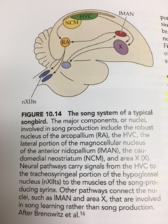

The synapses in the RA are modifiable, so if the input comes from the SMP, the synapses don’t change, but will change if the input comes from the AFP (synapses change and output is different).
- RA is bigger in males of most songbird species than females
- Lman and area x (sensory learning)
- Motor nuclei = dictation detail of how the song will change
  - Also known as nxiiTs

3 Avian orders are song learners = parrots, hummingbirds, and songbirds
- Did the song learning ability exhibited by the 3 groups of birds evolve independently or not?
  - To check this, we have to identify the brain structures that are involved with their singing abilities = kill the birds and examine the places with ZENK gene. Activity maps for these 3 species of Avian have strong similarities:
    - Cells from NCM activate their ZENK genes when exposed to songs. NCM located roughly in same part in all 3. When they vocalize – the anterior part of the forebrain responds with heightened ZENK gene activity.
  - Against that the song learning abilities evolved independently.

Song dialect learning has a reproductive disadvantage = time, E, and special neural mechanisms that this behavior requires (Darwinian Puzzle). What are the benefits?
- Advantage = 1) males can fine-tune their song as a dialect that can be transmitted in the habitat they live in
  - Learns from older male neighbors
  - How environment influences the evolution of communication of songs = white-crowns in densely vegetated habitats sing with slower trills and lower freq. Satin bowerbird and great tit sing with how freq. in dense forests.
  - Adjust songs to different conditions
- Advantage = 2) match songs of singer’s social environment
  - Should learn from territorial neighbors = as social tutors = use this as a way to tell neighbor that they recognize that male as an indiv and he was not a novice competitor, but old enough and experienced to have utilized info from neighbor’s song.
- Ability to produce songs of rival neighbors is a characteristic of the song sparrow = learn their songs from tutors (neighbors). Their final repertoire is similar to the immediate neighbors.

How does a bird benefit from song-matching? = can signal a threat signals with a match telling the neighbor they’re highly aggressive or can signal a desire to back off with an unshared song – while a song match might signal intermediate aggression.
- Matched songs generate a more highly aggressive or intermediate aggression while a song that was an unshared type generated a less aggression response

Modulating song challenges is truly adaptive! Duration of territorial tenure should be a function of song types a male shares with neighbors = # of years male holds territory increases about 4x as the # of song types shared with neighbors goes from less than 5 to more than 20.
- To form long-term associations in sparrow communities is to advertise their aggressive intentions.

Female Preferences and Song Learning
- Learning the dialect associated with location of birth place = make males announce their possession of certain traits well adapted for certain areas
  - Females hatched in that area have a preference for males that sing the local dialect = endow offspring with genetic info to promote development for locally adaptive characteristics.
  - Ex) White-crowns in Tioga Pass, California sing the local dialect were less infected with a blood parasite = females use this information to secure healthier mates. Males that didn’t match the song of the local dialect, fathered less offspring.
  - If females have a preference to mate with males produced in their natal area, they should prefer males with the local dialect they heard as nestlings!
    - Males aren’t locked in local dialect, can change it if they move to another area so females can’t rely on that information solely for birthplace info.
- Another hypothesis is that females get information from that sing about their developmental history = can tell if they’re unhealthy.
  - To acquire a mate that has genes that worked well and that are worth passing to offspring.
  - In song sparrows, males that have a larger repertoire have a larger HVC and are also in better condition due to larger fat reserves and apparently a robust immune system.
  - Ex) European warbler females prefer males with larger repertoires.
    - Song-rich sedge warblers bring more food to their offspring, which grow bigger, which almost raises the reproductive success for females

Indicators of male developmental history
- One hypothesis = quality of vocal learning (song learning occurs when males are very young and grow rapidly = if rapid growth is hard to sustain, if males are handicapped by genetic defects and nutritional stress, will result in suboptimal brain development).
  - Even with the slightest deficient brains may be less able to meet the demands of complex song learning
  - This was tested by Nowicki where they controlled what 2 groups of birds ate = controls ate whatever they wanted, whereas another group received only 70% of what the controls had. After 2 weeks, birds can feed themselves and the control weighed 3x more than the 70% less group = this nutritional stress period was brief, but had large effects = components of the song system were significantly smaller and also sing poorer copies of songs.
- Nestlings exposed to nutritional shortages after hatching have smaller HVC
- It can also effect the ability to sing species’ song = when split into 2 groups (high-protein and low-protein), the birds with the better diet grew larger and solved the a food related trial-and-error task faster.
- Superior diets translate into birds with superior learning abilities, which can affect the ability of a male to forge efficiently and come into play for paternal males.

Do females pay attention to information encoded into the males songs? Nowicki tested this = copied the songs of song sparrows from tape tutors with varying degrees of accuracy and played them to females
- Females can be hormonally primed to respond with a tail-up precopulatory display to male songs they find sexually stimulating. The more accurately coped songs are sung, the more precopulatory displays!
- Stressed out young males sing less and shorter songs = females prefer songs more difficult to produce.
  - Ex) the faster a male swamp sparrow sings its trilled song, the harder it is to sing.
  - Ex) female Serins prefer males that sing a high frequency, another physiological challenge.
- Females are in effect favoring males that are healthy and in good condition = superior donors of genes or caregiver to offspring

Proximate ways = if we want to understand why white-crowns from Marin and Berkeley sing somewhat different songs, we have to understand how the song control mechanisms develop. White-crowned males and females differ genetically = create different gene-environment interactions – they affect:
- Brain and Nervous system

The proximate differences among white-crowns generate differences in their dialects have an evolutionary basis = lineages leading to today’s white-crowns differed in song control system + ability to learn a dialect accurately.
- If genetic differences among males were translated into differences in acquiring a dialect = desirability as mates or capacity to cope with rival mates, NS would have resulted in the spread of those hereditary traits with greater reproductive success.
- The male that made the greatest genetic contribution to the next generation = supplied more of the genes available to participate in the interactive developmental processes within members of that generation.

Hippocampus is imp in proximate cues (lines of converging evidence – possible Qs)

Place Cells = fire in a particular place (in the hippocampus) = respond strongly to being in a particular spot.

Neuro-etiological studies (3rd line of evidence)

Food storing and cashing
- Hippocampus is larger in birds that use this food cashing = need to remember where they hide 1000s of pellets of food in a large space. Remember which location they got food from already.

Prairie Vole (monogamous) vs. Meadow Vole (polygamous)
- Difference in behavior = different mating system
- Brain of male prairie vole has a bigger hippocampus in the polygamous species.
- Meadow vole (larger hippocampus in the spring) = they have a large space to breed because they have to look for females (need spatial info)
  - Hippocampus changing on a seasonal basis = we don’t see this change in monogamous species
  - Hippocampus in male and female prairie vole don’t change, they’re the same.
- 2 complementary evolutionary or ultimate explanations for their unusual mating system:
  - The adaptive value of the trait
  - Long-term history dealing with proximate factors
- Male prairie voles contain a protein receptor that binds chemically with a hormone called = vasopressin, which is produced + released in bloodstream when they copulate several times with a given female. Vasopressin carried to the Ventral Pallidum (near base of brain that provides rewarding sensations!) – receptor proteins called V1a are stimulated by vaso. They trigger activity in the receptor-rich cells = affects neural pathways that provide positive feedback for this mating behavior!
- Reward system in polygamous brain is different = V1a receptors are less numerous and don’t get same kind of feedback when they copulate.

Nov. 4

Search image is an evolved behavior of cryptic behavior (they act the way the object they’re mimicking does)

Mimicry of monarch butterflies = other insects that have similar colors and patterns to match the monarch for example.

ZENK = a gene that codes for a specific product ZENK
- When italicized = refers to the gene
- When it’s not italicized = refers to the protein

- ZENK is a protein that is a transcription factor, which controls the activity or expression of other genes
  - It only appears in certain brain structures associated with auditory processing.
  - Ex) zebra finch hear a song of their own species, the ZENK protein is strongly produced in the nuclei that controls song production. Again, ZENK is a transcription factor that is a regulatory apparatus that determines whether info from one or more genes is expressed. What these other genes do when the bird song appears affects which proteins appear in the connections between brain cells (synapses) = ZENK and the genes the protein regulates influence how one nerve cell communicates with another = changes in the connections can alter the bird’s behavior.

- Many genes are involved in the process of the way synapses operate = with the activation of ZENK, other processes then occur by changing their synaptic plasticity
  - It sets the stage for neuroplasticity that is involved in the changes in behavior for learning songs.
- Birds that learn songs = changes in the brain
  - How the ability to localize the expression of ZENK in neural circuitry for song learning? = the bird has to perceive, produce the song and change the way it produces that song.

Evolution of multiple specialized learning-memory systems
- Learning and memory abilities are adaptive specializations (shaped by NS to solve specific problems posed by an animal’s environment)
- Problems are characterized by the demands they place an encoding, storage, and retrieval of information.

Functional incompatibility (2 different learning problems)
- Rules that underlie storage, retrieval…for one problem is incompatible with another different problem.
- A system that is specialized to serve a certain function will not be able to serve this certain function because of it’s specialized design.
- The specific properties of the system that make it effective for one memory problem, render it incompatible with the demands of other memory problems.
  - Incompatible because it’s a different design.

Song learning and food-storing appear to have same incompatible functional requirement
- Properties of song learning
  - Restrictions on what is admitted to memory
    - If a crow hears a crown sparrow song during the sensitive period, it will sing that song
  - Restricted learning period
  - Long-periods of retention without modifications or decay (auditory template doesn’t change)
- Properties of Cache recovery
  - No restrictions on what kind of spatial locations can be remembered
  - No restricted period during which cache sites can be remembered
  - Continuous turnover of remembered locations
    - Remembering of 100s of spatial locations

- Some indivs have same abilities
- To remember all locations for feed caching to do it properly there is no restricting spatial info = incompatible to song learning because you can’t know massive amount of info for both problems
- Not to be restricted to a sensitive period to produce a song and learn where they stored food.
- Brain circuitry in songbirds that learn aren’t in the birds that don’t learn songs

Ch.11 – Nature vs. Nurture Controversy

Proximate analysis = rat mazes
- Tools that behavioral neurobiologists use to understand spatial mechanisms in the brain + structures
- By lesion of hippocampus = leads to conclusion of what that area can contribute to a task.

