The Economist as a Scientist

The Scientific Method: Observation, Theory, and More Observation
- Development and testing of theories about how the world works
- The use of theories and observations used in physics is also used for economics (Isaac Newton)
  - Ex) An economist might notice prices rapidly rising and would want to find out why
    - He would collect and analyze data
    - If he finds a link in his data, he would be confident is his theory
- Economists can’t do experiments because they can’t adjust a nation’s monetary policy to see what would happen, therefore, they must use whatever historical data that has been produced in the past
  - Ex) War in Middle East interrupts flow of Crude Oil
    - Oil prices increase globally
    - Depresses living standards of most consumers
    - Economic policymakers have difficulty on how to respond
    - Economic scientists get an opportunity to study the effects of a key natural resource on every nation’s economy
The Role of Assumptions
- Assumptions can simplify the complex world and make it easier to understand
  - Ex) To study international trade, we can assume that the world only consists of two countries
    - Allows us to clearly understand the concept by focusing our thinking on a simpler scenario
- Different assumptions are made when studying the short-run vs long-run effects of inflation

Economic Models
- Like anatomy, models are also used by economists to learn about the world
  - Composed of Diagrams and Equations → Allows us to see what’s important

First Model: The Circular-Flow Diagram
- The economy consists of millions of people engaged in hundreds of different activities
- Circular-Flow Diagram simplifies the way we think about activities and represents how the economy is organized and how individuals interact with each other
  - Two Types of Decision Makers → Households and Firms
    - Firms produce goods and services using inputs; such as the factors of production
    - Households own the factors of production and consume goods and services
- Interactions of firms and households occur in two markets
  - Markets for Goods and Services → Households are buyers, firms are sellers
    - Households consume the outputs of firms
  - Markets for the Factors of Production
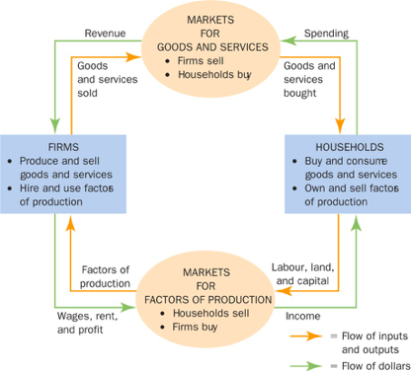
- Therefore, CF diagram simplifies economic transactions that occur between firms and households
- Inner loop -- Represents flows of inputs and outputs
- Outer loop -- Represents flow of dollars. Read P1 Page 25
- Example P2 Page 25
- A more complex diagram would include the role of government and international trade

Second Model: The Production Possibilities Frontier
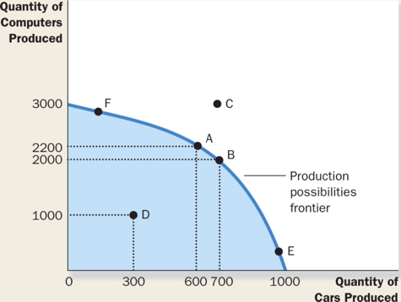
- Assumes that economies only produce two goods
- The endpoints of the PPF represent extreme possibilities
- A PPF would most likely like to produce more or less an equal amount of the goods
- Due to scarcity, an economy cannot produce unlimited goods, like point C
  - Not enough factors of production
    - Must produce within the line
- An outcome is efficient if the economy is using all of its factors of resources efficiently
  - On the line
- Anything inside the line is inefficient
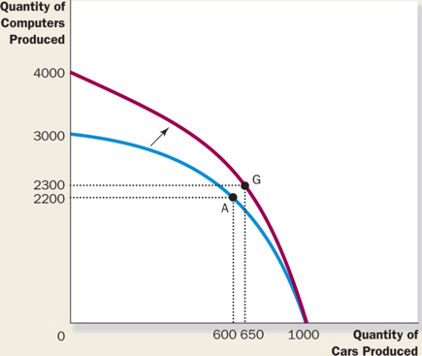
  - Unemployment
- Tradeoff: What good to produce, which is more important (Opportunity Cost)
  - The slope of PPF represents the opportunity cost. Read Page 28
- The tradeoff (Opportunity Cost) can change over time
  - Ex) Advancement in technology can lead to more computers produced
    - Economic Growth (Prosperity)
      - They can enjoy (x+a) computers instead of just x computers
Microeconomics and Macroeconomics
- Microeconomics:
  - Effects of rent control on housing
  - Impact of foreign competition on Canadian auto industry
  - Effects of compulsory school attendance on workers’ earnings
- Macroeconomics:
  - Effect of borrowing by the federal government
  - Changes over time in economy’s unemployment rate
  - Creation of policies intended to raise growth in national living standards

The Economist as Policy Adviser
- Economists are asked to recommend policies to improve economic outcomes

Positive vs Normative Analysis
- Positive Statement: Minimum wage laws cause unemployment (Descriptive)
  - Validity → Confirm or refute
- Normative Statement: The government should raise the minimum wage (Prescriptive)
  - Evaluation → Good policy or bad
- Positive statements and other analysis lead to normative statements
- Positive → Scientist who describes economy as it is
- Normative → Policy advisers that try to improve the economy

Economists in Ottawa
- Most policy decisions involve tradeoffs
- Page 32, John Maynard Keynes observation

Why Economists’ Advice is Not Always Followed
- Governments don’t always take economists’ advise into consideration
- Economic policy making is a difficult tasks, which is why politicians don’t always advance on them

Why Economists Disagree
- Due to validity of positive theories and differences among values and (normative) views

Differences in Scientific Judgements
- When there are differences among positive and normative views
- Economists have different feelings towards some theories
  - Ex) Income tax vs Consumption tax

Differences in Values
- Ex) Who should get taxed more?
  - A girl who has a disability and pursued a career in acting (Lower Income, Taxed more)
  - A man who works long hours in a high paying job and received a large inheritance
- Advisers would have conflicting solutions, mainly due to different values

Perception vs Reality
- Economists sometimes offer united views
- Page 34 Table 2.2
- Economists surveyed, respondents gave their views on certain policy proposition
- Political barriers are one reason why some policies aren’t being put in place or because economists haven’t convinced the general public yet as to why some policies are bad

