UNIT 1

Evolution
- The process by which different kinds of living organisms are thought to have developed and diversified from earlier forms during the history of the earth.

Why are some organisms so good at invading new habitats?
- They aren’t picky
- They have few/zero predators in that area
- They have lots of food options/ are better at competing for food than the original occupants are.

Key points

What do invasive species effect?
- Economic, aesthetic, biological parts of the community.

Peer-reviewed primary literature
- The standard means by which scientists share their research findings.

UNIT 2

The major levels of biological organization.
Domain
Kingdom
Phylum
Class
Organism
Family
Genus
Species

Drunk King Phillip Cant Orgasm For Girls Soooo…

Ecosystem
Community
Population
Species
Organism
Organ system
Organ
Tissue
Cell
Example of Phenotypic difference
- How mussels of one species are shaped in a slow river vs. how a mussel of the same species is shaped in a fast river.
  - They have changed their morphology (through natural selection) to live more comfortably/efficiently in the environment they are in.

Morphological variation
- Differences in form and structure of an organisms bones/organs/arms/legs/etc. compared to a different organisms forms and structure. (Same species)
- Morphological adaptation examples: thick fur/blubber

Abundance vs. Variation vs. Diversity vs. Disparity

Disparity
- How physically different a number of species are from each other
  - Mussels are not very disparate (they all look the same pretty much) but are quite diverse (there’s a lot of different kinds)

Diversity
- A measure of the number of species
  - Mammals aren’t very diverse but they are very disparate. (I.E. bats vs. giraffes vs. shrews all look very different)
Abundance
- Number of individuals

Variation
- Differences among individuals in a species.

Different measures of variability at different scales

Biological scale | Examples
Differences in diversity, abundance, and distribution among major groups of life (Domains, Kingdoms, Phyla, etc.) | Bacteria vs. eukaryotes; Plants vs. animals; Arthropods vs. chordates
Differences in diversity, abundance, and distribution within particular groups (Classes, Orders, Families, etc.) | Amphibians vs. mammals; Rodents vs. primates; Old World monkeys vs. hominids
Genetic and/or phenotypic differences among populations within a species. | Human populations in Africa vs. in southeast Asia.
Genetic and/or phenotypic differences among individual organisms within populations. | Your classmates vs. you.

Anatomy of a Phylogeny (phylogenetic trees)

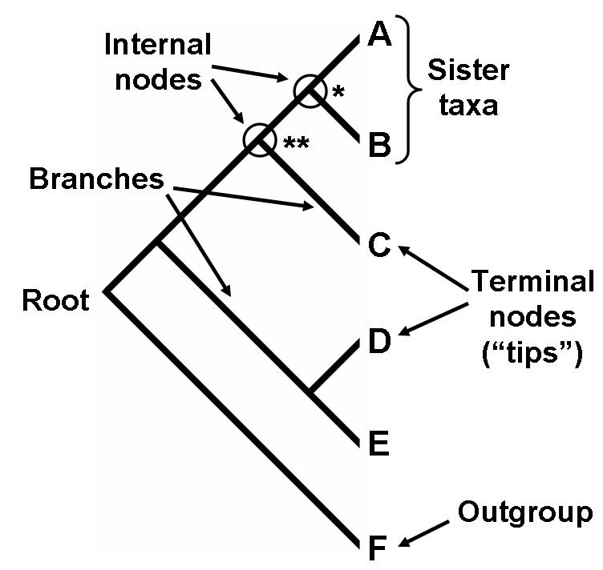

Monophyletic group
- Doesn’t leave out any descendants
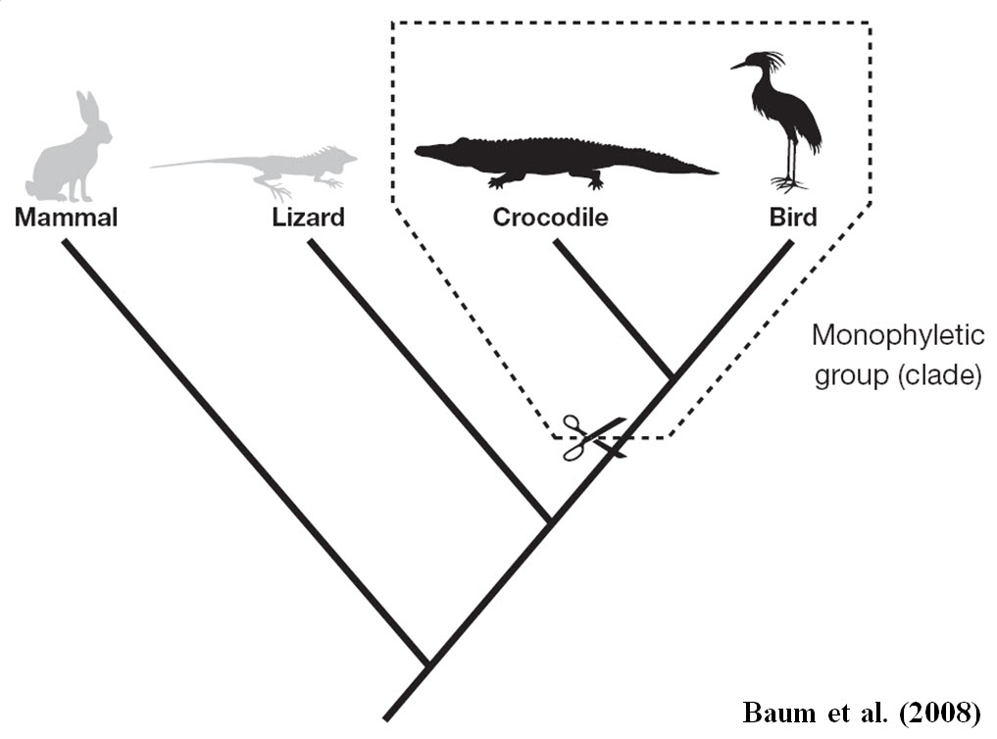
Paraphyletic Group
- Leaves out at least one descendant of a common ancestor.
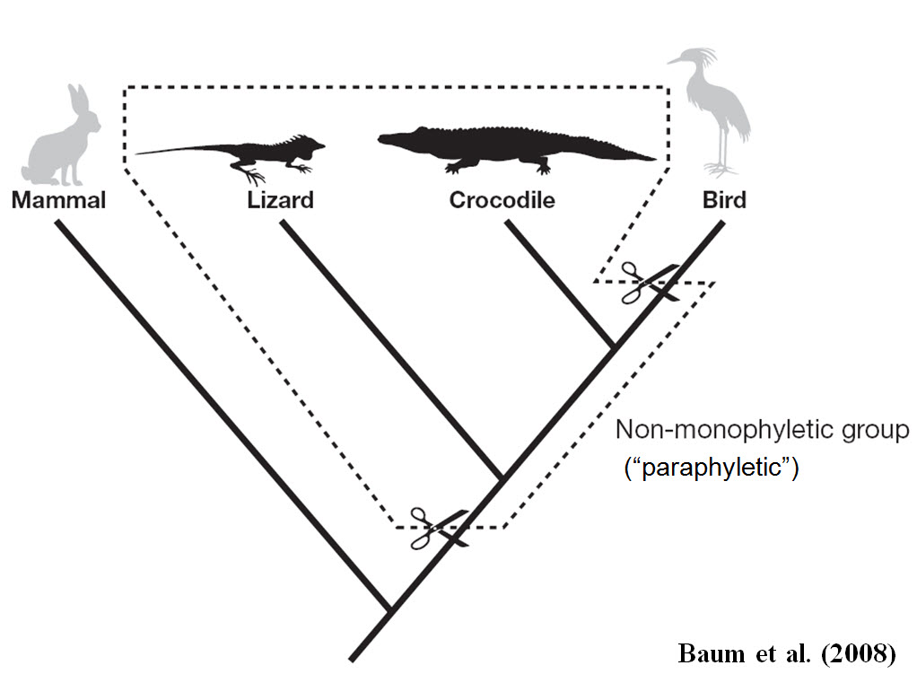
UNIT 3

Adaptation and specialization

Mutation
- The origin of new genetic variation
- Can be beneficial or harmful to the organism

Genetic drift
- Variation in the relative frequency of different genotypes in a small population, owing to the chance disappearance of particular genes as individuals die or do not reproduce.

Gene flow/migration
- The movement of genes from one population to another.
- This causes the two populations to become more similar to each other
  - Decreases genetic variability

Population bottleneck
- An event that drastically reduces the size of a population.
  - May be caused by an environmental disaster, the hunting of a species to the point of extinction, or habitat destruction that results in the deaths of organisms.

NOTE: Adaptation/natural selection does not involve changes to individual organisms in response to pressures. Think bigger picture/ longer time frame

NOTE: Exposure does not cause an individual to “become” resistant

10 really important points about natural selection

1. Natural selection by itself does not create new traits; it only changes the proportion of variation that is already present in the population. Most often, natural selection reduces the amount of variation in a population because some variants are eliminated.
2. Mutation, not natural selection, is the source of new variation. The repeated two-step interaction of mutation and natural selection is what leads to the evolution of new adaptive features.
3. Mutation is random with respect to fitness — that is, it occurs without regard for what happens to the organism. It is simply a genetic error. Natural selection is, by definition, non-random with respect to fitness. This means that, overall, it is a serious misconception to consider adaptation as happening “by chance”.
4. Mutations occur with all three possible outcomes: neutral (no phenotypic effect), deleterious (bad effects), and beneficial (positive effects). Beneficial mutations may be rare and deliver only a minor advantage, but these can nonetheless increase in proportion in the population over many generations by natural selection. The occurrence of any particular beneficial mutation may be very improbable, but natural selection is very effective at causing these individually unlikely improvements to accumulate. Natural selection is an improbability concentrator.
5. No organisms change as the population adapts. Rather, this involves changes in the proportion of beneficial traits across multiple generations.
6. The direction in which change occurs is dependent on the environment. A change in environment can make previously beneficial traits neutral or detrimental and vice versa.
7. Adaptation does not result in optimal characteristics. It is constrained by historical, genetic, and developmental limitations and by trade-offs among features.
8. It does not matter what an “ideal” adaptive feature might be – the only relevant factor is that variants that happen to result in greater survival and reproduction relative to alternative variants are passed on more frequently. As Darwin wrote in a letter to Joseph Hooker (11 Sept. 1857), “I have just been writing an audacious little discussion, to show that organic beings are not perfect, only perfect enough to struggle with their competitors.”
9. The process of adaptation by natural selection is not forward-looking, and it cannot produce features on the grounds that they might become beneficial sometime in the future. In fact, adaptations are always to the conditions experienced by generations in the past.
10. Natural selection is not the only mechanism of evolution. Mutation, genetic drift, and gene flow can also change the proportion of variants in a population.

What is a species?

Speciation
- The formation of new and distinct species in the course of evolution.

Extirpation and Extinction

Extirpation
- Means that a species still exists, but no longer in an area they were once common in.
- Not permanent (like extinction)

Unit 4

Ecology
- The branch of biology that deals with the relations of organisms to one another and to their physical surroundings.

Population
- The collection of individuals of a single species within a defined area at a specified point in time.

Population ecology
- Concerned with factors such as population size, population density, and patterns of dispersion, age distributions and population growth.

Community ecology
- The study of the structure and dynamics of animal and plant communities.

Community studies
- Examines how populations of many species interact with one another, such as between predators and their prey, or competitors that share common resources.

Ecosystem
- Is a community of organisms that interact with each other and environmental factors (e.g., abiotic factors).

Ecosystem ecologists
- Focus on the investigating processes that influence the composition and distribution of organisms. This includes the transfer of energy and cycling of nutrients.

Biodiversity
- Refers to the different scales of biological variation.
- In general, biodiversity comprises three scales of variation: genetic, species, and ecosystem.

Species Richness
- The number of species present in a defined area such as a community or ecosystem.
- Determined by plotting the number of new species observed with each sampling unit. Sampling species richness is complete when the species area curve is saturated. (Example below)

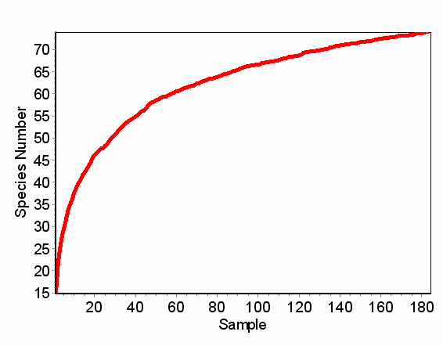
This is called a Species Accumulation Curve. (AKA species area curve)

Species Abundance
- Number of individuals per species (in a defined area)

Relative abundance
- The number of individuals of a species compared to the number of individuals of another species within the same designated area

High evenness
- Although different communities may have the same species, they may differ in relative abundance. For example, each community may contain 10 species and 210 individuals, but in one community all species are equally common
  - To have high evenness would mean all 10 species would have about 21 individuals.

Low evenness
- Although different communities may have the same species, they may differ in relative abundance. For example, each community may contain 10 species and 210 individuals, but in one community all species are equally common
  - Low evenness would mean that of those 10 different species there would be some that would be more frequently occurring and some that are more rare. (5 individuals of one species and 30 individuals of another)

Unit 5

Obligate mutualism/parasitism
- Must live with its partner species
- Example: mussels need to put their babies in the gills of fish in order to complete their reproductive cycle.

Facultative mutualism/parasitism
- Can live without its partner species).
- Example: Clown fish and anemone

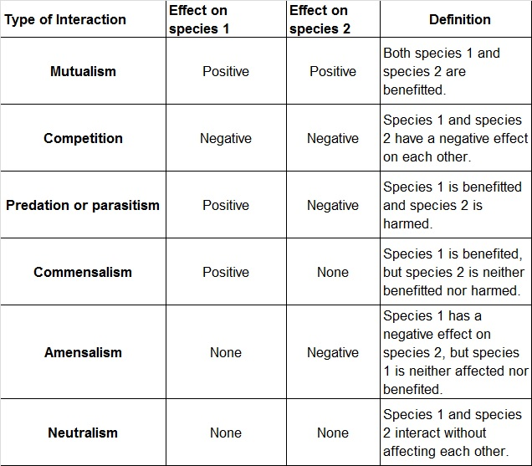

Population Growth
- Defined as the change in the number of individuals during some period of time.
- Population growth rate = birth rate – death rate + immigration – emigration.
- The calculation of population size is expressed as Final Pop. = Initial Pop + (Births) – (Deaths) + (Immigrants) – (Emigrants),

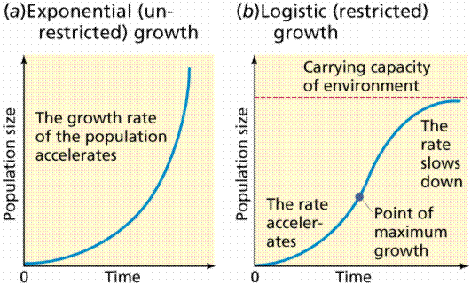

Carrying Capacity
- The number of individuals that can survive on the available resources within a given area.

Facts About Carrying Capacity:
- The carrying capacity for any landscape area is not fixed as it can be altered by disturbances that deplete resources.
- The depletion of resources is often accompanied by a decrease in population size.
- No population can live beyond the environment’s carrying capacity for very long.
- Population growth rate will begin to level out as carrying capacity is reached.

Ecosystem Ecology:
- The study of abiotic and biotic materials and their interactions within an ecosystem.

Elements are not lost from ecosystems, but rather continuously recycled.

Ecosystem Processes
- Water cycle: water circulates from the oceans, to the atmosphere, to rain, to the top of a mountain, to run down into a stream, which runs into an ocean ect….
- Mineral cycle: transfer of nutrients throughout the ecosystem (I.E. nutrients from a plant are eaten by a deer which is eaten by a wolf and when the wolf rots and dies the fungi uses these nutrients ect…)
- Energy flow: Deer eats plants which has energy it absorbed from the sun, deer gets eaten, the energy it had absorbed now gets (partially) absorbed by the animal that ate it, all the while heat is being released into the atmosphere (heat = energy)

Ecosystem Processes in a simple sense = the flow of energy and cycling of materials.
Spatial variation
- Geological/habitat/weather differences
- High spatial variation can lead to higher persistence.
  - This is because the probability of all the subpopulations of a population being affected simultaneously by some catastrophe is low when high spatial variation exists.
- With low spatial variation, the likelihood of a bad year affecting the entire population is high.

Temporal variation
- Something that changes as a result of time (examples: erosion of a river bank or depletion of a natural resource)
- Increased variation equals lower persistence.

Explanation of variation in diversity relating to spatial/temporal scales in a forest.
- Diversity will vary due to spatial and temporal factors. For example, the amount of garlic mustard will increase if foot traffic increases throughout the dairy bush (temporal) and in geographical areas favored by garlic mustard (for example, shade)

Edge effects and factors
Abiotic Factors
- Examples: Temperature, humidity, sunlight, water, wind
Access
- When resources are spatially separated and edge provides access to both resources.
- Aka more options for munch
Species Interactions:
- Many incidences of increased nest predation for birds nesting in edge habitats.
- There are more predators because edge habitats are gateways between two ecosystems, two different ecosystems = more possibility for predators!

Species Distribution
- Where a species is located compared to others of the same species)
- There are three kinds, uniform, random, and clumped distributions

Uniform Distribution
- Individuals maximize space between each other.
  - Example: plants species usually do this so they do not have to compete for resources (such as water or soil nutrients) with each other.
Random Distribution
- Individuals don’t really care/aren’t really affected by the proximity of other individuals.
  - Example: dandelions just spread their seeds wherever and let them sprout up with no apparent direction.

Clumped Distribution
- Individuals minimize the space between each other
  - Example: fish do this to protect themselves from predators, they all clump up into one giant pod of fish so that not one can be picked out
  - Example 2: animals that hunt in packs/groups do this to maximize the likelihood of a kill.

In an area with a low carrying capacity, what type(s) of distribution(s) is/are most likely?
- If the carrying capacity of an area is small, then clumped or random distributions are more likely because when resources are hard to find individuals tend to “clump” around an area with the most resources.

Unit 6

Niche
- The set of biotic and abiotic conditions in which a species is able to persist and maintain stable population sizes

Fundamental Niche
- The environmental conditions in which a species can survive and persist; however the species may not be present within all of this space

Realized Niche
- The environmental and ecological conditions under which a species actually exists and persists.
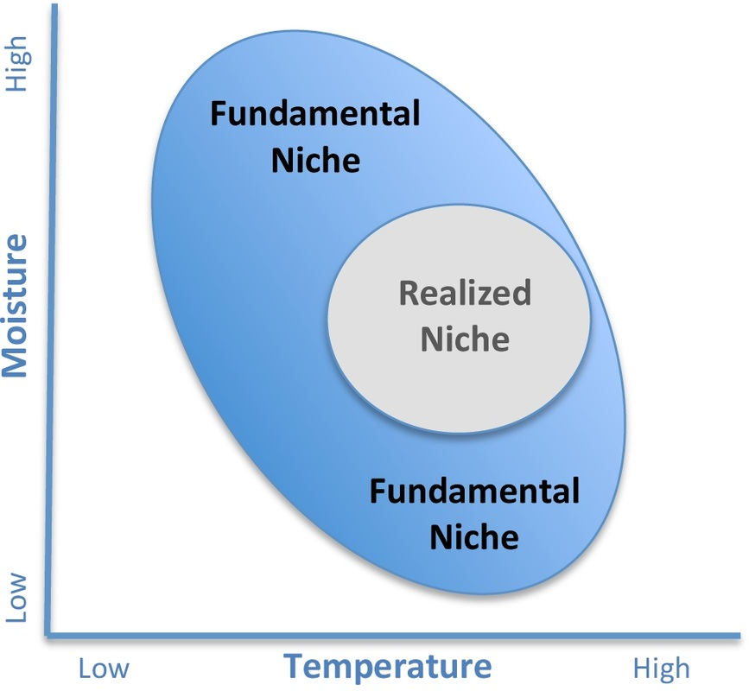
Habitat
- The environment in which a species is known to occur.
- Habitats can be either large or small scales. For example, the habitat of woodland caribou is boreal forest biome, whereas a species of lichen may only occur on acidic rocks.

Habitat diversity
- The range of habitats present in a region
- Having more habitats (high habitat diversity) is often correlated with higher species richness in ecosystems.

Functional traits
- Those traits that are uniquely adapted to an organisms ecological niche; such as body size, tolerance and sensitivity to environmental conditions.

Functional diversity
- The diversity of functional traits of all the species in a community/ecosystem.

Ecosystem engineer
- An organism that modifies creates or destroys habitat and directly or indirectly affects the availability of resources to other species.
- Causes physical state changes in biotic or abiotic materials.

Niche construction
- The process in which an organism alters its own (or other species') environment, often but not always in a manner that increases its chances of survival.

Competitive Exclusion Principle
- When two competing life forms attempt to occupy the same niche, one will drive out the other.
- Competitive exclusion happens when two species/organisms are competing for the same limited resource.

Character Displacement:
- The divergence of adaptations or other characteristics in two similar species in locations where the animals share a habitat.
- This happens because of competition between the two species in areas where their ranges overlap.
- Example: bird A has a smaller beak than bird B when they are found on the same island (this is so bird A will eat the smaller seeds and bird B will eat the bigger seeds) but when they are on separate islands (bird A on one and bird B on the other) they have beaks that are more intermediate than when they are together.
Abiotic factors affect species distributions in a positive and negative ways
- Example: lots of wind could increase the dispersal of dandelion seeds, and increase the size of their realized niche.

Co-existence at reduced carrying capacity:
- When a species enters another species’ habitat and the number of individuals of species one begins to drop (because of the competition for resources)
  - The carrying capacity of the first individual has been reduced because of the competition for resources with this new species.
- Species one is black species two is blue
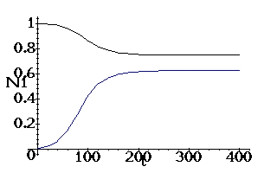

Alpha Diversity
- “Average species diversity in habitats/sites” COMBINED WITH “total number of species in one habitat (woodland or field or…)”
- High alpha diversity: lots of different species and similar abundances between species

Beta Diversity:
- Differentiation among habitats in an area. I.E. if habitat 1 has species A B C D and E in it and habitat 2 has A B and E in it then beta diversity is 2 (C and D)
- High beta diversity: two very different habitats.

Gamma Diversity:
- Total number of species in multiple habitats.

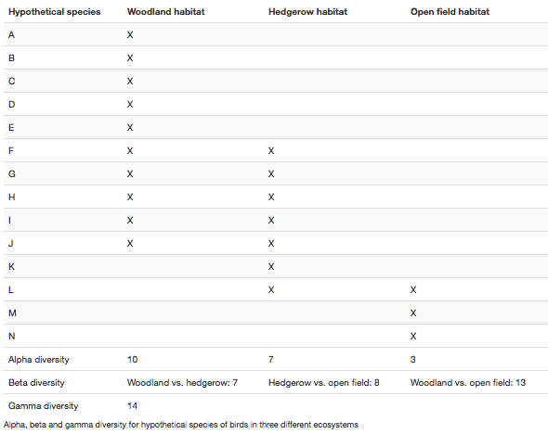

Understand that biogeographical patterns and range distributions are explained or predicted through knowledge and understanding of a species traits and niche requirements in the context of species habitat.

Biogeographical
- The graphical distribution of animals and plants

Biogeographical patterns
- The patterns in species richness/ other patterns that come about because of the geographical location of a species.

Range distributions
- In biology, the range or distribution of a species is the geographical area within which that species can be found.
- Within that range, dispersion is variation in local density.

Species traits
- Might be talking about genotype and phenotype…
- Genotype = the genes and phenotype = genes expressed in a physical matter

Species habitat
- A habitat is an ecological or environmental area that is inhabited by a particular species of animal, plant, or other type of organism.
- The natural environment in which an organism lives, or the physical environment that surrounds a species population.

Define and give an example of a species that is an ecosystem engineer.
- Create, modify, and change habitats.
- Example: zebra mussels, because of their mass quantities they filter the water, making it more clear thus letting more light reach the lake bottom which affects the algae growth

Unit 7

Population density:
- Population density is a measurement of population per unit area or unit volume

Biological population regulation:
- Definition: Biological things that effect population

Density-Dependent Factors
- Include events or conditions that change in severity as a population's size increases or decreases. Common examples of density-dependent factors include predation, parasitism, and disease

Density-Independent Factors
- Include events or conditions; often weather- or climate-related that affects all individuals equally, regardless of the overall population density. A hard freeze, for example, will kill the same high percentage of the potato leafhoppers in a farmer's peanut field -- no matter if the population contains a few hundred or a few million individuals.

Forest fragmentation (how could this influence forest biodiversity?)
- Forest fragmentation is a form of habitat fragmentation, occurring when forests are cut down in a manner that leaves relatively small, isolated patches of forest known as forest fragments.

How could this influence forest biodiversity?
- The inability of individual forest fragments to support viable populations, especially of large vertebrates
- The local extinction of species that do not have at least one fragment capable of supporting a viable population
- Edge Effects that alter the conditions of the outer areas of the fragment, greatly reducing the amount of true forest interior habitat.

Intermediate Disturbance Hypothesis (IDH) (how could this influence forest biodiversity?)
- States that local species diversity is maximized when ecological disturbance is intermediate

Co-management (modern ecosystem management tool)
- A situation in which two or more social actors negotiate, define and guarantee amongst themselves a fair sharing of the management functions, entitlements and responsibilities for a given territory, area, or set of natural resources

Species/area curves
- In ecology, a species-area curve is a relationship between the area of a habitat, or of part of a habitat, and the number of species found within that area. Larger areas tend to contain larger numbers of species, and empirically, the relative numbers seem to follow systematic mathematical relationships.

Edge effects
- In ecology, edge effects refer to the changes in population or community structures that occur at the boundary of two habitats
- Areas with small habitat fragments exhibit especially pronounced edge effects that may extend throughout the range. As the edge effects increase, the boundary habitat allows for greater biodiversity.
Biotic homogenization
- The replacement of local biotas with non-native species that can co-exist with humans.

Ecosystem Function:
- The exchange of energy/nutrients among plants, animals, and the environment.

Ecosystem Service:
- The processes within ecosystems that provide fundamental resources (such as water, clean air or even the decomposition of waste products.)
  - Woodlots provide many services, such as carbon recycling. (e.g., carbon dioxide in the air converted into biomass in wood and leaves),

Adaptive Management:
- Adaptive management utilizes ecosystem management as a tool to alter the functioning of an ecosystem.
  - For example a woodlot manger may want to change a conifer-dominated woodlot into one that is dominated by hardwoods. This approach might include a management strategy built on hypotheses concerning the propagation and growth requirement of specific hardwood species in response to manipulating light from the existing conifer canopy.

NOTES and stuff I know about things

This Topic is about management plans/treatments that you can apply to populations to change the population size.

Discuss the differences and consequences of independent vs. dependent ‘management’ practices.
- Independent: a natural disaster doesn’t care how many ants it’s drowning with the flood. It will kill a percent of them if there’s 100 or 1,000
- Dependent: Disease, a denser population would be affected more than a not very dense population
Comprehend the concepts of ecosystem function and services in the context of adaptive management.
Ecosystem function
- How the animals/plants/ecosystem interact and share energy with each other. (Adaptive management: if you control what is in the ecosystem/ the job of an organism in an ecosystem then you can alter how/how frequently different species interact)

Ecosystem services
- The services (fundamental resources) provided by an ecosystem. Examples include; clean air, filtered water, and decomposition of waste products. (Adaptive management: alter the ecosystem services, you alter the product of that ecosystem. Ex: clean air, decomposition of materials etc.)

Urbanization can sometimes result in an increase in species richness
- Especially at intermediate (middle) levels of development.

What could an invasive species do to affect species richness and diversity of the native species?
- Increases total species richness (increase total number of individuals)
- Decreases the diversity of native species. (Decrease the number of types of native species found)

What is this called?
- Biotic homogenization.

Biotic homogenization
- The replacement of native species with non-native species that can co-exist with humans

The number of nonnative species increases with urbanization, while the number of native species decreases. (Usually but not always)

The highest species richness will occur at an intermediate (middle) level of intensity or frequency of natural disturbance.

Not all animals or plants respond in the same way to the same stresses.

Low levels of disturbance do not create many habitats to support a variety of species.

High levels of disturbance will eliminate many habitats that support species diversity.

Video Summary; Units 4-7.

An Urban Forest Island (How will this affect the biodiversity that lives there?)
- Arboretum/Dairy Bush/Browns woods
  - Increased predation (especially for nesting birds as cats come in from neighboring homes and kill them)
  - Encroachment of outside species. (the cat and/or plant species)

Edge Effects on Forests
- Waste disposal, exotic invasive garden plants, paths, fire pits, forts, removal of vegetation.

Edge Effects on Dairy Bush Field
- The forest is encroaching onto/into the field and spreading the tree seeds and then the trees begin to grow in the field

List the characteristics of each of the University woodlots.

Browns woods:
- Small
- 1887 undergraduate students planted 13 species of trees philko

North Campus Ravine:
- Many animals present here have been introduced

The Arboretum:
- Woodlot habitat
- Public gardens. Bridge between Guelph community and the University. (Outreach/education for people/students/children/elderly)
- Almost every type of tree/shrub found in southern Ontario is growing there
- 1970
- Education research and outreach
- It’s always being encroached on by the Universities developments.

Dairy Bush:
- Lots of arthropods (insects, spiders)
- Called the “Natural Laboratory”
- Forest ecosystem
- Is a reservoir for species in a changing climate
- Contains old trees (Pre US constitution)

Dairy Bush Field:
- Absolutely full of trees (but you cant see them)
- Field ecosystem

What woodlot do I believe we should protect?
- I believe that because of the bridge it brings between the city of Guelph and the University The Arboretum should be protected. Through public gardens and outreach/educational programs the University has used the Arboretum to forge a more familiar connection with the city and its residence. The Arboretum also contains almost every type of shrub/tree found in southern Ontario, opening up a world of biodiversity between the branches. It is also a hot spot for biologists to come gather information and new data, and new things frequently arise from the Arboretum. Around the 15th of October new lichen was discovered right inside! This is a prime example as to why the Arboretum is the most important woodlot to protect of the four woodlots on the University of Guelph Campus.

Campus Master plan

What is it?
- It is a 50 year plan
- Reviewed every 10 years

How it has changed:
- Athletic needs have increase
- More students
- Need for new buildings
- Maintenance
- Presentation

How does it involve preserving natural space?
- We know we need to preserve as much nature as possible but reasonably, the campus needs to expand.
- It recognizes distances/barriers that need to be put in place to maintain natural areas
- “Development should not encroach within 10 meters of natural areas….” This was put in place to help protect the natural areas from development.

Tree A is bigger than Tree B. This does not mean that Tree A is older than Tree B
UNIT 8

Learning Outcomes for Unit 8
- Organize complex biological information, understanding what we know and what we need to know.
- Explain how climate change may impact organisms on different timescales and levels of organization.
- Consider the long-term impact of climate change on an Arctic carnivorous mammal, the polar bear.
- Name some arctic plants and animals. Explain the terms endotherm and ectotherm with reference to arctic animals.

Arctic Ecosystem 8 degrees Warmer?

CO₂ effects
- CO₂ in the air influences the overall mean temperature of the planet.
- Rising CO₂ levels (from burning fossil fuels) therefore contributes to the warming of the earth.

Impacts at different Levels of organization

In the previous Inquiry Case, we focused mainly on populations, communities, and ecosystems. Each of these levels could be affected by climate change.

Populations
- Within a group of individuals of the same species living together climate change may affect survival, growth and reproduction. For example, an Arctic plant may thrive as temperatures increase, but they may now dominate an area where a competing species is negatively impacted by increased temperature.

Communities
- When one considers populations of different species living in the same area, climate change may cause changes in species distribution or frequency within that community.

Ecosystems
- Within the broader context of an entire ecosystem (e.g. arctic ecosystem), climate change may have many complex effects that influence nutrient cycling between the abiotic and biotic factors. However, in this Inquiry Case we will extend our investigation to additional levels, including the organism and the levels that are contained within it.
How might climate change affect different levels of organization?

Molecule
- Temperature impacts the motion of molecules.
- Higher temperatures increase motion: lower temperatures decrease motion.

Macromolecule (Lipids, proteins, nucleic acids)
- Sensitive to temperature change
- Enzyme productivity can change with temperature. (slower in colder temperatures, can denature at too extreme of a temperature)

Cell
- May cause cells to go under a stress response
- Most cells can tolerate a brief increase in temperature, but after a long period of time the cell tends to die. (Because enzymes cant do their thing)
- May cause “chaperones” to be produced

Chaperones: molecular chaperones help complex proteins fold and find the correct intracellular compartment.

Organ systems
- For an ectotherm, an increase in temperature will cause an increase in heart rate/increase of blood flow/increase in cardiovascular rate/increase in metabolism.

Whole organism
- Endotherm: increase in temperature causes sweating/panting (or another process) to bring the internal temperature of the organism back to approximately 37 degrees Celsius.
- Exotherm: increase in ambient temperature would cause the organisms internal temperature to also increase.

Key Points for Unit 8
The Arctic is warming faster than other areas of the Earth in response to man-made activity.

Mammals
- Endotherms that maintain body temperatures near 37°C.

Fish are ectotherms that rely on the external temperature to set body temperature.

Plants in the Arctic
- Face challenging conditions and tend to be slow growing and hardy.
- Lichens (symbiosis between fungi and algae/cyanobacteria) thrive in the Arctic because they are desiccation and cold tolerant.

Diminished sea ice is projected to impact arctic coastal communities in multiple potentially catastrophic ways.

UNIT 9

Learning outcomes for unit 9
- Provide examples of genetic adaptations and acclimatization in Arctic organisms.
- Explain how structure is tightly linked to function at multiple levels of organization in both arctic plants and animals.
- Analyze data from published research articles to enhance understanding of the impact of climate change on plant or animal function.
- Investigate the unique symbiotic relationship within lichens.

Acute
- Short term

Chronic
- Long-term (within an organisms lifetime)

Generational
- Across multiple generations

Acclimatization
- Adjustment by individual organisms to chronic stresses

Adaptation
- The evolution of populations across generation under natural selection

Materials exchanged by Arctic Animals

Gases
- Most animals require O₂ for metabolism and release CO₂ as the respiratory waste product.

Nutrients
- Animals utilize many different types of food, obtaining carbohydrates, fats, and proteins in their diets.

Wastes
- Fluid and solid wastes from digestion and metabolism are released.
- Organisms must also balance the ion composition of their internal fluids.
  - Ions are obtained from food or directly from the environment (especially in aquatic animals).

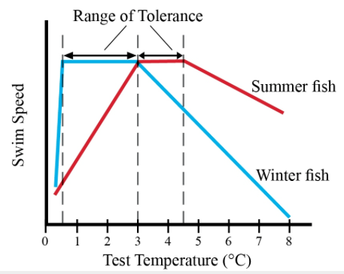
Range of tolerance = the flat part of both graphs
- Where the organisms functions best

Example of seasonal acclimatization
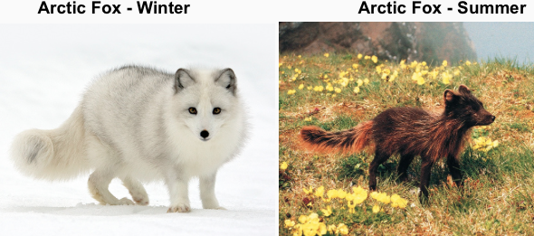

Cell membrane Acclimatization

Ectotherms
- Change the composition of their cell membranes with changing temperatures to maintain membrane fluidity.
- Fish will (over a period of days or weeks) alter the lipid composition over days to weeks to maintain membrane fluidity under these new colder conditions
- Ectotherms that are exposed to seasonal changes in temperature in the arctic undergo cell membrane acclimatization between seasons

Circadian Rhythms

Circadian rhythm
- If the pattern observed follows a rhythm over 24 hours it is called a circadian rhythm.
- Includes body temperature (endotherms only) sleep patterns, feeding behaviors
- Controlled by: endogenous or internal mechanism that acts like a clock.

How does the “internal clock” work?
- Set by external light conditions
- Not dependent on light (if you’re in a completely dark cave you will still sleep about 8 hours)

Circannual rhythm
- Proceed over the course of a year.
- Example: hibernation

Key Points For Unit #9

All organisms need to exchange molecules with their environment.
- In small animals this occurs directly from the external medium to the internal cell or cells.
- For larger multicellular animals the circulatory system delivers and carries away substances from the interstitial fluid bathing the cells.
  - Exchange occurs directly between the interstitial fluid and the cells.
  - Body systems are dependent on the circulatory system for gases, nutrients and waste removal.

Thermoregulation
- Controlled by the hypothalamus in mammals where signals are coordinated to bring about the necessary response to a change in temperature.

Animals undergo reversible changes
- I.e. acclimatization, in response to environmental changes (e.g. seasons).

Range of tolerance
- Defines the range of environmental parameters (e.g. temperature, salinity) that an animal can easily tolerate (at a given time and under prevailing conditions) without losing functional capacity.

Plants in the Arctic
- Face many challenges including drying stress, high winds, cold temperatures, a short growing season and limited nutrients.

UNIT 10

Body Size and Surface Area

The larger the animal, the greater its absolute requirements are for gases and nutrients
- Absolute requirements: for example food, oxygen, water
- An elephant uses more oxygen, food, and water than a mouse does in a day therefore has greater absolute requirements

Absolute requirement
- How much a single organism uses food/water/oxygen
  - Large animals have a greater absolute requirement than small animals

Relative requirement
- How much an organism uses food/water/oxygen compared to its body size.
  - Small animals have a higher relative requirement than large animals

However, if you took a group of mice that weighed as much as an elephant they would use more oxygen/food/water than the elephant of equal mass would.
- A mouse uses up more oxygen per unit of body mass than an elephant.

Relative metabolic requirements go down with body size.
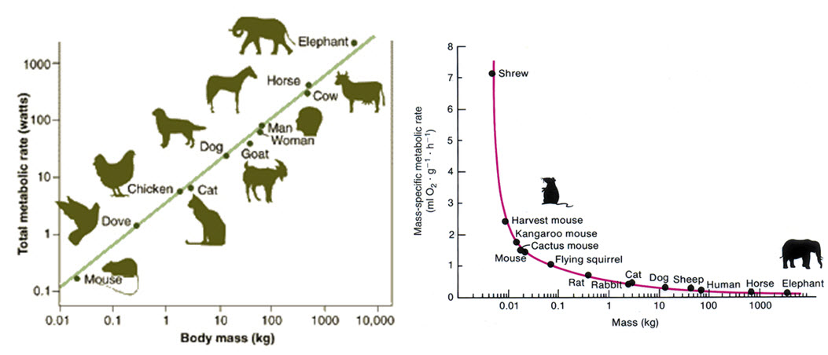

Surface area to volume ratio
- Definition: the amount of surface area exposed to the environment relative to the total volume of the object.
- The surface area to volume ratio decreases as body size increases (and therefore is less efficient with the environment)
- Therefore: the surface area to volume ratio increases as body size decreases (which means more efficient exchange with the environment.)

What do large animals do because they have a lower surface area to volume ratio?
- They increase the surface area (I.E. in folds of the lungs/intestines/stomach)
- When surface area is needed, organisms may have specialized structures (see above brackets-folding) to increase the total area.

Metabolic Rate and Temperature

Metabolic rate
- Definition: the overall indication of how much energy or O₂ is being consumed per unit time.

Ectotherm
- Definition: an animal that is dependent on external sources of body heat
- Decrease in environmental temperature = decrease in body temperature = decrease in metabolic rate = less O₂ consumed per unit time

Endotherm:
- Definition: an animal that is dependent on/capable of the internal generation of heat; a warm-blooded animal.

How to calculate the change in metabolic rate…

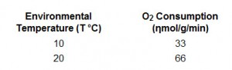

- Q_{(change in degree)} = Rate(temp in degrees Celsius) Rate [temp in degrees Celsius – (change in degree)]

- Q₁₀ = Rate (temp in degrees Celsius) / Rate (temp in degrees Celsius – 10)

- Q₁₀ = O₂ consumption at 20 degrees Celsius / O₂ consumption at 10 degrees Celsius

- Q₁₀ = 66 / 33

- Q₁₀ = 2

Why hibernate?

Why do endotherms hibernate?
- When ambient temperatures begin to fall (I.E. it starts getting colder out) there is a larger temperature gradient between internal and external temperature and greater heat loss
  - Colder ambient temperature = farther away (in degrees) from the core temperature of the organism
  - Great heat loss = gets colder more easily/faster

- Hibernation decreases metabolic rate and temperature
  - Lower temperature = lower temperature gradient

Hibernation
- Lasts for several weeks or months

Torpor
- Shorter than several weeks or months
- Example: hummingbirds may enter torpor nightly
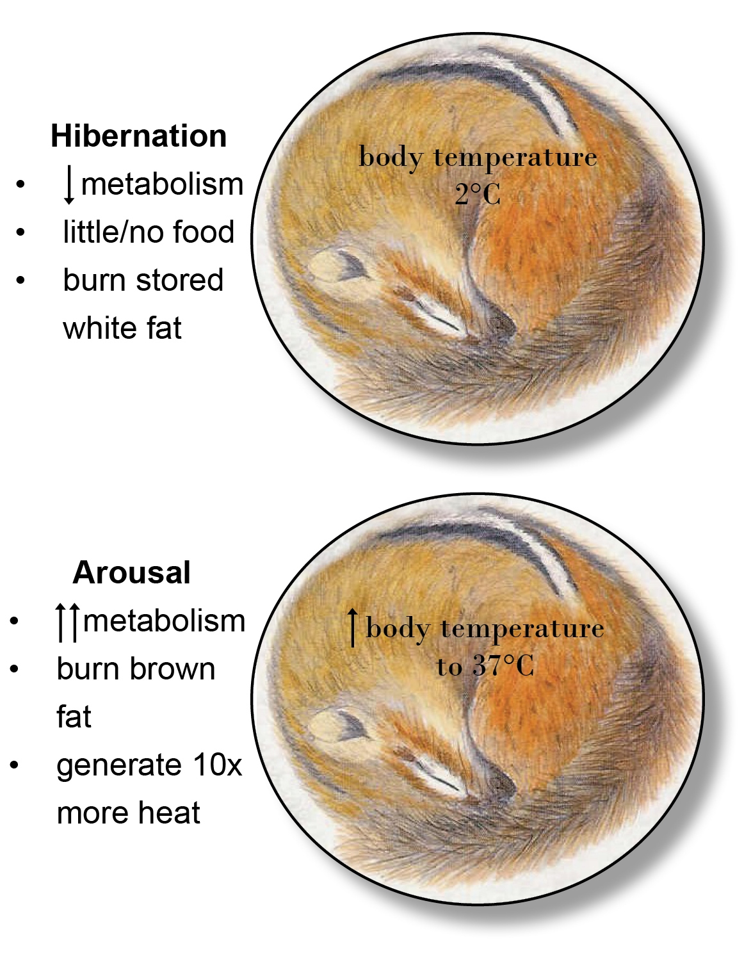

Is body size a factor in why small animals tend to hibernate and large animals tend to stay awake?
- Yes, small animals (because of their higher surface area to volume ratio) loose heat much faster than large animals do
- If you are small, you need more energy to fuel each cell and you loose heat faster.

Note: smaller animals need to supply more energy for each cell than larger animals do

Thermogenesis: The production of heat (not usually much most often referring to human/animal body)

Brown Fat and Non-Shivering Thermogenesis

Hibernaculum: the “den”

Challenges of hibernation
- Building up white fat prior to entering the hibernaculum
- Arousal (waking up) consumes a great deal of energy

White Fat
- White fat stores provide sufficient fuel to sustain a low level of metabolic activity during hibernation.
- Generates about 10x less heat per cell than brown fat does

Brown Fat
- Non-shivering thermogenesis, which involves specialized brown fat cells, is used to quickly restore active metabolism in mammals during arousal from hibernation
- AKA when an animal wakes up during hibernation (body temperature returns to approximately 37 degrees Celsius and metabolism goes from low to active) it uses brown fat to fuel the cells
- High density of mitochondria (mitochondria synthesizes ATP for the cell)
- Brown fat mitochondria contain an unusual protein called thermoglobin.
- Generates about 10x more heat per cell than white fat does

Non-shivering thermogenesis
- Definition: the process where brown fat is used to generate body heat

Brown fat metabolism
- Must be carefully regulated otherwise animals would overheat when they have no need of extra warmth.
- Key switch: release of adrenaline.

Summary of white and brown fat
- White fat
  - Provides sufficient fuel during hibernation
  - Fat stores (penguins)
  - The major fuel used when hibernating
- Brown fat
  - Is used to quickly restore active metabolism in mammals during arousal from hibernation (thermogenesis)
  - Has a fine meshwork of blood vessels that supplies O2 and carries heat to warm the entire body.

Active Overwintering Small Mammals

What are other ways to keep warm without hibernating?
- Huddling to reduce the amount of surface area exposed to the cold (penguins)
What’s in the news?

Fun Facts About Polar Bears
- They eat ringed seals, bearded seals and sometimes narwhals
- Males can stand more than 3 meters tall and weigh 600 kg.
- Largest bears on the planet
- Polar bears are legally hunted (only about 600 per year) but the inuits tend to sell their rights to people because it makes them money.

Key Points for Unit 10

Small Arctic mammals tend to hibernate in winter because of the high cost of thermoregulation, whereas larger mammals have the advantage of a lower rate of heat loss. There are exceptions to this rule (e.g. lemmings and voles remain active under the snow).

Animals that hibernate lower their metabolic rate and body temperature, using white fat as their major fuel. During arousal, non-shivering thermogenesis (brown fat metabolism) provides additional heat to return to a body temperature around 37°C.

UNIT 11

Learning outcomes
Explain why freezing temperatures are dangerous for animals and some of the strategies animals use to prevent cell damage.
Design an experiment to test hypotheses relating to antifreeze protein synthesis in a freeze intolerant species.
Apply concepts from ecology, evolution, and physiology to the question of Arctic biodiversity in the face of climate change.

Surviving in an icy arctic

Osmotic pressure change due to ice crystals in extracellular fluid. (Ectotherm)
- These reduce the amount of water available outside of the cell, which therefore changes the osmotic pressure.
- Less water, cell becomes more hypertonic, water leaves cell in order to adjust to this osmotic pressure. This can be damaging to the cell.

Effects of Ice Crystals in extracellular fluid (ectotherm)
- Causes osmotic pressure change.
  - Cells become more hypertonic
- Can be physically damaging to cell membranes and other cellular structures

Extracellular fluid
- Fluid outside of the cell

Intracellular fluid
- Fluid inside the cell

To Freeze or Not to Freeze?

Cryoprotectants (glycerol/sugars)
- Freeze tolerant
  - Stabilize cells to prevent osmotic damage when extra cellular fluid freeze
  - NOTE: Glycerol protects delicate cell membranes/ Glucose acts as an antifreeze and inhibits metabolic processes
- Freeze Intolerant
  - Increase Supercooling capacity (lowers freezing point)

Antifreeze Proteins (AFP’s)
- Freeze tolerant
  - Inhibit additional ice formation (but allow it)
- Freeze Intolerant
  - Stabilize a super cooled state. (Makes sure the organism doesn’t freeze)

Ice-Nucleating agents
- Freeze Tolerant
  - Initiate ice formation outside cells
- Freeze Intolerant
  - Not used
  - Organisms instead voids gut contents to prevent ice formation

Supercooling (freeze intolerant)
- Dangerous at extremely low temperatures. (aka arctic animals generally don’t use it)

Freeze Tolerant Organisms
- CONTROLLED ice formation in cells
- Just because some of them freezes doesn’t mean they freeze entirely
  - Intracellular fluid is maintain with AFP’s
- Heart and respiration stop when frozen. This does not mean the organism is dead.

Freeze Intolerant Organisms
- No ice formation in cells
- Voids gut to avoid freezing

NOTES FROM CLASS

Population regulation - Density dependent
- Definition: when the density of individuals in an area affects the severity of effects.
- Examples: for example; if there are 10 mice in a field and one becomes diseased the disease will spread slower and kill a smaller percent of mice than if there were 1 million mice in a field.

Population regulation - Density independent
- Definition: when the density of individuals in an area does not affect the severity of an effect.
- For example; if there are 10 mice in a field compared to 1 million mice in a field and there is a frost the frost doesn’t rely on how many mice there are, it just freezes whatever is there no matter the # of individuals.

Population regulation - Efficiently controlling a population
- We use density dependent factors to control populations. (Example: introduce a predator... high density prey = more munch = more successful predator = less prey)
- We DO NOT use density independent factors because they are useless.
- If you introduce a mouse’s predator (density dependent) to a field rather than drowning all the mice in a field (density independent) it will be more effective.
  - Populations tend to resort back to normal numbers after a period of time after a natural disaster.
  - Density independent factors are very similar to natural disasters

Inflection point
- This is the point on the graph where the Y value goes from increasing to decreasing

Ecological Biogeography
- The account of present day distribution of species in terms of abiotic and biotic factors.

Historical Biogeography
- The reconstruction of speciation, dispersal, establishment, distribution, and extinction of species

Range
- The area or location inhabited by species for a defined amount of time
- Scale dependent (global, local)

Endemic Species
- Native to a specific region or environment and not occurring naturally anywhere else
- Evolved and found there.

Dispersal
- When a species moves to a new location from where it originally evolved.

Vicariance
- Definition: A speciation event where a species' distribution becomes segmented and the separated populations evolve due to different selecting factors, causing the populations to become unique species.
- How and what: Could be something as long and slow as the rising of a mountain range or the separation of Gondwana to something as quick as an erupting volcano.

Timing of continental drift
- Laurasia and Gondwana separate
- Gondwana begins to drift apart
- Gondwana is fully separated; Laurasia begins to drift apart
- Continents near current positions

Why is the southern hemisphere more diverse?
- The north stayed together longer therefore gene flow affected diversity.
- Less intermingling = more diversity!
  - One would assume more intermingling would lead to more diversity among species but we know that gene flow (which is increased with more species in an area) reduces diversity.

Impacts at different time scales and severities of change
Acute: Immediate response (e.g. Cold temperature and shivering)
- Example: rick mercer being dipped in cold water
Chronic acclimatization/adaptation: Change in physiology to adjust set points in relation to prolonged changes in the environment (occurs at multiple levels of organization) can you give an example?
- Longer than acute
Evolutionary/generational adaptation: over many generations we see an adaptation or a stimulus. (Occurs at multiple levels of organism)
- Example: Rick would need to have babies out in the cold and they would need to have babies in the cold.

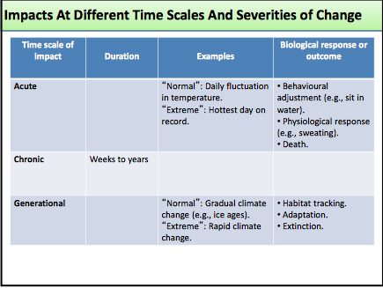

Minutes to Hours

- Migration
- Acclimatization
- Death
“normal”: seasonal fluctuation in temperature
“Extreme”: hottest seasons on record.

Multiple generations

How would an arctic fox versus an arctic char respond to a 5c increase in temperature if change were…

Acute
- Char (extotherm): move to colder areas/sink lower to find colder temps (unsustainable since the prey/ water pressures are different at a deeper depth)/enzymes will not work/will not be able to work efficiently (ectotherm therefore temp outside = temp inside)
- Fox (endotherm): sweating/panting/blood vessels dilate/ spend more time in shade

Chronic
Char: relocate to
Fox: more shedding would occur

Generational:

Adaptations/severities of change
- When an acute, chronic, or generational change happens, organisms have both behavioral and physiological ways to maintain homeostasis.
  - Behavioral Adjustment: if it’s too hot one day (Acute) then an organism will seek out a cooler place.
  - Physiological adjustment: if it is too hot for an organism they will sweat. (This is only for endotherms as ectotherms cannot control their own body heat)

Physiology
- The biological processes and functions of the parts of an organism.
  - The functions, mechanisms, and activities of organisms at the cellular or organ system level.

Range of tolerance
- The entire set of conditions, such as air temperature or soil moisture, under which an organism is potentially able to survive. Levels outside of this range will be lethal.

Difference between Acclimation and Acclimatization
- Acclimatization
  - Response in the wild induced by climatic changes in the natural environment.
- Acclimation
  - Response in lab induced by experimentally induced changes.

Regional heterothermy
- Uses countercurrent heat exchange to prevent heat loss
  - Countercurrent heat exchange is when the arteries going to the extremities give up most of their heat to the veins coming from the extremities (such as penguins/wolves/caribous feet and the flukes of flippers of whales/seals/walrus)
- This prevents heat loss from limbs because by the time the blood gets to the extremities it has been precooled, and therefore less heat is lost.

Homeoviscous adaptation
- Maintains the correct membrane fluidity at the new conditions/temperatures

Biochemical adaptation
- Changes to the structure, function, regulation, and integration of biological molecules and metabolic processes.
  - Organisms can maintain metabolic processes

What biochemical adaptations are associated with regional heterothermy?

Changes at the Cellular/Molecular level
- Homeoviscous adaptation (GINT HINT: graph this)
- Remember, “adaptation” in this sense is not the same as “adaptation” in evolutionary biology

Homeoviscous
- The maintenance of the viscosity of cell membranes.
  - The harder the membranes the harder it is for molecules to pass through.

Cholesterol
- Makes arteries harder (good for elephant seals for when they dive deep)

POLAR BEARS ADAPTATION TO A COLD CLIMATE
 | Acute | Chronic | Evolutionary
Molecular |  | Release of glucagon increases breakdown of fatty acids | Adaptations in haemoglobin related to cold
Cellular/tissue | Counter current exchange regulation | Decrease metabolism | More fat and thicker fur  Hairs are hollow and trap heat emitted from the skin
Organism | Burry nose in fur and curl into ball to reduce surface area to volume ratio | Winter coat comes in, more fat is stored as it gets colder. | Large bodies with small appendages (such as ears)  Can go long period of time without food  Low surface area to volume ratio
Population | Snuggle close to mom/babies |  | ?

Adaptations to the cold in Polar Bears
- Thick fur (although not as insulating as we might expect)
- Blubber
- Large size, low surface area to volume ratio
- Hairs are hollow and trap heat emitted from the skin

Example of a good hypothesis/prediction/experiment/results/implications
Hypothesis:
- Woolly mammoth haemoglobin had properties that allowed it to function un cold extremities and appendages, despite having warmer core temperature
Prediction:
- Woolly mammoth haemoglobin structure will be more similar to that of arctic mammals than to the haemoglobin structure of closely related tropical elephants
Experiment?
A: Analyze structure
- Extracted DNA
B: Analyze function
Results?
- Woolly mammoth haemoglobin unloaded oxygen more efficiently in colder conditions than haemoglobin from living elephants
Implications?
- This biochemical specialization may have been involve in the exploitation of high-latitude environments by this African-derived elephantid lineage during the Pleistocene period.

How do wood frogs survive the winter?

 | Acute | Chronic | Evolutionary
Molecular
Cellular/tissue
Organism
Population

How do winter flounder survive in subzero water?

 | Acute | Chronic | Evolutionary
Molecular
Cellular/tissue
Organism
Population

Strategies for surviving in the cold as an ectotherm

- Freeze avoidance/intolerant:
- Using strategies to avoid freezing even at subzero temperatures
- Species that use this strategy are freeze-intolerant.
- Unable to survive freezing therefore has adaptations to avoid it.

- Freeze tolerance
- Has adaptations to prevent freeze damage
- Able to actually freeze

Who does which?
Strategies | Freeze Tolerant | Freeze Intolerant
1. Behavioral avoidance (migration) | N | Y
2. Production of antifreeze compounds | N | Y
3. Synthesis of ice nucleating agents (makes ice form faster, control the formation of ice) | Y | N
4. Supercooling (temperate NOT arctic species) | N | Y

Freeze Avoidance/Intolerance (ectotherm)
- Objective is to promote conditions where cellular water can be cooled to below 0 degrees before ice crystal formation occurs

Super cooling involves
- Making antifreeze--- bind microscopic ice crystals
- (Below freezing temperature of the environment)
- Make cryprotectants glycerol, sugars and proteins which lower the freezing point

Why is there a difference in freezing point? (this is related to the winter flounder)
- Seawater freezes at -1.9 and body fluids freeze -0.6 to -1.1

Freeze Tolerance (ectotherm)
- Objective is to allow the body to cool to the point of freezing without causing permanent tissue damage
- This requires the careful management of body fluids and ice crystal formation

Regional Dehydration
- Definition:

Ice Nucleating agents.
- Ice nucleating = ice forming/creating
- These are in freeze tolerant ectotherms to help them freeze

Lichen Forms…
- Fruticose
- Foliose
- Crustose

Green Algal Lichens
- Uncommon lichens with green-algae as the photobionts
- Very green when wet

Photobionts
- The photo synthetic partner
- Algae is a photobiont, it absorbs the suns light

Cyanolichens
- Uncommon and sensitive lichens with blue green-algae as the photobionts
- Very black when wet

Lichens are fungi; sometimes fungi grow on fungi!

READ THE ABSTRACT ABOUT THE HALF FREEZE TOLERANT AND HALF FREEZE INTOLERANT THING. END OF LECTURE 21’S SLIDE

Class Notes
November 24th

Learning outcomes
- Understand some of the costs and benefits of endothermy and ectothermy
- Understand some of the mechanisms involved in regulating body temperature
- Understand the basis and significance of heterothermy

Think about it…(EXAM)
- Are there any freeze tolerant endotherms?
  - No.
- Do all endotherms attempt to regular a constant high body temperature at all times in the cold?
- How do endotherms deal with extreme cold? Does it depend on timescale exposure? How?

Classifying animals in terms of response to environment- regulators and conformers

Conformers
- Allow internal environments to follow external changes
Regulators
- Maintain constant internal environments in the face of varying environmental conditions.
- Fights against change

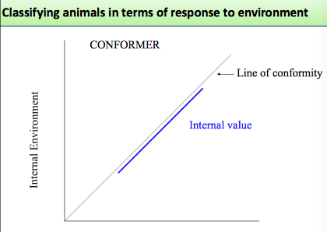
(“External Environment ex. Salinity or temperature” on X axis)

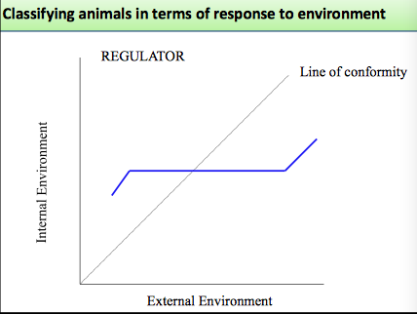
Flat line = zone of stability where homeostasis is maintained.

What kinds of animals are conformers?

What kinds of animals are regulators?

Can animals be both a regulator and a conformer?

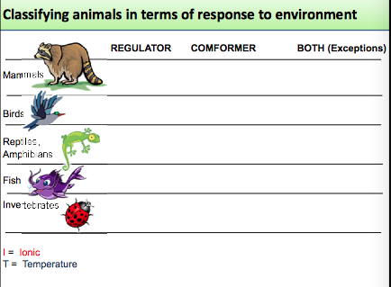
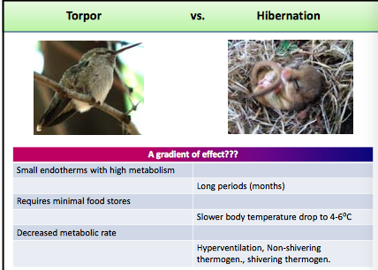

Countercurrent exchange is related to regional heterothermy

There is a problem with reheating by shivering
- Because there isn’t a lot of oxygen in the muscles shivering isn’t the best way to reheat right away.
- Go from non shivering to shivering thermogenesis

Recap
- White fat is for exercise/energy (oranges in a bag = what it looks like)
- Brown fat is for quickly warming the body back up (grapes in a bag = what it looks like)

Ice fish
- Has no hemoglobin, no red blood cells, therefore no oxygen being transported around body.
- RANDOM FACT: Cold water holds more oxygen
- Has a maladaptive trait, the ice fish didn’t adapt to the environment. It just so happens that the environment works just enough for the ice fish to live in.

Evolution:
- The processes by which biodiversity originates and is interrelated (evolution, with emphasis on natural selection and “tree thinking”).
- Variability occurs at multiple levels: variation (population) vs. diversity (species) and may be visible (phenotypic) or not necessarily visible (genetic).
- Causes and consequences of variation at population & species level.
- The factors determining, relatedness and phylogeny, genetic isolation.
- Adaptation and the pros/cons of specialization, invasions and radiations.
- Consequences for competition (short-term, among conspecifics or between species), speciation (long-term), and extinction risk (long-term).
- Ecology:
- The nature of interactions among organisms and between organisms and their biotic and abiotic environments at the ecological scale.
- Variability is expressed at different levels of organization (ecosystems, populations/species, and individuals).
- Causes of diversity at each level can be understood by studying the processes operating in the levels below; the consequences of diversity can be examined as they affect diversity in the levels above.
- Ecosystem diversity is known to vary both in space and time. Historical processes affect the dynamics of species diversity.
- Understanding the complexity of variables associated with the causes and consequences of diversity.
- Uncertainty in current dogma and the putative effects of anthropogenic change.
Physiology:
- The complexity of organisms and the importance of physical organization and regulatory processes (e.g., information flow, structure/function, development).
- Changes in the external environment impacts organisms. Organisms i) exchange molecules with the external environment, ii) regulate internal environment (homeostasis) through feedback mechanisms, iii) regulate, others conform to specific environmental parameters.
- Organisms are organized in a hierarchy from cells to tissues to organs to organ systems. Structural features at all levels of organization have functional significance.
- Plants respond to environment changes; circadian rhythms, dormancy, temperature stress.
- Animals respond to temperature changes differently depending on their thermal group (endothermy, ectothermy): methods of heat transfer; metabolic rate changes with animal size, activity, temperature; strategies to cope with extreme cold in ectotherms and endotherms; time frame of responses (acute, chronic, evolutionary time).
- Impacts of climate change in arctic organisms include factors such as physiological change, geographic range and ecosystem disruption.

Specific Learning Outcomes:
- Explain the central concepts of biodiversity, methods of analysis, and its ecological and societal importance.
- Develop accurate conceptions of evolutionary processes and patterns (especially natural selection and “tree thinking”), and to correct common misconceptions about evolution.
- Construct a conceptual framework that explains some of the causes and consequences of forest diversity.
- Describe the interactions between organisms and their biotic and abiotic environments and be able to apply these concepts to real-world examples.
- Organize and analyze data that characterize biological variation, patterns and relationships.
- Interpret complex graphs and figures and be able to choose appropriate graphs and figures to illustrate different types of data.
- Practice the process of biological inquiry using scientific methods and reasoning using real examples.
- Appreciate the integrative nature of modern biological science.
- Develop a level of comfort with the complexity and uncertainty inherent in biological science.

