Econ 201 Midterm Review

Chapter 1

Definition of Economics
- A social science that studies how we allocate limited resources to satisfy unlimited wants.

*social science is the experiment on people
- When there isn’t enough resources to satisfy our wants it becomes limited; a.k.a. Scarcity

How to deal with Scarcity?
- Prioritize and make decisions Economics is the study on how to make choices; the study of our lives

Major Trade off in Economics

- Efficiency: use all your resources
- Equity: allocate your resources equally
** higher standard of living if you’re efficient
**the more you focus on equity the less quality

Opportunity cost; best alternative to what you gave up (what you get in return)

Rationality
- Based on what you know at the time you will always choose what you think is best for you (can’t be wrong at the time)

Decision making is based on self-interest, people respond well to incentives.
Markets

- Good way to organize an economy
- What to produce?
- How much to produce?
- How to produce it?
- For whom to produce?
-------> The market is the best way to answer these questions and organize the economy. The buyers and sellers of the market ca best answer these questions. Trade offs making everyone better off.

Property Rights: you paid for it you have the rights to it (individually)

Mixed Economy: the government and the market make up a mix for the economy sometimes the government will be more in power than the market e.g. Canada Post- the big of a job to be private especially in the 60’s

The government has acquired skills and expertise better than known private organizations. Every country has some sort of government nor is there a pure govn’t economy; there will always be private organizations.

Capitalism: is an economic system in which the means of production and distribution are privately or corporately owned and the operations are funded by profits. e.g. the prison system in the US is being operated by private companies.

***The centerpiece of all economics is that we build models which are built on assumptions; these assumptions can pre-determine our conclusion. Models are ALWAYS built on assumptions. Microeconomics is fixed.

Model

Assumptions
- One Person (Robinson Crusoe - Canada)
- 2 Goods (Fish&Rice)
- Inputs are fixed
** 2 goods = 2 dimensioned
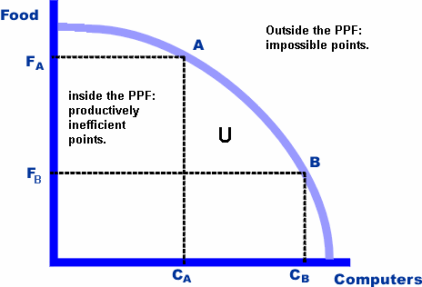

-Any point under the PPF is inefficient because not all resources are being used

-Any point outside the PPF is impossible/unattainable

-The PPF line seperates what is feasible and not feasible

- The slope of the line is the oppourtunity cost; the number of fish or rice I gave up to get the other, is my OC (always the same amount)

The curve of the line is important. If it is constant (or linear) it means that the resources that are used to make the 2 goods are very similar.

Increasing opportunity cost means that the 2 goods are made differently.
** Slope steeper = opp. Cost is steeper

Macro – deals with decision making of the economy as a whole (recessions, banks, trade relations, etc.

Micro – deals with decision making of 3 agents
- Household/ individual
- Firms/ Business
- Government

Normative and Positive Economics

Positive – Way to express yourself, states info in the form of fact e.g. today is Thursday

Normative – state info in the form of an opinion e.g. today could be Friday
** could/should/would/maybe = uncertainty = normative opinions
Equity is based on opinion

Chapter 3

Supply & Demand

Demand
- Law of Demand
- Demand Schedule
- Demand Curve
- Shifts in Demand

- Law of Demand
- Ceteris Parebus: as the price of something goes up, your willingness to buy it goes down.
- Substitution Effect: changes in price motivate consumers to buy relatively cheaper substitute goods
- Income Effect: changes in price affect the purchasing power of consumers’ income
- The law of diminishing marginal utility: as you continue to consume a given product, you will eventually get less addiction utility (satisfaction) from each unit you consume

- Demand Schedule
- Individual demand schedule VS market demand schedule
- Y-axis is the dependant axis
- X-axis is the independent axis
- **value of y depends on the value of x
- in economics; Qd = f (P) but exceptions Q is “x”

- Demand Curve
- Because of Aldred Marshall the Economics graph is drawn backwards as opposed to the regular (x,y) graph

- Shifts in Demand

If… | Then Demand Shifts..
Income Increases | D Increases; shifts right (normal gd)  Or shifts left (inferior gd)
Income Decreases | D decreases; shifts left
Taste/Preferences increases | D increases; shift right
P of Substitute goods increases | D increases; shifts right
P of Complementary increases | D decreases; shifts left
P Expectation increases | D increases; shifts right
# of Consumers | D increases; shifts right
Complementary Good: 2 goods that you consume together e.g. ketchup and hot-dogs

Substitute Goods: 2 goods that you buy either one or the other e.g. coke or pepsi

Supply

- Law of Supply
- Ceteris Parebus: as the price of something goes up, your willingness to produce it goes up!!! (everything equal)

Formula : Qs = f (P)

Demand and supply are positively related goes up together

- Shifts in Supply

If… | Then Supply Shifts..
Price of Input increases (labour, land, capital) | Q decreases ; shift left
Tech/Productivity increases | Q increases; shifts right
Tax increases | Q decreases; shifts left (you don’t want to produce is as much)
Subsidy increases (bonus payment makes money each time its produced) | Q increase; shifts right (productivity increases)
P Expectation increases | Q decreases; shifts left (want to hold onto supply to sell it for more $$)
# of Producers | Q increases; shifts right

Supply and Demand Together

Intersection = Equilibrium

- If Supply if above equilibrium, there is a surplus or Price Floor
- If Demand is lower than equilibrium, there is a shortage or Price Ceiling. Creates the black market.

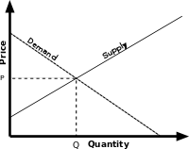
Price Controls
        - If govn’t causes surplus, he govn’t will pay the excess surplus
Chapter 4

Price Elasticity

Ep = Percentage change in Quantity = (Q1-Qo) / (Q1+Qo)
Percentage change in Price (P1-Po) / (P1+Po)
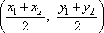
Midpoint Formula =

*when doing the Ep doing demand and there is a negative sign, ignore it because we know its supposed to be there e.g. Ep= 1% (not -1%)
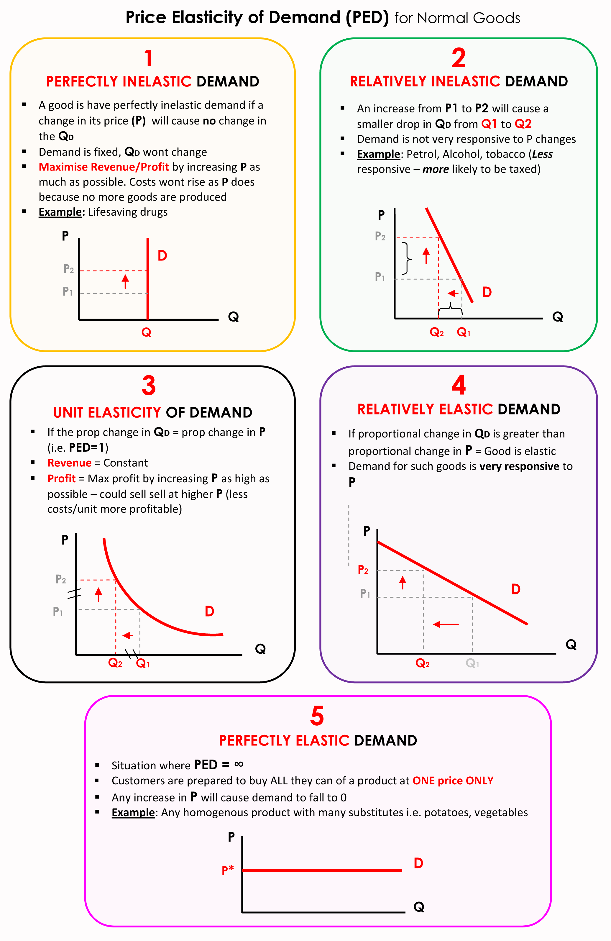

Ep = 0 Perfectly Inelastic “no reaction” - example medicine’s that are life saving (diabetes) Price goes up or down but demand doesn’t change either way.

0 < Ep < 1 Inelastic; Elasticity is between 1 and 0 e.g. cars, gas, pet food, alcohol

Ep=1 Unit Elastic; things you spend a fix amount of money on no matter the price e.g. lottery tickets

1 < Ep < ∞ Elastic; very responsive to price e.g. too expensive, I won’t buy

E = ∞ Perfectly Elastic; extremely responsive to price, if price changes a little bit demand will fall to zero.

Total Revenue = TR
TR= P x Q

If… | Then Total Revenue .. when Price goes up
Ep=0 | Goes up
0 < Ep < 1 | Goes up
E = 1 | Stays the same (revenue doesn’t change)
1 < E < ∞ | Goes down
E = ∞ | Goes down

What determines elasticity?
**ceteris parebus**
- The more substitutes, the more elastic
- The more your income the more elastic
- The more time to respond, the more elastic
- The more of a luxury, the more elastic

Cross-Price Elasticity

- If changing the price of product A how much does price of product B change?

When comparing 2 goods, the positivety and negativity can help you determine what relation they have.

0 ≤ Ep ≤ ∞ Demand/ Supply

***** NEGATIVE MATTER IN CROSS-PRICE ELASTICITY*****

-∞ < Ex < ∞ The more negative, the more complimentary they are. (far from each other in store)
The more positive, the more substitute they are. (side by side in a grocery store)

-∞ < Ei < ∞ The more negative, the more a good is inferior
The more positive, the more a good is normal
if at zero, there is no affect.

Taxing a Product
- The tax is paid by the side that views the good as more inelastic.
Pd = Ps + t or Pd- Ps = t

The more demand is inelastic, tax will fall on CONSUMER
The more demand is elastic, tax will fall on PRODUCER
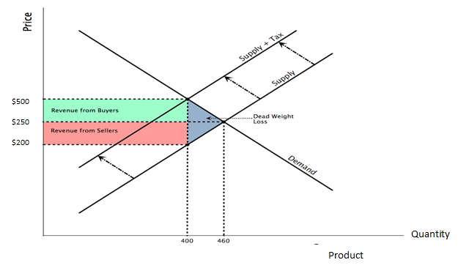

Chapter 5

Welfare Economics

- Consumer Surplus (individual/household)
- Producer Surplus (supplier)
- Government Revenue (govn’t)

Consumer Surplus

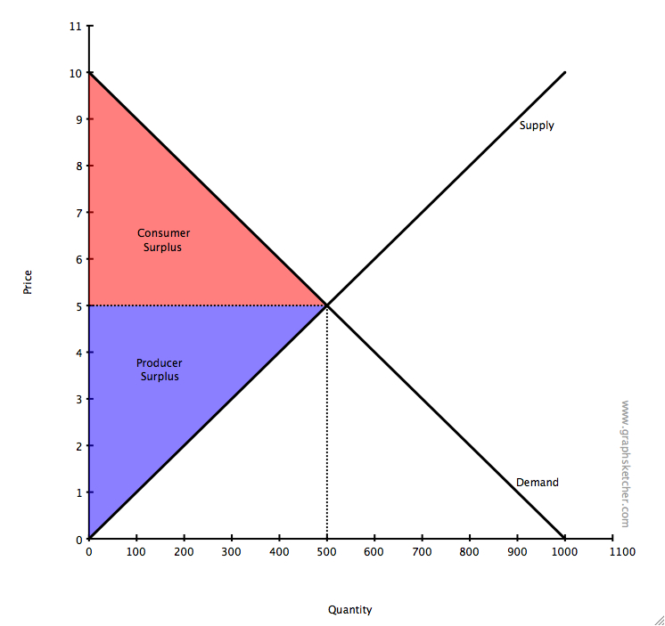
- Consumer surplus is the difference between what a consumer is willing to pay and what he actually pays
e.g. Willing to pay $7 for an ice cap but only paying $3 so consumer surplus is $4
****cannot be negative*** and maximum is infinity. The more inelastic the more C.S can reach to 0.

Producer Surplus

-Producer surplus is the difference of what you actually receive and what you would of excepted.
e.g. setting the price of a car very high but expecting to bring it down by negotiation. Producer surplus would be the absolute lowest you would accept and the price someone actually paid for the car.
****cannot be negative**** if perfectly elastic, then P.S. is = 0
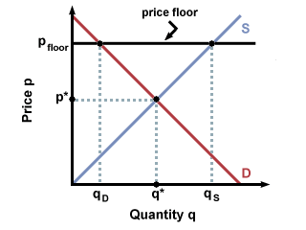
both consumer and producer surplus are found by doing (bxh)/2 to find the area of the triangle which will give you the amount in dollars of surplus.

Minimum Wage Example (Price Floor)

 | No Price Floor | With Price Floor
Consumer Surplus | A, B, C | A
Producer Surplus | D, E | B, D
Total Surplus | A ,B, C, D, E | A, B, D
C-E are deadweight loss
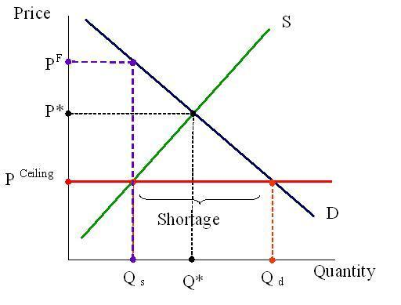
Rent Control Example (Price Ceiling)

 | No Price Ceiling | With Price Ceiling
Consumer Surplus | A, B | A, C
Producer Surplus | C, D, E | E
Total Surplus | A, B, C, D, E | A, C, E

B-D are deadweight loss

Taxing Products
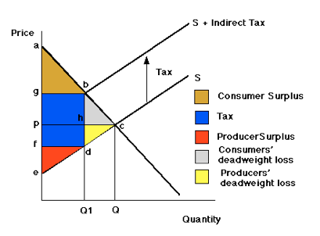
 | No Tax | With Tax
Consumer Surplus | A, B, C | A
Producer Surplus | D, E, F | F
Government Revenue | 0 | B, D
Total Surplus | A, B, C, D, E, F | A, F

C+E = deadweight loss

Externality
- When there is a third party to a transaction that is neither the buyer or seller. Someone affected by the transaction but it not part of it. Comes in 2 different varieties; positive and negative.

- Positive Externality is where the third party benefits from the transaction (positive supply and positive demand) e.g. someone got a flu shot
- Negative Externality is where the third party is affected in a harmful way (negative supply and negative demand) e.g. smoking
** Can also be both; e.g. cigarette smoker upsets non-smoker but pleases the second-hand smoker that is trying to quit

Negative Supply Externality
(ice cap example) more ice caps, more health problems, more time at hospital
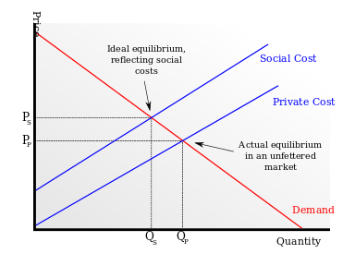

SMC= Society Marginal Cost
PMC= Private Marginal Cost

Equilibrium = balancing marginal benefit and cost

Sociably optimal outcome is to internalize the negative externality by TAXING A PRODUCT

e.g. if we have a smoker, how do we make him re-think a decision? Tax him; consumer pays for the tax because he is the cause of the externality

***Solution to Externality is Tax***

Negative over produces and under prices

To Find producer surplus of a negative externality, it is subtracting everything under the SMC by the what’s between the PMC equilibrium and SMC

Positive Demand Externality

A positive externality has both demand and SMC going downwards, deadweight loss is found on the left of equilibrium.

With no externality; the government has no involvement
With externality; government has to tax or be involved

Mr. Pigou recognized that by subsidizing an externality, it will internalized it and will better society Pigouvian Tax/Subsidy

Public Good
- Non-rival & non-exclusive*

Non-Rival: if you consume this good, you don’t stop someone else from consuming the good e.g. learning, driving on a street, the navy

Non-Exclusive: producer can’t stop you from consuming the good e.g. display of fireworks

The problem producer can’t charge everyone; everyone has the incentive to be a free rider

#1 Solution make it a private good (rival and exclusive) e.g. private parking, private university

#2 Solution make everyone pay (or tax) whether they use it or not

Chapter 6

Individual Choice

Where did the demand curve come from?
- 2 goods beer & pizza
- 1 person

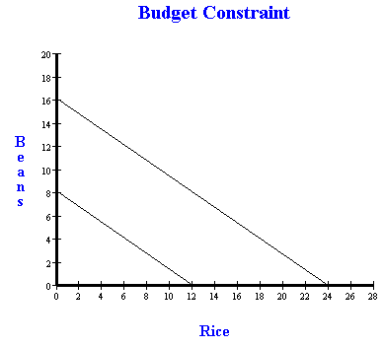
The Budget constraint is the line that states all the possible combinations of beer and pizza I could have with using all my income. Anything under the budget constraint line is inefficient because I still have money left over, and everything over the line is impossible because I don’t have any more money than what’s at the line.

M= income
Pb = price of beer
Pz = price of pizza
M = the max of beer I can afford
Pb

Indifference Curve

- Means to try and measure happiness (utility)
- Four features
- Higher IC = higher levels of happiness
- I.C. cannot touch contradiction
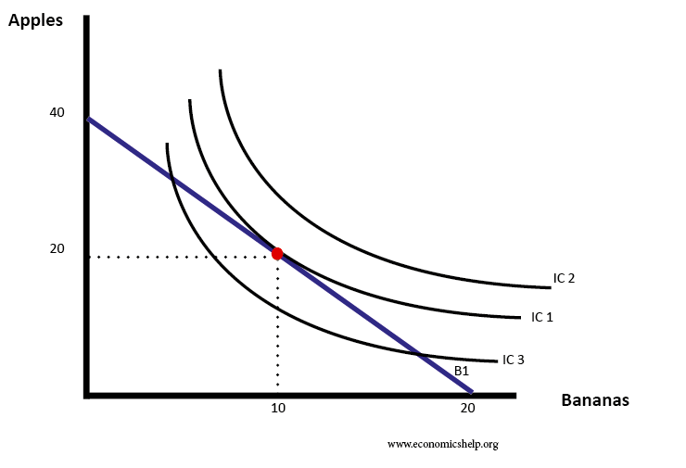
- Have to slope down
- Cant blow out

*Red dot is the highest level of happiness in regards to the budget

At the optimum: Slope of Budget Constraint = Slope of Indifference Curve

Slope of Budget Constraint = (m/Pb) / (m/Pz) or Pz/Pb

Slope of Indifference Curve = delta u= change in happiness delta u = delta b x Mub + delata Z x Muz

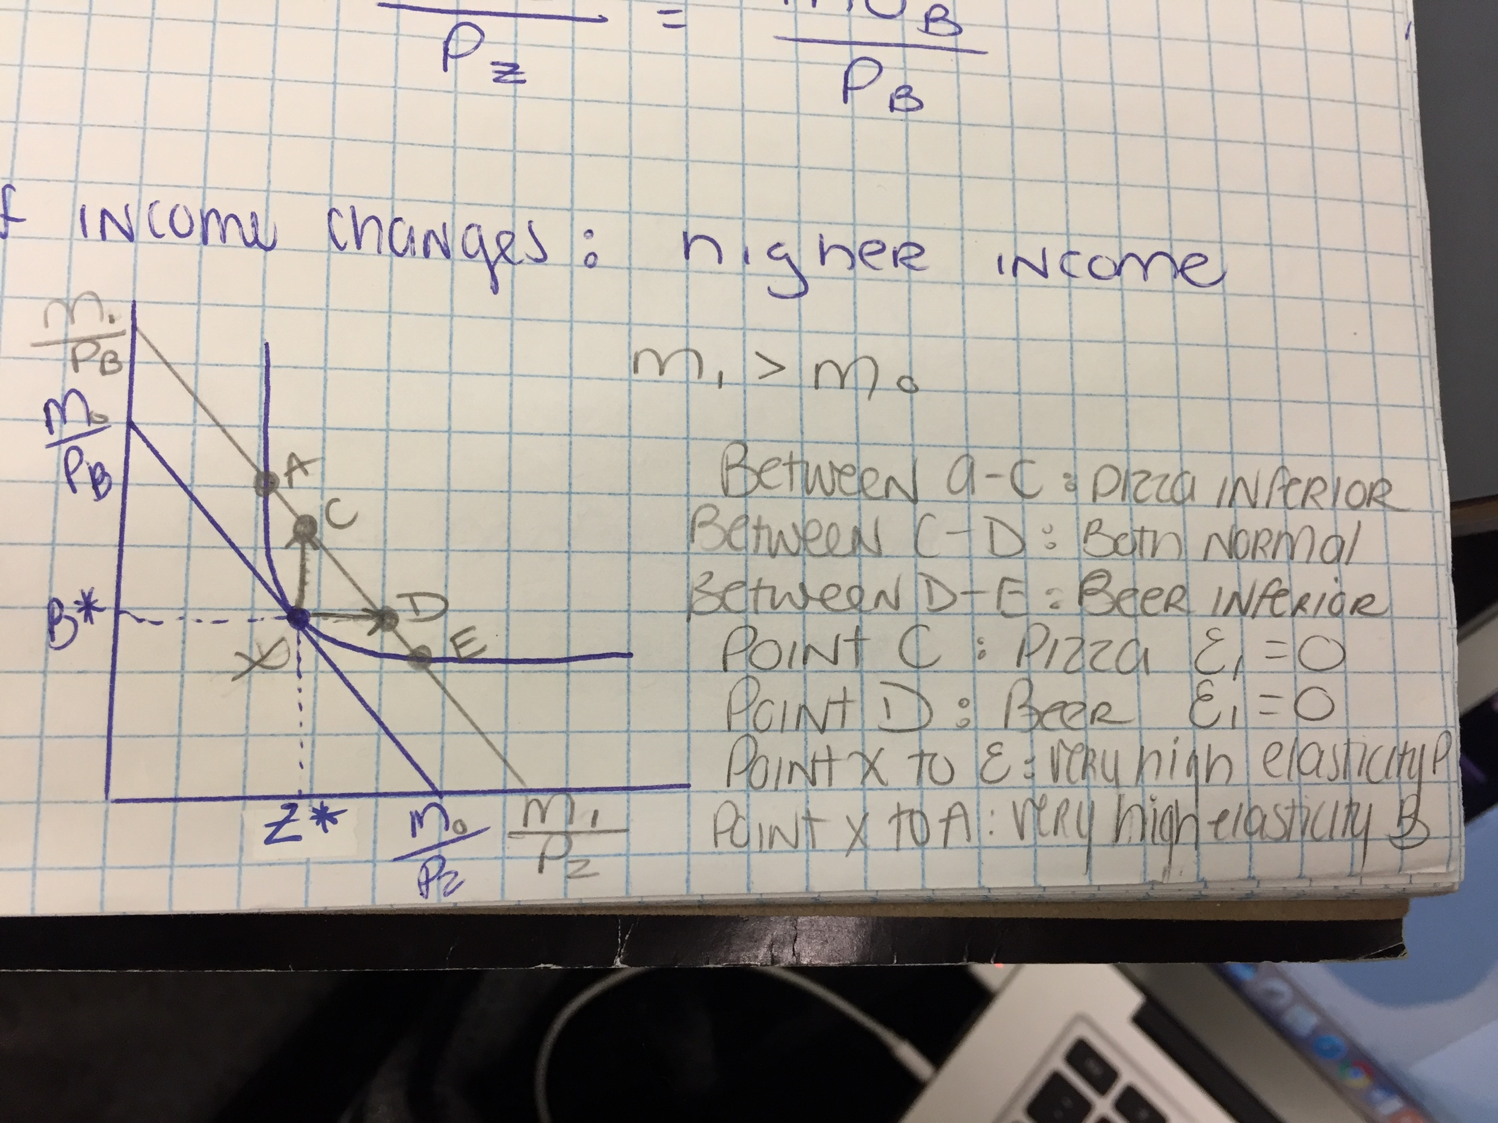

Key terms

Chap 1

Macroeconomics studies the economy as a system in which feedback among sectors determine national output, employment and prices.

Microeconomics is the study of individual behaviour in the context of scarcity.

Mixed Economy goods and services are supplied both by private suppliers and government.

Model is a formalization of theory that facilitates scientific inquiry

Theory is a logical view of how things work, and is frequently formulated on the basis of observation.

Opportunity Cost of a choice is what must be sacrificed when a choice is made.

Production possibility frontier (PPF) defines the combination of goods that can be produced using all of the resources available.

Consumption possibility frontier (CPF) the combination of goods that can be consumed as a result of a given production choice.

Economy-wide PPF is the set of goods combinations that be produced in the economy when all available productive resources are in use.

Productivity of Labour is the output of goods and services per worker.

Capital Stock: the buildings, machinery, equipment and software used in producing goods and services.

Full employment output equals to Yc =(number of workers at full employment)×(output per worker)

Recession: when output falls below the economy’s capacity output.

Boom: a period of high growth that raises output above normal capacity output.

Chap 2

Variables: measures that can take on different sizes

Data: recorded values of variables

Time series data: a set of measurements made sequentially at different points in time

Cross-section data: values for different variables recordered at a point in time

Repeated cross-section data: cross-section data recorded at regular or irregular intervals

Longitudinal Data follow the same units of observation through time.

Percentage change = (change in values)/ original value X 100

Inflation (deflation) rate: the annual percentage increase/decrease in the level of consumer prices.

Real Price: the actual price adjusted by the general (consumer) price level in the economy.

Regression Line: representation of the average relationship between two variables

Positive economics studies information in the form of scientific explanations of how the economy works.

Normative economics offers information that incorporate value judgements (opinion).

Economic equity is concerned with the distribution of well-being among members of the economy.

Chap 3

Demand is the quantity of a good or service that buyers wish to purchase at each possible price with all other influences on demand remaining unchanged.

Supply is the quantity of a good or service that sellers are willing to sell at each possible price, with all other influence on supply being unchanged.

Quantity demanded defines the amount purchases at a particular price.

Quantitiy supplied refers to the amount supplied at a particular price.

Equilibirum price: equilibrates the market. It is the price at which quantity demanded equals quantity supplied.

Excess Supply exists when the quantity supplied exceeds the quantity demanded at the going price.

Excess Demand exits when the quantity demanded exceeds quantity supplied at the going price.

Short side of the market determines outcomes at prices other than the equilibrium.

Substitute Goods: when a price reduction (rise) for related product increases

Chap 4

Price elasticity of demand is measured as the percentage change in quantity demanded, divided by the percentage change in price.

Demand is elastic if the price elasticity is greater than unity. It is inelastic if the value lies between unity and 0. It is unit elastic if the value is exactly one.

Cross-price elasticity of demand is the percentage change in the quantity demanded of a product divided by the percentage change in the price of another.

Income elasticity of demand is the percentage change in quantity demanded divided by a percentage change in income.

Luxury good or service is one whose income elasticity equals or exceeds unity.
Necessity is one whose income elasticity is greater than zero and is less than unity.
Inferior goods have a negative income elasticity.

Elasticity of supply is defined as the percentage change in quantity supplied divided by the percentage change in price.

Tax Incidence describes how the burden of a tax is shared between buyer and seller.

Chap 5

Welfare economics assesses how well the economy allocates its scarce resources in accordance with the goals of efficiency and equity.

Efficiency addresses the question of how well the economy's resources are used and allocated.

Equity deals with how society's goods and rewards are, and should be, distributed among its different members, and how the associated costs should be apportioned.

Consumer surplus is the excess of consumer willingness to pay over the market price.

Supplier or producer surplus is the excess of market price over the reservation price of the supplier.

Efficient market: maximizes the sum of producer and consumer surpluses.

Tax wedge is the difference between the consumer and producer prices.

Revenue burden is the amount of tax revenue raised by a tax.

Excess burden of a tax is the component of consumer and producer surpluses forming a net loss to the whole economy.

Deadweight loss of a tax is the component of consumer and producer surpluses forming a net loss to the whole economy.

Distortion in resource allocation means that production is not at an efficient output.

Externality is a benefit or cost falling on people other than those involved in the activity's market. It can create a difference between private costs or values and social costs or values.

Corrective tax seeks to direct the market towards a more efficient output.

Greenhouse gases that accumulate excessively in the earth's atmosphere prevent heat from escaping and lead to global warming.

Marginal damage curve reflects the cost to society of an additional unit of pollution.

Marginal abatement curve reflects the cost to society of reducing the quantity of pollution by one unit.

Tradable permits are a market-based system aimed at reducing GHGs.

Carbon taxes are a market-based system aimed at reducing GHGs.

Chap 6

Cardinal utility is a measurable concept of satisfaction.

Total utility is a measure of the total satisfaction derived from consuming a given amount of goods and services.

Marginal utility is the addition to total utility created when one more unit of a good or service is consumed.

Diminishing marginal utility implies that the addition to total utility from each extra unit of a good or service consumed is declining.

Consumer equilibrium occurs when marginal utility per dollar spent on the last unit of each good is equal.

Law of demand states that, other things being equal, more of a good is demanded the lower is its price.

Ordinal utility assumes that individuals can rank commodity bundles in accordance with the level of satisfaction associated with each bundle.

Budget constraint defines all bundles of goods that the consumer can afford with a given budget.

Affordable set of goods and services for the consumer is bounded by the budget line from above; the non-affordable set lies strictly above the budget line.

Indifference curve defines combinations of goods and services that yield the same level of satisfaction to the consumer.

Indifference map is a set of indifference curves, where curves further from the origin denote a higher level of satisfaction.

Marginal rate of substitution is the slope of the indifference curve. It defines the amount of one good the consumer is willing to sacrifice in order to obtain a given increment of the other, while maintaining utility unchanged.

Diminishing marginal rate of substitution reflects a higher marginal value being associated with smaller quantities of any good consumed.

Consumer optimum occurs where the chosen consumption bundle is a point such that the price ratio equals the marginal rate of substitution.

