CS101 A September 28th

^{Review of Last Week}
- Text and contexts; feeling and critical thinking- “doing media studies”, Mark Lipton
- Four characteristics of communications studies in Canada: critical sensibility’ cultural policy focus; orientation toward social justice and interdisciplinary.
- Hamilton on “crucial” vs “administrative” approaches to communication studies.

Origins of a tenacious idea
Administrative
Conducted in the service of a public or private admin agency
Sees media as useful tools to be harnessed for corporate/agency/gov’t/ goals.

… Inaccuracy and Simplicity…” (of this idea --- Hamilton, 4.)
•This distinction, though ubiquitous, is not accurate or useful
•Administrative work is political
•Critical work can be empirical and still draw o theory
•Administrative work can use qualitative analysis
•Critical work can focus on specific issues, even for specific institutions (addressing diversity at broadcaster, for instance)
•In other words, how the boundaries are blurry and should be

What is the difference between “concentration” and “convergence”?
Concentration
•When multiple media outlets have the same owner
•Horizontal integration (chains) Increasing production of goods and services at the same part of the suppley chain (American eagle makes T-shirt Aeropostale makes pants so they decide to start trading)
A lot of media in the same hands such as newspapers they own several publishers such as Toronto star, Montreal gazette, New York Times etc.
•Vertical integration
A company that owns an entire chain such as movies, they make the movie, publish it, and release it in the cinema (Tim Hortons instead of buying beans, cups, lids, they buy all those companies’ to make it themselves)
• Conglomerates
The same company owns business that directs other people to their other business doesn’t need to be the same Cinemas owning restaurants in their theaters. (Warren Buffet and Berkshire Hathaway, they own a shit ton of other companies Wikipedia)
Convergence
- When media companies specializing in different forms of media come together to take advantage of presumed synergies enabled by digitization/digital content. Ex. One of the huge media companies called global bought a chain of newspapers. They would buy a newspaper company and relate it to their TV station, website in order to synergize everything together.

Consolidation
• This is what business calls these processes
- “concentration” and “convergence” are more specific and, importantly for our purposes, more critical terms

So what why should we care about this??
Because:
- “marketplace of ideas” (Bildook)
democracy is “a ‘marketplace of ideas,’ where a wide range of
people and organizations have a real opportunity to express information. It has been established that a competitive market is necessary for the exchange of ideas.
- Essential for a healthy democracy
a free and diverse media are a vital component of a healthy democracy
With the limited owners in the media industry, it is essential that they don't provide limited choice in terms of where consumers can get their information as these forms society values, opinion, beliefs.
- Ensure Choice
Mass media is primarily a business for companies unfortunately the metrics of a business don't always coincide with the metrics of a democracy. Black Tuesday (August 27, 1980) when one media outlet closed down so the only other media outlet had a monopoly in that province creating a chain reaction with other provinces. Giving the public little to no choice from where they were their media from.
Owners could influence their audience if they for instance own a huge media corporation you will be able to see their biased.
- Labor issues
With convergence and economies, they thought that they had surplus staff so they thought they would be fine laying off a good portion of their staff

The Canadian media oligopoly
- Canada’s media industry is large, not small. Eighth largest in the world, just behind Italy and ahead of South Korea and Spain
- There is public media in Canada and private media
- Public media is big business too (ads on TV, commissioning content, central to the entire eco – system)
- A small handful of companies control almost all private media in Canada
The players in the oligopoly (from Thekadath and Thomas)
•Astral (iffy shouldn't really be on list)
•Bell Media
•Postmedia
•Quebecor
•Rogers
•Shaw: Cable provider. Largest market shares in the country as a provider of cable. Dominate in some parts of the country. Bought cam west in 2010 since this acquisition they were able to get several different channels.
•Telus
•Torstar

Ownership Issues (from Bildook)
• Concentration in one medium
Journalists’ opinions regarding the concentration of newspaper ownership are quite clear. A vast proportion believe that greater concentration of newspaper ownership decreases the quality of newspaper content (86%) and decreases the public credibility of newspapers (95%). ... But a substantial proportion (56%) also feels that news stories often reflect the owners’ views and interests. (Soroka and Fournier 2003).

Figure 1: Views of ownership impact by newspaper
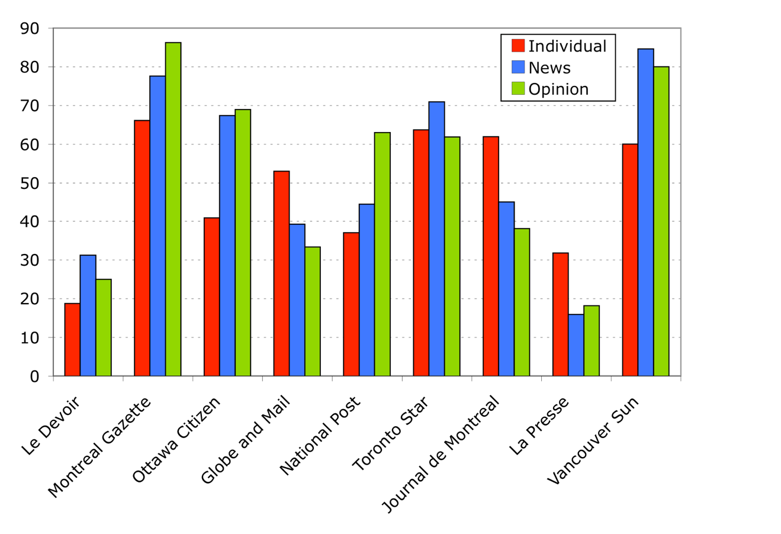

• Cross- media ownership
Ownership of more than one type of media outlet in Canada:
• Foreign ownership
Could be less attractive for them as they would need to start liberalizing trade agreements and institutions such as NAFTA and the WTO. Foreign investors can operate magazines within Canada with a 50% threshold of Canadian (or original) content and operate within the same advertising tax structure as Canadian‐owned magazines.
Limits to convergence and concentration:
1970: The senate special committee on mass media (Davey report)
1980: Royal commission on newspapers (Kent commission)
Mid 80’s: A ban on cross- ownership, but it was allowed by parliament to lapse
2006: Senate report on Canadian News Media
2008: CRCT imposes new rules:
• No one company own more than two major media types in the same market
•No one company can own more than 45% of audience share between their
properties.

CS101 October 5th
History of regulation and the C.B.C
•1920’s broadcasting in Canada begins (mostly private American radio)
- Mostly private American radio
- Canadians pretty much only received American radio station
- Concern about national sovereignty
•1920 Aird Commission (“The state or the United States” – G. Spry)
- Look into the situation of Canadian broadcasting
- Did research and announced that yes Canada does need a national broadcaster
•1932 Canadian Radio Broadcasting Act
- Yes, we need a public broadcaster so they created the Canadian Radio broadcasting coming
•1936 CRBC becomes CBC
- Changed the name from CRBC to CBC
- The CBC is charged with regulating the Airway
- Wasn't the only Radio station each town still had their own
•1952 CBC/Radio Canada Television Broadcasting
- Television didn't start in 1952 people close to the boarder have already watch American TV from Canada
- Less than 20 percent had television
•1957-58 Royal commission on Broadcasting, creating of the BBG, first CanCon regulations
- Explosion in the audience for television
- By the late 50’s Majority of the population had Television
- The Board of Broadcast governors (BBG) replaced the CBC as the regulators of broadcast in Canada
- BBG is not affiliated with the Government
•1961 first private television network – CTV
- One channel until 1961 unless you were able to Tune in to American TV
- Prior to 1961 the only broadcast channel was the state broadcaster which is owned by the government.
- CTV for profit business (add sales)
- 1968 new Broadcasting Act and the formation of the Canadian Radio- Television Commission now the Canadian Radio-Television and Telecommunications Commission) C.R.T.C.
- 1971 Satellite TV
- People didn't want to broadcast in towns that ads wont sells such as Nunavut or Iqaluit so broadcaster don’t bother providing channels
- 1991 Broadcasting Act revised again
- The fucking rule book
- 1999 CRTC rules that internet content is outside of “Broadcasting
- Didn't treat internet as broadcasting
- 2000s various tweaks and consolations, including “Lets Talk TV” in 2014
- CRTC forces the cable companies to have a simple cable package.
General Principles of Canadian Broadcasting
- Effective owned and controlled by Canadian
- This is why we own specialty TV channels making foregners unable to broadcast in Canada.
- Got to be a Canadian owned and established company to broadcast in Canada
- Operated primarily in French and English has public private and community elements
- Serves to safeguard, enrich and strengthen the cultural, political, social and economic fabric of Canada
- We don't want a broadcast system that only benefits the shareholders which is why there are community and public elements (related to principle #2)
- Encourages the development of Canadian expression by providing programming the reflects Canadian attitudes, opinions, idea, values and arthritic creativity.
- Crazy principle for a broadcast policy
- Continues to change overtime
- Serves the needs and interest (and reflects the circumstances) of Canadian women and men, including equal rights, linguistic duality, multicultural and multiracial society and the special place of Indigenous Peoples of Canada
- Representation is relatively important for a media broadcast
- Makes maximum use of Canadian creative talent and recourse
- Economic aspect: give work to talented Canadians
The result of these principles? Canadian Content (“CanCon”)
- Broadcast quotas
- 35 percent of the radio music has to be Canadian (6am-6pm must be Canadian content)
- 60 percent of the TV channels have to be Canadian
- 50 percent of TV content needs to be specialty channels
- Production measurement
- How do we determine if its Canadian Content?
- People were hired to solve any confusion
- Canadian Media Fund (CMF) – Watch Canada’s Media Oligopoly at Work!!!
- A body established by the federal government
- Funded by the cable and satellite broadcasters in Canada
- CMF announced a percentage of cable and satellite companies to pay up a percentage of revenue so they could make Candian content
- Government will donate a percentage of CMF too each year
- CMF generates over hundred of millions of dollars every year
- CMF later distributes their Canadian content created to broadcasters
- Different but related, government programs/agencies such as Telefilm Canada
How does the Government know if its “Canadian” enough?
•MAPL(Music) (2/4=Canadian Music)
•M(music): the music is composed entirely by a Canadian
•A (artist): the music is, or the lyrics are, performed principally by a Canadian
• P (performance): the musical selections consist of a live performance that is
- Recorded wholly in Canada, or
- Performed wholly in Canada and broadcast live in Canada
•L(lyrics): the lyrics are written entirely by a Canadian
CAVCO (Canadian Audio-Visual Certification Office) 6 Points to be certified Canadian
•Director 2 points
•Screenwriter 2 points
• Lead performer 1 point
•Second lead performer 1 point
•D.O.P 1 point
•Art director 1 point
•Music composer 1 point
•Picture Editor 1 point

Does the current media environment render such rules irrelevant?
•Is Netflix a broadcaster?
• Should it be treated like one?
•Or, should broadcaster be treated like Netflix?

MIDTERM
• Study lecture notes, esepcailly emphasized topics and ones that appear both in lecture and readings.
• MUST KNOW WHO WROTE EACH ARTICLE/ WHO SAID WHAT. Just try to focus on main points and main supporting arguments. Gist of what they said for knowing names.
• Mostly about understanding concepts and ideas and just some facts.
• Need to understand relative chronology (what happened before or after what, not so much dates)
• The kent commission
• The aird reports: we should have a national Canadian public broadcaster
• Different lists in the readings
• Samples questions:
1) It is generally agreed that free and diverse media is not a vital component of democracy.
a) True
b) False
Answer is FALSE

2) The royal commission on newspapers was known as:
a) The press commission
b) The press council
c) The kent commission
d) The lincol commission
Answer is THE KENT COMMISION

3) Internet service providers are “broadcasting undertaking” under the broadcasting act
a) True
b) False
Answer is FALSE

Lecture 4
• Trajectory from passive to active is about btoh how audiences are understood and what audience behavior and prctive show use over time
• Audience models:
- Media effects → the effect of media on the audience, how do media messages impact the way people think. Administrative. Refered to as hypodermic needle model. Came from early social science behavioral model. After ww2 this was seen as flawed, so indirect effects were considered (media tells us not what to think, but what to thinka bout)
- Agenda setting→ media says whats important to think about. Two step procces,
- Cultivation analasys→ pres lindon jhonson in 60’s, large concern about the content of tv, studies discovered that media cultivate understandings about the world over time.
- Users and gratifications → asks what do audiences do with media? Why do we consum the media that we do? Shows audiences can consume media in ways that were not intended by the producer.
- Active audiences and prosumers → consumers but also produce. Audience understood to be actuve in producing meaning.
- Social media audiences→ how audience produce and SHARE meaning
- Making culture→ audiences are ecoming producers with increased technological availability
Wagman
• The Canadian presence withing fb seems to have mititgated what would have been a need for a media technology that is distinctly Canadian. Saying that the need to make candian version never actually happened with fb. No one worried about it, ppl just accepted it for the way it was. Fb is a media from that is similar to other medias, but Canadians never had guilt associated with its use event htough its forgeing owned. This is because its just a short term deviation from what someone is doing.

Ira wagman reading (October 19th)
Log on, Goof off, and look up
Facebook In Canada:
- Facebook was the second most popular website amongst Canadians just behind google.
- Approximately 3/5 Canadians have a Facebook account.
- Canada has the 3 largest amount of Facebook subscribers behind the United states and the United Kingdom.

Facebook:
- Originally only available to students at universities
- In 2007 it became available to anyone with an email address.
- Social media websites keep changing in order to successfully adapt and adjust to the internet everyday.
- Most information contained in a profile is hyperlinked so when you click on it, it takes you to pages of other people who enjoy the same content
- Enabling you to becomes friends with these people because of similar interests.
- One of the most popular classes of applications are those that promote users to engage in virtually gesture forms of communication to get more attention (poking, hugging,)

Dana Boyd and Nicole Ellison
- They suggest social networking sites share 3 general characteristics
- They allow users to construct a public or a semi public profile within a bounded system such as within the Facebook “universe”
- They allow users to generate a list of friends whom they wish to share connections within that universe
- They allow users in the to examine connections made by other friends within the system

Brief encounters and Heavy checking: Characterizing Internet use
- Manuel Castells argues that network societies represent spaces of “flows”

