Chapter 3 – Job-order Cost Accounting

Cost accounting systems
- Accounts for the various manufacturing costs.
- Cost accounting system uses a perpetual inventory system. Why? Because such system provides immediate up-to-date information on the cost of a product
- 2 basic types of cost accounting systems: Job-order cost system & Process cost system

Job-order cost system
“each job is unique + low volumes”
A job-order cost system measures costs for each completed job, rather than for a set time period.

Example:
Assigning a cost to a job: manufacture of a private aircraft by Bombardier
Assigning a cost to a batch: printing of 225 wedding invitations by a local print shop

Cost allocation
- the process of assigning costs to cost objects
- Cost allocation works with approximation
- Overhead rate it based on estimations
- Works with a predetermine overhead rate
Trying to find an indicator to find out how much MOH to allocate to each job.
More direct labour spent for one job -> more MOH for that same job

Assigning manufacturing costs to work in process

Assigning manufacturing costs to work in process results in the following entries:
- debits are made to WIP inventory
- credits are made to RM inventory, Factory labour, and MOH.
The journal entries to assign costs to work in process are usually made and posted monthly.

Job Cost sheet
- is a subsidiary ledger
- is a form that is used to record the costs that are chargeable to a specific job and to determine the total and unit costs of the completed job.
MOH is not total. It is found using the predetermined overhead rate.

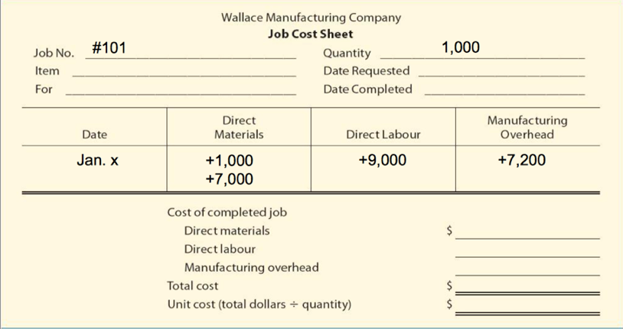

Stage 1. Accumulate the manufacturing costs incurred

Raw materials cost

Materials requisition slip
The company will charge direct materials to WIP inventory and indirect materials to MOH.

Example Journal entry:

MOH (IDM) 200
WIP inventory (DM) 800
Raw materials inv. 1,000

Labour cost

Example Journal entry:

Factory labour 7,000
Wages Expense (SG&A) 3,000
Salaries & Wages Payable 10,000

MOH
Example J/E
MOH 300
Rent payable 100
Utilities 200

Stage 2. Assignment stage
more dealing with labour and MOH

- Assign factory labour to both accounts.
Example J/E:

MOH (IDL) 2,000
WIP inventory (DL) 5,000
Factory labour 7,000

- Apply overhead using predetermined overhead rate “Normal Costing”
Total estimated cost of MOH for the year

Step 1. Decide on activity base
Direct materials
Direct labour (usually use direct labour in either dollars or hours)
Machine hours

Step 2. Calculate Predetermined overhead rat based on estimations

$$Predetermined Overhead Rate=\frac{Estimated annual MOH}{Total estimated use of activity base}$$

Step 3. Assign MOH based on actual activity base

$$Actual Activity based used × Predetermined overhead rate$$

Stage 3. Moving finished units to FG
J/E

Finished goods 5,000
WIP 5,000

Stage 4. Sale of item

CoGS 5,000
Finished Goods inv. 5,000

If they tell you markup, you have to do sales J/E

Under-/over-applied overhead
At the end of the period, the applied MOH ≠ actual MOH costs.
But in CoGM schedule -> use MOH applied
And then you must find under/over applied MOH

*Value is subtracted from CoGS when it Over Applied & added to CoGS when Under Applied*

In exams, its going to be mentioned which method to use

To find it, there is 2 methods:

CoGS method: under/over is eliminated by adjusting CoGS
“adjust to CoGS” or “Immaterial amount”

J/E:
When under applied:
CoGS 5,000
MoH 5,000
When over applied:
MOH 5,000
CoGS 5,000

On income statement:

Income Statement

Sales 88,650
CoGS:
Beg. Finished Goods 15,000
+ CoGM 78,400
= Cost of goods available 93,400
- End Finished Goods 34,300
= CoGS 59,100
+/- under/over applied MOH (5,000)
Adjusted CoGS 54,100
= Gross Profit 34,550
- SG&A
= Net Income

Proration Method: under/over is pro-rated among WIP, finished goods inventory, and CoGS using their ending balances.

* when under applied
WIP x
FG inv. x
CoGS x
MOH x

*When over applied
MOH x
WIP x
FG inv. x
CoGS x

Example:
Actual Overhead = 100,000
Applied Overhead = 90,000
Under applied = 10,000

Acc Balance Share
WIP 10,000 10%
FG inv. 20,000 20%
CoGS 70,000 70%
Total costs 100,00

Adjusting Entries:
WIP 1,000
FG inv. 2,000
CoGS 7,000
MOH 10,000

Chapter 4 - Process Cost Accounting: Process Cost Flow

Companies use process cost systems to apply costs to similar products that are mass-produced in a continuous way.
Looking at the costs to each step of the process

Similarities and differences between job-order cost and process cost systems

Similarities
- Manufacturing cost elements: both cost systems track 3 manufacturing costs – DM, DL, MOH.
- The accumulation of the costs of materials, labour, and overhead: Raw materials are debited to RM inventory, factory labour are debited to FL, and MOH costs are debited to MOH.
- The flow of costs: The costs are assigned to the same accounts in both methods – WIP, FG inventory, CoGS. However, methods of assigning costs differ.

Differences
- # of WIP accounts used: in process cost systems, several WIP accounts are used (1 for each process).
- Documents to track costs: Cost are summarized in a production cost report for each department, rather than a job cost sheet.
- The point at which costs are totaled: The total cost is determined at the end of a period of time, rather then when the job is completed.
- Unit cost calculation: The unit cost is TMC for the period divided by the units produced during the period.
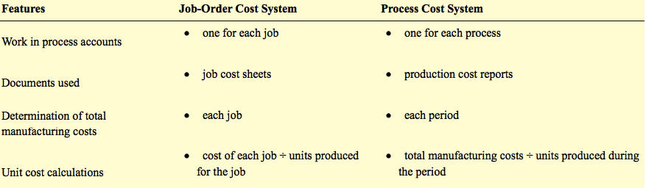

Operations costing “hybrid costing system”
- A combination of a job-order cost and a process cost system.

The flow and Assignment of Manufacturing Costs

Assigning Materials costs
Example J/E
WIP – machining x
WIP – Assembly x
Raw Materials Inventory x

Assigning Factory Labour
Example J/E
WIP – machining x
WIP – Assembly x
Factory Labour x

Assigning MOH

Transfer of costs between the WIP accounts
WIP – Assembly x
WIP – Machining x

Transfer completed goods to FG inventory

Record CoGS at the time of sale

Equivalent Units

In exams,
Evenly throughout/ All along the process -> every step, you’re adding the cost along the line

Weighted-Average method (WA)
“what is the level of completeness at the end of the period?”
Weighting means considering the degree of completion

$$Units completed and transfered out+Equivalent units of ending WIP =Equivalent Units of production$$
The beginning WIP is not part of calculation of equivalent units

FIFO method
“What work did I do this period?”
Beginning WIP is completed before new work is started

You’re looking at what needs to be completed. For this reason,
Equivalent units = (1- degree of completion) x Units of beginning WIP

*Weighted average and FIFO give same quantity when there is no beginning inventory.
*Same rate of completion will give the same amount for the equivalent units for materials and conversion cost.

Production Cost Report

Chapter 5 - Activity-based costing (ABC)
ABC is an approach for allocating MOH. It allocates overhead to multiple activity cost pools, and then assigns the activity cost pools to products and services by using cost drivers.

In chapter 3&4, we used the predetermined overheard rate. But now in chapter 5, we say its not that accurate.
Overhear allocation is now based on multiple allocation bases (activity cost pools & cost drivers).

Just a different way to allocate MOH. You can use ABC with job-order costing or process-costing because DM and DL remain the same.

Activity cost pool:
- Is a distinct type of activity (i.e: ordering materials or setting up a machine)

Cost driver:
- Is any factor or activity that has a direct cause-effect relationship with the resources consumed.

How it works: Overhead is allocated in 2 stages
- Overhead costs are allocated to activity cost pools (i.e. purchasing $, storing $, machining $, supervising $).
- Overhead costs allocated to the cost pools (from step 1) are assigned to products using cost drivers (i.e. number of purchase orders, square meters occupied, number of machine hours, number of employees)

Complexity effect
Compared to traditional costing, high volume standard products (lower manufacturing complexity) apprear cheaper under ABC

Compared to traditional costing, low volume customized products (higher manufacturing complexity) appear more expensive under ABC

Benefits and Limitations of ABC

Benefits – More accurate product costing through:
- Use of more cost pools to assign overhead costs
- Better control over overhead costs
- Better management decisions

Limitations of ABC:
- Can be expensive to use
- Some arbitrary allocations continue

For exam question answer
In normal costing, we apply all overhead as if it was all unit based. ABC reflects the reality that not all overhead is incurred by unit level activities. Some overhead is unit-level, batch-level, product-level, facility-level. By breaking overhead up into multiple cost pools and applying it using multiple cost drivers, you are able to control overhead cost better (increase accuracy of moh application), which leads to better decision making.

Chapter 6 - Decision-making: Cost-volume profit

CVP analysis
- Study of the effects that changes in costs and volume have on a company’s profit.
- Important in profit planning.
- Critical factor in such management decisions as setting selling prices, determining product mix, and maximizing the use of production facilities.

CVP is the interrelationship with the following 5 components:
- Volume or level of activity (amount we’re selling)
- Unit selling prices
- Variable cost per unit
- Total fixed costs
- Sales mix

Assumptions that underlie each CVP analysis
- Linear CVP model: behavior of both costs and revenues is linear throughout the relevant range of the activity index
- Either variable of fix: all costs can be classified as either variable or fixed with reasonable accuracy
- Only sales quantity affects costs: changes in activity are the only factors that affect costs
- All units produced are sold – inventory levels remain constant
- Single product or constant sales mix: when more than one type of product is sold, the sales mix remain constant
When these 5 assumptions are not valid, the results of CVP analysis may be innacurate.

Contribution Margin
Amount of revenue remaining after deducting variable costs

Contribution margin per unit = unit selling price – unit variable costs
- the money left to cover fixed costs and contribute to operating income

Contribution margin ratio = $\frac{contribution margin per unit}{unit selling price}$

- Percentage of sales available to cover fixed costs and contribute to operating income

Applying CVP analysis

Break-even analysis
Sales units or sales in dollars, where operating income = 0
3 approaches:

Mathematical equation
Break-even point in units =$fixed costs÷(unit selling prics-variable cost per unit)$

Break-even point in sales = $break even sales units × unit selling price$

Contribution margin technique
at break-even, contribution margin = total fixed costs

Graphic presentation

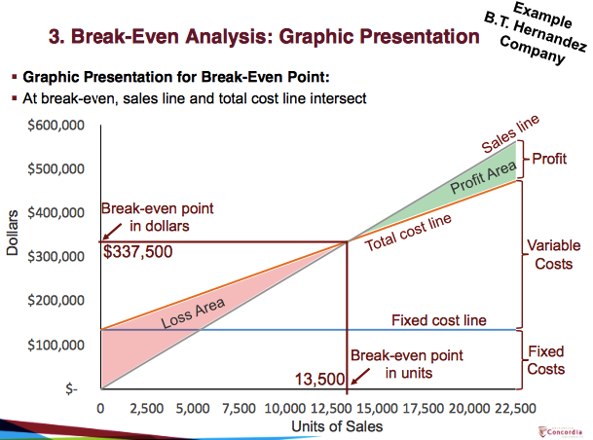

Target operating income
Indicates sales needed to achieve targeted level of income
3 approaches:

Mathematical equation

In class

P = CM x Q – FC

CM = unit selling price – VC

UNITS
Break-even: Q= FC/CM
Target income no taxes: Q = (FC + Profit)/ CM
Target income with taxes: = (FC + taxes + profit) / CM

SALES DOLLARS
Break-even: Sales = FC / CM ratio
Target income no taxes: Sales = (FC + Profit)/ CM ratio
Target income with taxes: sales = (FC + Taxes + Profit)/CM ration

Target profit before taxes = TC + Profit

1.CVP income statement
Total Per unit
Sales (25 x 20 000) 500,000 25
Variable costs 15 x 20,000 300,000 15
Contribution margin 200,000 10
Fixed costs 135,000
Net income 65,000

CM = p – vc = 25 - 15=10
CM ratio = CM / Selling price = 10/25 = 40%

2. break-even point
BEP in units:
Q = FC/CM = 135,000/10 = 13,500 units

BEP in sales dollars:
Q = FC/ CM ration = 337,500 OR 13,500 x 25$ = 337,500

3. target profit no taxes

units:
Q = FC + Profit / CM = 135,000 + 65,000/ 10 = 20,000

Sales= 20,000 x 25$ = 500,000

4. target profit with taxes
use NI before taxes

Target income before taxes = 65,000 / (1-40%) =108,333
units: Q= FC + profit before taxes / CM
Q = 135,000 + 108,333/ CM
Q = 24,333.33 units -> 24,334

Sales:
Sales = 135,000 +108,333 / 0.4 = 608,333 OR
Sales = 24,333.33 x 25 = 608,350

5. Margin of safety
margin of safety = expected sales (qty) - break-even sales (qty)

margin of safety in units = 20,000 – 13,500 = 6,500 units
margin of safety in sales = 500,000 – 337,500 = 162,500

as a ratio:
margin of safety ratio = margin of safety in units / expected qty
= 6,500 / 20,000
= 32.5%

OR

margin of safety ratio = margin of safety in sales / expected sales
= 162,500 / 500,000
= 32.5%

this means that our sales can drop by this amount and still generate profit

6. operating leverage

degree of operating leverage = CM / operating income
= 200,000 / 65,000
= 3.0769
example: sales increase 20%, then net income increases by 61.5% (3.0769 x 20%)

SLIDE 33

A-1 BEP
Units: Q = FC / CM = 750,000/ 1.50 = 500,000

CM = 3.50 – 2.00

Sales = FC / CM ratio = 750,000/ 0.42857 = 1,750,000
A-2 net profit for the expected sales volume

Expected sales volume = 800,000 jars

Net income = Q x CM – FC = 800,000 x 1.50 – 750,000 = 450,000
OR
Sales 2.8M
-VC 1.6M
=CM 1.2M
-FC 0.750M
=NI 450,000

A-3 margin of safety

In units = 800,000 – 500,000 = 300,000

Margin of safety ratio = 300,000/800,000 = 37.5%

A-4 CVP chart

B-

Sales 2.5M
-VC 2.0M
=CM 0.5M
-FC 0.750M
=NI (250,000)

- reject idea

C-

VC= 2.25 per unit

Profit= (selling price per unit – VC)Q – FC
450,000 = (selling – 2.20)800,000 – 750,000
selling price per unit = 3.70

OR

Increase selling price by 0.20 because VC increase by 0.2 and FC did not change.

Tutorial Feb 12th

Sales
-Variable costs
= CM
-Fixed costs
= Net income

Variable costs include all product and period variable costs
Fixed costs include all product and period variable costs

Operating leverage

Def: Measure of earning volatility
If sales changes, how much will net income react

