- Problem Identification:
Compute the area and perimeter of a Rectangle, Circle, or a Triangle based on the users choice.

- Gathering Information and I/O Description:

Rectangle:
Area = Width x Height
Perimeter = (2 * Width) + (2 * Height)

Circle:
Area = Pi x Radius^2
Perimeter = 2 x Pi x Radius

Triangle:
Area = (Ax(By – Cy) + Bx(Cy – Ay) + Cx(Ay – By)) / 2
Perimeter = A + B + C

Distance Formula:
Square Root of (x2 – x1)^2 + (y2 – y1)^2

I/O Description: Point1 (x,y)
Point2 (x,y) Area
………. Perimeter

- Algorithm:
Begin

Print “Welcome to Cartesian geometry! Please choose a shape by entering its number”

Print “Rectangle -> 1 Circle -> 2 Triangle -> 3 Exit -> 4

Read choice

Call appropriate Function

Circle
Rectangle
Triangle
Exit
Print enter x,y coordinates of point (point + i)
Print enter x,y coordinates of point
Print enter x,y coordinates of point (point + i)

Read Coordinates
Read Coordinates
Read Coordinates

Yes
Yes
I < 3
I < 4
No
No
No
Yes
I < 2
Calculate Area
Calculate Area
Calculate Area
Calculate Perimeter
Calculate Perimeter
Calculate Perimeter

Display Area, Perimeter
Display Area, Perimeter
Display Area, Perimeter

End

- Pseudocode :
Define Pi as Symbolic constant with the value of 3.141592
Define function Rectangle
Define function Circle
Define function Triangle
Define Function Exit

Define Point as structure containing two double variables called x,y

Define 'function pointer array' functions
Print “Welcome to Cartesian geometry! Please choose a shape by entering its number”
Print “Rectangle => enter 1 Circle => enter 2 Triangle => enter 3 EXIT Program => enter 4”
Define integer choice
Read user's input to choice
If choice is larger than 0 and smaller than 4
Call function[choice – 1]()
Else print
“Invalid Choice”

Function Rectangle:
Declare distance as double array
Declare points as Point structure array

While i = 0 is less than 4
Declare char variable named point
Print “Enter Point (point) x,y values
Add i to point
Read input to points[i]
If i is larger than zero
Assign the distance between the current point and previous point to distance[i]
Assign the distance between the last two points to distance[3]
Declare area of type double
Assign the width(distance[0]) multiplied by the height(distance[1]) to area
Declare perimeter of type double
Assign double the width plus double the height to perimeter
Print area and perimeter

Function Circle:
Declare distance of type double
Declare centerPoint and point of type point
Print “Enter the center point x,y coordinates”
Read input to centerPoint
Print “Enter the x,y coordinates of any point on the circle”
Read input to point
Declare area of type double and assign Pi * distance^2 to it
Declare perimeter of type double and assign 2 * distance * Pi to it
Display area, Perimeter

Function Triangle:
Declare distance as double array
Declare points as Point structure array

While i = 0 is less than 3
Declare char variable named point
Print “Enter Point (point) x,y values
Add i to point
Read input to points[i]
If i is larger than zero
Assign the distance between the current point and previous point to distance[i]
Assign the distance between point a and point c to distance[2]
Declare area of type double
Assign Ax(By – Cy) + Bx(Cy – Ay) + Cx(Ay – By) / 2 to area
Declare perimeter of type double
For i = 0 < 3
Add the value of distance[i] to perimeter
Print area and perimeter
Function Exit:
Terminate the application

- Implementation:
/*-------------------------------------------------*/
/* Date: Jan 26, 2012 */
/* Program: lab.c */
/* Description: This program computes the area */
/* and perimeter based on two or more points in the selected shapre. */
/*-------------------------------------------------*/
#include <stdio.h>
#include <stdlib.h>
#include <math.h>
#define PI 3.141592 // Defines PI as a symbolic constant to avoid using literals throughout the code

//Prototype for functions each of which correspounds to a choice, adhereing to the structured programming philosophy.
void Rectangle();
void Triangle();
void Circle();
void Exit();

struct Point // Defining a structure to facilitate the mangement of points
{
double x;
double y;

};

int main()
{

// Declaring an array of function pointers to avoid the use of selection structures
void (*functions[3])() = {Rectangle,Circle,Triangle};

//Display a menu of choices
printf("Welcome to Cartesian geometry! Please choose a shape by entering its number:\n");
printf("\n");

int choice;
scanf("%d",&choice); // Read the choice

// Call the function associated with shape selected, and check for incorrect input
if ( choice <= 4 && choice > 0)
functions[choice - 1]();

else
printf("Invalid Choice\n"); // Display an error message in case of invalid input

// Delay the termination of the application in enviornmens such as Visual Studio
getchar();
getchar();

return 0; // Terminate the application
}

void Rectangle()
{

double distance[4]; // Declare a double array to hold the caculated distances
struct Point points[4]; // Declare an array of the previously defined structure to represent points

// Using loop for reoccuring coordinate entry
for (int i = 0; i < 4;i++)
{
char point = 'a';
printf("Enter point %c x,y values:",point + i);

scanf("%lf%lf",&points[i].x, &points[i].y);
printf("\n");

if (i) // Execute the second time after two points have been entered and calculate the distance between them using the Distance Formula
distance[i - 1] = sqrt( pow(points[i].x - points[i - 1].x ,2.0) + pow(points[i].y - points[i - 1].y,2.0));

}
// Given that the loop will excute only three times additional distance calculation is needed
distance[3] = sqrt( pow(points[3].x - points[2].x, 2.0) + pow(points[3].y - points[2].y,2.0));

// Caculate the area by multiplying the width by the height
double area = distance[0] * distance[1];
// Calculate the perimeter by adding double the width to double the height
double perimeter = (2 * distance[0]) + (2 * distance[1]);

// Handles the output of the area abd perimeter
printf("Area of circle is %0.2f\nPerimeter is %0.2f\n",area,perimeter);

}

void Triangle()
{

double distance[3]; // Declare a double array to hold the caculated distances

struct Point points[3]; // Declare an array of the previously defined structure to represent points
// Using loop for reoccuring coordinate entry
for (int i = 0; i < 3;i++)
{

char point = 'a';
printf("Enter point %c x,y values:",point + i);
scanf("%lf%lf",&points[i].x, &points[i].y);
printf("\n");

}
// Calculate the distance between the points
distance[0] = sqrt( pow(points[1].x - points[0].x, 2.0) + pow(points[1].y - points[0].y, 2.0) );
distance[1] = sqrt( pow(points[2].x - points[1].x, 2.0) + pow(points[2].y - points[1].y, 2.0) );
distance[2] = sqrt( pow(points[0].x - points[2].x, 2.0) + pow(points[0].y - points[2].y, 2.0) );

// Calculate the perimeter by adding the distances
double perimeter = 0;
for (int i = 0; i < 3;i++)
perimeter += distance[i];

// Calculate the area using the following formula : Ax(By - Cy) + Bx(Cy - Ay) + Cx(Ay - By) divided by 2
double area = (((points[0].x * (points[1].y - points[2].y)) + (points[1].x * (points[2].y - points[0].y )) + (points[2].x * (points[0].y - points[1].y)) ) / 2);
if ( area < 0) // Reverse the sign if negative
area = -(area);
// Outputs the area and perimeter
printf("Area of rectangle is %lf\nPerimeter is %lf\n", area, perimeter);

}

void Circle()
{

double distance; // Store the radius

// Declares a Point structure to hold point coordinates
struct Point centerPoint;

struct Point point;

printf("Enter the center point x,y coordinates:"); // Prompts the user to enter the center point
scanf("%lf%lf",&centerPoint.x, &centerPoint.y); // Reads the point x,y coordinates
printf("\nEnter any x,y coordinates on the circle: "); // Asks for the coordinates for any point on the circumfrance
scanf("%lf%lf",&point.x,&point.y); // Reads the coordinates
distance = sqrt(pow(point.x - centerPoint.x,2.0) + pow(point.y - centerPoint.y,2.0)); // Calculate the raduis using the Distance Formula

double area = PI * pow(distance, 2.0); // Calculate the area

double perimter = 2 * distance * PI; // Calculate the perimeter
printf("Area of circle is %f\nPerimeter is %f\n", area, perimter); // Displays the area and perimeter

}

void Exit() // Terminate the application
{
return;
}

- Software Testing and Validation:
Triangle:
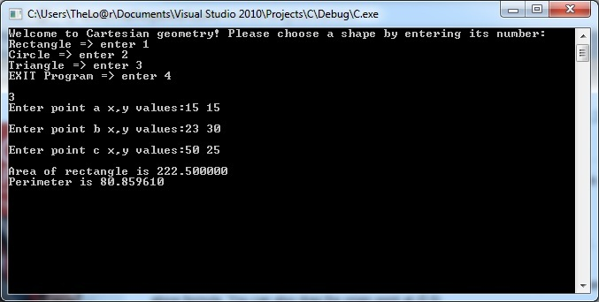

Rectangle:
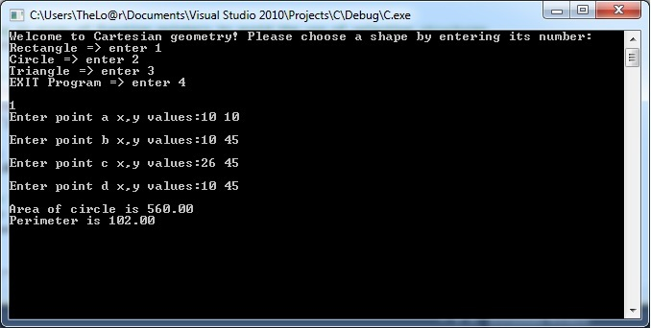
Circle:


