Chapter 4:
Ten principles of Macroeconomics:
- People face tradeoffs
- The cost of something is what you give up to get it
- Rational people think at the margin
- People respond to incentives
- Tradeoffs can make everyone better off.

Opportunity cost is the second best choice!

Economists play two roles:
- Scientists: try to explain the world: Positive statements
- Policy advisors: try to improve it: Normative statements
*a statement can be positive and false!

The Market Forces of Supply and Demand

Monopoly does not have a supply curve.

Market: a group of buyers and sellers.

Competitive market: many buyers and sellers

Quantity demanded: the amount of a good that buyers are willing and able to buy at a given price (1 point on the graph)

Demand curve: graph of the relationship between the price of a good and the Q demanded

Market demand: the sum of all individual demands for a particular good or service.

Factors that shift the demand curve:
- Income
- Price of related goods (substitutes and compliments)
- Preferences
- Expectations
- Number of Buyers
Supply: the behaviour of the sellers

Law of Supply: ceterus parabus, the Q supplied of a good increases as the price of a good increases.

Market Supply: the sum of all the supplies of all sellers.

Factors that shift the demand curve:
- Input prices
- Technology
- Expectations
- Number of Sellers

Equilibrium: a situation in which the price has reached the level where the Q supplied equals the Q demanded.

Surplus: Q supplied > Q demanded
Shortage: Q supplied < Q demanded

Ex. As it gets hotter, the quantity demanded for ice cream increases

*do exercises on supply and demand curves and equilibriums etc

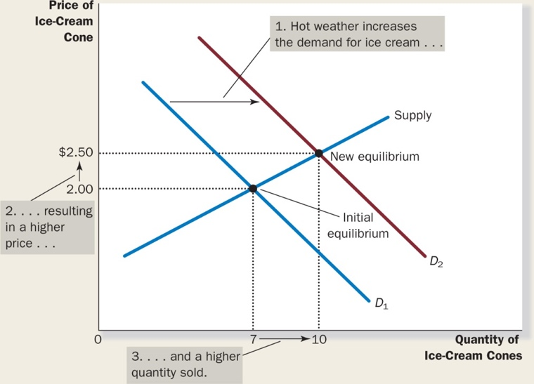
^ there is a shortage

Factors that shift the supply curve:
- Input prices
- Technology
- Expectations
- Number of sellers
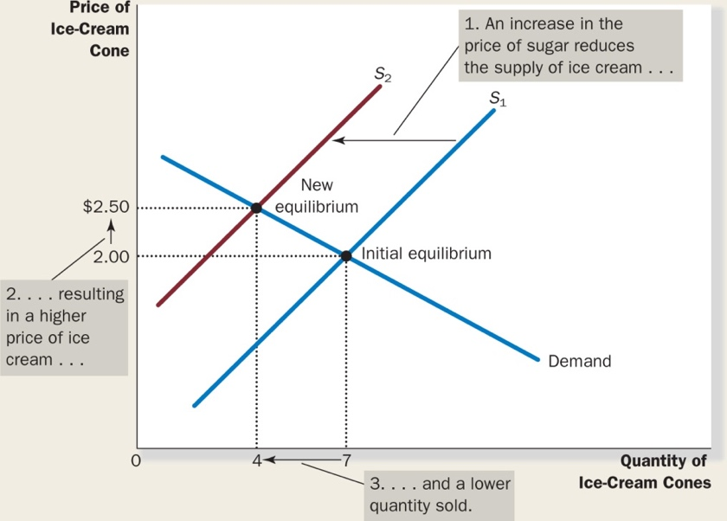
^this is also a shortage because supply decreases, which means supply < demand

The size of the shift in demand and supply determines how much the price and quantity change. (elasticity)

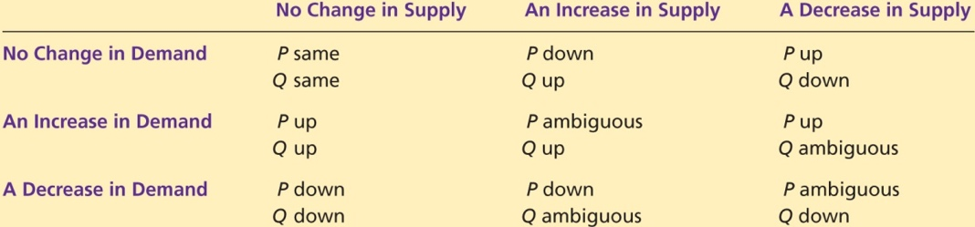

Chapter 5 – Measuring a Nation’s Income

Micro: the study of how individuals and how firms make decisions and how they interact in markets

Macro: the study of economy-wide phenomena, including inflation, unemployment, and economic growth.

Gross Domestic Product (GDP): measures total income of a nation; the most widely watched economic statistic because it is the best measure of a society’s economic well-being

For an economy as a whole, income must equal expenditure.

GDP is the market value of all final goods and services within a country in a given period of time.

Lecture 5:

Assignment > chapter 8

Chap 5 cont’d:

GDP adds together many different kinds of products into a single measure of the value of economic activity

Oranges cost $5; makes OJ and sells for $10
Registered amount = price of oranges + added value to juice = 5 + 5 = $10

GDP = economic activity in the country only
GNP = includes that country’s economic activity outside of country

Ben Bernanke Book on website on Macroeconomics!!

Components of GDP:

Y = C + I + G + NX

Y: GDP
C: Consumption: spending by households in goods and services, with the exception of purchases of new housing
I: Investment: spending in capital-equipment, inventories, and structures, including household spending on new housing.
G: Government purchases: spending in goods and services by local, territorial, provincial, and federal governments.
NX: Net exports: the value of a nation’s exports minus the value of its imports; also called the trade balance.
Austerity measures refer to official actions taken by the government, during a period of adverse economic conditions, to reduce its budget deficit using a combination of spending cuts or tax rises.

How do we account for taxes?
REAL vs NOMINAL GDP

Lecture 6: 29/09/15

Real and Nominal GDP
Remember: establish a base year and use prices from this base year for REAL GDP.

Nominal GDP: determines the effect of PRICES on the economy
GDP deflator: a measure of the price level calculated as the ratio of nominal GDP to real GDP times 100.

GDP deflator: (Nominal GDP / Real GDP) X 100
- Do Study Guide Questions!
Consumer Price index (CPI): the overall measure of the costs of the goods and services bought by a typical consumer. “Basket of goods” of the typical consumer, how much he/she would spend.

LECTURE 7: 02/10/15
CPI = (Price of basket of goods & services in current year/Price of basket in base year) X 100

Inflation rate in year 2 = (CPI in year 2 – CPI in year 1)/(CPI in year 1) X 100
Problems measuring the Cost of Living:
- Commodity substitution bias
- Introduction of new goods
- Unmeasured quality change
Overall, the sources of bias cause the CPI to overstate the cost of living by 0.6 percentage points a year, according to Bank of Canada.

The GDP deflator reflects the current level of prices relative to the level of prices in the base year.

If Bombardier creates a fight plane and sells it to the Canadian Forces, it is not relevant to the average consumer’s consumption.

BOC Inflation Calculator:
http://www.bankofcanada.ca/rates/related/inflation-calculator/

Indexation: the automatic correction of a dollar amount for the effects of inflation by law or contract.

Cola: A COLA automatically raises the wage when the CPI raises.

Nominal Interest Rate: the interest rate that is usually reported without a correction for the effects of inflation.
Real Interest Rate: the interest rate that is corrected for the effects of inflation.

Real Interest Rate = Nominal Interest Rate – Inflation Rate

Chap. 7 – Production and Growth: 06/10/15

How Productivity is Determined:
- Natural Resources
- Technological Knowledge

Growth model P = A x f(K, L, H, N)

China has a growth rate of about 10% each year. (Extremely high)

The Importance of Saving and Investment
- To grow, you need capital.
- In order to accumulate capital, you must invest.
- This involves a trade-off: you must reduce your consumption to save more. The money saved will be used to gain more in the future.

Diminishing Returns and the Catch-up Effect
- Governments tend to encourage investment by raising the saving rate.
- Each extra unit of capital will increase production, but that rate of increase is decreasing.
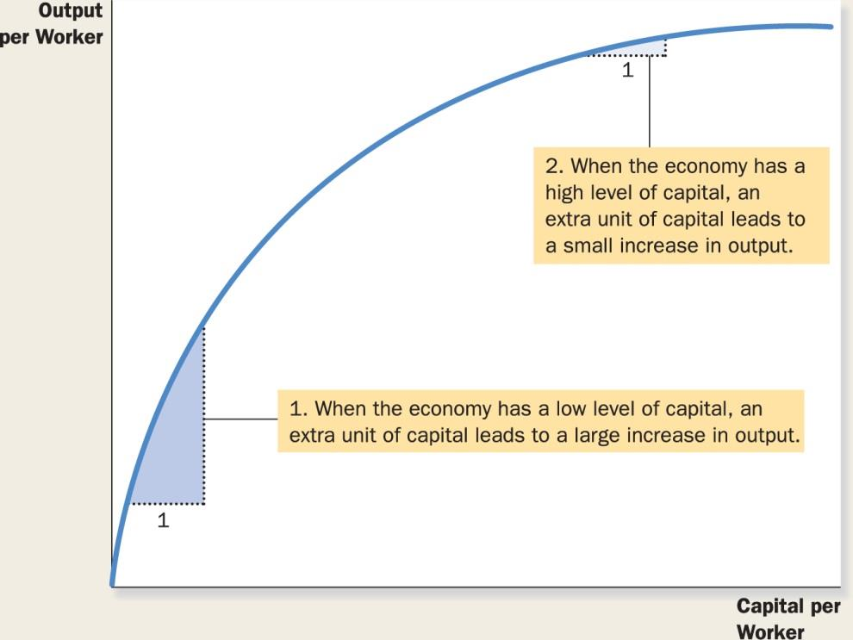
- Diminishing returns: the benefit from an extra unit of an input declines as the quantity of the input increase.
- Catch-up effect: countries that start off poor tend to grow more rapidly than countries that start off rich.

Investment from Abroad
- A country can acquire capital from foreign investment
- Foreign direct investment: a capital investment that is owned and operated by a foreign entity
- Foreign indirect investment: an investment that is financed with foreign money operated by domestic residents.
- Foreign portfolio investment: an investment that is financed with foreign money but operated by domestic residents.

Education
- Investment in human capital (education) is at least as important as investment in physical capital for long-run economic success.
- More education leads to higher wages and salaries
- Providing good schools is how governments can improve the standard of living.
- Human capital contributes to economic growth because it conveys positive externalities.
- Externalities: the effect of one person’s actions on the well-being of a bystander.
- Some poor countries face a brain drain.
- Brain drain: the immigration of many of the most educated workers to rich countries, where they can enjoy a higher standard of living.
*look up Milton Freeman

Health and Nutrition
- Healthier workers are generally more productive.
- Poor countries are poor because their populations are not healthy.
- Populations are not healthy because they are poor.
- It is a vicious cycle

Property Right and Political Stability
- For the price system to work, property rights must be respected.
- Property rights: the ability of people to exercise authority over the resources they own.
- Political instability is a threat to property rights.

Free Trade
- When a country eliminates trade restrictions it often experiences the same kind of economic growth that would occur after a major technological advance.
- Trade volume is determined by geography

Research and Development
- Technological knowledge has progressed so much which contributes to higher living standards
- Knowledge is a public good

Population Growth
- Larger population means larger total output of goods and services
- Does not mean higher standard of living for a typical citizen
- Stretching natural resources
- A large population means a larger workforce.
- A large population means more consumers.
- Diluting capital stock

Lecture 09/10/15

Chapter 8: Saving, Investment, and the Financial System

Financial system: the group of institutions in the economy that help to match one person’s savings with another person’s investment.

Financial markets: financial institutions through which savers can directly provide funds to borrowers.

Bond: a certificate of indebtness that specifies the obligation of the borrower to the holder of the bond.

Debt finance: the sale of a bond to raise money
Characteristics:
- The bond’s term
- The bond’s credit risk

Stock: a claim to partial ownership in a firm.

Stock | Bond
Equity Finance | Debt Finance
Part-owner | Creditor
Affected by success of the company | Affected by interest rates
Owns part of the company | Gets an IOU from the company

Market for loanable funds: market in which those who to save supply funds and those who want to borrow to invest demand funds.

An investor is someone who takes the money and does something with it.

- Saving is the source of supply for loanable funds
- Investment is the source of demand for loanable funds.
- The interest rate is the price of a loan.

An investment tax credit gives a tax advantage to any firm building a new factory or buying a new piece of equipment.

Government debt: the sum of past budget deficits and surpluses.

Crowding out: a decrease in investment that results from government borrowing.

Y = C + I + G

National saving (saving): is the total income in the economy that remains after paying for the consumption and government purchases.

Private saving: the income that households have left after paying for taxes and consumption

Public saving: tax revenue that the government has left after paying for its spending

Budget surplus: an excess of tax revenue over government spending

Budget deficit: a shortfall of tax revenue from government spending

SAVING = INVESTMENT

Y = C + I + G (assuming this is a closed economy which means to exports/imports)

Y – C – G = I

S = I

ASSIGNMENT:

DUE NOVEMBER 1st
Savings percentage of disposable income (income you could be consuming realistically)

1 or 2-page essay, understandable for someone who is not an economist.

submit to blackboard

Chapter 9: Unemployment and its Natural Rate

The problem of unemployment is usually divided into two categories:
- The long-run problem
- The short-run problem
The economy’s natural rate of unemployment refers to the amount of employment the economy normally experiences.

Cyclical unemployment refers to the year-to-year fluctuations in unemployment around the natural rate.

20/10/15

*Midterm: 4, 5, 6, 7, 8, 9

Unemployment can be measured through surveys.

Labour Force = No. of employed + No. of unemployed

Unemployment rate = $\frac{No. of unemployed}{Labour Force}$ X 100

Labour force participation rate = $\frac{Labour Force}{Adult Population}$ X 100

HALF of unemployed population ends up as discourages workers.

- Natural unemployment rate: the rate of unemployment to which the economy tends to return in the long run.
- Cyclical unemployment: the deviation of unemployment from its natural rate.
- Frictional unemployment: unemployment that results because it takes time for workers to search for jobs that best suit their tastes and skills.
- Structural unemployment: unemployment that results because the number of jobs available in some labour markets is insufficient to provide a job for everyone who wants one.
Employment insurance (ER): a gov’t program that partially protects workers’ incomes when they become unemployed.

Minimum wage laws:
- examine how structural unemployment results when the number of jobs is insufficient for the number of workers.
- Examine how minimum-wage laws effect unemployment
- Not the most important explanation for structural unemployment, but still important.

Union: a worker association that bargains with employers over wages and working conditions.

Collective bargaining: the process by which unions and firms agree on the terms of employment.

Strike: the organized withdrawal of labour from a firm by a union.

it is believed that unions cause conflict between the insiders and the outsiders.

Efficiency wages: above-equilibrium wages paid by firms in order to increase worker productivity.

according to the theory of efficiency wages it may be profitable to keep wages high as an incentive for productivity, even if it causes a surplus of labour (unemployment).

Chapter 10: The Monetary System

The Meaning of Money

Money: the set of assets in the economy that people regularly use to buy goods and service from other people.

The Functions of Money

Medium of exchange: an item that buyers give to sellers when they want to purchase goods or services.

Unit of account: the yardstick people use to post prices and record debts.

Store of value: an item that people can use to transfer purchasing power from the present to the future.
Wealth: is the total of all stores of value, including both monetary and non-monetary assets.

The Kinds of Money

Liquidity: describes the ease with which an asset can be converted into a medium of exchange
- Money is the most liquid of assets.

Commodity money: money that takes the form of a commodity with intrinsic value.

Fiat money: money without intrinsic value that is accepted as money because of government decree.

Money in the Canadian Economy

Currency: these are the paper bills and coins in the hands of the public.

Demand deposits: These are the balances in bank accounts that the depositors can access on demand by writing a cheque or using a debit card.

The Bank of Canada

The Bank of Canada (BoC): the central bank of Canada.

Central bank: an institution designed to regulate the quantity of money the economy.

Monet supply: the quantity of money available in the economy.

Monetary policy: the setting of the money supply by policy makers in the central bank.

The BoC has four main functions:
- Issue currency
- Banker to the commercial banks
- Banker to the Canadian government
- Control the money supply

Assumptions:
- An economy with not banks.
- Currency is the only form of money.
- The initial supply of money is $100.

Money multiplier: the amount of money the banking system generates with each dollar it receives.
= $\frac{1}{R}$

Bank capital: the resources the bank owners put into an institution from issuing equity (e.g. Stock).

*FINISH NOTE

Friday the 13th: Chapter 11

Money Growth and Inflation

Inflation: increase in overall price levels
Deflation: fall in the overall price levels

The economy’s overall price level can be viewed in two ways:
- As the price of a basket of goods and services
- As a measure of the value of money

The value of money is determined by the supply and demand for money.

Recall that the supply of money is controlled by the Bank of Canada and the banking system.

The demand for money reflects how much will people want to hold in liquid form.

The demand for money is sometimes referred to as “liquidity preference”.

Quantity of money theory: the theory that there is a direct relationship between the quantity of money in an economy and the level of prices of goods and services sold.

- Nominal variables: variables measured in monetary units.
- Real variables: variables measured in physical units.

Classical dichotomy: the theoretical separation of nominal and real variables.

Monetary neutrality: the proposition that changes in the money supply do not affect real variables.

How many times per year is the typical dollar used to pay for a newly produced good or service?

Velocity of money: the rate at which money changes hands.

$$V = (P × Y)÷M$$

V: velocity of money
Y: Real GDP
P: Price level
M: Quantity of money

Quantity equation: the equation that relates the quantity of money, the velocity of money, and the dollar value of the economy’s output of goods and services.

$$M × V = P × Y$$

Inflation tax: the revenue the government raises by creating money.

Inflation is closely watched and wifely discussed because it is thought to be a serious economic problem.

Shoeleather cost: the resources wasted when inflation encourages people to reduce their money holdings.

Real Interest rate = Nominal interest rate – inflation rate
Nominal interest rate = Real interest rate + Inflation rate

Fisher effect: the one-for-one adjustment of the nominal interest rate to the inflation.

Recession consumption is low and private investment is very low

The Inflation Fallacy inflation does not in itself reduce people’s real purchasing power. If nominal incomes tend to keep pace with rising prices, inflation is not a problem. There are, however, costs associated with inflation.

Menu costs: the cost of changing prices.

Chapter 12: Open-Economy Macroeconomics: Basic Concepts

- Net capital outflow (NCO) always equals net exports (NX):

$$NCO = NX$$
Closed economy: an economy that does not interact with other economies in the world.

Open economy: an economy that interacts freely with other economies around the world.

Net exports: exports – imports

Nominal exchange rate: the rate at which a person can trade the currency of one country for the currency of another.

Real exchange rate: the rate at which a person can trade the goods and services of one country for the goods and services of another.

$$Real xrate=\frac{Nominal xrate × Domestic price}{Foreign price}$$

When studying an economy as a whole, macroeconomists focus on overall prices rather than the prices of individual items.

Real x-rate = $\frac{e × P}{P*}$

Purchasing-power parity (PPP): a theory of exchange rates whereby a unit of a given currency should be able to buy the same quantity of goods in all countries.

the economist

Small open economy: an economy that trades goods and services with other economies and, by itself, has no effect or very little effect on world prices and interest rates.

Perfect capital mobility: full access to world financial markets.

$$r=r^{w}$$

Interest rate parity: a theory of interest rate determination whereby the real interest rate on comparable financial assets should be the same in all economies with full access to world financial markets.

A Macroeconomic Theory of the Small Open Economy: Chap 13:

Assumptions for our small open economy model:
- The level of GDP is given.
- The price level is fixed.
- The real interest rate is equal to the world interest rate is taken and given.

Saving$=Domestic Investment+Net Capital Outflow$

$$S=I+NCO$$

*USE A GRAPH FOR THE SECOND ASSIGNMENT *AND LOOK UP THE ECONOMIST

Aggregate Demand and Aggregate Supply: Chapter 14

Model of aggregate demand and aggregate supply: the model most economists use to explain short-run fluctuations in economic activity around its long-run trend
The Aggregate-Supply Curve
Aggregate-demand curve: a curve that shows the quantity of goods and services that households, firms, and the government want to buy at each price level
The aggregate-supply curve tells us the total quantity of goods and services that firms produce and sell at any given price.
In the long run, the prices do not matter. What really matters is how much capital is accumulated, natural resources, labour supplies, and technology.
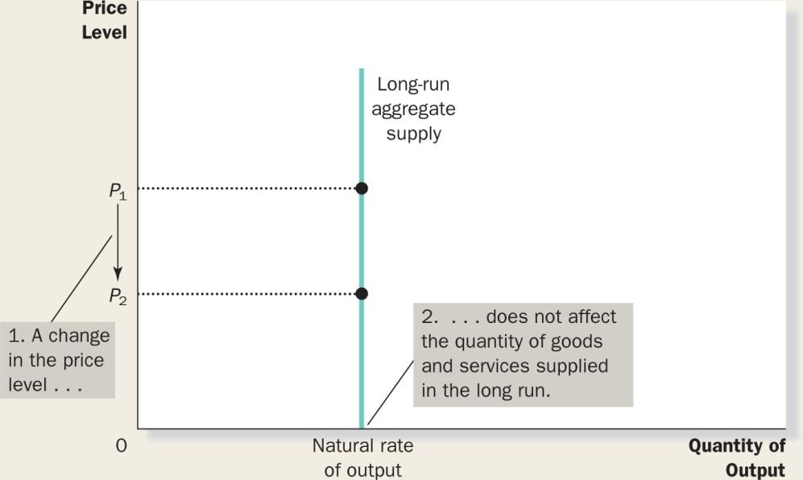

Natural rate of output: the production of goods and services that an economy achieves in the long run when unemployment is at its normal rate. (Potential output, full-employment output)

Causes for shifts in the Long-Run Aggregate-Supply Curve: changes in labour, changes in capital, changes in natural resources, changes in technological knowledge.

In the short run, the price level does affect the economy’s output.

An increase in the overall level of prices tends to raise the quantity of goods and services supplied and vice versa.

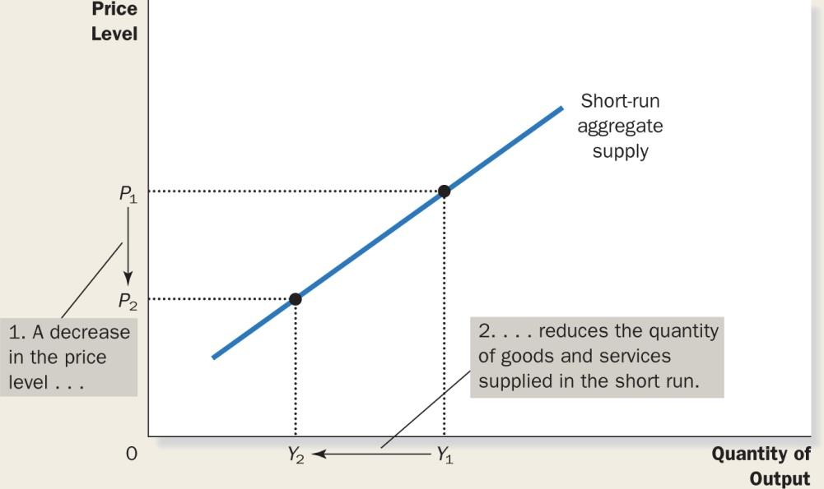

Three theories for the upward slope of the short-run aggregate supply curve:
- The Sticky Wage Theory: if the prices are dropped, less will be produced. When prices decrease so revenues, which means suppliers drop production to deal with the decrease in revenue since wages cannot be decreased and employees cannot be fired in the short-run
- The Sticky Price Theory: reducing prices in the short-run adds additional costs, which means suppliers/businesses are reluctant to change prices.
- The Sticky Misperceptions Theory: when drops in prices are misperceived as a drop in quality as opposed to the aggregate prices, supply decreases too.

The Aggregate-Demand Curve
Aggregate-supply curve: a curve that shows the quantity of goods and services that firms choose to produce and sell at each price level
Four steps for analyzing this impact:
- Does the event affect aggregate demand or aggregate supply?
- Determine the direction of the shift.
- Use the diagram of aggregate demand and aggregate supply to compare the initial and new equilibrium.
- Keep track of the new short-run equilibrium, the new long-run equilibrium, and the transition between them.
A Contraction in Aggregate Demand:
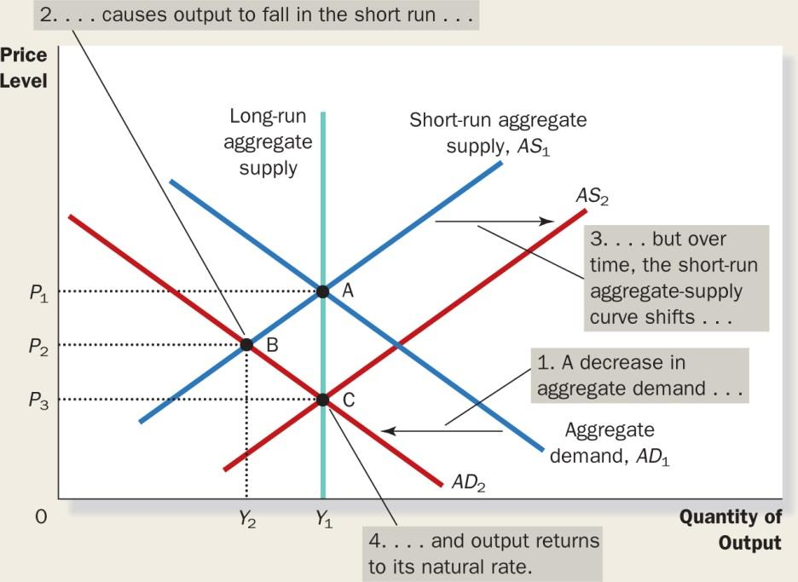

REMEMBER:
- In the short run, shifts in aggregate demand cause fluctuations in the economy’s output of goods and services.
- In the long run, shifts in aggregate demand affect the overall price level but do not affect the level of output.
- Policy makers who influence aggregate demand can potentially mitigate that severity of economic fluctuations.
AND:
- Shifts in aggregate supply can cause stagflation—a combination of recession (falling output) and inflation (rising prices).
- Policy makers who can influence aggregate demand can potentially mitigate the adverse impact on output but only at the cost of exacerbating the problem of inflation.
Keynesian Economics

The Influence of Monetary and Fiscal Policy on Aggregate Demand: Chap 15

The aggregate-demand curve slopes downward for 3 reasons:
- The Wealth Effect
- The Interest Rate Effect
- The Real Exchange Rate Effect
#3 is the most important!
The theory of liquidity preference: Keynes’s theory that the interest rate adjusts to bring money supply and money demand into balance.

The Bank of Canada alters money supply by:
- Changing the bank rate
- Open-market operations (buying & selling bonds, foreign exchange)

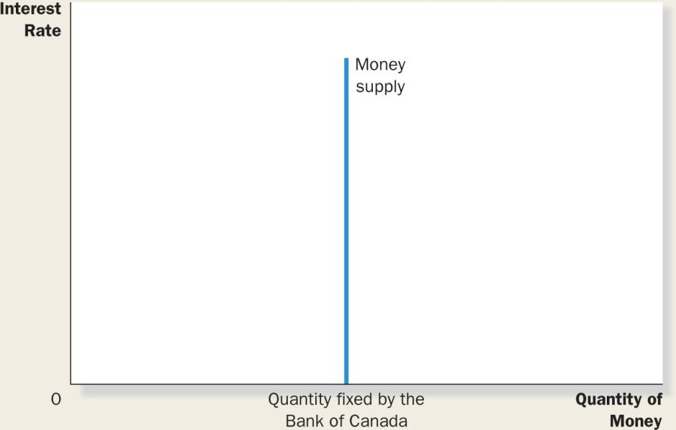

Interest rates high spending decreases
Interest rates fall spending increases

Due the abuse of monetary polices, interest rates are almost at 0 (in attempt to increase aggregate demand).

Deeper understanding of interest rates:

How much return you get when you save money

By having a lower interest rate, your opportunity cost of holding your own money is lower, so you chose to hold it yourself.

Fiscal Policy:

Multiplier effect: the additional shifts in aggregate demand that result when expansionary fiscal policy increases income and thereby increases consumer spending.

MPC = Marginal Propensity to consume

$$Total change in demand = (1 + MPC + {MPC}^{2} + M{PC}^{3} + …) × 5 billion$$

$$Multiplier= \frac{1}{1-MPC}$$
In an open economy:
$$Multiplier= \frac{1}{1-MPC+MPI}$$

Crowding-out effect on investment: the offset in aggregate demand that results when expansionary fiscal policy raises the interest rate and thereby reduces investment spending.

If the gov’t taxes less, aggregate demand will increase.

