University of Ottawa

CHM2123
Organic Chemistry II Laboratory

Experiment #1: Separation and Purification of Natural Products

Abdel Rahman LePabic
7697085
Partner: Jason Wu 8315003

TA: Ying Sun

Due Date:
September 30, 2016

Introduction:
The separation and purification of chemical compounds is very important in the way that certain chemical compounds can be isolated and then tested for certain properties. When extracting and purifying such compounds from plant or animal sources, a combination of techniques may be used.
The goal of the following experiment is to extract and recrystallize caffeine from black tea and to determine the purity of the recrystallized caffeine in a melting point apparatus. Using an extraction technique along with a TLC and a Cold Finger apparatus, my partner and I were able to extract caffeine in a rather purified form.
Utilizing caffeine’s higher solubility in dichloromethane, we were able to successfully separate the caffeine in the boiled tea into the organic phase while any undesirable compounds remained in the aqueous phase of the extraction. After the extraction, the dichloromethane was steamed off to leave behind a crude caffeine residue.
Using a cold finger apparatus, the caffeine was vaporized and recrystallized to try and purify it. Because caffeine possesses a high melting point and an appreciable vapour pressure under standard conditions, it was possible to further isolate the caffeine that was extracted from the tea from other contaminants by condensation.
Finally, to confirm that we were able to extract and purify the caffeine, my partner and I ran a TLC in a 99:1 acetone: acetic acid solution to act as the developing solvent and used a melting point apparatus to check the melting range of the sample. By comparing the crude caffeine sample with the purified sample and an authentic caffeine sample, it was confirmed that we successfully extracted the desired compound.
The melting point test also assessed the purity of the end product but measuring the melting point range of the sample. The purity of our sample was determined on how close the melting range was to the known melting range of caffeine. If the melting range of our end product was either much higher or lower than the known melting range of caffeine, then this would indicate the presence of contaminants in the end product.
It is to be noted that at the beginning of the lab, we were told not to perform part B of the lab therefore part B will not be included in this lab report.
Experimental Procedure:
Refer to CHM2123 lab manual pages 21-33. An alteration was made to exclude part B from our experiment. It will not be referred in this report.

Table of Reagents:
Compound | Mol. Mass (g/mol) | Quantity | Density (g/mL) | Mmol | Equivalents
Dichloromethane | 84.93 | 40 mL | 1.33 | - | 1.0
Na₂Co₃ | 105.99 | 2.0 g | 2.45 | - | -
Na Cl | 58.44 | 15 mL | 2.16 | - | -
Na₂SO₄ | 142.04 | 1.0 g | 2.66 | - | -
H Cl | 36.46 | 3.0 mL | 1.18 | 1.0 M | -

Observations and Results:
Key Step | Observation
Addition of dichloromethane to separatory funnel | The clear dichloromethane turned slightly yellowish.
Addition of Na₂CO₃ | Caused the steeped tea to become murky
Addition of Na₂SO₄ | Any brown extract disappeared and appearance of hydrated salt
Cold Finger Sublimation | Crude caffeine vaporized and formation of a crystal on the cold finger surface appears
Table of Results
Compound | Tea mass | Crude Caffeine extract | Purified Caffeine recrystallization | Theoretical mass of caffeine | Percent yield of caffeine from tea | Melting point (°C)
Caffeine | 6.54 g | 0.03 g | 0.0036 g | 0.262 g | 1.37 % | 232-234 (lit. 238 °C)

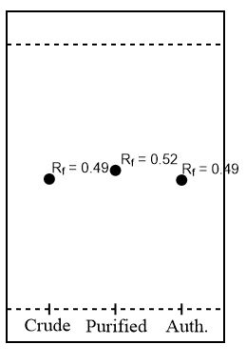
TLC
TLC taken of the Caffeine extraction. Crude = The crude extract of caffeine from the tea, Purified = the purified caffeine, Auth. = an authentic sample of caffeine. Solvent system is 99:1 acetone: acetic acid

Calculations
$$Theoretical mass of caffeine=mass of tea × 4\%=6.54 g × 4\%=0.2616 ≈0.262 g of caffeine$$
$$Percent yield \left(\%\right)= \frac{mass of purified caffeine}{theoretical mass of caffeine}×100\%=\frac{0.0036}{0.262}×100\%=1.374 ≈1.37 \% yield of caffeine$$
Flowchart:
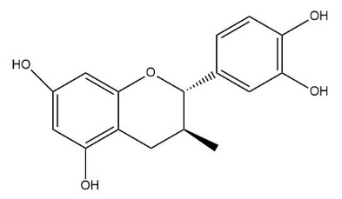
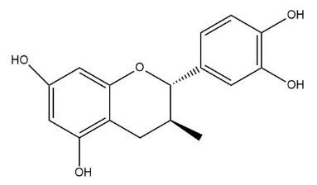
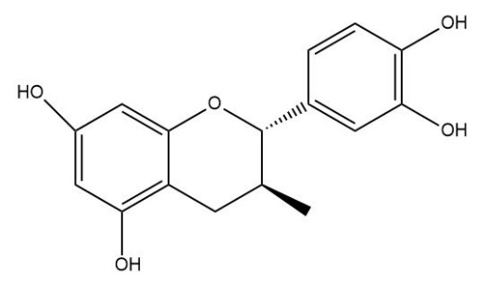
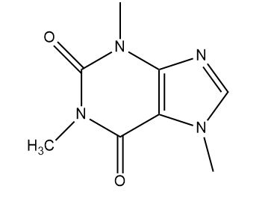
Dry w/ Na₂SO₄ , Evap. Solvent, Recrystallize
Aq. phase
Org. phase
Add H₂O and Dichloromethane
Na₂CO₃
Some of Catechin
Na₂CO₃

Discussion:
The goal of this experiment was to extract and purify caffeine from the tea using a separatory funnel and a cold finger apparatus. We also used a TLC test and a melting point apparatus to confirm that we were able to extract and purify caffeine. Initially the tea was steeped in 60 mL and then Na₂CO₃ was added. The Na₂CO₃ was used as a base that would interact with the Catechin in the steeped tea to become an ionic salt. This would help increase the solubility of caffeine in dichloromethane in order to separate the caffeine into the organic phase. After the separation of the aqueous and organic phase, Na₂SO₄ was used to remove any trace amounts of water which was then filtered through gravity filtration to remove both the salt and any other contaminants in the organic phase.
We then proceeded to dry out the solvent and placed the crude caffeine inside the cold finger for recrystallization. The caffeine was then further isolated through vaporization and recrystallization on the cold finger. By lowering the pressure through a vacuum and increasing the heat, the caffeine was able to turn directly from a solid to gas. Since the conditions for sublimation of caffeine is different when compared to other possible contaminants, we were able to isolate caffeine relatively well. However, the yield of caffeine was low because we were told by the TA to stop scraping the caffeine crystals off the cold finger so that we may continue with the experiment. There was still excess caffeine on the cold finger that we did not include in the total weight measurement of purified caffeine.
In the final two parts of the experiment, we performed a TLC and used a melting point apparatus. From our TLC, it can be seen that all three spotting lanes had spots that were of nearly the same R_{f} value. This would indicate that we were successful in extracting the caffeine from the tea and our recrystallization did not affect the extracted caffeine since the crude and purified caffeine samples matched the authentic sample. The melting point apparatus was also used to test the purity of the caffeine after recrystallization. When testing the melting range, it is key to know that the closer the experimental range was to the actual range, then the purer the sample. If the experimental range was either too high or too low, then that would indicate that there is some contamination of our sample. In our case, the melting range was just below the actual melting range so it would indicate that there is some contamination but the sample was still considered pure because the melting range was 4-6 °C less than the actual melting point which is considered to be somewhat insignificant.
In conclusion, we were successful in the extraction and recrystallization of caffeine from brewed tea however our caffeine yield is low but it was of a high degree of purity.
Question:
- A NaCl solution will increase the surface tension of the bubbles of the emulsion. It will also increase the density of the aqueous phase which will force the separation of the emulsion more.
- In order to isolate catechin from the brewed tea, an acidic solute should be used to interact with the caffeine. This would allow the catechin to favor the organic phase more and therefore separate the catechin into the organic phase. You can then proceed to follow the same steps that were taken with caffeine in the experiment.
- Drawn out on the next page.
- The reason a pencil is used instead of a pen when marking a TLC plate is because the ink from the pen will travel up along with the solvent and that will ruin your TLC results.

