Business Law Textbook Notes
Midterm 1, 2, 3, 4, 28, 13, 14

Chapter 1

Law in the Business Environment

Business Law:
- Defines general rules of commerce
- Protects business ideas and more tangible forms of property
- Provides mechanisms that permit businesspeople to select their desired degree of participation and exposure to risk in business ventures
- Seeks to ensure that losses are borne by those who are responsible for them
- Facilitates planning by ensuring compliance with commitments

Rules and Principles

The law protects members of society in two ways:
- It sets rules with penalties in order to encourage compliance
- It seeks to hold those who break the law accountable for their misconduct

- The law addresses failed relations but it’s primary job isn’t about conflict. It’s primary job is to prevent disputes and to facilitate relationships. While there are rules and regulations set in place by the law for business it’s main task is to facilitate an environment in which fair and productive business can occur. Laws provide mechanisms for two parties to engage and enforce commitments they make to each other. The creation of certainty in business relationships is an important role of law.

Providing Mechanisms for Dispute Resolution

- In order to avoid litigation offering severance packages or incentives may be less costly than the outcome of being sued.
- Questions to ask if you are thinking of litigation
  - Are legal proceedings absolutely necessary?
  - Is there a way to resolve the problem from a larger, relationship preserving perspective, rather than from a strictly legal viewpoint?

How and Why the Law Works

- The Canadian justice system is not perfect but it is good.
- The judge is there to provide an unbiased ruling, and decide what the actual agreement between parties was.

Knowledge of the Law as a Business Asset

- If you take the time to inform yourself about the law you can use it to your advantage instead of having it used against you.
- A good way to avoid being taken advantage of possibly by your lack of knowledge about the law is to implement a legal risk management plan.

Law and Business Ethics
- Business to consumer - when does promoting become deception (aka. overhype)
- Business to society - How far should the company go to give value to stakeholders/shareholders? Ex. Child labor? What if child labor gives families a means of survival?
- Business to Employee - Should a business monitor employee emails and internet use?
- Business to business - Is it ethical to bluff during negotiations? When does it become corruption/fraud?

How does the law affect business?
- Business form - sole proprietor, partner, etc.
- Business name - how similar can it be to an existing business?
- Financing decisions - loan, capital, how are you financing this? How will you pay it back? If you go public there is a whole new set of laws.
- Property - property laws will affect how you can expand your business.
- Services - if you hire staff there are staffing, training, and hiring laws that must be followed.
- Marketing - no false advertising or misleading advertising. Trademark and copyright laws are also important to remember.

The main goal of business law is to facilitate commercial interactions through contract law.

Terms
Breach of contract: failure to comply with a contractual promise.
Age of majority: the age at which a person becomes an adult for legal purposes. In Canada, this ranges from 18-19 years of age, depending on the province.
Contract Law: Rules that make agreements binding and, therefore, facilitate planning and the enforcement of expectations.
Litigation: the process involved when one person sues another.
Mediation: A process through which the parties to a dispute endeavour to reach a resolution with the assistance of a neutral person.
Arbitration: A process through which a neutral party makes a decision (usually binding) that resolves a dispute.
Liability: Legal responsibility for the event or loss that has occurred.
Legal risk management plan: a comprehensive action plan for dealing with the legal risks involved in operating a business.
Business Ethics: Moral principles and values that seek to determine right and wrong in the business world.

Chapter 2
The Canadian Legal System

Questions to think about during this chapter:
- Who assesses whether the legislation is permissible?

The Canadian legal system is charged with enforcing limits on the powers of different levels of government and upholding the values of a nation. These rules are tied to liberalism, which puts individual freedoms first.

The legislative branch of government passes laws that impact business operations. Failing to adhere to these laws can result in fines and closure of business. Ignoring laws means missed opportunities for the business, including influencing laws and fighting them.

The executive branch of government implements and generates policy that may be directed at businesses. Large businesses have divisions dedicated to monitoring the changing policies in order to apply them to the business or fight them. Smaller organizations will have more power working with associations and hiring lobbyists.

The judicial branch provides rulings for disputes and then sets precedent for future cases. This can impact a wide range of players.

The Canadian Constitution

Written Elements
- Constitution Act, 1867: Divides legislative power between the federal and provincial governments
- Canadian Charter of Rights and Freedoms: Identifies the rights and freedoms that are guaranteed in Canada + relevant decisions by judges conscerning constitutional law.
- Constitutional Conventions: a code of ethics that governs our political processes. Not enforceable in a court of law.

Law-Making Jurisdiction

Federal Government → Parliment, house of commons, senate → Law making jurisdiction provided by s. 91 of the Constitution Act 1867
→ Territorial Government → Limited self-government, subject to federal control

Provincial Government → Legislature, Law making jurisdiction provided by s.92 of the Constitution Act 1867.
→ Municipal Governments → Law making jurisdiction provided by the provincial legislature.

Federal
- interprovincial/international trade and commerce, trade, postal, navigation/shipping, seacoast/inland fisheries, currency, national defence, criminal law, banking, unassigned legislative areas.
Provincial
- Hospitals, property and civil rights within the province, administration of justice, local matters, incorporation of provincial companies.
Municipal
- Zoning, subdivision, taxation for the benefit of the municipality, licensing.

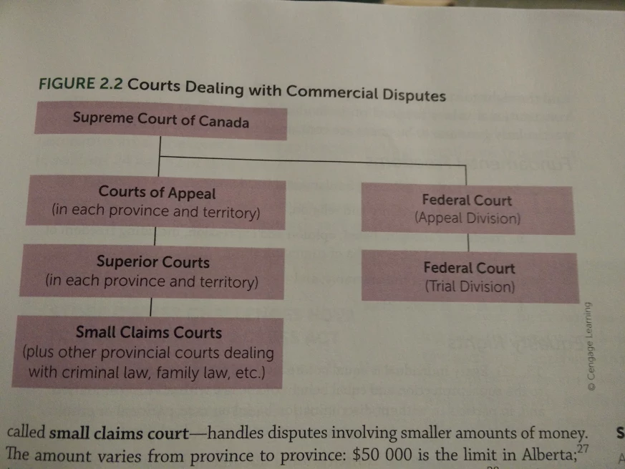

The Canadian Charter of Rights and Freedoms

Everyone has the following freedoms:
- Freedom of conscience and religion
- Freedom of thought, belief, opinion and expression, including freedom of the press and other media of communication
- Freedom of peaceful assembly
- Freedom of association

Equality Rights
- S. 15 Every individual is equal before and under the law and has the right to the equal protection and equal benefit of the law without discrimination and, in particular, without discrimination based on race, national or ethnic origin, colour, religion, sex, age, or mental or physical disability.
- S.1 The government can infringe on the charter so long as they can justify it within the law.

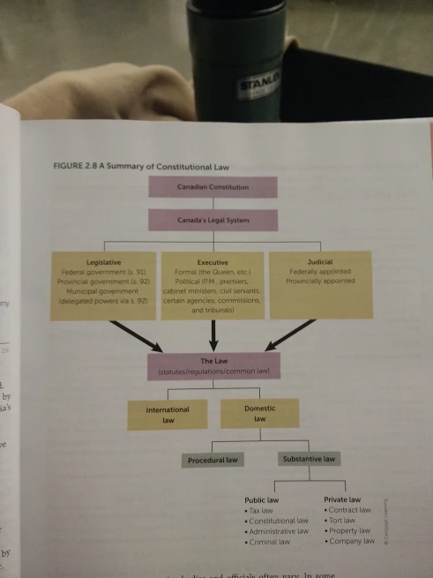

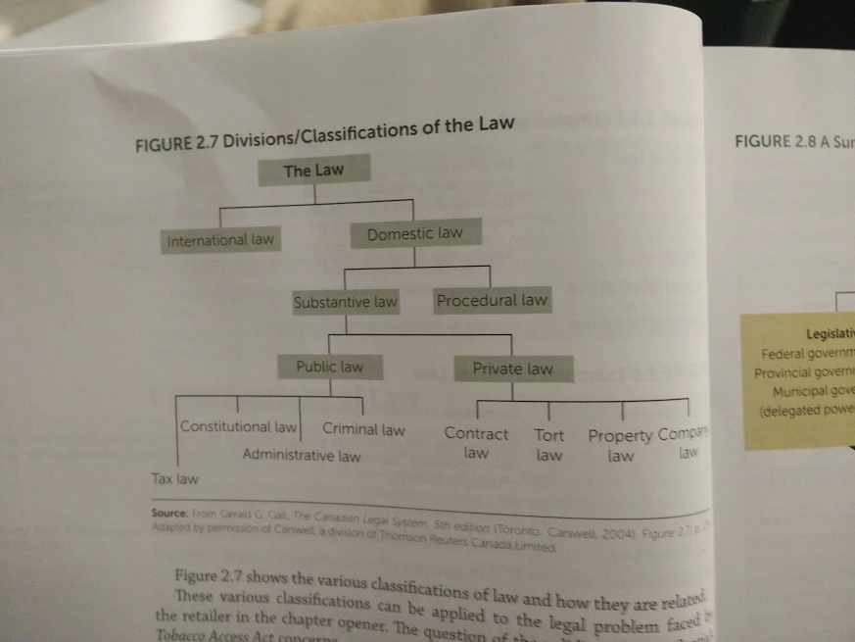

Terms
Government Policy: The central ideas or principles that guide government in its work, including the kind of laws it passes.
Constitutional Law: The supreme law of Canada that constrains and controls how the branches of government exercise power.
Liberalism: A political philosophy that emphasizes individual freedom as its key organizing value.
Canadian legal system: the machinery that compromises and governs the legislative, executive, and judicial branches of government.
Constitutional conventions: Important rules that are not enforceable by a court of law but that practically determine how a given power is exercised by government.
Legislative Branch: the branch of government that creates statute law.
Statute Law: Formal, written laws created or enacted by the legislative branch of government.
Jurisdiction: The power that a given level of government has to enact laws.
Exclusive jurisdiction: Jurisdiction that one level of government holds entirely on it’s own and not on a shared basis with another level.
Concurrent jurisdiction: jurisdiction that is shared between levels of government
Paramountcy: a doctrine that provides that federal laws prevail when there are conflicting or inconsistent federal and provincial laws.
Ratify: To authorize or approve.
Treaty: An agreement between two or more states that is governed by international law.
Bylaws: Laws made by the municipal level of government.
Formal executive: The branch of government responsible for the ceremonial features of government.
Political executive: The branch of government responsible for day to day operations, including formulating and executing government policy, as well as administering all departments of government.
Cabinet: a body composed of all ministers heading government departments as well as the prime minister or premier.
Regulations: Rules created by the political executive that have the force of law.
Judiciary: a collective reference to judges.
Judges: those appointed by federal or provincial governments to adjudicate on a variety of disputes, as well as to preside over criminal proceedings.
Inferior court: a court with limited financial jurisdiction whose judges are appointed by the provincial government.
Small claims court: a court that deals with claims up to a specified amount.
Superior courts: courts with unlimited financial jurisdiction whose judges are appointed by the federal government.
Supreme Court of Canada: the final court for appeals in the country.
Federal Court of Canada: the court that deals with some types of litigation involving the federal government.
Canadian Charter of Rights and Freedoms: A guarantee of specific rights and freedoms enshrined in the Constitution and enforceable by the judiciary.
Royal prerogative: historical rights and privileges of the Crown, including the right to conduct foreign affairs and to declare war.
Common law: Rules that are formulated in judgements.
Precedent: An earlier case used to resolve a current case because of its similarity.
Equity: Rules that focus on what would be fair given the specific circumstances of the case, as opposed to what the strict rules of common law might dictate.
Domestic law: the internal law of a given country, which includes both statute and common.
INternational Law: law that governs relations between states and other entities with international legal status.
Substantive law: law that defines rights, duties, and liabilities.
Procedural law: The law governing the procedure to enforce rights, duties, and liabilities.
Public law: areas of the law that relate to or regulate the relationship between persons and government at all levels.
Private law: areas of law that concern dealings between persons.
Civil Code of Quebec: the rules of private law that govern Quebec.

Chapter 3: Managing Legal Risks

Four Step Process
- Identify the Legal Risks
- Evaluate the Risks
- Devise a Risk Management Plan
- Implement the Plan

Step 1: Identify the Legal Risks
- Assess the organization's functional areas
  - Marketing: aggressive marketing
  - Sales: breach of contract, improper transportation
  - Production: processes could harm the environment
  - Human resources: injury to workers, employee harassment, improper terminations
  - Finance and Accounting: unable to pay debts to creditors, aggressive accounting processes
- Review the organization's business decisions
- Examine the organization's business relationships
- Analyze the organization's operations and transactions

Risk management is not a one man job as no one has complete business knowledge.

There is no one method that works best, however, the best methods work systematically and do not overlook any major risks.

The purpose of step one is to provide a realistic assessment of the potential legal dangers of doing business, with a view towards minimizing loss.

Step 2: Evaluate the Risks
- Assess the probability of loss.
- Assess the severity of loss.

A high probability that a particular event will occur can be offset by a relatively low level of loss should it occur. A low probability that something will occur needs high attention if the potential loss is high.
The point of evaluating risks is to recognize that not all risks are alike, nor should they be treated alike. Some risks turn into liabilities others do not. Choosing which to prioritize is important.

Step 3: Devise a Risk Management Plan
- Avoid or eliminate the risk
  - Appropriate when the risk is simply too great or when the undesirable result is greater than the advantages.
- Reduce the risk
  - Involves policies, practices, and procedures to reduce the probability of an unwanted event happening.
- Transfer the risk
  - Transfer the remaining risk to another by contract. Paying people who were injured will be done through insurance, as opposed to out of pocket.
- Retain the risk
  - When the cost of avoiding or transferring the risk is greater than the negative impact of the risk materializing.
  - Losses are paid out of pocket.
  - Self-insurance: organization can establish a funded reserve.
  - Insurance policy deductibles: the organization can retain risks to a certain dollar amount.
  - Noninsurance: the organization can charge losses as an expense item.

Step 4: Implement the Plan
- Carry out the plan
  - The document should include a schedule of inspections, accident reporting system, and information on any insurance coverage in place.
  - Must be continually monitored and revised
- Monitor and revise the plan

Interacting With the Legal Environment
Reacting when Prevention Fails
- When prevention fails crisis management plans must be in place
- Immediately pull/recall the product and make a public apology and work with the public and the company to repair and compensate for the damage.
Managing Legal Services
- Knowing when to consult legal counsel is cost effective.
- If there is an internal law department it will most likely be them who decides whether or not a situation requires outside help.
- Choosing a lawyer is like anything, you have to choose one that fits your needs
- Cost, availability, and expertise are all things that need to be considered, negotiated and agreed upon between lawyers and clients
- The goal is to have a long term relationship with your lawyer so they become more familiar with your business and can benefit you in the long run.

Summary
- Assess the environment and possible risks
- Develop a plan to deal with them
- React by hiring legal help and having crisis plans
- Follow up until losses are resolved
- Adjust operations accordingly

Terms
Legal risk: a business risk with legal implications.
Enterprise risk management: the process of identifying and managing all business risks.
Risk Avoidance: ceasing a business activity because the legal risk is too great.
Risk reduction: implementing practices in a business to lower the probability of a loss and its severity.
Risk transference: shifting the risk to someone else through contract.
Risk retention: absorbing the loss if a legal risk materializes.
Lawyer: a person who is legally qualified to practice law.
Law firm: a partnership formed by lawyers.

Chapter 4: Dispute Resolution

Alternative Dispute Resolution
- Negotiation
  - Can be used in many situations
  - Can’t be used in some, ex. Insurance claims
  - Can be done by the involved parties with or without counsel (legal or otherwise)
  - First step is to investigate the situation and get the facts
  - Apologies are not:
    - Admissions of liability
    - Relevant when a judge makes a decision
    - Not evidence
    - Cannot be used to void an insurance policy
  - You can say you’re sorry, but can’t say what you’re sorry about without risking making an admission.
  - In the majority of cases when negotiations end there is either a settlement or one party goes to the next step, mediation or litigation.
- Mediation
  - Mediator assists the parties in reaching a settlement
    - Less expensive, quicker
    - Helps preserve the relationship between parties
    - There is a roster of mediators just like there are lawyers
    - Manages the process, organizes the discussion, clears up misunderstandings, and helps reduce tensions between the parties.
    - Does not impose a solution on the parties.
    - High success rate.
- Arbitration
  - Appointed by the parties and makes the decision
  - Involves a hearing where both parties make a submission and then the decision is made out of the control of the parties.
  - Can theoretically resolve any issue.
  - Cases are subject to arbitration legislation in the relevant jurisdictions.
  - Arbitration award is binding

Litigation Process
- Litigation comes about when one party brings legal action against another.
- Used when all other methods have failed
- Slow, expensive and unpredictable
- Outcome of a lawsuit are governed by legal rules contained in common law and statute law.
- How the claim is carried through the justice system is dictated by procedural rules.

Lawsuits
- First stage is pleadings, exchange of formal documents outlining the suit → the claim
  - Defendant has 20 days (in ontario) to respond to these claims
- In between the first and second stage there will be either acceptance of the claim by the defendant or the dispute of some or all of the claims, where the defendant will seek legal advice and prepare a defence.
  - The defendant may actually submit a counterclaim which says the plaintiff is actually at fault.
- Second stage is called the discovery where both parties must now reveal and demonstrate the facts that support their allegations.
- If no settlement is reached at the discovery stage, the plaintiff can proceed to trial. The timing depends on the availability of the court.
- If a case is too complex the jury won’t be used for fear of the jury not understanding it. Most trials are just in front of a judge and no jury.
- The burden of truth is on the plaintiff whose claim must be proven beyond reasonable doubt.
- Next step is the the trial where at the end the judge makes a decision.
- Fourth stage is the enforcement of the judgement awarded to the winning party.
- Appeals can be submitted where one party disagrees with the decision. In front of a panel of judges both parties make statements either denouncing the appeal or approving it. The judges decide whether or not to confirm the decision, change it in some way, or reverse the decision. In exceptional cases another trial will be conducted.

Terms
Alternative dispute resolution ADR: a range of options for resolving disputes as an alternative to litigation
Negotiation: a process of deliberation and discussion intended to reach a mutually acceptable resolution to a dispute.
Release: an agreement where a party agrees to relinquish past, present, and future claims arising from a certain event.
Mediation: A person who helps the parties resolve their dispute.
Arbitrator: a person who listens to the parties to a dispute and makes a ruling that is usually binding on the parties.
Binding: final and enforceable in the courts
Plaintiff: the party that initiates a lawsuit against another party.
Defendant: the party being sued.
Limitation period: the time period specified by legislation for commencing legal action.
Class action: a lawsuit launched by one person who represents a class of persons having similar claims against the same defendant.
Pleadings: the formal documents concerning the basis for a lawsuit.
Claim: the formal document that initiates litigation by setting out the plaintiff’s allegations against the defendant.
Defence: the defendant’s formal response to the plaintiff’s allegations
Counterclaim: a claim by the defendant against the plaintiff.
Discovery: the process of disclosing evidence to support the claims in a lawsuit.
Trial: a formal hearing before a judge that results in a binding decision.
Burden of proof: The obligation of the plaintiff to prove its case.
Evidence: Proof presented in court to support a claim.
Costs: legal expenses that a judge orders the loser to pay the winner.
Judgment debtor: the party ordered by the court to pay a specified amount to the winner of the lawsuit.
Appeal: The process of arguing to a higher court that a court decision is wrong.
Appellant: the party who begins or files an appeal.
Respondent: The party against whom an appeal is filed.
Contingency fee: a fee based on a percentage of the judgement awarded, and paid by the client to the lawyer only if the auction is successful.

INSURANCE

Insurance is a way to cover yourself when dealing with present risks.
- Common Law vs. Marriage example
  - Catherina zeta and Michael Douglas - buying mutual assets when married. Pre-nups are hard to follow after time and after you start going outside the lines of the prenup.
Types of Insurance
- Life and disability insurance
  - Payments when we have death
  - Money goes to beneficiary without being taxed
- Property insurance/fire insurance
  - When goods are damaged or destroyed you can make a claim
    - Auto insurance, if your car is destroyed you can pay the deductible and have the damages covered.
    - This raises your rates but will probably cost you less in the long run.
- Liability Insurance / Casualty insurance
  - When you’re liable for causing harm to others
    - Express statements that are considered liable - Trump accusing Hillary of being a liar.

Special Clauses relating to Contracts
- Deductible - the part of a loss that the insured party is responsible for.
- Duty to disclose - required to provide all information to the insurer related to the risk
  - If you’re a smoker and you fake saying you’re a non-smoker you’re screwed. You can’t lie to insurance.
- Insurable interest - there has to be some financial element at stake in whatever is being insured
  - You can’t insure the University of Ottawa because you don’t own a personal stake in it, however, you can insure your car.
- Indemnity - you cannot profit from what is happening
  - You can’t have 3x car insurance, only one insurance on each asset.
    - If you set up getting our car stolen you could take out 3x the payout.
- The co-insurance clause - Insurance companies will request a minimum amount of value of the property in order to get the benefit of the insurance
  - When you own a house if your value is set at a minimum of 90% of the market price. If your house falls below the threshold they will pro-rate your coverage and only give you a certain percentage of coverage. Ex. on a $100,000 home, you may only get the insurance for $50,000 of it and fire for $20,000 damage. Since you are only covering 50% of the value of the house, they will only cover you for 50% of the damage.
- Salvage - This is where the insurer has the right to enter and be granted title to the remains of the assets when there is a total loss.
  - If your car is totalled in an accident they will only give you the market value of the car.
- Forfeiture rule - You cannot profit from a crime
  - You can’t do something and then take advantage of the situation.
    - Shawshank redemption -
    - Burning down your own house - collecting the insurance money
- Rider Clause - a clause that will add coverage or modify an existing clause
  - Trying to increase your third party liability
  - Changes in auto insurance - rates - tp coverage is now a lowered minimum coverage to reduce premiums. In order to have enough coverage you need to buy more.
  - Exclusions - mechanical failures, criminal offences.
  - No coverage if someone drives without your consent, used to carry explosives, used as a cab, bus, or sightseeing vehicle.

Terms

Insurance Policy: A contract of insurance.
Insurer: a company that sells insurance coverage.
Insured: one who buys insurance coverage.
Premium: the price paid for insurance coverage.
Deductible: the part of a loss for which the insured is responsible.
Duty to disclose: the obligation of the insured to provide to the insurer all information that relates to the risk being insured.
Insurable Interest: A financial stake in what is being insured.
Salvage: An insurer’s right to title of what remains of property after paying for a total loss.
Forfeiture rule: A rule that provides that a criminal should not be permitted to profit from a crime.
Rider: A clause altering or adding to coverage in a standard insurance policy.
Endorsement: written evidence of a change to an existing insurance policy.
All-risks property insurance: Insurance coverage that protects property against all types of physical loss or injury arising from an external cause unless specifically excluded.
Insurance adjuster: One who investigates and evaluates insurance claims.

Chapter #13

The Agency Relationship

Terms

Agency: a relationship that exists when one party represents another party in the formation of legal relations.
Agent: A person who is authorized to act on behalf of another.
Principal: a person who has permitted another to act on her behalf.
Outsider: The party with whom the agent does business on behalf of the principal.
Law of agency: the law governing the relationship where one party, the agent, acts on behalf of another, the principal.
Power of attorney: an agency agreement in writing and under seal.
Actual authority: the power of an agent that derives from either express or implied agreement.
Apparent authority: the power that an agent appears to have to an outsider because of conduct or statements of the principal.
Agency by estoppel: an agency relationship created when the principal acts such that third parties reasonably conclude that an agency relationship exists.
Agency by ratification: An agency relationship created when one party adopts a contract entered into on his behalf by another who at the time acted without authority.
Fiduciary duty: a duty imposed on a person who has a special relationship of trust with another.
Fiduciary: a person who has a duty of good faith toward another because of their relationship.
Warranty of authority: a representation of authority by a person who purports to be an agent.

