Gamestop case analysis

Table of Contents
EXECUTIVE SUMMARY: 3
IDENTIFY THE PROBLEM: 3
ANALYSIS: 3
ALTERNATIVE SOLUTION: 5
RECOMMENDATION AND IMPLEMENTATION PLAN: 5
EXHIBITS: 5
BIBLIOGRAPHY: 5

EXECUTIVE SUMMARY:
An ongoing issue for GameStop persists as they find themselves losing market share in the video game industry. This is primarily due to their inability to gain a digital presence while losing business to online competitors with integrated e-commerce. To overcome this problem, GameStop needs to formulate a solution that aligns the strategy with the environmental factors in order for them to achieve organizational effectiveness.
In the short-term, GameStop can survive amongst its competition by achieving a digital presence via an acquisition of a small or medium scale online software developing company. It is through this route that GameStop can employ integration by commanding and ultimately gaining control of their supply chain. As a result, GameStop will be able to utilize the expertise of their acquired supply chain to develop various video game software and consequently will be able to rapidly adapt to the fast paced environment.
In the long-term, it is recommended that GameStop look into the upcoming virtual reality market. Currently, GameStop is seeing a growth in hardware and accessories sales, so to increase the percentage of sales even more GameStop can invest into selling virtual reality hardware and accessories. This will help balance out the risk of declining software sales in the long-run and help GameStop capitalize the opportunity now instead of later.

INTRODUCTION:
GameStop is a global multichannel video games, electronics and wireless service retailer, best known as being the world’s largest specialty retailer of video game hardware and software (Marketline, 2016). However, GameStop’s business has recently been regressing, as digital downloads and e-commerce are eating into the organization’s business. Thus, this report is dedicated to analyzing GameStop and its environment to provide a recommendation to solve this pressing issue. Therefore, it is recommended that should acquire a software manufacturer to increase their digital presence. As well, in the long term take advantage of the virtual reality trend by increasing sales for hardware and accessories in this video gaming market.
ANALYSIS:
GameStop has recently experienced a greater than expected decline, as the organization was the most shortened stock in the Standard & Poor’s 500 Index as 2015 drew to a close. (Daurat, 2016) GameStop shares fell a total of 13% in 2015 (Exhibit 1), as the organization is being threatened by digital downloads and a decrease in overall software sales (Steele, 2016) (Please refer to Exhibit 2). The organization has been able to offset some decline in sales, by diversifying their organization by growing their tech brands and collectables. However, some experts fear that GameStop may soon be dislocated by digital adoption and could follow the same footsteps as RadioShack and Blockbuster (Palmeri, 2015). With the rapid growth of technology, consumers are opting to download digital games and do more business online. GameStop is losing out on opportunities to make physical sales, as software sales may now be made over gaming consoles such as PlayStation Network and Xbox One (Steele, 2016). With these advancements in technologies, GameStop has noticed that demand for older legacy systems is quickly declining. Therefore, it is imperative that GameStop innovates if the organization wants to continue to be a major player in the video game industry.
GameStop has a strong culture that is consistent with its mission in terms of ensuring career growth, providing adequate training and development, encouraging innovation, forming close relationships, and being diverse (GameStop Culture, 2016). GameStops culture aligns with their mission statement, an example includes their core value of having their employees provide an exceptional experience to their customers is the execution plan to attaining their mission, which is GameStop’s ultimate goal (Exhibit 3). Furthermore, their core values consist of helping and creating great experiences for customers, empowerment, and accountability (GameStop Values, 2016). GameStop’s values support their plans in a way that ensures the fulfillment of official goals of the company and also ultimately result in the cohesion of employees in the process.
GameStop has focused on being effective through centering on innovation and the newest technology for customers, evident in the company values, “We are empowered to disrupt legacy thinking with innovation and agility, create powerful experiences for our customers, take risks and trust each other on the decisions we make” (GameStop Values 2016). They do this through acquiring new and popular technology gaming companies, to ensure they are the primary resource acquirers in the industry. By having a dominant hand in the industry, GameStop aims to gain access to ideas, people and ultimately technologies that will give them a potential bargaining position. They believe the best way to be innovative and create these experiences for customers is to acquire the newest technology to beat out its competition. However, GameStop has not been seeing the big picture and therefore has not understood the needs and wants of their consumers. They have not used their various companies and resources together to give customers the ultimate gaming experience, which is something that they need to improve upon in order to create the utmost effectiveness of their organization.
GameStop is currently located at the elaboration stage in the organizational life cycle, where the organization needs revitalization. This stage is often the “do or die” stage for an organization since the organization is in need of innovating and must improve communication or the business will fail (Teamtwinkies). It is in this stage that organizations reach maturity, and may go through temporary decline since the organization may no longer be inline with the environment and may need to go through stages of streamlining and innovation (Teamtwinkies). This stage perfectly reflects the position in which GameStop occupies, since they currently are experiencing a temporary decline, and need to innovate to realign with the added competitors that have entered their environment. The position in which GameStop is currently in, is a challenging position to be in since the organization cannot realign itself with the growing consumer demand for digital downloads, it may become stagnant or fail. However, if the organization is able to innovate and continue to grow, it has the ability to weed out inefficiencies and refocus, thus becoming an even more dominant player within the video game market. However, GameStop will need to continue to diversify its organization to mitigate potential risks, as video game technologies are continuously evolving. Virtual Reality (VR) headsets are expected to become a prominent part of the gaming future, which means GameStop needs to position itself to be a location you want to buy your VR headsets, games and accessories to take advantage of this opportunity (Makuch, 2016).
The video game industry is characterized by growth, high degree of innovation, and dynamic which is changing at hyper speed. Hence to be sustainable in the environment, companies must be flexible and timely to adapt to the radical changes (Marchand, 2013). In the past GameStop has ran a successfully used game trade in credit program. However with technological advancement, consumers have increased purchasing digitally instead of a physical copy (Forbes, 2015). This shift has resulted in the used video game market to diminish and GameStop to lose market share. GameStop is slowly adapting to the change by allowing consumers to purchase digital content in stores (Full Disclosure Wire, 2016). This method of distribution is an advantage to GameStop as younger customers may not have access to a credit card to buy online and their loyal customers can use their trade in credit to make purchases to reduce the price.
Globalization in the past couple of years has resulted in the video game market to become more competitive (Exhibit 4). With the shift of consumers purchasing digitally, more companies are entering the market to directly sell to the consumers. Even GameStop’s current suppliers are becoming their own distribution channel which increases competition for GameStop (Marchand et al, 2013). Thus GameStop needs find a unique advantage that will help them stay ahead of their competitors
In the video game retail industry, companies often deal with ambiguity from the stakeholders such as game publishers, game console manufacturers, and customers which causes high uncertainty in the environment. Video games are cyclical in nature where each game is designed for a specific console (Marchand, 2013). Therefore, as the console suppliers continues to innovate new technology and release new devices, the environment will continuous change as a generation’s life cycle affects the video game at a point in time (MarketLine, 2016). Retailers stores like GameStop thus are highly dependent on oligopolistic console suppliers and game publishers to release new video game products and devices in order to boost sales. The dependency that GameStop has on their suppliers decreases control and lessens their adaptability to the changing environments.
The changing of the general environment can also cause GameStop to face challenges that they will need to adjust to. Video games are price sensitive due to the luxury aspect of the good, hence during economic downfalls consumers are less encouraged to purchase video games or consoles (MarketLine, 2016). As well, GameStop is an international organization that has their headquarters in United States. Thus profits are converted back to United States Dollar and when the economy is unstable, global organizations like GameStop experience currency risk that may decrease profits after currency conversion. Consumers themselves are a huge factor to the success of an organization. In order to boost sales, retailers and publishers must communicate their products to the consumer. By doing so, consumer will increase awareness and anticipation for the product which can result in a higher perceived value. Hence collaboration and communication with the suppliers is a key factor to success. The biggest political factor for GameStop is censorship. Across the world, there are government regulations which restrict the content many popular games. Unfortunately, the government views game companies in a bad light as society tends to believe they have a negative effect on the youth of our generation, therefore regulations have been put in place. Video Game developers and retailers are also required to be licensed to sell and rent product which GameStop already has (Dyer-Witherford et Al., 2005). However, the regulations by the government has little impact on video game sales therefore political influence has little effect in the video game industry.
Due to the speed in which technology is progressing and the rate in which video game usage is evolving, GameStop’s solution must be able to adapt to a rapidly changing environment. GameStop is an organization that has the capital to make new acquisition and is looking to innovate, so the organization needs to position itself in control of how the organization is moving forward in the future and where it is important to understand game publishing. It is also imperative that GameStop improves the organization’s digital capacity as consumer demand for video games and technologies are expected to shift more towards digital. In addition, since GameStop is currently in a declining state, the organization must try to minimize risky business activities and try to minimize expenses to keep stakeholders happy. Therefore, a recommendation for GameStop must look to best satisfy these decision criterias.

ALTERNATIVES
- Add on a division and form a R&D group by gathering people inside to create our own games and obtain digital presence. By doing so, GameStop can hold the control on the supply side and be more initiative and reactive to the market changes.
- Closing stores across North America and even across the world. By doing so, GameStop can devote more resources to its AT&T and Apple partnerships, due to GameStop’s currently established relationships with those companies. This way, GameStop can take advantage of the consumer bases of those two companies in being able to sell electronics online

RECOMMENDATION AND IMPLEMENTATION PLAN:
In order for GameStop to further develop the organization’s digital presence, GameStop should acquire a small to medium size digital game developing company. By doing so, GameStop can gain control in their supply chain and expertise of the existing organization, and use the relevant companies that they have acquired to develop video game softwares. By gaining the expertise that already exist in the acquired organization, GameStop will be more knowledgeable in the software manufacture industry. This will allow GameStop to have an upper hand in comparison to entering the industry without any knowledge. The action plan will happen within a year which will help GameStop adapt to the fast paced environment in a timely manner. In addition, as the virtual reality market is growing GameStop should take advantage of this opportunity and invest into selling virtual reality accessories or hardware to adapt to this new trend in the market. By doing so the company increase sales in the already growing markets (Exhibit X). This strategy will allow GameStop to mitigate some risk of the declining software sales that poses as a current issue to GameStop and increase in hardware sales.
In order to implement this recommendation, GameStop will need to follow steps to ensure that the organization will be structured accordingly for the new acquired company to work well within GameStop. They will first need to research various up and coming companies that have certain characteristics that match what GameStop needs in an organization. These will include the right engineers and experienced people, the values and culture of this company should be similar to GameStop, the size of the company should be in the growing stages to ensure they are not too big however they are somewhat established to prove they have potential, and lastly the ideas of the organization. After negotiating with companies and acquiring the best one, GameStop needs to change the structure to a flatter organization by combining the resources and increasing communication across the organization. This will be done by creating research and development teams made up of the new and existing members of GameStop that will use their combined knowledge to grow each of their segments, with an operative goal to increase digital downloads. By increasing the communication across the various organizations under GameStop, they will ultimately increase effectiveness and cohesiveness by focusing on customer needs overall, rather than their individual companies. This collaboration will allow GameStop to continually find new ways to reach their target markets, increase longevity and adapt to volatile changes in consumer preferences including the change to virtual reality games. Through this new R&D team, GameStop will start to produce their own games, become their own supplier in the industry and gain a superior digital presence (Exhibit 6).

EXHIBITS:
Exhibit 1

Exhibit 2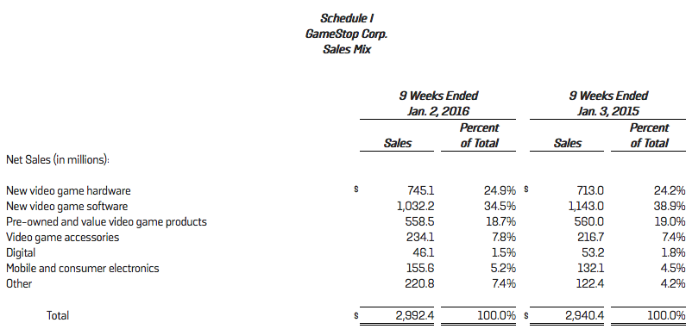
Exhibit 3
Mission | "Together, we hold a passion for gaming, a commitment to our industry and a disciplined business perspective to continuously drive value with shareholders, customers, vendors and employees."
Vision Core Principles | Stay Customer Centered  Execution at the store level ensures success at the corporate level. That's why we think of our organizational chart as inverted, with stores at the top. The ideas and execution that inform our strategy and drive our success come from customers, our associates, and all of us who are committed to listening.  Having a Competitive Mindset  We seek competitive individuals who demand the best of themselves, who constantly strive to meet and surpass the next challenge, and who set the bar continuously higher. We are in a fast-paced business that demands much and delivers much to those who always improve.  Encourage Hands-On, Empowered Leadership  GameStop management is deeply involved in both long-term strategy and day-to-day operations. We lead by doing and work diligently to engage and empower every associate to create lasting and creative solutions. We seek, promote, and reward top talent; continuously bring out the best in others; remain focused on what matters to our people and our business; and we make creative, courageous decisions focused on our customers and our associates.  Take Personal Responsibility  We are in the game business, but GameStop isn't a game: it is a business that we take seriously and we realize that our shareholders expect the best we have to offer, just as we expect the best from ourselves.  Embrace Change as Opportunity  We believe that the most successful organizations and people are willing to reinvent themselves as often as needed. This principle has helped us build an innovative and profitable business that protects our large family of associates.
Core Values | We are passionate about serving others, creating great experiences for our customers and our people, and sharing the magic of gaming.  We are empowered to disrupt legacy thinking with innovation and agility, create powerful experiences for our customers, take risks and trust each other on the decisions we make.  We are responsible for holding each other accountable, doing what’s right to contribute to our long-term success and making time to give back in the communities in which we live, work and play.

Exhibit 4
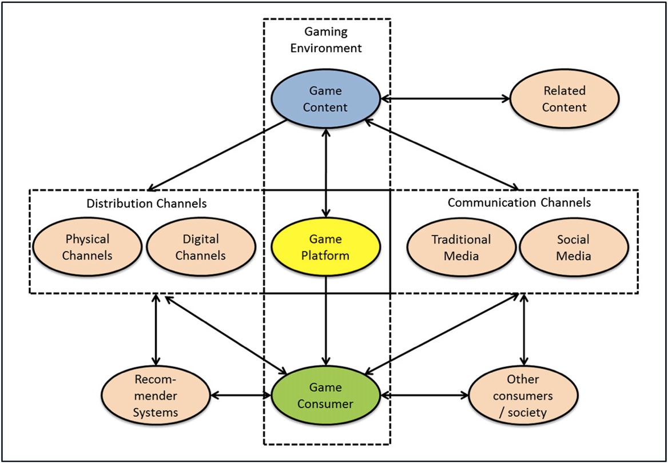

Exhibit 5
Strengths  - GameStop has built customer relationship and is experienced in the field in comparison to the publishers  - High brand awareness  - Diversified company  - A big organization that has lots of capital  - Strong loyalty program (43 million members in the PowerUp rewards program) () | Weakness  - High inventory of used products that cannot be resold  - The video game market is price sensitive and GameStop is using a non-competitive pricing strategy  - Relies on publisher and manufactures for new products and to be innovate  - Low levels of control
Opportunities  - The video game industry is growing with more people playing games  - Increasing revenue of 22% for virtual goods  - Video games are moving from physical to digital which increase profit margins  - E-commerce is a growing industry  - Acquisition of technological companies  - Old school gamer still has the preference of collecting physical copies and game exchange  - Development of technology has allowed more methods of payments  - Increasing units of hardware sales  - Oligopolistic market where big players obtain 62% of the market share | Threats  - Intense competition as publishers selling directly to consumers  - Smartphone games are entering the market making it more competitive  - The video game market is a cyclical business where technical capabilities highly depend on the hardware they are designed for therefore there is constant change  - Unstable Environment  - Piracy concerning video games being illegally used  - Increasing labor wages in the company’s key markets

Exhibits 6
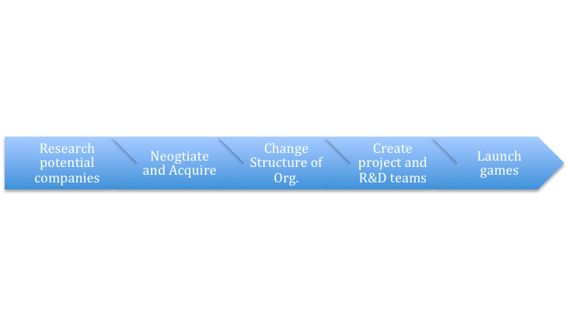

BIBLIOGRAPHY:
Daurat, Cecile. (2016). GameStop is Biggest Decliner in S&P 500 After Forecast Change. BloombergBusiness. Retried February 17th, 2016, from: http://www.bloomberg.com/news/articles/2016-01-12/gamestop-is-biggest-decliner-in-s-p-500-after-forecast-change
Dyer-Witherford, Sharman. (2005). The Political Economy of Canada's Video and Computer Game Industry. Canadian Journal of Communication. Retrieved February 19, 2016, from: http://www.cjc-online.ca/index.php/journal/article/view/1575/1728
Fair Disclosure Wire. (2016, Jan 12). GameStop corp at ICR conference – final. Retrieved from http://search.proquest.com/docview/1760547645?accountid=15090
Forbes. (2015, May 28). Declining Video-Game Hardware Demand To Offset Growth In Software Sales For GameStop In Q1 2015. Retrieved February 20, 2016, from http://www.forbes.com/sites/greatspeculations/2015/05/28/declining-video-game-hardware-demand-to-offset-growth-in-software-sales-for-gamestop-in-q1-2015/#3a60f53a33de
Game Stop Corp. Core Values. (2015). Retrieved February 19, 2016, from http://news.gamestop.com/phoenix.zhtml?c=130125&p=corevalues
Game Stop Corp. CULTURE. (2016). Retrieved February 19, 2016, from http://careers.gamestop.com/culture/
Makuch, Eddie. (2016). PS4 Virtual Reality Headset Has Strongest Games Lineup, GameStop CEO Says. GameSpot. Retrieved February 18th, 2016, from: http://www.gamespot.com/articles/ps4-virtual-reality-headset-has-strongest-games-li/1100-6433750/
MarketLine (2015). Company Profile: GameStop Corp. Retrieved February 19, 2016, from http://advantage.marketline.com.libproxy.wlu.ca/Product?pid=6BC022A2-27B5-4493-BDD7-A36DB6CA35B5
Palmeri, Christopher. (2015). Digital downloads cast doubt on GameStop’s future. The Toronto Star. Retrieved February 19th, 2016, from: http://www.thestar.com/business/2015/12/30/digital-downloads-cast-doubt-on-gamestops-future.html
Steele, Anne. (2016). GameStop shares tumble as earnings fall short. Marketwatch. Retrieved February 20th, 2016, from: http://www.marketwatch.com/story/gamestop-shares-tumble-as-earnings-fall-short-2016-01-12
Teamtwinkies . Organization Life Cycle. Retrieved February 15th, 2016, from: https://teamtwinkies.wordpress.com/2013/03/10/organizational-life-cycle/

