CHANDLER –
Major Claims :
- Successful businesses capitalize on:
  - Economies of scale and Economies of scope
  - Create manager structures
  - Invest in R&D for First Mover advantage
- Businesses should take advantage of their first mover opportunity
  - Difficult to regain the competitive advantage afterwards
- Growth should be attained through related diversification
- Stock Market Pressure: Business ownership patterns have diminished the likelihood of many firms’ long-term success
Key Concepts:
- Economies of Scale: Produce more of the same product using the same production equipment and resources in order to minimize the cost/unit. Benefits larger plants.
- Economies of Scope: Use the same production equipment and resources in order to produce a variety of goods.
- Managerial Enterprise:
  - large industrial concerns
  - operating and investment decisions are made by a hierarchy of salaried managers
  - managers governed by a board of directors
- First Mover advantages : innovation, strategy more powerful weapon than pricing
  - To benefit from comparable costs, challengers need to build plants of comparable size
  - Production and distribution carried out more capably
  - Products and processes improved by systematic R&D
  - Locating better sources of supply
  - Provide more effective marketing
  - They differentiate their products
  - They move rapidly into growing markets and out of declining ones
  - A first mover is not necessarily an inventor
- Horizontal growth: Growth through partnerships, acquisitions
- Vertical growth: Growth from within (materials and outlets control)
- Growth by geographic expansion: based on economies of scale
- Market penetration for related products: based on economies of scope
- Related diversification:
  - Penetration of markets that you are knowledgeable of
  - If not, hire people who know what they are doing
  - Otherwise, it leads to separation of upper management // middle management
GREINER – MGMT practices that work well in one phase may bring on a crisis in the next
Major Claims :
- The future of an organization maybe less determined by outside forces than it is by the organization’s history
- Organizational growth is characterized as a series of developmental phases
- Management practices that work well in one phase may bring on a crisis in the next
- Organizations should not try to skip phases
- Growth is NOT inevitable
- Top managers whose style is no longer appropriate should remove themselves
Key Concepts:
- Evolution: prolonged periods of growth where no major upheaval occurs in the organizations` practices
- Revolution: periods of substantial turmoil in the organizations` life
- 5 key dimensions:
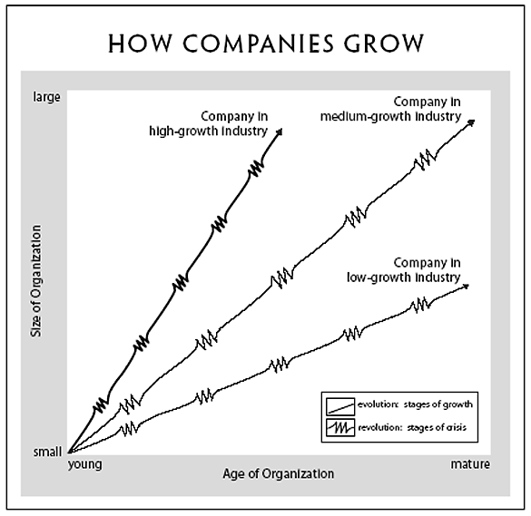
  - Age of the organization
  - Size of the organization
    - No growth in size can retain many of the same management issues over a lengthy period of time
    - Growth however causes evolution and revolutions!
  - Stages of Evolution
    - Typically 4-8 years (linear) once a company survives a revolution
  - Stages of Revolution
    - Finding a new set of organization practices to overcome the crisis
    - Those unable to abandon past practices are likely to fail or level off
  - Growth rate of the industry
    - Speed at which an organization experiences phases of evolution and revolution
    - Each phase is an effect from the previous phase
    - Each phase is the cause for the next phase

Growth phases:
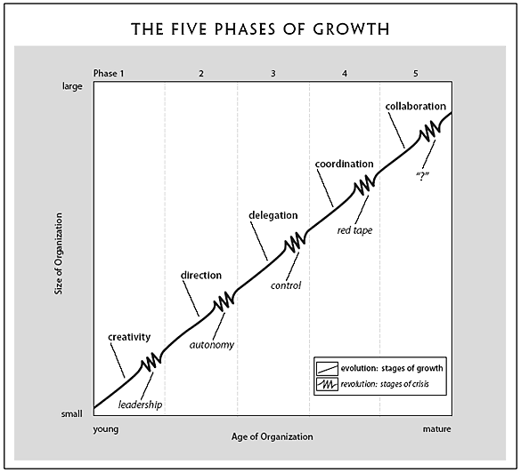
- Creativity phase:
- Focus on making, selling a product
- Frequent, informal communication between employees
- Long hours of work rewarded by modest salaries, promises/hopes of ownership
Leadership crisis:
  - Creativity becomes a problem
  - Larger production requires more knowledge
  - Increased number of employees requires leadership through formal communication
  - Hire a set leader

- Direction phase :
- Functional organizational structure separates manufacturing from marketing.
- Accounting systems for inventory are introduced.
- Incentives, budgets and work standards are adopted.
- Top level management assumes the direction responsibilities.
- Low level management become `functional specialists` - Non-autonomous.
Autonomy crisis:
  - The organization is too complex for the directional system in place.
  - Lower level mgmt is restricted and more knowledgeable (about the manufacturing process and about marketing) than upper level.
  - Lower level mgmt is torn between following `outdated` procedure or taking initiative.
- Delegation phase:
- Decentralization: greater responsibility is given to lower managers of plants and marketing.
- Bonuses are used as incentives for productivity.
- Communication from the top is infrequent and impersonal: correspondence, phone, brief visits.
- Decentralized managers with greater authority and incentive are able to penetrate large markets, respond faster to customers’ needs and develop new products.
- Mergers and acquisitions
Control crisis:
  - Top executives sense they are losing control of the operations.

- Co-ordination phase:
- Decentralized units are merged into product groups
- Formal planning procedures are established and intensively controlled
- HR personnel is hired and stationed at HQ to initiate company-wide programs of control and review for line managers
- Stock options and companywide profit sharing are used to encourage identity with the firm
- Ex: big expenses must be approved by higher level of mgmt.
Red-Tape crisis:
  - Lack of confidence arises between (line and staff) and (HQ and the field)
  - They become less co-operative with the others
  - Proliferation of procedure systems begin to exceed their utility – Bureaucracy is criticized
  - Too many levels of management.

- Collaboration phase :
- Focus on solving problems quickly through team work
- HQ HR experts are reduced in number, reassigned and combined with teams in order to consult, not direct, field units
- Behavioural and conflict resolution skills are now part of the managerial training
- Rewards become team-based more than individual based
- New ideas and experiments are encouraged
- Transition is difficult for the `old school`
- Training and education
Psychological saturation crisis? Burnout ? Work/life balance is breached. Mental cost
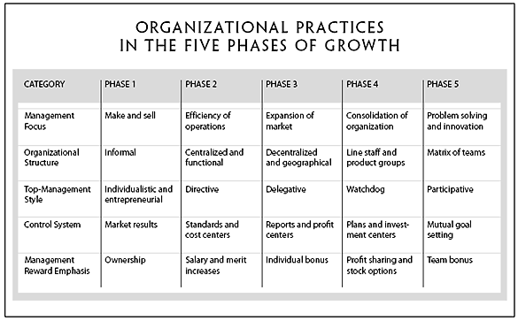
TANNENBAUM&SCHIMDT – leadership pattern
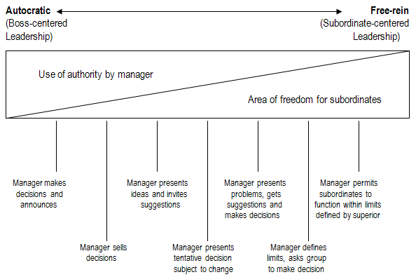
Major Claim:
A successful manager cannot be characterized through authoritarian or permissive, but rather through maintaining a « high batting average » in assessing appropriate behaviours at any given time and being able to act accordingly. He does not see leadership as a dilemma.

- The manager makes the decision and announces it
  - Identifies the problem, considers options, makes the decision and presents it.
  - No opportunity for the subordinates to participate in the decision-making process
- The managers `sells` his decision
  - Identifies the problem, considers options, makes the decision and presents it.
  - Explains the decision, hoping to persuade the subordinates to accept it.
- The manager presents the idea, invites questions
  - Identifies the problem, considers options, makes the decision and presents it.
  - Explains the decision, hoping to persuade the subordinates to accept it.
  - He invites questions, providing the subordinates with the opportunity to understand the reasoning behind the decision
- The manager presents a tentative decision subject to change
  - Identifies the problem, considers options and makes the TENTATIVE decision.
  - Consults with the subordinates for possible issues with the decision
  - The final decision is still the manager`s
- The manager presents the problem, gets suggestions and makes decision
  - Identifies the problem.
  - Consults subordinates for solutions.
  - Manager makes decision.
- The manager defines the limits and requests the group to make a decision
  - Identifies the problem and the boundaries to be respected in the solution.
  - The group (including the manager as member) takes the decision.
- The manager permits the group to make decision within prescribed limits
  - Same as above but manager is not part of the group

3 types of forces
- Forces in the manager
  - Value system (they have pre-established values, different point of views)
  - Confidence in subordinates
  - Leadership inclinations
  - Feelings of security in an uncertain situation

- Forces in the subordinates (More Democratic)
  - Need for independence
  - Readiness to assume responsibility for decision-making
  - Tolerance for ambiguity
  - Interest in the problem
  - Understanding of the organization`s goals
  - Necessary knowledge and experience
  - Expectancy to share decision-making

- Forces in the situation
  - Type of organization
  - Group effectiveness
  - The problem itself
  - The pressure of time
  - Long-run Strategy
  - Objectives to be attained

COLLINS&PORRAS – Building your Company’s Vision
Major Claim : Companies that enjoy enduring success have core values and a core purpose that remain fixed while their business strategies and practices endlessly adapt to a changing world.
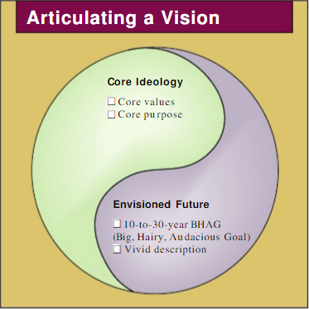
Core Ideology: “the glue that holds an organization together through time” (yin)
- Core Values: What you stand for
- Core Purpose: Reason for being / 5W’s
  - HP: To make technical contributions for the advancement and welfare of humanity
  - Wal-Mart: To give ordinary folks the chance to buy the same things as rich people
Envisioned Future: what we aspire to become / achieve / create (yang)
- BHAG: Big, Hairy, Audacious Goals. Clear, compelling and engages people. P(success)=[.50, .70]
  - HP: Become as respected in 20 years HP is today (1996)
  - Wal-Mart: Become a $125 billion company by the year 2000 (1990)
- Vivid Description:
  - A vibrant, engaging and specific description of what it will be like to achieve the BHAG.
  - Translate the vision in pictures.

ZALEZNIK – Managers vs Leaders
Major Claim: The difference between managers lies in the conceptions they hold, deep in their psyches, of chaos and order.
- Managers:
    - Embrace process, seek stability and control, try to resolve problems quickly
- Leaders:
    - Tolerate chaos and lack of structure
    - Willing to delay closure in order to understand the issues fully

- Both are required in order to succeed
- Reduced focus on logic and strategies in order to favor a creativity-friendly environment

 | Manager | Leader
Personality | - Emphasize rationality / control  - Problem solver  - Persistence, hard work, analytical ability, tolerance and goodwill | - Must gain control of himself before controlling others  - Generate disorder  - “Problem maker”
Attitude towards Goals | - Impersonal, passive, reactive  - Goals arise out of necessity  - Goals deeply embebbed in the organization’s culture | - Personal, active  - Shape ideas  - Goals arise out of desire  - Set company’s direction
Conceptions of Work | - Enabling process involving people and interactions  - Flexible tactics  - Act to limit choices  - Avoid risk | - Develop fresh approaches  - Add choices  - Disposed to seek out risk  - High risk high return
Relations with Others | - Prefer to work with people but  - Low emotional involvement  - Seek interaction, collaboration  - Relate to people according to the role they play in the process  - HOW things are done | - More empathetic  - Concerned with ideas, not people  - Strong feeling of identity  - WHAT the events / decisions mean to the participants
Senses of Self | - Conservators and regulators of an existing order of affairs which they identify to  - Feels part of the organization | - Feel separate from the organization

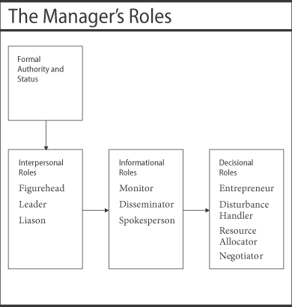
MINTZBERG – Manager’s Job

Myths vs Facts
Myth: The manager is a reflective, systematic planner.
Fact Their activities are characterized by brevity, variety and discontinuity.
They are action oriented, and dislike reflective activities.
Myth: The effective manager has no regular duties to perform.
Fact: Managerial work involves performing a number of regular duties, including ritual and ceremony, negotiation and processing of soft information that links the organization with its environment.
Myth: The senior manager needs aggregated information.
Fact Managers strongly favor verbal media, telephone calls and meetings over documents.
Myth: Management is becoming a science and a profession.
Fact: The manager’s program – to schedule time, process information, make decisions, and so on – remain locked deep inside their brains. (Judgement and intuition)
Manager’s roles
- Interpersonal roles (creating relationship and communicated between people)
  - Figurehead: Performing ceremonial duties (Internal rep.)
  - Leader: Responsible for the work of the people in their unit.
  - Liaison: Making contacts outside the vertical chain.

- Informational roles
  - Monitor : Manager is perpetually scanning the environment for information
  - Disseminator: Passing information to subordinates
  - Spokesperson: Speaks to people outside of the company or plant.

- Decisional roles
  - Entrepreneur: Seeks to improve unit, to adapt it to changing conditions.
  - Disturbance-handler: Response to pressures.
  - Resource-allocator: Deciding who will get what, which projects get what part of the budget.
  - Negotiator: Negotiate decisions (discussion aimed at reaching an agreement).

FRENCH&RAVEN – Bases of social power
- Reward Power:
    - Power through the ability to mediate rewards

- Coercive Power:
    - Power through negative reinforcement (ability to mediate punishment)

- Legitimate Power:
    - Power based on the assumption that X has the legitimate right to influence Y
- Referent Power:
    - Power of X over Y based on the fact that Y looks up to X (aspiring identity)
- Expert Power:
    - Power based on X’s special knowledge or expertise (doctor)

BARNEY – Competitive Advantage
Major Claim: A firm gains competitive advantage if its resources and capabilities (RC) are valuable, rare, hard and costly to imitate, and organized in such a manner to exploit potential opportunities.
Resources and Capabilities (assets)
- Financial: Debt, equity, retained earnings
- Physical: Machines, manufacturing, facilities, buildings.
- Human: Experience, knowledge, judgement, wisdom.
- Organizational: History, relationships, trust, culture, formal reporting structure.
Value
- Do a firm’s RC add value by enabling it to exploit opportunities and/or neutralize threats?
- Value varies in time: customer taste, industry, technology change.
Rareness
- How many competing firms already possess these valuable RC?
- Wal-Mart: For many years, valuable point-of-purchase inventory control systems were rare
Imitability
- Do firms without a RC face a cost disadvantage in obtaining it compared to firms that already possess it?
- 2 forms of imitation: Duplication or Substitution
- Reasons they would be costly to imitate:
  - History: What lead to Company X having RC Y? Skills, abilities, exterior support, etc.
  - Numerous (Internal) Small Decisions: Invisible to competing firms, harder to see.
  - Socially Complex Resources: reputation, trust, loyalty, etc
Organization
- Formal reporting structures
  - Wal-Mart: ^^ decreased the probability of stock outs and reduced inventory costs in rural locations
- Management control systems
- Compensation policies, etc.

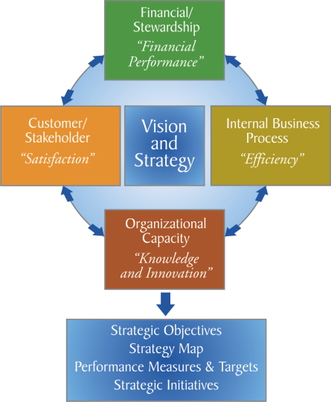
KAPLAN&NORTON – Measuring Performance
Major Claim: The scorecard tracks the key elements of a company’s strategy
Balanced Scorecard:
- A set of measures the gives top managers a fast but comprehensive view of the business
- Financial Measures
- Operations Measures (Customer satisfaction, Internal Process, Innovation)

Financial Perspective: How do we look to shareholders?
Customer perspective: How do customers see us?
Internal Business Perspective: What must we excel at? (Meet customer’s expectations)
Innovation and Learning Perspective: How can we continue to improve and create value?

For every perspective:
- Goal, Measure, Target, Due Date

HANDY – Sigmoid Curve
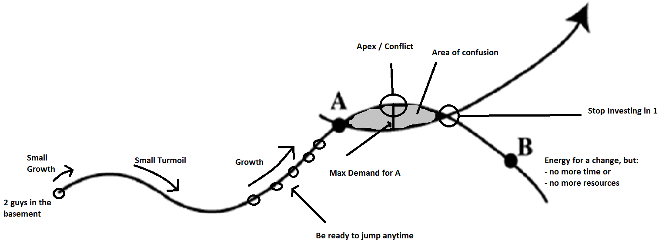
Major Claim: The secret to constant growth is to start a new sigmoid curve before the 1st one peters out

Discipline of the 2nd curve:
- Follows the traditional 4-stage cycle of discovery
  - Questions
  - Ideas, Possibilities, Hypothesis
  - Experimentation
  - Reviewing
- Do not re-invent: 2nd curve is always different, although it is inspired by the 1st
- 2nd curve needs the time and resources that only the 1st curve can provide (B too late)
- Important that Seniors (1st curve) give permission and encouragement to the next generation (2nd curve)
Curvilinear Logic:
- Everything in the world is a Sigmoid curve
- Ups and downs
- Does not last forever
- “What got you there will not keep you there”
- Exception to the Sigmoid Curve: Coca Cola
Kaizen: Continuous Improvement
The secret of balance in a time of paradox is to allow the past and the future to co-exist in the present

HERZBERG – Employee Motivation
Major Claim: People are motivated by interesting work, challenge and increasing responsibility. These factors answer people’s deep-seated need for growth and achievement.
Hygiene Factors:
- Needed to ensure an employee does not become dissatisfied
Motivation Factors:
- Needed to motivate employees into better performance
- Primary source of satisfaction
Factors for Satisfaction | Factors for Dissatisfaction
Achievement  Recognition  The work itself  Responsibility  Advancement  Growth | Company policies  Supervision  Relationship with supervisor and peers  Work conditions  Salary  Status  Security

Opposite of satisfaction = NO satisfaction ≠ dissatisfaction
Opposite of dissatisfaction = NO dissatisfaction ≠ satisfaction

Combinations of Hygiene and Motivator factors:
 | High Hygiene | Low Hygiene
High Motivation | ↑ motivation  Few complaints  (Ideal situation) | ↑ motivation  Many complaints  (Exciting/challenging job, poor conditions)
Low Motivation | ↓ motivation  Few complaints  (Jobs = Paycheck) | ↓ motivation  Many complaints  (Worse situation, McDonald’s)

Job Enrichment (Vertical Job Enlargement):
- Giving employees more responsibility along with the authority needed to complete tasks
- Make information available to employees
- Employees gain an enhanced sense of achievement and responsibility
Job Loading:
- Horizontal:
  - Adding tasks but not responsibilities
  - Meaninglessness of the job ↑
- Vertical
  - Adding meaningful tasks leading to personal growth
  - Motivates employees
Horizontal Job Enlargement:
- Blah. Think dick enlargement – Quality over Quantity.
- No good.
Job Rotation:
- Avoids monotony
- Improves job satisfaction but does not motivate

