ECO2143 Macroeconomic Theory II
Second mid-term examination: March 21st 2016
University of Ottawa
Professor: Greg Caldwell
Time allotted: 1h 20 min

Attention: You must answer according to the material seen in this course. Read all answer choices before choosing your answer. GOOD LUCK!

QUESTIONNAIRE A
I. MULTIPLE CHOICE QUESTIONS (2 points each)
1. | Which sentence is definitely inappropriate to finish the statement “In an open economy, the capital stock can be expanded…”:  - Without a decrease in consumption  - When the credit spreads of the sovereign increase. x  - Without any technological productivity gains  - If the country’s domestic interest rate is below the world level of interest rates.
2. | Which of the following is a barrier to international technology transfers?  - Having a pegged foreign exchange rate regime with capital controls.  - Having a lack of tacit knowledge of existing advance technologies.x  - Having a non-democratic governmental structure.  - Having a strong legal framework for patent protection domestically.
3. | Country 1 has a technology growth rate of 0.84 per year, and country 2 has a productivity of 0.75 relative to country 1. What is the “break-even” point whereby the technology and efficiency lags are equally important in order for country 1 to catch up to country 2 technologically?  - 15 years  - 17 years x  - 25 years  - Never
4. | In an open economy, the equilibrium level of capital per worker is not impacted by depreciation and savings rates, because:  - There is a world interest rate that determines the optimal amount of capital per worker for each country  - There is no depreciation when foreign investment can be relied upon  - The savers can save outside their countries and thus savings no longer equals domestic investment  - Both (a) and (c) are correct. x
5 | A normative statement and a positive statement would be consistent with the following:  - Normative: What will not happen and Positive: what will happen.  - Normative: What should happen and Positive: what could happen.x  - Normative: What did happen and Positive: should happen.  - Normative: What is happening and Positive: what is the best outcome to happen.
6 | Which of the following statements are unambiguously false about gini coefficients  - Gini coefficient can determine inequality in income distributions.  - Gini coefficient is used to determine the Lorenz curve.x  - Gini coefficient for a kleptocratic and autocratic country would be closer to 1 then for a democracy with a rule of law that is vigorously enforced.  - Gini coefficient is often tracked over time to determine evidence of a Kuznets curve hypothesis.
7. | Countries that are at threat of default is due to the following:  - A significant debt position domestically held by domestic citizens  - A huge current account surplus has been accumulating for the past 20 years  - A series of bonds denominated in US dollars are coming due this month, and the countries in question are not the US x  - The credit spreads have failed to price in the likelihood of default
8. | Which of the following is generally TRUE?  (a) The duration of a patent's validity is an important determinant of R&D efforts. x  (b) If Country A has a lower level of factor accumulation than Country B but Country B has higher output, then Country B has higher Total Factor Productivity.  (c) Development accounting is used to figure out changes in the growth rate of income.  (d) The high growth experiences of Hong Kong and Singapore between the 1960 and 1990s are both explained by similarly high productivity growth.
9. | In an open economy, where a country has borrowed extensively, so that it must service its prior debts with interest payments, which of the following is unambiguously true:  - The country will have higher steady state capital per worker than as a closed economy since it must set aside a portion of its savings to service its debt  - The country will have higher stead state capital per worker, always, because it is now operating in an open economy.  - High inflationary expectations will limit the impact of the debt servicing requirements on the steady state level of capital in an open economy.  - The country will experience a higher steady state capital per worker than as a closed economy only if it increases its current account deficit to compensate for the debt servicing.x
10 | The following is NOT an example of a situation that explains the observed differences in efficiency across countries:  - Japanese auto manufacturer productivity differences are related to its superior relationships with its suppliers relative the Germany and the US  - In the 1900s textile industry some countries were able to produce multiples of other countries per worker even though the technology was identical  - The Soviet Union’s central planning regime meant that centralized production decisions were devoid of market forces that could identify relative scarcities of inputs and outputs  - The size of government as described under Wagner’s law will inevitably increase due to more complex regulation and the multitudes of public goods that arise that government attends to.x

NAME AND ID:

II. PROBLEMS

Answer the following questions in the space provided. Your answers must be accompanied with clear explanations. Graphs and equations without explanations will not get you far
1. Consider two countries, denoted 1 and 2, each with $N_{i}, i=1,2,$workers. Cobb-douglas production functions of the form $y_{i}=A_{i}\left(1-γ_{i}\right), i=1,2$, where $y_{i}$ is production per worker,$A_{i }$is the technology in country $i$, $γ_{i}$ is the proportion of population in country $i$ that is currently working in research in development (R&D). The only difference is country 1 has twice the level of technology as does country 2. Both face a common price of new R&D of $μ.$
(a) Determine $\hat{A}$ (the technology production function), for country 1. Describe with graphs:
- the situation when country allocates more of its population to R&D and
- what impact that has on the growth rate of technology and also output per worker. (3)
Given a population of N we know $\hat{A}$ =Na/mu = gamma*N/mu

(b) Suppose that country 2 can choose to bypass investing in R&D and copy country 2’s technology at a cost of$μ_{c}$. That cost is a decreasing function of the relative productivities of country 1 and 2. Describe with the use of graph country 2’s choice of its $A_{2}$in terms of relative technology gaps ${A_{1}}/{A_{2}}$(4)
As the gap in technology between county 1 and 2 increases A1/A2 increases. As shown in the graph when A2<A1 and the growth of A2 is higher than A1 (right of A1/A2ss) even though the gap is large (suggesting a low cost to copy), country 2 will grow faster than country 1. As that happens A1/A2 drops to the steady state. Vice versa if below A1/A2ss. Country will copy and catch up until both countries grow at the same rate.

(c) This R&D model, as discussed in class, is quite simplified and suggests that country 1 would be adversely effected by such ‘copying’. Given what you have subsequently learned in this course about open economies and government’s role in growth, explain why such a prediction of ‘copying’ might not occur in actuality.(6)
- The technology gap is too small and the cost of copying might be too prohibitive
- Human capital deficiencies associated with tacit knowledge gaps and suitable technology for adoption
- Government’s role might crowd out or weak rule of law results in expropriation and/or lax enforcement standards
2. Suppose a country (‘Peterland’ or PL) has an expected income stream of Y1<Y2.
(a) If PL wishes to consumption smooth show graphically that it can do better than just consuming its endowment. (4)
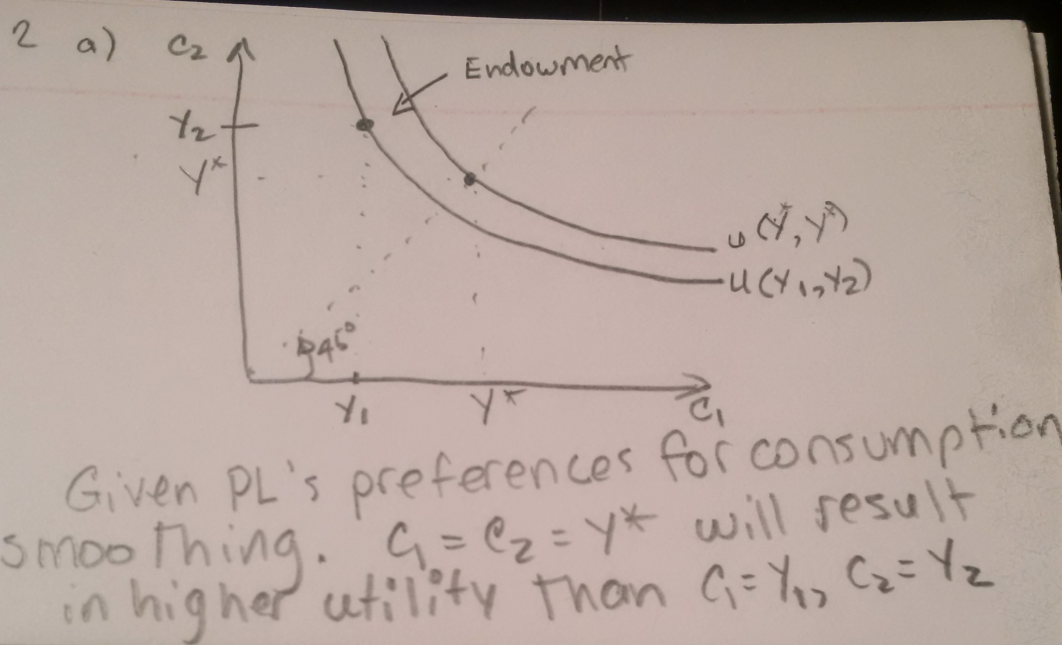

(b) Suppose PL learns that it can utilize foreign borrowing/lending from the Kingdom of Quahog at a world interest rate of rw. Show graphically and explain what the governor of PL could do given its forecasted income streams over the two periods? (6)

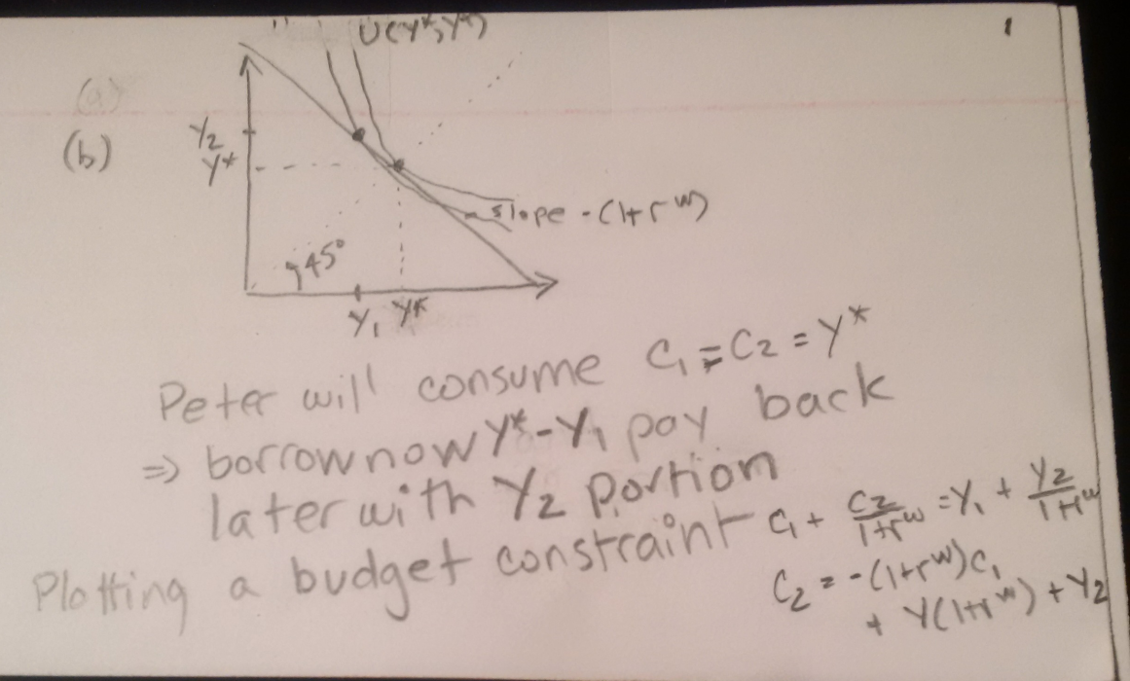

(c) Suppose PL has a diminishing returns technology (a tractor) for which the first 5 units of income invested in capital each have a marginal productivity of capital above 1+rw. Show graphically what the governor of PL will demand is produced, if anything, and what is borrowed or lent in international markets. Explain how this results in a consumption stream that is preferential to autarky in question (a) and simple borrowing/lending in international financial markets in question (b) (7)
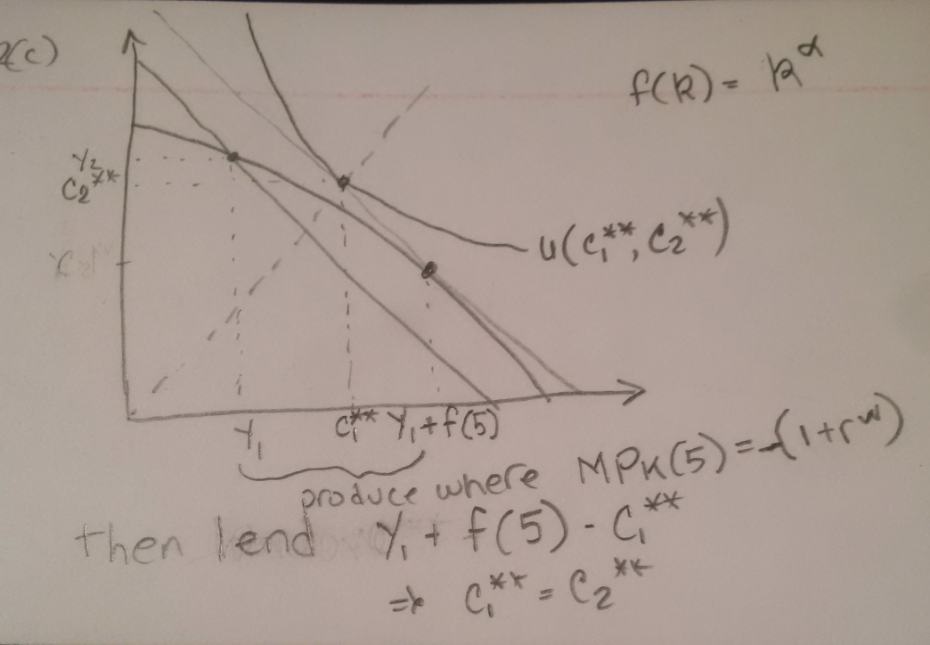

Additional paper for questions

Additional paper to answer questions

