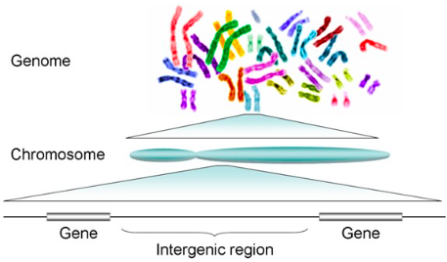
Lecture 18: Transcription

Objectives
- Understand, describe and demonstrate the steps involved in transcribing DNA to mRNA
- Be familiar with the elements comprised in a transcription intuition complex and its role
- Explain and demonstrate RNA maturation and splicing
- Compare and contract RNA transcription in prokaryotes vs. eukaryotes

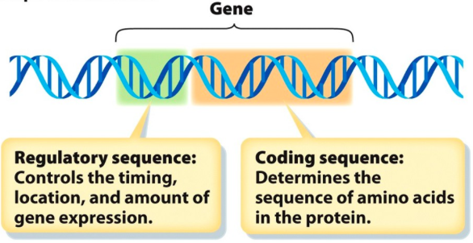
Only a small amount of DNA is actually for coding. Most of the structure of DNA is there for support and structure
DNA histones solenoids chromatin chromosome
- There are various regions where there are multiple sequences that transcribe genes. The regions nearby the genes are there to aid in how the gene is transcribed

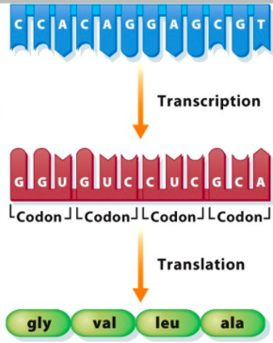
Definition of a Gene Promoter
- Promoter are located ahead of the gene called a regulatory sequence
- This is where there are switches present to control the timing, location and amount of gene expression
Consists of a:
- Promoter (site where DNA transcription begins)
- Operator (sequence of bases that control transcription and bind regulatory factors)
- Coding regions (sequences that code for actual proteins)

DNA replication DOES NOT need to occur for transcription to occur

Definition of Gene Expression
- The coding sequence of the DNA first needs to be found in order to activate transcription
- A copy of the section of DNA is made into mRNA which is able to leave the nucleus
- Transcription occurs in the nucleus
- The rRNA uses mRNA to code for proteins (translation)
- The entire process cannot occur in the nucleus because amino acids require a different environment then DNA
- Translation occurring outside the cell also allows various activities to occur at multiple times (efficiency)
- If translation of an enzyme occurs inside the nucleus, it can damage DNA
- Both DNA strands DO NOT need to be copied since RNA is only single stranded
- In prokaryotes, replication, transcription and translation occurs all in the cytosol of the cell

Prokaryotes vs. Eukaryotes
- In prokaryotic cells, there is no nucleus. Transcription however occurs in the same process as in eukaryotes which will go to a ribosome and translation occurs
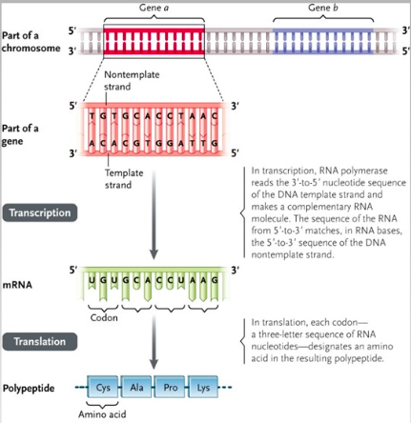
- In eukaryotes, a pre-mRNA is made which is processed to form the actual mature mRNA, which then leaves the cell for translation. The processing of mRNA also occurs in the nucleus of the cell

Which Strand?
- A template strand is the one that is copied into mRNA (occurs 5’ to 3’)
- As you extend the copy, the finals mRNA will move from 5’ to 3’
- The 3’ to 5’ strand is going to be the template strand and the 5’ to 3’ is going to be the non-template strand.
- All T are switched to U in mRNA

How does it get started?

- Intracellular receptors act as gene transcription factors which will activate transcription
- Any signalling inside the cell will activate gene transcription to be on or off in order to obtain a response in the cell

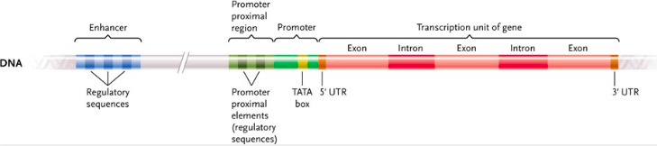
Prokaryotes
- Binding to the promoter of polymerase subunits, particularly the sigma subunit (σ) – serves as a guide to place RNA polymerase
- RNA polymerase initiates transcription
- There are protein portions of RNA polymerase which will bind sigma subunits and attach to the DNA sequence to transcribe RNA
Eukaryotes
- Binding to the promoter of transcription factors, activators, receptors
- Formation of transcription initiation complex (TFs and protein)
- Then, RNA polymerase II is recruited to initiate transcription
- RNA polymerase will troll DNA to finding a promoter to begin transcription
- A transcription initiation complex can recite various proteins to cause many things to occur in the process of transcription

RNA Polymerases
- RNA polymerase I = rRNA (ribosomal)
- RNA polymerase II = mRNA (messenger)
- RNA polymerase III = tRNA (transfer – translation)
- Only RNA polymerase II will lead to protein (ie translate), but RNA polymerase I and II contribute to this (by providing the ribosomes and the transfer RNA brings the amino acids)
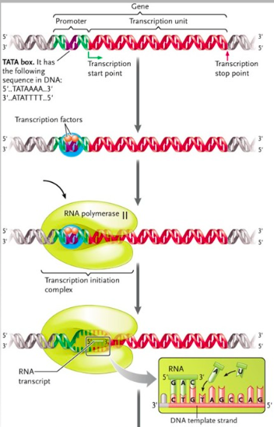
Organization of the Gene
- Near the TATA box, there are regulatory sequences right before the promoter region
- Distil elements from the promoter region are able to interact as activators and inhibitors in the promoter region as DNA is flexible such as the enhancer (regulatory sequence)

- Initiation

- RNA polymerase II binds at the promoter (specialized nucleotide sequence that lies just before a gene on one strand of DNA) and unwinds the DNA
- The TATA box is a key component of the promoter. Prokaryotes have a TATAAT sequence instead
- The transcriptional unit is the portion of the DNA strand that will be changed into RNA
- When the transcription initiation complex is ready, RNA polymerase II comes in and attaches to the promoter region which begins at the coding region called the transcription initiation site
- While it unwinds the DNA sequence, it begins transcription

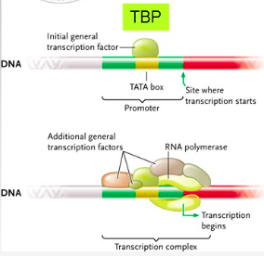
Transcription Initiation Complex (TIC)
- 1st step – TBP (TATA box binding protein) binds to the TATA sequence on DNA. This positions the helix transcription
- 2nd step – Additional proteins come and complete the TIC (these include transcription factors and regulatory elements). This provides stability and allows RNA polymerase II to come and start transcription
- Various proteins come in to form the large protein complex, which will determine how long, how fast etc. will the transcription factor last
- As long as the complex is there, RNA polymerase II and other proteins can continuously allow transcription
- As soon as the site dissociates, the complex needs to be formed again for transcription to occur
- There is no proofreading and therefore, point mutations can occur

- Elongation
- mRNA is made 5’ to 3’ by RNA polymerase, using one DNA strand as the template, with no RNA primers needed
- As RNA polymerase passes, the DNA double helix reforms
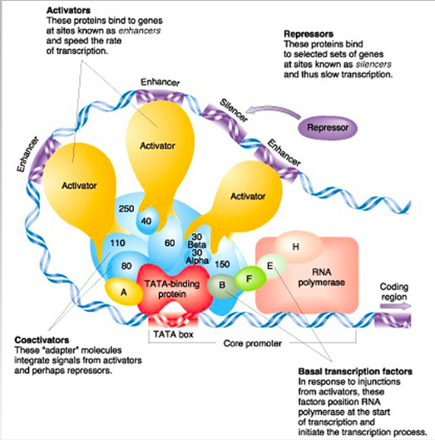
- The other DNA strand is not copied and is termed the coding strand
- Many copies of mRNA are made at the same time such that the protein coded is mass produced

- Termination
Prokaryotes
- There are 2 mechanisms for termination
- Rho protein has fixed itself on to the end of the transcribed sequence to end transcription
- There can also be a termination sequence which will produce a hair-pin like structure which will pull RNA polymerase off the DNA codon which will stop transcription
Eukaryotes
- When RNA polymerase recognizes a termination sequence (sequences of base pairs at the end of a gene), a signal is sent to end transcription
- Eukaryotes have a string of U on the mRNA which bind a protein to stop transcription

Post- transcription modifications
- Tailing – 50-250 adenine nucleotides called the poly (A) tail are added to the 3’ end by poly-A-polymerase protecting it from enzymes
- Capping –a 5’ cap consisting of 7 guanines is added to the 5’ end by a different enzyme complex which is used as a site of attachment for ribosomes
- mRNA leaves the nucleus through the pores
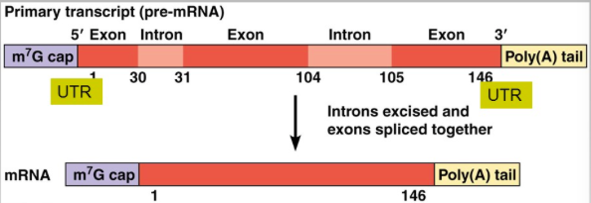
Prokaryotes vs. Eukaryotes
- Getting rid of introns so there are only coding regions present; exons (in eukaryotes)
- In prokaryotes, the gene organization for transcription is different. There is no TATA box in prokaryotic DNA
- The mature mRNA is made right away in prokaryotes, but transcription only creates a pre-mRNA in eukaryotes

Eukaryote transcript – Pre-messenger RNA
- The poly-A-tail is made from adenine (50-250)
- It is required for mRNA to have a tail as it stops the mRNA from being degraded by nucleases in the nucleus
- A 5’ cap is added during transcription once the mRNA is about 50 nucleotides in. The 5’ cap and poly-A-tail are not translated

RNA maturation: Splicing
- Splicing occurs by a structure called a spliceosome
- snRNPs: small nuclear ribonuclear proteins
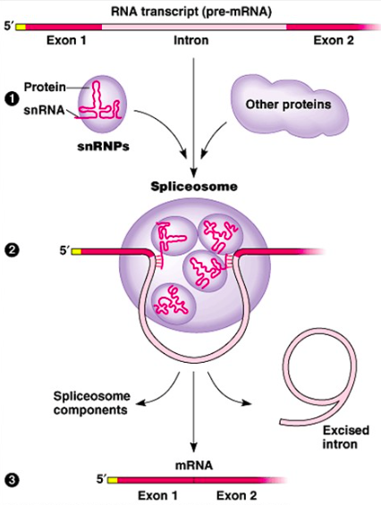
- Recognize the ends of introns and catalyze their cleavage. The ends of exons after removal of introns will be joined together for a continuous coding sequence
- mRNA splicing – introns (non-coding) are deleted and exons (coding) are left and reconnected in order to make the correct protein
- Occurs in the spliceosome complex with snRNPs
- Made from small nuclear RNA which compliment the actual mRNA
- Proteins are recruited to cut out the introns and exons are reattached.
- Once the complimentary strand is formed, the intron is degraded
- A transcript needs to be long enough to produce a protein that has a certain amount of amino acids

