Mark 302 midterm review notes

Chapter 3:

Secondary Data: data that has been previously gathered. Could be found internally (within the company) or externally (outside of the company).

- Advantages of Secondary Data: cheaper, less time and more convenient. It may also clarify or redefine the problem, may provide solution, may provide sample frame.
- Disadvantages of Secondary Data: lack of availability, lack of relevance, inaccuracy and insufficiency.

Primary Data: new data gathered to help solve the problem under investigation.

Fact Finding Objectives
Trend Analysis: doing market tracking to analyze trends in industry volume and brand share over time.
Environmental scanning: detecting environmental changes
Behavioral targeting: to understand consumer’s habits, demographics and social networks in order to increase the effectiveness of online advertising.

Model Building Objectives
Estimating market potential and sales for geographic areas.

Internal Databases: collection of related info developed from data within the organization.
- Can be created from sales info, response to promotions, customers who have become members of brand communities.

Database Marketing: Relies on customer’s profile and purchase patterns to create a targeted marketing mix.
- Allows for individualized direct marketing and customer relationship management.

Using Big Data
-5 terabytes or more is considered “big”.
-1 terabyte = a billion bytes.
Deeper insights: instead of market segments, look at individuals, products and transactions.
Data visualization: easier to see patterns using graphs.

Data Mining: use of statistical and other advanced software to discover non-obvious patterns hidden in database.
Neutral Networks: computer program that mimic the process of the human brain and is capable of learning from examples to find patterns in data.
-Using scanner data: retailers know which products deserve space. They can track margins, coupon elasticity and display elasticity.

Single source data: diverse types of data offered by a single company. Data using integrated on basis of common variable such as geographic area/ store.

Competitive intelligence: obtaining info using legal means and protecting yourself from economic espionage.

Longitudinal: over the years/seconds (over a period of time)

Chapter 4:

Qualitative: type of question used is probing, the sample size is small, the type of research is exploratory and used in research training as psychology, sociology and marketing.

- Advantages of Qualitative: less expensive, can provide “first-hand” impressions of consumer behavior and can improve efficiency of quantitative data collection.

- Disadvantages of Qualitative: may not distinguish small differences in attitudes and opinion regarding marketing mix. Usually is not a representative sample of the population and opinion in groups may be swayed significantly by a strong –willed respondent.

Quantitative: type of question use if limited probing, sample size is large, type of research is descriptive and casual and used in research training in statistics, decision models and marketing research.

Focus Groups: 8-12 respondents led by a moderator. It is a in depth discussion for about 90 min or one particular topic/ concept.

-Group Dynamic: interactions among people in the group. The moderator must manage group carefully.

-Focus groups are: excellent for idea generating, brainstorming, understanding customer vocabulary. They provide insight to motives, attitudes, and perceptions. They can reveal needs, likes and dislikes by emotions.

- Advantages of Focus Group: look customers in the eye, generate fresh ideas and brainstorming, allow client to observe and comment on site, executed quickly and can enhance other data collection methods.

- Disadvantages of Focus Groups: expertise is needed, participation issues (no shows), interpretation is subjective and often misused as representative of the general population.

Conduct a Focus Group:
- Decide on research objectives for focus groups.
- Use secondary research to refine group questions
- Select focus group facility.
- Select a moderator
- Create discussion guide to ensure flow- avoid too many questions
- Conduct focus group
- Review videotape, notes and analyze results.
- Prepare written report for client-instant analysis first.

Moderators should:
- Meet and great participants before focus groups
- Ask simple and light personal questions during warm up
- Reveal something personal info about themselves
- Ask participants assistance during the process. “Your opinion is valuable”
- Use humor when appropriate
- Dress the same as respondent.
- Start focus group session sitting down.
- Have a client approved discussion guide to assist.

A Good Moderator?
- Good oral, written and organizational skills.
- Able to manage conversation flow.
- Good at follow up questioning and probing
- Excellent attention to detail and is precise.
- Reliable, responsive and trustworthy.
- Ability to provide feedback and be a sounding board for client.

Focus Group trends: adding marketing professionals as participants, helps when company is not receiving the required insights from consumers.
“Prosumers”: understand both sides of the question.

In-Depth interviews: (qualitative methodoly) one on one discussions that probe to elicit detailed answers, often using non-directive techniques to uncover hidden motivations.

- Advantages of in depth interviews: group pressure is eliminated, getting underlying info, more personalized attention given, interview can be conducted anywhere, respondent can be more forthright and interviewer becomes more sensitive to non-verbal cues.
- Disadvantages of in depth interviews: more costly than focus groups and lacks advantage of group dynamics.
- Delphi method: panel of experts that provide anonymous input over a number of rounds, feedback consists of summary of opinions.
- Hermeneutics: spontaneous one on one conversations with consumers over time.

Projective Tests: technique tapping respondent’s deepest feelings by having them project feelings into an unstructured situation. Ex: word association test, photo sorts, cartoon test and analogy.

Chapter 8:

They need to know:
-Why: why did they buy or not
-How: how did they make the decision
-Who-: who is the consumer from demographic/lifestyle perspective?

2 main kind of survey errors:
1) Random Sampling Error: due to chance variation, elements that are randomly selected still may not always be representative, so results may turn out not as expected.
2) Systematic Error/Bias: results from flaws in research design/ execution.
3 kinds of sample design error and 6 kinds of measurement error.

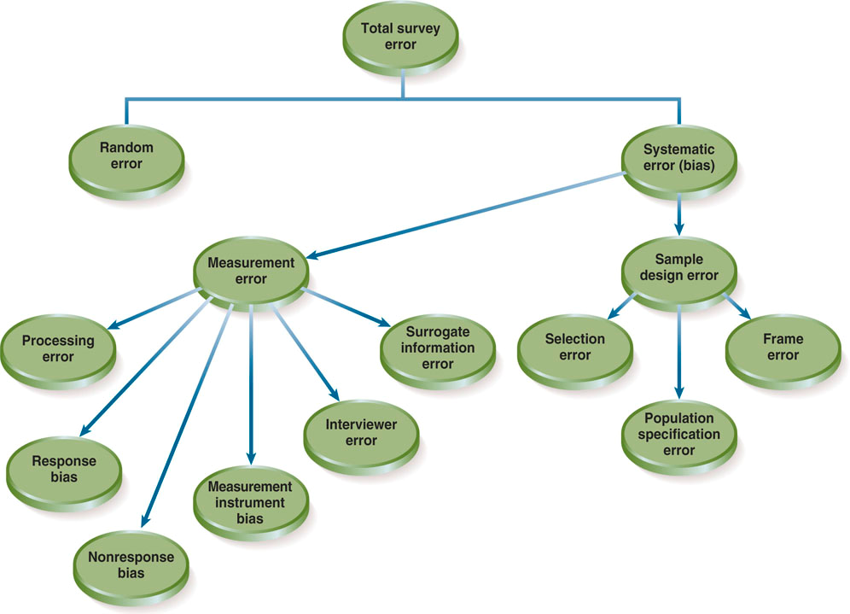

Sample Design Error:
- Population specification error: due to incorrectly defining the population or universe from which sample is chosen.
- Selection error: due to incomplete or improper sampling procedures or when sampling procedures are not followed
- Frame error: incomplete, inaccurate sampling frame
Measurement Error:
- Surrogate info error: due to discrepancy between info needed to solve a problem and info asked by the researcher.
- Interviewer error/bias: due to interviewer influencing
- Measurement instrument bias: due to design of questionnaire, questionnaire bias
- Non-response bias: systematic difference between those who don’t and those who do answer. Refusal of cooperation.
- Processing error: due to incorrect data entry of info from a survey minimized with phone and web surveys, also due to incorrect coding.
- Response bias: due to respondents answering incorrectly. Ex: only using endpoints scale, desire to appear smart and normal.

Type of Surveys:

-Door to door interviews
Pros: direct customer contact and can demonstrate products
Cons: expensive, bad image, liability and safety issues.

-Executive interviews
Pros: talking with decision maker is valuable and can have complicated questions
Cons: hard to get decision-maker and limited sample size.

-Mall intercept interviews
Pros: direct customer contact, can test products and human interaction
Cons: expensive, not always representative of population and busy environment

-Central location telephone interviews
Pros: good segmentation, can verify respondents as the right person, customization of questionnaire with (CATI) computer assisted telephone interviews, data can be directly entered into computer, it can have skip patterns and data entry errors are rare.
Cons: expensive, response rates are slipping, need to have short surveys. For CATI, there are computer glitches, need interview training and expensive training.

-Self administered questionnaires
Pros: respondents can take their time, good response rates.
Cons: Respondents often take a long time; researcher can overcomplicate the survey since respondents have more time.

-Mail surveys
Pros: not too expensive, can get targeted mailing lists, can make longer questionnaires.
Cons: low response rates, mailing list often out of date, not sure who completed the survey and manual data entry is common.

Chapter 9:

80% north americans are online
30% world’s population is online and it continues to grow

Online Focus Groups
- Advantages: access to hard to reach, lower costs, faster turnaround time, increased openness of respondents and efficient moderator-client interaction.
- Disadvantages: group dynamics diminished, non-verbal inputs hard to obtain, client involvement reduced, exposure to external stimuli is more difficult and more difficult task for moderator.

Web community research: a carefully selected group of consumers who agree to participate in an ongoing dialogue with corporation.
-Engage customers in space where they are comfortable
-Establish brand advocates who are emotionally invested in company’s success.
-Create forum in which natural dialogue allows customers to initiate topics important to them.

Online Survey research
- Advantages: broadcasted to thousands, results are viewed instantly, lower costs, ready personalized, high response rates, ability to contact hard to reach, simplified and enhanced panel management.
- Disadvantages: anyone who wishes to complete questionnaire can, problems arise if respondent has access to questionnaire over and over again, too broad, lack of “callback”, no way to clarify open ended responses. Limited range: cannot be used in all countries. Lack of bandwidth: some respondents cant download photos or complete survey this way. Programming erros: can cause problems when taking questionnaire.

2 kind of platforms
- online survey tools(Survey Mokey)
- crowdsourcing platforms(Crowdflower)
3 steps:
- create online questionnaire
- recruit participants
- collect responses

Crowdsourcing: the practice of obtaining needed services, ideas or content by soliciting contributions from a large group of people and especially from the online community rather than from a traditional employees/suppliers.

Managing online panels:

-Open and closed online panel recruitment
Open: anyone can self-select be aware of professionals
Closed: only pre-validated individuals invited

-Respondent cooperation: varies but panel response rate is relatively good.

-Controlling the panel
Need frequency controls, protect privacy, no selling
Must recruit continuously to keep panel fresh as members ages, attrition occurs.

Mobile Marketing Research: the next step, 75% Canadians have access to the internet on their phones.
- Advantages: mobile technology creates new opportunities for marketing research such as point of scale customer satisfaction queries, continuous real time event feedback, brand and advertising tracking and feedback and live product concept testing.
- Disadvantages: profile may not reflect the average consumer, questionnaires must be short, and question types and length of questions are limited. Higher incentives must be offered to remove the financial burden of receiving and completing mobile surveys from respondent.

Chapter 6:

What is to be measured?

Concepts: abstract idea, category of thought.
Constructs: theoretical, abstract-inferred not observable ex: brand loyalty
Constitutive (theoretical/conceptual) definition: defines what the construct is and it is not, the “domain” of the construct.
Operational definition: specifies operations necessary to measure a concept.

Nominal Data: scales that have labeling characteristics “nominal from name”
Ex: Yes/no questions, marital status, profession, gender, race

Ordinal Data: scales that maintain the labeling characteristics of nominal scales and how the ability to order date
Ex: first second third, brand preference, what is your age? Less than 20, 21-30
Interval Data: scales that have the characteristics of ordinal scales, plus equal intervals between points. Ex: please rate your level of satisfaction with --------
Very satisfied, very dissatisfied.

Ratio Data: scales that have the characteristics of interval scales, plus a meaningful zero point. Ex: age (not an age range)

Nominal and ordinal known as non metric.
Interval and ration known as metric.

3 criteria for good measurement:
- reliability: degree to which measures are free from random error and therefore yield consistent results. Multi item scales are always more reliable than single items.
- Validity: extent to which what you’re trying to measure is actually measured.
- Sensitivity: ability to accurately measure variability in stimuli or responses. Multi item scales are most sensitive.

Methods of Assessing Reliability:
- Test-retest method: administering the same scale or measure to the same respondent at 2 separate points in time to test stability.
- Equivalent-Form method: measures correlation between instrument(scales) designed to be equivalent, administered to the same group of subjects.
- Internal consistency: assessed equivalence by assessing the homogeneity of a set of items on how well they “hang together”. Used to be checked by the split-half technique(splitting the set of items into 2 halves, looking at the correlation.
Now always done with Cronbach’s alpha (computing mean reliability coefficient estimates for all possible ways of splitting a set of items in half) or with K-20, this is the easiest and most used method.

Types of Validity:
- Face validity (weakest form): do questions and items on scale make sense, seem logical? Are they clear? Ex: measuring residency status with “are you a Canadian citizen?” is not good.
- Content validity: degree to which the measure or scale covers the entire domain of the contstruct and nothing else. Ex: store ambiance, scale that include items asking about return policies and store hours but not décor has poor content validity.
- Criterion: ability to measure to predict a criterion(dependant)variable. 2 types of criterion.
- predictive: predict criterion variable at different time. Ex: a purchase intent scale should be good predictor of future purchases of new products.
- Concurrent: predict criterion variable at the same time. Ex: an electrodiagram should be able to tell you if there are blocked arteries in your heart right now.
- Construct validity: the measure should behave according to the theory behind the prediction.

Attitude: an engineering disposition to consistently respond in a given manner to various aspects of the world. Ex: price sensitivity. Not directly observable but measurable through indirect indicators- verbal expression or behavior.

Importance of using the right level of measurement:
-determines what can you say about subjects (cannot do statistical test unless data is metric)
-normally use highest level possible: metric( interval and ratio)

Nominal and Ordinal Advantages: easier to conduct, easier for subjects to answer and may be best option when looking for choice among alternatives.

Attitude measurement scales: motivations, emotions, perceptions, cognitive processes.

Non-comparitive scales: judgement is made without reference to another object, concept or person.

Comparative scale: one object, concept or person is compared to another on scale.

Graphic Rating (non-comparative)

Itemized rating (non-comparative) not at all 1 2 3 4 5 extremely used

Semantic differential (non-comparative) makes the design across the questionnaire

Staple scale (non-comparative) +5 +4 … -5 -4

Likert scale (non-comparative) strongly agree , strongly disagree.

Purchase intent scale (non-comparative) would you recommend to a friend? Def, probs , probs not , defs not.

Rank order( comparative) put fast food chains in order of preference, burger kind, wendys and KFC

Q-sorting : a form of rank ordering using card sorts. Respondents rank X number of items in order from best to worst by putting the cards representing the idea at hand into ranked piles.

Paired comparisons (comparative) which drink do you prefer? Coke or pepsi, pepsi or sprite, sprite or coke.

Constant sum scale (comparative) what features you want in a car? Sun roof, leather seats, ABS breaks.

How to select a scale: speed and cost issue: rank order is easier, semantic differential harder.
Survey mode: if phone or web surveys, use fewer scaled categories. Respondents prefer ordinal and nominal questions.

Chapter 7:

Criteria for a good questionnaire:
- Should provide decision-making info for management
- Should consider the respondent
- Should meet editing and coding requirements

Response Format:
- Open-ended questions: respondents replies in their own words, response is recorded verbatim (same words were used originally), probing is helpful to achieve deeper understanding
- Close-ended questions: respondents choose from a list of potential responses –Dichotomous (agree/disagree, yes/no)
-Multiple choices
-Scaled responses.

Asking clear questions:
Use everyday vocabulary suited to respondent
Avoid double-barelled questions(have you often, sometimes)
Provide frame of reference in time and space, define terms, dinner could mean two different things in different countries.
Avoid biasing the respondent (leading question implies the answer)
Consider respondent ability to answer
Consider respondent willingness to answer
-third person question
-counterbiasing: in these difficult times, many people have to carry a credit card balance. Do you carry a balance?

Evaluating questionnaires:
Is the questionnaire too long?
Is the questionnaire necessary?
Will questions provide the info needed to accomplish research objectives?
*also separate independent variable and dependent variable into 2 questions.

Questionnaire Flow:

Screeners: establish if the respondent qualifies, excuse those who don’t. “have you shopped for groceries in the past week?”

Warm ups: get the respondent thinking about the topic, develop report. “How often do you go shopping?”

Transitions: set the tone for the difficult questions to come. “ Now im going to ask you some more difficult questions”

Complicated questions/ main section of questionnaire: use of rating scaled for behaviors, attitudes and beliefs and opinions.

Classification: sensitive/personal/demographic questions: always ask last or respondent may abort the interview. Ex: “what is your total annual household income?”

Order of independent and dependant variables: put questions about the dependant variable first

Design Considerations:

Start with opening script : who you are, why are you doing the survey and how long will it take

Use plenty of white space between the questions

State instructions clearly

Ensure format, layout, font is consistent

Use respondents core vocabulary

Clarify questions as they are asked, allow enough space for open ended questions

Number questions and ensure questions are interrelated

Include a closing statement “thank you , your opinion counts!”

Chapter 11:

Concepts of sampling:

Population: entire group of elements about whom info is needed. (also called universe or population of interest)
Sample: subset of all members of population

Census: data obtained from every or almost every member of population of interest.

Sampling: process of obtaining info from a subset (sample) of larger group (population). Takes result from sample and makes estimate of characteristic of larger group.

Sampling frame: a list of population elements from which units to be sampled can be selected or specified procedure for generating such a list.
(RDD) random-digit dialing: generates a list of telephone numbers at random.

2 groups (probability and non-probability sampling methods)

Probability sampling method: every element of population has a known, non-zero likelihood of selection.
- Advantages of probability samples: sampling error can be computed, results can be projected to total population, obtaining info from a representative cross –section of population interest.
Probability sampling Methods:

- simple random sampling: purest form probability of selection= sample size/population size. Assign number to each element of population. Using a table of random numbers to select specific elements for inclusion in the sample.

- Systematic sampling: produces samples almost identical to simple random sampling, number the entire population, then determines skip interval and selects elements based on this interval: population size/sample size
It is less expensive and less time consuming but possibility that hidden patterns within the population list may inadvertently be pulled into the sample.

- Stratified sampling: original population is divided into two or more mutually exclusive and collectively exhaustive subsets (male and female for ex), then they are chosen independently of each other. Identify the demographic/classification factors that are correlated with behavior of interest. Determine what porportions of population fall into various subgroups under each stratum.
Proportional allocation n/N n being size of stratum and N the size of population, or disproportional(optimal allocation)

- Cluster Sampling: selected in groups, the population of interest is divided into mutually exclusive and exhaustive subsets, random sample of the subsets is selected.
If sample consists of all elements in selected subsets then its called one stage cluster sample. Two stage if sample of elements chosen in problematic manner. Sampling units selected from a number of small geographic areas to reduce date-collection costs (this is area sampling) ex: cities, city blocks.

Non-probability sampling method: selected in a non-random manner, doesn’t allow them to be chosen randomly.
- Disadvantages of non-probability samples: sampling error cannot be computed, researcher doesn’t know degree to which the sample is representative of population, results cannot and shouldn’t be projected to total population, because sample is unknown.
- Advantages of non-probability: cost less, gathered quickly, reasonably representative if collected in careful, thorough manner.

Non-Probability Sampling Methods:

- Convenience: using people who are easily accessible, such as mall intercepts or other high traffic locations “ person in the street”

- Judgment: Based on researchers personal judgment about representativeness of the population under study. Researcher selects who should be in the study based on observed cues such as gender, age and usage of the product.

- Snowball: selected based on referrals from initial respondents by researcher, used when sample unit characteristics are quite rare or very difficult to find. Ex: good for low-income respondents.

- Quota: based on demographic or classification factors selected by researcher are established for population subgroups. Ex: JMSB students with different majors.

Sampling error: when sample is selected, is not perfectly representative of the population

2 types of sampling error:
- Administrative: relates to the problems in the execution of the sample. Flaws in design of execution of sample
- Random: Due to chance and cannot be avoided, error could be reduced, but never totally eliminated by increasing the sample size.

Non-sampling errors include all factors other than sampling error that may cause inaccuracy and bias in survey results.

Non- response bias: occurs when respondent to a survey are different from those who didn’t respond in terms of their demographic characteristics/attitudes.

Population parameter: value that defines a true characteristic of a total population.

