ADM2372 Midterm Review

Chapter 1: Information Systems and Business Strategy

Information systems’ impact on business ops

MIS is responsible to lower costs, improve productivity and generate growth through initiatives such a soft ware, hard ware. IT also provides communication and data analysis.
Organizations typically operate by functional areas or “silos”. In order to share common information, departments must function interdependently.

Relationship among People, Processes, IT

People use processes to work with information systems to produce information/business success. People -> Processes -> Information Technology. All three are interdependent. People use processes which use IT. Processes should be called organization because processes are only a small sliver of the organization.

Different information cultures found in Organizations

Information-Functional Culture: Employees use info as a means of exercising influence or power over others. For example, a sales manager refuses to share info with marketing. This causes marketing to need whenever the sales manger’s input a new sales strategy is developed.

Information-Inquiring Culture: Employees across departments search for info to better understand the future and align themselves with current trends and directions.

Information-Sharing Culture: Employees across departments trust each other to use info to improve performance.

Information-Discovery Culture: Employees across departments are open to new insights about crises and radical changes and seek ways to create competitive advantages.

IS Basics

Information Services: Computer-Based tools that used to used with information and support the information and information-processing needs of an organization, Includes hardware, software, trained personnel, policies and procedures and security measures. IS is an enabler of business success and innovation.
Information Technology: The acquisition, processing, storage, and distribution of voice, graphics, text, and numbers and other information by a combination of computers and telecommunications networks.
Management Information Services: The function that plans for, develops, implements, and maintains IS hardware, software, and applications that people use to support the goals of an organization. MIS is a business function, similar to Accounting, Finance, Operations, and Human Resources

IS vs. IT vs. MIS

- IS existed long before IT
– Before IT, using books and ledgers, hotels were able to
  - take reservations
  - check guests in and out
  - keep track of room status
  - manage inventory

– Before IT, banks already had sophisticated information systems to
- perform input,
- process, store,
- output activities (capture info, process info, store info, disseminate info)

Data, Information, BI & Knowledge

Data -> Information -> Business Intelligence -> Knowledge

Data: Raw facts that describe the characteristics of an event or object. Ex: Order date, amount sold, customer number, etc.

Information: Data converted into a meaningful and useful context. Ex: Best-selling product, best customer, etc.

Business Intelligence: Information collected from multiple sources that analyzes patterns, trends and relationships for strategic decision making. Ex: Lowest sales per week compared with the economic interest rate.

Knowledge: The skills, experience and expertise, coupled with information and intelligence, that creates a person’s intellectual resources. Ex: choosing not to fire a sales rep who is underperforming knowing that the person is experiencing family troubles.

IS Roles and Responsibilities

• Chief information officer(CIO)
– Oversees all uses of IT and ensures the strategic alignment of IT with business goals and objectives

• Chief knowledge officer (CKO)
– Responsible for collecting, maintaining, and distributing the organization’s knowledge

• Chief privacy officer (CPO)
– Responsible for ensuring the ethical and legal use of information

• Chief security officer (CSO)
– Responsible for ensuring the safety of IT resources including data, hardware, software, and people

• Chief technology officer (CTO)
– Responsible for ensuring the throughput, speed, accuracy, availability, and reliability of IT

1.3 Business Strategy

Competitive Advantage: A product or service that an organization’s customers place a greater value on than similar offerings from a competitor

First-mover Advantage: Occurs when an organization can significantly impact its market share by being first to market with a competitive advantage. Always temporary as it is quickly copied.

Identifying Competitive Advantage

Environmental Scanning: the acquisition and analysis of events and trends in the environment external to an organization

Three common tools used in developing competitive advantages:

Porter’s Five Forces Model:
- Buyer Power: the ability of buyers to affect the price of an item. High when buyers have many choices of who to buy from and low when they aren’t many options. A way to solve this problem as a company is to offer loyalty programs
- Supplier Power: The ability of suppliers to set prices and terms. High when buyers have few choices and low when buyers have many options
- Threat of Substitute Products or Services: high when there are many alternatives to a product or service and low when there are not many alternatives. Companies prefer being in markets with few substitutes or alternatives
- Threat of New Entrants: high when it is easy for new competitors to enter a market and low when there are many barriers to entering a new market
- Rivalry Among Existing Competitors: high when competition is fierce and low when competition is more complacent

Porter’s three generic strategies: An organization can follow these 3 strategies when entering a new market:
- 1. Broad cost leadership: reach a large market segment, low cost (Toyota)
- 2. broad differentiation: large market segment, high-cost (Audi)
- or 3. Focused strategy: target a niche market (Tesla)

Value chains: views an organization as a series of processes, each of which adds value to the product or service for each customer. To create a competitive advantage, the value chain must provide unique value to its customers.

Business-Driven Information Systems

Porters Five Forces Model
- An external analysis of industry forces impacting on the organization
- IS collects, processes and reports Environmental Scan information
- IS provides the technology to support strategies to limit the threat of the forces

Three Generic Strategies
- The strategic decision a company can make in about its business focus
- IS can run simulations and models of possible alternatives updated in real time

The Value Chain
- An internal analysis that helps a business optimize the value from its functions
- IS integrates the functions by enabling critical data/information sharing

Business-Driven Information Systems
- Information Systems developed to support a business’ competitive strategy
- Business strategy drives information systems design and choices

Chapter 2.1: Decision Making and Information Systems
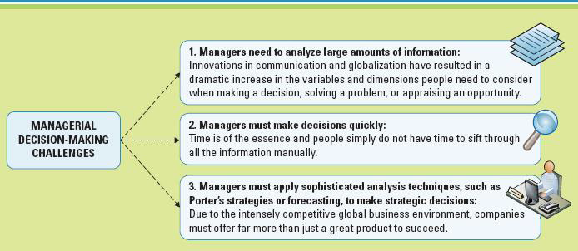

Decision-making and problem solving occur at each level in an organization: Strategic, Managerial, and Operational

Operational Decision Making
- Employees develop, control, and maintain core business activities requires to run the day-to-day operations
- Structured decisions: Situations where established processes offer potential solutions

Managerial Decision Making
- Employees evaluate company operations to identify, adapt to, and leverage change
- Semi-structured Decisions: Occur in situations in which a few established processes help to evaluate potential solutions, but not enough to lead to a definite recommended decision

Strategic Decision Making
- Managers develop overall strategies, goals, and objectives
- Unstructured decisions: Occurs in situations in which no procedures or rules exist to guide decision makers toward the correct choice

Measuring Success
- Metrics
  - Measurements that evaluate results to determine whether a project is meeting its goals
  - Common Types:
  - KPIs – Key Performance Indicators
  - Efficiency and Effectiveness

Efficiency Metrics | Effectiveness Metrics
- Throughput  - Transaction speed  - System availability  - Information accuracy  - Response time  - Very quick, fewer efforts to get things done | - Usability  - Customer satisfaction  - Conversion rates  - Financial goal achievement  - Outcomes, consequences of doing something
The balance of the two is very important, very often it is hard to get both

Key Performance Indicators (KPIs)
- The quantifiable metrics a company uses to evaluate progress toward critical success factors
  - Turnover rates of employees
  - Number of product returns
  - Number of new customers
  - Average customer spending

Critical Success Factors
- The crucial steps companies make to perform to achieve their goals and objectives and implement strategies
  - Create high-quality products
  - Retain competitive advantages
  - Reduce product costs
  - Increase customer satisfaction
  - Hire and retain the best professionals

Benchmarking: A process of continuously measuring system results, comparing those results to benchmark values (baseline values the system seeks to attain), and identifying steps and procedures to improve system performance

Types of Information:
- Transactional data
  - Encompasses all the raw facts within a single business process or unit of work
  - Supports daily operational tasks
  - More rich than analytical data, can get more information out of it
  - Ex: order size, manager’s salary, product price, stock price
- Analytical Information
  - Summarized transactional data
  - Used support decision analysis
  - Ex: market trends, forecasts, sales, by region, environmental scans

Types of Information Processing
- Online Transactions Processing (OLTP)
  - Captures, stores, updates and process data according to defined rules
- Online Analytical Processing (OLAP)
  - Summarization or aggregation of raw data from transaction systems
  - Data transformed into information for the managerial and strategic organizational levels
- Granularity: Level of detail from raw data (granular or fine) to summarized data (coarse)

Business Intelligence: Broad term describing the information supporting analytical and strategic decision-making

Consolidation: Aggregation of information into groups of interrelated information

Drill-Down: Breaking out of details into successive levels of greater granularity

Slice-and-Dice: Grouping data in different ways to offer differing perspectives

Three Major Classes of IS
- Transaction processing systems
- Handles data for the operational level
- Performs OLAP for transactional data (eg., Payroll, and order entry0

- Decision Support Systems
- Models data and information to support managerial decisions
- Performs OLAP

- Executive Information Systems
- Highly aggregated data for strategic decisions
- Usually presented in a graphical format

Quantitative Models used by DSS

Sensitivity Analysis: Changing one factor in an analysis and observing the change in result

What-if Analysis: Changing a basic assumption in the analysis and observing the impact on the result. Often used for contingency plans.

Goal-Seeking Analysis: Determining the optimal configuration of resources necessary to achieve a stated goal.

Executive Information Systems
•Specialized DSS for senior managers & executives
•Uses external as well as internal data
•Essential results at a glance
•Visualization tools display key results

Digital Dashboards: Integrates information from multiple components and presents it in a unified display.

Three Major Classes of IS
What are the Differences between TPS, DSS, and EIS?

Artificial Intelligence (AI): Stimulates human intelligence such as the ability to reason and learn

Intelligent system:
- Various commercial applications of AI
Expert Systems | - Software apps that imitate human reasoning in a specific subject area.  - Computer playing chess against you
Neural Networks | - Attempts to emulate the way the human brain works in learning and adjusting to new circumstances on its own  - Credit card company checking for fraud
Genetic Algorithm | - A system that evaluates thousands of options choosing the most likely to succeed  - Investment companies in trading decisions
Virtual Reality | - Computer generated environment that simulates a real world or imaginary world experience  - Flight simulation for pilot training

Chapter 2.2: Business Processes

Business Process
•Standardized set of activities that accomplish a specific task
•Transform a set of inputs into a set of outputs (goods & services)
–Customer check-out process, order delivery processes, invoicing process, payroll process

Importance
•Determine bottlenecks, eliminate duplication, identify and benchmark smooth running processes

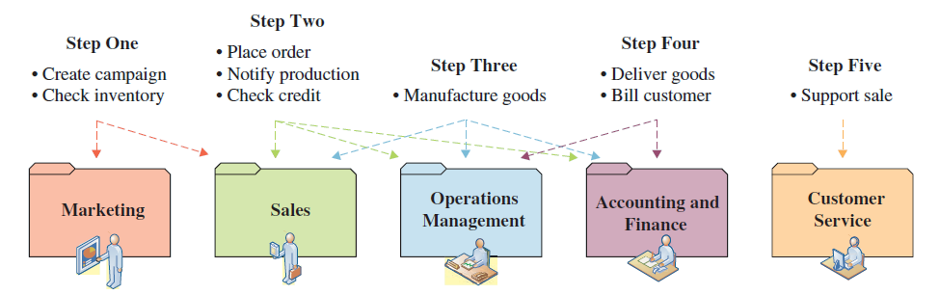

Customer & Business Facing Processes
Examples of customer facing, industry specific & business facing processes
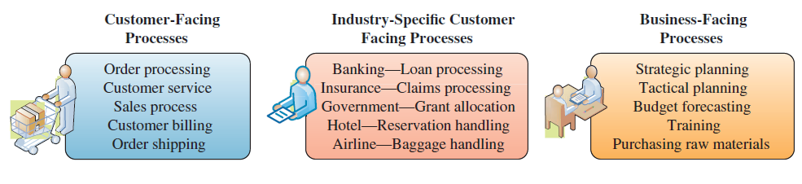

Business process modeling (mapping): The activity of creating a detailed flow chart or process map of a work process showing its inputs, tasks, and activities, in a structured sequence

As-Is process model: Current state of the operation without improvements or changes

To-Be process model: Shows the results of proposed changes to As-Is model

Business Process Improvement
Attempts to understand and measure current processes and make performance improvements accordingly.

Three conditions for initiating a business process change:
1.A pronounced shift in the market the process was designed to serve.
2.The company is markedly below industry benchmarks on the performance of its core processes.
3.To regain competitiveness, the company must leapfrog the competition on key dimensions.

Workflow: Tasks, activities, and responsibilities required executing each step in a business process.

Critical Ingredients in Process Improvement: Understanding workflow, customer expectations and the competitive environment

Business Process Re-engineering
•Is the analysis and re-design of workflow within and between enterprises
•Is not built off of the old process. Is always revolutionary not evolutionary.
•A vision is created and an entirely innovated process is implemented.
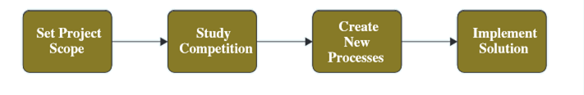

Results in better, faster and cheaper AND re-defining best practices in the industry.
•Focus must be on core business activities:
–Does it impact highly on customer satisfaction?
–Is it consistent with the strategic direction?
–Is it crucial for productivity improvement?
–Does it fall below best in class?

Creating Customer Value
The key driver for business process re=engineering

Business Process Management: integrates all of an organization’s business processes to make individual processes more efficient.

Focus on People & Systems
–Focuses on evaluating and improving processes that include both person-to-person workflow and system-to-system communications
–Works across functional areas so IT and functional managers must understand each other and work together

Requirements
–Flexibility with cultural and organizational change
–Willingness to share power and information

Chapter 3 – Data, Information and Knowledge

For specific business issue, employees must be able to obtain and analyze all relevant data.
Data come in different levels, formats and detail. There is valuable and sometimes surprising results from compiling, sorting and analyzing data of multiple types.

Granularity: refers to the level of detail. Course granularity is summarized data and fine granularity is often raw data.

Timeliness of data depends on the decision that requires it. Real time data and real time information are immediate and up-to-date. They allow smaller inventories, more efficient operations, faster diagnosis and solutions to problems and faster cycle times for cash, sales, deliveries and payments.

Data & Information Quality

Characteristics of High-Quality Data and Information
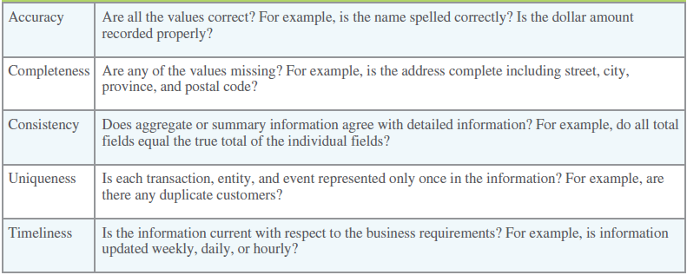

Data Governance: refers to the overall management of the availability, usability, integrity, and security of organizational data. Business are required to have policies specifying accountabilities for data quality, security, privacy and as to who can access what data & information. Companies must comply with government laws and regulations, and accounting or other professional policies and by-laws.

Knowledge: Actionable information that requires understanding of the information, ability to make inferences between “tidbits” of information, be able to apply the information in the appropriate context.

Explicit knowledge: which can be documented
Tacit knowledge: contained in peoples’ heads

Knowledge Management and Knowledge Management Systems: Codifying employees, partners & customer’s knowledge. Accessing expertise/experts whenever it is needed. Best practice for sharing tacit knowledge. Shadowing and Joint Problem Solving.

KM Technologies: Databases, tools involving some AI, discussion and chat technologies, search and data mining tools

Crowdsourcing: Collecting knowledge from outside the organization. Ex: Procter & Gamble, Wikipedia, Kickstarter.

Social Networking Analysis: (SNA) is a process of mapping a group’s contacts to identify who knows whom and who works with them. Displays remotely connected employees. Can identify experts in a required field and create “communities of practice”. Also, identifies knowledge flows through an organization.

Transactive Memory System: It consists of the knowledge stored in each individual's memory combined with metamemory containing information regarding the different group members’ domains of expertise

Business Intelligence: Application and technologies that are used to gather, provide access to, and analyze information to support decision-making.

Big Data: Vast quantities of data collected from multiple sources such as suppliers, customers, competitors etc. Analyzed for patterns, trends and relationships for strategic decision-making. Term broadly encompasses analytics to data structures.

Business Analytics: Use of predictive, applied and statistical analysis to explore an organization’s data

Operational BI: helps with immediate actions, results in sales revenue

Tactical BI: helps with daily analysis, results in refined campaign

Strategic BI: helps with planning, results in marketing campaign

Categories of BI Benefits

Direct Quantifiable Benefits: Measurable and observable benefits. Ex: lower cost or faster cycle time

Indirect Quantifiable Benefits: Measurable but observed through other events. Ex: Increase in customer orders because sales representatives are happier because commissions are paid more accurately and faster.

Unpredictable Benefits: Unexpected: Ex: New “green” process has higher profit margin

Intangible Benefits: Not directly observed such as improved reputation or employee morale

Section 3.2 – Delivering Information, Knowledge, and Intelligence Across the Organization

Collaboration Systems

Unstructured Collaboration: Document exchange, shared whiteboards, discussion forums and emails

Structured Collaboration: Participating in business processes such as workflow, where the way knowledge is used is hard-coded rules

Business Uses of Collaboration: When expertise is required that is beyond the scope of an individual or an organization. Types of collaboration includes: teams, partnerships, strategic alliances formed internally or externally.

Core Competency: an organizational strength. Core competency strategy is when an organization focuses on what they do best. Teaming up with other businesses adds complementary resources.

Information Partnership: two or more companies integrate their information systems

KM and Collaboration Tools: Bring people and technology together. Use of AI and social media to help in knowledge sharing. Ex: Wikis, discussion forums, data mining.

Content Management Systems: Provide tools to manage, create, store, edit, search and publish information in a collaborative environment. Content management reduces duplication, increase accessibility, improves security and reduces fraud. Provided by large outside vendors but also smaller suppliers specializing in legal, medical or other specific applications.

Common Types of Content Management Systems
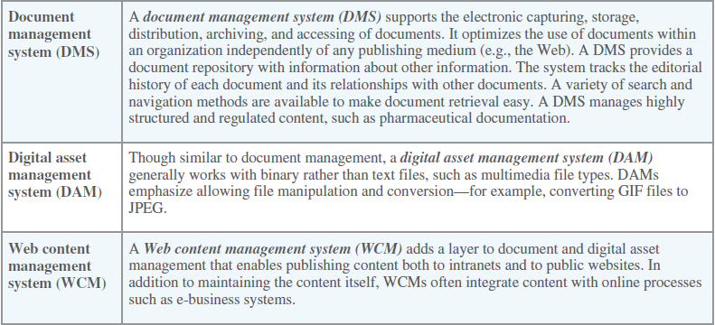

Workflow Management: Facilitates the automation and management of business processes and controls the movement of work through the business process.

Workflow: defines all the steps or business rules, form beginning to end, required for a business process. Workflow software automates many business tasks and accurately routes information electronically.

Types of Workflow Systems

Message Based workflow system: uses the email system to send out work assignments, tracks the flow of work completed and to be completed. Automatically routes the work in process to the next individual.

Database-based workflow system: Project documentation is held in a central location. Team members log in to access documents to work on.

Advantages of workflow systems: unified format, process support, allows for communication and collaboration in a unified environment.

Groupware: Software that supports team interaction and dynamics including calendaring, scheduling, and video conferencing. Groupware integrates various systems and functionalities into a common set of services or a single application. Can represent a wide range of systems and different ways to integrate them.

Synchronous Groupware: allows collaboration when team members work together at the same time

Asynchronous Groupware: allows collaboration when group members are working at different times

Advantages of Groupware Services:
- Facilitates communication (faster, easier, clearer)
- Enables Telecommuting
- Reduces Travel Costs
- Allows for Sharing Expertise
- Facilitates forming groups with common interests without problems of geographic distances
- Saves time and cost of coordination
- Facilitates group problem-solving.

Videconferencing: also called telepresence, uses telecommunications to bring people at remote sites together for a meeting. P2P links 2 sites, Multi-point links more than2 sites.

Webconferencing: Blends audio, video, and document-sharing technologies to create virtual meetings. Interaction is in real-time using phone, email, text, or VoIP. Users need an account and to download a small app. Not restricted to special hardware or software.

Enterprise Portals: Single-point Web browser interface used within an organization to gather, share and disseminate information. Information gateway, a directory of information with links to the on-line resource. Confidential resources are assessed using a login and password.

Uses of Enterprise Portals:
- Primary purpose is to help employees navigate organizational information
- Secondary purpose is to provide unique content such as:
  - Workflow and project management software, expense reporting & travel reservation applications, & other specialized functions
  - Features that support information and knowledge sharing:
    - A publishing facility on to which users post and index information
    - An automatic indexing facility that immediately indexes information
    - A subscription facility that notifies and distributes relevant information
    - Intelligence agents that understand user preferences to help him/her find relevant information and present it in a useful way

Instant Messaging: Synchronous real-time communications between two individuals.

M-learning: uses portable, wireless computing devices to enable mobile learning.

Chapter 5 – Internet and E-Business

Disruptive Technology: A new way of doing things that opens new markets and destroys old ones

Digital Darwinism: Implies organizations which cannot adapt to the new demands placed on them for surviving in the information age doomed to extinction

Sustaining Technologies: provides improved products in an established market

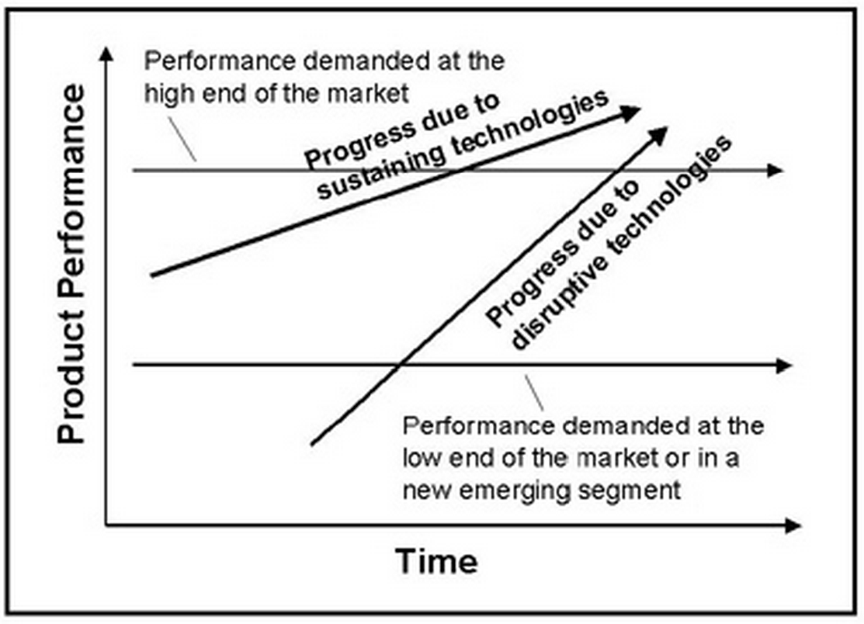

Outdated Distribution Method: When competitors entered the market with new, more convenient distribution methods, Blockbuster failed to innovate and was left behind

Tried to Charge for Services: When Yahoo! Tried to charge its users for e-mail and file sharing, the newcomer, Google, started giving them away for free. Users made the easy choice to switch

Late to Digital Photography: Kodak failed to innovate and capitalize on the demand for digital photography, as well as the printers, file-sharing, and the apps that followed

Digital Divide: Identifies the social and economic disadvantage to those without Internet technology versus those who have it

E-Commerce: The buying and selling of goods and services over the Internet

E-Business: The conducting of business on the Internet including not only buying and selling, but also serving customers and collaborating with business partners

Consumer Decision-Making Process: Recognition -> Search -> Evaluation -> Purchase -> Post-Purchase

Mass Customization: provides a range of features in standard products that can be altered to customer specifics

Long-Tail Model: Because E-businesses are not limited by shelf space, they can offer a far wider selection of products that may suit only a few customers

Intermediaries: Agents, business or software which provides an infrastructure to bring buyers and sellers together

Disintermediation: Occurs when businesses use the Web to connect directly to customers and by-pass intermediaries. This reduces costs & improves responsiveness.

Reintermediation: The addition of entities into the value chain to improve the business process

Online Marketing initiatives

Associate (affiliate) program: Provides commissions or referral fees when a customer at one site clicks through to a link to another merchant’s site

Banner Ad: A box running across the top of a website advertising the products and services of another business

Click-Through: A count of a visitor to a site when the visitor clicked on an advertisement linked to the advertiser.

Cookie: A small file deposited in the browser’s computer. Cookies perform legitimate services to foster transactions. Others illegally track customer activities without their permission.

Pop-Up Ad: A promotional web page appears in front of the current site. Pop under appears after the original web page is closed.

Viral Marketing: Word of mouth advertising

Basic Models

Business-to-Consumer (B2C): Selling-based on social media and mobile devices. Eg., Amazon

Consumer-to-Business (C2B): Consumer engagement and value creation (Mass customization, pre-order, online-to-offline), Priceline (name your own price). Eg., Google AdSense (Promote products for companies)

Consumer-to-Consumer (C2C): Sharing economy, collaborative consumption. Examples are eBay, Kijiji, Uber, AirBnb

Web 3.0: Provides a way of describing relationships between web pages so that machines understand the meaning of hyperlinked information.
- Transforming the web into a database.
- Evolutionary to artificial intelligence
- Evolution to 3D

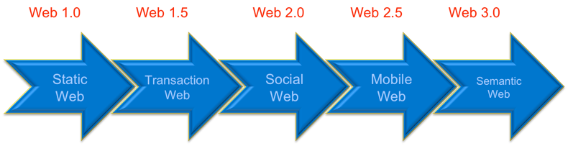

Chapter 7 – Enterprise Computing Challenges and Enterprise Resource Planning

Technology will impact business in the future more extensively than anything since the Industrial Revolution through:
- Innovation
- Social Networks
- Social Responsibility

Businesses and Social Networks

- Passive Search: Finding people for new jobs who are happy and productive where they are by using business networking sites.
- Boomerangs: Former employees returning to old jobs.
- Marketing Networks: Help businesses find employees but also suppliers, partners and needed resources. Forging communities among current and would-be customers

Social Responsibility

- Social Responsibility: Implies the individual or organization sees their responsibility to society at large.
- Corporate Policy: Reflects the position a company takes on social and political issues.
- Sustainable or “Green”: Describes systems that minimize damage to the environment.

Energy Consumption

- Throughput Computing: chip manufacturers focused not only on processing power but also the amount of energy being consumed.
- Government Involvement: Energy Rebates, Limits on carbon emissions
- Alternative Energy Sources
  - Such as Wind mills, solar energy
- Virtualization: A framework of dividing resources of a computer into multiple execution environments. Manage multiple programs on a single machine, maximizing hardware and reducing energy.

Recycle IT Equipment

- Sustainable IT disposal
  - New manufacturing regulations to create products that reduce waste
  - Provincial governments levy recycling surcharges on the purchase of electronic equipment.
  - The safe disposal of MIS assets at the end of their life cycle.
- Electronic Product Stewardship Canada (EPSC): An industry association that educates and encourages e-waste control
- Recent International laws restrict the use of hazardous materials.

Virtuality

Virtual Workforces + Virtual Organization + Virtual Worlds = A Whole New World

Virtual World: While not as popular as in previous years, websites provide places for virtual meetings, events & virtual experiences

Virtual Workforce: Allowing employees to work away from the office. Lowers fuel emissions, lower costs, increases productivity.

- Tools for the Virtual Workforce
  - M-commerce (mobile commerce) provides purchasing capability through an Internet-enabled device
  - Telematics is the blending of computers and wireless telecommunications
  - Electronic tagging identifies and tracks assets and individuals through RFID and smart cards.

Virtual Organization: Occur when employees from different organizations need to collaborate for a common purpose. Technology as an enabler/

Enterprise Resource Planning (ERP): Integrates all departments and functions into a single information system. Employees can make decisions by viewing enterprise-wide data.

Legacy Systems: Older computer systems that remain in use because they still do the job they were designed to do. They respond adequately to needs and are overall cheaper than expensive replacements

Functional Systems: An Information System that serves a single business unit. Not integrated with other units.

ERP Advantages

- ERP is a logical solution to the mess of incompatible applications that had sprung up in most businesses.
- ERP addresses the need for global information sharing and reporting.
- ERP is used to avoid the pain and expense of fixing legacy systems.

Extended ERP
The Evolution of ERP

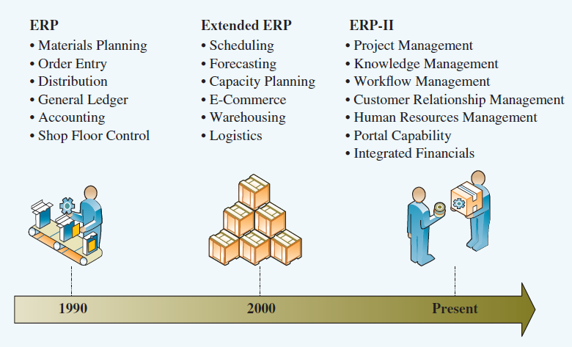
Accounting & Finance ERP Components

- Manage a wide range of financial functions including general ledger, A/P, A/R, budgeting & asset management.
- Includes a credit-management function setting and monitoring credit limits, product profit analysis and real-time customer account balances
- Performs advanced profitability modelling.

Production & Materials Management

- Handles production planning & execution from demand forecasting to quality control.
- Each component is integrated in real-time to reduce excess or insufficient inventory, delayed production etc.

Human Resources ERP Component

- Tracks employee data
- Manages payroll, benefits, compensation, performance assessment, and assures legal compliance
- Identifies individual employees for training, rewards or disciplinary purposes
- Analysis including productivity assessments, salary trends, health and safety metrics etc.

Extended ERP Components

Business Intelligence: Summarizes data, uses analytical tools to turn data into information, and to support decision-making

Customer Relationship Management: Identifies the relative value of each customer and uses data to provide information on customer preferences and to improve customer experience to maintain customer loyalty

Supply Chain Components
- SCM (Supply Chain Management) manages data flows through the distribution stages to maximize profitability
- Helps with planning, scheduling and controls of supply and delivery

E-Business ERP Component

The newest extension of ERP is to move outside the organization and connect to the organization’s stakeholders
- E-logistics manages the transportation and storage of goods.
- E-procurement is the business-to-business purchase and sale of supplies and services
- They fulfill business orders effectively using the Web
  - Can provide stakeholders with useful data to improve service such as inventory levels, forecasts
- Disadvantages of e-business ERP include security risks in trusting outside organizations with proprietary data

Integrating SCM, CRM, and ERP

Primary Users and Benefits
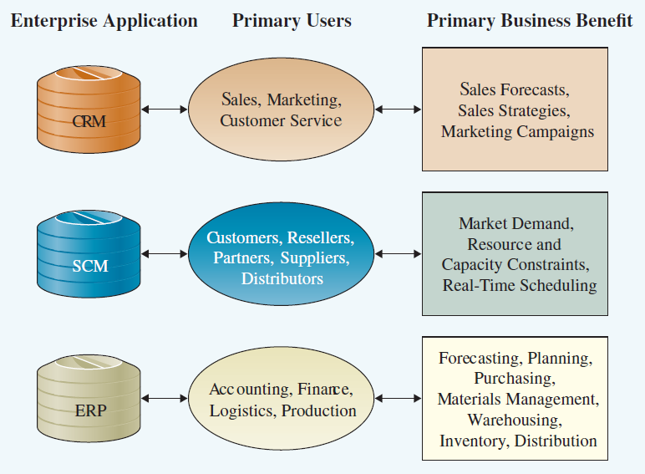

Integration Tools
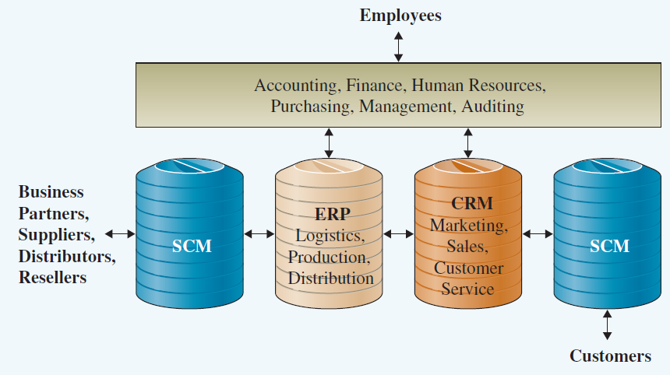
Finding the Right ERP Solution

- Successful projects share three basic attributes:
  - Overall fit between the system and the business process.
  - Proper business analysis
  - Solid implementation plans.

- Three methods of implementation include:
  - Turnkey (off the rack/off the shelf)
    - Systems that have been previously designed and fit the business requirements. Usually for minor implementations.
  - Off the rack/off the shelf tailored to fit
    - Previously designed but still require an investment in implementation
    - Most common
  - Customer Designed
    - Designed from scratch
    - Usually the most expensive

ERP & the SME Markets

- The Small & Medium Enterprise Market is different:
  - SME has a greater requirement for affordability and ease-of-use
  - SME’s are unfamiliar with large ERP vendors
    - Limited relationship results in limited trust
  - Canadian SME’s are different than those in the USA and US mid-market solutions don’t work here
  - SME’s purchase through resellers as direct sales are too small to be economical. ERP vendors are used to direct sales.

